

REQUEST FOR AN EXTENSION TO ASSIGNMENT DEADLINE FORM

This form should be used to request an extension for a particular assignment. The extension must be agreed by either the module tutor or your programme leader. When the form is completed, please attach to your assignment to show that an extension has been agreed.

To be completed by the STUDENT: (in BLOCK CAPITALS please)
section a – personal details
Surname: PERERA |  | forename(s): MOLLIGODA ARACHCHIGE ANOJ THILINA
student id number: |  | S25021960
programme title: MSc Computer Science
LEVEL: |  | 07
SECTION B – ASSIGNMENT DETAILS
MODULE CODE: COM 763 | MODULE TITLE: Advanced Machine Learning
MODULE TUTOR: Ms. Sathya
TITLE OF ASSIGNMENT: Portfolio Task 1
REASON FOR REQUEST: Infected by Dengue
ORIGINAL SUBMISSION DATE: |  |  | 16-july-2026
SECTION C – DETAILS OF REQUEST FOR EXTENSION
I respectfully request an extension for my assignment submission due to a medical condition. I began experiencing symptoms suspected to be dengue on 6 July 2026 and was diagnosed with dengue fever on 8 July 2026. I was admitted to the hospital on 10 July 2026 and discharged on 13 July 2026. Although I have been discharged, I am still recovering and have not yet returned to full health. My illness and ongoing recovery have significantly affected my ability to complete the assignment by the submission deadline. I kindly request an extension to allow me sufficient time to complete and submit my work.

STUDENT DECLARATION
I declare that the information that I have given on this form is true.

Student Signature: 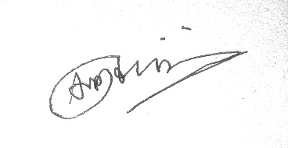 | Date: 15-july-2026



REQUEST FOR AN EXTENSION TO ASSIGNMENT DEADLINE FORM

DECISION OF MODULE TUTOR / PROGRAMME LEADER

(Please tick appropriate boxes)

1A Request Accepted.

New assignment submission date: …………………………………………………………………

1B Request Rejected

Reason for request being rejected : …………………………………………………………………

…………………………………………………………………………………………………………….

…………………………………………………………………………………………………………….

Signature of Module Tutor /Programme Leader: | Date:

Mae’r ffurflen hon ar gael yn y Gymraeg/This form is available in Welsh

