Sun Medical Hospital (SMH)
Extended Database Design
ER Diagram | Design Notes | Relational Schema

1. Entity-Relationship Diagram
The diagram below extends the original SMH ER model so that the institute can offer the new Dental and Optic services in addition to its existing Emergency and General Practice services. New / changed components are highlighted in green on the diagram.
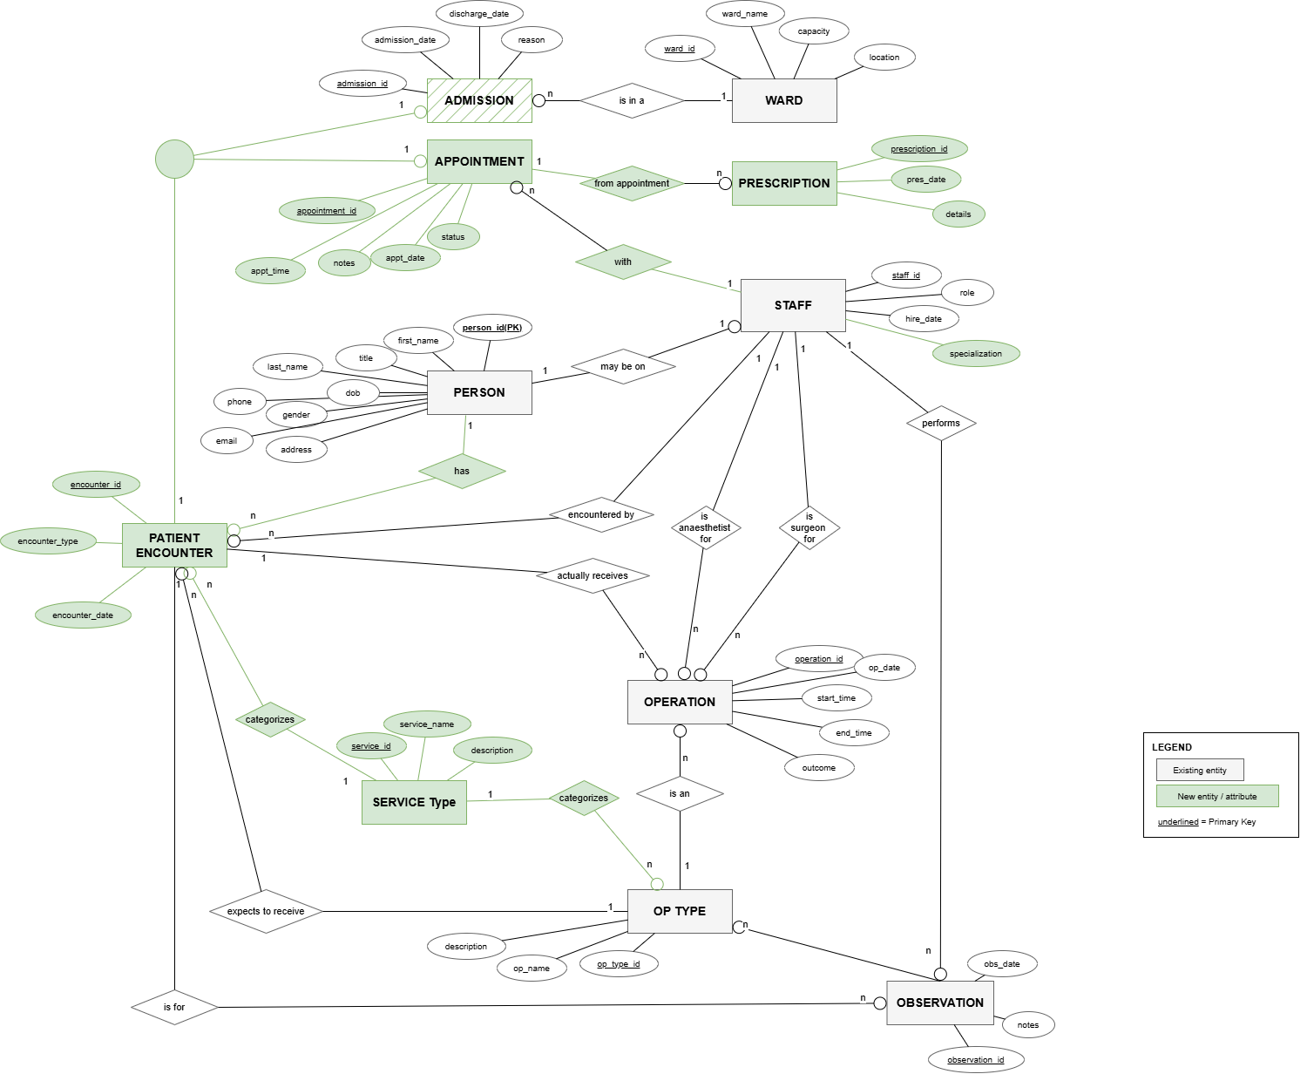
Newly added or modified components (highlighted green):
- PATIENT_ENCOUNTER super-class with disjoint specialisation into ADMISSION (existing) and APPOINTMENT (new) — replaces the standalone ADMISSION entity in the original model.
- APPOINTMENT entity — supports walk-in / scheduled visits required by Dental, Optic and GP services.
- PRESCRIPTION entity — captures medications/treatment plans issued from an appointment.
- SERVICE_TYPE entity — categorises each encounter and operation type (Emergency, GP, Dental, Optic, Surgery).
- OP_TYPE extended with new dental and optic procedures (Tooth Extraction, Root Canal, Lasik Eye Surgery, Cataract Surgery, etc.).
- STAFF role attribute extended to include Dentist and Optometrist.

2. Design Notes

2.1 Overall Approach
The original SMH database was built around a single ADMISSION entity, which suited an inpatient-only workflow (Emergency / Surgical). To support outpatient Dental and Optic services we generalised the patient-visit concept into a PATIENT_ENCOUNTER super-class with two disjoint sub-types: ADMISSION (inpatient) and APPOINTMENT (outpatient). This avoids duplicating attributes such as person_id, staff_id, encounter_date and service_type on multiple entities and keeps the model normalised.

2.2 Why a Super-class / Sub-class Hierarchy
- ADMISSION and APPOINTMENT share the patient, the responsible staff member, the service type, and the encounter date, but differ in their specific data — admissions need a ward and discharge date; appointments need an appointment time and status. A disjoint specialisation captures both common and specific attributes cleanly.
- All downstream entities (OPERATION, OBSERVATION) link to PATIENT_ENCOUNTER so that an operation or observation can be tied to either an admitted patient or an outpatient appointment without duplication.
- Disjointness (the d circle in the ER) enforces that an encounter is exactly one of {Admission, Appointment}. We implement this with the encounter_type discriminator constrained by a CHECK list.

2.3 Integrating the New Services
- SERVICE_TYPE is a small reference table holding {Emergency, GP, Dental, Optic, Surgery}. Every encounter and every OP_TYPE points to a SERVICE_TYPE, so adding a future service line (e.g. Pediatrics) only requires a new row, not a schema change.
- New OP_TYPE rows for the dental and optic services (Tooth Extraction, Root Canal, Cataract Surgery, Lasik) inherit the existing OPERATION table — surgeons / optometrists / dentists are all simply STAFF rows with a different role.
- New WARD types (Dental Ward, Optic Ward) accommodate any inpatient stays from the new specialities, while still serving the existing Emergency and General wards.
- PRESCRIPTION lives off APPOINTMENT — typical for GP/Dental/Optic outpatient flow — and is intentionally not linked to ADMISSION, since inpatient medications are recorded as OBSERVATIONs.

2.4 Key Relationships and Cardinalities
Relationship | Card. | Meaning
PERSON has PATIENT_ENCOUNTER | 1 : N | A person can have many encounters; each encounter is for one person.
PATIENT_ENCOUNTER -> ADMISSION / APPOINTMENT | 1 : 1 (disjoint) | Each encounter is exactly one of the two sub-types.
ADMISSION is in a WARD | N : 1 | Many admissions can share a ward; each admission is in one ward.
APPOINTMENT with STAFF | N : 1 | Each appointment is with one staff member.
APPOINTMENT yields PRESCRIPTION | 1 : N | An appointment can produce zero or more prescriptions.
STAFF encountered by PATIENT_ENCOUNTER | 1 : N | Records who handled the encounter (front-desk doctor / receiving staff).
PATIENT_ENCOUNTER actually receives OPERATION | 1 : N | An encounter may include one or more operations.
PATIENT_ENCOUNTER expects to receive OP_TYPE | N : 1 | Pre-encounter expected procedure (may be NULL).
OPERATION is an OP_TYPE | N : 1 | Each operation is classified by exactly one type.
STAFF is surgeon / anaesthetist for OPERATION | 1 : N (each role) | Each operation has one surgeon and optionally one anaesthetist.
STAFF performs OP_TYPE | M : N | Tracks which staff are certified for which procedures.
OBSERVATION is for PATIENT_ENCOUNTER and OP_TYPE | M : N (resolved via FK) | Clinical observations recorded against an encounter and (optionally) a procedure type.
SERVICE_TYPE categorises PATIENT_ENCOUNTER & OP_TYPE | 1 : N each | Drives reporting by service line.

2.5 Design Decisions / Trade-offs
- We model the disjoint specialisation as a super-class table plus two sub-class tables (Class-Table-Inheritance). This avoids NULL-heavy single-table inheritance and lets sub-class-specific FKs (ward_id, with_staff_id) be declared NOT NULL on the right table.
- OPERATION carries surgeon_id and anaesthetist_id directly rather than using an associative table, because each operation has at most one surgeon and one anaesthetist — a 1:N relationship from STAFF, not M:N.
- STAFF.role is constrained by a CHECK list to keep cardinality controllable while remaining easy to extend.
- Dates and date-times use ISO formats so the schema is portable across SQLite (Google Colab default), MySQL, and PostgreSQL.

3. Relational Schema
Notation: PK = Primary Key, FK = Foreign Key. Relations are written R(attr1, attr2, ...). Underline-style emphasis is replaced with the explicit PK / FK column.

3.1 Domains
Domain | Type | Description / Constraint
ID | INTEGER | Surrogate primary keys (auto-managed).
NAME | VARCHAR(40) | Human names; NOT NULL.
LONGTEXT | VARCHAR(200-300) | Notes, descriptions, instructions.
DATE_T | DATE | Calendar date (ISO YYYY-MM-DD).
DATETIME_T | DATETIME | Date + time (ISO).
GENDER_T | CHAR(1) | M / F / O (CHECK).
ROLE_T | VARCHAR(25) | GP, Surgeon, Anaesthetist, Nurse, Dentist, Optometrist, Specialist (CHECK).
ENC_TYPE_T | VARCHAR(15) | Admission or Appointment (CHECK).
APPT_STATUS_T | VARCHAR(15) | Scheduled / Completed / Cancelled / NoShow (CHECK).
PHONE_T | VARCHAR(20) | Free-format phone string.
EMAIL_T | VARCHAR(60) | Email format string.

3.2 Relations

PERSON
PERSON(person_id, first_name, last_name, dob, gender, phone, address, blood_group, insurance_no)
Attribute | Domain | Constraint
person_id | ID | PK
first_name / last_name | NAME | NOT NULL
dob | DATE_T | NOT NULL
gender | GENDER_T | CHECK (M/F/O)
phone, address | VARCHAR | optional
blood_group | VARCHAR(3) | optional
insurance_no | VARCHAR(25) | optional

STAFF
STAFF(staff_id, first_name, last_name, role, department, phone, email, hire_date)
Attribute | Domain | Constraint
staff_id | ID | PK
first_name / last_name | NAME | NOT NULL
role | ROLE_T | NOT NULL, CHECK list
department | VARCHAR(40) | optional
phone / email | PHONE_T / EMAIL_T | optional
hire_date | DATE_T | optional

WARD
WARD(ward_id, ward_name, ward_type, capacity)
Attribute | Domain | Constraint
ward_id | ID | PK
ward_name | NAME | NOT NULL
ward_type | VARCHAR(30) | optional
capacity | INTEGER | CHECK > 0

SERVICE_TYPE (NEW)
SERVICE_TYPE(service_type_id, name, description)
Attribute | Domain | Constraint
service_type_id | ID | PK
name | VARCHAR(30) | NOT NULL, UNIQUE
description | LONGTEXT | optional

OP_TYPE
OP_TYPE(op_type_id, service_type_id, name, description, typical_duration)
Attribute | Domain | Constraint
op_type_id | ID | PK
service_type_id | ID | FK -> SERVICE_TYPE, NOT NULL
name | VARCHAR(60) | NOT NULL
description | LONGTEXT | optional
typical_duration | INTEGER | minutes

PATIENT_ENCOUNTER (super-class, NEW abstraction)
PATIENT_ENCOUNTER(encounter_id, person_id, staff_id, service_type_id, encounter_type, encounter_date, expected_op_type_id)
Attribute | Domain | Constraint
encounter_id | ID | PK
person_id | ID | FK -> PERSON, NOT NULL
staff_id | ID | FK -> STAFF, NOT NULL
service_type_id | ID | FK -> SERVICE_TYPE, NOT NULL
encounter_type | ENC_TYPE_T | NOT NULL, CHECK
encounter_date | DATETIME_T | NOT NULL
expected_op_type_id | ID | FK -> OP_TYPE, nullable

ADMISSION (sub-class)
ADMISSION(encounter_id, ward_id, admit_date, discharge_date)
Attribute | Domain | Constraint
encounter_id | ID | PK, FK -> PATIENT_ENCOUNTER
ward_id | ID | FK -> WARD, NOT NULL
admit_date | DATE_T | NOT NULL
discharge_date | DATE_T | nullable; CHECK >= admit_date

APPOINTMENT (sub-class, NEW)
APPOINTMENT(encounter_id, with_staff_id, appointment_time, status)
Attribute | Domain | Constraint
encounter_id | ID | PK, FK -> PATIENT_ENCOUNTER
with_staff_id | ID | FK -> STAFF, NOT NULL
appointment_time | DATETIME_T | NOT NULL
status | APPT_STATUS_T | CHECK list

PRESCRIPTION (NEW)
PRESCRIPTION(prescription_id, encounter_id, medication, dosage, instructions, issued_date)
Attribute | Domain | Constraint
prescription_id | ID | PK
encounter_id | ID | FK -> APPOINTMENT, NOT NULL
medication | VARCHAR(80) | NOT NULL
dosage | VARCHAR(40) | optional
instructions | LONGTEXT | optional
issued_date | DATE_T | NOT NULL

OPERATION
OPERATION(operation_id, encounter_id, op_type_id, surgeon_id, anaesthetist_id, operation_date, room)
Attribute | Domain | Constraint
operation_id | ID | PK
encounter_id | ID | FK -> PATIENT_ENCOUNTER, NOT NULL
op_type_id | ID | FK -> OP_TYPE, NOT NULL
surgeon_id | ID | FK -> STAFF, NOT NULL
anaesthetist_id | ID | FK -> STAFF, nullable
operation_date | DATETIME_T | NOT NULL
room | VARCHAR(20) | optional

STAFF_OP_TYPE (M:N resolver)
STAFF_OP_TYPE(staff_id, op_type_id, certification_date)
Attribute | Domain | Constraint
staff_id | ID | PK part 1, FK -> STAFF
op_type_id | ID | PK part 2, FK -> OP_TYPE
certification_date | DATE_T | optional

OBSERVATION
OBSERVATION(observation_id, encounter_id, op_type_id, observation_date, notes, recorded_by_staff)
Attribute | Domain | Constraint
observation_id | ID | PK
encounter_id | ID | FK -> PATIENT_ENCOUNTER, NOT NULL
op_type_id | ID | FK -> OP_TYPE, nullable
observation_date | DATETIME_T | NOT NULL
notes | LONGTEXT | optional
recorded_by_staff | ID | FK -> STAFF, optional

3.3 Referential-Integrity Summary
- All FK columns enforce ON DELETE / UPDATE NO ACTION (default) to prevent orphan rows.
- encounter_type discriminator + sub-class PKs equal to PATIENT_ENCOUNTER.encounter_id ensures the disjoint specialisation in storage.
- CHECK constraints on gender, role, encounter_type and appointment status keep enumerated values consistent.
- Composite PK on STAFF_OP_TYPE prevents duplicate certifications for the same staff/procedure pair.

