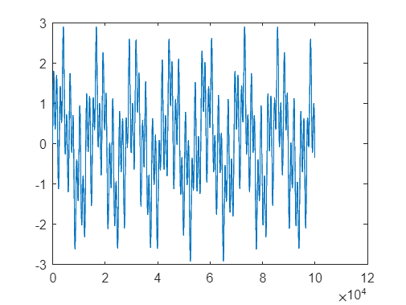
Figure 1. Clear signal (2,5, and 22Hz)
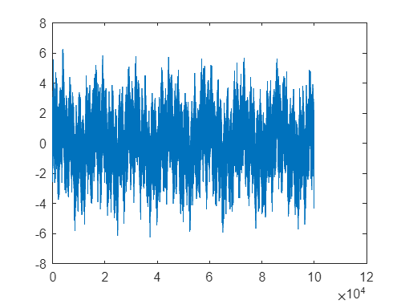
Figure 2. Signal with white noise
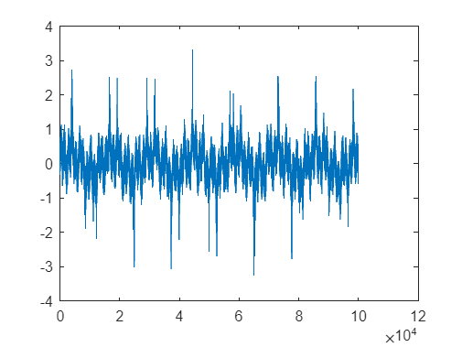
Figure 3. Filtered signal by Wiener filter.
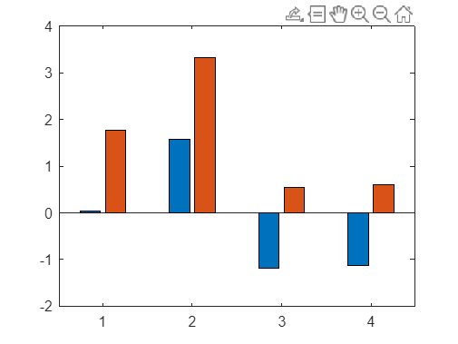
Figure 4. PSNR and SNR comparison by Wiener filter. (1) noisy signal (2) filtered signal (3) sum of 5 IMF (4) filtered residual + sum of 5 IMF
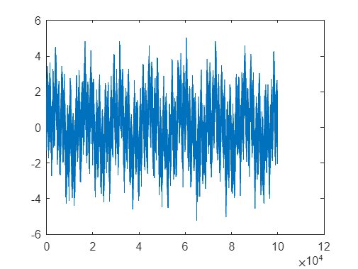
Figure 5. Filtered signal by Median filter.
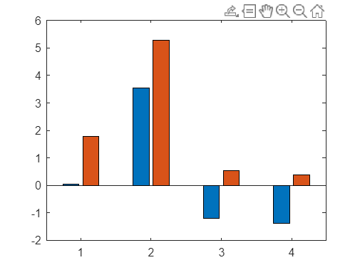
Figure 6. PSNR and SNR comparison by Median filter. (1) noisy signal (2) filtered signal (3) sum of 5 IMF (4) filtered residual + sum of 5 IMF
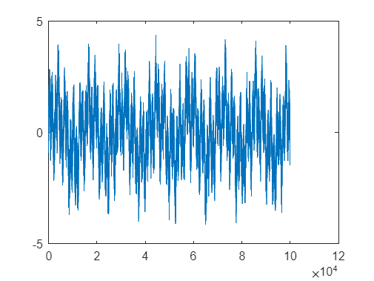
Figure 7. Filtered signal by Average filter.
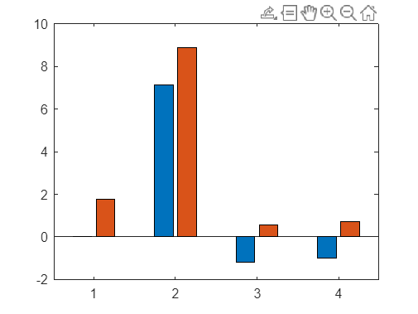x
Figure 8. PSNR and SNR comparison by Average filter. (1) noisy signal (2) filtered signal (3) sum of 5 IMF (4) filtered residual + sum of 5 IMF

