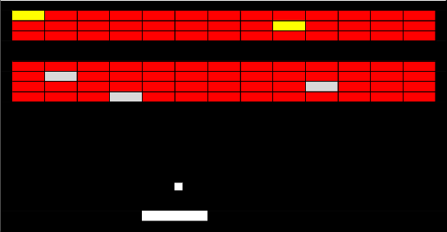
Super Breakout

Overview
Using the paddle, you direct a ball that is bouncing around the screen in order to break the blocks out of the wall above you.
It’s been a long time since I played the original, but here are the basic rules that I remember.

Basic Rules
- If the ball hits the bottom of the screen you loose a life.
- The blocks have different levels of toughness, and if aren’t destroyed on the first hit will change colors each time they’re hit.
- The wall will advance on you every so often, with more wall being generated behind it, indefinitely. Since we’re required to have 3 levels it might be better not to generate more wall. The wall will not advance below a certain point, but being so close to the paddle makes it very hard to clear them.
- The ball will react to the motion of the paddle.

Variations
- Power Ups/Downs: Have some blocks drop power up and power downs. Here are some of the possible effects. They’re all temporary effects.
  - Multi-balls – Generates multiple balls on the screen, for maximum chaos. Balls can hit the bottom of the screen and you won’t lose a life as long as there is one ball left on the screen.
  - Sticky Paddle – The ball sticks to the paddle and you have to push a button to release it.
  - Resize Paddle (shrink/grow) – Resizes the paddle, either growing it or shrinking it.
  - Change Ball Velocity (fast/slow) – Changes the velocity of the ball.
  - Exploding Ball – Ball is more powerful, and does an area of effect damage. E.g. It does 3 points of damage to the block it hits, and 1 point of damage to any blocks within a certain radius of the ball.

Difficulty
Depending on the variations you add to the game, this could be a hard game given the following items.
- Physics engine involved.
- Control of speed/frame rate

