Results_draft

James Ng

12/13/2019

# Methods

The dataset contains 7 factors that are potentially associated with the salaries of the Houston College of Medicine faculty. These are department, gender, primary emphasis (clinical or research), certification (board certified or not certified), publication rate (publications on CV/ years between CV date and MD date), years since obtaining MD and rank. The mean salary for the 1994 academic year and the salary for the 1995 academic year (salary after increment to the 1994 income) are the outcomes. Histograms were were made to visualize the distribution of the outcomes. The histograms show right skewness so log transformations of the outcomes were carried out (supplemental - ###). Since gender was the main variable of interest, models were analyzed in R studio (citation - ###) to test for associations between gender and salary. A simple linear regression model was developed using mean salaries for the 2 years provided and gender. Using this model as the reference point, other variables in the dataset were analyzed as potential confounders or interactions. Model selection was made using criterion-based procedures. Once the final model was determined, residuals vs fitted values plot, quantile-quantile plot, scale-location plot and residuals vs leverage plots were used to diagnose the model (supplemental - ###).

# Results

Several of the other variables (department, primary emphasis, certification, publication rate and experience) were determined to be confounders, while rank was found to be an interaction. High collinearity was found between publication rate and primary emphasis, so publication rate was dropped from the model. The final model (supplemental figure ###) shows that gender is a significant variable in determining salary. Males on average, earn more than females by exp(.074) dollars when adjusting for department, primary emphasis, experience certification, and rank. Associated p values are also provided. The model shows an adjusted $R^{2}$ value of .9322, meaning that 93% of the variability of the data is represent by the model. Cook’s distance, quantile-quantile plot, and residuals plots show one observation (the 184th observation) is an influential point. Influential points were not dropped from model because this is a model for association.

|  |  |  |  |
| --- | --- | --- | --- |
|  | Females (N=106) | Males (N=155) | Total (N=261) |
| dept |  |  |  |
| - Biochemistry/Molecular Biology | 20 (18.9%) | 30 (19.4%) | 50 (19.2%) |
| - Physiology | 20 (18.9%) | 20 (12.9%) | 40 (15.3%) |
| - Genetics | 11 (10.4%) | 10 (6.5%) | 21 (8.0%) |
| - Pediatrics | 20 (18.9%) | 10 (6.5%) | 30 (11.5%) |
| - Medicine | 30 (28.3%) | 50 (32.3%) | 80 (30.7%) |
| - Surgery | 5 (4.7%) | 35 (22.6%) | 40 (15.3%) |
| clin |  |  |  |
| - Primarily research emphasis | 46 (43.4%) | 55 (35.5%) | 101 (38.7%) |
| - Primarily clinical emphasis | 60 (56.6%) | 100 (64.5%) | 160 (61.3%) |
| cert |  |  |  |
| - Not Certified | 36 (34.0%) | 37 (23.9%) | 73 (28.0%) |
| - Board Certified | 70 (66.0%) | 118 (76.1%) | 188 (72.0%) |
| prate |  |  |  |
| - Mean (SD) | 5.35 (1.89) | 4.65 (1.94) | 4.93 (1.94) |
| - Median (Q1, Q3) | 5.25 (3.73, 7.27) | 4.00 (3.10, 6.70) | 4.40 (3.20, 6.90) |
| exper |  |  |  |
| - Mean (SD) | 7.49 (4.17) | 12.10 (6.70) | 10.23 (6.23) |
| - Median (Q1, Q3) | 7.00 (5.00, 10.00) | 10.00 (7.00, 15.00) | 9.00 (6.00, 14.00) |
| rank |  |  |  |
| - Assistant | 69 (65.1%) | 43 (27.7%) | 112 (42.9%) |
| - Associate | 21 (19.8%) | 43 (27.7%) | 64 (24.5%) |
| - Full professor | 16 (15.1%) | 69 (44.5%) | 85 (32.6%) |
| sal94 |  |  |  |
| - Mean (SD) | 118871.27 (56168.01) | 177338.76 (85930.54) | 153593.34 (80469.67) |
| - Median (Q1, Q3) | 108457.00 (75774.50, 143096.00) | 155006.00 (109687.00, 231501.50) | 133284.00 (90771.00, 200543.00) |
| sal95 |  |  |  |
| - Mean (SD) | 130876.92 (62034.51) | 194914.09 (94902.73) | 168906.66 (88778.43) |
| - Median (Q1, Q3) | 119135.00 (82345.25, 154170.50) | 170967.00 (119952.50, 257163.00) | 148117.00 (99972.00, 218955.00) |

## `stat_bin()` using `bins = 30`. Pick better value with `binwidth`.  
## `stat_bin()` using `bins = 30`. Pick better value with `binwidth`.

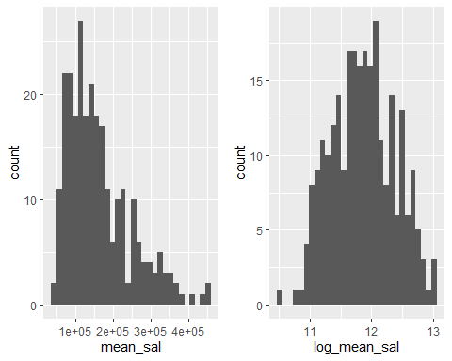

## Final model

final_model= lm(log_mean_sal ~ dept + clin + cert + exper + gender*rank, data = data)  
summary(final_model)

##   
## Call:  
## lm(formula = log_mean_sal ~ dept + clin + cert + exper + gender *   
## rank, data = data)  
##   
## Residuals:  
## Min 1Q Median 3Q Max   
## -0.32667 -0.08080 -0.01075 0.07646 0.86686   
##   
## Coefficients:  
## Estimate Std. Error t value Pr(>|t|)   
## (Intercept) 10.959335 0.027936 392.307 < 2e-16 ***  
## deptPhysiology -0.175544 0.028871 -6.080 4.53e-09 ***  
## deptGenetics 0.184572 0.036206 5.098 6.84e-07 ***  
## deptPediatrics 0.208468 0.035528 5.868 1.41e-08 ***  
## deptMedicine 0.543204 0.029364 18.499 < 2e-16 ***  
## deptSurgery 0.931388 0.035267 26.409 < 2e-16 ***  
## clinPrimarily clinical emphasis 0.197031 0.022175 8.885 < 2e-16 ***  
## certBoard Certified 0.191213 0.021363 8.951 < 2e-16 ***  
## exper 0.018171 0.001806 10.064 < 2e-16 ***  
## genderMales 0.074479 0.027568 2.702 0.00738 **   
## rankAssociate 0.173142 0.033904 5.107 6.55e-07 ***  
## rankFull professor 0.282281 0.039594 7.129 1.11e-11 ***  
## genderMales:rankAssociate -0.082943 0.044750 -1.853 0.06501 .   
## genderMales:rankFull professor -0.105271 0.046654 -2.256 0.02492 *   
## ---  
## Signif. codes: 0 '***' 0.001 '**' 0.01 '*' 0.05 '.' 0.1 ' ' 1  
##   
## Residual standard error: 0.1325 on 247 degrees of freedom  
## Multiple R-squared: 0.9355, Adjusted R-squared: 0.9322   
## F-statistic: 275.8 on 13 and 247 DF, p-value: < 2.2e-16

par(mfrow=c(2,2))  
plot(final_model)

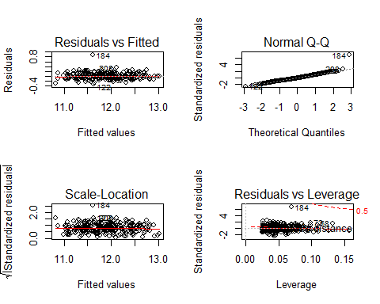

## Outliers and influ.point

Observation 184 is identified with high DFFITS value so it affects the observation 184 fitted value. On the diagnostic plot, case 184 appears problematic on each plot. Therefore, we try to remove this point and do analysis again.

remove_184 = data[-c(184),]  
remove.mod = lm(log_mean_sal ~ dept + clin + cert + exper + gender*rank, data=remove_184)  
summary(remove.mod)

##   
## Call:  
## lm(formula = log_mean_sal ~ dept + clin + cert + exper + gender *   
## rank, data = remove_184)  
##   
## Residuals:  
## Min 1Q Median 3Q Max   
## -0.33708 -0.07434 -0.01380 0.08434 0.33209   
##   
## Coefficients:  
## Estimate Std. Error t value Pr(>|t|)   
## (Intercept) 10.949637 0.025286 433.035 < 2e-16 ***  
## deptPhysiology -0.181193 0.026110 -6.940 3.46e-11 ***  
## deptGenetics 0.180068 0.032734 5.501 9.46e-08 ***  
## deptPediatrics 0.189702 0.032214 5.889 1.27e-08 ***  
## deptMedicine 0.515765 0.026795 19.249 < 2e-16 ***  
## deptSurgery 0.915461 0.031951 28.652 < 2e-16 ***  
## clinPrimarily clinical emphasis 0.218278 0.020244 10.782 < 2e-16 ***  
## certBoard Certified 0.207168 0.019428 10.663 < 2e-16 ***  
## exper 0.018590 0.001633 11.383 < 2e-16 ***  
## genderMales 0.045856 0.025211 1.819 0.0701 .   
## rankAssociate 0.167412 0.030658 5.461 1.16e-07 ***  
## rankFull professor 0.273861 0.035809 7.648 4.60e-13 ***  
## genderMales:rankAssociate -0.050384 0.040684 -1.238 0.2167   
## genderMales:rankFull professor -0.077467 0.042336 -1.830 0.0685 .   
## ---  
## Signif. codes: 0 '***' 0.001 '**' 0.01 '*' 0.05 '.' 0.1 ' ' 1  
##   
## Residual standard error: 0.1198 on 246 degrees of freedom  
## Multiple R-squared: 0.9472, Adjusted R-squared: 0.9445   
## F-statistic: 339.8 on 13 and 246 DF, p-value: < 2.2e-16

par(mfrow=c(2,2))  
plot(remove.mod)

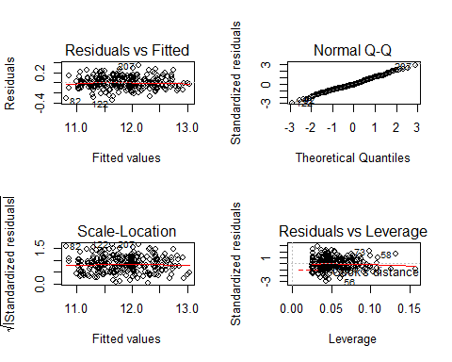

### stratified if needed.

data_rank_3 = data %>%   
 filter(rank == "Full professor")  
data_rank_2 = data %>%   
 filter(rank == "Associate")  
data_rank_1 = data %>%   
 filter(rank == "Assistant")  
  
final_model_3 = lm(log_mean_sal ~ dept + clin + cert + exper + gender, data = data_rank_3)  
summary(final_model_3)

##   
## Call:  
## lm(formula = log_mean_sal ~ dept + clin + cert + exper + gender,   
## data = data_rank_3)  
##   
## Residuals:  
## Min 1Q Median 3Q Max   
## -0.279999 -0.079443 -0.000564 0.075727 0.253899   
##   
## Coefficients:  
## Estimate Std. Error t value Pr(>|t|)   
## (Intercept) 11.247757 0.048321 232.773 < 2e-16 ***  
## deptPhysiology -0.127860 0.038834 -3.292 0.00152 **   
## deptGenetics 0.248823 0.055205 4.507 2.38e-05 ***  
## deptPediatrics 0.166793 0.066371 2.513 0.01412 *   
## deptMedicine 0.528191 0.039209 13.471 < 2e-16 ***  
## deptSurgery 0.948635 0.050331 18.848 < 2e-16 ***  
## clinPrimarily clinical emphasis 0.179305 0.033412 5.367 8.61e-07 ***  
## certBoard Certified 0.258010 0.033989 7.591 7.14e-11 ***  
## exper 0.014871 0.002253 6.601 5.15e-09 ***  
## genderMales -0.040413 0.036217 -1.116 0.26805   
## ---  
## Signif. codes: 0 '***' 0.001 '**' 0.01 '*' 0.05 '.' 0.1 ' ' 1  
##   
## Residual standard error: 0.1165 on 75 degrees of freedom  
## Multiple R-squared: 0.9511, Adjusted R-squared: 0.9452   
## F-statistic: 161.9 on 9 and 75 DF, p-value: < 2.2e-16

final_model_2 = lm(log_mean_sal ~ dept + clin + cert + exper + gender, data = data_rank_2)  
summary(final_model_2)

##   
## Call:  
## lm(formula = log_mean_sal ~ dept + clin + cert + exper + gender,   
## data = data_rank_2)  
##   
## Residuals:  
## Min 1Q Median 3Q Max   
## -0.268895 -0.061719 0.008443 0.069568 0.186993   
##   
## Coefficients:  
## Estimate Std. Error t value Pr(>|t|)   
## (Intercept) 11.093068 0.045411 244.283 < 2e-16 ***  
## deptPhysiology -0.189342 0.043481 -4.355 5.99e-05 ***  
## deptGenetics 0.170588 0.055740 3.060 0.003439 **   
## deptPediatrics 0.210069 0.055921 3.757 0.000424 ***  
## deptMedicine 0.507098 0.050051 10.132 4.30e-14 ***  
## deptSurgery 0.931900 0.057099 16.321 < 2e-16 ***  
## clinPrimarily clinical emphasis 0.220247 0.037705 5.841 3.06e-07 ***  
## certBoard Certified 0.200488 0.031803 6.304 5.53e-08 ***  
## exper 0.021512 0.002619 8.214 4.45e-11 ***  
## genderMales -0.013277 0.031011 -0.428 0.670252   
## ---  
## Signif. codes: 0 '***' 0.001 '**' 0.01 '*' 0.05 '.' 0.1 ' ' 1  
##   
## Residual standard error: 0.1033 on 54 degrees of freedom  
## Multiple R-squared: 0.9621, Adjusted R-squared: 0.9558   
## F-statistic: 152.2 on 9 and 54 DF, p-value: < 2.2e-16

final_model_1= lm(log_mean_sal ~ dept + clin + cert + exper + gender, data = data_rank_1)  
summary(final_model_1)

##   
## Call:  
## lm(formula = log_mean_sal ~ dept + clin + cert + exper + gender,   
## data = data_rank_1)  
##   
## Residuals:  
## Min 1Q Median 3Q Max   
## -0.30995 -0.09230 -0.01370 0.07692 0.78854   
##   
## Coefficients:  
## Estimate Std. Error t value Pr(>|t|)   
## (Intercept) 10.958748 0.058460 187.457 < 2e-16 ***  
## deptPhysiology -0.201314 0.063379 -3.176 0.001973 **   
## deptGenetics 0.143432 0.069186 2.073 0.040681 *   
## deptPediatrics 0.255421 0.066715 3.829 0.000223 ***  
## deptMedicine 0.600806 0.061033 9.844 < 2e-16 ***  
## deptSurgery 0.943082 0.070044 13.464 < 2e-16 ***  
## clinPrimarily clinical emphasis 0.179071 0.042166 4.247 4.80e-05 ***  
## certBoard Certified 0.119828 0.040890 2.931 0.004176 **   
## exper 0.024735 0.005354 4.620 1.12e-05 ***  
## genderMales 0.082656 0.035347 2.338 0.021316 *   
## ---  
## Signif. codes: 0 '***' 0.001 '**' 0.01 '*' 0.05 '.' 0.1 ' ' 1  
##   
## Residual standard error: 0.1541 on 102 degrees of freedom  
## Multiple R-squared: 0.9126, Adjusted R-squared: 0.9049   
## F-statistic: 118.3 on 9 and 102 DF, p-value: < 2.2e-16