|  |
| --- |
| MJ Gaming |
| Angry Bullet |
|  |
| Version #1.0  All work Copyright © 2012 by XX Games.  All rights reserved. |
| **[Ziqing(James) Qiu] 300919236**  **[Matt(Xi) Chen 300939786]** |
|  |



|  |
| --- |
| Aug 8th 2018 |

**Table of Contents**

Contents

Game Overview 4

Game Play Mechanics 4

Camera 4

Controls 4

Interface Sketch 5

Menu and Screen Descriptions 6

Game World 6

Levels 6

Game Progression 7

Characters 7

Enemies 7

Weapons 8

Items 8

Scoring 8

Cheat Codes 8

Sound Index 9

Art / Multimedia Index 9

Future Features 10

**Version History**

|  |  |
| --- | --- |
| Jul 30 2018 | Created this document |
| Aug 8 2018 | Version 1.0 |
|  |  |

# Game Overview

This 2d game is a space shooting game. Player will control a spaceship to defeat enemies. There are totally three levels and one boss at the end of each level. During each level, there will be bullet power up items for player to upgrade the bullets.

# Game Play Mechanics

This game is a real time space shooting game. The scene is updated each frame. Player earn score by shooting enemy and bosses, destroy the ship, catching the bullet upgrade package.

# Camera

This game is using the god’s view.

# Controls

This game uses keyboard to control the space ship.

W or Up-arrow: control the spaceship to fast move forward

A or Left-arrow: control the spaceship to slow move left

D or Right-arrow: control the spaceship to slow move right

S or Down-arrow: control the spaceship to slow move backward

Space: fire bullet

# Interface Sketch

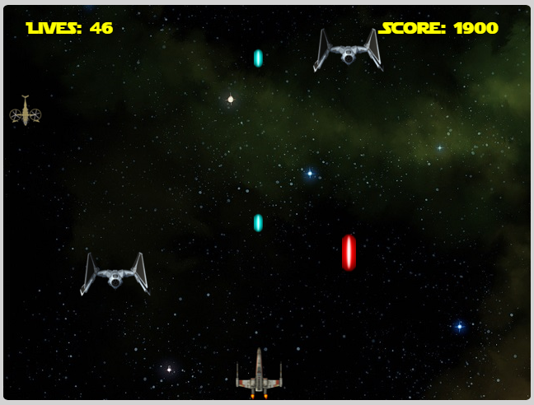

# Menu and Screen Descriptions

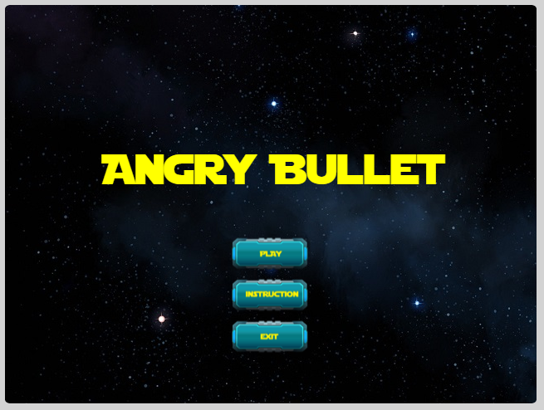

Play: start the game

Instruction: guide player to the instruction page including the keyboard description

Exit: exit the game

# Game World

This game’s world is the universe or the outer space

# Levels

There are total three levels, each level will have two stages, and one is the enemy while the other is the BOSS. After player defeat each level’s BOSS, it will lead the player to the next level.

# Game Progression

This game’s background scrolling is from top to down.

# Characters

Player’s spaceship is the X-wing. A very famous spaceship in STAR WARS

# Enemies

There are different enemies in different level:

Level 1:

TIE fighter: middle speed with 5 HP

Jedi Starfighter: fast speed with 1HP

Level 1 BOSS: 50 HP

Level 2:

TIE fighter lv2: middle speed with 10 HP

crazy Q: fast speed with 15 HP

Level 2 BOSS: 60 HP

Level 3:

TIE fighter lv3: middle speed with 15 HP

dark Jedi: fast speed with 15 HP

Level 3 BOSS: 70 HP

# Weapons

Player and enemies has two separate mutable bullet sets.

Player’s bullet has three types, basically they are blue tone

* laser bullet lv1
* laser bullet lv2
* rocket bullet lv 1

Enemies’ bullet has different types, and equipped by different enemies, they are red tone.

* laser bullet lv1
* laser bullet lv2
* bomb lv 1

# Items

By default, the player is equipped with laser bullet lv1 which cause 1 HP damage per hit.

There are three bullet power up packages can be found in the game.

* package F: upgrade the player’s laser bullet lv 1 double, therefore the damage is 2 HP per hit
* package S: upgrade the player’s bullet to laser bullet lv2, and it is fired to three directions like shot gun. The damage is 2 HP per hit
* package L: upgrade the player’s bullet to rocket bullet lv1. It can be fired to only one direction but can cause 5 HP per hit

# Scoring

The scoring will add score to player based on different target hit. Also there will be a live power up when player get more than 10,000.

# Cheat Codes

Player can press keyboard b for unlimited lives during the playing

# Sound Index

{id: "coin", src: "./Assets/audio/coin.wav"},

{id: "life", src: "./Assets/audio/lives.wav"},

{id: "gamewin", src: "./Assets/audio/win.wav"},

{id: "explosion", src: "./Assets/audio/explosion.mp3"},

{id: "blt_sound_laser_lv1", src: "./Assets/audio/bullet_laser_lv1.wav"},

{id: "blt_sound_laser_lv2", src: "./Assets/audio/bullet_laser_lv2.wav"},

{id: "blt_sound_rocket_lv1", src: "./Assets/audio/bullet_rocket_lv1.mp3"},

{id: "main_theme", src: "./Assets/audio/main_theme.mp3"},

{id: "level1_background", src: "./Assets/audio/level1_background.mp3"},

{id: "level1_final_background", src: "./Assets/audio/level1_final_background.mp3"},

{id: "level2_background", src: "./Assets/audio/level2_background.mp3"},

{id: "level2_final_background", src: "./Assets/audio/level2_final_background.mp3"},

{id: "level3_background", src: "./Assets/audio/level3_background.mp3"}

# Art / Multimedia Index

animations": {

"blt_boss_bomb_lv1": { "frames": [0, 1, 2, 3],"speed": 0.1 },

"blt_boss_laser_lv1": { "frames": [4, 5, 6],"speed": 0.1 },

"blt_enemy_laser_lv1": { "frames": [7] },

"blt_enemy_laser_lv2": { "frames": [8, 9, 10, 11],"speed": 0.1 },

"blt_player_laser_lv1": { "frames": [12] },

"blt_player_laser_lv2": { "frames": [13, 14, 15, 16],"speed": 0.1 },

"blt_player_rocket_lv1": { "frames": [17, 18, 19, 20, 21],"speed": 0.1 },

"boss_lv1": { "frames": [22, 23, 24],"speed": 0.1 },

"boss_lv2": { "frames": [25, 26, 27],"speed": 0.1 },

"boss_lv3": { "frames": [28, 29, 30],"speed": 0.1 },

"btn_back": { "frames": [31] },

"btn_exit": { "frames": [32] },

"btn_instruct": { "frames": [33] },

"btn_restart": { "frames": [34] },

"btn_start": { "frames": [35] },

"crazyq": { "frames": [36, 37, 38, 39, 40, 41, 42, 43],"speed": 0.1 },

"empire": { "frames": [44, 45, 46, 47, 48, 49, 50],"speed": 0.1 },

"explosion": { "frames": [51, 52, 53, 54, 55, 56, 57] },

"kb_a": { "frames": [58] },

"kb_blankspace": { "frames": [59] },

"kb_d": { "frames": [60] },

"kb_down": { "frames": [61] },

"kb_left": { "frames": [62] },

"kb_right": { "frames": [63] },

"kb_s": { "frames": [64] },

"kb_up": { "frames": [65] },

"kb_w": { "frames": [66] },

"planeflash": { "frames": [67, 68] },

"player_lv1": { "frames": [69, 70, 71, 72],"speed": 0.16 },

"power_up_F": { "frames": [73] },

"power_up_L": { "frames": [74] },

"power_up_S": { "frames": [75] },

"slaveI": { "frames": [76] },

"smallexplosion": { "frames": [77, 78, 79, 80, 81, 82] },

"tie": { "frames": [83] },

"tie_lv2": { "frames": [84] },

"tie_lv3": { "frames": [85] }

}

# Future Features

We do plan to add more features in the future.

* Player gets invulnerable for a certain amount of time after get hit
* More bullet types
* More upgrade items