**Requirement txt:**

pip install gensim

python -c "import nltk; nltk.download('punkt')"

pip install pyemd

**Possible problems:**

1. pip install pyemd reports an error
2. When importing pyemd, the error occurs

The following is a detailed workaround.

1. pip install pyemd reports an error as shown below

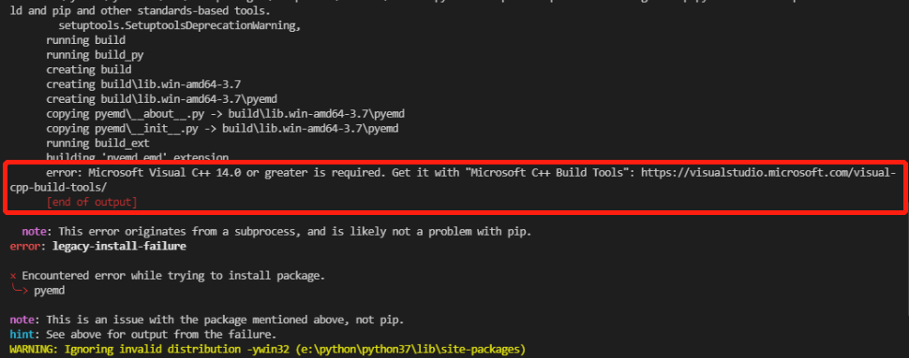

This means that the pyemd package cannot be installed directly through pip install on this computer.

**Solution:**

There are three solutions below, you can choose one of them:

1. **By downloading the wheel, install it locally**

Find the suitable wheel at this URL: <https://www.lfd.uci.edu/~gohlke/pythonlibs/#pyemd>

E.g., Using python3.7, [MSC v.1914 64 bit (AMD64)] on win32, you need to download the wheel files of cp37 and amd64, as shown in the figure below.

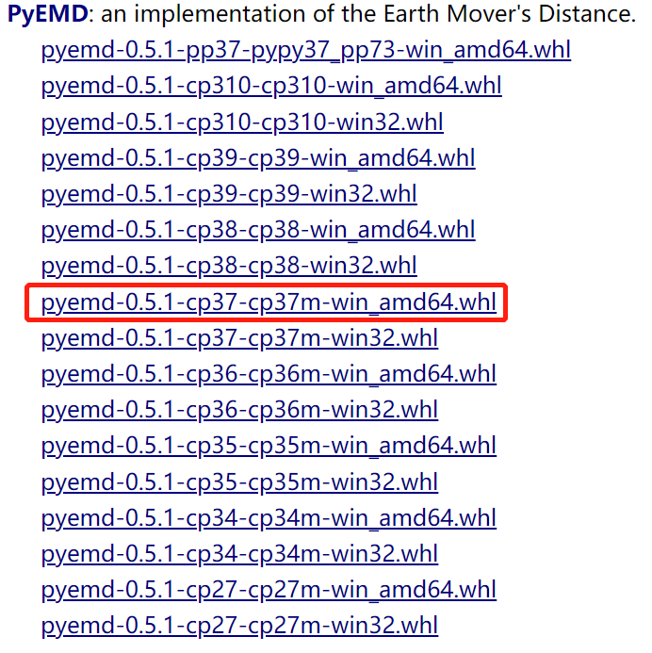

Next, put the downloaded .whl file in any path you want, enter cmd from this path, and enter:

**pip install filename.whl**

E.g., pip install pyemd-0.5.1-cp37-cp37m-win_amd64.whl

Next, check whether the installation is successful, enter in cmd:

**python -c "import pyemd; print(pyemd.__version__)"**

If the version number is returned successfully, the installation is successful.

If the above method does not work, try the second method.

1. **Install locally directly via setup.py from the installation package zip**

Download the pyemd tar file (Click the icon below to download)



Unzip, and enter cmd in the unzipped folder path, enter:

**pip setup.py install**

Next, check whether the installation is successful, enter in cmd:

**python -c "import pyemd; print(pyemd.__version__)"**

If the version number is returned successfully, the installation is successful.

If the second method has not successfully installed pyemd, try the last method.

1. **According to the error message, install Microsoft Visual C++ 14.0+**

Download from <https://visualstudio.microsoft.com/en-hans/visual-cpp-build-tools/>

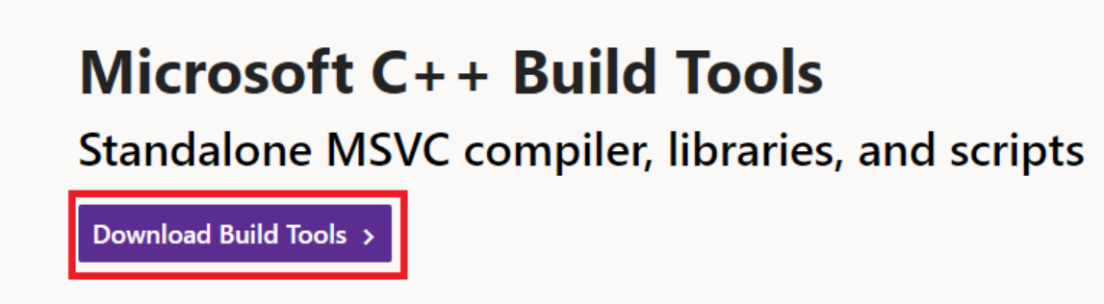

After the download is complete, start the downloaded exe program and choose to install the first build tool in the upper left corner. The list on the right will be automatically checked.

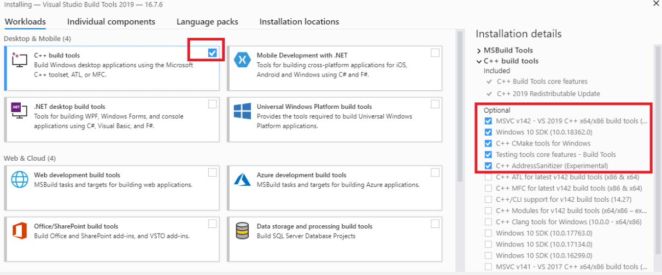

After successful installation, restart the computer and try again in cmd:

**pip install pyemd**

Enter:

**python -c "import pyemd; print(pyemd.__version__)"**

to see if the installation is successful.

If not successful, repeat the first and second installation methods above. At this point, the issue should be resolved.

1. When importing pyemd, the following error occurs:

1647509096(1)

**Solution:**

**pip install --upgrade numpy**