MDM-IOT
AF 52 - A
Project Report on
Automatic clothes Protection system
Submitted in partial fulfillment of the requirements of the Third Year of
Bachelor of Technology In

Artificial Intelligence and Machine Learning
by

Under the Guidance of

DEPARTMENT OF Artificial Intelligence and Machine Learning
2026-2027

Certificate of Approval

This is to certify that, following are confide students of T. Tech in Artificial Intelligence and Machine Learning Department. They have satisfactorily completed the requirements of Capstone Project for the MDM-IOT course as prescribed by (), while working on “Automatic clothes Protection system”.

Signature: Name:
Signature: Name:

Signature: External Signature:
Name:

Declaration

I/we declare that this written submission represents my/our ideas in my/our own words and where others’ ideas or words have been included, I/we have adequately cited and referenced the original sources. I/we also declare that I/we have adhered to all principles of academic honesty and integrity and have not misrepresented or fabricated or falsified any idea/data/fact/source in my/our submission. I/we understand that any violation of the above will be cause for disciplinary action by the Institute and can also evoke penal action from the sources which have thus not been properly cited or from whom proper permission has not been taken when needed.

Date: -

ACKNOWLEDGEMENT

We would like to express our deepest appreciation and profound gratitude to our project guide, for her invaluable guidance, continuous encouragement, and unwavering support throughout the course of this project. Her profound knowledge, technical expertise, and keen attention to detail were instrumental in shaping our abstract ideas into a fully functional and complex simulator. We are truly grateful for the time she dedicated to reviewing our progress, helping us resolve conceptual roadblocks, and motivating us to push the boundaries of our technical skills.
We also extend our sincere thanks to our Head of the Department, , and our respected Principal, , for providing us with a highly conducive academic environment, state-of-the-art laboratory facilities, and the institutional support required to successfully execute and complete this project.
Lastly, we would like to take this opportunity to thank our parents, family members, and friends for their endless moral support, patience, and encouragement during the challenging phases of development and debugging. Without their constant belief in our capabilities, this project would not have reached its successful completion.

Project Members:

ABSTRACT

The Automatic Clothes Protection System is an Internet of Things (IoT)-based project designed to protect clothes from unexpected weather conditions such as rain, excessive moisture, and other environmental factors. Clothes kept for drying outdoors can become wet due to sudden rainfall, causing inconvenience and requiring additional time and effort to dry them again. This project aims to provide an automated and efficient solution to this problem by integrating sensors, a microcontroller, and a motorized mechanism.
The project, titled “Automatic Clothes Protection System,” focuses on detecting environmental changes and automatically protecting clothes without requiring continuous human intervention. The system uses suitable sensors, such as a rain sensor, to detect rainfall or moisture. The sensor sends signals to a microcontroller, such as an ESP32 or Arduino, which processes the information and controls a motorized mechanism to move the clothes to a sheltered area when rain is detected. When the weather conditions become suitable, the system can be designed to return the clothes to the drying area.
The system demonstrates the practical application of IoT technology through sensor-based monitoring, automated decision-making, and hardware control. It reduces the need for manual intervention and helps prevent clothes from getting wet due to unexpected rainfall. The system can also be enhanced with additional features such as humidity monitoring, wireless notifications, and remote monitoring to improve convenience and functionality.
The primary objective of this project is to develop a smart, reliable, and cost-effective solution for protecting clothes from unpredictable weather conditions. By combining sensors, microcontroller programming, and automation, the project demonstrates how IoT can be used to solve everyday problems efficiently. It also provides practical knowledge of sensor interfacing, embedded systems, automation, and real-time environmental monitoring.
In conclusion, the Automatic Clothes Protection System is a practical IoT-based solution that bridges the gap between traditional clothes-drying methods and smart home automation. It is particularly useful for households, hostels, and other places where clothes are dried outdoors. The project helps improve convenience, reduce manual effort, and protect clothes from sudden rainfall through an intelligent and automated mechanism.

Keywords: Internet of Things (IoT), Automatic Clothes Protection System, Rain Sensor, ESP32, Arduino, Smart Home Automation, Environmental Monitoring, Sensor-Based Automation, Motorized Mechanism, Weather Protection.

CONT EN TS
- List of Figures i
- List of Tables ii
- Abbreviations and symbols iii

Chapter No. | Topic  Overview | Page No.  1
 | 1.1Introduction | 1
 | 1.2 Background | 2
Chapter1 | 1.3 Importance of the project | 2
 | 1.4 Perspective of stakeholders and customers | 4
 | 1.5Objectives and scope of the project | 5
 | 1.6 Summary | 6
 | Literature Survey & Proposed work | 7
 | 2.1Introduction | 7
 | 2.2 Literature Survey Table | 8
Chapter2 | 2.3Problem Definition | 9
 | 2.4Feasibility Study | 9
 | 2.5Methodology Used | 11
 | 2.6 Summary | 12
 | Analysis and Planning | 13
 | 3.1Introduction | 13
Chapter3 | 3.2Project Planning | 13
 | 3.3 Scheduling | 14
 | 3.4 Summary | 15
 | Design & Implementation | 16
 | 4.1 DFD | 16
 | 4.2Block Diagram | 17
Chapter4 | 4.3FlowChart | 18
 | 4.4 UML | 19
 | 4.5 Project Images | 20
 | Results & Discussion | 21
 | 5.1Actual Results | 21
Chapter5 | 5.2Future Scope | 22
Chapter6 | Conclusion | 24
 | References | 25

List of Figures

Figure No. | Figure Name | Page No.
1 | DFD | 16
2 | Block Diagram | 17
3 | Flow Chart | 18
4 | UML | 19
5 | Image01 | 20
6 | Image02 | 20

List of Tables

Figure No. Figure Name Page No.
  - Survey Table 8
  - Result Table 21

Abbreviations and symbols

• UI - User Interface
• UX - User Experience
• AI - Artificial Intelligence
• OS - Operating System
• API - Application Programming Interface
• HTML - HyperText Markup Language
• CSS- Cascading Style Sheets
• JS - JavaScript
• JSX - JavaScript XML
• SSL - Secure Sockets Layer
• URL - Uniform Resource Locator
• Vite - Frontend Build Tool

Chapter-1

Overview

  - Introduction

In today's world, automation and smart technologies are becoming increasingly important in everyday life. Traditional methods of performing household activities often require continuous human attention and manual effort. One such activity is drying clothes outdoors. Clothes are commonly placed on balconies, terraces, or open spaces to dry under sunlight. However, sudden rainfall and unexpected changes in weather conditions can make the clothes wet again, creating inconvenience and requiring additional time and effort.
The Automatic Clothes Protection System is an Internet of Things (IoT)-based project designed to address this problem by providing an automated solution for protecting clothes from unexpected rainfall. The system uses environmental sensors, a microcontroller, and a motorized mechanism to detect rain and move the clothes to a sheltered location automatically. This reduces the need for continuous human monitoring and helps protect clothes from getting wet.
The main principle of the system is to monitor environmental conditions and respond automatically when rain is detected. A rain sensor detects the presence of water droplets and sends a signal to a microcontroller, such as an ESP32 or Arduino. The microcontroller processes the sensor input and activates a motorized mechanism to move the clothes-drying rack or hanging arrangement to a protected area. Depending on the system design, the mechanism can also return the clothes to the outdoor drying area when suitable weather conditions are restored.
The project demonstrates the practical application of IoT, embedded systems, sensor interfacing, and automation in solving a common household problem. It combines hardware components and programming logic to create a smart system that responds to changes in the surrounding environment. Additional features, such as humidity monitoring, wireless notifications, and remote monitoring, can also be incorporated to improve its functionality.
The primary motivation behind this project is to reduce manual effort, improve convenience, and prevent clothes from becoming wet due to sudden rainfall. By applying automation to a traditional clothes-drying process, the system demonstrates how IoT technology can make household activities smarter, more efficient, and more reliable.
This project integrates three important technical areas:
- Internet of Things (IoT): The project demonstrates the use of connected devices, sensors, and microcontrollers for monitoring environmental conditions and controlling a physical mechanism.
- Embedded Systems and Automation: The system uses a microcontroller to process sensor inputs and execute programmed actions based on detected conditions.
- Sensor Technology and Hardware Control: The rain sensor detects rainfall, while a motorized mechanism performs the required movement to protect clothes.
Thus, the Automatic Clothes Protection System provides a practical example of how smart automation can be applied to everyday life.

Background

Clothes drying is a routine household activity that traditionally depends on sunlight, airflow, and suitable weather conditions. Many households dry clothes on balconies, terraces, rooftops, and outdoor clotheslines. Although this method is simple and economical, it has a major limitation: clothes remain exposed to changing environmental conditions.
Unexpected rainfall can wet clothes that have already been partially or completely dried. This results in inconvenience, additional drying time, and unnecessary manual effort. People may not always be available to monitor the weather or move the clothes indoors at the appropriate time. These limitations create a need for an automatic system that can respond to rainfall without requiring continuous human intervention.
With the development of IoT and embedded technologies, it has become possible to automate household activities using sensors, microcontrollers, and electrical or mechanical devices. Sensors can detect environmental changes, microcontrollers can process the collected information, and actuators can perform physical actions according to programmed instructions.
The Automatic Clothes Protection System is based on this concept. A rain sensor monitors the presence of rainfall and provides input to the controller. When rain is detected, the controller activates a motorized mechanism that moves the clothes to a sheltered location. The system can also incorporate suitable control logic to prevent unnecessary movement and to return the clothes to the drying area when the weather becomes suitable.
The development of this project focuses on simplifying the clothes-drying process and improving protection against sudden rainfall. It demonstrates how relatively simple electronic components can be integrated into a useful automated application.
The project is also relevant to smart home automation because it applies sensing, decision-making, and physical control to a common household task. It provides practical learning opportunities in microcontroller programming, sensor interfacing, actuator control, and the design of automated systems.

Importance of the Project
The Automatic Clothes Protection System is important because it provides an automated solution to a common problem faced by people who dry clothes outdoors. It improves convenience by reducing dependence on manual monitoring and helps protect clothes from unexpected rainfall.
The importance of this project can be explained through the following points:
1.Automatic Rain Detection:
The system uses a rain sensor to detect the presence of rainfall and initiates the protection process automatically.
2. Protection of Clothes:
It helps prevent clothes from becoming wet due to sudden rainfall by moving them to a sheltered location when rain is detected.
3. Reduction in Manual Effort:
Users do not need to continuously monitor weather conditions or rush to move clothes indoors whenever rainfall begins.
4. Smart Home Automation:
The project demonstrates how IoT and embedded technologies can be applied to everyday household activities to make them more convenient.
5. Improved Time Management:
Automatic operation reduces the time and attention required to protect clothes, allowing users to focus on other activities.
6. Practical Application of IoT:
The project provides practical experience in sensor interfacing, microcontroller programming, actuator control, and environmental monitoring.
7. Cost-Effective Solution:
The system can be developed using commonly available electronic components, making it suitable for educational projects and small-scale household applications.
8. Scope for Future Enhancement:
Additional features such as humidity sensing, weather information integration, wireless alerts, and remote monitoring can be included to improve system performance.
Overall, the project demonstrates the usefulness of automation in improving household convenience and reducing the problems associated with unpredictable weather conditions.

Perspective of Stakeholders and Customers
The Automatic Clothes Protection System can benefit different categories of users and stakeholders. Each group may benefit from the system in a different way.
1. Households:
Families that dry clothes on balconies, terraces, or outdoor clotheslines can use the system to reduce the risk of clothes becoming wet during unexpected rainfall.
2. Working Professionals:
People who spend most of their day outside their homes can benefit from an automated mechanism that protects clothes without requiring their immediate presence.
3. Students and Hostel Residents:
Students and hostel residents who share outdoor drying spaces can benefit from a convenient solution that reduces the need for constant weather monitoring.
4. Elderly People and Individuals with Limited Mobility:
The system can reduce the physical effort required to move clothes during sudden rainfall, making the clothes-drying process more convenient.
5. Educational Institutions:
Colleges and technical institutions can use the project to demonstrate practical applications of IoT, embedded systems, sensor technology, and automation.
6. IoT Developers and Researchers:
Developers can use the project as a foundation for exploring smart home automation, environmental sensing, and automatic control mechanisms.
7. Manufacturers and Smart Home Solution Providers:
The project concept can be further developed into a household automation product with improved reliability, safety features, and optional remote-control capabilities.
8. Customers and End Users:
End users benefit from a system designed to reduce manual intervention, improve convenience, and provide timely protection for clothes exposed to changing weather conditions.
The perspectives of these stakeholders highlight the practical usefulness and potential applications of the Automatic Clothes Protection System in residential and educational environments.

Objectives and Scope of the Project

Objectives of the Project
The primary objective of the Automatic Clothes Protection System is to develop an automated mechanism that detects rainfall and protects clothes by moving them to a sheltered location. The project aims to reduce manual effort and improve the reliability of outdoor clothes drying.
The specific objectives are as follows:
1. Automatic Rain Detection:
To detect the presence of rainfall using a suitable rain sensor and generate an input signal for the controller.
2. Microcontroller-Based Control:
To use a microcontroller, such as an ESP32 or Arduino, to process sensor data and execute the required control logic.
3. Automatic Movement of Clothes:
To control a motorized mechanism that moves the clothes-drying arrangement to a protected location when rainfall is detected.
4. Reduction of Human Intervention:
To minimize the need for users to continuously observe weather conditions and manually move clothes.
5. Reliable System Operation:
To design suitable control logic that enables the system to respond appropriately to detected rainfall and avoid unnecessary movement.

Scope of the Project
The scope of the Automatic Clothes Protection System includes the design and implementation of an automated clothes-protection mechanism based on environmental sensing and programmed control.
1. Rain Sensing:
The system monitors rainfall using a rain sensor. The sensor provides information about the presence of water, which is used to initiate the protection process.
2. Microcontroller Integration:
An ESP32 or Arduino can be used as the main controller to receive sensor signals, process the input, and control the motorized mechanism.
3. Motorized Protection Mechanism:
The system includes a suitable motor and mechanical arrangement for moving the clothes-drying rack or hanging system to a sheltered location.
4. Automated Decision-Making:
The controller follows predefined conditions to determine when the protection mechanism should operate. Additional control logic can be implemented to manage the return movement when suitable weather conditions are restored.
5. Hardware and Software Integration:
The project covers sensor connections, controller programming, motor control, and testing of the overall system.

Summary
This chapter provided an overview of the project titled “Automatic Clothes Protection System.” It introduced the problem of clothes becoming wet due to unexpected rainfall and explained the need for an automated solution to improve the clothes-drying process.
The chapter discussed the background of the project and explained how IoT technology, rain sensors, microcontrollers, and motorized mechanisms can be integrated to detect rainfall and protect clothes automatically. It also highlighted the importance of the system in reducing manual effort, improving household convenience, and demonstrating the practical applications of automation.
Overall, this chapter establishes the foundation for the Automatic Clothes Protection System by explaining its purpose, significance, objectives, and scope. The following chapters can build upon this foundation by discussing the system requirements, hardware components, system design, implementation methodology, testing, and results.

Chapter-2
Literature Survey & Proposed work

Introduction

The Internet of Things (IoT) has become an important technology for developing smart and automated systems that improve efficiency, convenience, and safety in everyday life. IoT-based systems use sensors, microcontrollers, communication technologies, and actuators to monitor environmental conditions and perform actions automatically. These technologies are widely applicable in smart homes, agriculture, industrial automation, and environmental monitoring.
Traditional clothes-drying methods depend on sunlight and suitable weather conditions. Clothes kept outdoors are vulnerable to sudden rainfall, which can make them wet and increase the time and effort required for drying. Manual intervention is generally required to move clothes to a sheltered location when rain begins. This creates inconvenience, especially when users are away from home or unable to monitor weather conditions continuously.
The literature survey for the Automatic Clothes Protection System focuses on existing technologies and approaches related to rain detection, sensor-based automation, microcontroller-controlled mechanisms, and smart home applications. Understanding these technologies helps identify suitable components and methods for developing an automated solution.

Related Technologies and Approaches
1. Rain Sensor-Based Detection
Rain sensors are used to detect the presence of water droplets on a sensing surface. They provide an electrical signal that can be processed by a microcontroller. In an automatic clothes protection system, the rain sensor acts as the primary input device for identifying rainfall and initiating the protection mechanism.
2. Microcontroller-Based Automation
Microcontrollers such as Arduino and ESP32 are commonly used in embedded automation projects. They receive signals from sensors, process the input according to programmed instructions, and control output devices. In this project, the microcontroller acts as the main control unit that coordinates rain detection and the movement of the clothes-drying arrangement.
3. Motorized Mechanisms
Motors and suitable motor-driving circuits can be used to move a clothes rack or retractable clothesline between an exposed drying area and a sheltered location. The movement depends on the mechanical design, motor type, and control circuit used in the implementation.
4. IoT-Based Smart Home Systems
IoT technology enables electronic devices to exchange information and support remote monitoring or control. A controller with wireless connectivity, such as an ESP32, can support additional features such as status updates and mobile notifications. These features are optional and depend on the project's actual hardware and software implementation.
5. Environmental Monitoring
Environmental monitoring systems use sensors to observe conditions such as rainfall, temperature, and humidity. Integrating suitable sensors can help improve automated decision-making. For example, a humidity sensor may provide additional environmental information, although humidity alone cannot reliably determine whether it is raining.

2.2Literature Survey Table

Sr. No. | Technology / Approach | Method Used | Relevance to the Project
1 | Rain Detection Systems | Water-sensitive rain sensors detect rainfall. | Provides the primary input for identifying rain and triggering protection.
2 | Microcontroller-Based Systems | Arduino or ESP32 processes sensor signals and controls outputs. | Acts as the main controller for automated operation.
3 | Motor Control Systems | Motors and driver circuits produce controlled mechanical movement. | Moves the clothes-drying arrangement to a sheltered location.
4 | IoT-Based Smart Home Automation | Connected controllers support monitoring and communication. | Provides scope for remote status monitoring and notifications.
5 | Environmental Monitoring Systems | Sensors monitor environmental conditions such as humidity and rainfall. | Supports environmental awareness and possible future enhancements.
6 | Automatic Clothes-Drying Mechanisms | Mechanical arrangements move or retract clotheslines. | Provides the physical mechanism required to protect clothes from rain.

Problem Definition
Drying clothes outdoors is a common household practice, but it creates difficulties when weather conditions change unexpectedly. Clothes exposed to sudden rainfall may become wet again, resulting in inconvenience, additional drying time, and manual effort.
Traditional clothes-drying arrangements generally require users to monitor the weather and move clothes to a protected location when rainfall begins. This approach is not always convenient, particularly when users are working, travelling, or otherwise unavailable.
The main problems addressed by the Automatic Clothes Protection System are as follows:
1. Lack of Automatic Rain Detection:
Traditional clotheslines do not automatically detect rainfall or initiate a protective action.
2. Dependence on Manual Intervention:
Users must move clothes manually when rain begins, which can be inconvenient when they are away from home.
3. Unexpected Weather Conditions:
Sudden rainfall can wet clothes before users have an opportunity to move them to a sheltered location.
4. Additional Drying Time:
When clothes become wet again, they may require additional time to dry, delaying their use.
5. Lack of Integrated Automation:
A conventional clothes-drying arrangement does not typically integrate sensors, a controller, and a motorized mechanism for automatic protection.
6. Need for a Practical and Affordable Solution:
An effective solution should use suitable components, require minimal user intervention, and be practical for household applications.

Feasibility Study
The feasibility study evaluates whether the Automatic Clothes Protection System can be designed and implemented using available hardware, software, time, and resources.
The project is feasible in the following aspects:
1. Technical Feasibility
The system can be implemented using commonly available components such as a rain sensor, an ESP32 or Arduino microcontroller, a suitable motor, a motor driver, a power supply, and a mechanical frame. Programming tools and libraries are available for developing and testing the controller logic.
2. Economic Feasibility
The project can be developed using affordable electronic components and commonly available development tools. A basic prototype can be constructed without requiring expensive industrial equipment. The overall cost depends on the motor, mechanical structure, controller, and additional features selected.
3. Operational Feasibility
The system is intended to operate automatically after it has been powered on and configured. When the rain sensor detects rainfall, the controller activates the protection mechanism according to the programmed logic. This reduces the need for continuous manual monitoring.
The system should include appropriate movement limits and safety measures to avoid unnecessary or excessive motor operation.
4. Time Feasibility
The project can be completed within an academic project timeline by dividing the work into stages, including component selection, circuit design, programming, mechanical assembly, integration, and testing. A basic prototype can be developed first, followed by improvements if time permits.
5. Practical Feasibility
The project addresses a real household problem and can be demonstrated in a small-scale prototype. It is suitable for learning about sensor interfacing, embedded programming, automation, and motor control.
6. Maintenance Feasibility
The system uses modular components that can be inspected and replaced when necessary. Regular checking of the rain sensor, mechanical movement, wiring, and power supply can help maintain reliable operation. Since the system may be exposed to outdoor conditions, suitable protection against moisture and electrical hazards is necessary.

Methodology Used

The methodology adopted for developing the Automatic Clothes Protection System follows a systematic process, beginning with problem identification and requirement analysis and continuing through design, implementation, integration, and testing.
Phase 1: Problem Identification and Requirement Analysis
The first phase involves identifying the difficulties associated with drying clothes outdoors, particularly the risk of unexpected rainfall. The functional requirements are established to determine how the system will detect rain, process sensor inputs, and move clothes to a protected location.
Phase 2: Component Selection
The next phase involves selecting the hardware components required to implement the system.
The main components may include:
- Rain sensor: Detects water or rainfall on its sensing surface.
- Microcontroller: An ESP32 or Arduino processes the sensor signal and executes the control logic.
- Motor and motor driver: Provide the movement required to shift the clothes-drying arrangement.
- Power supply: Provides the electrical power required by the controller and motor.
- Mechanical structure: Supports the clothesline or rack and enables movement between the drying and protected positions.
- Connecting wires and supporting components: Establish the electrical connections required for system operation.
The selection of the motor and mechanical arrangement must account for the weight of the clothes, required movement, and available power.
Phase 3: System Design
In this phase, the overall hardware architecture is planned. The rain sensor is connected to an appropriate input pin of the microcontroller. The motor is connected through a suitable motor driver rather than directly to a microcontroller pin.
The controller is programmed to monitor the sensor and activate the motor when rainfall is detected. The mechanical design determines how the clothes are moved and how the movement is stopped safely at the protected position.
The basic working sequence is:
- The system is switched on.
- The rain sensor continuously monitors for water.
- The sensor provides a signal to the microcontroller.
- The microcontroller evaluates the sensor input.
- When rainfall is detected, the controller activates the motor driver.
- The motor moves the clothes-drying arrangement to the sheltered position.
- The system stops the motor when the required position is reached, using the implemented stopping mechanism.
An automatic return to the drying position can be added if the system includes a suitable method for determining that conditions are safe for outdoor drying.
Phase 4: Hardware Implementation
The hardware implementation involves assembling the selected components and establishing the required connections.
The rain sensor is connected to the microcontroller, and the motor driver is connected to the motor and controller. The power supply is selected according to the electrical requirements of the components.
Phase 5: Software Development
The software development phase involves writing the microcontroller program that controls the system.
The program reads the rain sensor signal and determines whether rainfall has been detected. If the rain condition is satisfied, the controller activates the motor through the motor driver to move the clothes to a protected position.
The program should include suitable control logic to prevent repeated or unnecessary motor activation. Where supported by the hardware, limit switches or other position-detection mechanisms can be used to stop movement at the correct location.
Phase 6: System Integration
After the hardware and software have been developed, they are integrated into a complete prototype. The rain sensor, microcontroller, motor driver, motor, and mechanical structure are connected and tested together.
The integrated system is checked to confirm that the sensor input is interpreted correctly and that the motor responds to the programmed conditions. Any problems with sensor readings, wiring, motor movement, or stopping behavior are identified and corrected.

Summary
This chapter presented the literature survey and proposed work for the Automatic Clothes Protection System. It reviewed the relevant technologies, including rain sensors, microcontrollers, motorized mechanisms, environmental monitoring, and IoT-based smart home automation.
The chapter identified the major problems associated with outdoor clothes drying, such as unexpected rainfall, dependence on manual intervention, and additional drying time. The proposed system addresses these problems by using a rain sensor and microcontroller to activate a motorized mechanism that moves clothes to a sheltered location.
A feasibility study was also presented to evaluate the technical, economic, operational, time, practical, and maintenance aspects of the project. The methodology explained the development process, from requirement analysis and component selection to system design, hardware implementation, software development, integration, and testing.

Chapter-3 Analysis and Planning
  - Introduction
This chapter focuses on the analysis and planning phase of the project “Automatic Clothes Protection System.” In the field of the Internet of Things (IoT), proper analysis and planning are essential for developing an efficient, reliable, and user-friendly automated system. This phase plays an important role in identifying the problem, understanding user requirements, and defining the overall structure of the proposed system.
The analysis process involves studying traditional clothes-drying methods, identifying their limitations, and determining the requirements for the proposed automatic protection system. Clothes dried outdoors are vulnerable to unexpected rainfall, which can make them wet and require additional time and effort for drying. The proposed system aims to overcome this problem by detecting rainfall through a rain sensor and automatically activating a mechanism to move clothes to a sheltered location.
The analysis phase also identifies the hardware and software components required for implementation, such as a rain sensor, microcontroller, motor driver, motor, power supply, and suitable mechanical structure. The inputs, processing operations, and outputs are defined to ensure that the system functions according to the required conditions.

Project Planning
Project planning is an important phase in the development of the Automatic Clothes Protection System. It involves organizing the tasks, resources, and timeline required to complete the project successfully. Proper planning ensures that the system is developed systematically and meets its intended objectives.
The planning process begins by defining the project's objectives and scope. The main objective is to detect rainfall automatically and activate a mechanism that moves clothes to a protected location. Based on this objective, the necessary hardware components, software tools, and implementation procedures are identified.
The project is divided into different phases, including requirement analysis, component selection, system design, hardware implementation, software development, integration, testing, and documentation. Each phase is planned carefully to ensure a smooth development process.

Scheduling
Scheduling is important for managing the time and tasks involved in developing the Automatic Clothes Protection System. The project schedule divides the development process into specific phases, allowing each activity to be completed in a planned sequence.
The project schedule consists of the following phases:
1. Requirement Analysis
The initial phase involves understanding the problem associated with outdoor clothes drying and identifying the requirements of the proposed system. The required functionality, operating conditions, and expected outcomes are defined.
2. Component Selection
Suitable hardware components are identified, including the rain sensor, microcontroller, motor driver, motor, power supply, and supporting mechanical components. The selection is based on compatibility, availability, cost, and project requirements.
3. System Design
The overall system architecture is planned. The connections between the sensor, microcontroller, motor driver, and motor are defined. The mechanism for moving clothes between the drying area and sheltered location is also planned.
4. Hardware Implementation
The selected components are assembled and connected according to the system design. The mechanical arrangement is prepared, and the electrical connections are checked before testing.
5. Software Development
The microcontroller program is developed to read the rain sensor signal and control the motor. The control logic determines when the protection mechanism should operate based on the detected rainfall.
6. System Integration
The hardware and software components are integrated into a complete prototype. The system is checked to ensure that sensor readings correctly trigger the required motor operation.

7. Testing and Validation
The system is tested under different conditions to verify rain detection, motor activation, movement to the protected position, and safe stopping. Any errors identified during testing are corrected.

Summary
This chapter focused on the analysis and planning of the project titled “Automatic Clothes Protection System.” It explained the importance of analyzing the problems associated with traditional clothes-drying methods and identifying the requirements for an automated solution.
The chapter also discussed project planning, including the selection of suitable hardware and software components, the design of the system workflow, and the identification of potential implementation challenges. The scheduling section outlined the major development phases, including requirement analysis, component selection, system design, hardware implementation, software development, integration, testing, documentation, and final submission.
Proper analysis and planning help ensure that the system is developed systematically and operates according to its intended purpose. Overall, this chapter provides a clear roadmap for the next stages of the project, particularly system design, implementation, and testing of the Automatic Clothes Protection System.

Chapter-4
Design & Implementation
  - DFD

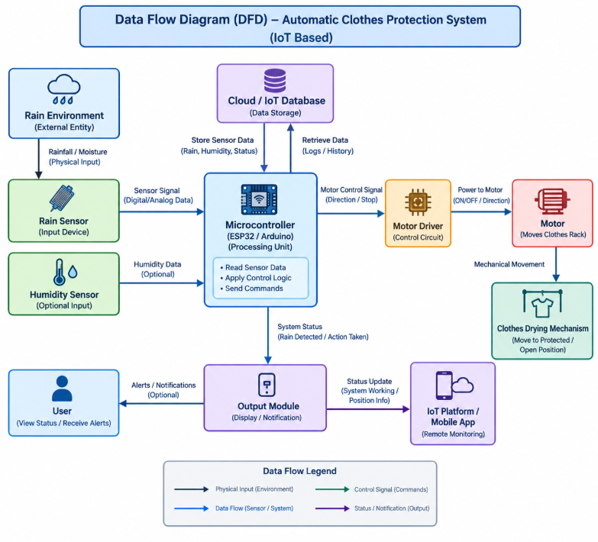
The Data Flow Diagram (DFD) of the Automatic Clothes Protection System represents the flow of information between the user, rain sensor, microcontroller, and motorized mechanism. The process begins when the rain sensor detects the presence of rain or moisture in the surrounding environment. The sensor sends the corresponding signal to the microcontroller, such as an ESP32 or Arduino, which acts as the central processing unit of the system.
When rain is detected, the controller activates the motorized mechanism to move the clothes or drying rack to a sheltered location, helping prevent the clothes from becoming wet. When the sensor no longer detects rain, the system can follow its programmed control logic to determine whether the mechanism should remain in the protected position or return to its original position, depending on the implemented design.
Overall, the DFD illustrates how sensor data is collected, processed, and converted into physical action. The proposed system aims to improve convenience, reduce the risk of clothes getting wet due to unexpected rainfall, and demonstrate the practical application of sensor-based automation in an IoT-enabled smart home environment.

Block Diagram

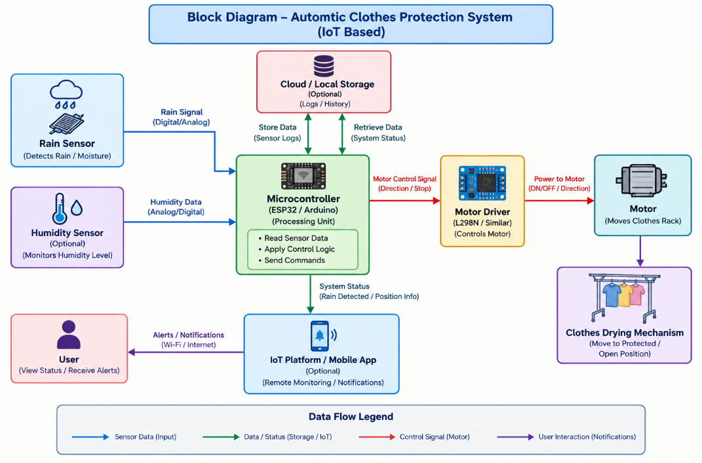The Block Diagram of the Automatic Clothes Protection System illustrates a modular architecture designed to detect rainfall and automatically protect clothes from getting wet. The architecture is centered around the Microcontroller unit, such as an ESP32 or Arduino, which acts as the main processing unit responsible for receiving sensor inputs, processing environmental data, and controlling the motorized mechanism.
The workflow begins when the Rain Sensor detects rainfall or moisture in the surrounding environment and sends a corresponding signal to the Microcontroller. The controller processes this input according to the programmed control logic and determines whether protective action is required. An optional Humidity Sensor can also provide additional environmental information if it is included in the implementation.
If IoT connectivity and a suitable application are implemented, the system can also transmit status information, such as rain detection and the current mechanism position, to the user through a mobile application or monitoring platform. An optional notification feature can provide alerts about changes in environmental conditions or system activity.
This modular design ensures that sensor input is accurately processed and converted into appropriate physical actions. By integrating environmental sensing, microcontroller-based decision-making, motor control, and optional IoT monitoring, the Automatic Clothes Protection System provides a convenient and efficient approach to protecting clothes from unexpected rainfall while reducing the need for manual intervention.

FlowChart

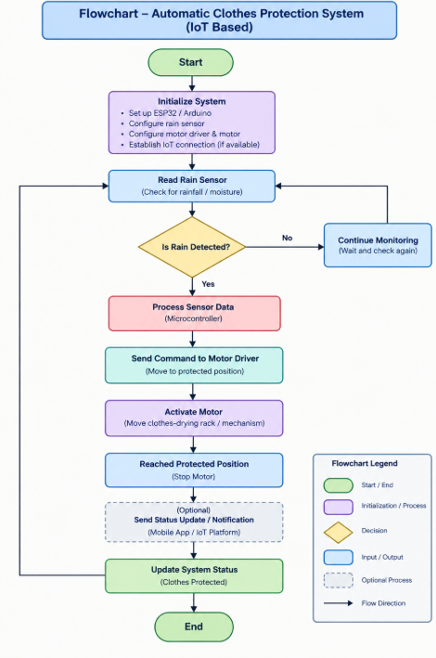
The Flowchart for the Automatic Clothes Protection System provides a logical representation of the complete system operation, beginning at the Start node. The initial step involves initializing the microcontroller, such as an ESP32 or Arduino, and configuring the rain sensor and motor control components. The system then continuously monitors the surrounding environment through the rain sensor to determine whether rainfall is detected.
After collecting the sensor input, the system enters a decision phase to check whether rain is present. If rain is not detected, the system continues monitoring the environment. If rain is detected, the microcontroller processes the sensor signal and sends a control command to the motor driver. The motor driver then activates the motor to move the clothes-drying rack or mechanism to a sheltered position, protecting the clothes from unexpected rainfall.
When the rain condition changes, the system checks the sensor input again and performs the appropriate action according to its configured logic. The process continues in a loop while the system is operating.

UML

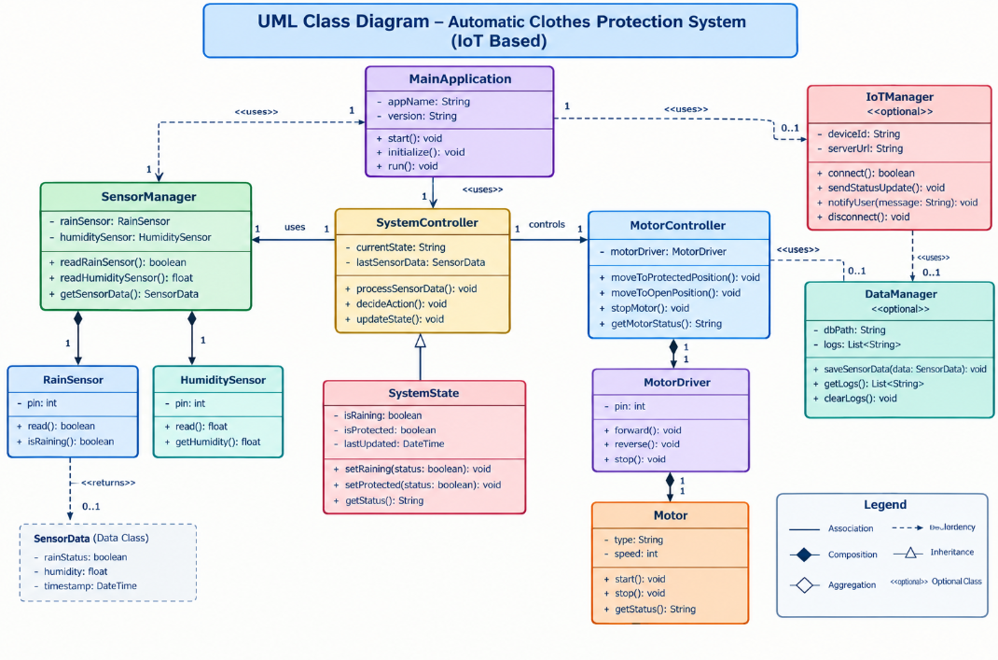
The UML Class Diagram for the Automatic Clothes Protection System provides an overview of the system's object-oriented architecture and the relationships between its major components. At the top level, the MainApplication class acts as the entry point and coordinates the operation of the SensorManager, SystemController, and MotorController classes.
The SensorManager class handles the collection of environmental data from the rain sensor and, if implemented, the humidity sensor. It provides methods such as readRainSensor() and readHumiditySensor() to obtain sensor readings. The SystemController acts as the central processing unit of the software architecture, receiving sensor data, applying the programmed decision-making logic, and determining whether the clothes-drying mechanism should move to a protected position.
The MotorController class manages motor operation through methods such as moveToProtectedPosition(), moveToOpenPosition(), and stopMotor(), depending on the implemented hardware and control logic. The RainSensor and optional HumiditySensor classes represent the environmental input devices, while the MotorDriver class represents the interface between the microcontroller and the motor.
It may provide methods such as sendStatusUpdate() and notifyUser() if these features are included in the implementation. Similarly, an optional DataManager class can maintain sensor readings, system status, and event logs when data storage is required.

Project Images
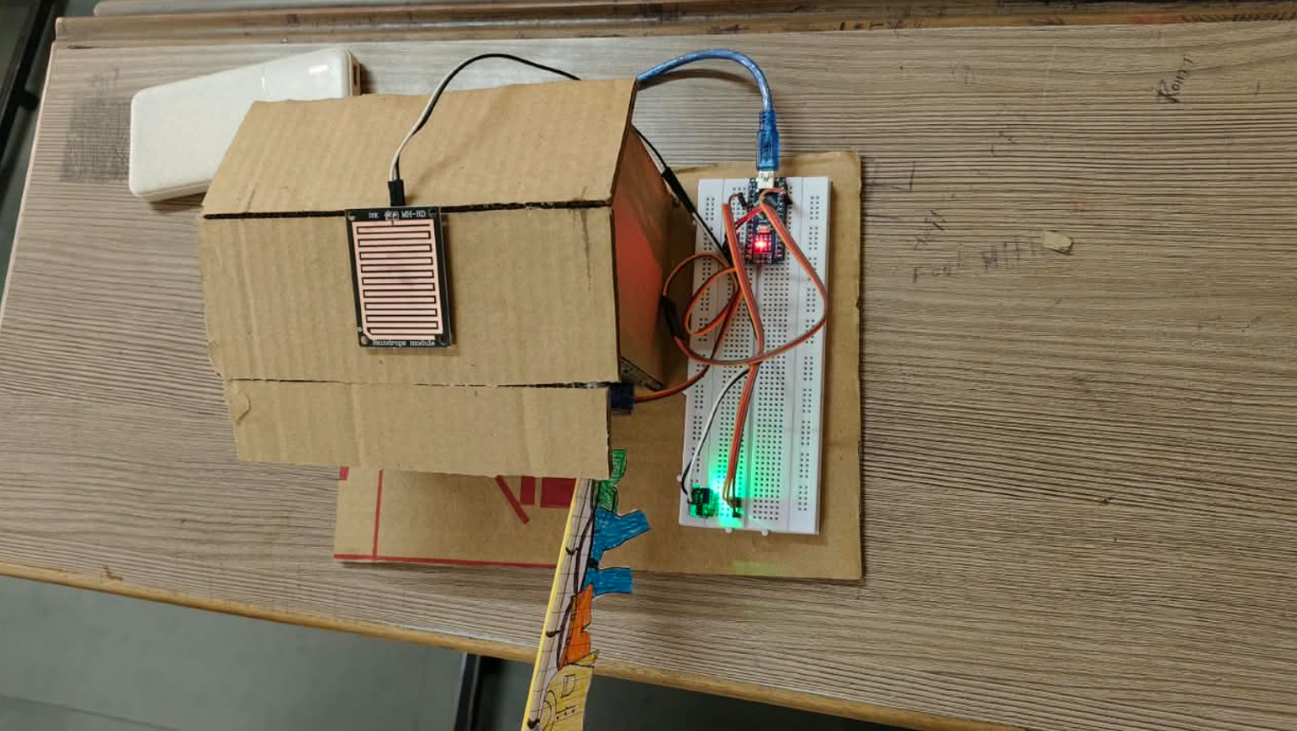

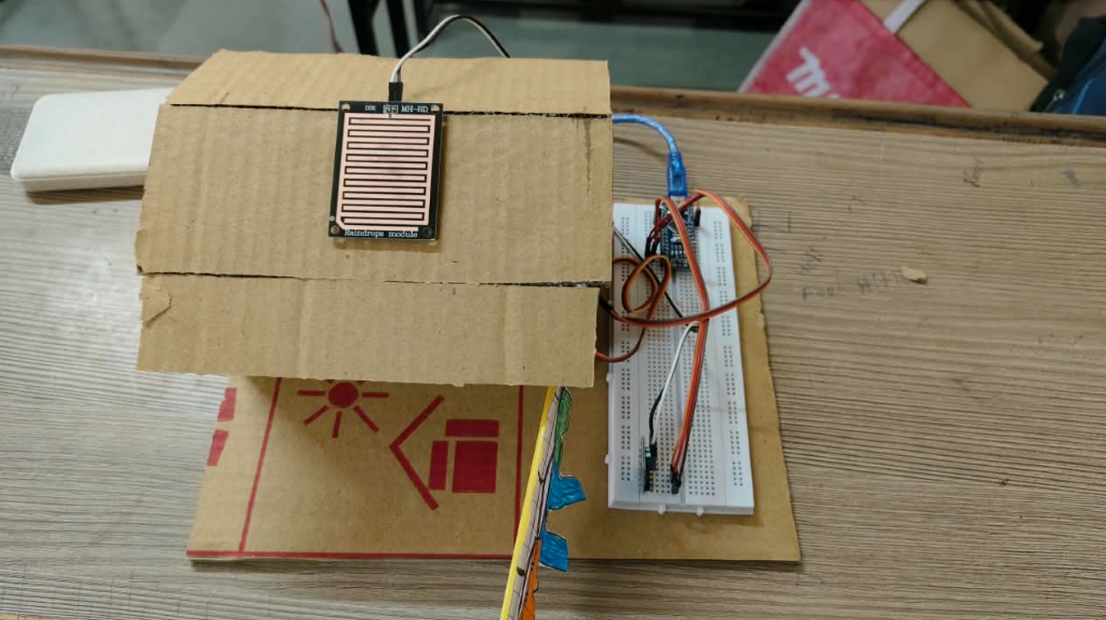

Chapter-5

Results & Discussion
5.1Actual Results
The Automatic Clothes Protection System is designed to detect rainfall and automatically move clothes or the drying rack to a protected location using a sensor-based control mechanism. The system uses a rain sensor to detect the presence of rain and sends the sensor signal to a microcontroller, such as an ESP32 or Arduino. The microcontroller processes the input and controls the motor driver to activate the motor and move the clothes-drying mechanism.
The expected outcome is that the system responds automatically when rain is detected, reducing the need for manual intervention and helping prevent clothes from becoming wet due to unexpected rainfall. If IoT connectivity is implemented, the system can also provide status updates or notifications to the user.
To evaluate the proposed system, its functionality can be compared with traditional manual clothes protection methods. The following table presents the intended benefits of the proposed system.
Feature | Traditional/Existing Methods | Proposed Automatic Clothes Protection System
Rain Detection | Requires a person to notice rainfall. | Uses a rain sensor to detect rainfall automatically.
System Operation | Clothes must be moved manually. | A microcontroller controls the motorized mechanism.
Response Time | Depends on the user's availability and reaction. | Responds according to sensor input and programmed control logic.
Clothes Protection | Clothes may become wet if rainfall goes unnoticed. | Moves the clothes-drying rack to a sheltered location when rain is detected.
User Convenience | Requires continuous attention to weather conditions. | Reduces manual effort through automatic operation.
Environmental Monitoring | Usually depends on direct observation. | Uses sensor readings to monitor environmental conditions.
IoT Connectivity | Generally does not include remote monitoring. | Can support remote monitoring and notifications if IoT features are implemented.
System Monitoring | Requires the user to check the mechanism physically. | System status can be monitored through an optional display or IoT platform.
Expandability | Additional automation requires manual modifications. | Can be extended with humidity sensors, notifications, and other smart-home features.
The proposed system demonstrates the potential of integrating environmental sensors, microcontroller-based decision-making, and motor control into a practical household application. Its effectiveness can be evaluated by testing rain detection, motor activation, movement to the protected position, and the system's response under different environmental conditions.
Note: The table describes the intended benefits of the proposed system. Actual response times, detection accuracy, reliability, and successful hardware operation should be reported only after testing the implemented prototype.

Future Scope
The Automatic Clothes Protection System can be enhanced in several ways to improve its functionality, reliability, and usability. The future scope of the project includes the following improvements:
1. Integration of Additional Sensors
Additional sensors, such as a humidity sensor, can be incorporated to monitor environmental conditions and support more informed control decisions.
2. IoT-Based Remote Monitoring
The system can be connected to an IoT platform or mobile application, allowing users to monitor sensor readings and system status remotely.
3. Mobile Notifications
A notification feature can alert users when rain is detected or when the clothes-drying mechanism moves to a protected position.
4. Automatic Return Mechanism
The system can be enhanced to return the drying rack to its original position when rainfall has stopped and the programmed conditions are satisfied.
5. Improved Motor Control
Limit switches or position sensors can be added to detect the end positions of the mechanism, helping prevent excessive movement and improving operational safety.
6. Weather Forecast Integration
Online weather services can be integrated to obtain forecast information and provide an additional input for deciding when clothes should be protected.
7. Solar-Powered Operation
Solar panels and a suitable battery system can be explored to reduce dependence on conventional electrical power.
8. Enhanced Safety and Reliability
Protective features such as motor overload protection, manual override controls, sensor-failure detection, and emergency stopping can be incorporated to improve system reliability.
9. Data Logging and Performance Analysis
The system can record rainfall events, sensor readings, motor operations, and response times to support performance evaluation and troubleshooting.
10. Smart Home Integration
The system can be integrated with other smart-home devices to support centralized monitoring and coordinated household automation.

Chapter-6

Conclusion

The project titled “Automatic Clothes Protection System” presents an IoT-based approach to protecting clothes from unexpected rainfall through sensor-based automation. The main objective of the project is to reduce manual effort by detecting rain and automatically moving the clothes-drying rack or mechanism to a sheltered location using a microcontroller and motorized control system.
In Chapter 1, an introduction to the Automatic Clothes Protection System was presented, including its background, importance, objectives, scope, and significance in everyday household applications. Chapter 2 focused on the literature survey and proposed work, discussing relevant technologies such as rain sensors, microcontroller-based automation, motorized mechanisms, and IoT-enabled smart-home systems. It also covered the problem definition, feasibility study, and methodology used for the proposed system.
Chapter 3 discussed the analysis and planning phase, including project planning and scheduling of the major development activities. Chapter 4 presented the system design through diagrams such as the Data Flow Diagram (DFD), block diagram, flowchart, and UML class diagram. These diagrams explained the system architecture, information flow, operational sequence, and relationships between the software components.
Chapter 5 described the expected results, discussion, and future scope of the project. The proposed system is intended to detect rainfall through a rain sensor, process the sensor input using a microcontroller such as an ESP32 or Arduino, and activate a motor through a motor driver to move the clothes-drying mechanism to a protected position. Optional IoT features can further support remote monitoring and user notifications.
Overall, the Automatic Clothes Protection System demonstrates how environmental sensing, embedded systems, motor control, and IoT technologies can be combined to address a common household problem. The proposed solution aims to improve convenience, minimize manual intervention, and reduce the risk of clothes becoming wet during unexpected rainfall. Further enhancements, including weather forecast integration, additional sensors, improved safety mechanisms, and smart-home connectivity, can increase the system's functionality and reliability.

Reference

[1] Espressif Systems, ESP32 Series Datasheet. [Online]. Available: https://www.espressif.com/en/products/socs/esp32

[2] Arduino, Arduino Documentation. [Online]. Available: https://docs.arduino.cc/

[3] Arduino, Arduino Language Reference. [Online]. Available: https://docs.arduino.cc/language-reference/

[4] STMicroelectronics, L298 Dual Full-Bridge Driver Datasheet. [Online]. Available: https://www.st.com/resource/en/datasheet/l298.pdf

[5] Random Nerd Tutorials, ESP32 Tutorials and Projects. [Online]. Available: https://randomnerdtutorials.com/projects-esp32/

[6] Espressif Systems, ESP-IDF Programming Guide. [Online]. Available: https://docs.espressif.com/projects/esp-idf/en/stable/esp32/

[7] OASIS, MQTT Version 3.1.1 — OASIS Standard. [Online]. Available: https://docs.oasis-open.org/mqtt/mqtt/v3.1.1/os/mqtt-v3.1.1-os.html

[8] IEEE, IEEE Xplore Digital Library: Research on Internet of Things, Sensor-Based Automation, and Smart Home Systems. [Online]. Available: https://ieeexplore.ieee.org/

[9] Espressif Systems, ESP-MQTT Documentation. [Online]. Available: https://docs.espressif.com/projects/esp-idf/en/stable/esp32/api-reference/protocols/mqtt.html

[10] Wokwi, Electronics Simulator. [Online]. Available: https://wokwi.com/

