**Project Name:** **Online Learning Platform**

**Team Members:**

**Md Rifat Hasan- 1712162642**

**Syed Md Zishan Ali- 1712587042**

**Md Oahiduzzaman Mondol Zihad- 1711855642**

**Project Report**

Contents

**1. Introduction** 4

1.1 Overview 4

1.2 Purpose: 4

1.3 Scenario: 4

1.4 Intended Use: 5

2. Overall Description 5

2.1 Users: 5

2.2 Goals & Scope: 5

2.3 Stakeholders 5

3. Requirements Elicitation 6

3.1 Feasibility Study: 6

3.2 Requirements Collection: 6

3.3 Survey Questions: 6

3.4 Survey Result: 7

4. System Features and Requirements 11

4.1 Functional Requirements: 11

4.2 Non-Functional Requirements 11

4.3 Technical Process 12

5. Project Backlog 12

6. Project Design and Development 13

6.1 Django 13

6.2 Bootstrap 15

**The Powerful Grid System** 15

**Rapid Development** 16

**Browser Compatibility** 16

**Customization** 16

**Open Source** 16

7. UML Design 17

7.1 The Course App 17

7.2 The Authentication Model 18

7.3 Relationship among the models 19

8. Conclusion 20

Bibliography 20

# **1. Introduction**

This document lays out a project plan for the development of an Online Learning Platform system. The intended readers of this document are current and future developers working on this project and the sponsors of the project. It includes the project overview and the software requirement

## Overview

E-learning is an education via the Internet, network, or standalone computer. E-learning is basically the network-enabled convey of skills and knowledge. E-learning refers to using electronic applications and processes to learn. E-learning includes all forms of electronically supported learning and teaching. Our project is based on this concept. It is an education platform where students can learn and teachers can create contents. For this project the user group of interests are users from Bangladesh.

## Purpose:

This project is chosen for building a platform for both students and teachers. Many students face trouble on understanding important concepts in the class properly. Besides, there are lots of students who are eager to learn but can’t get enough resources or accessibility. But most people now have access to the internet and smart devices. So, with this project we want to make things accessible to people who wants to learn and teach. This project is based on the following principles:

• To provide useful contents and resources to high school and university students.

• To create a platform for tutors to upload contents and sell them.

• This E-learning Website Can be Also Provide Information About Questions.

## 1.3 Scenario:

E-learning is getting popular in most of the developed countries. Web sites like Coursera, Khan Academy, EDX, Byjus are some of the leading e-learning platforms. We want to develop such platform in Bangladesh to provide a skill-based learning system for the users.

## Intended Use:

There are 3 types of service in this system:

1.Services for students:Students will be able to register, enroll in courses, have questions and answer session with course provider, ask questions, reply to questions, publish blogs, save progresses etc.

2.Services for teachers:Teachers can create and update courses. Can sell them in the marketplace or publish for free.

3.Mentorship Program:People can sign up for mentor. Chat system for student and mentor. Write blogs, answer to questions.

# 2. Overall Description

## 2.1 Users:

The system is developed for everyone. Anyone can use this application ranging from a child to and old-age person. The focused users are the peoples who want to learn and teach.

## 2.2 Goals& Scope:

Main goal of all projects is the satisfaction of the users. Without the usability and reliability, a project has no value. So, for the project to be successful the software has to be well designed, responsive and should contain uniqueness. Beside this it has to have good contents, and the course designers and providers also have to be very skillful. The system should help its user to learn and gain skills. It will help them to get employed and building connection by showcasing their skills in their profile.

## 2.3 Stakeholders

The project stakeholder includes both the client and the customers. It includes:

• Founder of the company

• Company that will run the business

• The development teams

• Testers

• Sponsors

• Students

• Teachers

• Content providers

• Parents of the students

# 3. Requirements Elicitation

## 3.1 Feasibility Study:

The Project focuses on a large group of users. It includes students, teachers, contributors and even the online users. Since this is a platform for mass users so, the development and maintenance cost will be very high. It is also necessary to know if the users are eager to use such system. Without the need it is completely worthless to build such a system. So, we have done some study based of demographic region of several areas in Bangladesh, accessibility to the internet and smart devices and collected opinions from people of different age group

## 3.2 Requirements Collection:

It is very important to know the demand of the market to decide if it is worthy of building an education platform. To analyze the market demand for such platform and to know about people’s reactions requirement collection is very necessary. We used brainstorming technique from generating ideas for the project. We have done small survey on group of people and collected their user stories for the project.

## 3.3 Survey Questions:

1. Do you believe that having an online learning platform will have a positive impact on our education system?
2. Have you ever taken any online course?
3. Will it help to enhance the knowledge of peoples?
4. Why do you think you need an online learning platform? a) Better Grades b} Build Skills c} Getting a job
5. What do you think about project based interactive learning platform? Positive/Negative
6. Is it worthy to spend money on online course? a) Yes b) no c) Depends on the course d) Depends on the price
7. Is it likely to pay for courses that will be built in collaboration of companies?
8. What to you think about an online mentoring system? a) Useful b) No need
9. Do you believe that an online course can contribute in developing your skill and get you a job?

## 3.4 Survey Result:

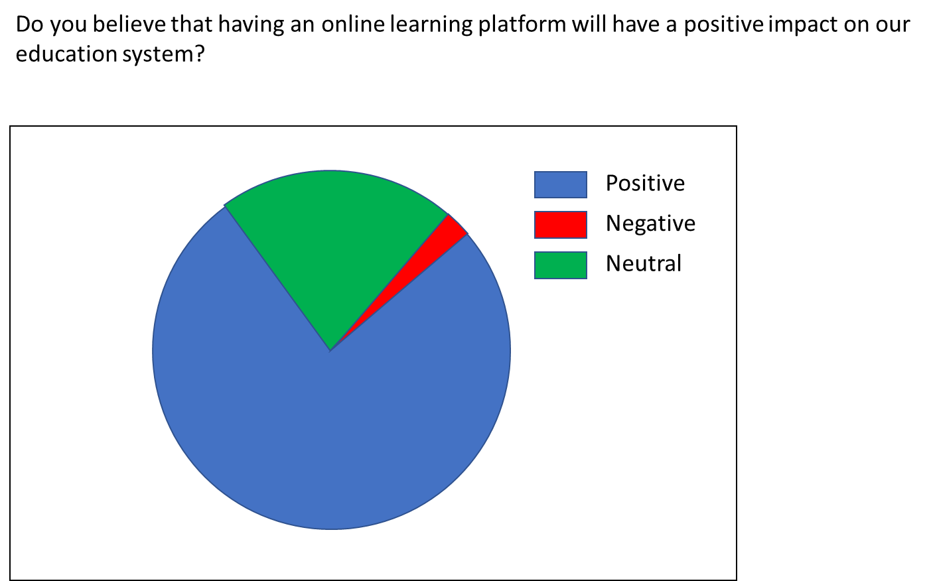

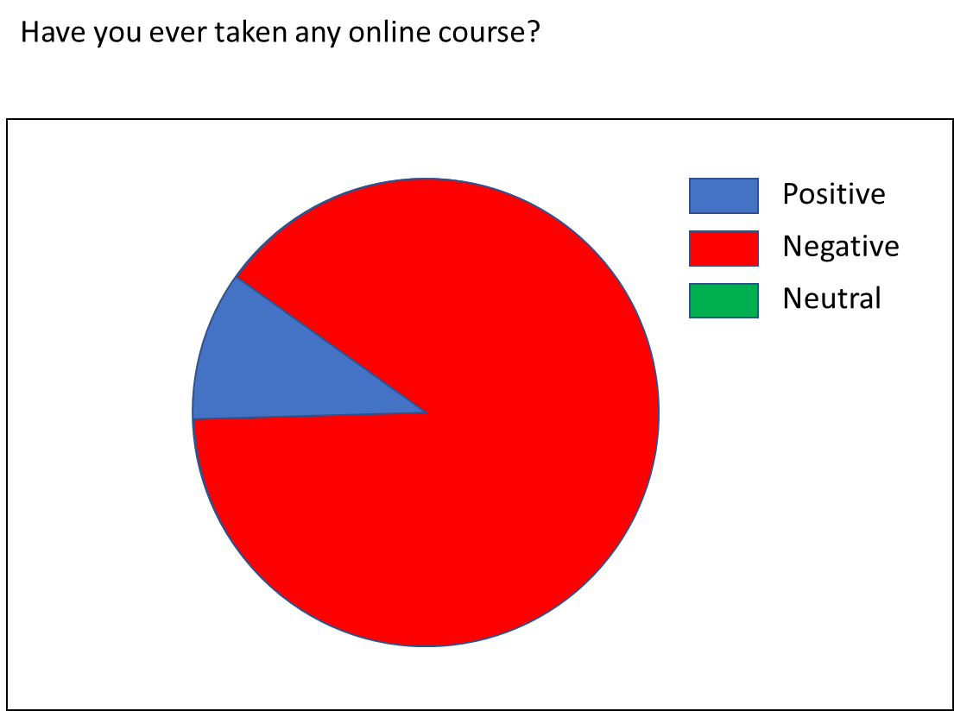

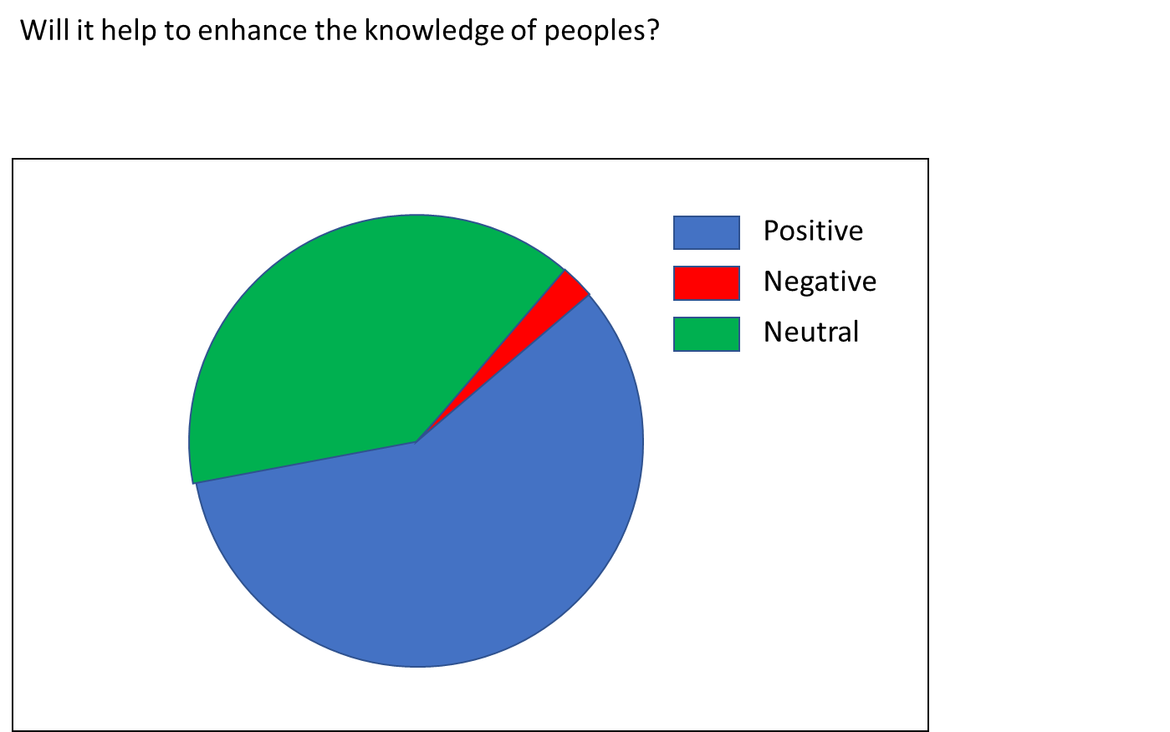

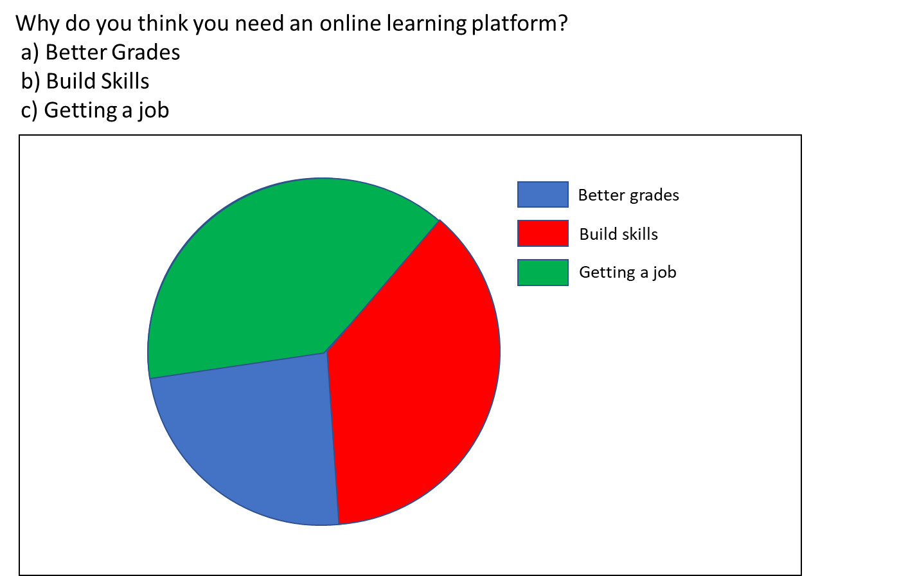

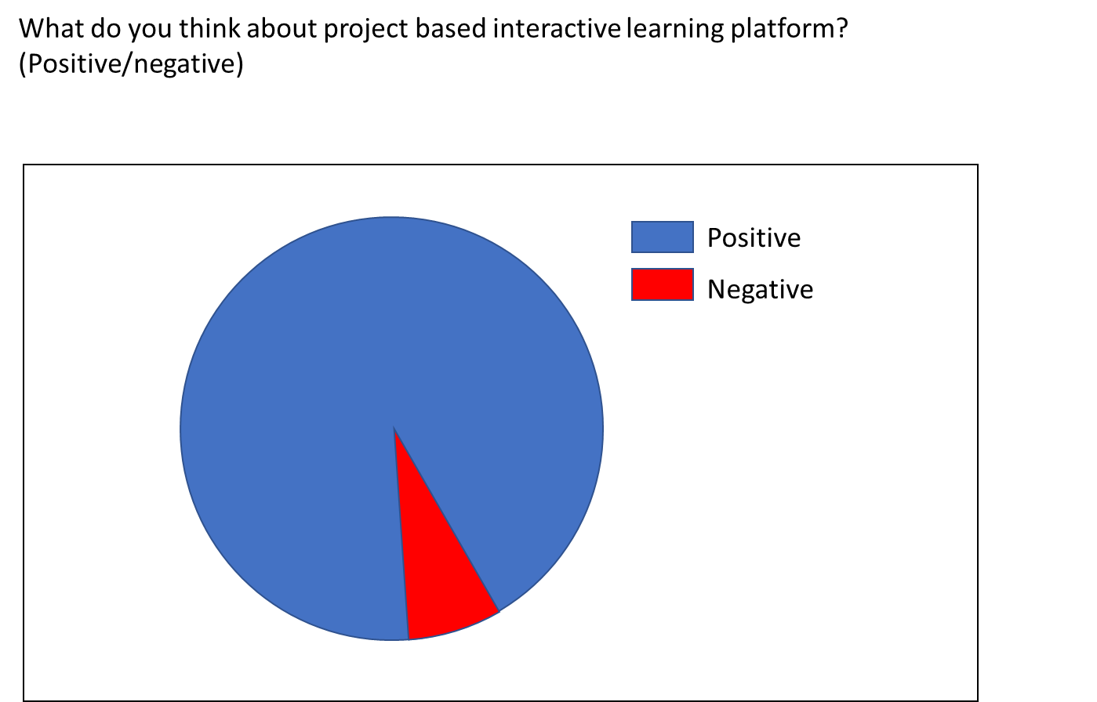

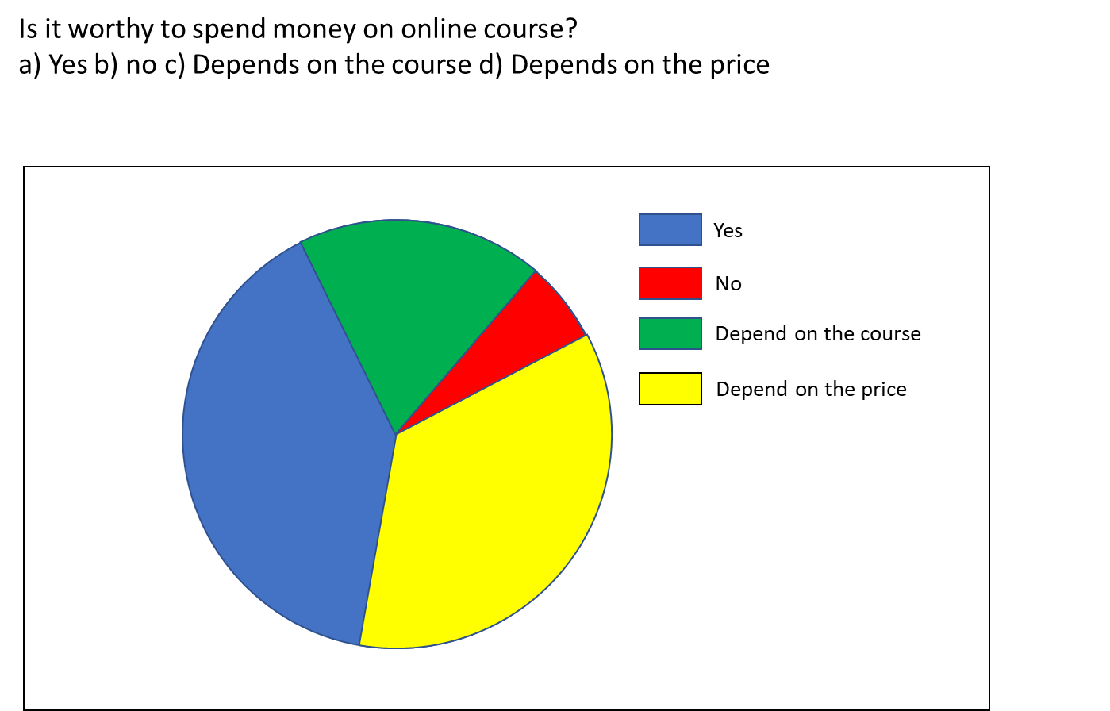

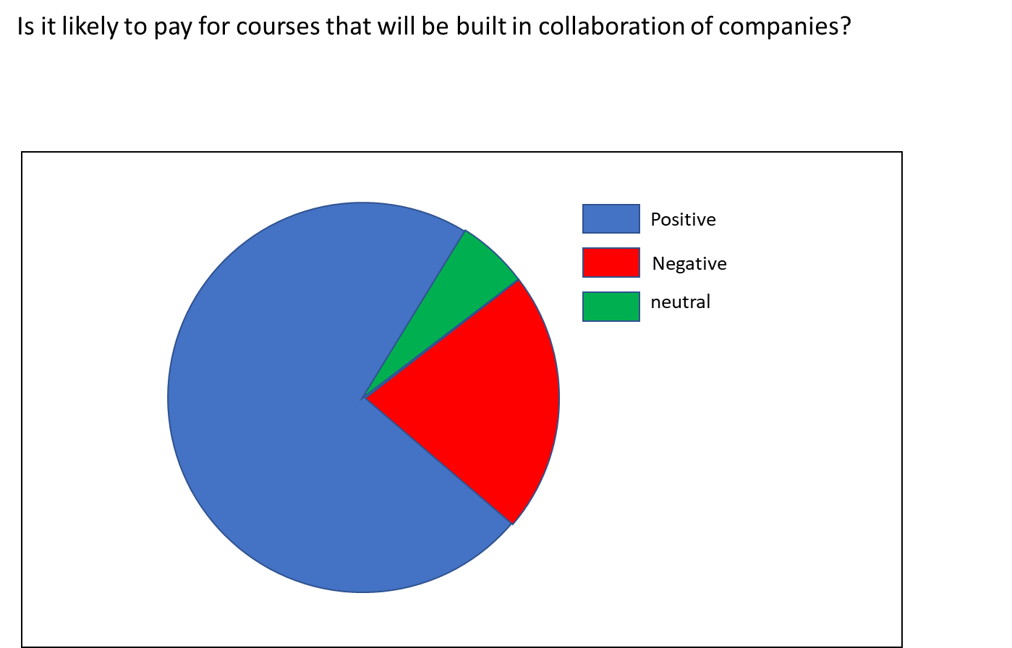

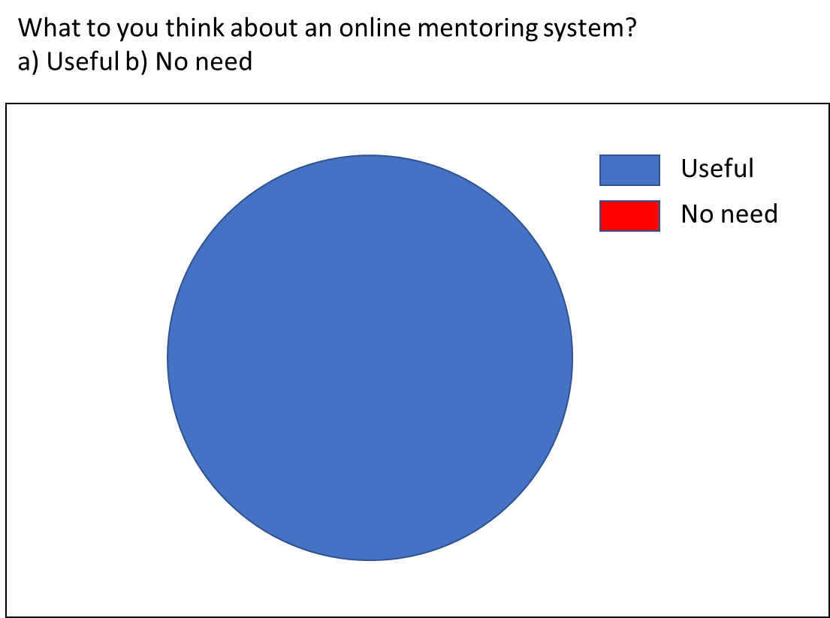

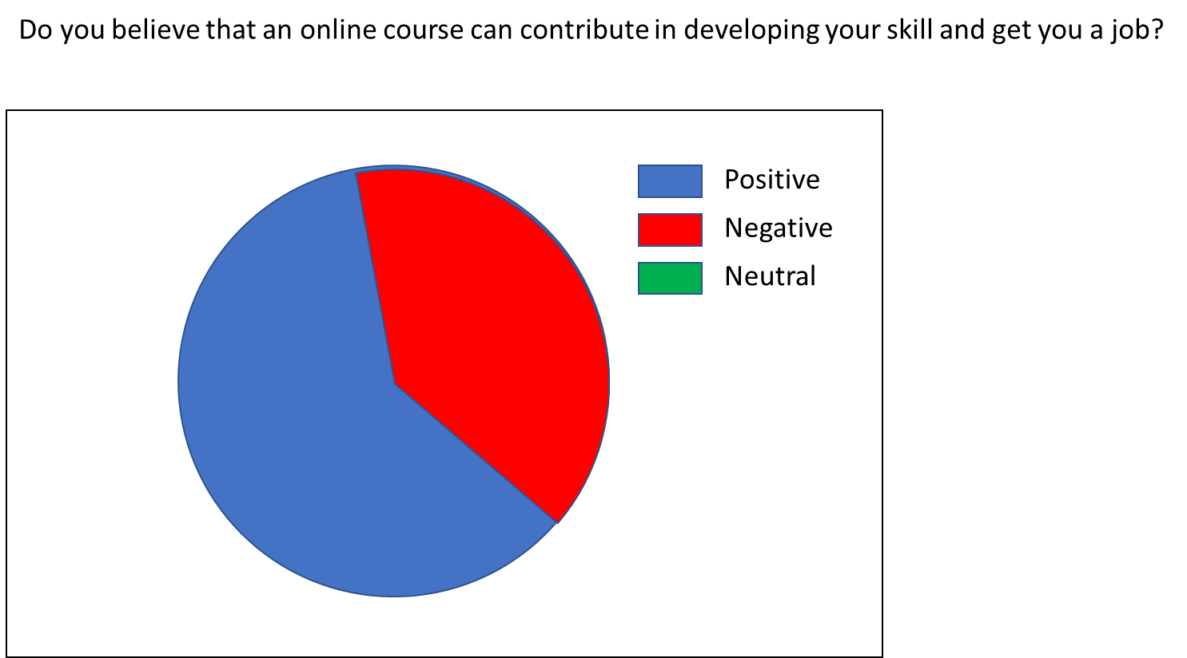

# 4. System Features and Requirements

## 4.1 Functional Requirements:

* The application should have responsive interface
* Users should be able to register for an account
* Users will be able to enroll in a course
* Users can review a course
* Teachers should be able to build and add contents to a course
* There should be secure payment gateway for users to buy a course
* There should be Content Management System (CMS) for content providers

## 4.2 Non-Functional Requirements

* The application shall be easy to use by all
* Users will be able to login with Google and Facebook
* User should be logged in for viewing a course
* Different interfaces for student and teachers

## 4.3 Technical Process

Following are the languages that would be used to develop the application:

Front-end development: HTML, CSS, JavaScript.

Back-end development: Python, PostgreSQL.

Framework: We will use Bootstrap as front-end framework and Django in the Backend and for building APIs.

# 5. Project Backlog

|  |  |  |  |
| --- | --- | --- | --- |
| **Product Backlog Online Learning Site** | | | |
| **Task ID** | **Story** | **Estimate**  **(Days)** | **Priority** |
| 4 | As a user, I want to view page contents, features and go through the whole site. | 10 | 1 |
| 2 | As a user, I want to able to register and log in to myaccount. | 4 | 2 |
| 3 | As an admin, I want to take control and view users activity. | 4 | 3 |
| 1 | As a content developer, want a system for easily design and upload contents | 7 | 4 |
| 6 | As a user of the site, it must have high security and easy payment gateway. | 6 | 5 |
| 10 | As a student, will be able to save my progress | 3 | 6 |
| 8 | As a student, will be able show my skill sets and completed courses to others in my profile | 5 | 7 |
| 7 | As a user, I want to be able to ask questions to the forum. | 9 | 8 |
| 9 | As a user, I want to write blogs and share resources. | 7 | 9 |
| 5 | As a student, I want to be able to chat we the course creator or a mentor. | 14 | 10 |

# 6. Project Design and Development

Based on the requirements from the stack holders and by reviewing the circumstances we decided to develop the project as a web app. We will be using one of the popular frameworks Django to power up our backend. In the frontend we will use Bootstrap and JavaScript frameworks (React). Here we have included a brief description of the advantages of using the frameworks.

## 6.1 Django

Django is an open-source [python web framework](https://www.educba.com/cheat-sheet-python/) used for rapid development, pragmatic, maintainable, clean design, and secures websites. A web application framework is a toolkit of all components need for application development. The main goal of the Django framework is to allow developers to focus on components of the application that are new instead of spending time on already developed components. Django is fully featured than many other frameworks on the market. It takes care of a lot of hassle [involved in the web development](https://www.educba.com/web-development-interview-questions/) enables users to focus on developing components needed for their application.

Below is the list of top 10 Uses of Django are as follows:

**Django is time-tested**

It’s been 13 years Django started developing its framework and the first release of open source commit as it was under development quite a long time before release. During these years it had many releases some of them have new features other releases focuses on security enhancements etc. Django is the first framework to respond to new issues and vulnerabilities and alter other frameworks to make patches to frameworks. The Latest release of it is focusing on new features and boundary case problems.

**Application Development**

Django was developed by online news operation team with an aim to [create web applications](https://www.educba.com/how-to-build-web-applications-using-mongodb/) using the Python programming language. The framework has templates, libraries, and APIS which work together. In general, applications developed using Django can be upgraded with minimal cost, changes, and additions and it make a lot of web development easier.

**Easy to Use**

Django uses [Python programming language](https://www.educba.com/python-programming-beginners-tutorial/) which is a popular language in 2015 and now most choosing language by programmers who are learning to code and applications of Django framework is widely used as it is free and open-source, developed and maintained by a large community of developers. It means we can find answers to the problems easily using Google.

**Operating System Dependent**

Django framework runs on any platform like PC, [Windows, Mac, Linux](https://www.educba.com/linux-vs-mac-vs-windows/) etc. It provides a layer between the developer and database called ORM (object-relational mapper) which makes it possible to move or migrate our applications to other major databases with few lines of code change.

**Excellent Documentation for real-world application**

Applications of Django has one of the best documentation for its framework to develop different kinds of real-world applications whereas many other frameworks used an alphabetical list of modules, attributes, and methods. This is very useful for quick reference for developers when we had confused between two methods or modules but not for fresher’s who are learning for the first time. It’s a difficult task for Django developers to maintain the documentation quality as it is one of the best open source documentation for any framework.

**Scalable and reliable**

As Django is a well-maintained web application framework and widely used across the industries so cloud providers taking all measures to provide support to run Django applications easily and quickly on cloud platforms. It means, once Django applications deployed then it can be managed by an authorized developer with a single command in a cloud environment. As Django developers are working in the same development environment for a long time so they will grow and expertise in these areas which means applications developed, websites created are getting better day by day, more functional, efficient and reliable.

**Community Support**

Django community is one of the best communities out there as it is governed by the Django software foundation which had some rules like for event there is a code of conduct. Django communities will have IRC and mailing list most welcome, even it may have bad appeals it will rectify immediately. Django offers stability, packages, documentation and a good community.

**DRY – Don’t repeat yourself**

Django framework follows don’t repeat yourself principle as it concentrates on getting most out of each and every line of code by which we can spend less time on debugging or code re-orientation etc. In general, DRY code means all uses of data change simultaneously rather than a need to be replicated and its fundamental reason to use of variables and functions in all programming.

With the uses of Django framework, we can develop and deploy web applications within hours as it takes care of much of the hassle of web development. Django is very fast, fully loaded such as it takes care of user authentication, content administration, security as Django takes it very seriously and helps to avoid SQL injection, cross-site scripting etc. and scalable as applications can be scalable to meet high demands and used to build any type of applications that’s why we call it as versatile framework. We can build different [applications from content management](https://www.educba.com/best-ecommerce-sites/) to social networking websites using Django framework. It offers lots of resources and good documentation which helps new learners to learn and experienced people for reference.

## 6.2 Bootstrap

Bootstrap provides a solid foundation for any website, irrespective of project size. It contains [Reboot](http://getbootstrap.com/docs/4.0/content/reboot/), which is based on [Normalize.css](http://necolas.github.io/normalize.css/) and helps level out browser differences for various page elements. Bootstrap also provides great typography. Even basic HTML form elements like checkboxes, radio buttons, select options, etc., have been restyled to give them a modern look. we use Bootstrap because it saves us a considerable amount of effort.

Today’s websites should be modern, sleek, responsive, and “mobile first”. Bootstrap helps us to achieve these goals with minimum fuss. Here are the top five reasons why I love Bootstrap:

## **The Powerful Grid System**

Bootstrap has one of the best responsive, mobile-first grid systems available. It’s built with Flexbox and it’s easy to use. It helps in scaling a single website design from the smallest mobile device to high-definition displays, logically dividing the screen into 12 columns, so that we can decide just how much screen real estate each element of our design should take up.

Although developers have CSS Grid Layout for layout building, the Bootstrap Grid component can still be handy for quick prototyping — at least while we get more familiar with the new native CSS tool at our disposal today.

## **Rapid Development**

Bootstrap comes complete with many reusable CSS and JavaScript components that can help achieve the functionality needed in almost any kind of website. We just have to use some HTML to plug them into your template, with no need to spend huge amounts of time writing complex CSS and JavaScript. Plus, all these components are responsive, too!

## **Browser Compatibility**

Bootstrap is compatible with the latest, stable releases of all major browsers and platforms. With regard to the Windows platform, Bootstrap works in Internet Explorer versions 10–11 and Microsoft Edge. If Bootstrap’s instructions are followed properly, we can create a website design that works in all these browsers.

## **Customization**

Bootstrap offers many ways to customize its default design. we can override all of its CSS and default JavaScript behavior. Bootstrap is even more interesting if you’re a [Sass](http://sass-lang.com/) developer, as it includes Sass customization options. These options let us smoothly create a new template using Bootstrap.

## **Open Source**

Bootstrap is an open-source project that’s [hosted on GitHub](https://github.com/twbs/bootstrap) and released under [the MIT license](http://opensource.org/licenses/MIT). This is one of the biggest reasons I use Bootstrap. My clients won’t have to deal with purchasing and licensing issues, and Bootstrap’s license gives me the freedom to completely change and experiment with it.

# 7. UML Design

We have used MVC pattern for developing the project. Our database design is mapped with Object Relation Model(ORM) comes built-in with Django. Bellow are the class diagram of the project:

## 7.1 The Course App

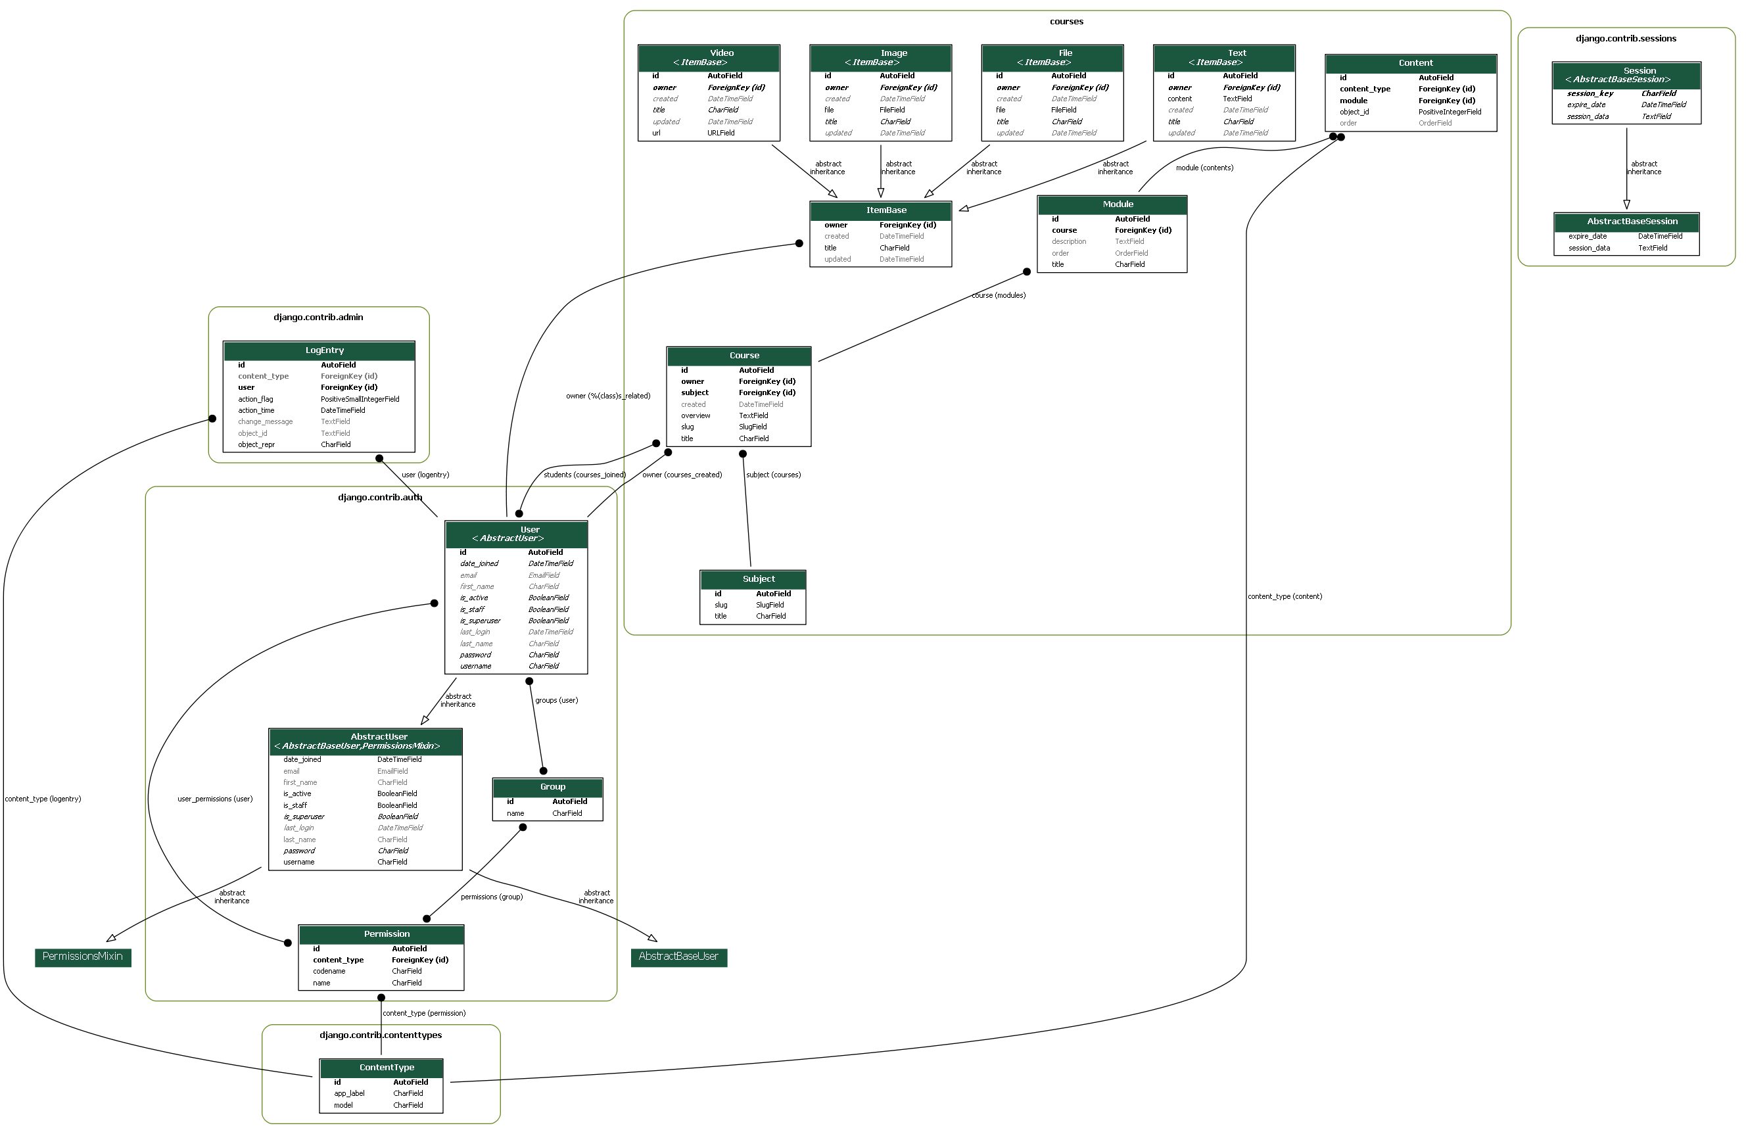

## 7.2 The Authentication Model



## 7.3 Relationship among the models



# 8. Conclusion

Theproject is a prototype of education learning platform. But in future we believe that prototype will turn into a biggest learning platform in Bangladesh. Our only competitor will be REPTO. But if we consider some points, we will be better than REPRO because REPTO is just a platform where people can learn job-based skills but our platform will focus on higher educational course that will help university students. Another point is we are using DANGO as framework and BOOTSTRAP as frontend design which are modern frameworks for backend and frontend and these frameworks are very updated with available resources and support. So, for future adaptation, it will be easy for us to make any changes to our website. And if we think about investment then it will be easy for us to get investment for our project because Bangladesh Government already declared that they will provide investment on Educational Start-up.

# Bibliography

|  |  |
| --- | --- |
| [1] | "Django," [Online]. Available: https://www.djangoproject.com/. |
| [2] | "Bootstrap," [Online]. Available: https://getbootstrap.com/. |
| [3] | "SmartDraw," [Online]. Available: https://www.smartdraw.com/uml-diagram/. |