w₁x+w₂x+b=0

Wx+1=0

Wx-1=0

Plug the positive or negative

Shrink the area through modifying the parameter.

Data Points must be classified correctly, and the datapoints cannot be in the street.

Algorithm:
Move the street,
Expand the street,

Learning rate, and expanding rate

Perceptron algorithm:

- Draw an overfit line (not recommended).

- Transform into a new dimension area.

C is large or not,
Allow the misclassification or not.

If C is too large, model might get too complex to try to avoid misclassification
-> Overfitting
If C is too small, model might be too simple -> underfitting

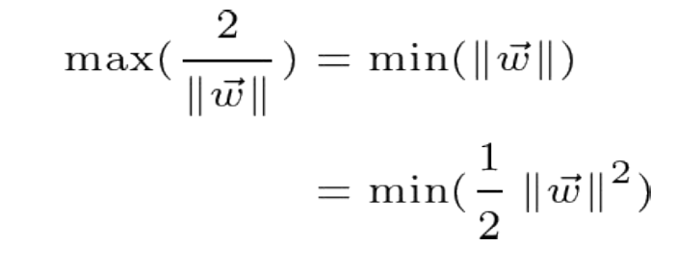
Get the absolute value of the w1 and w2:
Use the formula:
2/$√2=√2$

Two points distance, larger than $√2$

