ΕΙΣΑΓΩΓΗ ΚΑΙ MOTIVATION
- Τι αφορα το project:
Την υλοποίηση του παιχνιδιού Score Four

- Ποιο πρόβλημα λύνει;
Το Score 4 βοηθά στην αντικειμενική και απλή αξιολόγηση των επιδόσεων, με στόχο την αναγνώριση των τομέων που χρειάζονται βέλτιωση και την υποστήριξη της προόδου.

- Γιατί το επιλέξατε ;
Απόδειξη της ανώτερης σκέψης του ανθρώπινου νου έναντι του Η/Υ

OBJECTIVE & SCOPE
- Κύριοι στόχοι του project:
Αξιολόγηση επιδόσεων:Το σύστημα βαθμολογεί διάφορους τομείς ή παραμέτρους (π.χ απόδοση, ποιότητα , παραγωγικότητα κλπ).
Βελτίωση διαδικασιών: Βοηθάει στον εντοπισμό περιοχών που χρειάζονται βελτίωση, έτσι ώστε να ληφθούν τα κατάλληλα μέτρα.
Αναγνώριση επιτυχιών: Παρέχει έναν τρόπο να αναγνωρίζονται οι επιτυχίες ή οι τομείς που αποδίδουν καλύτερα.
- Δυνατότητες & Λειτουργίες που υποστηρίζει
Διαχείριση Σκορ & Πρόοδου:
Το Score 4 επιτρέπει την παρακολούθηση της προόδου ή της επίδοσης ενός ατόμου ή ομάδας με την πάροδο του χρόνου.
Μπορεί να παρέχει πληροφορίες για την εξέλιξη των επιδόσεων και να εντοπίζει αν υπάρχουν αυξομειώσεις στην απόδοση.

SYSTEM ARCHITECTURE
- Πως λειτουργεί το σύστημα;
Αποτελείται από δύο παίκτες(Υπολογιστής και Χρήστς).Ο κάθε παίκτης παίζει εναλλάξ με κύριο στόχο την επίτευξη κάθετων,οριζόντιων και διαγώνων τετράδων.Νικητής είναι αυτός που θα κάνει πρώτος την τετράδα.

- Κύριοι components;
Backend
- Τεχνολογίες που χρησιμοποιήθηκαν & λόγοι επιλογής;
Visual Studio 2022.
- Κυριοι λόγοι επιλογής:
1)Καλύτερο προγραμματιστικό περιβάλλον
2)Δυνατότητα προσθήκης γραφικών
ΚΩΔΙΚΑΣ & ΥΛΟΠΟΙΗΣΗ

#include <iostream>
#include <vector>
#include <limits>
#include <cstdlib> //dhlwsh bibliouhkwn
#include <ctime>
#include <algorithm>
#include <string>
#include "raylib.h"

using namespace std;

const int ROWS = 6; //arxikopoihsh grammwn pinaka
const int COLS = 7; //arxikopoihsh sthlwn pinaka
const int PLAYER = 1;
const int AI = 2;
const int MAX_DEPTH = 5;

// GUI constants
const int CELL_SIZE = 80;
const int BOARD_OFFSET_X = 50;
const int BOARD_OFFSET_Y = 50; //megethi pinaka
const int SCREEN_WIDTH = BOARD_OFFSET_X * 2 + COLS * CELL_SIZE;
const int SCREEN_HEIGHT = BOARD_OFFSET_Y * 2 + ROWS * CELL_SIZE + 100;

vector<vector<int>> board(ROWS, vector<int>(COLS, 0));
bool gameInProgress = false;
int turn = PLAYER;
int gameOver = 0;
string gameResult = "";

void printBoard() {
cout << "\n";
for (int r = 0; r < ROWS; r++) {
for (int c = 0; c < COLS; c++) {
if (board[r][c] == 0) cout << ". "; //emfanish pinaka
else if (board[r][c] == PLAYER) cout << "P ";
else cout << "A ";
}
cout << "\n";
}
cout << "0 1 2 3 4 5 6\n";
}

int isValidMove(int col) {
if (col < 0 || col >= COLS) return 0; //elegxos egkyrothtas kinhshs paikth
return board[0][col] == 0;
}

int getNextOpenRow(int col) {
for (int r = ROWS - 1; r >= 0; r--) { // Epistrefei tin proti dia8esimi grammi (apo kato pros ta pano) stin dothisa stili.
// An i stili einai gemati, epistrefei -1.
if (board[r][col] == 0) return r;
}
return -1;
}

void dropPiece(int row, int col, int piece) {
board[row][col] = piece; //topothethsh diskoy stis theseis
}

int winningMove(int piece) {
for (int c = 0; c < COLS - 3; c++) {
for (int r = 0; r < ROWS; r++) {
if (board[r][c] == piece && board[r][c+1] == piece &&
board[r][c+2] == piece && board[r][c+3] == piece) // Elegxei an yparxei nikifora kinisi gia ton paikti me to sygkekrimeno piece.
// Elegxei oριzontia, katheta, kai diagonia (kai pros tis dyo kateuthynseis).
// Epistrefei 1 an yparxei grammi 4 omoion kommatiwn, alliws epistrefei 0.
return 1;
}
}

for (int c = 0; c < COLS; c++) {
for (int r = 0; r < ROWS - 3; r++) {
if (board[r][c] == piece && board[r+1][c] == piece &&
board[r+2][c] == piece && board[r+3][c] == piece)
return 1;
}
}

for (int r = 3; r < ROWS; r++) {
for (int c = 0; c < COLS - 3; c++) {
if (board[r][c] == piece && board[r-1][c+1] == piece &&
board[r-2][c+2] == piece && board[r-3][c+3] == piece)
return 1;
}
}
for (int r = 0; r < ROWS - 3; r++) {
for (int c = 0; c < COLS - 3; c++) {
if (board[r][c] == piece && board[r+1][c+1] == piece &&
board[r+2][c+2] == piece && board[r+3][c+3] == piece)
return 1;
}
}

return 0;
}

bool isBoardFull() {
for (int c = 0; c < COLS; c++) {
if (isValidMove(c)) return false; //elegxos gia gemato pinaka
}
return true;
}

int scorePosition(int piece) {
if (winningMove(piece)) return 10000; // Dinei skor gia mia thesi sto tamplo me vasi to an yparxei nikifora kinisi.
// An o paixths me to sygkekrimeno kommati kerdizei, epistrefei 10000.
// An o antipalos mporei na kerdisei stin epomeni kinisi, epistrefei -10000.
// Alliws epistrefei 0.
if (winningMove(piece == PLAYER ? AI : PLAYER)) return -10000;
return 0;
}

int minimax(int depth, int alpha, int beta, int maximizingPlayer) {
if (depth == 0 || winningMove(PLAYER) || winningMove(AI) || isBoardFull()) {
return scorePosition(AI);
}

if (maximizingPlayer) {
int maxEval = numeric_limits<int>::min();
for (int col = 0; col < COLS; col++) {
if (isValidMove(col)) { //algorithmos minmax-AI
int row = getNextOpenRow(col);
board[row][col] = AI;
int eval = minimax(depth - 1, alpha, beta, 0);
board[row][col] = 0;
maxEval = max(maxEval, eval);
alpha = max(alpha, eval);
if (beta <= alpha) break;
}
}
return maxEval;
} else {
int minEval = numeric_limits<int>::max();
for (int col = 0; col < COLS; col++) {
if (isValidMove(col)) {
int row = getNextOpenRow(col);
board[row][col] = PLAYER;
int eval = minimax(depth - 1, alpha, beta, 1);
board[row][col] = 0;
minEval = min(minEval, eval);
beta = min(beta, eval);
if (beta <= alpha) break;
}
}
return minEval;
}
}

int getBestMove() {
int bestScore = numeric_limits<int>::min();
int bestCol = 3;

for (int col = 0; col < COLS; col++) { // Vriskei tin kaliteri kinisi gia ton AI paixti.
// 1) Elegxei an mporei na kerdisei amesa — epistrefei afti tin kinisi.
// 2) Elegxei an o antipalos mporei na kerdisei stin epomeni — kanei block.
// 3) An oute AI oute o paikths kerdizoun amesa, xrisimopoiei to minimax
// me alpha-beta pruning gia na vrei tin pio skorpismeni kinisi.
// Epistrefei tin stili me to kalitero score.
if (isValidMove(col)) {
int row = getNextOpenRow(col);
board[row][col] = AI;
if (winningMove(AI)) {
board[row][col] = 0;
return col;
}
board[row][col] = 0;
}
}

for (int col = 0; col < COLS; col++) {
if (isValidMove(col)) {
int row = getNextOpenRow(col);
board[row][col] = PLAYER;
if (winningMove(PLAYER)) {
board[row][col] = 0;
return col;
}
board[row][col] = 0;
}
}

for (int col = 0; col < COLS; col++) {
if (isValidMove(col)) {
int row = getNextOpenRow(col);
board[row][col] = AI;
int score = minimax(MAX_DEPTH - 1, numeric_limits<int>::min(), numeric_limits<int>::max(), 0);
board[row][col] = 0;
if (score > bestScore) {
bestScore = score;
bestCol = col;
}
}
}

if (!isValidMove(bestCol)) {
for (int col = 0; col < COLS; col++) {
if (isValidMove(col)) {
bestCol = col;
break;
}
}
}

return bestCol;
}

int getRandomChoice() {
return rand() % 3; //epilogh tyxaias epiloghs
}

int rockPaperScissors() {
string choices[] = {"rock", "paper", "scissors"}; //// Paizei Rock-Paper-Scissors gia na apofasistei poios paizei protos (PLAYER i AI).
int userChoice = -1;
bool validChoice = false;

while (!validChoice) {
ClearBackground(RAYWHITE); //here
BeginDrawing();

DrawText("Let's play Rock-Paper-Scissors to see who goes first!", 50, 100, 20, BLACK);
DrawText("Click your choice:", 50, 150, 20, BLACK);

DrawRectangle(50, 200, 100, 50, GRAY);
DrawText("Rock", 75, 215, 20, BLACK);
//sxediash mplok epilogwn rock,paper,scissors
DrawRectangle(200, 200, 100, 50, GRAY);
DrawText("Paper", 225, 215, 20, BLACK);

DrawRectangle(350, 200, 110, 50, GRAY);
DrawText("Scissors", 365, 215, 20, BLACK);

EndDrawing();

if (IsMouseButtonPressed(MOUSE_LEFT_BUTTON)) {
Vector2 mousePos = GetMousePosition();

if (mousePos.y >= 200 && mousePos.y <= 250) {
if (mousePos.x >= 50 && mousePos.x <= 150) {
userChoice = 0; // Rock
validChoice = true;
} else if (mousePos.x >= 200 && mousePos.x <= 300) {
userChoice = 1; // Paper
validChoice = true;
} else if (mousePos.x >= 350 && mousePos.x <= 450) {
userChoice = 2; // Scissors
validChoice = true;
}
}
}

if (WindowShouldClose()) {
CloseWindow();
exit(0);
}
}

int aiChoice = getRandomChoice();

for (int i = 0; i < 60; i++) {
ClearBackground(RAYWHITE);//here
BeginDrawing();

DrawText("Let's play Rock-Paper-Scissors to see who goes first!", 50, 100, 20, BLACK);
DrawText(("You chose: " + choices[userChoice]).c_str(), 50, 200, 20, BLACK);
DrawText(("AI chose: " + choices[aiChoice]).c_str(), 50, 230, 20, BLACK);

EndDrawing();

if (WindowShouldClose()) {
CloseWindow();
exit(0);
}
}

if (userChoice == aiChoice) {
return rockPaperScissors();
}

if ((userChoice == 0 && aiChoice == 2) || // h petra nikaei to xarti
(userChoice == 1 && aiChoice == 0) || // to xarti nikaei thn petra
(userChoice == 2 && aiChoice == 1)) { // to psalidi nikaei to xarti
return PLAYER;
} else {
return AI;
}
}

void resetGame() {

for (int r = 0; r < ROWS; r++) {
for (int c = 0; c < COLS; c++) {
board[r][c] = 0;
}
} // epanafora paixnidou

turn = rockPaperScissors();
gameOver = 0;
gameResult = "";
gameInProgress = true;
}

void drawBoard() {

DrawRectangle(BOARD_OFFSET_X - 10, BOARD_OFFSET_Y - 10,
COLS * CELL_SIZE + 20, ROWS * CELL_SIZE + 20, BLUE);

//// Zwgrafizei to tamplo kai ta diskakia tou paixnidiou stin othonh.
for (int r = 0; r < ROWS; r++) {
for (int c = 0; c < COLS; c++) {
int x = BOARD_OFFSET_X + c * CELL_SIZE + CELL_SIZE / 2;
int y = BOARD_OFFSET_Y + r * CELL_SIZE + CELL_SIZE / 2;

if (board[r][c] == 0) {
DrawCircle(x, y, CELL_SIZE / 2 - 5, LIGHTGRAY);
} else if (board[r][c] == PLAYER) {
DrawCircle(x, y, CELL_SIZE / 2 - 5, RED);
} else {
DrawCircle(x, y, CELL_SIZE / 2 - 5, YELLOW);
}
}
}

for (int c = 0; c < COLS; c++) {
DrawText(TextFormat("%d", c),
BOARD_OFFSET_X + c * CELL_SIZE + CELL_SIZE / 2 - 5,
BOARD_OFFSET_Y + ROWS * CELL_SIZE + 20,
20, BLACK);
}

if (!gameOver && turn == PLAYER) {
Vector2 mousePos = GetMousePosition();
if (mousePos.y >= BOARD_OFFSET_Y && mousePos.y <= BOARD_OFFSET_Y + ROWS * CELL_SIZE) {
for (int col = 0; col < COLS; col++) {
int colX = BOARD_OFFSET_X + col * CELL_SIZE;
if (mousePos.x >= colX && mousePos.x < colX + CELL_SIZE && isValidMove(col)) {
DrawRectangleLines(colX, BOARD_OFFSET_Y - 10,
CELL_SIZE, ROWS * CELL_SIZE + 20,
GREEN);
break;
}
}
}
}
}

int main() {

srand(time(0));

SetConfigFlags(FLAG_MSAA_4X_HINT | FLAG_VSYNC_HINT);
InitWindow(SCREEN_WIDTH, SCREEN_HEIGHT, "Connect Four");
SetTargetFPS(60);

SetExitKey(KEY_NULL);

gameInProgress = false;
int frameCount = 0;

while (!WindowShouldClose()) { // Kentriki epanalhpsh tou paixnidiou:xeirizetai thn eisodo,thn logiki paixnidiou kai zwgrafisi.
frameCount++;

if (!gameInProgress && IsKeyPressed(KEY_SPACE)) {
resetGame();
}

if (gameInProgress && !gameOver) {
if (turn == PLAYER) {

if (IsMouseButtonPressed(MOUSE_LEFT_BUTTON)) {
Vector2 mousePos = GetMousePosition();

if (mousePos.y >= BOARD_OFFSET_Y && mousePos.y <= BOARD_OFFSET_Y + ROWS * CELL_SIZE) {
for (int col = 0; col < COLS; col++) {
int colX = BOARD_OFFSET_X + col * CELL_SIZE;
if (mousePos.x >= colX && mousePos.x < colX + CELL_SIZE) {
if (isValidMove(col)) {
int row = getNextOpenRow(col);
dropPiece(row, col, PLAYER);
printBoard();

if (winningMove(PLAYER)) {
gameResult = "You win!";
gameOver = 1;
} else if (isBoardFull()) {
gameResult = "Draw!";
gameOver = 1;
} else {
turn = AI;
frameCount = 0;
}
}
break;
}
} //minima gia to poios nikaei
}
}
} else {

if (frameCount > 30) {
frameCount = 0;
int col = getBestMove();

if (isValidMove(col)) {
int row = getNextOpenRow(col);
dropPiece(row, col, AI);
printBoard();

if (winningMove(AI)) {
gameResult = "AI wins!";
gameOver = 1;
} else if (isBoardFull()) {
gameResult = "Draw!";
gameOver = 1;
} else {
turn = PLAYER;
}
} else {

for (int c = 0; c < COLS; c++) {
if (isValidMove(c)) {
col = c;
int row = getNextOpenRow(col);
dropPiece(row, col, AI);

if (winningMove(AI)) {
gameResult = "AI wins!";
gameOver = 1;
} else if (isBoardFull()) {
gameResult = "Draw!";
gameOver = 1;
} else {
turn = PLAYER;
}
break;
}
}
}
}
}
}

// zwgrafisma
BeginDrawing();
ClearBackground(RAYWHITE);

if (!gameInProgress) {

DrawText("Connect Four", SCREEN_WIDTH / 2 - 120, 100, 40, DARKBLUE);
DrawText("Press SPACE to start", SCREEN_WIDTH / 2 - 120, 200, 20, BLACK);
DrawText("Press ESC to quit", SCREEN_WIDTH / 2 - 100, 250, 20, BLACK);
} else {

drawBoard();

if (gameOver) {
DrawText(gameResult.c_str(), SCREEN_WIDTH / 2 - 100, BOARD_OFFSET_Y + ROWS * CELL_SIZE + 60, 30, BLACK);
DrawText("Press R to restart", SCREEN_WIDTH / 2 - 100, BOARD_OFFSET_Y + ROWS * CELL_SIZE + 90, 20, GRAY);

if (IsKeyPressed(KEY_R)) {
resetGame();
}
} else {
string turnText = (turn == PLAYER) ? "Your turn" : "AI is thinking...";
DrawText(turnText.c_str(), SCREEN_WIDTH / 2 - 100, BOARD_OFFSET_Y + ROWS * CELL_SIZE + 60, 30, BLACK);
}
}

EndDrawing();

if (WindowShouldClose()) {
break;
}
}

CloseWindow();
return 0;
}

ΑΠΟΤΕΛΕΣΜΑΤΑ & DEMO
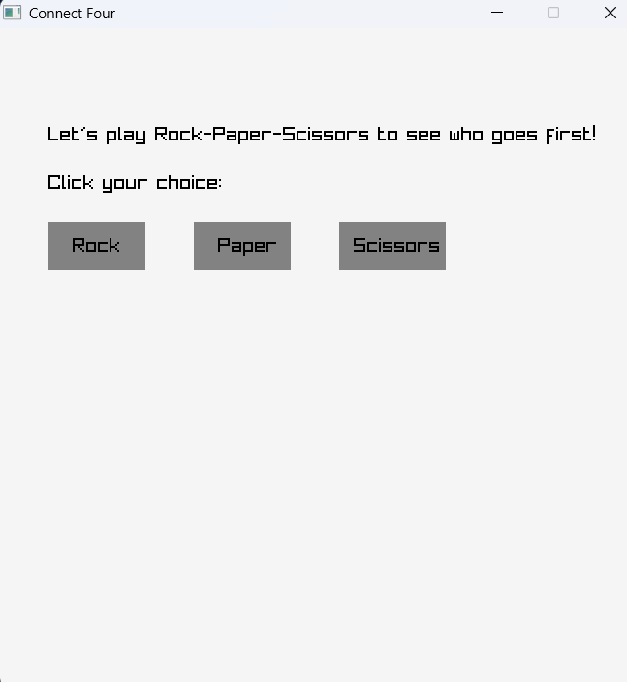

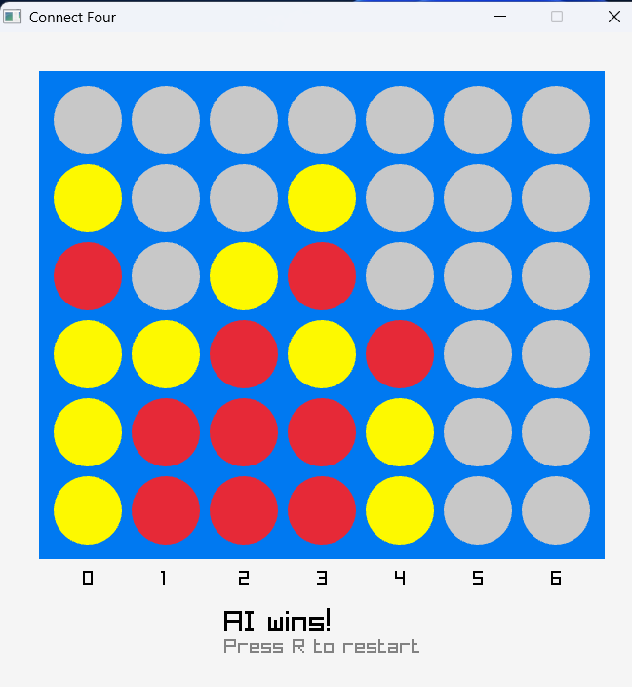
ΣΥΓΚΡΙΣΗ ΜΕ AI-GENERATED CODE
#include <iostream>
#include <vector>
#include <cstdlib>
#include <ctime>
#include <limits>

using namespace std;

const int ROWS = 6;
const int COLS = 7;
const int MAX_DEPTH = 4;
char board[ROWS][COLS];

void initializeBoard() {
for (int i = 0; i < ROWS; ++i)
for (int j = 0; j < COLS; ++j)
board[i][j] = '.';
}

void printBoard() {
cout << "\n";
for (int i = 0; i < ROWS; ++i) {
for (int j = 0; j < COLS; ++j)
cout << board[i][j] << " ";
cout << "\n";
}
for (int j = 1; j <= COLS; ++j)
cout << j << " ";
cout << "\n";
}

bool isColumnFull(int col) {
return board[0][col] != '.';
}

bool placeDisc(int col, char symbol) {
if (col < 0 || col >= COLS || isColumnFull(col)) return false;
for (int i = ROWS - 1; i >= 0; --i) {
if (board[i][col] == '.') {
board[i][col] = symbol;
return true;
}
}
return false;
}

void undoMove(int col) {
for (int i = 0; i < ROWS; ++i) {
if (board[i][col] != '.') {
board[i][col] = '.';
break;
}
}
}

bool checkDirection(int row, int col, int dr, int dc, char symbol) {
int count = 0;
for (int i = 0; i < 4; ++i) {
int r = row + dr * i;
int c = col + dc * i;
if (r >= 0 && r < ROWS && c >= 0 && c < COLS && board[r][c] == symbol)
count++;
else
break;
}
return count == 4;
}

bool checkWin(char symbol) {
for (int i = 0; i < ROWS; ++i)
for (int j = 0; j < COLS; ++j)
if (board[i][j] == symbol)
if (checkDirection(i, j, 0, 1, symbol) ||
checkDirection(i, j, 1, 0, symbol) ||
checkDirection(i, j, 1, 1, symbol) ||
checkDirection(i, j, 1, -1, symbol))
return true;
return false;
}

bool isDraw() {
for (int j = 0; j < COLS; ++j)
if (board[0][j] == '.') return false;
return true;
}

int evaluateBoard(char ai, char player) {
if (checkWin(ai)) return 1000;
if (checkWin(player)) return -1000;
return 0;
}

int minimax(int depth, bool maximizingPlayer, char ai, char player) {
int score = evaluateBoard(ai, player);
if (depth == 0 || score == 1000 || score == -1000 || isDraw())
return score;

if (maximizingPlayer) {
int maxEval = numeric_limits<int>::min();
for (int col = 0; col < COLS; ++col) {
if (!isColumnFull(col)) {
placeDisc(col, ai);
int eval = minimax(depth - 1, false, ai, player);
undoMove(col);
maxEval = max(maxEval, eval);
}
}
return maxEval;
} else {
int minEval = numeric_limits<int>::max();
for (int col = 0; col < COLS; ++col) {
if (!isColumnFull(col)) {
placeDisc(col, player);
int eval = minimax(depth - 1, true, ai, player);
undoMove(col);
minEval = min(minEval, eval);
}
}
return minEval;
}
}

int getBestMove(char ai, char player) {
int bestScore = numeric_limits<int>::min();
int bestCol = -1;

for (int col = 0; col < COLS; ++col) {
if (!isColumnFull(col)) {
placeDisc(col, ai);
int score = minimax(MAX_DEPTH - 1, false, ai, player);
undoMove(col);
if (score > bestScore) {
bestScore = score;
bestCol = col;
}
}
}

return bestCol;
}

int main() {
srand(time(0));
initializeBoard();
printBoard();

char player = 'X';
char computer = 'O';

while (true) {
int col;
cout << "\nYour turn (1-7): ";
cin >> col;
col--;

if (!placeDisc(col, player)) {
cout << "Invalid column. Try again.\n";
continue;
}

printBoard();
if (checkWin(player)) {
cout << "Congratulations! You win!\n";
break;
}
if (isDraw()) {
cout << "It's a draw!\n";
break;
}

int compMove = getBestMove(computer, player);
placeDisc(compMove, computer);
cout << "\nComputer played column " << (compMove + 1) << "\n";

printBoard();
if (checkWin(computer)) {
cout << "Computer wins! Better luck next time.\n";
break;
}
if (isDraw()) {
cout << "It's a draw!\n";
break;
}
}

return 0;
}

ΣΥΜΠΕΡΑΣΜΑΤΑ & LESSONS LEARNED
Τι μάθατε από το project;
1)Μάθαμε να προγραμματίζουμε σε περιβάλλον Visual Code
2)Εξασκήσαμε τις γνώσεις που μάθαμε στην θεωρία
3)Υλοποίηση του Project μας με κατάλληλη χρήση γραφικών

Τι θα μπορούσε να βελτιωθεί;
1)Εγκατάσταση ηχητικών εφέ
2)Σε περίπτωση ισοπαλίας ο πίνακας θα επεκτείνεται μέχρι να βρεθεί ο νικητής.

- Μελλοντικές προεκτάσεις του project
Μετατροπή από μοναδικό παιχνίδι σε mini game με την χρήση launcher.

- LAUNCHER
Ο όρος launcher αναφέρεται γενικά σε ένα πρόγραμμα ή εργαλείο που χρησιμοποιείται για να εκκινήσει άλλες εφαρμογές ή διαδικασίες σε ένα σύστημα υπολογιστή ή σε μια συσκευή.

