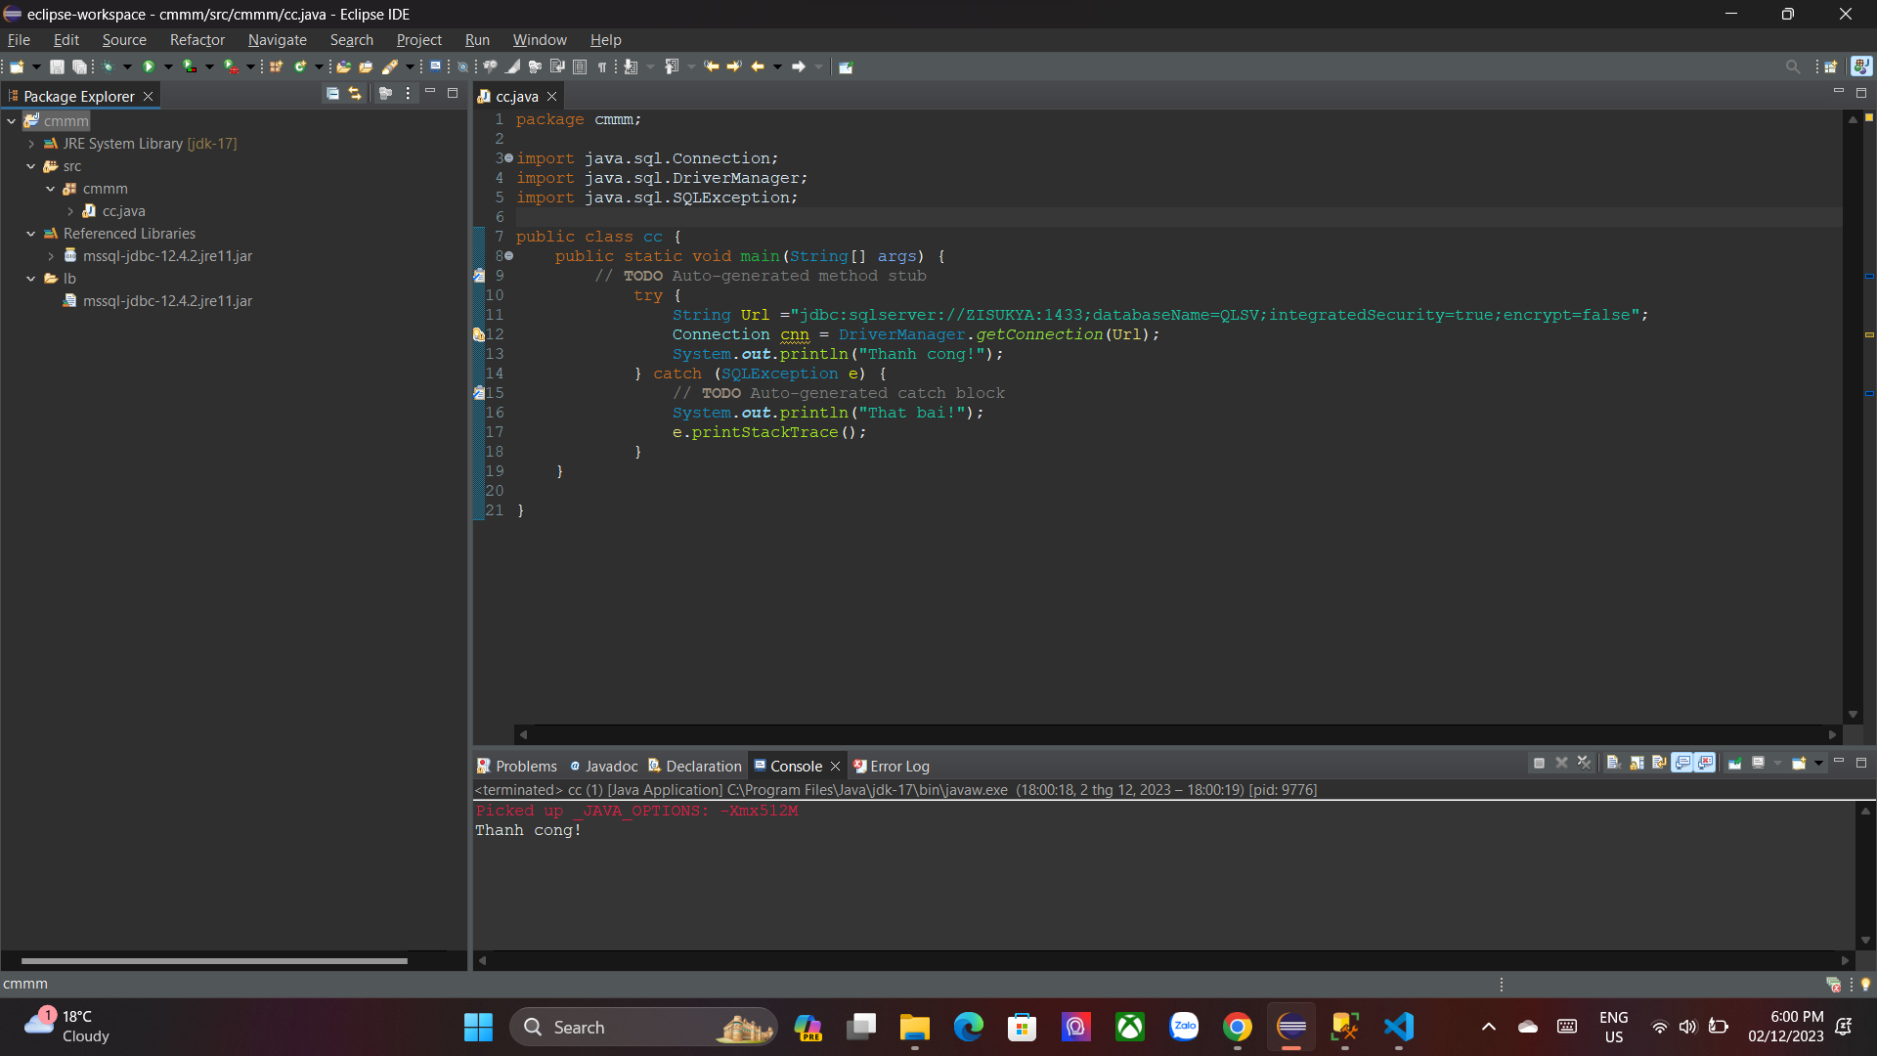

* JBDC: mssql-jdbc-12.4.2.jre11
* JDK: 17
* Code:
* public static void main(String[] args) {
* // **TODO** Auto-generated method stub
* try {
* String Url ="jdbc:sqlserver://ZISUKYA:1433;databaseName=QLSV;integratedSecurity=true;encrypt=false";
* Connection cnn = DriverManager.*getConnection*(Url);
* System.***out***.println("Thanh cong!");
* } catch (SQLException e) {
* // **TODO** Auto-generated catch block
* System.***out***.println("That bai!");
* e.printStackTrace();
* }
* }
* 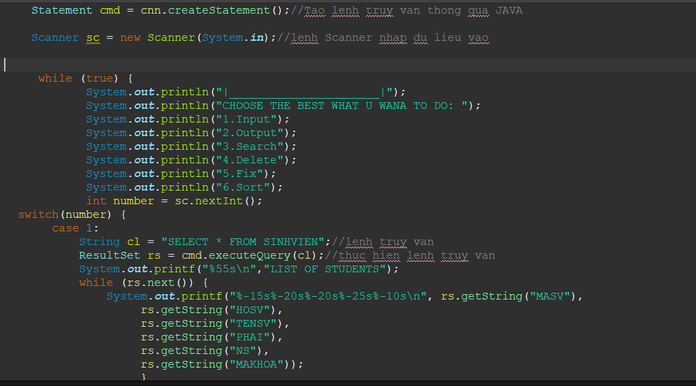
* 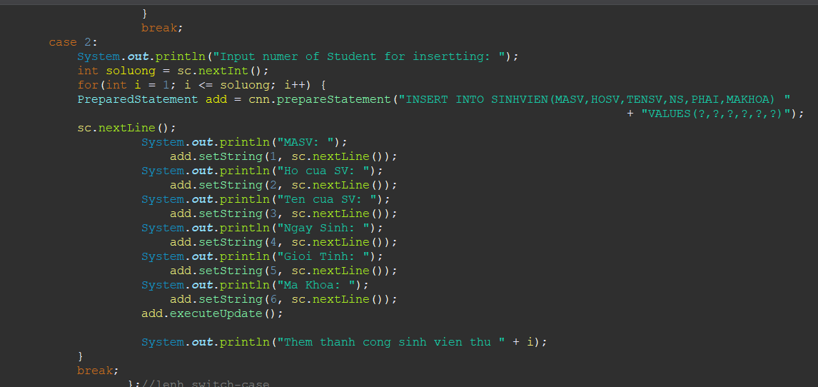
* CASE 3:
* System.***out***.println("Input MASV for Search: ");
* System.***out***.println("MASV: ");
* PreparedStatement sr =cnn.prepareStatement("SELECT * FROM SINHVIEN WHERE MASV = ?");
* sc.nextLine();
* sr.setString(1,sc.nextLine());
* ResultSet result = sr.executeQuery();
* boolean dataExists = false;
* if(result.next()) {
* dataExists = true;
* System.***out***.printf("%-15s%-20s%-20s%-25s%-10s\n", "MSV",
* "Ho ten",
* "Ten",
* "Gioi tinh",
* "Ngay sinh",
* "Ma khoa");
* System.***out***.printf("%-15s%-20s%-20s%-25s%-10s\n", result.getString("MASV"),
* result.getString("HOSV"),
* result.getString("TENSV"),
* result.getString("PHAI"),
* result.getString("NS"),
* result.getString("MAKHOA"));
* }
* if (!dataExists) {
* System.***out***.println("Not found MASV!");
* }
* break;

case 4:

System.***out***.println("Input MASV of student for Delete: ");

System.***out***.println("MASV: ");

sc.nextLine();

PreparedStatement sl = cnn.prepareStatement("SELECT * FROM SINHVIEN WHERE MASV = ?");

String input = sc.nextLine();

sl.setString(1, input);

ResultSet result1 = sl.executeQuery();

boolean dataExists1 = false;

if(result1.next()) {

dataExists1 = true;

PreparedStatement dl = cnn.prepareStatement("DELETE FROM SINHVIEN WHERE MASV =?");

dl.setString(1, input);

dl.executeUpdate();

System.***out***.println("Successful Delete!");

}

if (!dataExists1) {

System.***out***.println("Not found MASV!");

}

break;

case 5:

PreparedStatement checkExist = cnn.prepareStatement("SELECT * FROM SINHVIEN WHERE MASV = ?");

sc.nextLine();

System.***out***.println("Input MASV for CHECK: ");

String masv = sc.nextLine();

checkExist.setString(1, masv);

ResultSet exist = checkExist.executeQuery();

if (exist.next()) {

System.***out***.println("Exist!");

System.***out***.println("Input information of student for update: ");

PreparedStatement ud = cnn.prepareStatement("UPDATE SINHVIEN SET HOSV =?,"

+ " TENSV = ?,"

+ " NS = ?,"

+ "PHAI = ?,"

+ " MAKHOA =?"

+ " WHERE MASV = ?");

System.***out***.println("Ho cua SV: ");

ud.setString(1, sc.nextLine());

System.***out***.println("Ten cua SV: ");

ud.setString(2, sc.nextLine());

System.***out***.println("Ngay Sinh: ");

ud.setString(3, sc.nextLine());

System.***out***.println("Gioi Tinh: ");

ud.setString(4, sc.nextLine());

System.***out***.println("Ma Khoa: ");

ud.setString(5, sc.nextLine());

ud.setString(6,masv);

ud.executeUpdate();

System.***out***.println("Successful Update!");

}

else {

System.***out***.println("Not found MASV!");

};

break;