Reviewer #1 (Rationale for Significance Rating for Authors):
The data set and design of the study are interesting, and the manuscript is overall well written. The main claim is that the neural representations elicited by visual stimuli have a degree of "cue-invariance" quantified by a "cue-transfer decoding" method, but unfortunately it is not clear what this tells us about the structure of the neural representations.
Reviewer #1 :
This manuscript studies the structure of stimulus-evoked neural activity patterns in V1 and V2 of macaques. The data set and design of the study are interesting, and the manuscript is overall well written. The main claim is that the neural representations elicited by visual stimuli have a degree of "cue-invariance". The central analysis to support this is termed "cue-transfer decoding", which involves fitting a Procrustes transformation (or perhaps just a rotation according to the methods) between the neural activity patterns from different visual stimulus sets.

Reviewer's point 1 – terminology cue-invariant or cue-equivariant [0% done] [framing/wording change]
Let's start with a note on terminology: "cue-invariant neural representations" doesn't quite sound right in two ways. First, even if there was an invariance of the neural representations, it would be with respect to the rendering/appearance, not with respect to other features of the visual cue. Second, the neural representations aren't actually invariant if they need to be mapped by a Procrustes transformation to generalize from one rendering style to another. I believe the correct mathematical term for such a situation would be "equivariant", so a term like "rendering-equivariant neural representations" would be more accurate. (As an aside, I would argue that we already knew that at least in the human visual system, the neural representation in the early visual system cannot be truly invariant to rendering style, otherwise we couldn't distinguish different renderings of the same contour - this point should probably be mentioned when motivating the study).

Reply to point 1

Reviewer's point 2 – simple geometric measures like angles and distances [almost 100% done]
The properties that are actually invariant under a Procrustes transformation are relative distances between pairs of points (neural representations) and angles between them (i.e., the "shape" of the neural geometry, but not its overall scale). It seems puzzling that the authors don't test their main hypothesis directly in terms of these geometric quantities. Relative distances and angles of the neural geometry are easy to compute and compare across different renderings, without training any decoders. The RSA analysis of Fig. 3 makes a start in this direction, but of course one cannot say much from these dimensionally reduced plots. What would be needed to argue that there is a geometric structure in the neural representations that is approximately preserved between rendering styles is a systematic quantification of these properties (angles and relative distances), with a careful statistical comparison to a control model to investigate the degree to which they are preserved.

Reply to point 2
I. The direct reply: simple geometries show equivariance/invariance but modest - response mean geometry: pairwise distances and centroid-anchored angles
Related scripts: geometric_metrics_basic.m
Method: It builds two geometry matrices from the 50 stimulus-mean vectors in each rendering: pairwise Euclidean distances, and centroid-anchored cosine similarity (cosine between each mean and the others after subtracting the grand centroid of all 50 means). Cue-invariance is then the cross-rendering Pearson correlation of these matrices — over the 1225 unique off-diagonal pairs (triu(...,1), diagonal excluded so self-distance-0/self-cosine-1 don't inflate anything). For each rendering pair it draws three bootstrap distributions — Observed (per-trial-resample cross-rendering r), Null (stimulus-label shuffle nested inside the bootstrap so noise structure matches), Ceiling (two independent within-condition resamples per AC/EC/EX) — plus a trial-averaged point estimate (black triangle). Runs under two normalize_modes: raw, or zscore (per-neuron on the 500×N matrix, matching the decoder).
Result: while the general pattern holds across monkeys and visual areas, only KO V1 results (the best one) are shown here. Other figures can be found at ..\decoding-analysis\neuronal_decoding\results\figures\simple_geometrics\mean_of_trials
Two groups of figures computed using raw or per-neuron zscored spike counts. They are similar in general patterns, with z-scoring having higher values.
Start with the z-scored results.
i. heatmaps for stimulus-pairwise distance/cosine
The trial-averaged heatmaps (named “heatmap_avg”) show the geometry itself — three panels, one per rendering, each a picture of the fifty-by-fifty distance or angle matrix. The metrics are computed with trial-averaged means. The three panels resembling one another is the invariance, made visible directly. The trial-resampled heatmaps (named “heatmap_rs”) show the same thing built from the bootstrap-smoothed geometry instead, i.e, resample trials with replacement to compute the stimulus mean and then compute the metric; they look almost identical to the averaged ones.
“dist_” pairwise stimulus distance
“cos_” grand centroid anchored, pairwise stimulus angle cosine value
“dist_heatmap_avg_zscore.png”
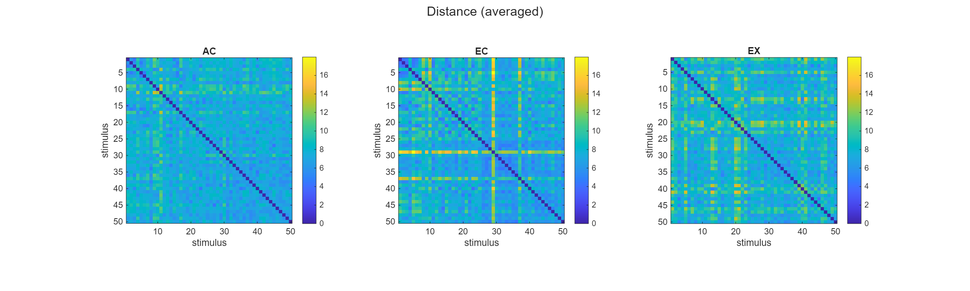
“dist_heatmap_rs_zscore.png”
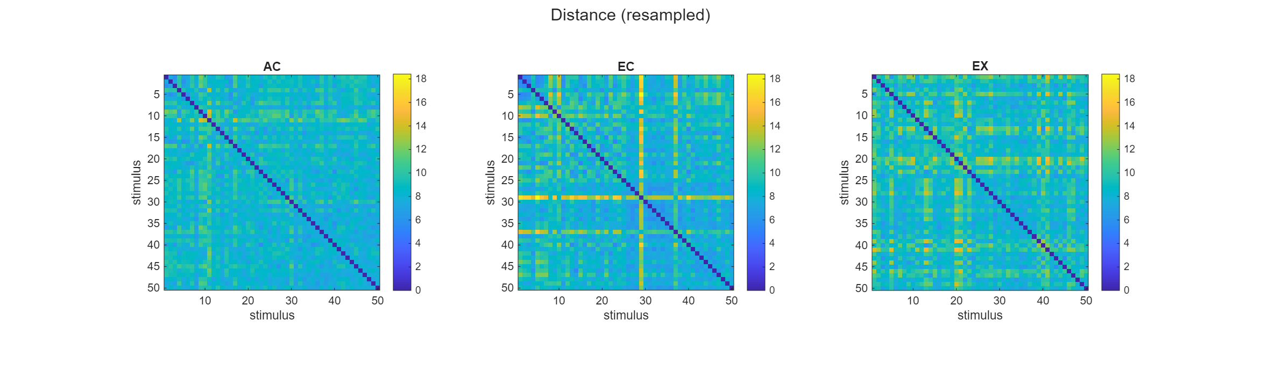
“cos_heatmap_avg_zscore.png”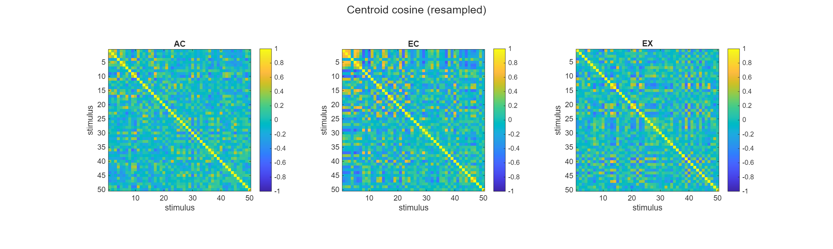
“cos_heatmap_rs_zscore.png”
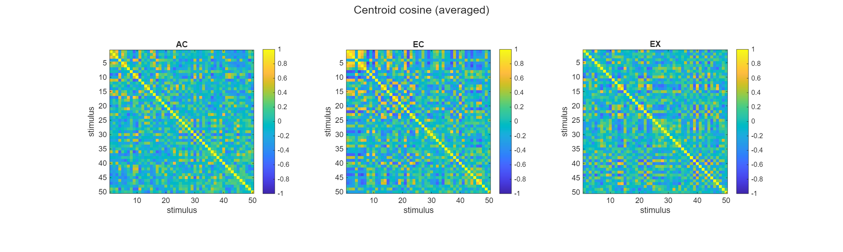
Interpretation: there are corresponding cross-like patterns across renderings. We need to quantify the invariance between cues, by computing the correlation.

ii. scatter plots of geometry metrics across renderings
The averaged scatter plots (named “scatter_avg”) take those same two geometries and plot one condition against the other, one dot per stimulus pair, so a tight diagonal cloud means the two conditions rank their stimulus pairs the same way. The resampled scatter (named “rs_avg”) does this on the smoothed version. It is built from the average of all 100 resamples. These are the visual form of the correlation number.
“dist_” pairwise stimulus distance
“cos_” grand centroid anchored, pairwise stimulus angle cosine value

dist_scatter_avg_zscore
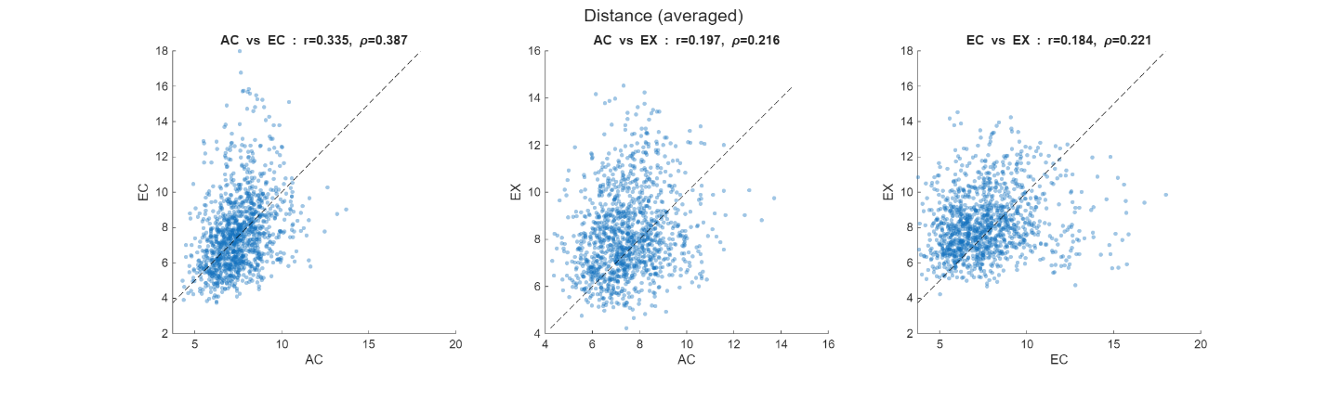

dist_scatter_rs_zscore
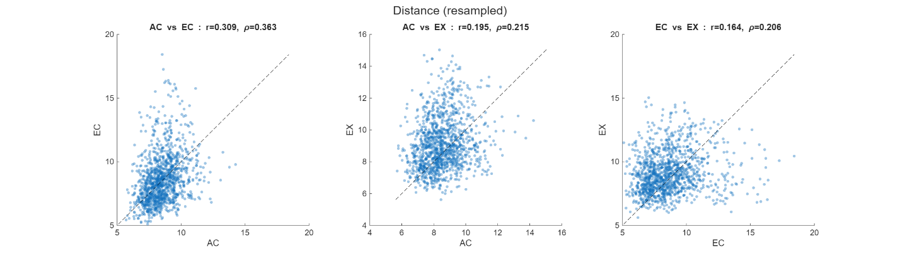

cos_scatter_avg_zscore
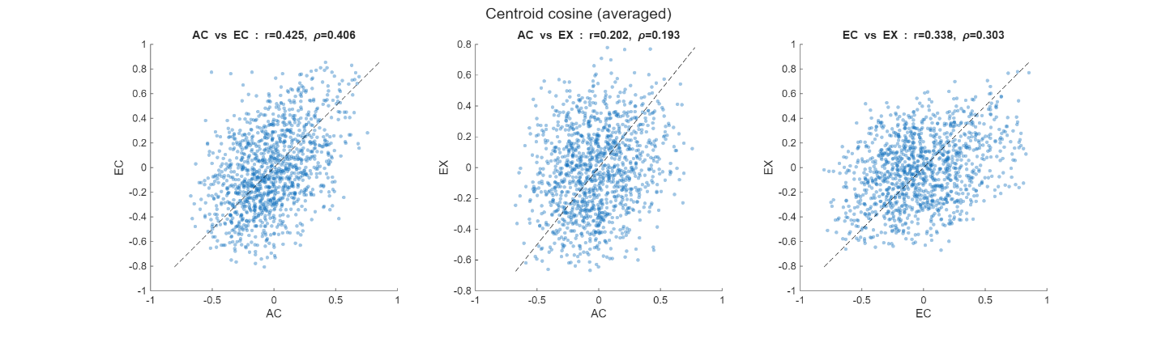

cos_scatter_rs_zscore
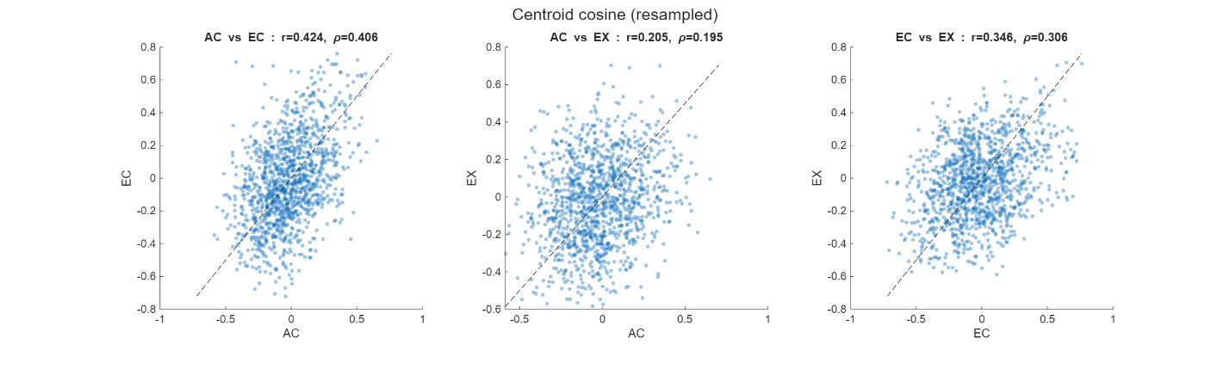

Interpretation: The scatter plots showed some modest correlation. We further quantify it by plotting the resampled and averaged correlation values against the self-ceiling and nulls.

iii. Distribution of correlation values
First, some explanations:
Trial-averaged Pass (deterministic). just averages all ten repeats of each stimulus, builds the geometry once, and correlates the two conditions once. This is the honest point estimate: the black triangles in the distribution plots.
Bootstrapped Pass (100 iterations). Repeat the above process a hundred times, each time drawing ten repeats with replacement before averaging, so the stimulus points wobble a little from draw to draw. Two useful things fall out of this. Averaging the hundred wobbled geometries together gives a smoothed version of the geometry, and recording the cross-condition correlation on each individual draw gives a whole spread of correlations rather than a single number — that spread is the so called "obs" distribution.
Ceiling pass — 100 iterations. sks how faithfully a single rendering even reproduces its own geometry. Within one condition it draws the trials twice, independently, builds two geometries, and correlates them. Because these are the same stimuli under the same condition, this is the most agreement you could ever hope to see across conditions; the true cross-condition correlation is bounded by it. It is called “AC/EC/EX self”
Null pass (1000 iterations). It is the opposite reference. It resamples exactly as before but scrambles which stimulus is which in one condition before correlating, so any real correspondence between the two geometries is deliberately destroyed. Whatever correlation survives that scrambling is what you'd get by chance.
dist_distributions_zscore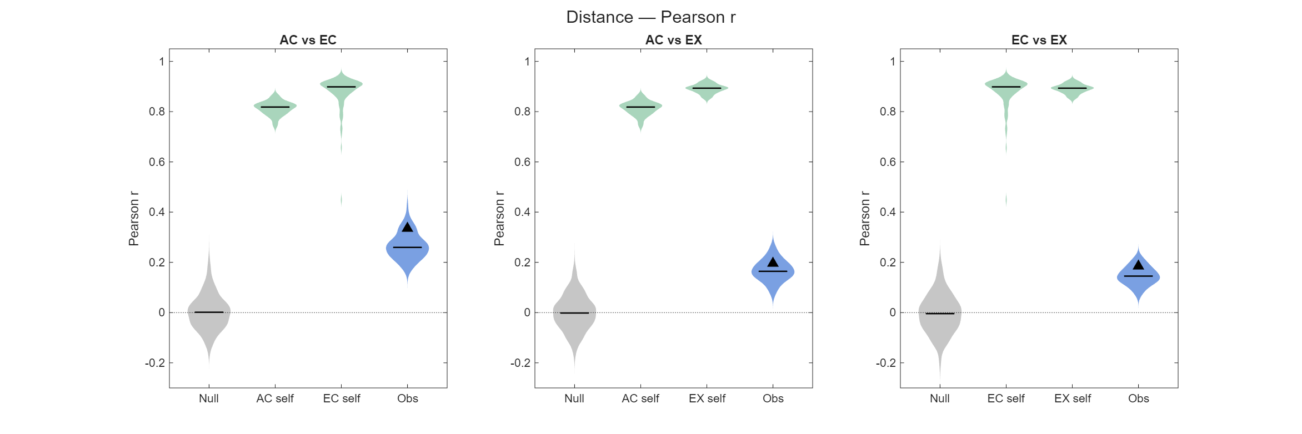
cos_distributions_zscore
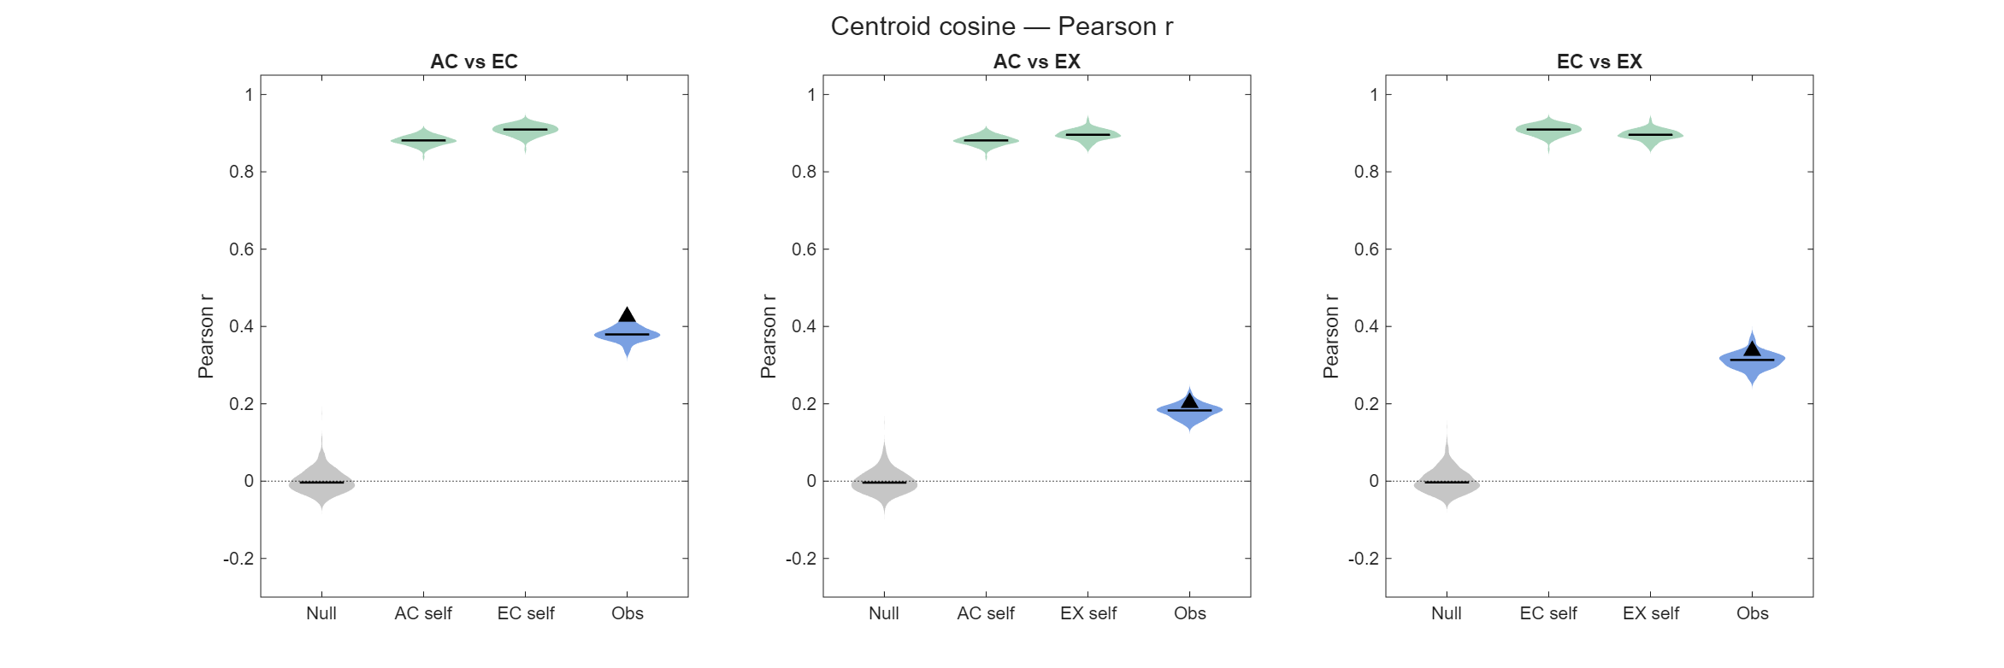
I only attached the summarized distribution for raw spike count here; other lower-level computation figures can be found in Git Repo: decoding-analysis\neuronal_decoding\results\figures\simple_geometrics\mean_of_trials
dist_distributions_raw
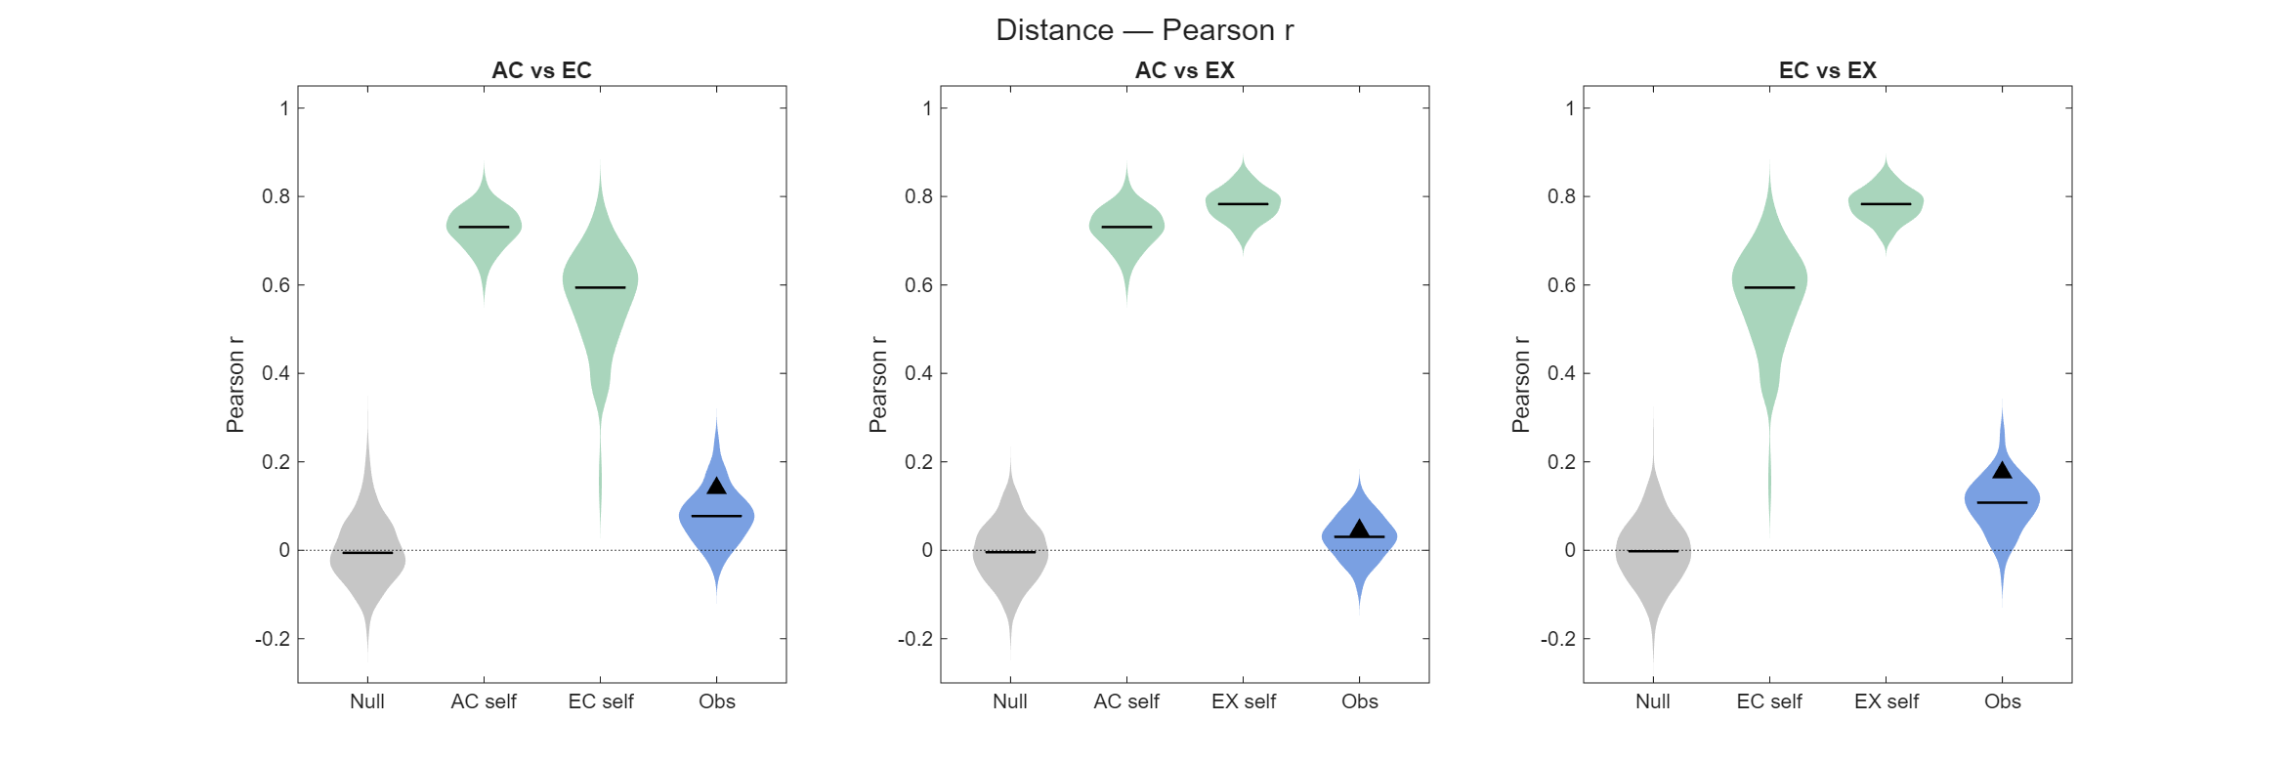
cos_distributions_raw
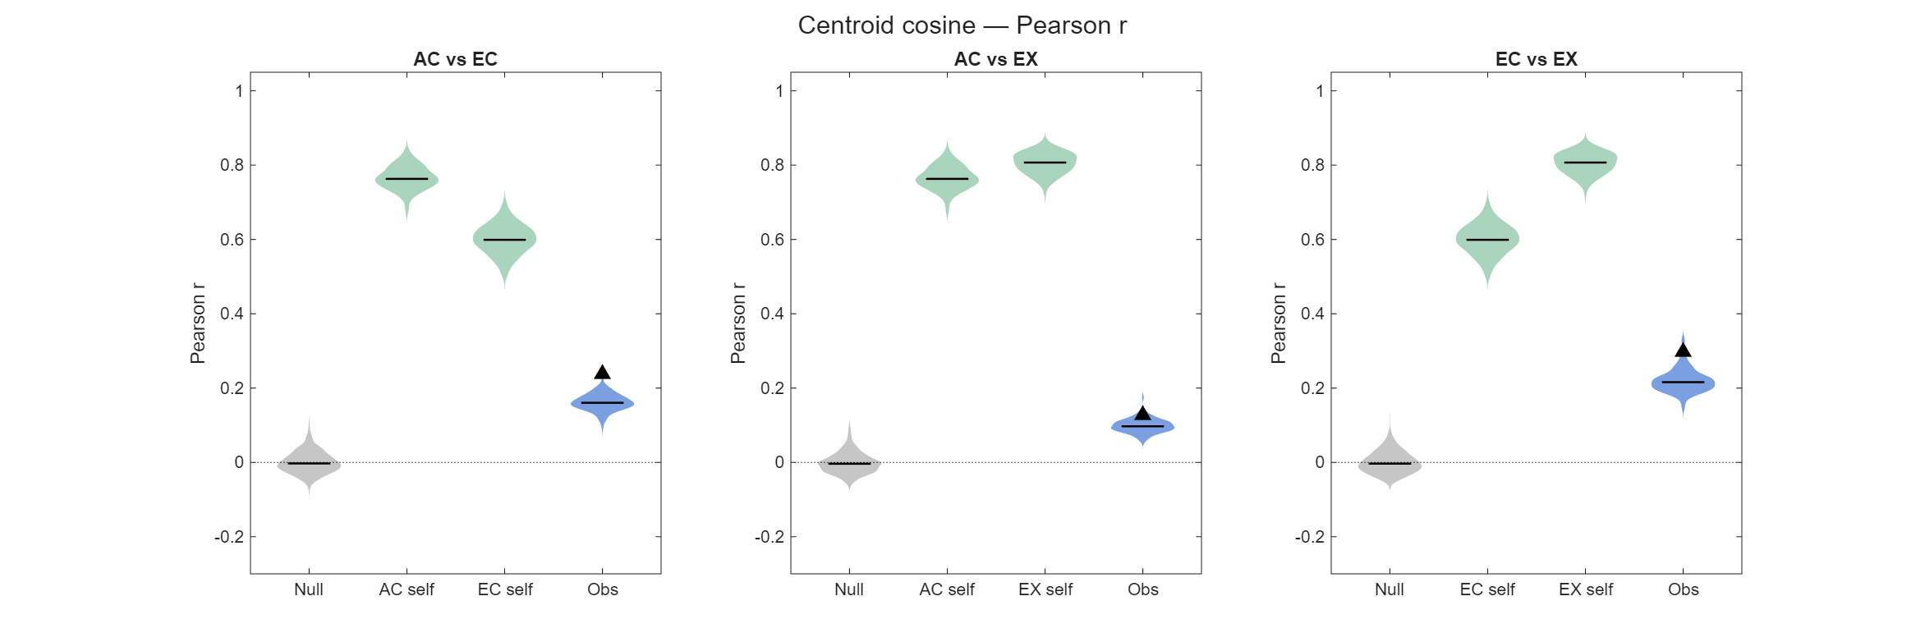

Overall conclusion for point 2 Section I: cross-rendering geometry correlation is clearly above null but well below ceiling — e.g. KO V1 z-scored: AC-EC ≈ 0.38, EC-EX ≈ 0.32, AC-EX ≈ 0.19, against ceilings 0.88–0.91 and null ≈ 0. Partial, not perfect, preservation of the shape — which is the honest decoder-free version of the claim. Note raw distance is nearly flat (0.06–0.11) and z-scoring is what reveals the structure; the paper's decoding pipeline z-scores too, so this is consistent.

II. Noise-correlation-removed control for simple geometries – removing NC has little effect on the simple geometries.
A natural follow-up question is whether the cross-rendering geometry could be manufactured by shared trial-to-trial noise correlations in the pseudopopulation rather than by genuine signal structure. This subsection repeats the distribution analysis of I-iii with noise correlations removed.
Method: The Null / self-ceiling / Obs distributions of I-iii, with the trial-averaged point estimate (triangle), are recomputed after breaking noise correlations and overlaid on the original (darker = original, lighter = NC removed). Noise correlations are removed with the same deterministic affine trial-cycling shift used in the decoding controls: within each (neuron, stimulus) block, the ten trials are cyclically reordered by a per-neuron pattern keyed to the recording session, so simultaneously recorded neurons no longer share trial-aligned covariability. Each neuron's marginal response distribution per stimulus is preserved exactly — the same values, only reordered — and only the cross-neuron correlation structure is destroyed. Because the geometry is built from trial-averaged responses and the shift merely permutes trials within a block, the full-sample mean is unchanged to machine precision: the point estimate (triangle) is invariant by construction, and noise correlations can act only on the bootstrap distributions, through the joint fluctuation of the per-neuron mean estimates across resamples. Original and NC-removed runs share matched resamples (same seed), so each category is compared with a paired signed-rank test.
(results/figures/simple_geometrics/nc_control/KO_V1/)
[zscore]
dist_distributions_nc_zscore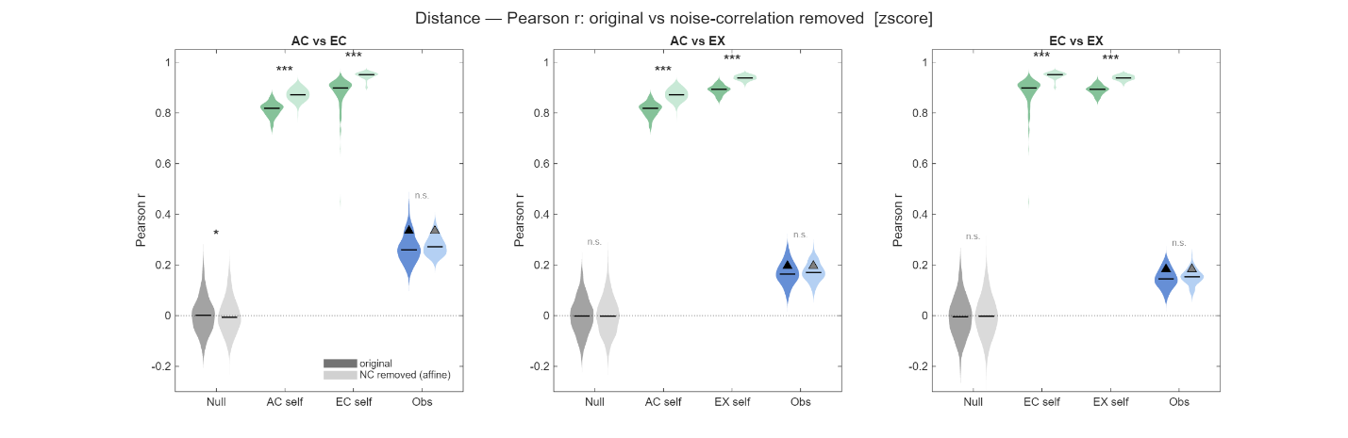
cos_distributions_nc_zscore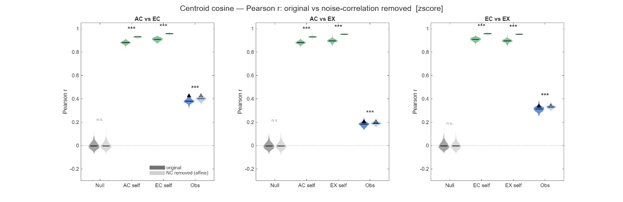
[raw] dist_distributions_nc_raw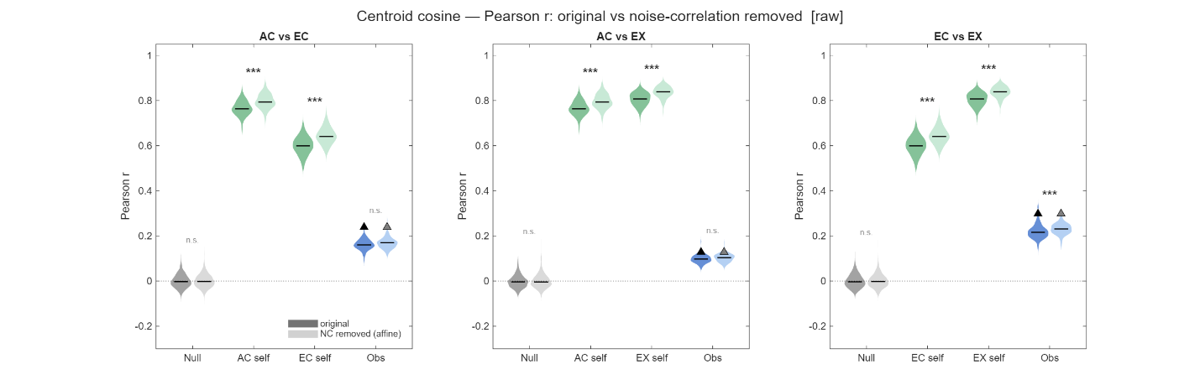
cos_distributions_nc_raw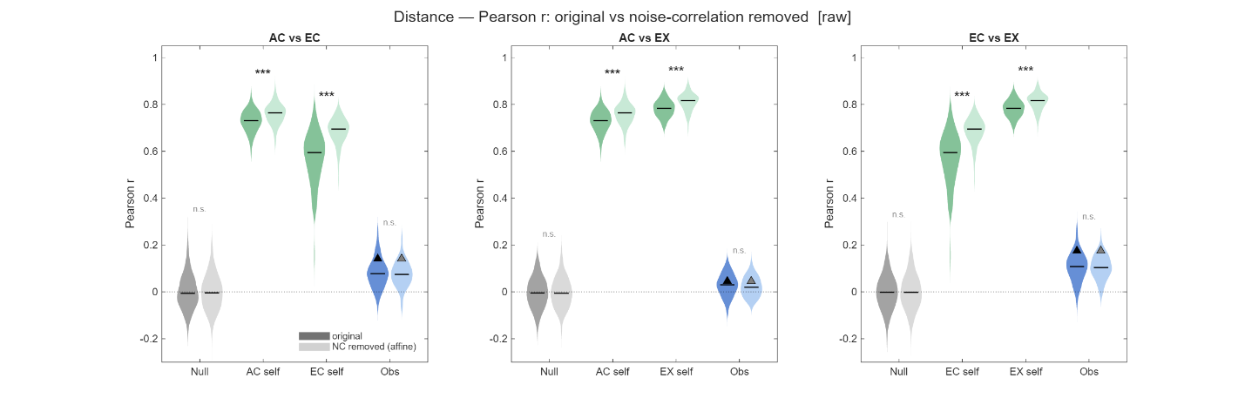
Result: Three features recur in every panel. (1) The two triangles coincide exactly — the trial-averaged cross-rendering correlation is untouched by NC removal, as guaranteed. (2) The null is unchanged and stays at zero. (3) The within-condition self-ceilings rise significantly once NC is removed (z-scored distance: AC 0.82→0.87, EC 0.90→0.95, EX 0.89→0.94; the noisiest, widest ceilings tighten most, e.g. raw EC-self 0.59→0.69), because stripping correlated bootstrap fluctuation makes each condition's geometry more reproducible across two independent resamples. Against that backdrop the observed cross-rendering distribution barely moves: for distance it is statistically indistinguishable between versions (n.s. in every panel, both normalizations), and for cosine it shifts upward by only ~0.01–0.03 (the paired test flags this in the z-scored panels because iterations are matched, but the effect is negligible in size and points away from the null, not toward it). At no point does removing NC pull the observed correlation down toward null or close its gap to the ceiling.
Conclusion for rev point 2 Section II: The cue-invariant geometry is not an artifact of pseudopopulation noise correlations. Were the cross-rendering correspondence driven by shared noise, breaking that noise would collapse the observed distribution toward null; instead it is left intact, if anything marginally higher. The one material consequence of removing NC is that the within-condition reliability ceiling rises — noise correlations limit how precisely the geometry can be estimated, but do not create the invariance itself. The partial-but-real preservation reported in I-i–iii therefore holds unchanged with noise correlations removed.

III. Supporting / documented negatives (use to show the search was thorough)
III-i. negative: which trials carry the geometry; do the trials away from the per-stimulus or across-all-stimuli mean preserves (outliers) the geometric structures better? The answer is no.
Related scripts: geometric_metrics_characteristic_trials.m
Method: pre-empts the alternative explanation that single-trial decoding rides on a few high-magnitude/outlier trials.
It's a variant of the basic geometry script built to answer one question: which trials actually carry the cue-invariant structure? The motivating hypothesis was that high-magnitude responses — trials sitting far out from the population center — might carry the shared geometry better than ordinary trials, which would explain how single-trial cue-transfer decoding succeeds even though the mean-level geometry correlation is only modest.
Instead of building each stimulus's point from all ten repeats, it builds the point from k selected trials and sweeps k from 1 to 10. Each trial is scored by its distance from a reference center, and three selection rules compete:
- near — the k trials closest to the center,
- far — the k trials farthest from the center,
- random — k trials picked at random (the noise-matched baseline).
Two more curves anchor the plot: mean, the full ten-trial average (the dashed line every rule must reach at k=10), and null, the random-k geometry with the stimulus correspondence between renderings scrambled (the chance floor).
The reference center comes in two flavors. In global mode, the center is the grand mean of all 500 trials, so "far" means the most population-distinctive . In own mode, the center is each stimulus's own mean, so "far" just means that stimulus's noisiest repeats. If distinctiveness genuinely helped, global-far would help while own-far hurt.
Everything runs inside a single bootstrap loop of 500 iterations. Each iteration resamples the ten repeats per stimulus once, and that one resample feeds every selection rule and every k, so all the curves share identical trial-sampling variability (their bands are directly comparable). For each rendering pair, each k, and each rule, it forms the two geometry matrices (pairwise distance, centroid cosine) and correlates them across the two renderings. The shaded bands are the spread of those correlations across the 500 iterations.
One structural fact explains the shape of every panel: for k ≤ 5 the near and far sets are disjoint, but as k grows they must overlap, and at k=10 all three rules are the full ten-trial mean — so all four curves necessarily collapse onto the dashed mean line at the right edge. The interesting information is entirely in how each rule approaches that shared endpoint from the left.
Result:
To ask which trials carry the cue-invariant geometry, each stimulus was represented not by its full ten-trial average but by the average of k selected trials, sweeping k from 1 to 10. Trials were scored by their distance from a reference center and selected three ways — the k nearest the center, the k farthest, and k at random — with the full ten-trial mean as the upper anchor and a stimulus-shuffled version as the chance floor. If high-magnitude, outlying responses carried the shared structure, the "far" rule would sit above the others. Because at k=10 every rule becomes the full mean, all curves necessarily converge on the dashed reference at the right edge; the information is in how each rule approaches it from the left.

“cos_ksweep_zscore_global”
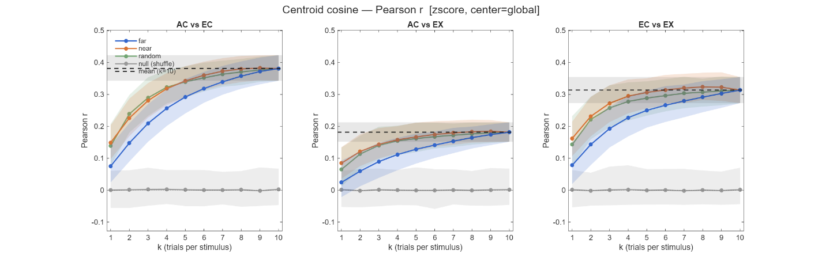
“cos_ksweep_raw_global”
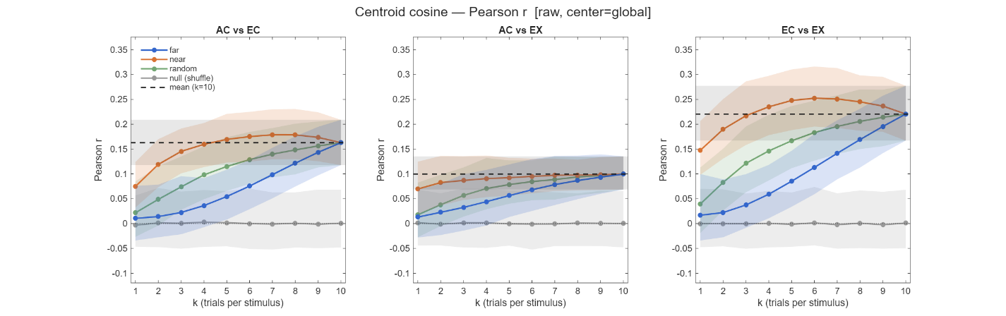
The centroid-cosine geometry under the global center. "Far" here means the trials most distinctive relative to the population grand mean. The hypothesis is refuted: the far curve (blue) is the lowest at every k across all three rendering pairs, approaching the full-mean value from below, while near and random sit together above it and the shuffled null hugs zero. Trials out at the population extremes carry less of the shared geometry than typical, central trials, not more. The effect is present in both normalizations, and as elsewhere the zscore panels are cleaner and higher than raw, confirming it isn't a normalization artifact.

cos_ksweep_zscore_own
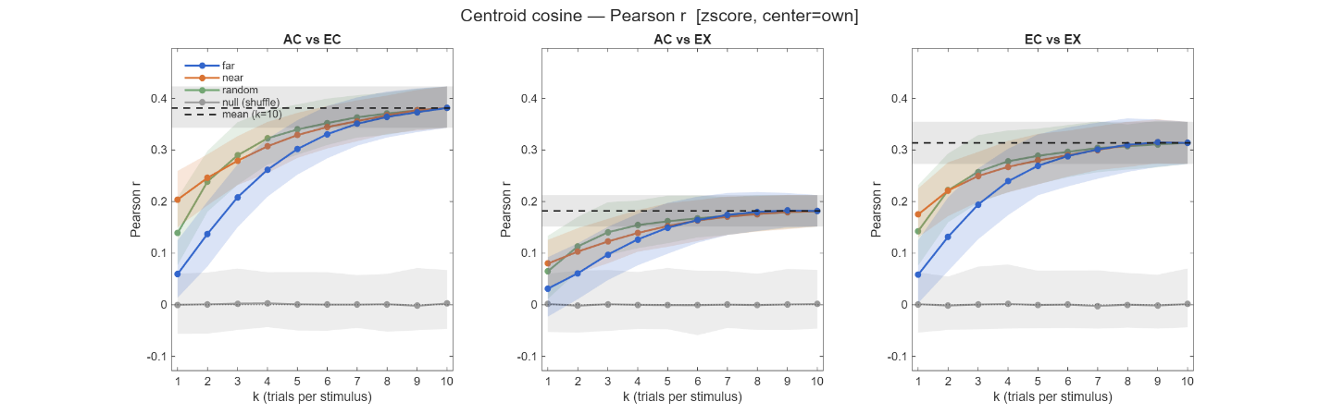

cos_ksweep_raw_own
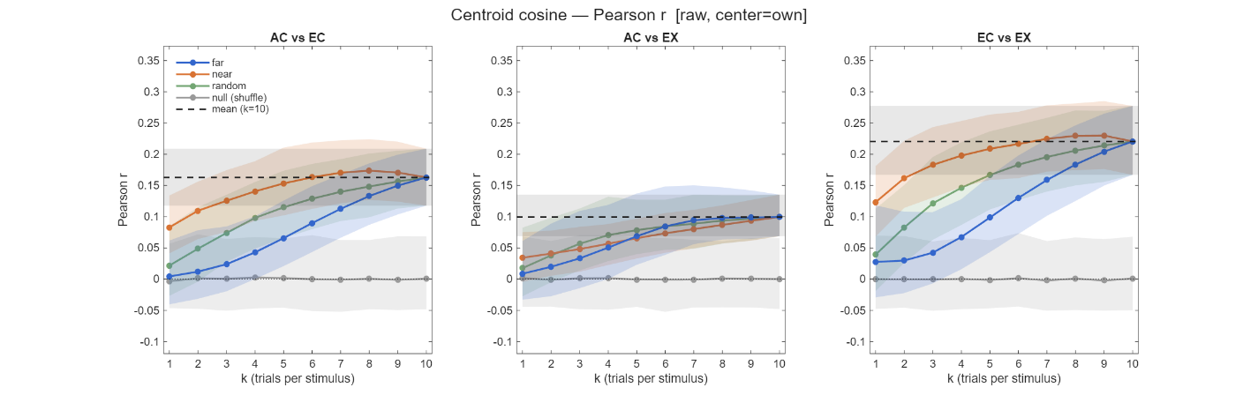
The same metric under the own-stimulus center, the negative control: here "far" simply means each stimulus's noisiest repeats. Far remains the worst rule throughout. This matters because it shows the effect is not peculiar to the global definition of extremeness — whether "far" is defined against the whole population or against a stimulus's own mean, extreme trials recover the cue-invariant geometry least well. The central bulk of the response distribution, not its tails, carries the invariance.

dist_ksweep_zscore_global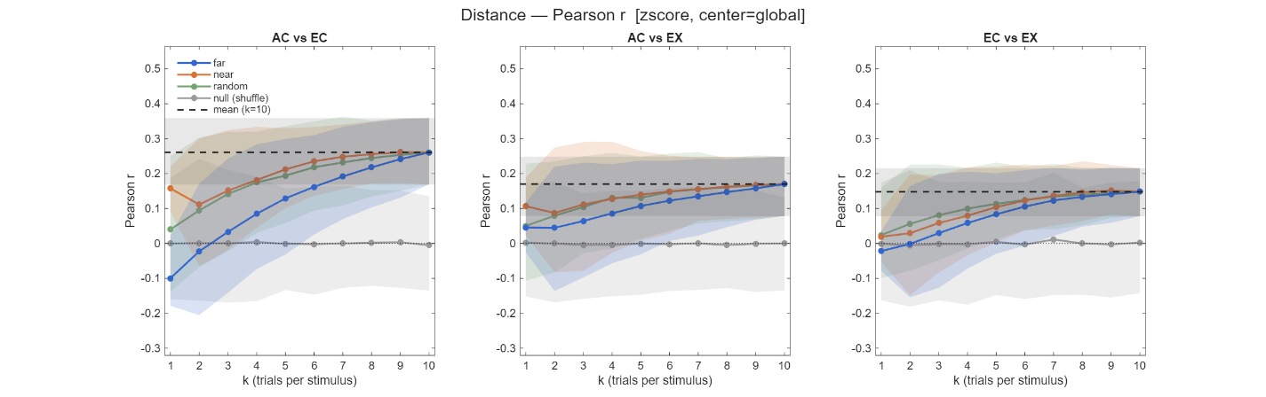

dist_ksweep_raw_global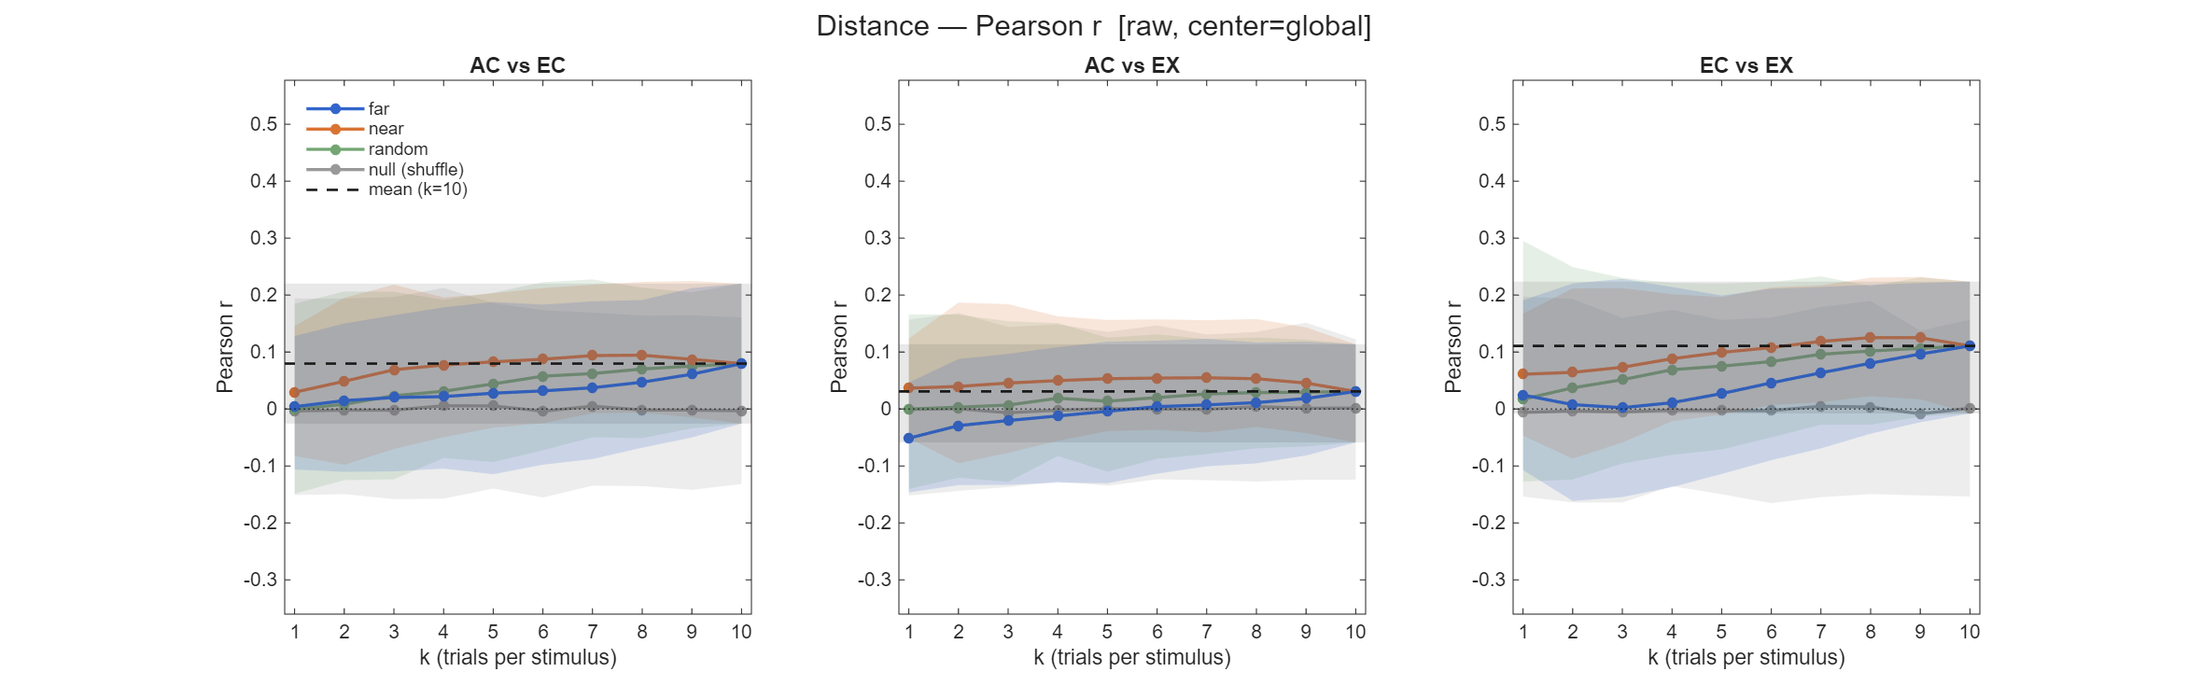
The pairwise-distance geometry under the global center, testing whether the same ordering holds for the second, independent metric. It does: near and random above, far below, converging at k=10. The distance metric is noisier — the bootstrap bands are wider, and the far curve dips slightly negative at the smallest k in the stronger pairs — but the ordering is unchanged, so the conclusion doesn't depend on which geometric quantity is measured.

dist_ksweep_zscore_own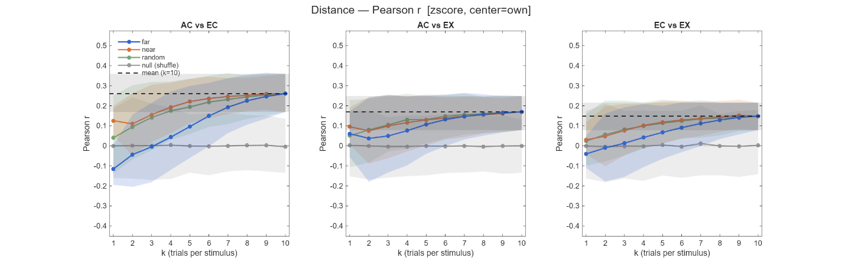dist_ksweep_raw_own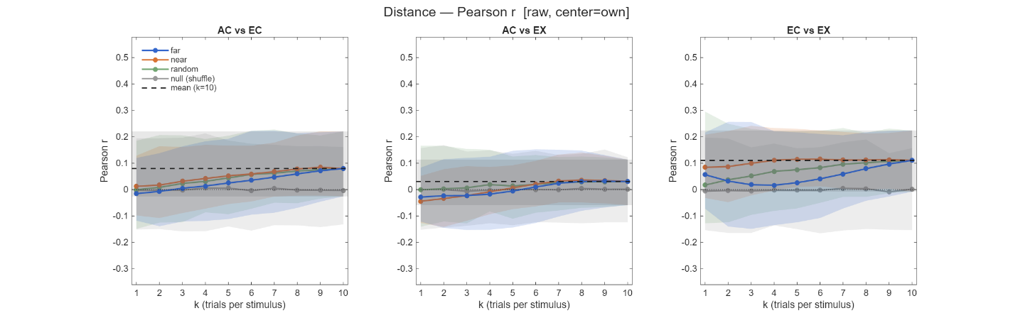
The distance metric under the own center rounds out the 2×2×2 grid. Separation between rules is weakest here — the noisiest metric crossed with the noisiest center definition — but the direction is consistent with every other panel, with far no better than the alternatives. Across all eight panels, the ordering never reverses.
Conclusion for point 2 Section III-i: Two consistent secondary patterns are visible throughout: the AC-EX pair is the weakest of the three (ceiling roughly 0.1–0.18) while AC-EC and EC-EX are stronger, matching the pair ordering in the main analysis. The upshot is a clean, robust negative: it actively rules out the alternative that single-trial cue-transfer decoding rides on high-magnitude outlier trials, and instead localizes the cue-invariant geometry in the typical, central portion of the response distribution.

III-ii. Noise-signal alignment (angel between 1st PCs of two stimuli): is it present, and is it cue-invariant? – very noisy, no reliable information available
Section I established that the signal geometry (the configuration of stimulus means) is partially cue-invariant. A separate question is whether the noise geometry carries cue-invariant structure too — specifically, whether each stimulus cloud's principal noise axis is systematically oriented relative to the signal directions, and whether that orientation is preserved across renderings. This is the noise-side analog of Section I.
Method: For each stimulus, the within-cloud first principal axis (PC1) is taken as the dominant noise direction, and its acute angle to each signal direction — the unit vector from that stimulus's mean to another stimulus's mean — is measured (0° = noise aligned with the discrimination axis, "information-limiting"; 90° = orthogonal, "harmless"). This gives an asymmetric alignment matrix per rendering (each entry uses one cloud's PC1 and its outgoing signal direction). Two questions follow: (a) within a rendering, is the angle distribution shifted away from the near-90° concentration expected of random directions in high dimensions; and (b) across renderings, is the per-pair alignment correlated, the same cross-rendering test as Section I applied to this matrix. Two nulls support them: a random-orientation null for (a) (replace each PC1 with a random unit vector, keep the real signal directions), and a stimulus-correspondence shuffle for (b).
Because PC1 is estimated from only ten trials ( the diagnostic in III-i shows it is a weak, near-isotropic direction), the analysis is exploratory and is run against two artifact axes that both inflate apparent alignment. First, if a cloud's PC1 and its mean are estimated from the same trials, the mean's sampling error tends to fall along PC1, dragging the signal direction toward PC1 and biasing alignment upward; the split-half version removes this by estimating PC1 and the mean from disjoint five-trial halves (full = biased all-trials; split = bias-free). Second, raw firing-rate heterogeneity across neurons manufactures a dominant PC1 on its own; per-neuron z-scoring removes it. The clean estimate is therefore zscore + split, with the other three configurations showing what each control removes.
(results/figures/simple_geometrics/pc1_angle/KO_V1/)
[within-rendering (a), clean vs biased]
angle_within_zscore_split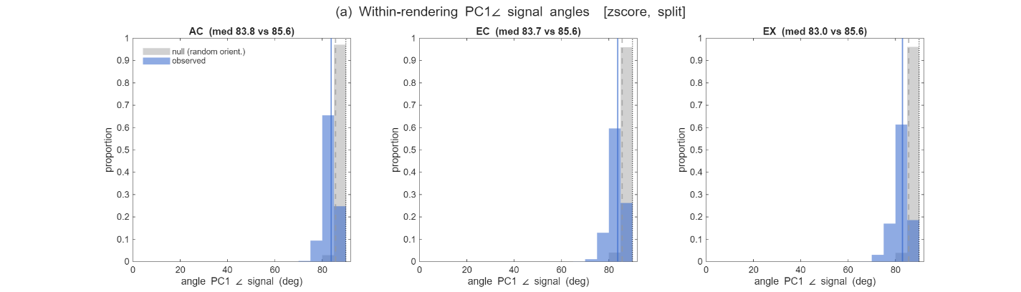
angle_within_raw_full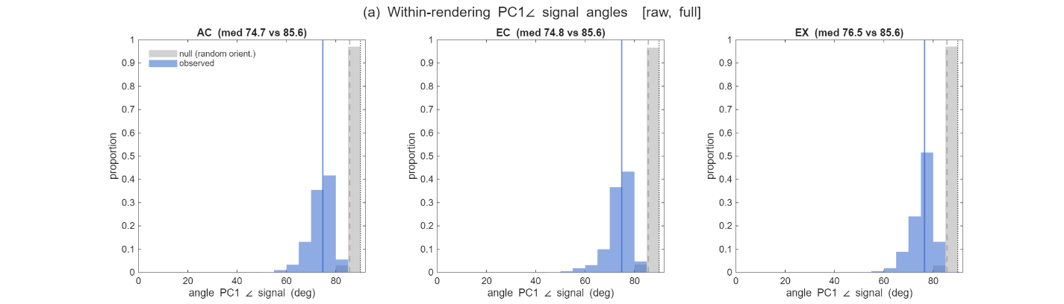
[within-rendering (a), single-control intermediates]
angle_within_zscore_full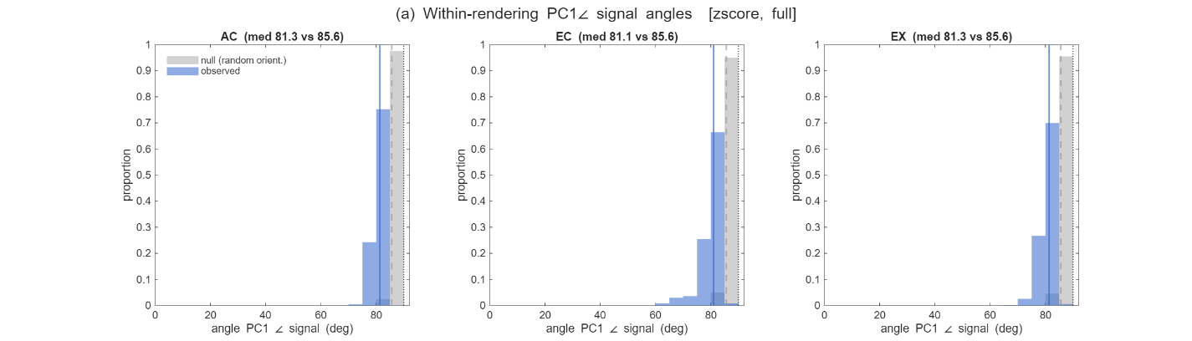
angle_within_raw_split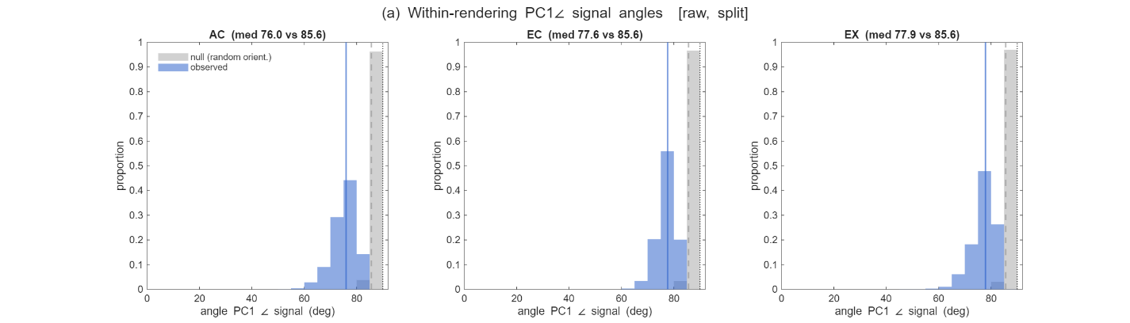
Result — within renderings (a). Uncontrolled, the angle distributions look meaningfully tilted toward alignment: raw + full gives observed medians of roughly 75–77° against the 85.6° random-orientation null, an apparent ~9–11° pull toward the signal directions. But almost all of it is artifact. Both controls move the medians back toward the null, and they act nearly additively: z-scoring accounts for the larger share (~6–7°; raw-full ~75° → zscore-full ~81°), the split-half correction a smaller one (~2–3°; full → split). With both applied, the clean zscore + split configuration leaves observed medians of ~83–84° — only about 2–3° below the 85.6° null. So once the estimation biases are removed, each cloud's principal noise axis is very nearly orthogonal to the signal directions, with at most a small residual tilt.
[across-rendering (b), all four]
angle_across_zscore_split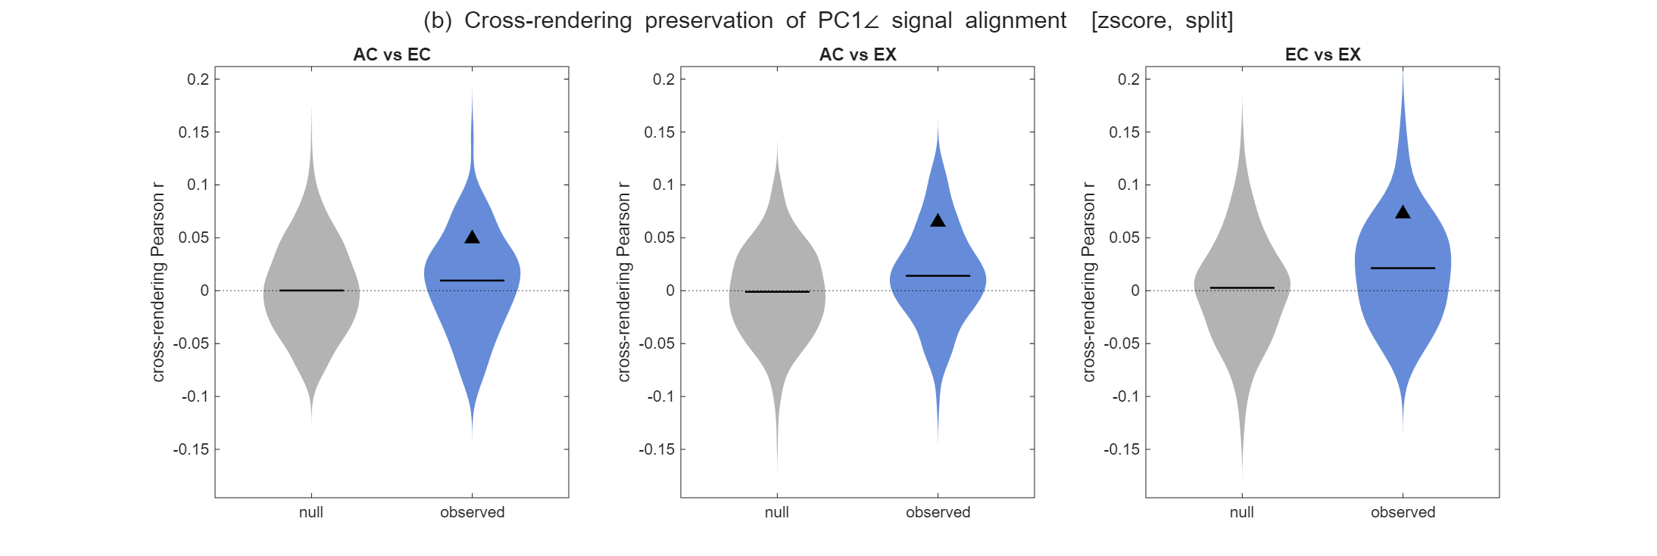
angle_across_raw_full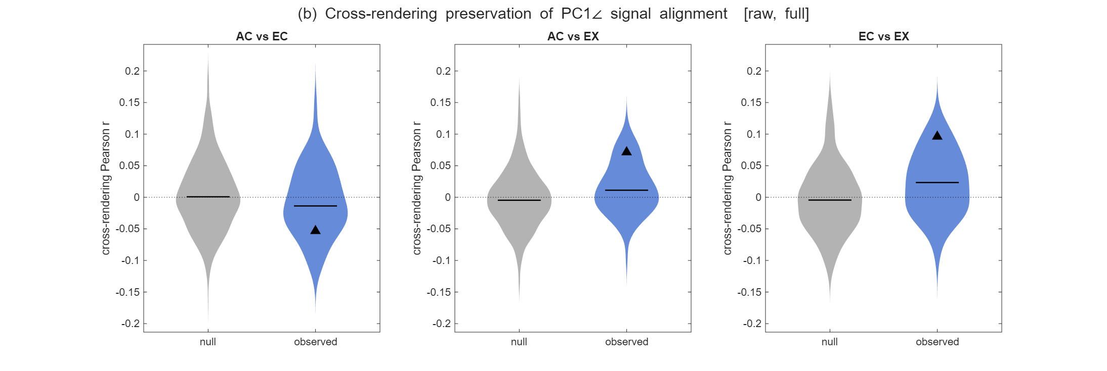
angle_across_zscore_full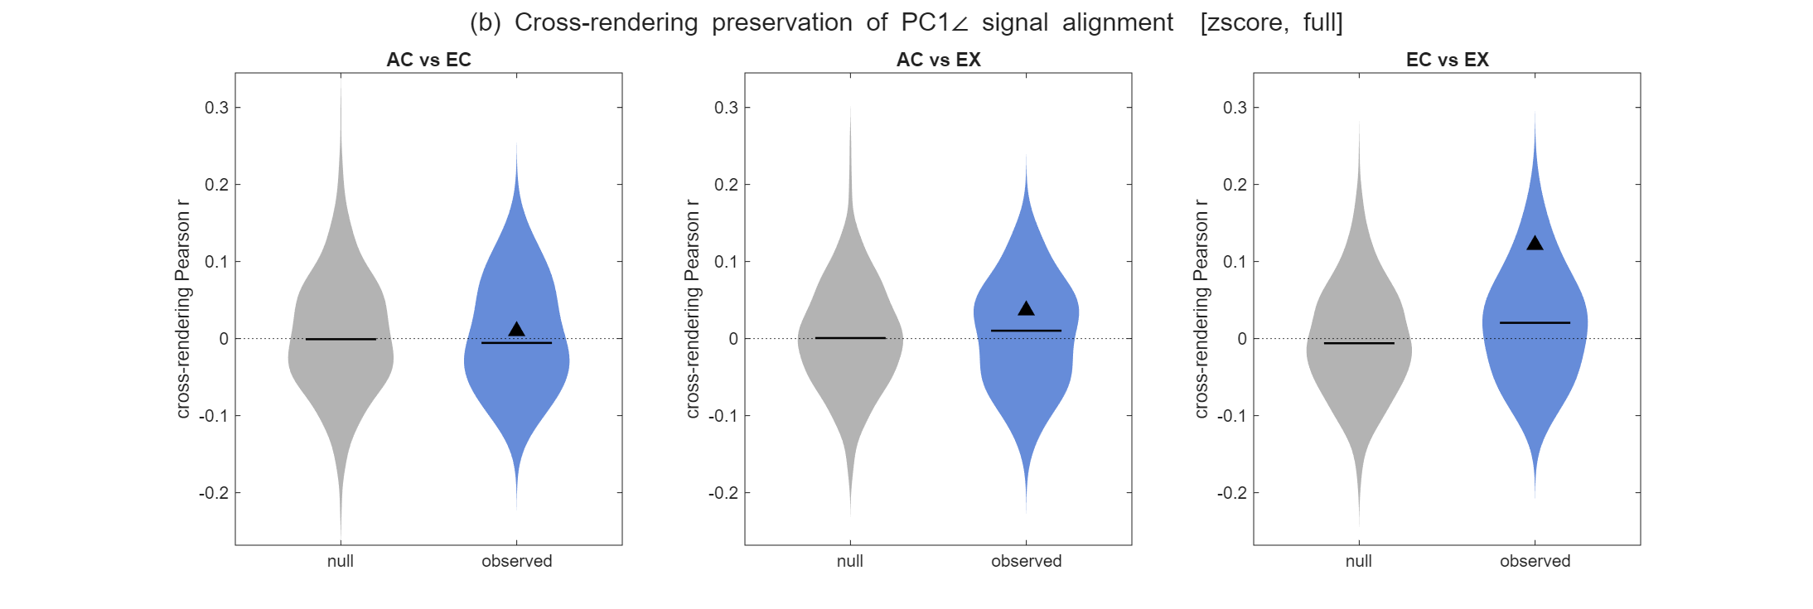
angle_across_raw_split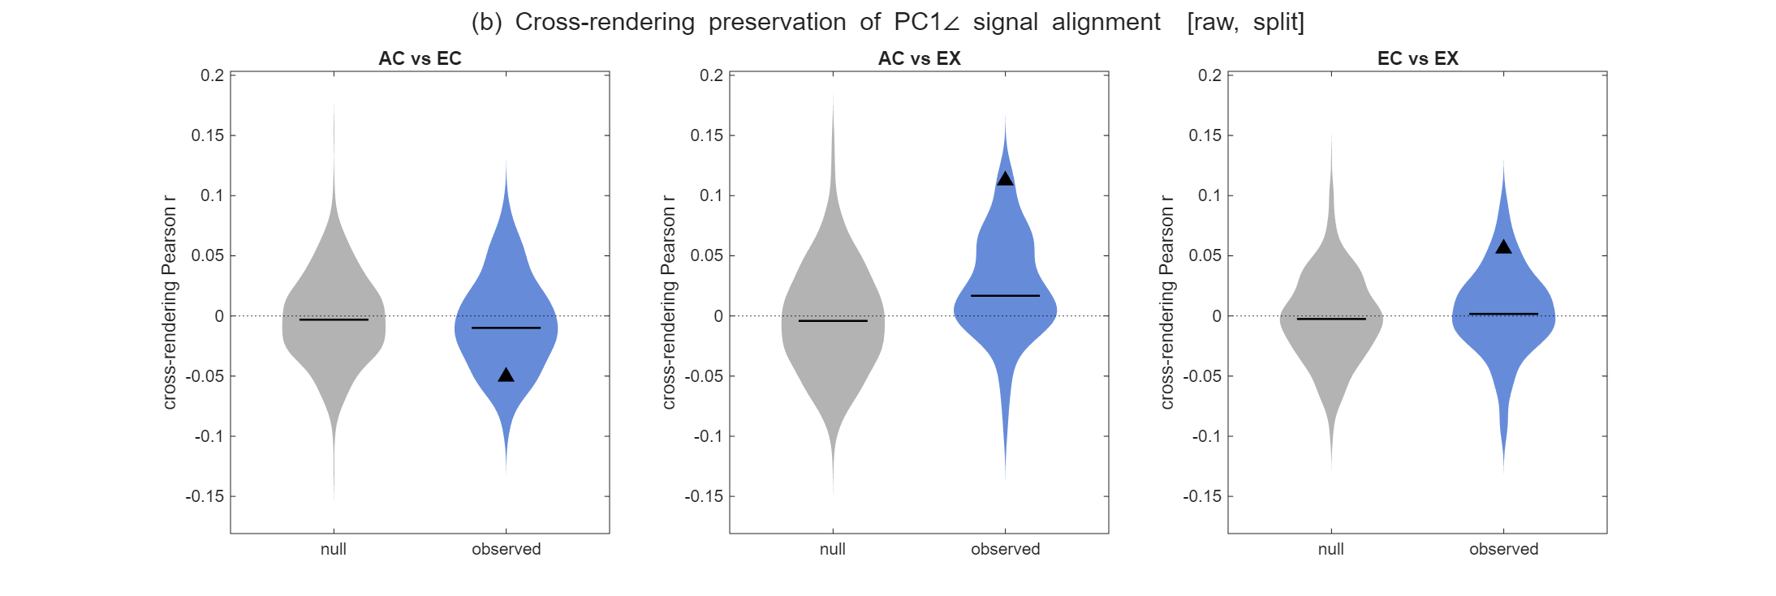
Result — across renderings (b). The cross-rendering correlation of the alignment matrices is weak and inconsistent in every configuration. Point estimates run from about −0.05 to 0.12 depending on pair and normalization — occasionally negative (AC-EC in the raw runs) — with per-iteration medians near zero and the observed violins overlapping the shuffle null throughout. There is no stable, cue-invariant noise-signal alignment to speak of. The contrast with Section I is the point: the signal-geometry correlations under the same z-scoring were 0.19–0.38, clearly clear of null, whereas the noise-geometry correlations here sit on top of it.
Conclusion of rev point 2 section III-ii. The within-cloud noise geometry carries essentially no cue-invariant structure. The apparent within-rendering alignment toward the signal directions is almost entirely an artifact of same-trial PC1/mean estimation and per-neuron variance heterogeneity; controlling both leaves the noise axes near-orthogonal to the signal, and whatever small residual remains is not preserved across renderings. This is consistent with the III-i diagnostic, where the within-cloud covariance is close to independent to begin with. The upshot for the rebuttal is that the cue-invariant transfer documented in Section I rests on the signal/mean configuration, not on structured noise-signal geometry — which also rules out an information-limiting-noise account of the cross-cue transfer.

Reviewer's point 3 – two classifiable multiclass manifolds must be relatable by a rotation (?) [50-80% done]
This leads us to the main point of this review: the crucial component that is unfortunately missing in this manuscript is evidence that successful transfer decoding actually implies a special geometric structure ("invariance") of the neural representations, as the authors claim. This is not obvious, because the rotation that is fit to transform the neural representation has a lot of parameters (of order N^2 for N neurons). For a linear SVM (which is how the authors describe their decoder in the main text) it is easy to see that the cue-transfer decoding procedure does not imply any special geometric structure of the neural representations. This is because the predictions of a linear SVM depend solely on a decision boundary described by a hyperplane in the neural activity space, and a rotation of the activity patterns is equivalent to a rotation of this hyperplane. This means that as long as one decoder can correctly classify the stimuli for one rendering, and another decoder can correctly classify them for another rendering, cue-transfer decoding will work, because the Procrustes transformation of the representations can effectively turn the decision boundary of one decoder in that of the other one. (This is related to the fact that the decision boundary is specified by only N parameters - much fewer than those involved in fitting the rotation).

Reply to point 3
The concession up front. We agree with the reviewer's central logic, and it prompted the strongest new analyses in the revision. A Procrustes rotation fit in the full neural space carries of order N²/2 free parameters, and when that number is large relative to the number of stimulus classes, transfer decoding can succeed between representations that share no geometric structure at all — so cue-transfer decoding against a chance (1/50) baseline is not, on its own, evidence of a special geometry, and we no longer rest the invariance claim on it. What follows does three things: (I) demonstrates the artifact directly, on both synthetic and real data, so it is characterized rather than hidden; (II) replaces the 1/50 baseline with structure-destroying surrogates matched to the real neuron count, so PT is scored against the right null; and (III) controls the rotation's degrees of freedom directly, which is the reviewer's own neuron-to-class-ratio point, and is the regime in which PT becomes interpretable again. The positive evidence for shared geometry itself lives in the transformation-free measures of Point 2, which carry none of these degrees of freedom.
I-i. Synthetic null from simulations — the reviewer's "simplest case" (mixture of Gaussians, random independent means)
Related scripts: generate_model1_trial_data.m, procrustes_decoding_simulation.m
Method: the reviewer's exact "simplest case": mean responses drawn i.i.d. per (neuron, stimulus, rendering), so there is no shared structure across renderings by construction, with Poisson trial noise. We fix the number of stimulus classes at 50 and sweep the number of neurons N, matching self-decoding across operating points so the comparison is not confounded by SNR.
Result (current run — to be regenerated):
Conclusion for point 3 Section I-i: Model 1 is the case the reviewer hoped could be ruled out, and at N ≥ ~50 it is not ruled out. This is the concession made concrete, and it reframes the finding as a methods contribution (report the floor; shift to relative comparisons) rather than a retraction.

I-ii. The same artifact on real data — self-consistent correspondence shuffle
Related scripts: NDC/code/procrustes_decoding_basic_trialShuffledWithMean.m (all four populations)
Method: a permutation π (shuffling of stimuli) is applied to the stimulus-mean matrix, a rotation-only Procrustes transform is fit from that permuted matrix onto the target, and the same π is applied to the held-out test trials. It is scored twice: against the target labels and against the shuffled-identity labels. (This replaces an earlier control that shuffled the training means but applied them to unshuffled test trials, which trivially only tested whether some random rotation works.)
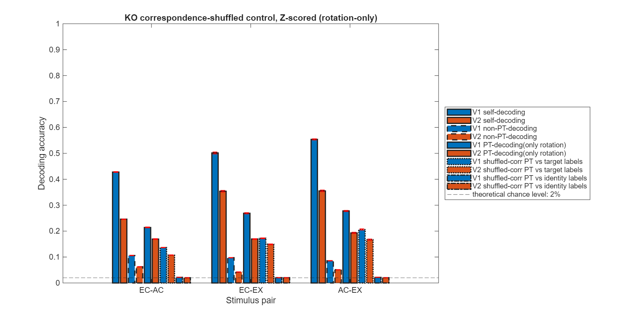
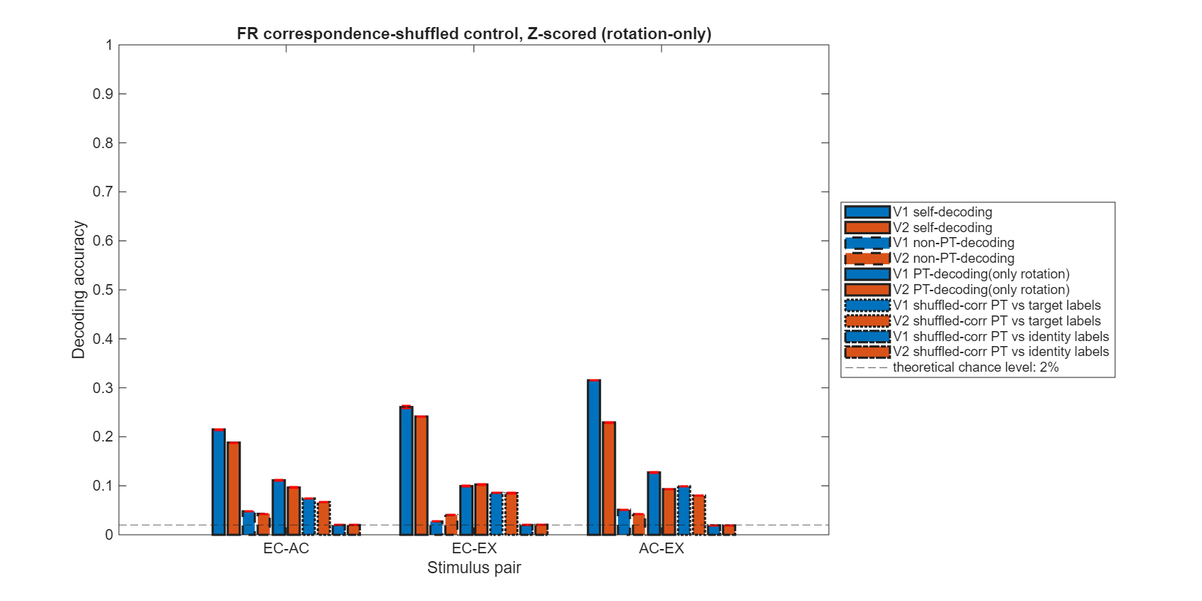
Result: scored against target labels the accuracy stays high — the rotation can be fit to force an essentially arbitrary correspondence — while scored against the shuffled identities it falls to ≈ chance, confirming the correspondence really was destroyed. On real data, as in simulation, a freely-fit rotation can impose a correspondence that was not there.
Conclusion for point 3 Section I: on both synthetic and real data, a full-DOF rotation can manufacture successful transfer, so PT-with-free-rotation cannot by itself certify that two representations share a specific geometry; at least the floor needs to be adjusted to the real null.

II. Controlling the rotation's degrees of freedom — a direct answer to the neuron-to-class ratio
Related scripts: procrustes_decoding_basic_incremental_pc.m (all four populations), visualization_variance_vs_pc.m
Method: rather than measuring the overfitting regime, we control it. The full recorded population is fixed and the number of retained PC dimensions k is swept from 1 to 49, so the rotation's degrees of freedom — k(k−1)/2 for a rotation-only Procrustes map — are set directly rather than inferred from neuron count (10 free parameters at k=5, ~1,176 at k=49, against a signal manifold of at most 49 dimensions and 50 stimulus anchors). Each cue is given its own mean-PCA basis built from the 50 centered condition means, with stim1's basis estimated from training trials only so held-out test trials never enter either the basis or the Procrustes fit (leakage-clean). Four quantities are tracked at every k: self-decoding (the within-cue ceiling), rotation-only PT and the self-consistent shuffle floor of Section I-ii (both scored on held-out trials), and — separately — the in-sample Procrustes shape residual on the mean configs used to fit the rotation (d_before with T=I, d_rot rotation-only, sharing MATLAB's stim2-target denominator). visualization_variance_vs_pc.m recomputes the cumulative signal-variance spectrum so we can state how many PCs actually carry the geometry (this also answers Reviewer 2's minor concern 6).
Result:
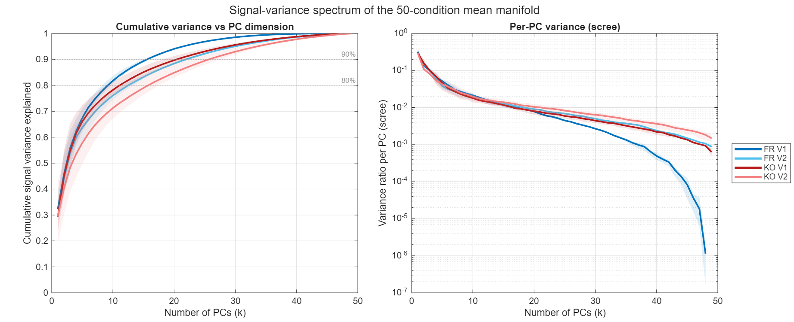
(a) How many PCs carry the geometry (fig_pc_signal_variance.png). The 50-condition mean manifold is genuinely high-dimensional. The leading PC captures only ≈ 30% of the signal variance and the scree curve decays smoothly with no sharp elbow; reaching 80% of the variance takes roughly k ≈ 8–20 and 90% takes k ≈ 15–30, depending on population (FR V1 most compact, KO V2 slowest). This matters for the whole section: because the shared structure is spread across tens of dimensions, capturing it requires a k in exactly the range where the rotation begins to acquire enough parameters to overfit. There is no k that is simultaneously rich enough to hold all the signal and lean enough to be immune — a tension we make explicit rather than hide. (FR V1's scree falls off a cliff past k ≈ 45 purely because N=48 caps its rank.)

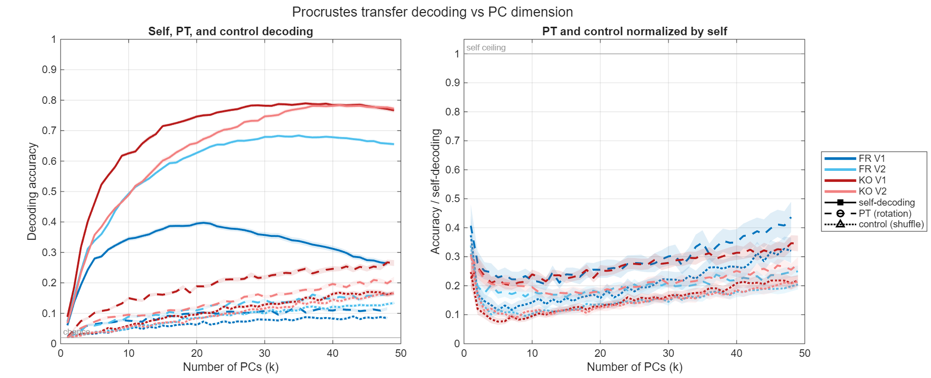
(b) Self, PT, and shuffle decoding vs k (fig_pc_self_pt_control.png). Self-decoding rises steeply and plateaus (KO V1 and KO V2 ≈ 0.78, FR V2 ≈ 0.68; FR V1 peaks near 0.40 at k ≈ 20 and then declines as its 48 dimensions run out, a caution flagged below). Held-out PT (rotation-only) rises far more gradually — KO V1 from ≈ 0.10 to ≈ 0.27 across the sweep — and the self-consistent shuffle floor rises more gradually still, from near chance to ≈ 0.15–0.17. Normalized by self-decoding, both curves trace a shallow U — high at k=1, a minimum near k ≈ 5–8, then a slow climb — and PT sits above its shuffle floor at every k beyond the first.

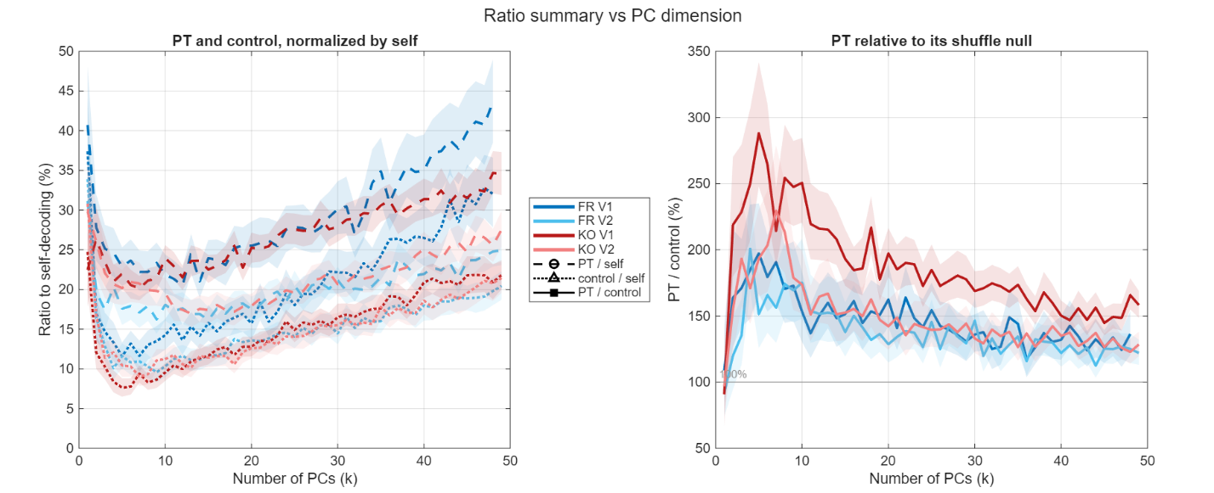
(c) PT relative to its own shuffle null (fig_pc_ratio_summary.png, right panel). This is the panel that answers the reviewer directly. Expressed as a ratio to its self-consistent shuffle floor, PT's margin is maximal where the rotation is most constrained and erodes as DOF are freed: KO V1 peaks at ≈ 2.9× its shuffle floor around k ≈ 5, KO V2 at ≈ 2.3×, and the two FR populations at ≈ 1.9–2.0×, with every population then declining monotonically toward ≈ 1.2–1.6× by k=49. At k=1 the ratio sits at or below 100% (a one-dimensional "rotation" is a sign flip and aligns nothing), so the informative window is small-but-nonzero k. This is the reviewer's prediction — that the outcome "will likely depend on the ratio between the number of neurons and the number of stimulus classes" — turned into a controlled axis and confirmed: separability from the overfitting null is best precisely when the effective dimension is low relative to the 50 classes, and the floor catches up as that ratio grows.

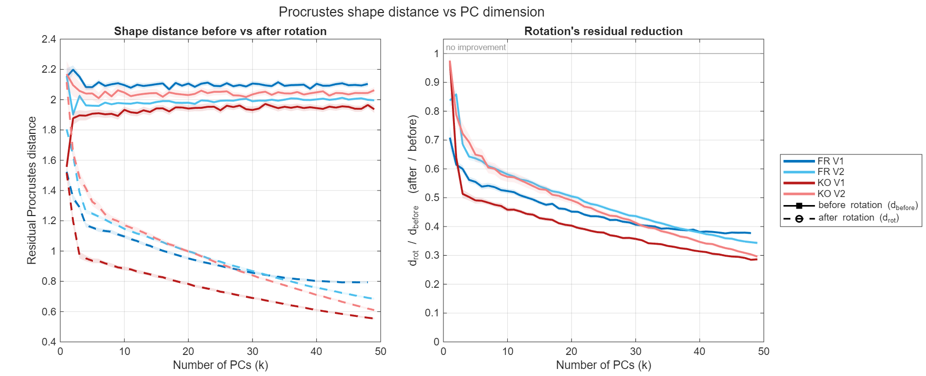
(d) The overfitting signature: training fit vs. generalization (fig_pc_procrustes_distance.png). The Procrustes shape distance d measures how mismatched the two 50-point mean clouds are on a 0-to-~2 scale (0 = identical, ~2 = unrelated). Because each cue is expressed in its own PCA frame, the clouds start almost maximally mismatched: d_before ≈ 2.0, flat across k. The fitted rotation reconciles the frames, and reconciles them more completely as dimensions are added — d_rot/d_before falls from ≈ 1 at k = 1 to ≈ 0.28–0.38 at k = 49 (removing up to ~72% of the mismatch for KO V1). Critically, this is a training-fit quantity: d_rot is scored on the very means the rotation was fit on, so it can only improve as parameters are added — there is no overfitting penalty within the fitting data. Set beside the held-out decoding margin of panel (c), which peaks at k ≈ 5–8 and then declines, the two curves diverge: the rotation's grip on the training configuration keeps tightening while its out-of-sample advantage over the shuffle null erodes. That gap is the overfitting the reviewer describes, shown directly. It also ties back to Point 2 — even at high k the residual never closes (d_rot ≈ 0.5–0.8), the shape-distance echo of "partial, not perfect" preservation.

Synthesis and one honest caveat. Two readings are ruled out by these panels. PT is not pure DOF artifact — the null-relative margin never collapses to 100% except at the degenerate k=1, and at constrained k real data stands 2–3× clear of its own overfitting floor. But PT also does not certify invariance on its own, since that margin shrinks toward the floor exactly in the high-dimensional regime needed to hold the full signal. The caveat concerns normalization: FR V1's PT/self ratio is the highest of the four at large k, but only because its self-decoding has collapsed to ≈ 0.26 there — a small numerator over a small denominator. We might therefore anchor the reviewer-facing claim on PT-relative-to-shuffle (figure c, right panel), which is null-referenced and does not inherit this artifact, and we report PT/self only as a secondary, ceiling-aware view.
Conclusion for point 3 Section II: the rotation's degrees of freedom are the single knob that governs whether transfer decoding is informative, and we control it directly rather than arguing about it. Freed (large k, or N ≫ classes), the shuffle floor rises to meet PT and the procedure is degenerate, as the reviewer says. Constrained (small k), real data separates reliably and maximally from its own overfitting null — up to ≈ 2.9× in KO V1 — establishing that PT carries genuine shared-geometry signal, not merely rotational slack. This is the bridge to Point 5(simulation): the decoder is a multiclass ECOC, not a single hyperplane, but the multiclass structure does not exempt it from the overfitting regime (Simulation Model 1 overfits with the same decoder), which is why the honest move is to control the DOF and report the null-relative margin. The positive invariance claim rests partly on the transformation-free metrics of Point 2; this section shows the decoder-based evidence is consistent with real structure once its degrees of freedom are properly accounted for, and quantifies exactly where that evidence is trustworthy.
Where the invariance claim now stands (closing). We concede that transfer decoding with a free rotation does not, by itself, imply special geometric structure, and we have characterized exactly when and why it fails (Section I), rescored it against the correct null (Section II), and identified the regime in which it remains informative (Section II). The positive claim of partial cue-invariance also rests on the transformation-free measures of Point 2 — pairwise distances and centroid-anchored angles — which involve no fitted transformation and so cannot inherit the rotation's degrees of freedom.
These two facts are two sides of the same coin. When you have random, structureless clouds in high dimensions, all the points end up roughly equidistant, so a fitted rotation can line up two unrelated clouds well enough that Procrustes transfer decoding still succeeds — spuriously, on the strength of rotational freedom alone. The fix is not to abandon PT but to give it the right yardstick: we score PT against a shuffle null that is granted the same rotational degrees of freedom, so whatever accuracy the free rotation can manufacture on its own is present in the baseline too and cancels out. What remains — PT's margin over that DOF-matched null — is the part that rotation alone cannot explain. This is exactly the regime the reviewer identifies (high dimensions, plenty of rotational freedom), and it is why the null-referenced margin, not raw PT accuracy, carries the claim. Point 4 (CCGP) provides the complementary decoder-based check that does not re-fit per stimulus.

Reviewer's point 4 – Compare with CCGP: whether our representational structures carry implications [near 100% done, only AC-EC is positive at the extreme train48-test2 conditions]
To put this in context, the authors might want to compare their analysis procedure to the Cross-Condition Generalization Performance of Bernardi et al. (Cell, 2020), where the main point is that the neural representations have a special structure (related to abstraction) when a decoder fit in a training context can generalize to a testing context (with different experimental conditions, e.g. different stimulus features) without rotating the neural representations or decision boundaries.

Reply to point 4
The framing up front. The reviewer asks us to place our method beside the Cross-Condition Generalization Performance (CCGP) of Bernardi et al. (2020), whose signature of "special structure" is generalization to held-out conditions without re-fitting a transformation per item. This lands on a specific gap in our main analysis: there, the cross-cue Procrustes rotation is fit on all 50 stimulus means and then tested on held-out trials of those same 50 stimuli (Fig. 3b), so the rotation has already seen every stimulus it is scored on. The reviewer's concern (Point 3) is that a rotation with O(N²) free parameters, allowed to see the test stimulus, does not by itself demonstrate a generalizable geometry. The honest test is therefore whether the cross-cue alignment is a global property of the population geometry — learnable from part of the manifold and correctly placing the rest — or whether it must be re-fit for every stimulus.
What the analysis does. We hold out n = 2 stimuli from the rotation's fitting set only, fit the rotation on the other 48 source→target means, and apply it to the 2 held-out stimuli. The decoder is a 2-class classifier trained on the target-rendering trials of those same 2 stimuli and tested on their source-rendering trials. Two consequences follow, and they are the whole point. First, the generalization being tested lives entirely in the rotation (fit on 48, applied to 2 it never saw); the decoder is trained and tested on the same two stimuli, only across renderings. Second, no-transform is our ordinary non-PT cue-transfer decoding — train on one rendering, test on the other, no rotation — computed on a 2-stimulus subset. It is not a generalization test, it does not involve the 48, and it simply reproduces the paper's existing non-PT result at a smaller class count. It serves one role only: the reference level against which the generalized rotation is judged. The comparison that carries Point 4 is therefore pt-gen vs no-transform: does a rotation learned from 48 other stimuli improve cross-rendering decoding of 2 stimuli it never saw, relative to not rotating at all?
The headline result. The generalized rotation beats the no-rotation reference only for AC↔EC; it is roughly neutral for EC↔EX and worse for AC↔EX, and in the stringent 1-in-50 placement it fails to beat no-rotation for every pair. Read plainly: the cross-cue alignment behaves as a global, generalizable manifold property — a rotation fit on other stimuli correctly re-placing unseen ones — for AC↔EC alone, and even there only as a two-way ranking gain rather than a full 1-in-50 placement gain. For the other pairs, the PT advantage seen in the main analysis (where the rotation saw every stimulus) is stimulus-specific: a rotation fit on other stimuli does not transfer, and can misplace the held-out stimuli. We report this at two levels — a trial-level decoder (Section I) and a decoder-free nearest-centroid version (Section II), which agree — and we explain the "worse than no rotation" case mechanistically (Section III) as the out-of-sample face of the Point 3 degrees-of-freedom concern.
I. Trial-level: does a rotation learned from 48 stimuli generalize to 2 it never saw?
Related scripts: procrustes_decoding_cross_stimulus_generalization.m; visualization_procrustes_decoding_cross_stimulus_generalization.m (all four populations, HoldStim2 shown; HoldStim10 on disk as a milder split).
Method: for each ordered cue pair (source → target) we draw a random split holding n = 2 stimuli out of the rotation fit. A rotation-only Procrustes map (no scale b, no translation c) is fit from the 48 training-stimulus source means onto the matched target means. A 2-class ECOC is trained on the target-rendering trials of the 2 held-out stimuli and scores their source-rendering test trials in five ways: self-decode (within-target-cue CV ceiling), no-transform (source trials, no rotation — the non-PT reference on this 2-stimulus subset), pt-gen (source trials rotated by the 48-fit rotation — the generalization measure), and an in-sample bracket pt-ceiling (rotation fit on the 2 stimuli themselves) and pt-floor (the self-consistent shuffle null of Point 3, one permutation on both the fit means and the test trials). rand-rot and analytic chance (= 1/2) complete the seven columns. Units are swept in 10-unit steps; aggregation is per-partition mean ± 1 SEM (partition = the resampling unit).
Result. Place the four population figures here:
- cross_stim_gen_HoldStim2_KO_V1.png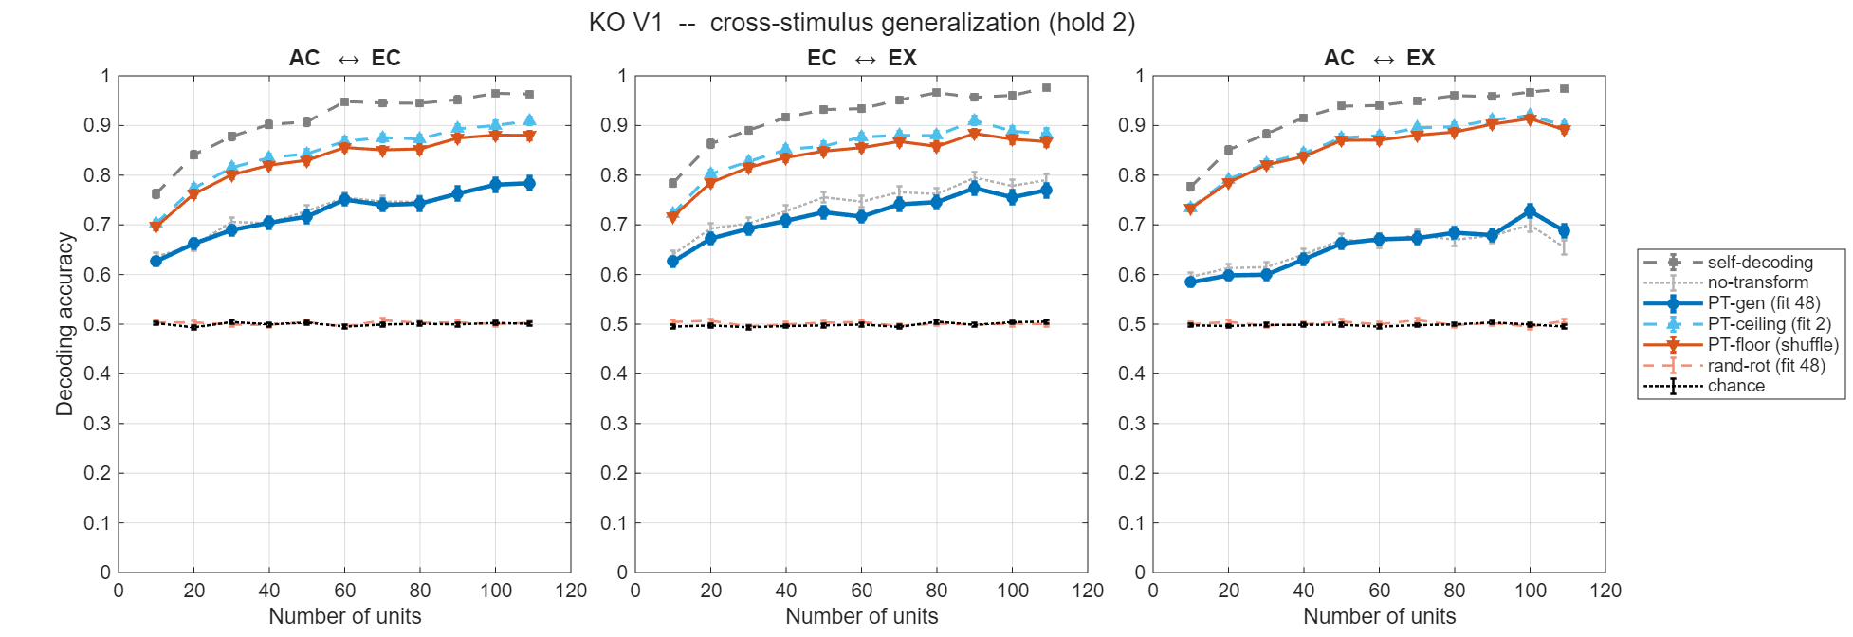
- cross_stim_gen_HoldStim2_KO_V2.png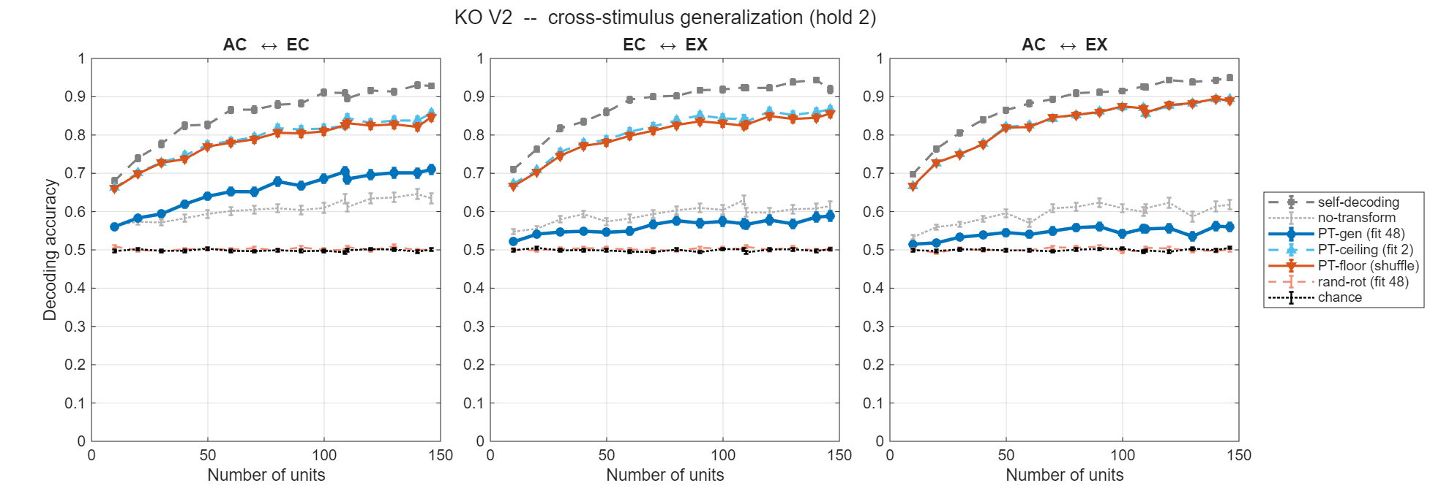

- cross_stim_gen_HoldStim2_FR_V1.png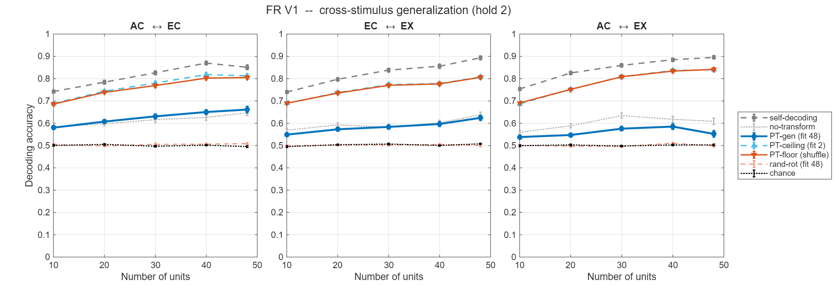

- cross_stim_gen_HoldStim2_FR_V2.png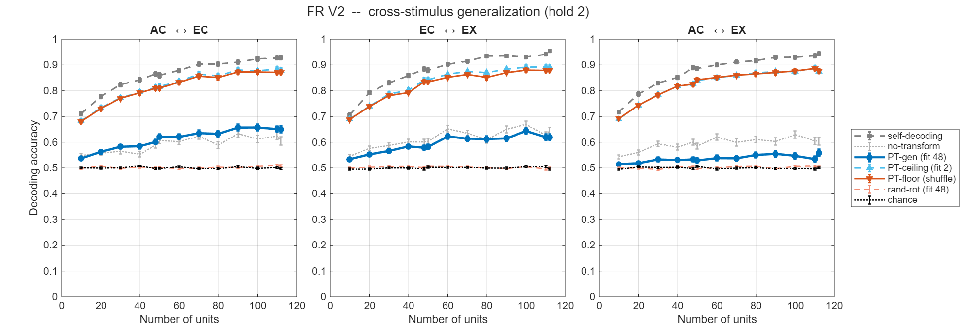

Read each panel in three steps. (i) The reference levels behave as expected, and are not findings. no-transform sits ≈ 0.55–0.65 across pairs and populations — the paper's non-PT cue-transfer, reproduced on 2-stimulus subsets — and self-decode is the within-cue ceiling above it. (ii) The in-sample bracket collapses and rides high — pt-ceiling ≈ pt-floor ≈ 0.66–0.91, tracking self-decode. This is the Point 3 signature reappearing: with only two anchor points and N ≫ 2, a rotation can force essentially any two-point correspondence, so the true-correspondence ceiling and the shuffle floor coincide. The in-sample bracket therefore cannot certify generalization; the meaningful quantity is pt-gen, whose rotation is constrained by the 48-stimulus fit. (iii) The test — pt-gen vs no-transform — is positive only for AC↔EC (pt-gen above no-transform, clearest in KO V2 and FR V2, comparable in KO V1 and FR V1); for EC↔EX pt-gen ≈ no-transform; for AC↔EX pt-gen sits below no-transform in every population.
Conclusion for point 4 Section I: a rotation learned from 48 stimuli generalizes to unseen stimuli, improving two-way cross-rendering decoding over no rotation, only for AC↔EC. The collapsed ceiling/floor bracket confirms the in-sample rotation is degrees-of-freedom-degenerate at this hold-out scale, so the generalizing measure pt-gen, read against the non-PT reference no-transform, is the honest one.

II. Decoder-free: does the rotation place held-out means correctly? (the easier, cleaner version)
Related scripts: procrustes_meancentroid_cross_stimulus_generalization.m; visualization_procrustes_meancentroid_cross_stimulus_generalization.m (all four populations, HoldStim2).
Method: the same 48-fit rotation, but the decoder are removed. After rotating a held-out source mean, does it land nearest its own target mean by Euclidean distance? Two reference sets: GLOBAL (nearest among all 50 target means; chance 1/50) and WITHIN (nearest among only the 2 held-out target means; chance 1/2). Variants: gen (rotation from 48 — the generalization measure), no-transform (raw source mean, no rotation — the raw-correspondence reference, i.e. the non-PT idea with the decoder stripped out), rand (shuffled-correspondence floor). No classifier parameters enter, so nothing here can come from decoder degrees of freedom; GLOBAL also shares the 1/50 chance level of the main analysis, making it the apples-to-apples scale. (In-sample ceiling/floor are omitted: a rotation-only map aligns 2 points near-perfectly whenever N ≥ 2, so they saturate; the constraint lives in the gen rotation, fit on 48.)
Result: Place the four population figures here:
- meancentroid_HoldStim2_KO_V1.png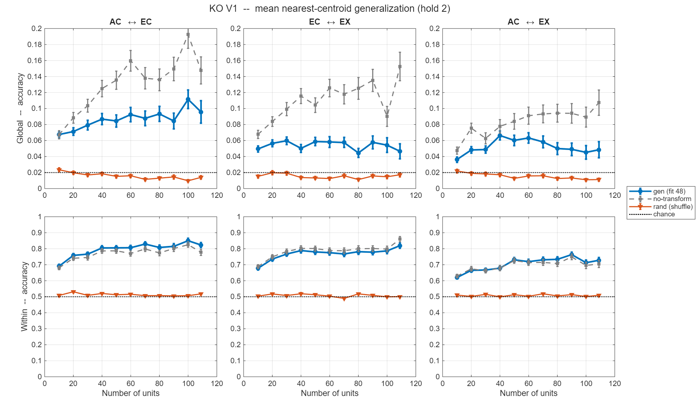

- meancentroid_HoldStim2_KO_V2.png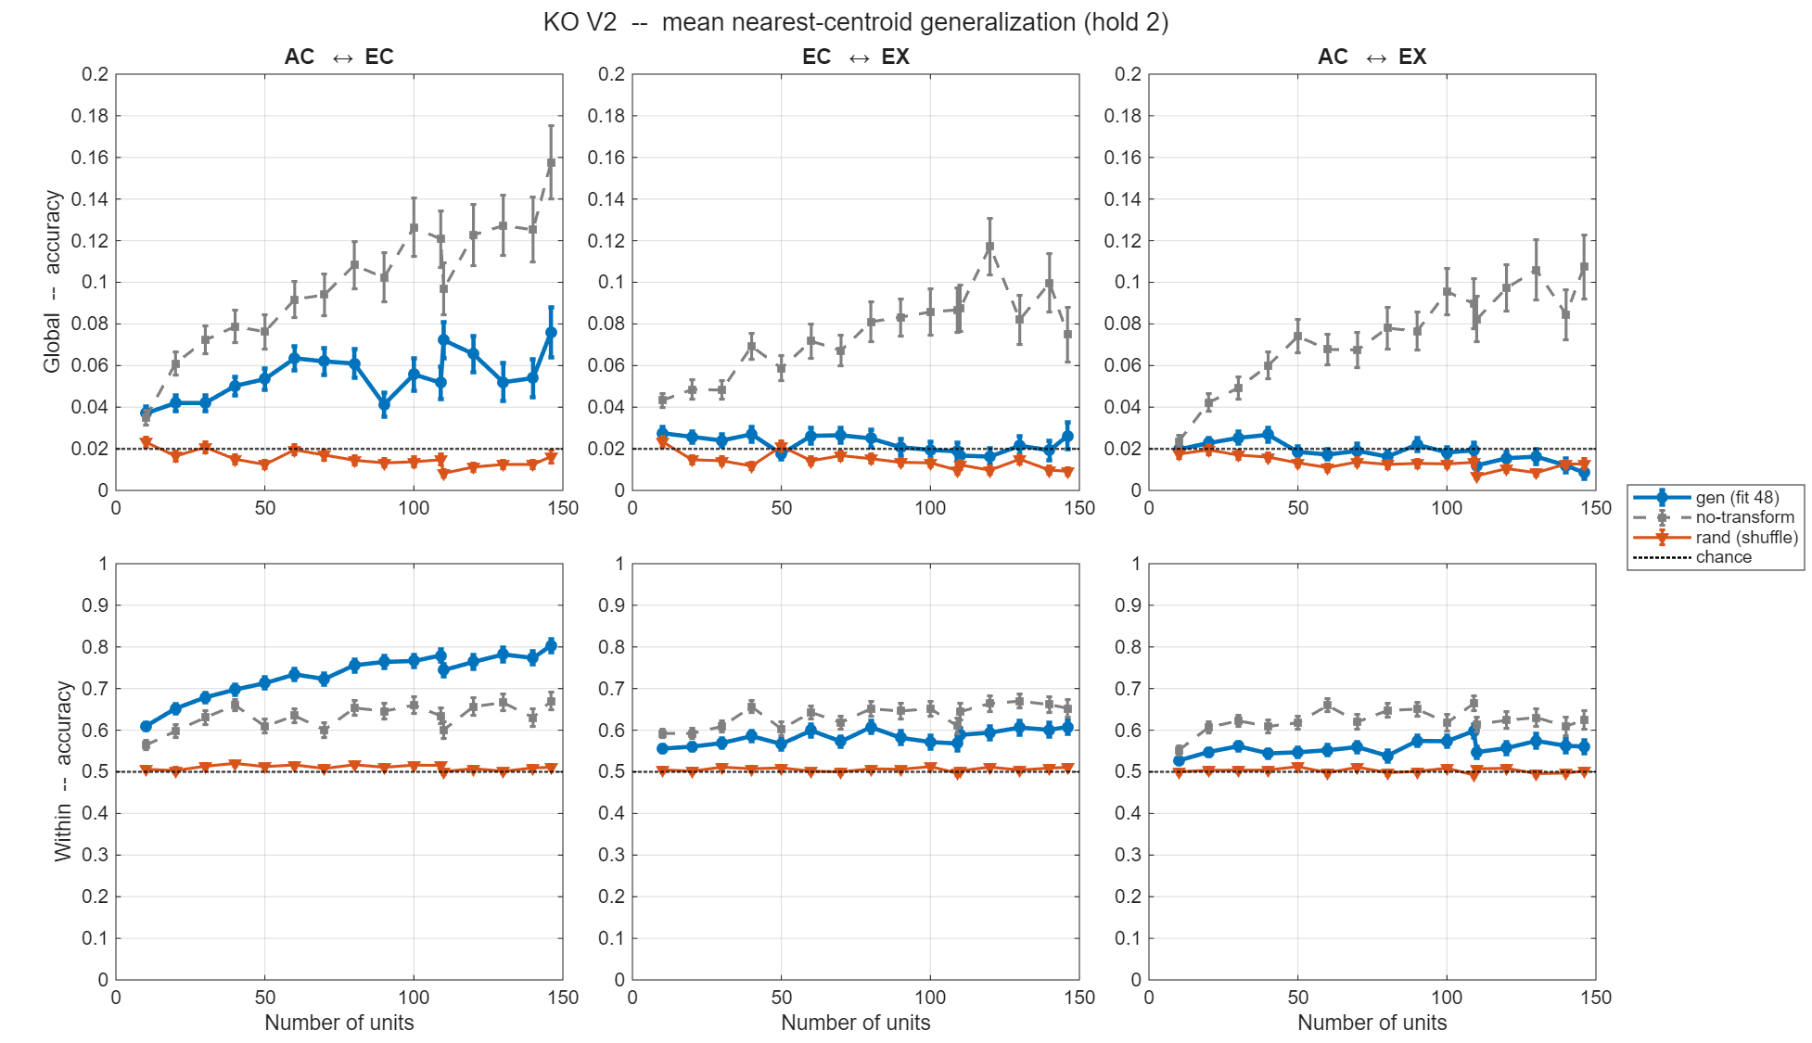

- meancentroid_HoldStim2_FR_V1.png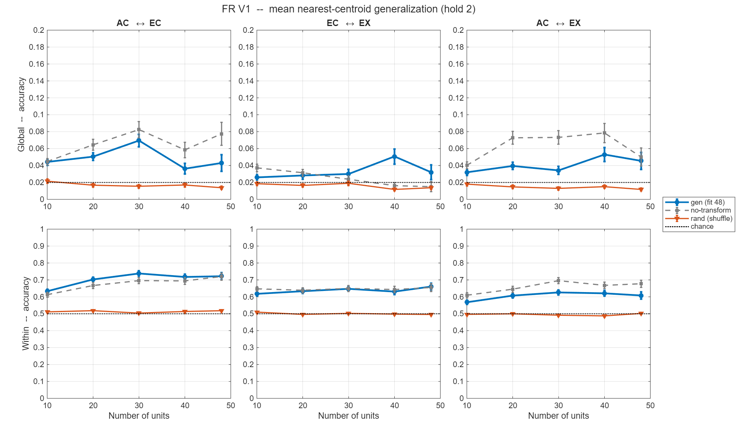

- meancentroid_HoldStim2_FR_V2.png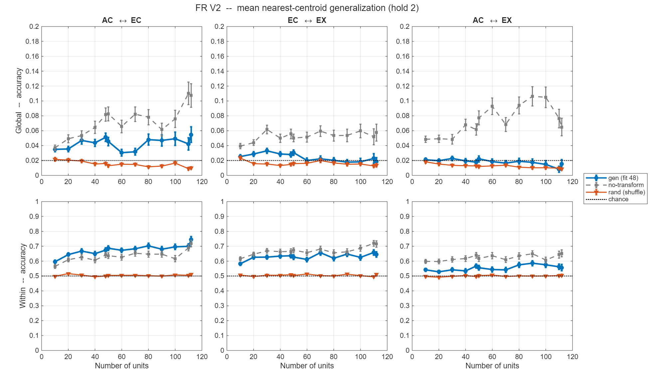
The ordering matches Section I, and the two reference sets separate the story cleanly. In the WITHIN row (chance 0.5, the two-way regime that matches the trial-level decoder) gen and no-transform climb to ≈ 0.55–0.85 while rand stays pinned at chance, and gen exceeds no-transform only for AC↔EC (clearest in KO V2 and FR V2, comparable/tracking in KO V1 and FR V1), is comparable for EC↔EX, and falls below for AC↔EX. In the stringent GLOBAL row (1-in-50) both gen and no-transform clear chance (≈ 0.02) and rise with unit count to ≈ 0.05–0.16, but here no-transform is at or above gen for every pair, including AC↔EC — the generalized rotation does not improve full 1-in-50 placement for any pair. That the decoder-free version reproduces the trial-level ordering shows the effect is a property of the rotation, not of the ECOC; that the AC↔EC gain appears in the two-way WITHIN test but not in 1-in-50 GLOBAL places its size: a local ranking improvement, not a global re-placement.
Conclusion for point 4 Section II: with the decoder removed, a rotation generalized from 48 stimuli improves raw cross-cue placement only for AC↔EC, and only as a two-way ranking gain; on the paper's own 1/50 transfer scale it does not beat no-rotation for any pair. So the PT advantage the main analysis reports on all 50 stimuli is, for held-out stimuli, either absent (EC↔EX, AC↔EX) or small and two-way-only (AC↔EC) — i.e. largely stimulus-specific.

III. Why a generalized rotation can be worse than no rotation
The counter-intuitive number — gen/pt-gen below no-transform (AC↔EX throughout, and gen below no-transform in the GLOBAL placement generally) — has a clean explanation that ties back to Point 3.
no-transform is a strong reference. Because the pseudo-population uses the same units across cues, a stimulus evokes a similar response vector in both, and after z-scoring the true cross-cue map is close to the identity — which is exactly why non-PT decoding is already above chance. A rotation helps only if there is a stimulus-general component that differs from the identity: learnable from some stimuli, valid for others.
When there is none, a rotation fit on other stimuli only adds error out of sample. Each stimulus has two response patterns, one per cue. Because the same neurons record both, the patterns already sit close; the small leftover gap is the residual e_h. No-transform just measures that gap, ‖e_h‖. A rotation applies one correction (learned from the other 48 stimuli) that nudges every pattern by a tilt Δ. It helps only if that nudge points the same way as this stimulus's gap — which requires the gaps across stimuli to share a common direction, since the nudge came from other stimuli. If each stimulus's gap is idiosyncratic, the learned nudge points somewhere unrelated, so you don't close the gap — you just shove the point off in a new wrong direction. That's the Pythagoras line: new distance² ≈ nudge² + gap² > gap². Rotating made it worse. And more free parameters (more neurons) means a bigger, more overfit shove, so a bigger miss on stimuli it never saw. So the sign of (gen − no-transform) tells you whether a real, transferable cross-cue rotation exists: positive → it does (AC↔EC); ~zero → nothing beyond identity (EC↔EX); negative → only overfitting, so it hurts (AC↔EX).
Same degrees-of-freedom story as Point 3, out of sample. There, the rotation's O(N²) freedom lets the in-sample shuffle floor climb to the ceiling; here, that freedom fails to transfer, so the fit-set tilt carries over as pure error and pushes pt-gen past no-transform. In-sample it manufactures fit; out-of-sample, miss — either way the trustworthy evidence is the DOF-free evidence.
Consistency checks. The pair where the rotation generalizes (AC↔EC) is the one Point 2 ranks most cue-invariant (KO V1 z-scored: AC-EC ≈ 0.38 > EC-EX ≈ 0.32 > AC-EX ≈ 0.19); the pair where it hurts (AC↔EX) is the least. This also answers Reviewer 2's worry (Point 10) that AC being a linear component of EX might inflate AC-EX alignment — AC↔EX is empirically the weakest pair, not the tightest.
Conclusion for point 4 Section III: the rotation loses to no rotation exactly where there is no generalizable alignment to learn; a same-neuron population already sits near the identity, so a rotation fit on other stimuli only carries fit-set overfitting onto the held-out ones — the out-of-sample signature of Point 3.

Where this leaves the CCGP comparison (closing). The Bernardi criterion is generalization to items the mapping was not fit on. Our code is 50-way stimulus identity, not a shared dichotomy, so rather than a literal CCGP we hold stimuli out of the rotation fit and ask whether the alignment still places them. It does, cleanly, for AC↔EC (both levels, two-way regime); for EC↔EX and AC↔EX it does not, and on the 1-in-50 scale it does not for any pair. So the PT advantage of the main analysis, where the rotation saw every stimulus, is largely stimulus-specific, not a global manifold property, with AC↔EC the one partial exception.

Reviewer's point 5 – benchmarking PT decoding with varying numbers of neurons and stimuli, through simulations [30% done; designing is done, need to calibrate and redo the simulation]
The decoder that's actually used in this paper is of course a multi-class classifier and from the methods I gather that it's essentially a one hidden layer neural network composed of several linear SVMs, which means that the decision boundaries are more complex and pieced together from the linear decision boundaries of individuals component SVMs. Because this decoder has more parameters, it's not immediately clear if successful cue-transfer decoding puts strong constraints on (the relationship between) the neural representations for two different rendering styles. Whether or not this is the case will likely depend on the ratio between the number of neurons and the number of stimulus classes to be classified. (Fewer classes and more neurons makes it easier for the Procrustes transformation to effectively align the decision boundaries). This needs to be studied systematically before we can draw any conclusions about what cue-transfer decoding really tells us.
A good starting point would be to benchmark the analysis pipeline on artificially generated data sets, where one can vary the number of neurons, the number of stimulus classes, and the statistics of the corresponding neural representations. E.g. one could use a mixture of Gaussians model for the neural representations, where in the simplest case the mean neural representations would be chosen randomly and independently for each stimulus class and each rendering style. (If cue-transfer decoding worked for this model of the representations, we'd conclude that it doesn't imply any special structure for this decoder architecture, so hopefully this can be ruled out). More interestingly, the mean representations could be determined by a linear combination of contour shape parameters (which are the same across different renderings), and rendering style/appearance parameters, which are different. The interesting question will then be which of the models in this family are consistent with the data, and which of them can be ruled out.

Reply to point 5
The framing up front. Point 5 and Point 3 share a backbone, and we keep them consistent rather than repeating. The reviewer's "simplest case," a mixture of Gaussians whose stimulus means are drawn randomly and independently for each stimulus and each rendering, is our null model, and it is presented in full under Point 3 (Section I), where it drives the overfitting demonstration: once the neuron count reaches or exceeds the 50 stimulus classes, transfer decoding of this structureless model already climbs well above the 1/50 baseline, which is precisely the outcome the reviewer hoped could be ruled out and which is not. Here we place that null inside the full family of generative models the reviewer requests, running from no shared structure through progressively richer shared geometry, and we describe the two axes (neuron count and stimulus-class count) along which each model is swept.
Calibration note (governs every number below). Before quoting benchmark values, we flag one open setup issue. In the current runs, we suspect the generative means were not produced with biologically sensible tuning: the per-stimulus modulation is likely too shallow (near-flat tuning), partly because the offset that keeps firing rates non-negative was large relative to the signal and so suppressed tuning depth. Flat tuning places the simulation at the wrong operating point and makes self-decoding, participation ratio, and transfer accuracy hard to compare against the real populations. We will recalibrate the means so that (a) each neuron's tuning across the 50 stimuli is modulated to a realistic depth rather than flattened by the positivity offset, and (b) the resulting within-rendering self-decoding matches the real populations, and we will then rerun every model at that common operating point. All quantitative entries below are placeholders pending this recalibration; only the qualitative roles of the models are settled.
Related scripts: generate_model1_trial_data.m, generate_model3_trial_data.m (generators), procrustes_decoding_simulation.m (shared decoding driver), calibrate_weight_scale.m (tuning-depth / self-decoding calibration).
The generative family (planned versions).
Model 1: independent random means. Each neuron's mean response to each stimulus and each rendering is drawn independently, so no structure is shared across renderings by construction. This is the reviewer's "simplest case" and serves as our null: if transfer decoding succeeds here, success cannot imply shared geometry. It has a high participation ratio. (Built; presented in full under Point 3, Section I.)
Model 2: per-stimulus readout weights. The means are a linear combination of the shared shape parameters, but with readout weights that change for every stimulus. This collapses algebraically to Model 1 and so adds nothing; it is listed only for completeness. (Not run, degenerate.)
Model 3: linear mixed selectivity. The means are a fixed linear readout of two shared shape latents (the contour geometry common to all renderings), with an independent readout per rendering. This is the reviewer's "more interesting" case: genuine shared low-dimensional geometry, rank two, so the participation ratio is near two. Transfer should be real but only partial, because an independent per-rendering readout leaves a general 2×2 map that a similarity transform cannot fully absorb. (Built and run; recalibration pending.)
Model 4: transpose / symmetry variant. The neuron and stimulus roles of Model 3 are swapped. This is redundant with Model 3 by the bilinear symmetry of the readout, and is listed only for completeness. (Not run, redundant.)
Model 5: extra appearance latent for one rendering. Two renderings share the rank-two shape geometry of Model 3; the third additionally reads out a rendering-specific appearance latent. This makes the reviewer's "rendering-style / appearance parameters that differ across renderings" explicit. Transfer between the two matched renderings should work, while transfer to the third should be only partial. It is the one model that uses all three renderings. (Planned.)
Model 6: nonlinear mixed selectivity. The means read out the two shared shape latents plus their product, a shared nonlinear feature. This is the key model: a curved shared manifold whose participation ratio exceeds two while transfer still succeeds, decoupling effective dimensionality from transferability, which is the regime the real data appear to occupy. (Planned.)
The two benchmark sweeps. Each model is run along the two axes the reviewer names. First, the neuron count is swept (currently 10, 50, and 100 for the null), which is what exposes the overfitting threshold: transfer of the structureless null is at chance when neurons are few relative to the 50 classes and rises as the neuron count crosses the class count. Second, the number of stimulus classes is swept with neuron count fixed, so the neuron-to-class ratio (the quantity the reviewer identifies as decisive) is also varied from the other side; this class-count sweep is planned and not yet run. The third axis the reviewer lists, the statistics of the representations, is what the model family itself spans, from the structureless null to the nonlinear shared-geometry model.
How each model is judged against the data. To keep the comparison free of firing-rate confounds, every model is calibrated to the same within-rendering self-decoding as the real populations (rather than to a shared signal amplitude, which is not comparable across models of different rank), and the participation ratio is then left free, since it is one of the quantities being measured. A model is consistent with the data if, at that matched self-decoding, it reproduces both the empirical participation ratio and the empirical margin of transfer decoding over its structure-matched null floor. The expected outcome, to be confirmed after recalibration: the null (Model 1) sits at too high a participation ratio and its transfer is pure overfitting; the linear model (Model 3) sits at too low a participation ratio (near two); the real populations lie between them, around a participation ratio of roughly eight to eleven, which points toward the nonlinear shared-geometry account of Model 6, where dimensionality can rise without transfer being lost. This is the reviewer's "which models are consistent with the data, and which can be ruled out" question, cast as a matched-self, participation-ratio comparison.

Reviewer's point 6 – functional and computational significance of the rotational structure; how is it implemented and utilized in the brain [a discussion point; ~70% done]
Other considerations the authors might want to expand on are how the brain could actually take advantage of their notion of "cue-invariance" if it indeed holds up, i.e., what would be the computational advantages (compared to say just using orthogonal subspaces for contour shape and rendering style), and how could this actually be achieved from the perspective of higher visual areas? Do the authors believe that a downstream readout can rotate the neural representation dynamically depending on the rendering style to read out the contour shapes of the stimuli? One wonders how this would be implemented in a network, especially given that rendering style is probably not discrete variable, but a multi-dimensional continuum, and each point in this style-space could correspond to a different rotation. Furthermore, the data preprocessing involves z-scoring of the representations (separately for the different rendering styles?), so this would probably also have to implemented by the readout system if the brain was to take advantage of the structure of representation implied by cue-transfer decoding.

Reply to point 6
The framing up front. This is largely a Discussion point, and we treat it as one. But it is not a point on which we have nothing: four analyses already in the revision constrain how a downstream area could exploit the structure, and one of them (the z-scoring runs) speaks to the reviewer's normalization worry directly. Two clarifications set up the comparison the reviewer asks for. First, an orthogonal-subspace code (contour shape in one subspace, rendering style in an orthogonal one, read by a single fixed shape-decoder that ignores rendering) is the stronger, cleaner form of invariance; it is a hypothesis about an ideally disentangled code, whereas our measurements describe what V1 and V2 actually contain. Second, our data do not show that clean factorization: the shape geometry is preserved across renderings only partially and only up to a low-dimensional transformation (Point 2: cross-rendering correlations of roughly 0.19 to 0.38, well below the within-condition ceiling of about 0.9). The renderings' shape geometries are therefore similar-but-rotated, not co-located in one shared subspace. So the honest question is not why a brain would prefer a rotation over orthogonal subspaces, but this: given that early cortex delivers a shared-but-transformed geometry rather than a disentangled one, how expensive is it for a downstream area to use it, and what does it buy over doing nothing? The payoff of a shared-but-rotated code, relative to dedicating orthogonal capacity per rendering, is efficiency and metric reuse. The same handful of population dimensions carry shape in every rendering rather than three times that many, and the relational structure (pairwise distances and angles) is reused across renderings up to one low-dimensional correction, which is exactly the quantity Point 2 shows is partially preserved. The four pieces below then bound the implementation cost of that correction.
1. The transformation a readout must undo is low-dimensional, not an N×N rotation. The signal geometry is confined to a small subspace: participation ratio saturates around 8 to 11 for all four populations against a theoretical cap of 49 (ND/results/figures/incremental_pr/fig1_accuracy_pr_vs_N.png, fig5_saturation_four_views.png), and the cumulative signal spectrum (visualization_variance_vs_pc.m) confirms the geometry is carried by roughly this many dimensions. The PC-sweep of Point 3 (procrustes_decoding_basic_incremental_pc.m) shows the alignment survives at small retained k, with its null-relative margin peaking near k ≈ 5 to 8. Implication for the brain: a downstream reader is not learning a rotation of the full N-neuron space. The alignment lives in a roughly 10-dimensional subspace, so the object to be rotated is about ten latent axes, a handful of parameters rather than thousands. This is the single most important constraint, because it converts the reviewer's "N×N matrix per rendering" worry into "a low-D rotation per rendering."
2. Where the alignment holds, it is a global property of the manifold, not a per-stimulus fix. A rotation that had to be re-fit for each stimulus would be biologically useless. The cross-stimulus generalization analysis of Point 4 tests exactly this: fit the rotation on 48 stimuli, then apply it to 2 it never saw. For AC↔EC the rotation places the held-out stimuli correctly, so a single fixed map for that rendering pair suffices across the manifold. We stay candid here, consistent with the Point 4 conclusion: for EC↔EX and AC↔EX the alignment is largely stimulus-specific, and on the full 1-in-50 scale it does not generalize for any pair. So the "fixed per-pair readout" story is supported for AC↔EC and not established for the others. The point for Point 6 is that the mechanism it implies, a fixed readout rather than a stimulus-conditioned one, is realized in at least one rendering pair and is the correct thing to test for.
Related scripts: procrustes_decoding_cross_stimulus_generalization.m, procrustes_meancentroid_cross_stimulus_generalization.m (Point 4).
3. The alignment is distributed across the population, not tied to specific neurons, though this piece needs a valid floor to carry weight. Within a rendering, a Procrustes map fit between two disjoint neuron halves still decodes stimulus identity (procrustes_decoding_half_and_half_populations.m and _incremental); across renderings, transfer survives permuting neuron correspondence (procrustes_decoding_neuron_shuffled.m). Naively both suggest a redundant, distributed code a subspace-pooling readout could access.
Caveat (vs Point 3). Both use the free-fit rotation Point 3 showed can manufacture alignment. Half-and-half is overparameterized in the KO half-space (54 dims, 50 anchors) and its built-in null is the discredited control, so it currently has no valid floor. Neuron-shuffle survival is near-automatic: a consistent permutation is orthogonal and the rotation absorbs it, so it tests a property of Procrustes, not the biology.
Fix. The clean, DOF-free version, matching Point 2: split the neurons, build each half's distance and angle matrices, and correlate across halves with no rotation. A positive half-to-half geometry correlation is direct evidence of redundant distributed coding. Until then, treat this piece as plausibility and rest the claim on the transformation-free measures.
4. A cortical hierarchy is the kind of system that can implement this, and the alignment is recoverable across the hierarchy. For the reviewer's "how could a higher area do this," the cross-area analysis fits and tests the rotation across the V1→V2 step (procrustes_decoding_across_area.m; figures ND/results/figures/{FR,KO} across area decoding.png), and the ANN analogue reproduces it in a feedforward network with feedback (ANN/code/decoding_scripts/procrustes_ann_decoding_along_hierarchy.m; ANN/results/figures/ALEXNET pool 2&5 feedforward and feedback decoding.png). The transformation is therefore not something a special-purpose circuit must invent; it is recoverable across an ordinary feedforward-plus-feedback hierarchy, which is a plausible substrate for a higher area to apply it.
On rendering style as a continuum. This is the reviewer's sharpest point, and we do not overclaim on it. Three considerations bound it. (i) We measured only three discrete renderings, so we cannot speak directly to interpolation across a style continuum, and we say so. (ii) Because the same neurons carry all three renderings, each stimulus already evokes a similar vector in each, so the two representations sit close to the identity and the fitted rotation is a small tilt away from it rather than a wholesale re-basis (this is the mechanism made explicit in Point 4, Section III). A continuum of such small tilts is a low-dimensional, smoothly parameterized family, the kind of thing a gain field or a gating variable could index, not a lookup table of unrelated high-dimensional rotations. (iii) Combining points 1 and 2: the transformation is low-dimensional and, where it holds, largely stimulus-general, so the continuum concern reduces to interpolating a low-D rotation as a smooth function of a rendering-style variable, not to storing a distinct rotation per stimulus. We offer this as a hypothesis the data are consistent with, not a demonstrated mechanism.
On the z-scoring sub-question. What the pipeline does: geometric_metrics_basic.m runs raw, zscore, and pt normalizations side by side, and the z-score is per-neuron applied within each rendering's own trial matrix, so it is done separately for each rendering style, as the reviewer surmised. Two honest points follow. First, per-neuron variance or gain normalization is not an exotic operation to attribute to a readout: divisive normalization and adaptation already implement something like a standing per-neuron gain control in cortex, so this need not be an explicit, rendering-labeled z-score that the readout computes on the fly. Second, and this is the candid part, the shared geometry is substantially weaker without normalization: for pairwise distance the raw cross-rendering correlation is only about 0.06 to 0.11, against roughly 0.19 to 0.38 once z-scored (Point 2). So the reported invariance does lean on normalization, and a reader that did not normalize would recover much less of it. Whether cortex's native normalization is sufficient for this purpose is an open question we cannot settle with these data, and we present it as such.

Reviewer's point 7 - pseudo-population limitation on the discovered structures and its implications on real population [~90% done; if we should check the rotation matrix]
Another subtle point in the analysis that requires careful considerations is that the neurons in the data set were presumably not simultaneously recorded. This means we actually have limited information about the correlations between neurons, which will probably affect the statistical power to draw conclusions about the structure of neural representation from successful transfer decoding (i.e. for ruling out certain models of representations), which needs to be studied. It will also affect the types of rotations found in the actual data analysis. E.g. one may find a block-diagonal structure in the fit rotation matrices corresponding to the sets of simultaneously recorded neurons.

Reply to point 7
The framing up front. The reviewer raises two consequences of building pseudo-populations from non-simultaneous recordings: (a) with limited access to real noise correlations (NC), our power to draw conclusions about representational structure — including ruling out models — is reduced; and (b) the type of rotation recovered may be affected, e.g. a block-diagonal structure in the fitted Procrustes matrices tied to sets of simultaneously recorded neurons. We agree the pseudo-population discards cross-session NC by construction, and we address both prongs directly. The logic that bounds the concern is the same one used in Point 2, Section II: the cue-invariant geometry is a trial-averaged quantity, and NC is a property of trial-to-trial covariation, so missing NC cannot touch the mean-level geometry — it can only affect single-trial decoding and the reliability of estimates. We therefore (I) measure how much NC actually exists and how it distributes across the pseudo-population, (II) remove it and re-run transfer decoding on the full pseudo-population, and — the test that actually answers the reviewer — (III) re-run transfer decoding on the genuine simultaneously recorded single-session populations, where NC is real. The rotation-structure sub-question is taken up in (IV). Two neighboring analyses are cross-referenced rather than repeated here: the geometry-level NC control is Point 2 Section II, and the injected-NC robustness simulation (Reviewer 2's mean r = 0.05–0.15) together with the model-discrimination question live in Points 8 and 5.
I. Noise correlation is real within a session but modest in the pseudo-population (cross-session)
Related scripts: noise_correlation_analysis.m (random-shuffle route, 100 iterations), noise_correlation_analysis_affine.m (deterministic affine route). These are two decorrelation controls that compute the same thing and reach the same conclusion; the affine route is the one to lead with and the shuffle route corroborates it.
Method: for every neuron pair we compute, at each of the 50 stimuli, the Pearson correlation of the two neurons' spike counts across the 10 trial repeats — this is the noise correlation, the trial-to-trial covariation with the stimulus held fixed. Each pair is then summarized by the mean and the variance of its 50 per-stimulus correlations, and tagged same-session or cross-session from the recording metadata. Decorrelation uses the same deterministic affine trial-cycling shift as the decoding controls (a per-neuron cyclic reorder of the 10 trials, keyed to the recording session), which preserves each neuron's marginal response distribution exactly and destroys only trial-aligned cross-neuron covariation; the random-shuffle route independently permutes the 10 trials 100 times as a check. We show KO V1 as the example; the other three populations are described in text.
The per-rendering scatter (one panel per rendering; KO V1 AC shown as the example).
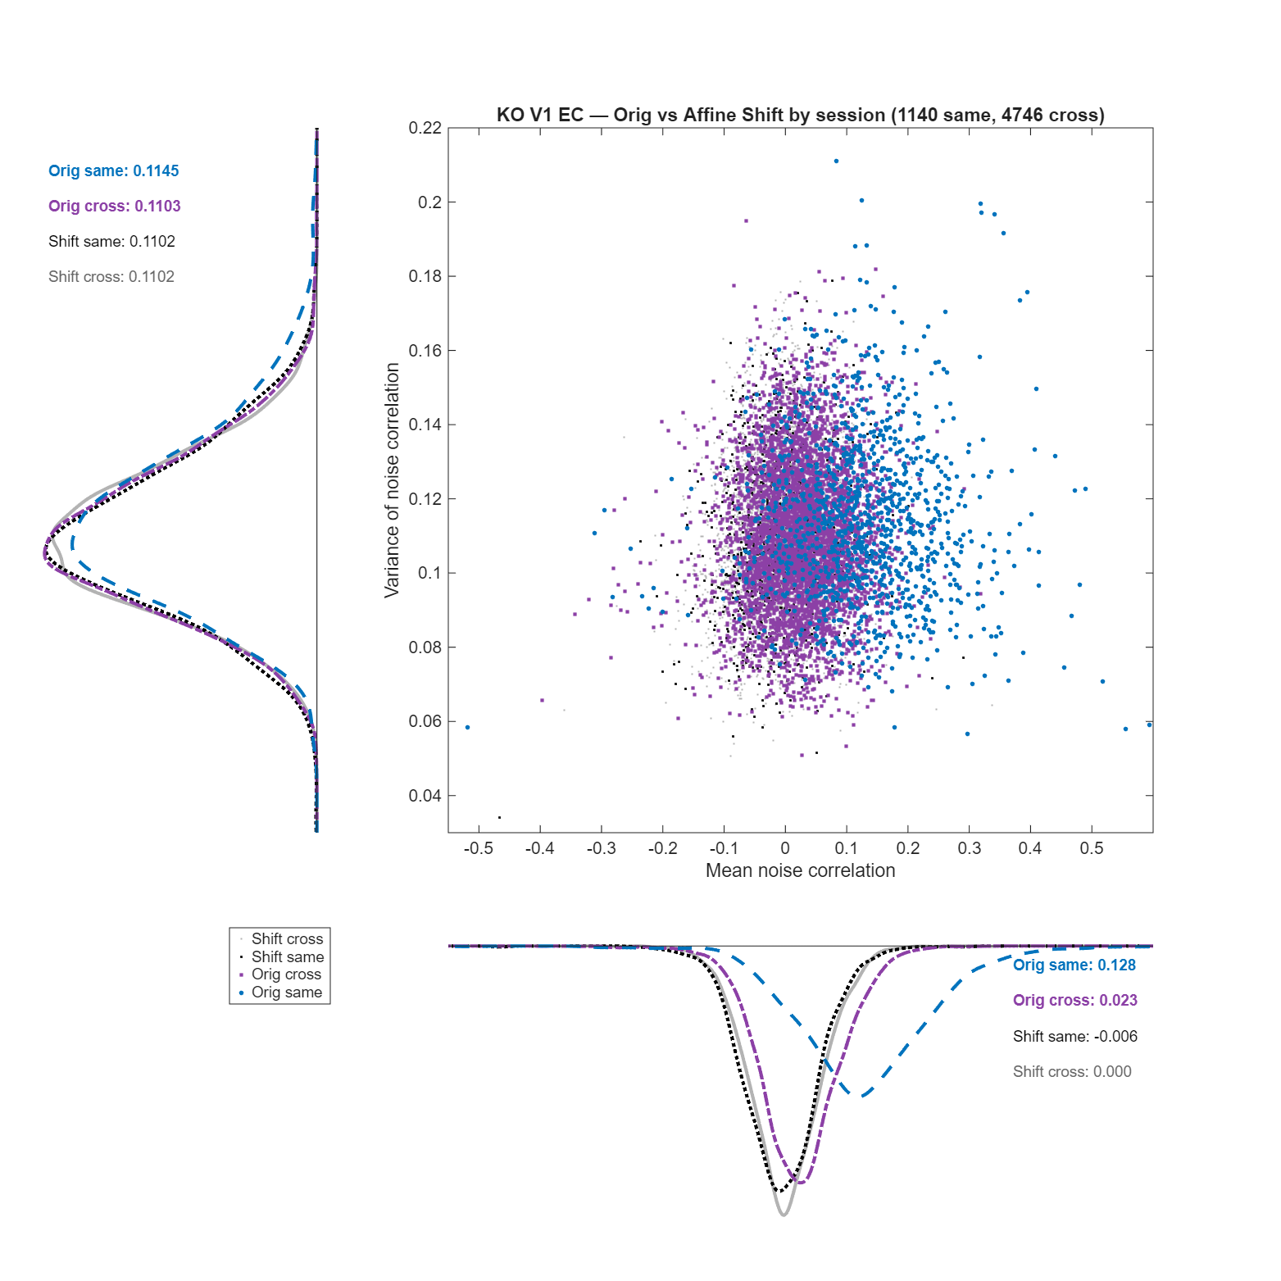
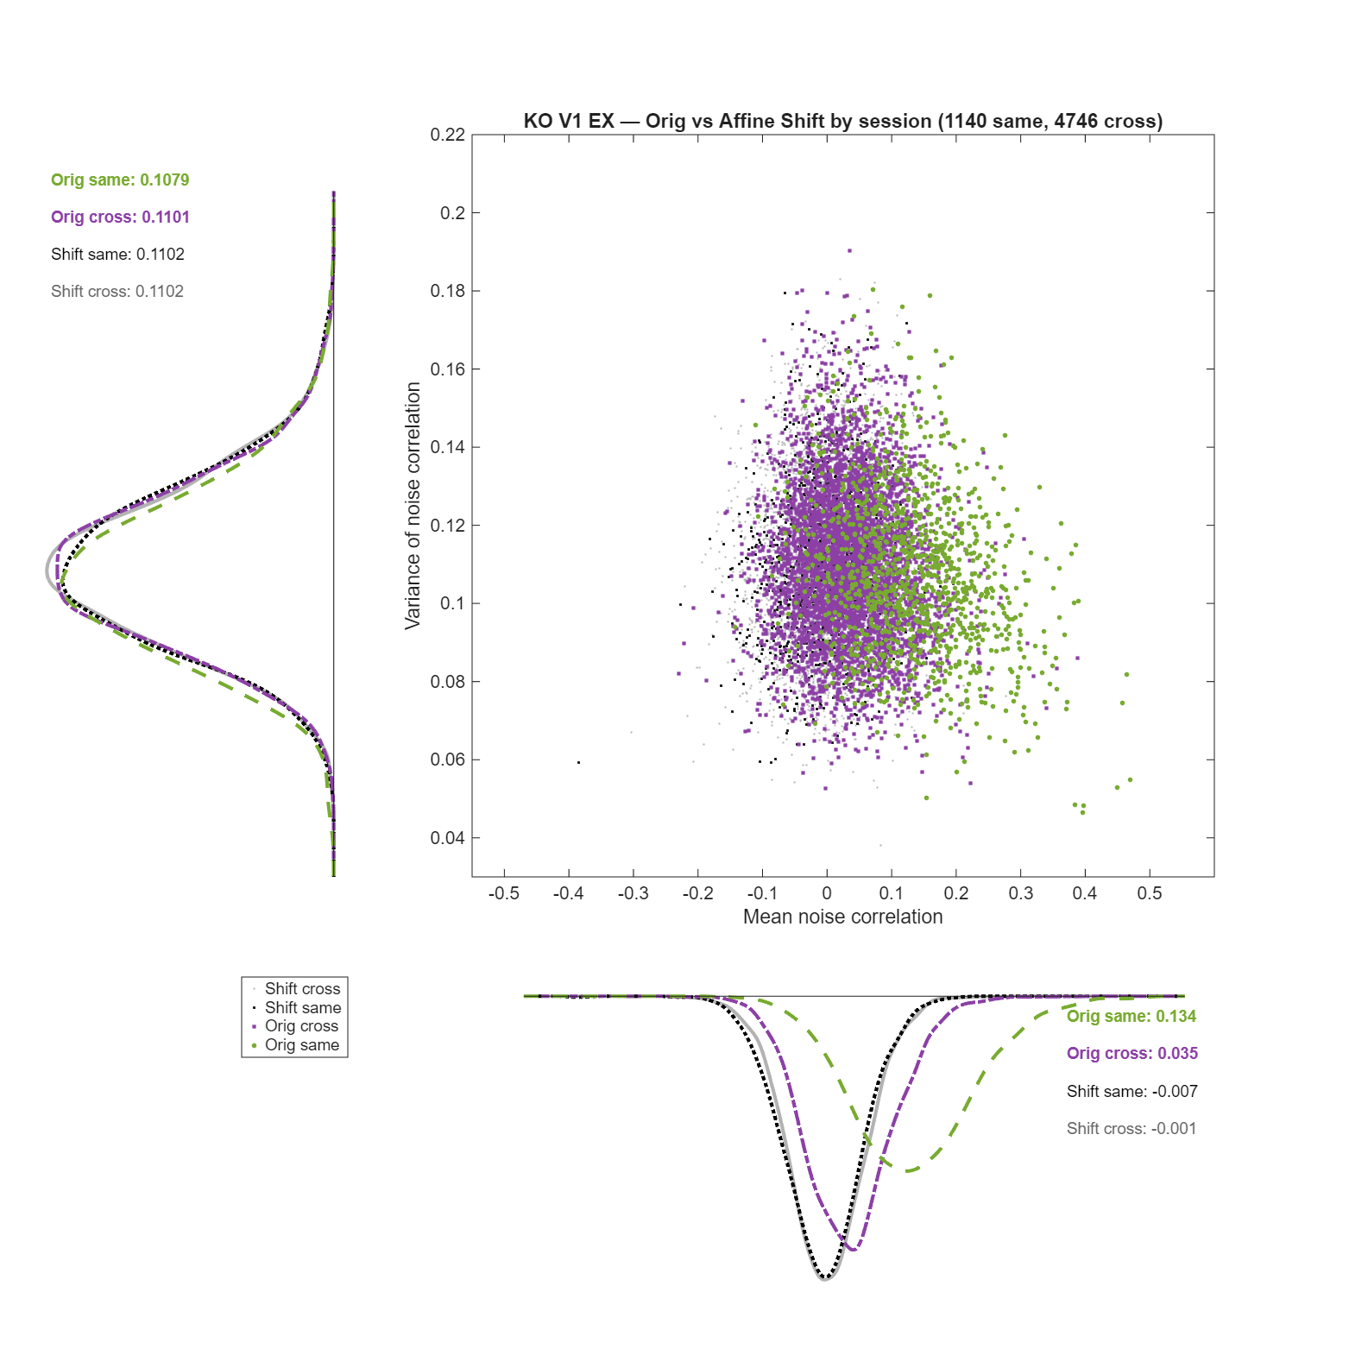
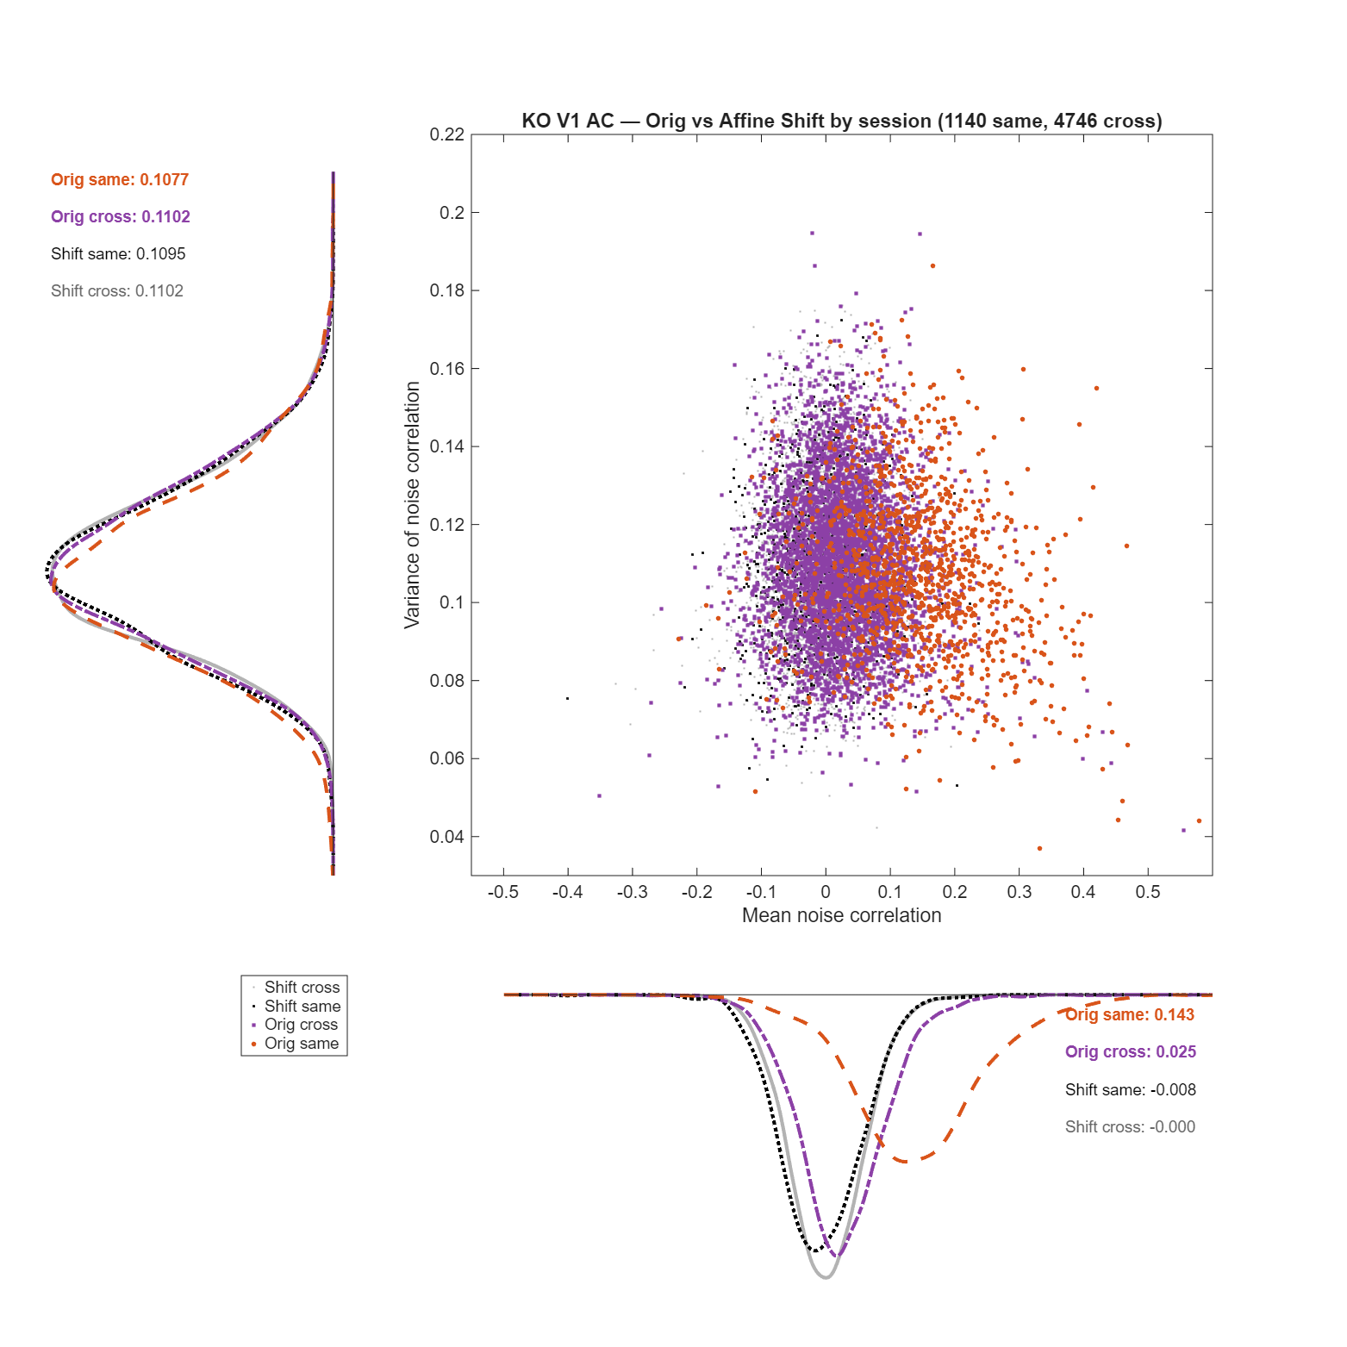
Take the AC figure as an example; each dot is one neuron pair, placed by its mean noise correlation across the 50 stimuli (x) and the variance of that correlation across stimuli (y); the two side panels are the marginal densities of those quantities. The legend crosses two factors — original vs affine-shifted, and same-session vs cross-session — giving four groups: Orig same (orange), Orig cross (purple), Shift same (black), Shift cross (gray). The bottom marginal, the mean noise correlation, carries the result: the original same-session pairs sit clearly to the right, centered at 0.143, while the original cross-session pairs already hug zero at 0.025, and after the affine shift both distributions collapse onto zero (shift same −0.008, shift cross −0.000). The left marginal, the variance of the correlation, tells the complementary story — all four groups are essentially identical at ≈ 0.108–0.110 — meaning the shift moves the center of the correlation to zero without changing the stimulus-to-stimulus scatter of the estimates, exactly what a manipulation that preserves single-neuron marginals and breaks only cross-neuron alignment should do. The EC and EX panels alongside are the same picture, with original same-session means of 0.128 and 0.134 (cross 0.023 and 0.035) collapsing likewise to ≈ 0 after the shift.

The 3-panel summary across renderings (the clearest single view).
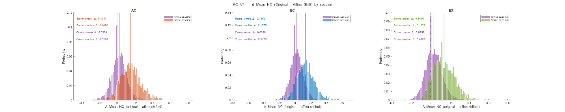
This collapses the three renderings into one figure: each panel histograms the per-pair amount of correlation removed, Δ mean NC = original − affine-shifted, split into same-session (colored) and cross-session (purple). In every rendering the same-session histogram is centered well to the right — mean Δ 0.151 (AC), 0.134 (EC), 0.141 (EX) — while the cross-session histogram sits against zero — mean Δ 0.025, 0.023, 0.036. So the correlation the shift strips out lives almost entirely in the same-session pairs; the cross-session pairs had almost nothing to remove.
Result (populations). Only 1,140 of KO V1's 5,886 pairs (≈ 19%) are same-session, so the pseudo-population is dominated by the ≈ 81% cross-session pairs that carry ≈ 0.02–0.03 to begin with. The pattern holds across all four populations: same-session mean NC ranges ≈ 0.11–0.20 (FR V1 highest at 0.15–0.20, FR V2 lowest at 0.11–0.13, KO V2 ≈ 0.14), cross-session ≈ 0.01–0.04, and decorrelation drives the same-session value to ≈ 0 in every population. The random-shuffle route (.../random_trial_shuffle/nc_random_KO_V1/...delta_mean_nc_by_session.png, on disk for all four populations) reproduces this to within rounding.
Conclusion for point 7 Section I: real, structured noise correlation exists in simultaneously recorded pairs (≈ 0.13, up to ≈ 0.20 in FR V1), squarely in the r = 0.05–0.15 range Reviewer 2 cites. Because it is concentrated in the ≈ one-fifth of pairs that are same-session, its dilution across the full pseudo-population leaves a modest population-average correlation of ≈ 0.03–0.05 (FR V1 0.054, KO V1 0.049, KO V2 0.035, FR V2 0.026) — real, but roughly a third of the same-session value and at or below the low end of the reviewer's range. So the pseudo-population is not correlation-free; it carries a modest population-level noise correlation, concentrated in same-session pairs, and it is precisely this residual whose removal 7b tests directly.
II. Decorrelated transfer decoding on the full pseudo-population
Related scripts: procrustes_decoding_trial_perturbed.m (affine mode), baseline procrustes_decoding_basic.m (the identical pipeline with no perturbation).
Method: apply the affine shift to the full pseudo-population, then re-run the complete PT pipeline (rotation-only Procrustes on the 50 stimulus means, held-out single-trial transfer decoding), and compare against the un-perturbed baseline. Self-decoding (column 1) and rotation-only PT (column 6) are read in each mode. (The pseudo-population decoder samples a fixed neuron count, matched across areas, in both modes, so the affine−none contrast is a fair within-area comparison.)
trial_affine_shifted_PT_decoding
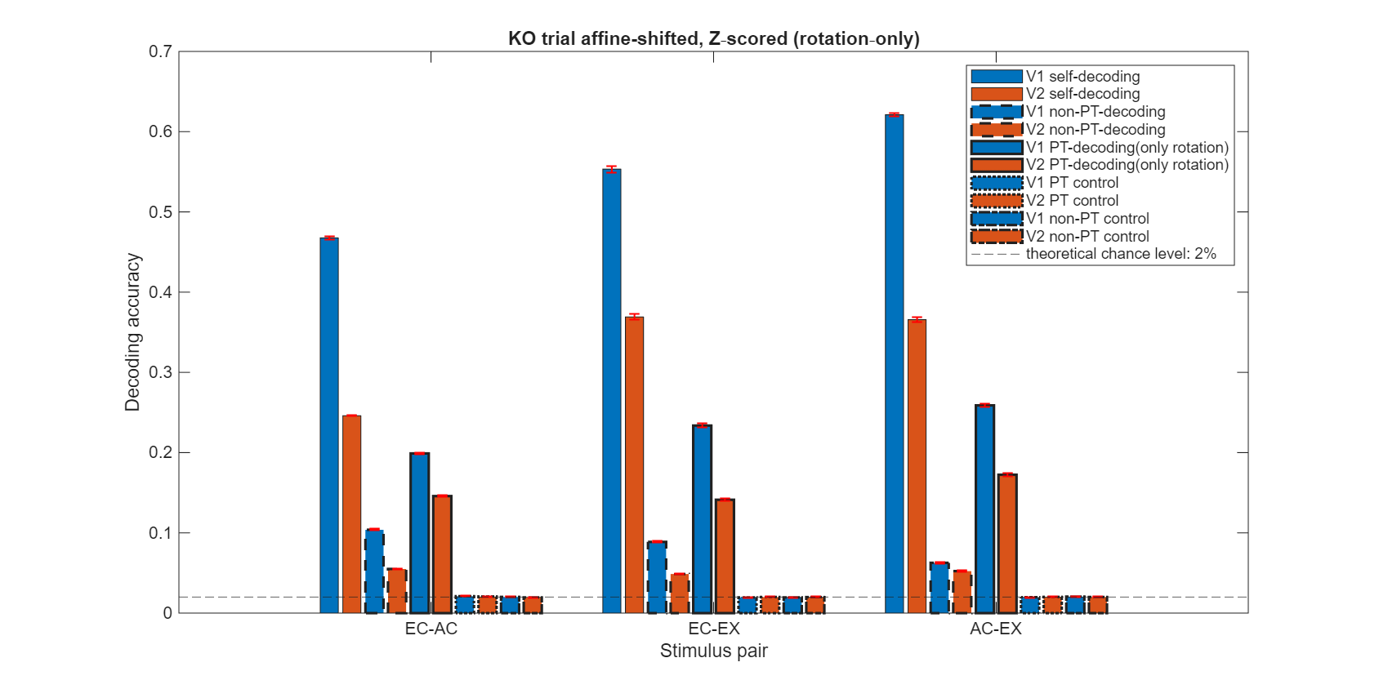
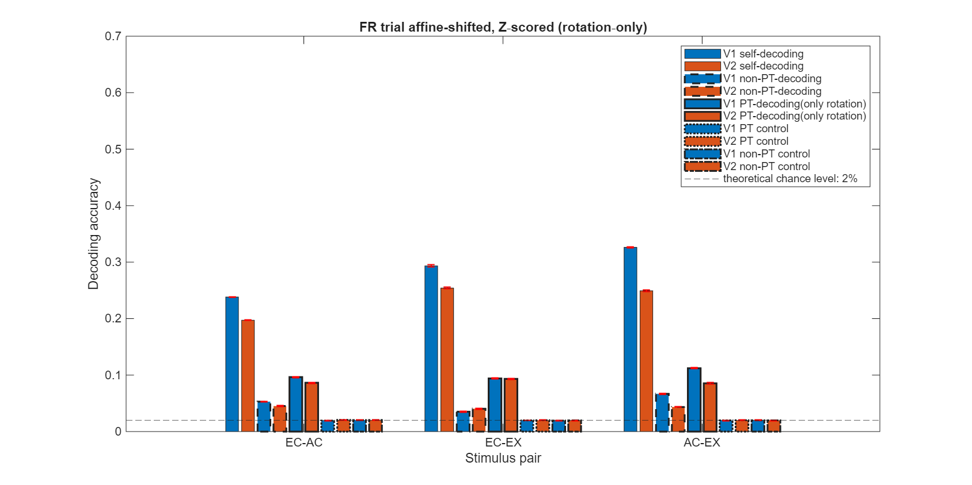
In comparison with original decoding:
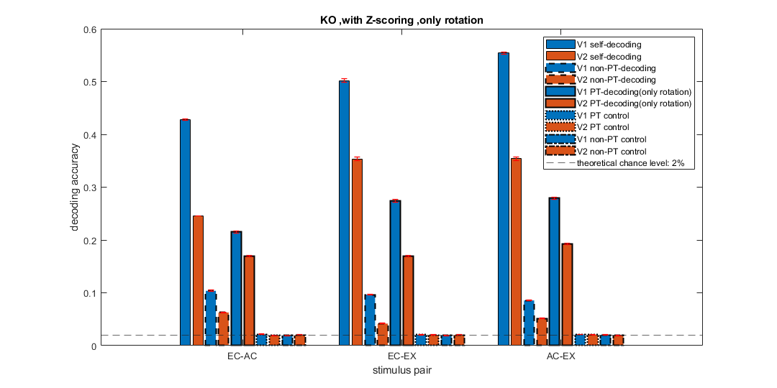
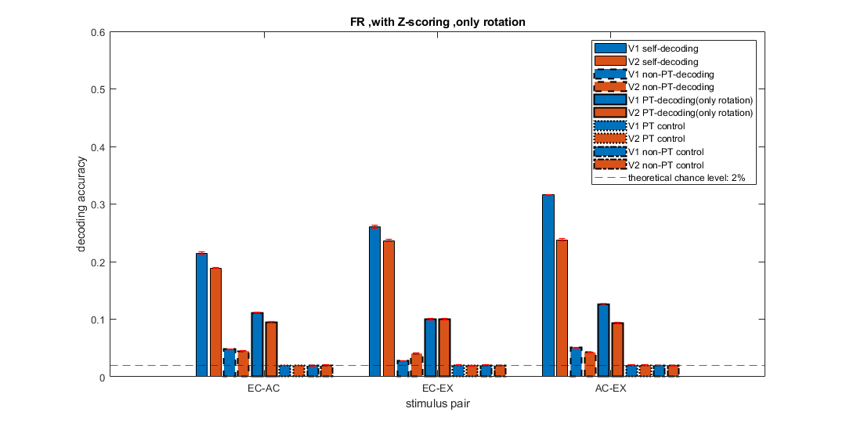
Result: removing NC moves self-decoding up and rotation-only PT slightly down, and the direction is uniform across all four populations and all three rendering pairs (self rises in 12/12 population × pair cells, PT-rot falls in 12/12). KO V1 EC-AC is the clearest: self 0.43 → 0.47, rotation-PT 0.22 → 0.20. The magnitudes are small — self Δ ranges +0.001 to +0.067 and rotation-PT Δ −0.006 to −0.040, with KO V1 largest and FR V2 smallest (FR shown on disk as FR_trial_perturbed_decoding.png). Mechanistically, this is what one expects: stripping shared trial-to-trial covariation makes the 50 classes marginally more separable (self up) while removing the covariation the fitted rotation could exploit (PT down), but rotation-PT stays far above the 2% chance floor in every case.
Conclusion for point 7 Section II: on the full pseudo-population, removing NC does not overturn the transfer-decoding result — it nudges self up and PT down by small amounts, leaving the qualitative geometry finding intact. But this is still a pseudo-population, so it is the reference point, not the answer.

III. Decorrelated transfer decoding on the real single-session populations (the load-bearing test)
Related scripts: procrustes_decoding_per_session.m; visualization_procrustes_decoding_per_session.m; visualization_procrustes_decoding_per_session_distribution_test.m.
Method: this is the analysis that actually answers the reviewer, because it uses genuine simultaneous recordings. The pseudo-population is sliced back into its constituent single sessions (5 sessions for V1, 7 for V2; ≈ 5–15 neurons each), with no neuron downsampling, and the full PT pipeline is run per session with and without the affine shift — so the "none" condition preserves each session's real noise correlation. We show KO throughout (FR equivalents on disk), building from the raw per-session accuracies to the pooled test.
The raw per-session curves, correlations preserved vs broken.
procrustes_decoding_per_session/KO/procrustes_decoding_per_session_KO_none.png (none — real NC preserved)
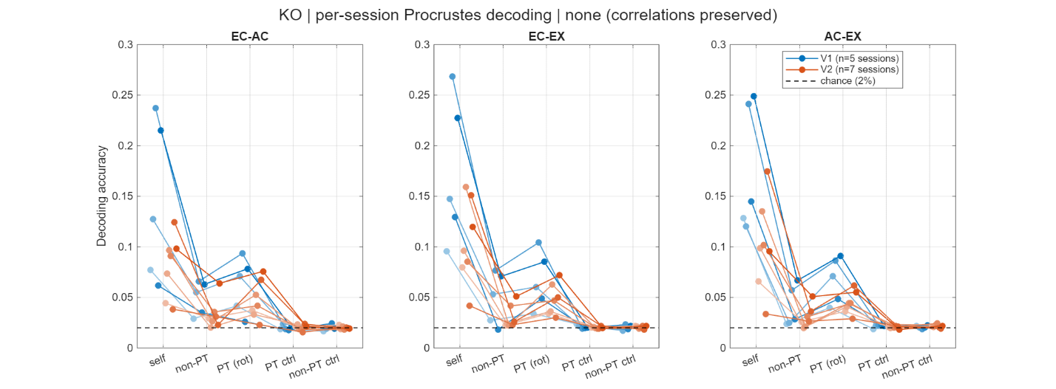
procrustes_decoding_per_session/KO/procrustes_decoding_per_session_KO_affine.png (affine — within-session NC broken)
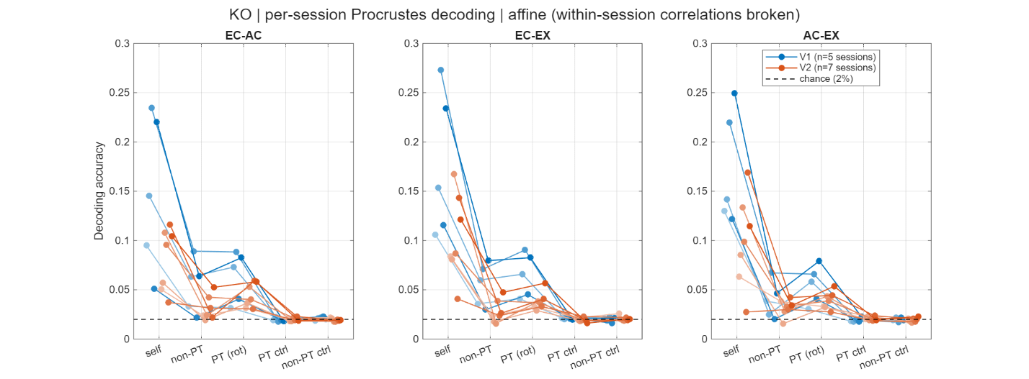
Three panels (EC-AC, EC-EX, AC-EX); within each, every session is one line traced across the five decoding types (self, non-PT, PT rot, PT ctrl, non-PT ctrl), V1 blue (5 sessions) and V2 orange (7), shaded by session index. Two things read off directly. First, the geometry signal is present even in these tiny single-session populations: self-decoding is well above the 2% chance line (up to ≈ 0.23–0.27 in the strongest V1 sessions, ≈ 0.05–0.15 typically), rotation-only PT sits above its two controls — PT ctrl and non-PT ctrl, both pinned at chance — and generally at or a touch above non-PT, so the per-session ordering matches the main analysis at ≈ 5–15 neurons. Second, and the point of the comparison, the none and affine panels are nearly indistinguishable: removing each session's real noise correlation barely moves the curves.
The difference, made explicit.
procrustes_decoding_per_session/KO/procrustes_decoding_per_session_KO_delta.png (Δ = affine − none)
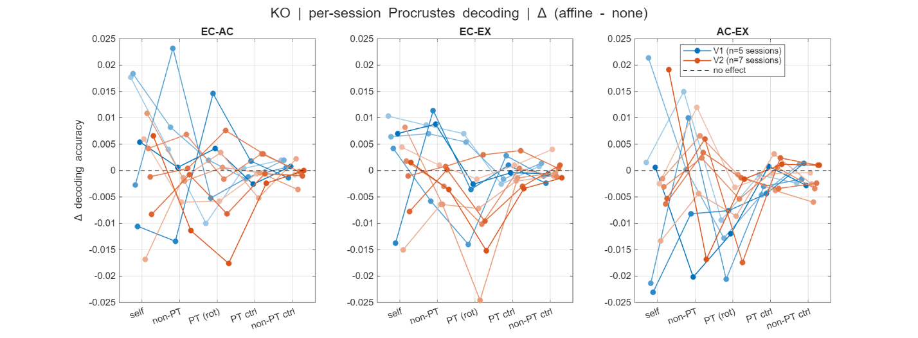
Re-plotting affine minus none per session collapses the y-axis to ± 0.025 and shows the effect is both tiny and non-unidirectional: for every decoding type the session lines straddle the "no effect" line, some above and some below, with no consistent sign. The clean up-self / down-PT direction of the pooled pseudo-population (Section II) is simply not visible session by session. (A self-vs-PT scatter per session is also on disk as ..._KO_self_vs_pt.png.)
The per-cell test (granular, but pseudoreplicated).
procrustes_decoding_per_session/KO/procrustes_decoding_per_session_KO_norm_delta.png (per-cell Mann-Whitney AUC = P(affine > none) − 0.5)
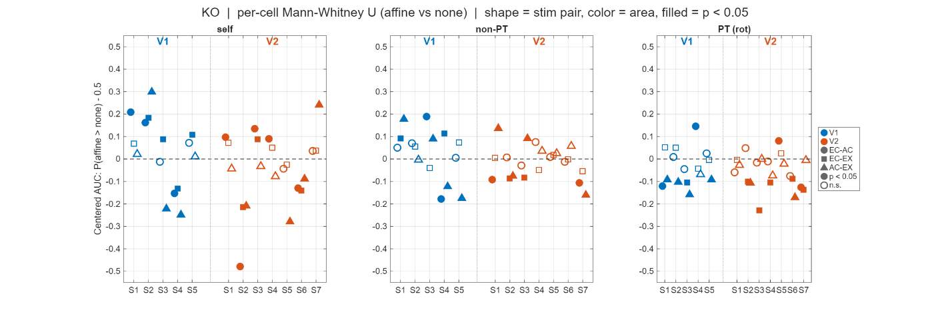
One marker per (session, stim pair, decoding type): shape = stim pair, color = area, filled = within-cell p < 0.05. Markers scatter above and below zero; in the PT-rot panel the KO points lean negative (affine < none, in the direction Section II would predict), but many are n.s., and — crucially — each cell's test compares non-independent within-session resamples, so a filled marker reflects resampling precision, not a biological effect. This is exactly why we do not count filled markers and instead rely on the session-as-unit test below.
The honest, session-as-unit test (load-bearing).
procrustes_decoding_per_session/KO/procrustes_decoding_per_session_pooled_pairs.png (pooled Wilcoxon, FR and KO, both areas — the same figure is saved under FR/ and KO/)
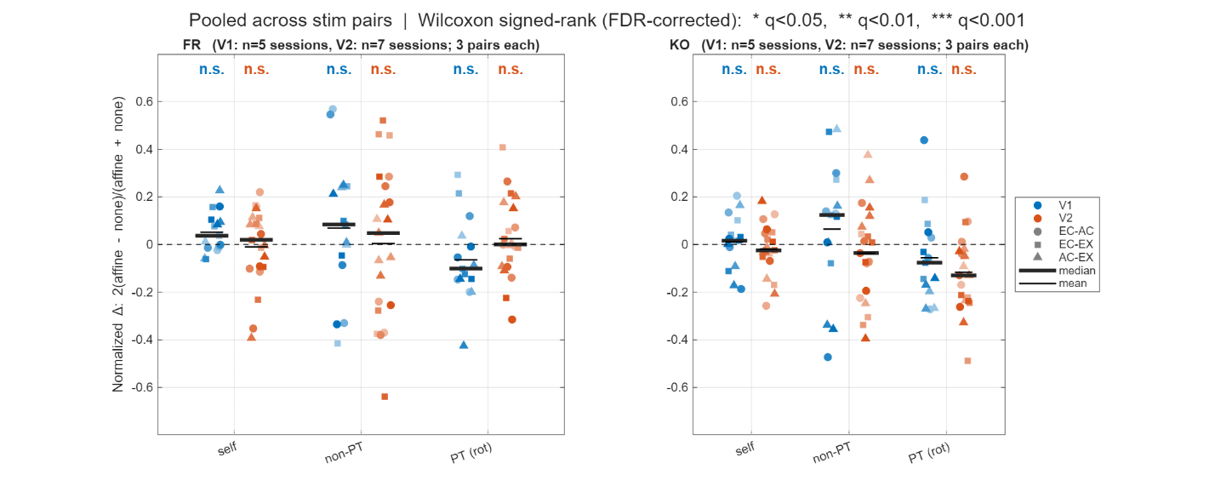
Per (monkey, area, decoding type) the N_sessions × 3 stim-pair normalized changes 2(affine−none)/(affine+none) are pooled, tested against zero with a Wilcoxon signed-rank, and BH-corrected across the 12 tests. Every cluster is labelled n.s. — nothing survives FDR. The most negative cluster is KO V2 rotation-only (median ≈ −0.13; raw p = 0.0064, q = 0.076), the one place a down-PT effect is even hinted at, and every other test has raw p > 0.06.
Result: the clean up-self / down-PT pattern of Section II does not reproduce as a single signed effect in real populations. The raw per-session curves are essentially unchanged by decorrelation (none vs affine overlap), the per-session Δ straddles zero with no consistent sign, and the pooled across-session test is n.s. everywhere. The per-cell Mann-Whitney tests flag many individually "significant" cells, but those are pseudoreplicated — the within-session resamples they compare are not independent biological observations — so their p-values are not interpretable as effects.
Conclusion for point 7 Section III: on real simultaneously recorded populations, decorrelation produces session- and pair-dependent, non-significant, non-unidirectional changes. The small pseudo-population effect of Section II does not survive as a directional effect once noise correlation is genuinely present and the test respects biological replication — preserved-vs-absent NC is not what drives the transfer-decoding result. We flag the two caveats explicitly: single-session populations are small (low power per session), and the per-cell tests are pseudoreplicated, which is why the conclusion rests on the across-session pooled test rather than on cell counts.

IV. The block-diagonal rotation sub-question
The reviewer's second, more specific prediction is that the fitted Procrustes rotation might carry block-diagonal structure aligned to the sets of simultaneously recorded neurons. We answer this with a mechanistic argument, and note the empirical option.
The argument: in every decoding script the rotation is fit by procrustes(stim2_means, stim1_means) on the two 50 × N trial-averaged stimulus-mean configurations — it never sees trial-to-trial covariance. Because noise correlations are averaged out before the rotation is fit, the only thing tied to which neurons were co-recorded is gone by the time T is estimated; the fit is determined by the 50-point signal geometry alone. There is no mechanism by which the recording-set partition could imprint a block structure on T, since the objective is blind to that partition. Two further facts reinforce this: neurons enter the pseudo-population in arbitrary (session-concatenated) order, and the shared cue-invariant geometry lives in a low-dimensional subspace (participation ratio ≈ 8–11; Points 3 and 6) that is distributed across neurons from many sessions — so the informative part of any rotation necessarily mixes across sessions rather than block-partitioning by them.
We note candidly that this is currently an argument, not a measurement: every decoding script computes T inline and discards it, so no fitted rotation has been stored or inspected. If the reviewer would prefer the empirical check, it is cheap — save T from procrustes_decoding_basic.m (one line) and quantify block structure directly (e.g. compare the magnitude of within-session vs cross-session entries |T_ij|, or a block-modularity score against a permutation null). [Decision needed: text argument as above, or add the T-matrix analysis. Recommend leading with the text argument and adding the measurement only if pressed, since it re-runs one decoding job.]
Conclusion for point 7 Section IV: because the rotation is fit on trial-averaged means and the population is session-concatenated in arbitrary order, the fitted transform has no route to acquire recording-set block structure; we can confirm this empirically with a one-line instrumentation if desired.
Where this leaves the pseudo-population concern (closing)
The pseudo-population does discard cross-session noise correlations — but those correlations are real only in the ≈ 20% of pairs that are same-session (Section I), removing them barely perturbs pseudo-population transfer decoding (Section II), and on genuine simultaneously recorded populations the effect of NC on transfer decoding is small, inconsistent in sign, and not significant (Section III). The rotation the analysis recovers is fit on trial-averaged signal geometry and cannot inherit block structure from the recording-set partition (Section IV). Missing NC therefore limits the precision of single-trial estimates, consistent with Point 2 Section II, but does not manufacture — or, when restored, dismantle — the cue-invariant geometry. The model-discrimination-power half of the reviewer's concern (how NC bounds which representational models can be ruled out) can be quantified directly by the injected-NC simulation in Point 8 and the generative-model family in Point 5.

Hopefully this review doesn't sounds overly negative - that was not the intention. The experiments described here are certainly interesting, the methods used are largely appropriate, and the manuscript has most of the parts of a good scientific paper. However, it feels incomplete without a systematic investigation of what the main analysis actually tells us about the neural representations.
Reviewer #2 (Rationale for Significance Rating for Authors):
The most interesting finding is that Procrustes-aligned population geometry reveals cue-invariant structure in V1 and V2 that single-neuron tuning correlations largely miss. The main limitation is that geometric invariance also emerges from simple Gabor filter banks (Fig. 15), leaving unclear what the biological data add beyond this baseline, and key results in V2 are inconsistent across the two animals.
Reviewer #2 :
Massot et al. ask whether V1 and V2 encode surface boundary information in a cue-invariant population geometry. They record 157 V1 and 258 V2 neurons in two macaques responding to 50 boundary patterns, each rendered as edge contours, natural image patches, and PCA-derived appearance contours. At the single-neuron level, tuning correlations across renderings are modest. At the population level, the authors apply Procrustes Transformation to align the geometric structure of population responses across renderings and show that this alignment boosts cue-transfer decoding accuracy two- to fourfold over raw transfer decoding.
The paper makes a genuine contribution and the cue-transfer decoding framework with Procrustes alignment is well-designed, and the demonstration that population geometry encodes invariances invisible to single-neuron analyses is valuable. However, several concerns (e.g., about the specificity of this geometric invariance, the implications of pseudo-population construction, and cross-animal inconsistencies) need to be addressed before the central claims can be fully evaluated.
Strengths
1. The stimulus set (natural boundary patterns rendered three ways) grounds cue-invariance in ecologically valid conditions rather than parametric stimuli.
2. The cue-transfer decoding framework is supported by well-chosen controls: stimulus-label shuffles (Fig. 11b) and neuron-index shuffles (Fig. 3c) confirm that PT alignment is non-trivial and identity-independent.
3. The multi-scale analysis (spanning single neurons, cortical layers, within- and across-area populations, and computational models) provides converging evidence.
4. The Gabor model comparison (Fig. 14-15) yields a useful dissociation between geometric and single-neuron tuning invariance. The authors report cross-animal inconsistencies transparently, and all data and code are publicly available.

Major Concerns

Reviewer's points 8 (Similar to Reviewer's point 7) - pseudo-population limitation on noise correlation in the discovered structures & simulations of PT decoding with varying injected noise correlations [~80% done; injected noise not done]
1. Pseudo-population construction eliminates noise correlations that shape real population geometry. The authors build pseudo-populations from non-simultaneous recordings (lines 411-414). While standard, this eliminates noise correlations that shape local manifold curvature, effective dimensionality, and the orientation of trial-to-trial variability, all of which influence Procrustes alignment and SVM decoding on single trials. A simulation injecting structured noise correlations of realistic magnitude (mean pairwise r = 0.05-0.15) into the pseudo-population would test whether PT decoding accuracy is robust or systematically biased by the independence assumption.

Reply to point 8
The framing up front. Point 8 is Reviewer 2's version of the pseudo-population/noise-correlation concern of Point 7, and it makes one specific new request: a simulation that injects structured noise correlation of realistic magnitude (mean pairwise r = 0.05–0.15) to test whether PT decoding is robust or systematically biased by the independence assumption. We answer in two parts. The concern's two testable halves — does noise correlation (NC) shape the geometry, and does it bias single-trial PT decoding — are already addressed by analyses in the revision, which we cite rather than repeat. The injection simulation is the one genuinely new piece; the existing controls all remove NC (or use real data that already contains it), so we describe how the injection slots into the Point 5 model framework and what it will test.
I. What the revision already establishes (cross-references)
The geometry is not shaped by NC (Point 2, Section II). The cue-invariant claim is a trial-averaged quantity, and removing NC with the same affine shift used here leaves the trial-averaged cross-rendering correlation invariant to machine precision — the point estimates coincide exactly, and the only material change is that the within-condition reliability ceiling rises. So NC bounds how precisely the geometry can be estimated; it does not create or curve the manifold the claim rests on. This directly meets the reviewer's "local manifold curvature" and "shape real population geometry" wording: the mean geometry is built from trial-averaged responses, which cross-neuron noise structure cannot move in expectation.
The two geometric quantities the reviewer names were measured, and neither carries the invariance. Effective dimensionality: participation ratio saturates at ≈ 8–11 across all four populations (Points 5 and 6). Orientation of trial-to-trial variability: the noise-signal alignment analysis (Point 2, Section III-ii) takes each stimulus cloud's principal noise axis and measures its angle to the signal directions; once same-trial estimation bias and variance heterogeneity are controlled, the noise axes are near-orthogonal to signal (medians ≈ 83–84° against an 85.6° random-orientation null) and their cross-rendering correlation is indistinguishable from zero. So the "orientation of trial-to-trial variability" the reviewer worries about is near-isotropic and not cue-invariant — it is not what PT rides on.
Single-trial PT decoding is empirically robust to realistic NC (Point 7). NC in the pseudo-population is modest — a population-average mean of ≈ 0.03–0.05, rising to ≈ 0.13 in the same-session pairs, squarely in the reviewer's r = 0.05–0.15 range (Point 7, Section I). Removing it from the full pseudo-population moves self-decoding up and rotation-only PT down by only small amounts (Point 7, Section II). Most importantly, the real single-session populations — genuine simultaneous recordings that contain NC — are themselves the "PT decoding with realistic NC present" condition the reviewer asks for, and there decorrelation produces non-significant, non-unidirectional changes (Point 7, Section III; nothing survives FDR). So on real data the independence assumption is not biasing PT in any detectable direction.
II. The injection simulation the reviewer requests (new; extends Point 5)
Related scripts: generate_model1_trial_data.m, generate_model3_trial_data.m, procrustes_decoding_simulation.m (the Point 5 framework).
Status: not yet implemented — and we are explicit that the existing framework cannot stand in for it. The current generators draw independent Poisson trials, so cross-neuron NC is zero by construction; the rho parameter they expose controls the fraction of signal (means) shared across renderings, not trial-to-trial noise correlation, and so does not answer this request. The injection is therefore a genuinely new generator, described here as planned (consistent with the calibration caveat governing all Point 5 numbers).
Method (planned): add a correlated-noise generator that imposes a target mean pairwise correlation r ∈ {0.05, 0.10, 0.15} across neurons while preserving each neuron's Poisson marginal — e.g. a shared multiplicative gain / common latent injected into co-"recorded" neurons, or a Gaussian-copula (Cholesky of a target covariance) construction on the Poisson marginals. To make the injection structured rather than uniform, the correlation is placed in blocks matched to the real recording-session sizes, so injected NC lives in same-session blocks exactly as it does in the data (this also gives the empirical counterpart to the block-diagonal question of Point 7, Section IV). The unchanged PT pipeline (procrustes_decoding_simulation.m) is then run across the r sweep crossed with the neuron-count sweep already used in Points 3 and 5.
Readout and prediction (to be confirmed after the Point 5 recalibration, at the same matched-self operating point): we track whether PT accuracy, its DOF-matched shuffle-null margin (Point 3), and the participation ratio shift as r increases. Because the Procrustes rotation is fit on trial-averaged means — unbiased by cross-neuron noise structure in expectation — we expect PT accuracy and, especially, its null-relative margin to be largely insensitive to injected r, with at most a modest change in single-trial SNR. This is the same robustness already observed empirically when real NC is present versus removed (Point 7, Section III). If instead PT moved systematically with r, that would flag the independence assumption as a real bias; the real-data result predicts it will not. The injection sweep and the removal controls thus bracket the identical question from opposite directions — add NC to an independent pseudo-population versus remove NC from a correlated real one — and we expect them to agree.
Where this leaves Point 8 (closing)
The pseudo-population's independence assumption affects single-trial estimation, not the trial-averaged geometry (Point 2, Section II); the two geometric quantities the reviewer flags — effective dimensionality and the orientation of trial-to-trial variability — were measured, and neither carries the invariance (Points 5/6; Point 2, Section III-ii); and PT decoding is empirically robust to realistic NC, both when it is removed from the pseudo-population and when it is genuinely present in real single-session recordings (Point 7). The requested injection simulation is the one outstanding piece: it does not yet exist in the code, it fits the Point 5 framework, and we will report it at the common operating point — with the real-data result already predicting robustness.

Reviewer's points 9 – Compare neurons with Gabor filters: what do neurons add? [~100% done]
2. Geometric invariance also emerges from Gabor filter banks, and the paper needs to articulate what the neural data add. The Gabor model analysis (Fig. 15) shows that filter banks produce PT decoding well above chance. The paper notes that Gabor models lack single-neuron tuning invariance (lines 875-876), but should sharpen this by statistically comparing neural versus Gabor PT decoding at matched population sizes and reporting intrinsic dimensionality (e.g., participation ratio) for both. If neural manifolds achieve comparable invariance in fewer effective dimensions, this would distinguish the biological finding from a generic filter-bank property.

Reply to point 9
The framing up front. Reviewer 2 asks us to do two concrete things — statistically compare neural versus Gabor cue-transfer decoding at matched population sizes, and report an intrinsic-dimensionality measure (participation ratio, PR) for both — and to test one specific hypothesis: that neural manifolds might achieve comparable invariance in fewer effective dimensions, which would separate the biological finding from a generic filter-bank property. We built exactly this comparison, on a common 10-unit population sweep with PR computed identically for neurons and filters. One framing point governs everything below. At matched neuron/filter count the filter bank wins on every axis, but only because it is near-noiseless (self-decoding ≈ 1.0 at every size); that comparison is real but uninformative. The reviewer's own criterion — comparable invariance in fewer effective dimensions — points instead at the matched-PR comparison, and that is where the interesting dissociation lives. We present the matched-count comparison first for honesty (Section I), then move to matched PR (Section II), transfer efficiency (Section III), and the saturation caveat (Section IV).
The headline result. The filter bank and the neural populations dissociate exactly along the reviewer's axis. Per effective dimension the Gabor bank is far more decodable — its self-decoding sits at ≈ 1.0 across the whole PR range, against 0.1–0.5 for neurons — yet cue-transfer does not follow decodability: at matched PR, KO V1's rotation-transfer sits above the Gabor curve (≈ 0.26 vs ≈ 0.18 at PR ≈ 7.8), and all four neural populations transfer a substantially larger fraction of their own decodable structure than the filter bank (PT/self ≈ 0.43–0.57 for neurons vs 0.08–0.40 for Gabor). Where the neural geometry is efficient, the efficiency is specific to transferable, cue-invariant structure, not to general decodability — which is precisely what distinguishes it from a generic filter bank. We are candid that this is population-specific rather than a blanket neural win: KO V1 clears the filter bank, FR V2 sits on it, FR V1 falls a little below, and KO V2 below — so the claim is “at least one real population beats the filter bank on transfer-per-dimension,” not “all neurons do.”

I. Matched population size: the filter bank leads, because it is near-noiseless (Fig 1).
Related scripts: procrustes_decoding_basic_incremental_pr.m (neural, all four populations → procrustes_decoding_basic_incremental_pr_results/<monkey>/<area>/); procrustes_Gabor_resps_decoding_basic_incremental_pr.m (Gabor, the even+odd combined filter model); generate_gabor_trial_data.m (Gabor trials: complex = Poisson on filter energy; odd/even = half-wave rectified then Poisson; combined = the concatenation used here); visualization_procrustes_decoding_basic_incremental_pr.m (Figs 1–5).
Method (the sweep and the participation ratio). Both pipelines sweep population size in uniform 10-unit steps (10, 20, …, max), so neural and Gabor sizes match exactly over the overlapping range, and both compute PR the same way. PR is the participation ratio (Σλ)² / Σλ² of the covariance spectrum, taken by SVD of the z-scored, 10-trial-averaged, stimulus-centered 50 × N signal manifold; it is computed once per neuron-sampling repeat, with no second renormalization after trial-averaging, and it is invariant to the Procrustes transform (rotation), so it is a clean per-condition quantity that characterizes the same geometry the decoder and the rotation operate on. Two fairness choices matter. The Gabor PR (and self/transfer) use the mean estimated from the generated Poisson trials, not the noiseless filter rate — otherwise the filter bank would enjoy a clean-mean advantage the neural data never gets. And PR is pooled per condition by gathering pr_stim1 from the pairs whose stim1 is that condition and pr_stim2 from those whose stim2 is (each condition appears in 4 of the 6 ordered pairs). PT throughout is the rotation-only transfer (column 6), matching the main results; self-decoding is the within-condition 10-fold ceiling (column 1). This PR definition is the one we will state in Methods.
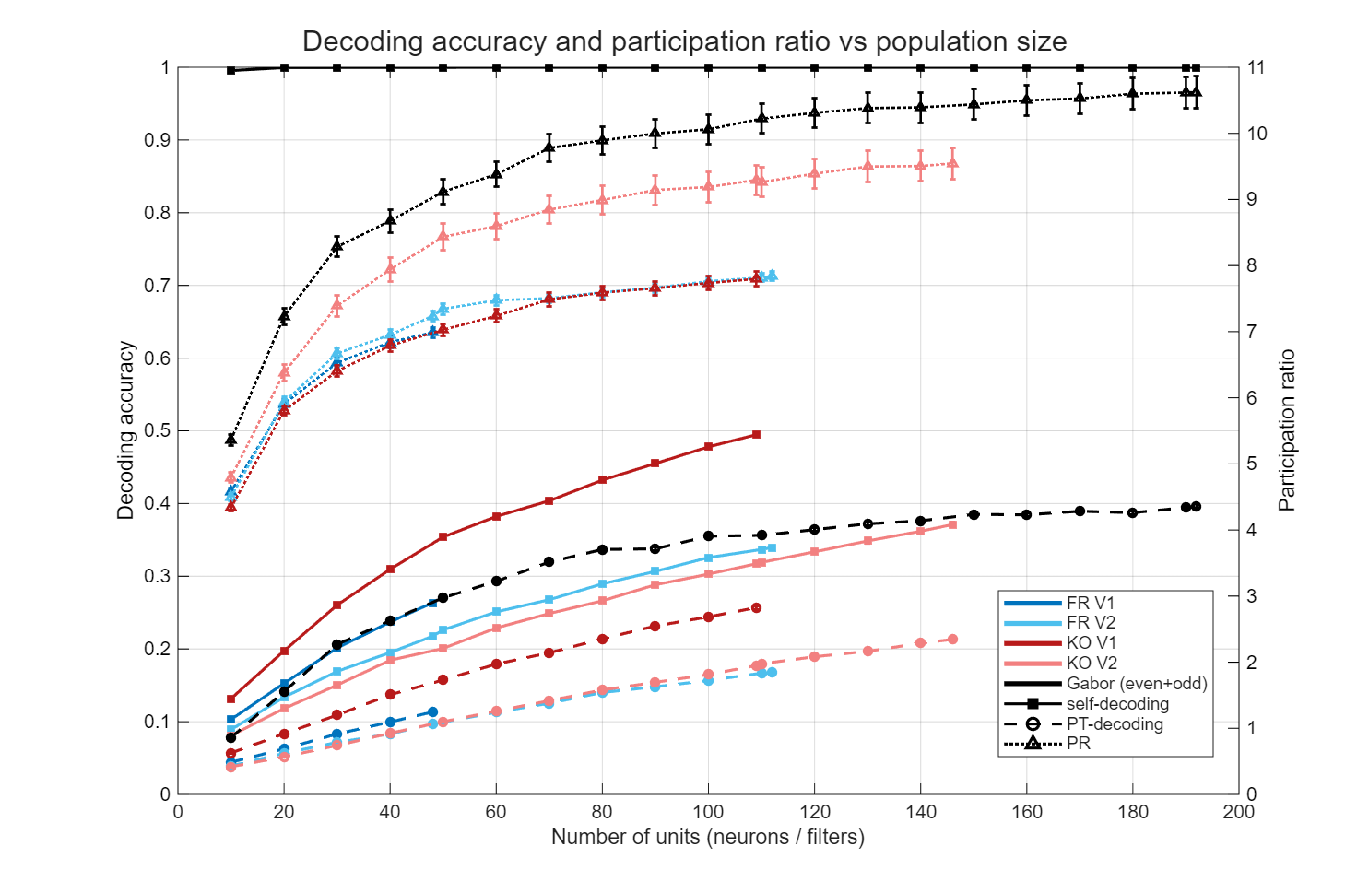
Figure 1. Decoding accuracy (self, PT) and participation ratio versus population size, neural populations and the Gabor filter bank.
Result: at matched count, the filter bank dominates all three axes. At N ≈ 110, Gabor self-decoding is ≈ 1.00, rotation-transfer ≈ 0.36, and PR ≈ 10.2; KO V1 (its largest size, N = 109) reaches self ≈ 0.50, transfer ≈ 0.26, PR ≈ 7.8. The filter bank’s self-decoding is ≈ 1.0 at every size — it is effectively noiseless, which is why it also carries the highest PR and the highest raw transfer. This is the comparison the reviewer names (“matched population sizes”), and taken at face value it is unfavorable to the neural data.
Conclusion for point 9 Section I: at matched population size the Gabor bank wins on self-decoding, on raw transfer, and on PR — but the win is an artifact of its near-zero trial noise, not of superior cue-invariant structure. A fair comparison has to remove the SNR gap, which is what the participation-ratio axis does.

II. Matched effective dimensionality: at equal PR, KO V1 out-transfers the filter bank (Fig 2 — the headline).
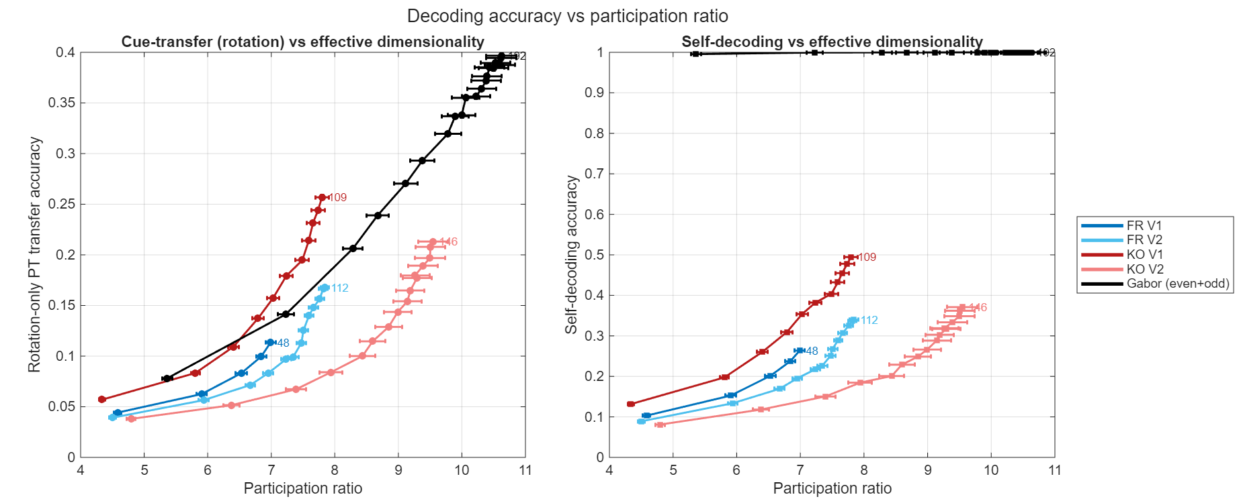
Figure 2. Cue-transfer (left) and self-decoding (right) versus participation ratio. At matched PR, KO V1 sits above the Gabor curve for transfer, while Gabor self-decoding is near 1.0 at every PR.
Result: re-plotting transfer against PR (left panel) instead of against N removes the SNR confound and reverses the picture for the strongest population. At matched PR, KO V1 sits clearly above the Gabor curve (clearest at the top of its range: PT ≈ 0.26 at PR ≈ 7.8, against ≈ 0.18 for the filter bank at the same PR — a +0.08 gap); FR V2 lands essentially on the curve (0.169 vs 0.179); FR V1 a little below (0.113 vs 0.133); and KO V2 below (0.212 vs 0.304). The right panel is the reason the matched-count comparison was unfair: Gabor self-decoding is ≈ 1.0 across the entire PR range, whereas neural self-decoding climbs from ≈ 0.1 to ≈ 0.5 — so per effective dimension the filter bank is far more separable, and yet it does not convert that into proportionally more transfer.
Conclusion for point 9 Section II: the reviewer’s distinguishing criterion — comparable invariance in fewer effective dimensions — is met, but population-specifically. KO V1 achieves higher cue-transfer than a matched-PR Gabor bank, i.e. it packs more transferable structure into fewer dimensions; FR V2 matches the filter bank; FR V1 and KO V2 do not. So neural geometry is not uniformly more dimension-efficient than a filter bank, but the best population clearly is, and no population is less transfer-efficient once its far lower decodability is accounted for.

III. Transfer efficiency and per-dimension transfer (Figs 3–4).
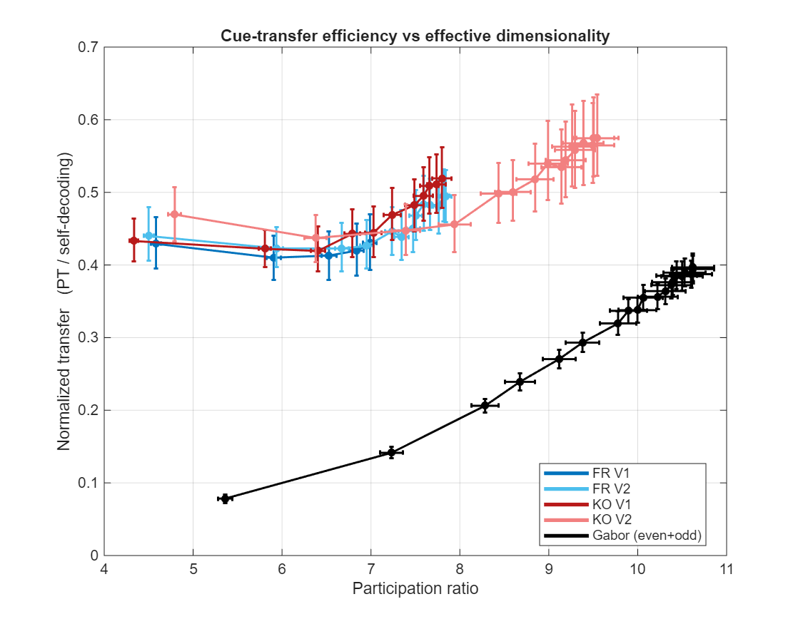
Figure 3. Normalized transfer (PT / self-decoding) versus participation ratio, with the correspondence-shuffled control overlaid (dashed).
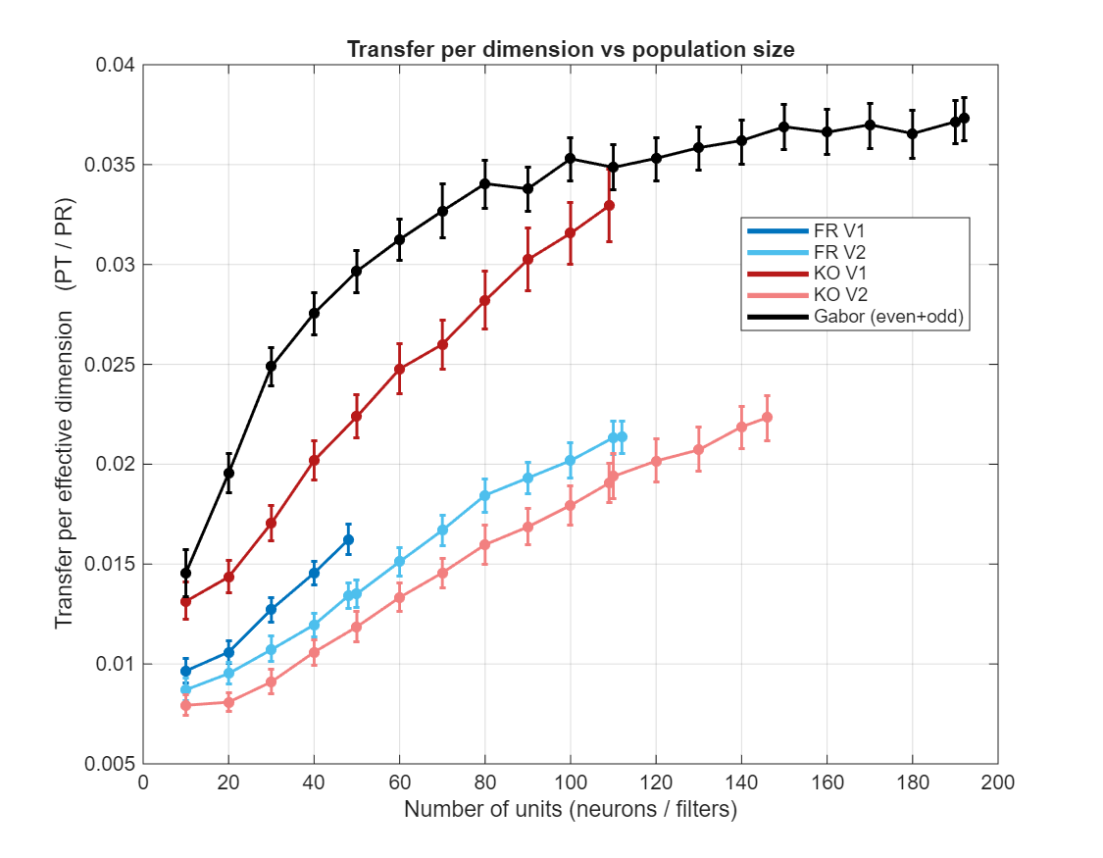
Figure 4. Transfer per effective dimension (PT / PR) versus population size.
Result: two normalizations sharpen the same dissociation. Normalized transfer PT/self (Fig 3) — what fraction of a population’s decodable structure survives the cross-cue rotation — separates neurons from the filter bank cleanly: all four neural populations sit at ≈ 0.43–0.57 and are flat-to-rising in PR, while the Gabor bank rises from ≈ 0.08 to ≈ 0.40 and only approaches the neural band at its highest dimensionalities; at matched PR the neural fraction is roughly two to three times the filter bank’s (e.g. 0.52 vs 0.18 at PR ≈ 7.8). We therefore read the matched-PR neural advantage of Section II together with the degrees-of-freedom control of Point 3, not in isolation. Point 3’s dimension-controlled sweep is the positive side of that same coin: when the rotation is restricted to the ≈ 5 principal components that carry most of the mean geometry, neural PT stands up to ≈ 2.9× above its shuffle null (KO V1; ≈ 2.3× KO V2, ≈ 1.9–2.0× FR), so the transferable structure entering the matched-PR comparison is genuine at controlled degrees of freedom, not merely rotational slack — we simply do not claim its full raw magnitude here. The complementary matched-count view, transfer-per-effective-dimension PT/PR against N (Fig 4), is the one place the filter bank still leads at equal N (≈ 0.035 vs ≈ 0.033 for KO V1 at N ≈ 110, rising to ≈ 0.037 by N = 192) — again because its raw PT is inflated by near-zero noise — but at matched PR the ordering flips (KO V1 ≈ 0.033 vs Gabor ≈ 0.023).
Conclusion for point 9 Section III: by the efficiency measure the reviewer’s question most directly asks for — how much cue-invariant transfer per unit of decodable or effective structure — the neural populations are the more efficient, transferring two-to-three-fold more of their decodable structure than a matched-PR filter bank; the filter bank leads only on raw per-dimension transfer at matched count, and only because it is noiseless.

IV. Where PR and PT saturate — one caveat (Fig 5).
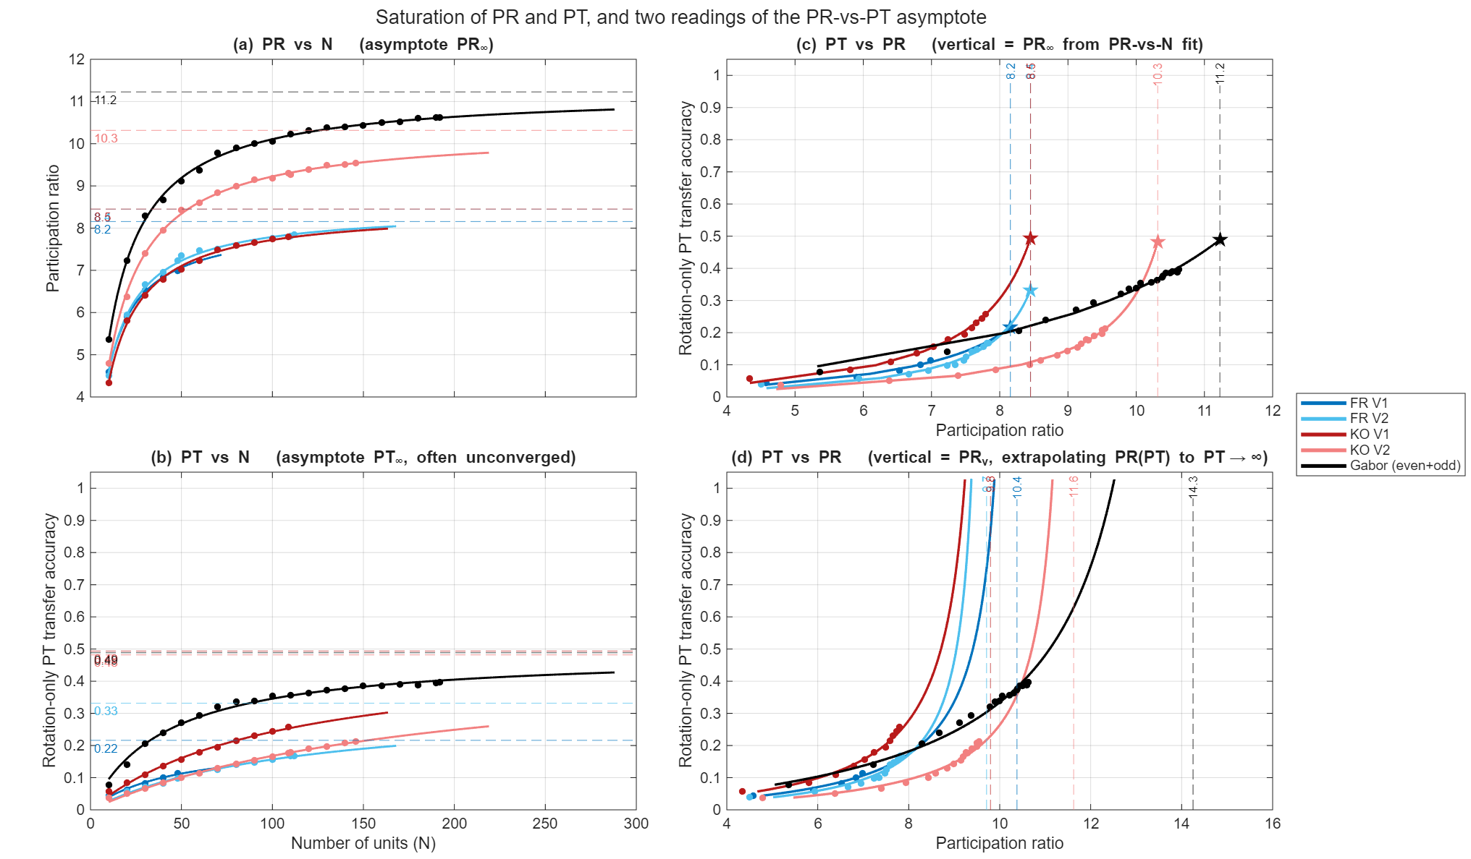
Figure 5. Saturation of PR and PT, and two readings of the PR-vs-PT asymptote.
Result: fitting PR and PT as saturating functions of N gives two different qualities of estimate. PR(N) is well-constrained: it plateaus within the observed range, with asymptotes PR∞ ≈ 8.2 (FR V1), ≈ 8.5 (FR V2, KO V1), ≈ 10.3 (KO V2), and ≈ 11.2 (Gabor) under the Michaelis–Menten fit shown in the figure — so neural manifolds genuinely occupy fewer effective dimensions than the filter bank, and the neural-vs-Gabor dimensionality gap is real (an exponential-saturation fit lands ≈ 1 PR unit lower throughout, a fit-form spread we can report as an uncertainty band). An independent measure of the same dimensionality — the cumulative signal-variance spectrum of the PC-sweep analysis (Point 3; visualization_variance_vs_pc.m) — agrees: the neural mean geometry needs roughly k ≈ 8–20 PCs to reach 80% of its signal variance, with no sharp elbow, so the low PR is a real property of the manifold rather than an artifact of the statistic (this also answers Reviewer 2’s minor concern 6). PT(N), by contrast, has not converged over the measured range: the curves are still climbing at the largest N, so the apparent ≈ 0.5 transfer ceiling is a projection from extrapolation, not an observed plateau, and it is strongly fit-form dependent — the same KO V1 data give PT∞ ≈ 0.51 under Michaelis–Menten but ≈ 0.33 under exponential saturation. We therefore present the PT asymptote as illustrative only and rest no claim on it.
Conclusion for point 9 Section IV: the dimensionality comparison is on firm ground — PR saturates and neural manifolds are lower-dimensional than the filter bank — but the transfer-ceiling comparison is not, because PT has not saturated at the population sizes available; we flag the PT∞ numbers as fit-dependent extrapolations rather than measured limits.

Where this leaves the Gabor comparison (closing). The honest answer to “what do the neural data add over a Gabor filter bank” is not more decodability — a near-noiseless filter bank is trivially more separable per dimension, and at matched population size it wins outright. What the neural data add is transferable, cue-invariant structure per unit of code: at matched effective dimensionality the best neural population (KO V1) out-transfers the filter bank, and every neural population devotes a two-to-three-fold larger fraction of its decodable structure to cross-cue transfer (Figs 2–3), while occupying genuinely fewer effective dimensions (Fig 5). This complements the single-neuron result already in the paper (Gabor filters lack the single-neuron tuning invariance the neurons show, lines 875–876) and the transformation-free geometry of Point 2, and it is scored against the same degrees-of-freedom control as Point 3. The comparison is population-specific, and we say so. Additional filter-bank baselines are on disk if the reviewer wants them — the complex-cell (energy) Gabor model and a size-downsampled variant (Gabor_decoding/results/decoding_outputs/{complex, even and odd combined, even and odd combined downsampled}/, with two saved only-rotation-PT figures) and the full ANN suite (AlexNet and VGG; basic, incremental, and along-hierarchy; ANN_decoding/results/, five saved figures) — and, if useful, we can fold the complex Gabor model into the matched-PR figures, break the comparison out by rendering pair (AC-EC / EC-EX / AC-EX), and show the satexp-vs-mm asymptote spread as an explicit band.

Reviewer's points 10 – Compare Procrustes residuals across all pairs to test whether AC-EX alignment is tighter than expected from genuine cue-invariance alone [~90% done]
3. The AC rendering shares linear structure with EX by construction, potentially inflating cue-invariance estimates. The AC rendering is the first principal component of the same patches defining EX (lines 459-462), making it a linear projection of EX by construction. AC-EX geometric alignment may therefore reflect shared stimulus structure rather than cue-invariant neural coding. Comparing Procrustes residuals across all three rendering pairs (EC-EX, EC-AC, AC-EX) would test whether AC-EX alignment is tighter than expected from genuine cue-invariance alone.

Reply to point 10
The framing up front. The reviewer's concern is a concrete, testable prediction. If AC↔EX alignment were inflated by the shared construction (AC being the first PC of the same patches that define EX) rather than by genuine cue-invariant coding, then AC↔EX should be the tightest of the three pairs: smallest Procrustes residual, highest geometric correlation. Every per-pair measure we have shows the opposite ordering. AC↔EX is the loosest pair, not the tightest. We give three converging per-pair readouts, from the reviewer's literal ask outward: (I) the Procrustes residual itself, broken out by pair; (II) the decoder-free geometry correlation of Point 2, computed per pair; (III) per-pair transfer decoding from Point 4. For each we state below what is already computed and what remains only a re-plot.

I. Procrustes residuals per rendering pair (the reviewer's literal quantity).
Related scripts: procrustes_decoding_basic_incremental_pc.m (all four populations, all six ordered pair files, output leaf procrustes_decoding_basic_incremental_pc_results/<monkey>/<area>/); visualization_procrustes_decoding_basic_incremental_pc_per_pair.m (the per-pair re-plot added for this point; the earlier visualization_procrustes_decoding_basic_incremental_pc.m pools all six pairs).
Method: for every cue pair we store the Procrustes residual distance in three forms: d_before (no rotation), d_rot (rotation only), and d_full (optimal scale, rotation, and translation). All three share MATLAB's common stim2-target denominator, so they are directly comparable across pairs, and a smaller residual means tighter alignment. The reviewer's prediction is a smaller d_rot and d_full for AC↔EX than for EC↔AC or EC↔EX. We un-pool the six ordered pair files into the three unordered pairs (EC↔AC = acec+ecac, EC↔EX = ecex+exec, AC↔EX = acex+exac) and compare them directly. We illustrate with the rotation-only residual d_rot, the quantity matched to the rotation-only transfer decoding used throughout; d_full gives the identical ordering.
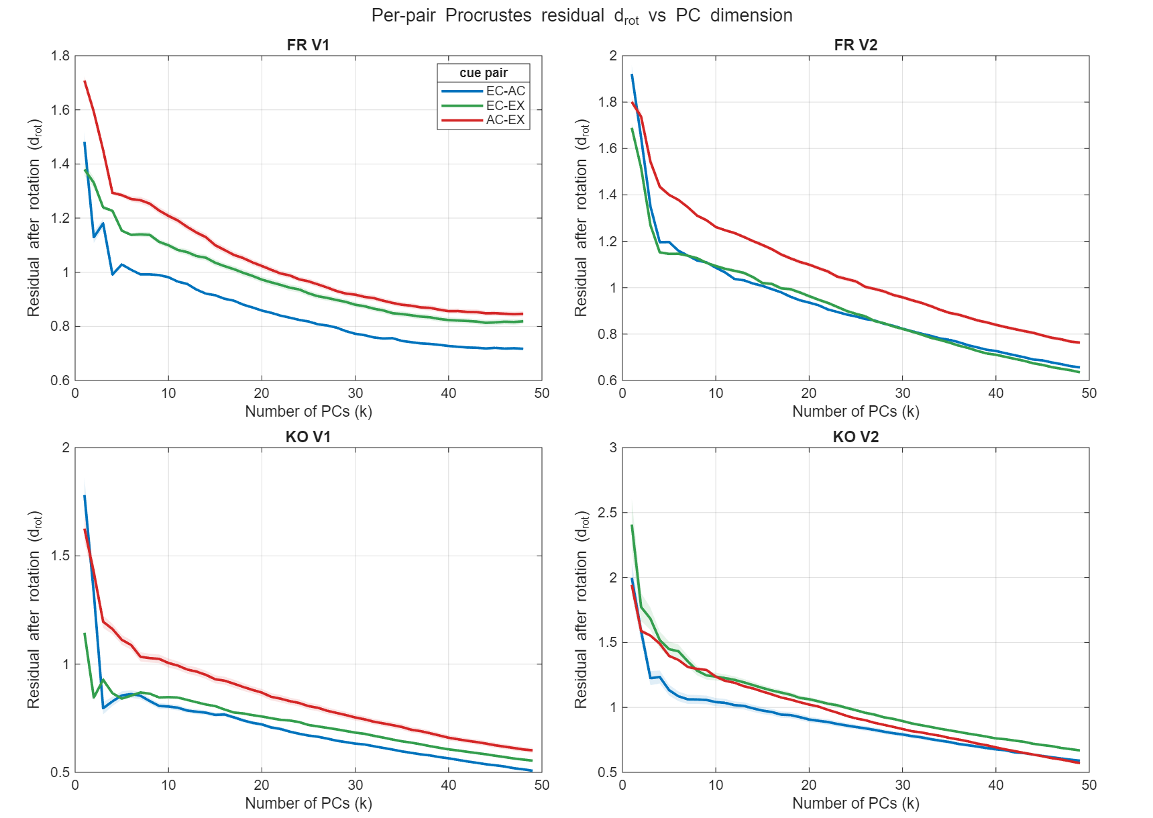
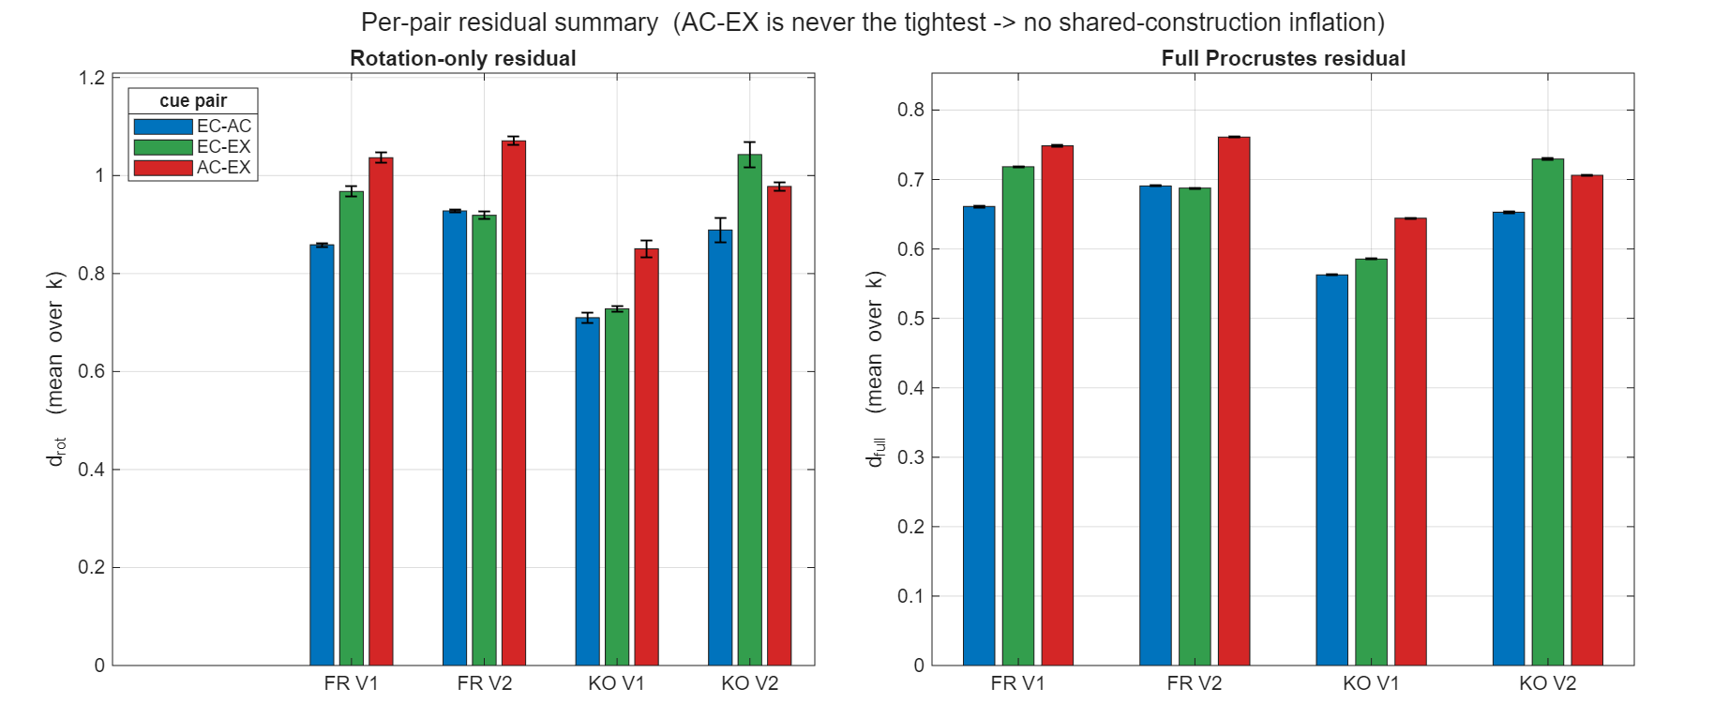
Result. The per-pair contrast is attached above (rotation-only residual d_rot vs number of retained PCs k, one panel per population, one coloured curve per unordered pair). The reviewer's prediction is not borne out: AC↔EX is never the tightest pair in any population. Averaging the residual over k, AC↔EX is the loosest of the three pairs in FR V1 (d_rot = 1.04, vs 0.86 for EC↔AC and 0.97 for EC↔EX), FR V2 (1.07, vs 0.93 and 0.92), and KO V1 (0.85, vs 0.71 and 0.73); in KO V2 it is the second-loosest (0.98), behind EC↔EX (1.04) and above EC↔AC (0.89). The separation is not a small-k artifact — the AC↔EX curve sits at or above the other two across essentially the whole k-axis (Figure X), and the full-transform residual d_full reproduces the same ordering in every population. In short, on the reviewer's exact quantity AC↔EX carries the largest or second-largest residual, never the smallest — the opposite of the inflation the concern predicts, which would have made AC↔EX the tightest pair.
Caveat to state. These residuals are taken after each cue is projected onto its own top-k mean-PCA basis, so they are residual shape distances within that basis, not the full cross-cue rotation magnitude; no full-population (non-PCA) residual is currently stored. [Optional: save the residual d from the basic pipeline, which currently discards it, to report the residual on the untruncated manifold if the reviewer wants it.]
Conclusion for point 10 Section I: the residual is the reviewer's exact quantity, it is already computed, and it is now displayed per pair. Across all four populations AC↔EX is never the tightest pair — loosest in three and second-loosest in the fourth — directly contradicting the shared-construction inflation the reviewer guards against. The converging per-pair readouts below (geometry correlation, transfer decoding) show the same ordering.

II. Decoder-free geometry per rendering pair (Point 2, no rotation at all).
Related scripts: geometric_metrics_basic.m (all four populations, output geom_zscore_results.mat).
Method: the cross-rendering correlation of the 50×50 pairwise-distance and centroid-cosine matrices is computed separately for each pair (AC-EC, EC-EX, AC-EX), each with its own stimulus-label-shuffle null (near 0) and its own split-half ceiling. No Procrustes rotation enters, so this measure cannot be inflated by the rotation’s degrees of freedom (Point 3). It is the cleanest test of whether AC↔EX geometry is anomalously close.
Result. See point 2, second II, for figures: simple geometries, like distance and angles, showed that AC-EX is the lowest, not the highest across all the pairs.
Conclusion for point 10 Section II: with both the decoder and the rotation removed, AC↔EX shares the least geometry of the three pairs, which directly contradicts the shared-construction inflation the reviewer raises.

III. Per-pair transfer decoding (paper main figure 3).
Related scripts: procrustes_decoding_basic.m (output procrustes_decoding_basic_results/<monkey>/<area>/) with visualization_procrustes_decoding_basic.m (figure already broken out by pair).
Method: rotation-only transfer accuracy reported separately for each pair.
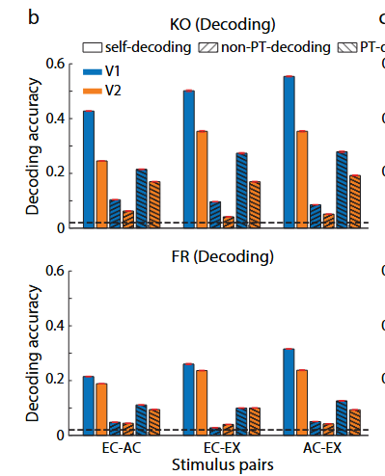
Result. In terms of absolute values, AC-EX and EC-EX are close. But if we normalize it by self-decoding, EC-EX is higher than AC-EX

IV. Rev Point 4 – CCGP-style decoding: AC-EC is the highest, same leader as the simple geometry. The pair where the CCGP-style rotation generalizes (AC↔EC) is the one Point 2 (simple geometries) ranks most cue-invariant (KO V1 z-scored: AC-EC ≈ 0.38 > EC-EX ≈ 0.32 > AC-EX ≈ 0.19); the pair where it hurts (AC↔EX) is the least. This also answers Reviewer 2's worry (Point 10) that AC being a linear component of EX might inflate AC-EX alignment — AC↔EX is empirically the weakest pair, not the tightest.

Where this leaves point 10 (closing). The reviewer’s worry predicts that AC↔EX should stand out as anomalously tight. All three per-pair readouts, the Procrustes residual, the decoder-free geometry, and the transfer decoding, instead rank AC↔EX last. Whatever linear structure the shared AC/EX construction imposes on the stimuli, it does not translate into inflated neural cue-invariance; if anything the reverse. Evidence already in hand: per-pair transfer decoding (figured) and the KO V1 decoder-free ordering. Remaining work, both light: un-pool the already-computed Procrustes residuals into the three pairs, and confirm the geometry ordering across all four populations.

Minor Concerns
1. The cue-transfer decoding methods (lines 552-605) are dense; pseudocode or a numbered step-by-step summary would improve accessibility.
2. Stimuli were 33×33 pixels for V1 and 45×45 for V2; the authors should discuss whether this size difference contributes to V1 > V2 cue-invariance through spatial frequency content differences.
3. Was V2 downsampling to match V1 size (line 181) repeated across multiple random subsamples to verify stability?
4. Procrustes assumes rigid/similarity transformations. Comparing with CCA or CKA would test whether a more general alignment better characterizes the cross-rendering geometric relationship.
5. With 15 figures, the main text is dense. Figures 5, 7, 9, 12, and 13 could be designated supplementary.
6. The 2D PCA projections (Fig. 3a) are visually compelling but Procrustes operates in ~150D; reporting variance captured by the first two PCs would contextualize these visualizations.
Reviewer #2 (Supplemental Material:):
The paper contains 15 figures but does not designate any as supplementary. Some Figures should be moved to a formal Supplemental section to improve readability (while being consistent with JNeurosci policy that all essential data must appear in main figures).
Reply to minor concerns

