JNeuro rebuttal – distilled summary
Zitong Wang · 2026-10-21 · distilled from JNeuro_rebuttal_Zitong_TScomments3_ZWDistilled.docx, with figures and numbers updated from neuron_decoding_rev, Gabor_decoding_rev, Simulations_v2 and Simulations_v3_partial_sharing.
How to read this document
- Each analysis follows the same pattern: a one-sentence subtitle (the finding), the minimal figure(s), Details (technique, a few sentences), then Interpretation: short numbered bullets followed by Prof. Lee's paragraph.
- Yellow highlight: Prof. Lee's interpretation (reviewer-facing draft text), kept from TS3. Where a fact or number had to change, the change is marked with a Word comment.
- Gray highlight: potential supplementary
- Cyan, red and green highlight: Prof. Lee's notes, to-dos and side remarks.
- Red font: key conclusion. Blue font: status of the point. Numbered bullets without highlight are ours.
- "Interpretation (new draft)" marks text written where TS3 has no interpretation yet, for Prof. Lee to review.
- All decoding figures use the corrected correspondence-shuffled control. Headroom = (PT − control) / (self − control): 0 = what rotation freedom alone produces, 1 = the target rendering's self-decoding.

Reviewer #1

Point 1 – Terminology: "cue-invariant" vs. "rendering-equivariant" [0% done; wording change]
Let's start with a note on terminology: "cue-invariant neural representations" doesn't quite sound right in two ways. First, even if there was an invariance of the neural representations, it would be with respect to the rendering/appearance, not with respect to other features of the visual cue. Second, the neural representations aren't actually invariant if they need to be mapped by a Procrustes transformation to generalize from one rendering style to another. I believe the correct mathematical term for such a situation would be "equivariant", so a term like "rendering-equivariant neural representations" would be more accurate. (As an aside, I would argue that we already knew that at least in the human visual system, the neural representation in the early visual system cannot be truly invariant to rendering style, otherwise we couldn't distinguish different renderings of the same contour - this point should probably be mentioned when motivating the study).
[Pending: reply to be written.] No analysis is needed. Two notes in this summary bear on the wording: Prof. Lee's Point 4 reply narrows the claim to "partial preservation of representational geometry", and his Point 4 side note asks whether invariance vs. equivariance is the right frame.

Point 2 – Simple geometric measures: distances and angles [done]
The properties that are actually invariant under a Procrustes transformation are relative distances between pairs of points (neural representations) and angles between them (i.e., the "shape" of the neural geometry, but not its overall scale). It seems puzzling that the authors don't test their main hypothesis directly in terms of these geometric quantities. Relative distances and angles of the neural geometry are easy to compute and compare across different renderings, without training any decoders. The RSA analysis of Fig. 3 makes a start in this direction, but of course one cannot say much from these dimensionally reduced plots. What would be needed to argue that there is a geometric structure in the neural representations that is approximately preserved between rendering styles is a systematic quantification of these properties (angles and relative distances), with a careful statistical comparison to a control model to investigate the degree to which they are preserved.

I. The direct reply: simple geometries are preserved across renderings, but only partially

i. Pairwise distances and angles are correlated across renderings, and angles more than distances.
dist_scatter_avg_zscore
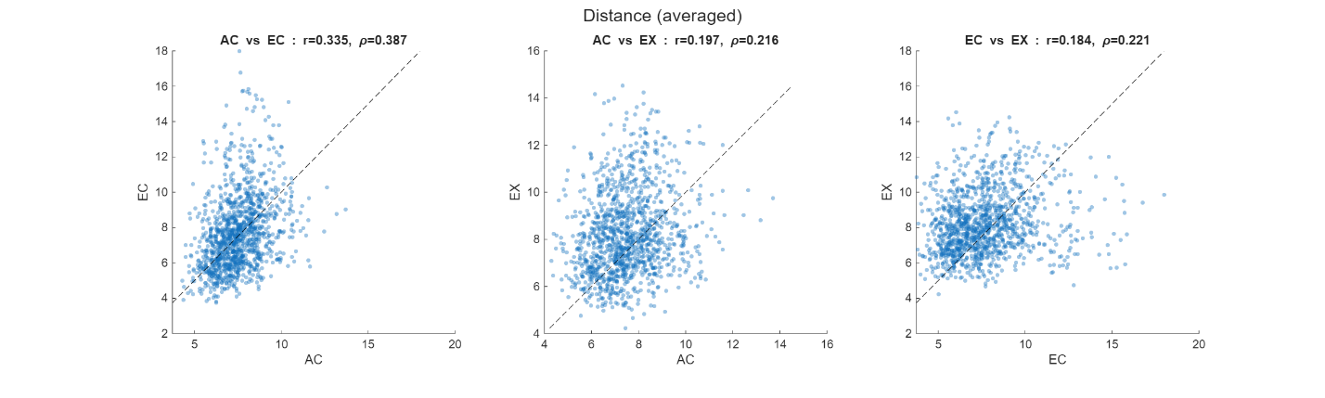
cos_scatter_avg_zscore
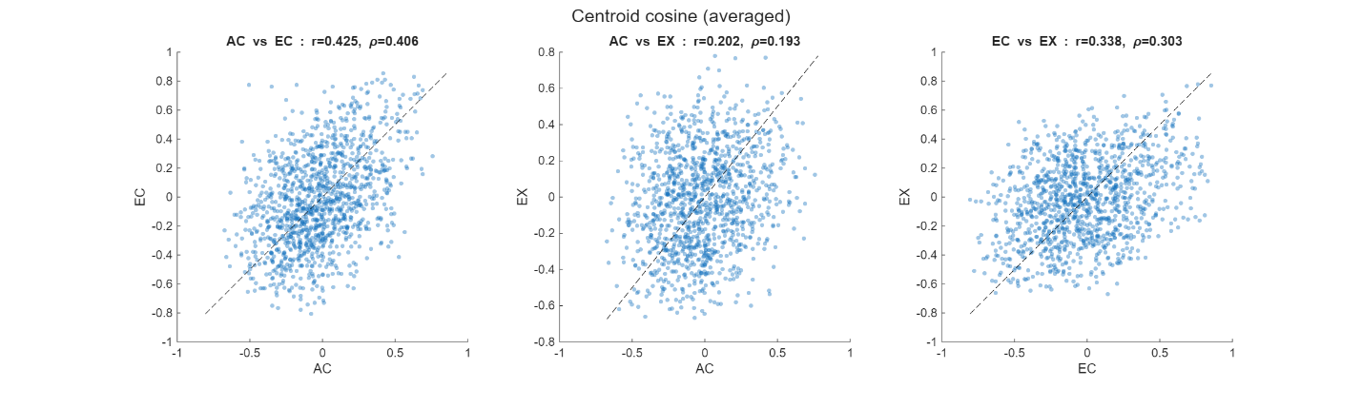
Details:
Cross-rendering scatter plots (dist_scatter_avg, cos_scatter_avg; KO V1, z-scored). Each dot is one of the 1,225 stimulus pairs, plotted as its value in one rendering against another. dist_ is the Euclidean distance between trial-averaged responses, and cos_ is the cosine between them, measured from the centroid. Titles give r and ρ, the same values marked by the triangles in the distribution figure.
Interpretation:
- (1) Angles are more correlated than distances.
- (2) Angle correlation: AC–EC > EC–EX > AC–EX.
We found that the representational structure is partially preserved across AC, EC, and EX, but preservation is stronger for response-vector direction than for absolute pairwise distance. AC and EC show the strongest correspondence under both cosine similarity (r = 0.425) and Euclidean distance (r = 0.335). EC and EX retain moderate angular correspondence (r = 0.338) but much weaker Euclidean correspondence (r = 0.184), suggesting that EX introduces additional variability that distorts pairwise spacing. One plausible explanation is that EX contains more extraneous visual information—such as texture, background structure, and shading—which may modulate neural response magnitudes and geometry while preserving some of the underlying response-direction structure. AC and EX are weakly related under both metrics (r = 0.202 cosine; r = 0.197 Euclidean).

ii. The cross-rendering correlations are far above a shuffle null but well below the within-rendering reliability ceiling.
dist_distributions_zscore
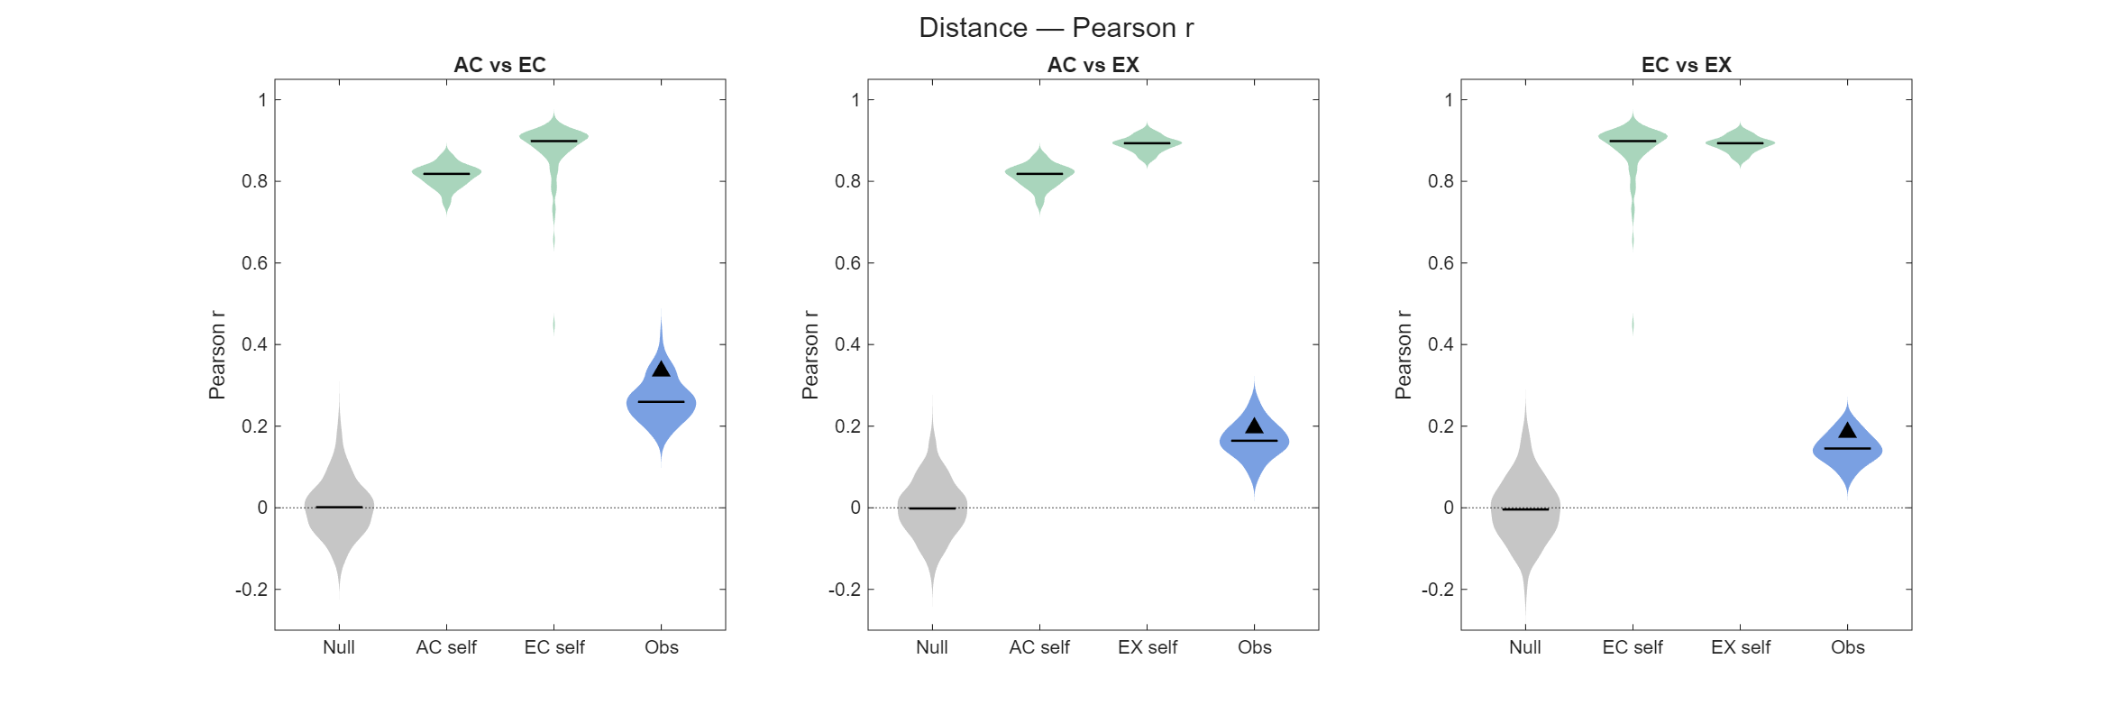
cos_distributions_zscore
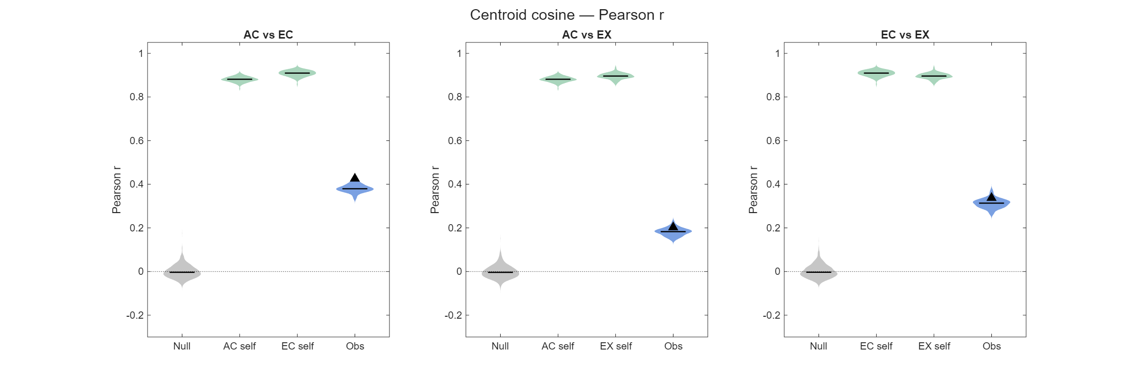
Details:
For each rendering, we build the stimulus geometry from z-scored, trial-averaged responses. The geometry consists of the 1,225 pairwise distances (dist_) and the centroid-anchored cosines (cos_). We then take the Pearson r between two renderings across these pairs.
- Obs: r on each of 100 bootstrap draws, resampling the 10 trials per stimulus with replacement.
- Self (ceiling): r between two independent draws of the same rendering (100 iterations). This is the most agreement trial noise allows.
- Null (chance): bootstrap draws with stimulus labels shuffled in one rendering (1,000 iterations).
Lines mark medians. Triangles mark the point estimate, a single r from all trials without resampling.
Interpretation:
- (1) Better than the null lower bound, but below half of the reliability upper bound.
- (2) The correlation of simple geometries is generally modest.
The above plots asked how similar the AC, EC and EX geometries are. But is the observed cross-condition similarity real relative to chance, and how large is it relative to the similarity that could be achieved given trial noise?
The plots show that the relatively modest cross-condition correlations cannot simply be attributed to noisy neural responses, because the same-condition geometries (SELF) can be recovered with very high correlation from independent trial samples. Given the relatively high measurement reliability, this suggests that AC, EC, and EX have substantially different geometries. The cross-condition geometry is genuinely shared, but only partially. AC, EC, and EX share a genuine representational structure that is far above chance, but cue transformation substantially changes that structure. AC–EC shows the strongest preservation, while relationships involving EX are generally weaker, consistent with the additional texture, shading, background, and other visual information in EX introducing condition-specific neural responses. Moreover, much of the cross-condition representational correspondence resides in the pattern of relative neural responses rather than in absolute firing-rate magnitude. Normalizing responses therefore reveals shared geometry that is obscured in raw spike-count distances (not shown here).

II. Control: removing noise correlations leaves the cross-rendering geometry unchanged

Removing noise correlations raises the within-rendering ceilings but does not lower the cross-rendering correlations.
dist_distributions_nc_zscore
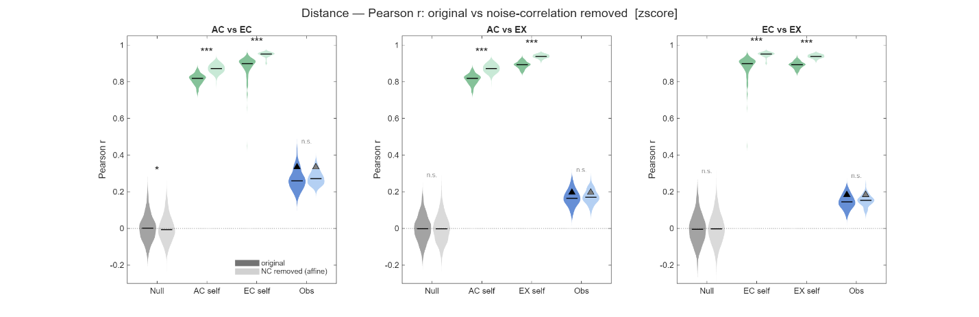
cos_distributions_nc_zscore
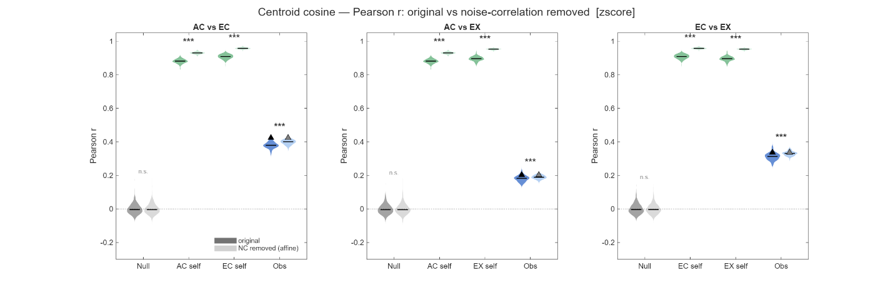
Details:
These are the same Null, Self and Obs distributions as in I-ii, recomputed after breaking noise correlations (NC) and overlaid on the original (darker = original, lighter = NC removed). NC is removed by a deterministic cyclic shift of the ten trials within each (neuron, stimulus) block, with a per-neuron pattern keyed to the recording session. Each neuron's responses are unchanged; only their trial alignment across neurons is broken. The trial-averaged point estimate (triangle) is therefore unchanged by construction, and NC can act only on the bootstrap distributions. Original and NC-removed runs share matched resamples and are compared with a paired signed-rank test.
Interpretation:
- (1) The point estimates coincide, and the null stays at 0.
- (2) Self ceilings rise (z-scored distance: AC 0.82→0.87, EC 0.90→0.95, EX 0.89→0.94). Obs is unchanged for distance and rises by only 0.01–0.03 for cosine.
The question is whether the cross-rendering geometric correspondence could be artificially produced by trial-by-trial noise correlations across neurons. If shared population noise contributes similarly across conditions, then in principle it could inflate correlations between their representational geometries.
We repeat the geometry analysis after removing trial-by-trial noise correlations using a trial-cycling/shuffling procedure. This preserves each neuron's stimulus-locked mean response but disrupts the simultaneous trial-to-trial covariance structure across neurons. We then recompute the null, within-condition self-consistency ceilings, and cross-rendering correlations for both Euclidean distance and cosine similarity, comparing the original and noise-correlation-removed data.
The results are very consistent across panels. First, the deterministic trial-averaged cross-rendering point estimate is unchanged, as expected, because trial shuffling does not alter the mean response vector for each stimulus. Second, the null distribution remains centered near zero. Third, removing noise correlations improves the within-condition self-consistency ceilings, for example from about 0.82 to 0.87 for AC, 0.90 to 0.95 for EC, and 0.89 to 0.94 for EX in the z-scored distance analysis. This indicates that correlated trial-to-trial fluctuations reduce the reproducibility of the estimated geometry.
Crucially, however, the cross-rendering correlations do not decrease after noise-correlation removal. For Euclidean distance, the observed distributions are essentially unchanged; for cosine similarity, they shift only slightly upward. Thus the effect goes in the opposite direction from what would be expected if shared noise were manufacturing the cross-rendering correspondence. In conclusion, the cross-rendering geometric correspondence is not explained by trial-by-trial noise correlations. Removing noise correlations improves within-condition geometric reliability but leaves the cross-rendering correlations essentially unchanged, or slightly increased. Noise correlations therefore limit the precision with which representational geometry is estimated, but do not appear to generate the shared geometry across AC, EC, and EX.

Point 3 – A rotation with ~N²/2 free parameters can manufacture transfer [done; corrected control]
This leads us to the main point of this review: the crucial component that is unfortunately missing in this manuscript is evidence that successful transfer decoding actually implies a special geometric structure ("invariance") of the neural representations, as the authors claim. This is not obvious, because the rotation that is fit to transform the neural representation has a lot of parameters (of order N^2 for N neurons). For a linear SVM (which is how the authors describe their decoder in the main text) it is easy to see that the cue-transfer decoding procedure does not imply any special geometric structure of the neural representations. This is because the predictions of a linear SVM depend solely on a decision boundary described by a hyperplane in the neural activity space, and a rotation of the activity patterns is equivalent to a rotation of this hyperplane. This means that as long as one decoder can correctly classify the stimuli for one rendering, and another decoder can correctly classify them for another rendering, cue-transfer decoding will work, because the Procrustes transformation of the representations can effectively turn the decision boundary of one decoder in that of the other one. (This is related to the fact that the decision boundary is specified by only N parameters - much fewer than those involved in fitting the rotation).
The concession up front. We agree: a freely fit rotation can produce transfer between representations that share no structure, so PT against the 2% chance baseline is not evidence of shared geometry. We therefore score PT against a correspondence-shuffled control with the same rotation freedom (I), and control the rotation's degrees of freedom directly (II). The synthetic version of the argument (Model 1) is in Point 5.

I. With the stimulus correspondence destroyed, a fitted rotation still transfers far above chance

The correspondence-shuffled control reaches 0.06–0.22 (chance 0.02), and true PT exceeds it in 11 of 12 population × pair cells.
fig3b_cue_transfer_full (neuron_decoding_rev; replaces main Fig. 3b)
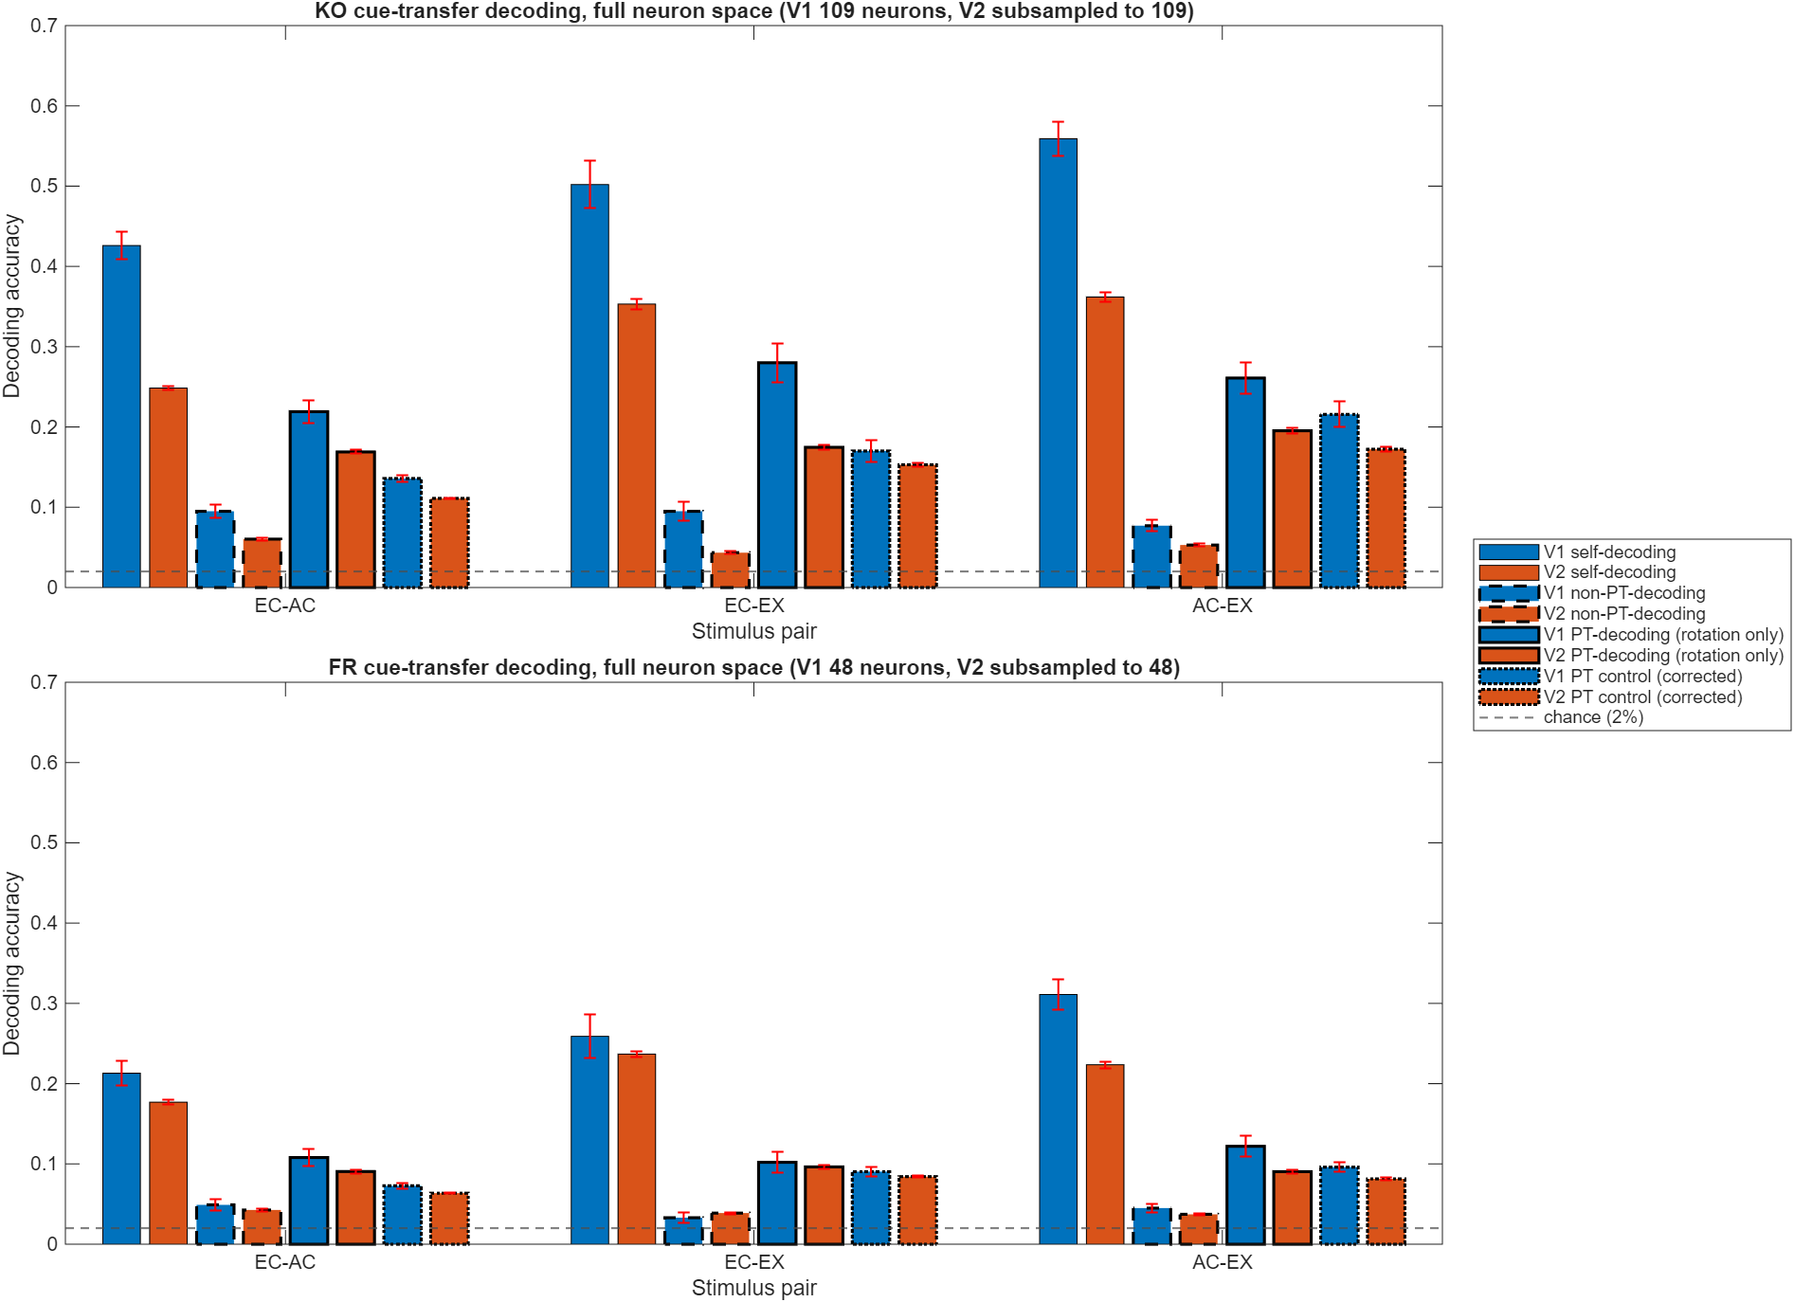
Details:
A permutation π of the 50 stimuli is applied to the source rendering's training means. A rotation-only Procrustes map is fit from these permuted means onto the target means, and the same π is applied to the held-out source trials, which are then decoded by the target decoder and scored against the target labels. This is the most transfer that rotation freedom alone can produce. (The earlier control applied the shuffled rotation to unshuffled test trials, so it sat at chance.) Rotation-only PT throughout; 10-fold trial partition shared by source and target; V2 subsampled to the V1 count (KO 109, FR 48 neurons); 20 neuron draws.
Interpretation:
- (1) Unrestricted PT can manufacture transfer: the control sits at 0.06–0.22, far above chance and above non-PT in every cell.
- (2) True PT still beats this equally flexible control (PT/control 1.11–1.65 per pair; it closes 14–25% of the control-to-self gap, i.e. headroom 0.14–0.25).
As the reviewer pointed out, high cross-cue decoding after fitting a full Procrustes rotation does not, by itself, prove that the two neural representations already possess a special shared geometry.
The reason is the flexibility of the fitted rotation. With N neurons, an orthogonal rotation has roughly N(N−1)/2 degrees of freedom. If the number of neurons is large relative to the number of stimulus classes, that transformation has considerable freedom to align two otherwise unrelated sets of class representations. A linear decoder then only needs the transformed classes to fall on the appropriate sides of its decision boundaries. Thus, good post-Procrustes decoding can partly reflect the flexibility of the alignment procedure rather than pre-existing geometric invariance.
To address this concern, we destroy the true stimulus correspondence between the two renderings by applying a permutation π to the stimulus identities. We then fit a rotation-only Procrustes transformation using this deliberately false correspondence. We found the PT decoding based on a correspondence-shuffled mapping remains well above the theoretical 2% chance level, even though the genuine stimulus correspondence has been destroyed. In contrast, our earlier results only show that when the result is evaluated relative to the actual stimulus identity correspondence, performance collapses toward chance. Our new experiment demonstrates that a high-dimensional rotation can indeed manufacture a decodable correspondence between two sets of class representations even when the correspondence is arbitrary.
Does shared geometry exist at all? Our transformation-free analyses from Point 2 still support correlations of pairwise distances/cosines, null distributions, reliability ceilings, noise controls, etc. Those analyses show genuine though partial preservation without fitting an N²-parameter transformation.
Does Procrustes exploit that genuine structure beyond what its flexibility alone can manufacture? We compare the Procrustes results against a matched correspondence-shuffled Procrustes null, and found the alignment (with PT decoding) does exceed the appropriate Procrustes null (i.e. shuffled-correspondence PT in the figure) in 11 of 12 population × pair cells, consistent with some preservation of geometry across cues.

II. Controlling the rotation's degrees of freedom

Adding neurons raises the control almost as fast as PT, as the reviewer predicted.
fig4c_cue_transfer_vs_N (neuron_decoding_rev; replaces main Fig. 4c)
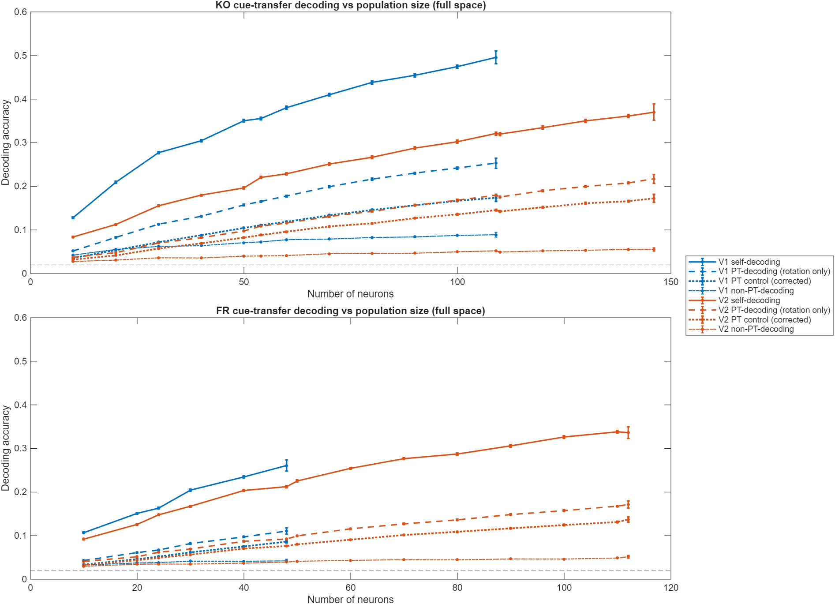
Details:
Self-decoding, PT, corrected control and non-PT as the population is subsampled in 10-neuron steps (20 draws per size, 50 classes). Each added neuron adds rotation parameters (N(N−1)/2 in total).

Restricted to k PCs, PT stays above the control at every k ≥ 2. The PT/control peak near k = 5 is a floor effect: the share of transferable structure (headroom) rises slowly with k.
pc_cue_metrics_vs_k (neuron_decoding_rev)
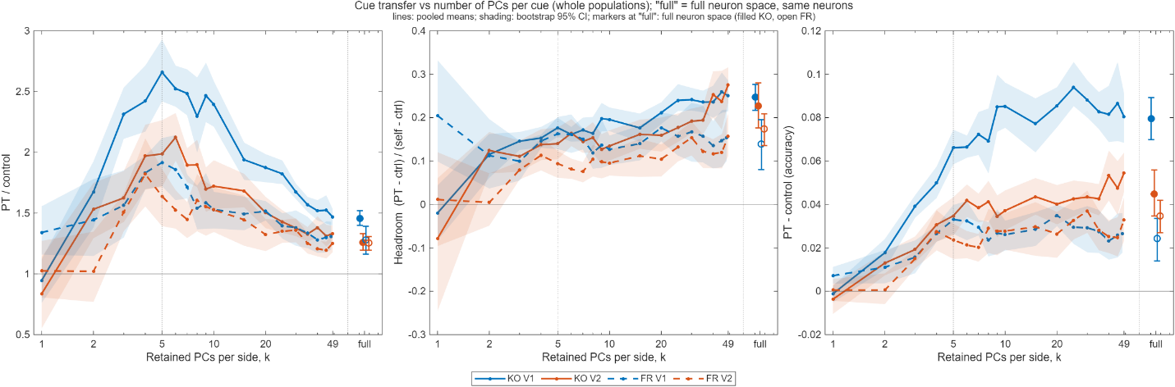
Details:
Each rendering is projected onto its own top k PCs of the 50 stimulus means (basis estimated from training trials only), and the rotation-only map is fit in that k-dimensional space, giving k(k−1)/2 free parameters (10 at k = 5). k = 1–49, whole populations. Left: PT/control; middle: headroom; right: PT − control. The "full" markers are the full neuron space with the same neurons.
Interpretation:
- (1) Neurons sweep: PT and the control rise together, so a PT curve alone overstates how transfer grows with N.
- (2) PC sweep: PT/control is highest near k = 5 (1.64–2.66, vs 1.25–1.46 in full space) because the control falls toward chance there. Headroom is 0.09–0.18 at k = 5 and 0.14–0.25 in full space.
- (3) PT − control is positive at every k ≥ 2, so the transfer contains a component that rotation freedom alone does not produce.
- The correspondence-shuffled control shows directly that unrestricted PT can manufacture transfer.
- The low-dimensional analysis shows that when rotational DOF are constrained, true PT exceeds the DOF-matched shuffled PT baseline.
Furthermore, we directly tested the reviewer's degrees-of-freedom explanation by restricting Procrustes alignment to progressively lower-dimensional PC subspaces. A rotation in k dimensions has only k(k−1)/2 free rotational parameters (e.g., 10 at k = 5, 45 at k = 10), dramatically reducing the flexibility of the transformation relative to the full neural population. We then compared transfer using the true stimulus correspondence with an identically fitted correspondence-shuffled PT null. In the strongly restricted regime (k = 5), true-correspondence PT was about 1.6–2.7-fold above the shuffled PT control, against 1.25–1.5-fold in the full neural space. This ratio is largest at small k mainly because the control falls toward chance there, not because more shared structure is revealed: measured as headroom, true PT recovers 9–18% of the control-to-self gap at k = 5, and this fraction rises slowly toward the full-space value (14–25%) as k grows. As rotational flexibility increases, the shuffled control rises, but true PT rises with it and stays above it at every k ≥ 2. Thus, while unrestricted PT can indeed manufacture transfer, the low-dimensional result demonstrates that the observed transfer contains a component attributable to genuine cross-cue representational correspondence rather than transformation flexibility alone.
Dropped from TS3: the Procrustes-residual panel (d) and its paragraph, which Prof. Lee flagged as possibly not central.

Point 4 – Comparison with CCGP (Bernardi et al., 2020) [done]
To put this in context, the authors might want to compare their analysis procedure to the Cross-Condition Generalization Performance of Bernardi et al. (Cell, 2020), where the main point is that the neural representations have a special structure (related to abstraction) when a decoder fit in a training context can generalize to a testing context (with different experimental conditions, e.g. different stimulus features) without rotating the neural representations or decision boundaries.

I. Our closest CCGP analogue is non-PT transfer, which is above chance but modest

Without any rotation, cue transfer is 0.03–0.10 (chance 0.02), so the renderings do not share a directly transferable decision boundary.
Figure: the non-PT (dashed) bars of the updated Fig. 3b, shown under Point 3-I.
Interpretation:
We appreciate the reviewer pointing out the important distinction between Procrustes-based cue transfer and CCGP-style cross-condition generalization. We agree that successful cue-transfer after fitting a high-dimensional transformation does not, by itself, establish abstract invariance in the CCGP sense. Indeed, as already shown in Fig. 3b of the manuscript, cue transfer without Procrustes alignment—the analysis most analogous to CCGP—is above chance but relatively modest. These results suggest that V1/V2 representations do not exhibit strong abstract invariance across EC, AC, and EX in the sense of a common, directly transferable decision boundary.
Our claim is therefore more limited and concerns partial preservation of representational geometry rather than pre-aligned abstraction. Specifically, transformation-free analyses of stimulus relationships (pairwise distances, cosine similarity, and angular relationships) demonstrate that the relative organization of stimuli is partially preserved across renderings. Procrustes alignment reveals that these partially conserved structures can be brought into stronger correspondence, but we do not claim that the representations are already aligned in early visual cortex. Rather, we propose that early visual representations retain geometric relationships that provide the substrate upon which downstream circuits could perform alignment operations to achieve cue-invariant readout.
We further note that a natural question is whether the learned alignment itself generalizes to held-out stimuli. In full-dimensional space, this analysis is limited by the large number of degrees of freedom relative to the number of stimuli, which is precisely the motivation for our dimensionality-restricted PT analyses and correspondence-shuffled controls.
Note that this is about how the different stimuli (of different nature) are organized in neural space, I guess I want to see if the relationship being preserved across cues. I am not sure it is an issue of invariance or equivariance, or Fusi's CCGP is relevant here.

II. (Optional) A rotation learned on 48 stimuli generalizes to 2 held-out stimuli only for AC↔EC (candidates for the supplement)
cross_stim_gen_HoldStim2_KO_V2
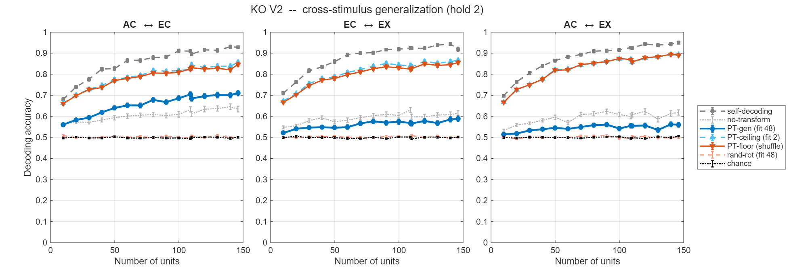
Details:
Two stimuli are held out of the rotation fit. A rotation-only map is fit on the other 48 stimulus means and applied to the 2 held-out stimuli; a 2-class decoder trained on their target-rendering trials scores their rotated source trials (pt-gen). References: no-transform (no rotation), the in-sample bracket (pt-ceiling: rotation fit on the 2 stimuli; pt-floor: shuffle control), self-decoding, and chance (0.5). KO V2 shown; the other populations and a decoder-free nearest-centroid version give the same ordering.
Interpretation (ZW draft, condensed):
- (1) pt-gen beats no-transform only for AC↔EC (clearest in KO V2 and FR V2, comparable in KO V1 and FR V1); it is about equal for EC↔EX and below for AC↔EX. In the strict 1-in-50 nearest-centroid version, the rotation beats no rotation for no pair.
- (2) So the PT advantage seen when the rotation has seen every stimulus is largely stimulus-specific, with AC↔EC the partial exception. The in-sample ceiling and floor coincide because, with 2 anchors and N ≫ 2, a rotation can force any correspondence (Point 3 at small scale).

Point 5 – Benchmarking PT decoding on synthetic data (neurons × classes) [done: Models 1 and 3, partial-sharing family; Models 5–6 not built]
The decoder that's actually used in this paper is of course a multi-class classifier and from the methods I gather that it's essentially a one hidden layer neural network composed of several linear SVMs, which means that the decision boundaries are more complex and pieced together from the linear decision boundaries of individuals component SVMs. Because this decoder has more parameters, it's not immediately clear if successful cue-transfer decoding puts strong constraints on (the relationship between) the neural representations for two different rendering styles. Whether or not this is the case will likely depend on the ratio between the number of neurons and the number of stimulus classes to be classified. (Fewer classes and more neurons makes it easier for the Procrustes transformation to effectively align the decision boundaries). This needs to be studied systematically before we can draw any conclusions about what cue-transfer decoding really tells us.
A good starting point would be to benchmark the analysis pipeline on artificially generated data sets, where one can vary the number of neurons, the number of stimulus classes, and the statistics of the corresponding neural representations. E.g. one could use a mixture of Gaussians model for the neural representations, where in the simplest case the mean neural representations would be chosen randomly and independently for each stimulus class and each rendering style. (If cue-transfer decoding worked for this model of the representations, we'd conclude that it doesn't imply any special structure for this decoder architecture, so hopefully this can be ruled out). More interestingly, the mean representations could be determined by a linear combination of contour shape parameters (which are the same across different renderings), and rendering style/appearance parameters, which are different. The interesting question will then be which of the models in this family are consistent with the data, and which of them can be ruled out.
The request in brief:
The reviewer's point is that we cannot interpret successful Procrustes-transfer (PT) decoding as evidence for shared/invariant neural geometry until we know how easily our particular PT + multiclass decoder can produce transfer when the underlying representations are unrelated.
Why? Because our pipeline has substantial flexibility:
- many neurons N
- 50 stimulus classes
- a high-dimensional Procrustes rotation with roughly N(N−1)/2 rotational degrees of freedom
- a multiclass decoder composed of multiple linear SVM decision boundaries
With many neurons and a limited number of stimulus classes, coordinate rotation may have enough freedom to align the representations and decoder boundaries even when the two representations have no meaningful relationship.
So the reviewer wants to know how the PT performance depends on the ratio of neural dimensionality to number of stimulus classes.

I. Model 1 (no shared structure) vs. Model 3 (fully shared geometry)

Under the null, PT equals the corrected control at every N and class count; with shared geometry, PT stays well above it.
fig1_synthetic_benchmark (Simulations_v2)
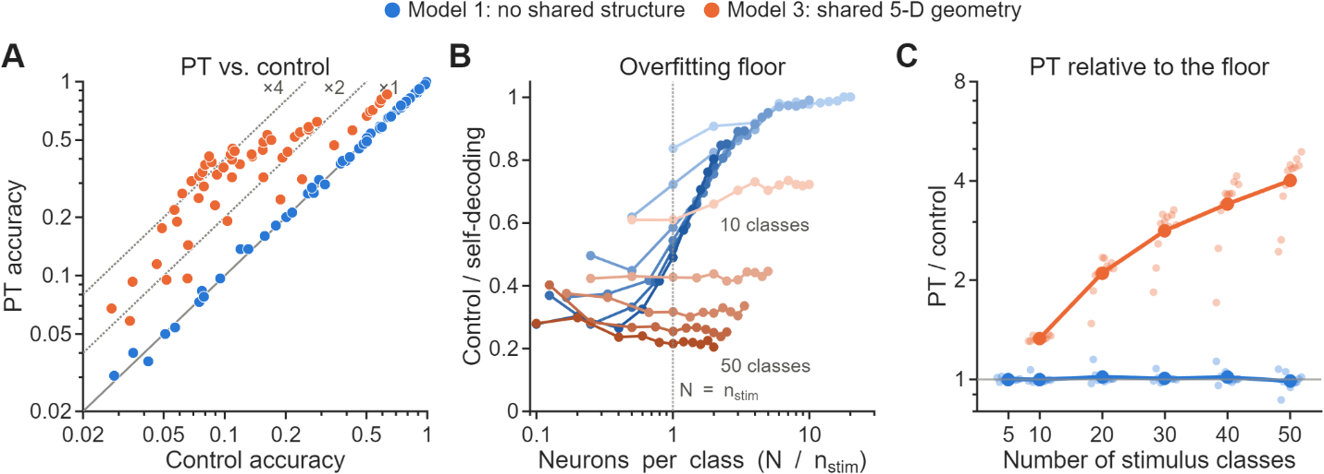
Details:
Synthetic populations take the recordings' single-neuron statistics (median count 9.4 spikes, tuning CV 0.14, Poisson trials) and are decoded with the same pipeline and corrected control as the data. Model 1: each neuron's mean response to each stimulus is drawn independently per rendering (the reviewer's "simplest case"). Model 3: means are a linear readout of a shared 5-D stimulus latent, with an independent readout per rendering. Sweep: N = 5–100 neurons × 5–50 classes (Model 3: 10–50), 16 populations per point. (A) PT vs. control; (B) control/self vs. neurons per class; (C) PT/control vs. number of classes.

The recordings lie between the two models: Model 1 has PT/control ≈ 1 at a higher dimensionality, while Model 3 matches their self-decoding and dimensionality but gives a margin about three times larger.
fig2_recorded_vs_models (Simulations_v2)
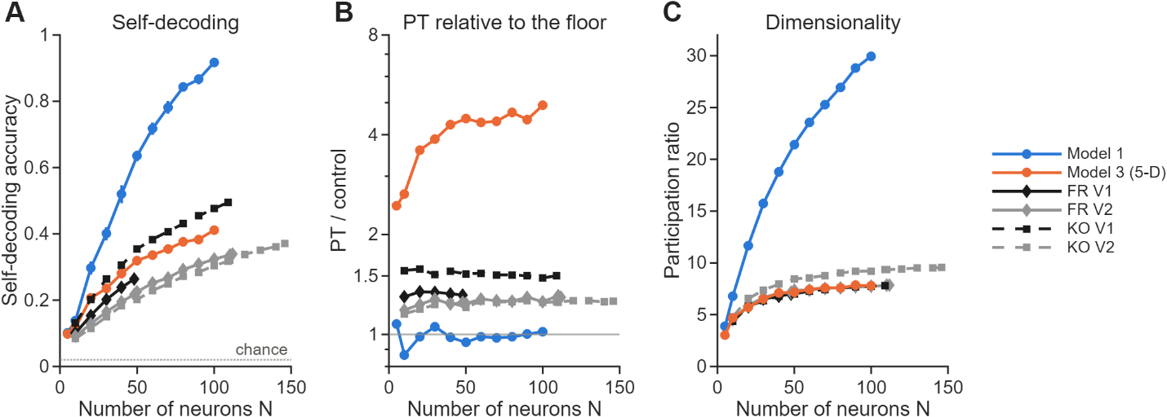
Details:
Recorded curves subsample neurons from each population (FR solid, KO dashed; V1 black, V2 grey) and use the same decoder and control as the models, at 50 stimulus classes; Model 3 has a 5-D shared latent. (A) Self-decoding (dotted line: chance); (B) PT/control (grey line: PT = control); (C) participation ratio of the z-scored, trial-averaged class means. Error bars in A: SEM across synthetic populations (models) or resamples (recorded data).

II. Partially shared geometry (α = shared fraction)

Headroom tracks the shared fraction α and hardly depends on N or the class count, whereas PT/control depends strongly on the class count.
fig1_partial_sharing_calibration (Simulations_v3_partial_sharing)
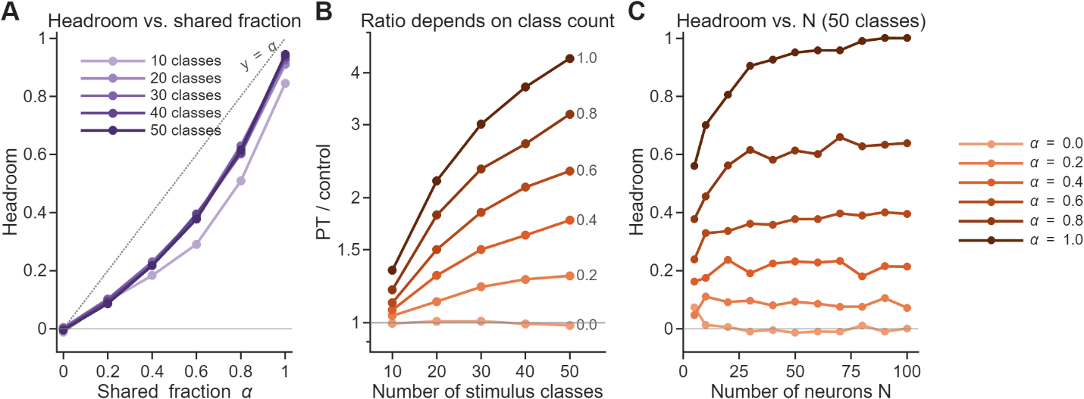
Details:
Each rendering has K = 5 latent dimensions, K_s of them shared across renderings (α = K_s/K = 0–1). Within-rendering statistics (tuning, participation ratio, self-decoding) are identical at every α, so only the cross-rendering relation changes. α = 1 is Model 3; α = 0 is a null at the recorded dimensionality.

The recorded populations sit at α ≈ 0.3–0.45 in this family, and their headroom stays flat over 20–50 stimulus classes, as the family predicts.
fig2_recorded_vs_partial_sharing (Simulations_v3_partial_sharing)
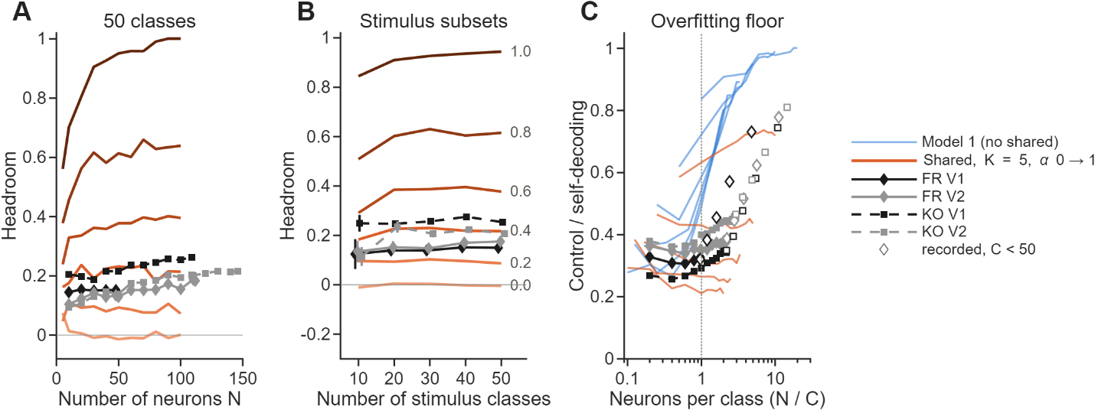
Details:
The recorded populations are decoded with the same decoder and control (A) at full size vs. N and (B) on random subsets of C = 10–50 stimuli (16 subsets per C); (C) the overfitting floor (control/self) vs. neurons per class, recorded and synthetic.
Interpretation (new draft, for Prof. Lee to review):
- (1) The reviewer's concern is confirmed and quantified. With no shared structure (Model 1), PT matches the corrected control everywhere (PT/control median 1.00), and the control approaches self-decoding as neurons outnumber classes (control/self 0.28–0.50 at N/n_stim ≤ 0.25; 0.97–1.00 at N/n_stim ≥ 6). Raw PT against chance therefore cannot certify shared geometry.
- (2) The corrected control separates the models: with fully shared geometry (Model 3), PT ≈ self and PT/control is 3.6–4.9 at 50 classes (N ≥ 20).
- (3) At the recordings' operating point neither extreme fits (fig2_recorded_vs_models). Model 1 reaches the recorded self-decoding (N = 20–40) only at a higher participation ratio (12–19 vs. 7.0–9.5) and with PT/control 0.98–1.05. Model 3 matches the recorded self-decoding and participation ratio (N = 40–100) but gives PT/control 4.3–4.9, about three times the recorded 1.26–1.50. This motivates the partially shared family below.
- (4) Headroom is the calibrated readout: 0.09, 0.22, 0.38, 0.62 and 0.94 for α = 0.2–1.0 (50 classes), changing by at most 0.03 between 20 and 50 classes.
- (5) Recorded headroom (0.15–0.26) corresponds to α ≈ 0.30–0.46 within this family, which rules out both no sharing (Model 1, α = 0) and full sharing (Model 3).
- (6) Caveats: α is defined within this family (linear readout, K = 5), so it calibrates rather than measures "how much is shared". The recordings' floor (control/self 0.33–0.45) is also higher than the family's (0.20–0.24) at matched self-decoding and dimensionality.
Not built: Model 2 (reduces to Model 1), Model 4 (equivalent to Model 3), Model 5 (three renderings, different α per pair), Model 6 (nonlinear shared features).

Point 6 – How could downstream areas use the rotated geometry? [discussion point]
Other considerations the authors might want to expand on are how the brain could actually take advantage of their notion of "cue-invariance" if it indeed holds up, i.e., what would be the computational advantages (compared to say just using orthogonal subspaces for contour shape and rendering style), and how could this actually be achieved from the perspective of higher visual areas? Do the authors believe that a downstream readout can rotate the neural representation dynamically depending on the rendering style to read out the contour shapes of the stimuli? One wonders how this would be implemented in a network, especially given that rendering style is probably not discrete variable, but a multi-dimensional continuum, and each point in this style-space could correspond to a different rotation. Furthermore, the data preprocessing involves z-scoring of the representations (separately for the different rendering styles?), so this would probably also have to implemented by the readout system if the brain was to take advantage of the structure of representation implied by cue-transfer decoding.
Interpretation:
Thus, we do not assume that EC, AC, and EX constitute points along a single continuous rendering-style axis. EC is designed to isolate boundary/contour structure, AC provides a richer but simplified visual manifestation of that structure, whereas EX embeds the same object information in substantially richer physical image statistics. Thus, these conditions are better regarded as distinct, biologically meaningful visual representations than as arbitrary samples from a homogeneous rendering continuum. A continuum certainly exists within the space of image appearance (e.g., texture, color, illumination, and material variation), but our data do not establish how the corresponding neural transformations vary across that continuum. The Procrustes transformation should therefore be interpreted as a descriptive characterization of the relationship between the particular representational spaces sampled here, rather than as evidence that the brain applies a separate rotation for every possible rendering.
The stronger correspondence between EC and AC, together with the weaker correspondence involving EX, is therefore consistent with two complementary interpretations. On the one hand, the additional image statistics in EX may act as nuisance variation that obscures otherwise shared shape geometry. On the other hand, the reduced correspondence may indicate that representations in V1/V2 remain substantially tied to the physical statistics of the image rather than being fully abstract or rendering-invariant. Thus, our results suggest not complete abstraction at the level of early visual cortex, but a partial abstraction in which shape-related geometry is preserved while remaining embedded in cue-dependent visual representations.
Supporting facts (ZW draft, condensed and updated to the rerun; for Prof. Lee to review):
- (1) The transformation a readout would have to undo is low-dimensional: the noise-corrected participation ratio saturates at 4.3–5.2, and the top 5 PCs hold 64–90% of the noise-corrected signal variance (neuron_decoding_rev, 08_dimensionality).
- (2) Where the alignment generalizes, it is a fixed per-pair map: a rotation fit on 48 stimuli transfers to held-out ones for AC↔EC only (Point 4-II).
- (3) Across areas (V1↔V2, updated Fig. 4b), PT is above the corrected control in both directions and both monkeys (pooled headroom 0.24–0.26), at the level of cue transfer.
- (4) Z-scoring is per neuron and separate for each rendering, as the reviewer surmised; per-neuron gain normalization resembles standard cortical operations such as divisive normalization. The shared geometry is weaker without it (raw-count distance r ≈ 0.04–0.17 vs. 0.18–0.34 z-scored, KO V1), and whether cortical normalization suffices is open.

Point 7 – Pseudo-population: missing noise correlations and block-structured rotations [done; block-structure analysis not run]
Another subtle point in the analysis that requires careful considerations is that the neurons in the data set were presumably not simultaneously recorded. This means we actually have limited information about the correlations between neurons, which will probably affect the statistical power to draw conclusions about the structure of neural representation from successful transfer decoding (i.e. for ruling out certain models of representations), which needs to be studied. It will also affect the types of rotations found in the actual data analysis. E.g. one may find a block-diagonal structure in the fit rotation matrices corresponding to the sets of simultaneously recorded neurons.

I. Noise correlations are real within sessions but small across the pseudo-population

In KO V1, same-session pairs carry mean NC ≈ 0.13–0.15, while cross-session pairs (≈ 81% of all pairs) carry ≈ 0.02–0.04.
delta_mean_nc_by_session (KO V1)
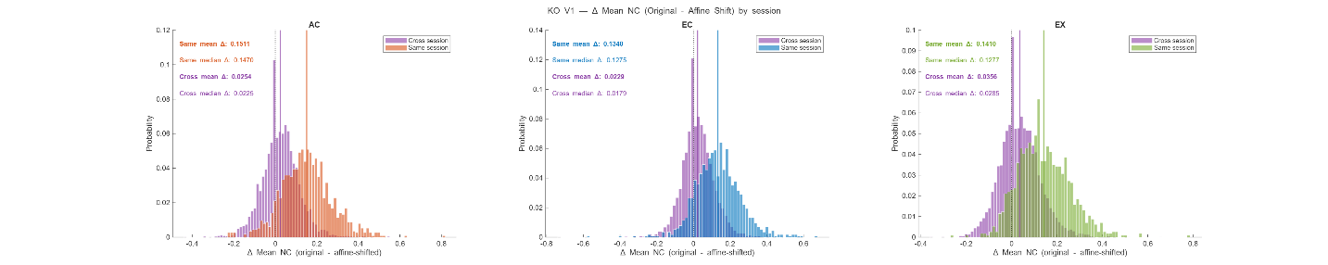
Details:
For each neuron pair, the noise correlation at a stimulus is the Pearson correlation of the two spike counts across the 10 repeats, averaged over the 50 stimuli; pairs are tagged same- or cross-session from the recording metadata. Histograms show how much NC the trial-cycling shift removes (original − shifted). KO V1 shown. All four populations: same-session 0.11–0.20, cross-session 0.01–0.04, population average 0.03–0.05.

II. Removing NC barely changes transfer decoding, in the pseudo-population and within real sessions

Within single recording sessions, where real NC is present, decorrelation produces small, sign-inconsistent, non-significant changes.
procrustes_decoding_per_session_pooled_pairs
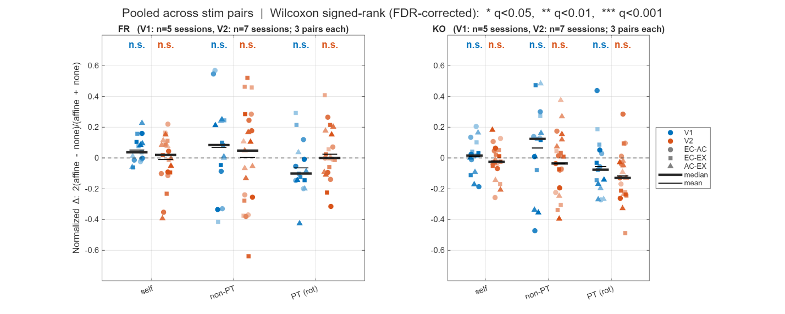
Details:
The pseudo-population is split back into its recording sessions (5 for V1, 7 for V2 per monkey; ≈ 5–15 neurons each), and the PT pipeline is run per session with real NC ("none") and with NC removed ("affine" shift). For each monkey, area and decoding type, the normalized changes 2(affine − none)/(affine + none) of all sessions × 3 pairs are tested against 0 (Wilcoxon signed-rank, BH-FDR over 12 tests). On the full pseudo-population, the same shift raises self-decoding by at most 0.07 and lowers PT by at most 0.04 (figure not shown: that run still uses the old control).
Interpretation:
- (1) NC is concentrated in the ≈ 19% of pairs that are same-session, so the pseudo-population carries little of it.
- (2) Within sessions, nothing survives FDR (most negative: KO V2 PT, median −0.13, q = 0.076).
We thank the reviewer for pointing out this limitation of the pseudo-population. We addressed it in two ways. First, we quantified trial-by-trial noise correlations and found substantial correlations among simultaneously recorded neurons (mean r ≈ 0.11–0.20), but little correlation across recording sessions (r ≈ 0.01–0.04); because most neuron pairs in the pseudo-population are cross-session, the resulting population-level correlation is modest (0.03–0.05). We then destroyed the remaining noise correlations by independently cyclically shifting trials for each neuron, preserving each neuron's stimulus-averaged response while eliminating trial-aligned cross-neuron covariance, and repeated the complete PT analysis. Removing noise correlations produced only small changes: self-decoding increased whereas PT transfer decreased slightly, but PT remained well above chance for every rendering pair and population.
Most importantly, we repeated this analysis within the genuinely simultaneously recorded populations, where the actual noise correlations are present. Across individual recording sessions, removing noise correlations produced small, session-dependent changes with no consistent direction, and the session-level pooled tests were nonsignificant. Thus, within the limits of the small simultaneously recorded populations, we find no evidence that the cue-transfer effect is driven by the missing noise correlations of the pseudo-population.
The reviewer also raised the possibility that the Procrustes transformation might acquire block structure associated with recording sessions. Because the transformation is fitted to trial-averaged stimulus means rather than trial-by-trial covariance, the recording-session partition is not available to the fitting procedure.
[Pending: analysis not yet run] (This is assuming that there is no effect.) We additionally tested whether the fitted Procrustes transformation exhibits block structure associated with recording sessions. For each neuron, we computed the fraction of its rotational weight T_ij² that remains within the same recording session, and compared this value with a permutation null obtained by randomly shuffling session assignments. The observed within-session weight was comparable to the permutation distribution, indicating no evidence that the Procrustes transformation preferentially mixes neurons within the same recording session. Thus, although neurons recorded within the same session may share tuning properties due to their local cortical organization, we find no detectable session-specific block structure in the fitted transformation itself. This provides an additional control against the possibility that the apparent cross-cue alignment is driven simply by the organization of the pseudo-population across recording sessions.

Reviewer #2

Point 8 – Inject realistic noise correlations into the pseudo-population [injection simulation not done]
1. Pseudo-population construction eliminates noise correlations that shape real population geometry. The authors build pseudo-populations from non-simultaneous recordings (lines 411-414). While standard, this eliminates noise correlations that shape local manifold curvature, effective dimensionality, and the orientation of trial-to-trial variability, all of which influence Procrustes alignment and SVM decoding on single trials. A simulation injecting structured noise correlations of realistic magnitude (mean pairwise r = 0.05-0.15) into the pseudo-population would test whether PT decoding accuracy is robust or systematically biased by the independence assumption.
Point 8 largely overlaps with Point 7, but the reviewer does ask something specific: inject realistic, structured noise correlations into the pseudo-population and see whether PT decoding changes.
The overall story: (1) remove NC from the real data, and PT survives (Point 7); (2) add NC to synthetic data, and PT remains robust (Point 8, pending). The injection simulation is therefore the main new analysis for Point 8. Already covered elsewhere: geometry with NC removed (Point 2-II), orientation of trial-to-trial variability (Point 2-III-ii), effective dimensionality (Point 6).
We agree that the pseudo-population does not preserve the trial-by-trial noise correlations present in simultaneously recorded populations. We addressed this concern in three complementary ways. First, our geometric analyses are based on trial-averaged stimulus responses. The trial-cycling procedure used to remove NC preserves each neuron's stimulus mean exactly while eliminating trial-by-trial covariance; accordingly, the cross-rendering stimulus geometry is unchanged, while the within-condition reliability ceiling increases. Thus, the measured mean-level geometry does not depend on the presence of NC.
Second, we directly tested the effect of NC on single-trial PT decoding. In genuinely simultaneous populations, which contain the actual noise correlations, removing NC produced only small, nonsystematic changes in PT transfer, with no significant session-level effect. In the full pseudo-population, removing NC similarly left PT transfer well above chance.
Third, to directly address the reviewer's proposed test, we injected structured noise correlations into the synthetic populations at realistic levels (r = 0.0, 0.05, 0.10, 0.15), with the correlations organized according to the sizes of the simultaneously recorded groups, and repeated the complete PT analysis. [RESULT.] PT accuracy and, importantly, its DOF-matched margin over the shuffled null remained [stable / only modestly changed] across the injected-NC range.
Together, these analyses indicate that the independence assumption of the pseudo-population does not materially account for the observed PT transfer. NC affects the reliability of single-trial responses, but we find no evidence that it generates the cross-cue transfer or the underlying mean-level geometric correspondence.
What to do to get the results? Add noise to Model 1 / Model 3 (different levels, r = 0, 0.05, 0.1, 0.15). We want to see if the PT transfer (classification) results do not change much with noise level; if PT transfer in the model changes dramatically, then we can't say PT is robust against noise correlation. Is this really necessary?

Point 9 – What do neurons add beyond a Gabor filter bank? [done with the corrected control; statistical test pending]
2. Geometric invariance also emerges from Gabor filter banks, and the paper needs to articulate what the neural data add. The Gabor model analysis (Fig. 15) shows that filter banks produce PT decoding well above chance. The paper notes that Gabor models lack single-neuron tuning invariance (lines 875-876), but should sharpen this by statistically comparing neural versus Gabor PT decoding at matched population sizes and reporting intrinsic dimensionality (e.g., participation ratio) for both. If neural manifolds achieve comparable invariance in fewer effective dimensions, this would distinguish the biological finding from a generic filter-bank property.
The reviewer is essentially saying: if a simple bank of Gabor filters already produces cue-transfer geometry, what is special about the neural data? They request (1) neural vs. Gabor PT decoding at matched population size and (2) a comparison at matched intrinsic dimensionality, using participation ratio (PR). The interesting hypothesis: if neurons achieve comparable or greater cue-invariant transfer with fewer effective dimensions, the neural result is not simply a generic consequence of having a bank of feature filters. That is the real target.

I. With the corrected control, most of the Gabor models' PT is rotation freedom

Gabor PT exceeds its corrected control by only 0.04–0.06 (headroom 0.04–0.09).
fig15_gabor_cue_transfer_full (Gabor_decoding_rev; replaces appendix Fig. 15)
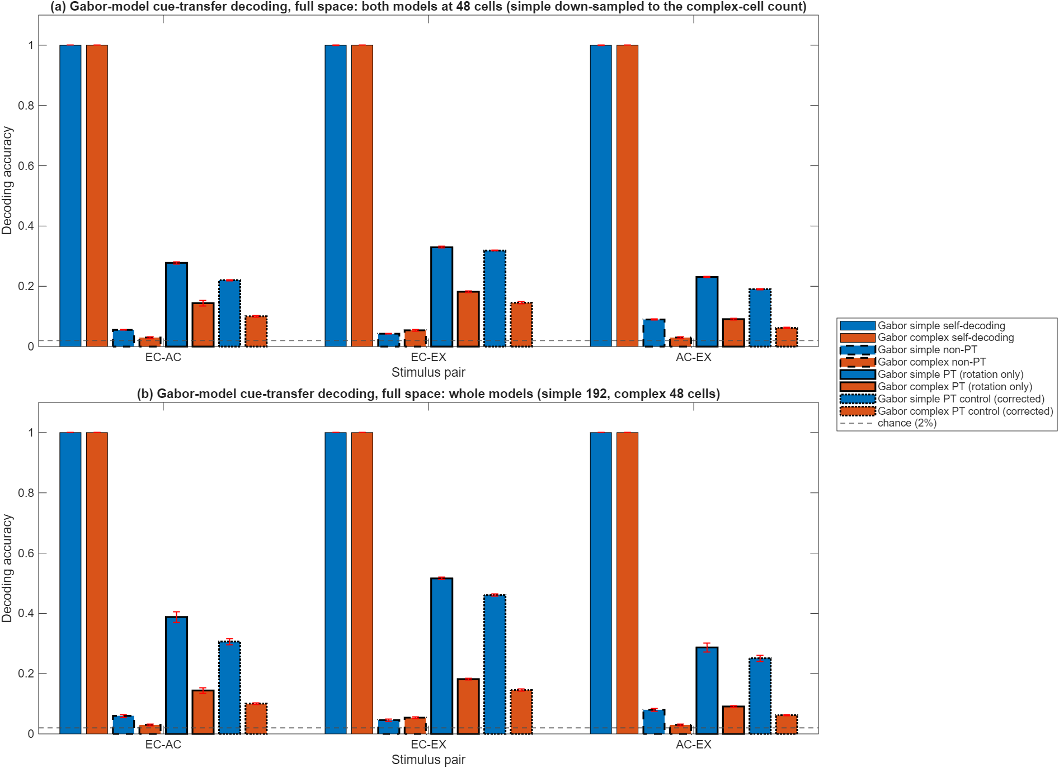
Details:
Simple-cell model (192 rectified even/odd filters: 3 scales × 16 orientations × ON/OFF) and complex-cell model (48 energy units); Poisson trials from the filter responses; same decoder and corrected control as the neurons. (a) Both models at 48 cells; (b) whole models.

II. At matched size and at matched dimensionality, neural headroom exceeds both Gabor models

Matched size: the Gabor bank wins on self-decoding and raw PT, but every neural population has higher headroom.
point9_vs_cells (Gabor_decoding_rev)
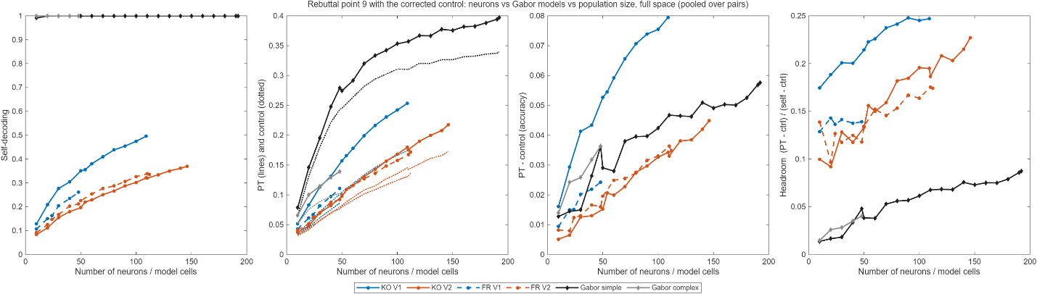
Details:
Population size swept in 10-unit steps for neurons and Gabor cells, full space, pooled over rendering pairs. Panels: self-decoding; PT (solid) and control (dotted); PT − control; headroom.

Matched dimensionality: at the same participation ratio (3–5), the complex-cell model reaches headroom 0.01–0.04, against 0.09–0.25 for neurons.
point9_vs_pr (Gabor_decoding_rev)
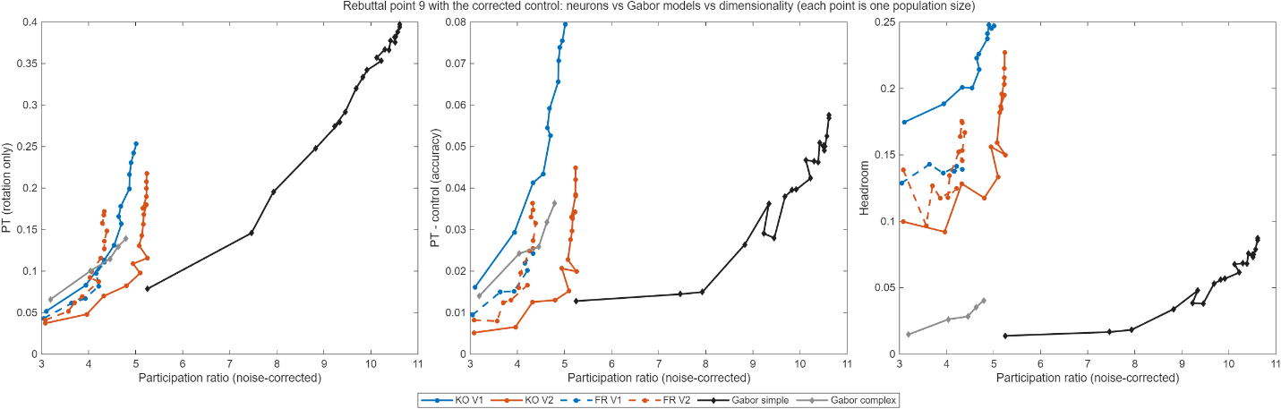
Details:
The same points plotted against the noise-corrected participation ratio of the stimulus-mean manifold, PR = (Σλ)²/Σλ², computed identically for neurons and Gabor cells (Gabor means estimated from the Poisson trials, not from the noiseless filter rates).
Interpretation:
- (1) Raw transfer is not uniquely biological: the Gabor banks reach high raw PT, but mostly through rotation freedom.
- (2) Neurons transfer a larger share of their decodable structure (headroom 0.09–0.25 vs. 0.01–0.09), both at matched size and at matched PR.
- (3) Caveat: in absolute PT − control, only KO V1 exceeds the Gabor bank, and the Gabor trials are nearly noiseless (self-decoding 1.0). A noise-matched Gabor variant is the remaining check.
The Gabor comparison clarifies what is and is not specific to the neural representation. A generic Gabor filter bank produces substantial raw cue-transfer after Procrustes alignment, but most of it is reproduced by an equally flexible correspondence-shuffled control (PT exceeds the control by only 0.04–0.06), so raw transfer alone is not uniquely biological. At matched population size, the Gabor bank actually achieves higher self-decoding and raw transfer, largely reflecting its substantially higher separability. The simple-cell bank also occupies more effective dimensions (noise-corrected PR 5.2–10.6 vs. 4.3–5.2 for neurons), while the complex-cell bank shares the neural range (3.2–4.8). When neural and Gabor representations are compared at matched participation ratio, all four neural populations show higher headroom than both Gabor models: at PR 3–5 the complex-cell model reaches 0.01–0.04 against 0.09–0.25 for neurons, and the simple-cell model reaches 0.04–0.09 only at PR 9–10.6. Consistently, neural populations preserve a substantially larger fraction of their own decodable structure across cues (headroom 0.09–0.25 vs. 0.01–0.09 at every matched size), indicating greater transfer efficiency. In absolute accuracy (PT − control), only KO V1 clearly exceeds the Gabor bank; for the other populations the advantage is relative to their lower decodability. Thus, the neural result is not that neurons are simply more decodable than generic filters; rather, the neural populations—particularly KO V1—organize information in a relatively low-dimensional representation in which a larger fraction of the available structure is shared across rendering conditions. This complements the single-neuron invariance and transformation-free geometric analyses.
Need to do: add an actual statistical comparison at matched PR (and/or matched N), because the reviewer explicitly requested it. We gave point estimates but we need a statistical comparison. Bootstrap distributions? Confidence intervals, or a permutation test comparing neural vs. Gabor at matched PR?

Point 10 – Is AC–EX alignment inflated because AC is built from EX? [done]
3. The AC rendering shares linear structure with EX by construction, potentially inflating cue-invariance estimates. The AC rendering is the first principal component of the same patches defining EX (lines 459-462), making it a linear projection of EX by construction. AC-EX geometric alignment may therefore reflect shared stimulus structure rather than cue-invariant neural coding. Comparing Procrustes residuals across all three rendering pairs (EC-EX, EC-AC, AC-EX) would test whether AC-EX alignment is tighter than expected from genuine cue-invariance alone.

AC–EX is never the tightest pair: it has the largest Procrustes residual in 3 of 4 populations, the weakest angle correlation, and never the highest transfer headroom.
per-pair Procrustes residual summary
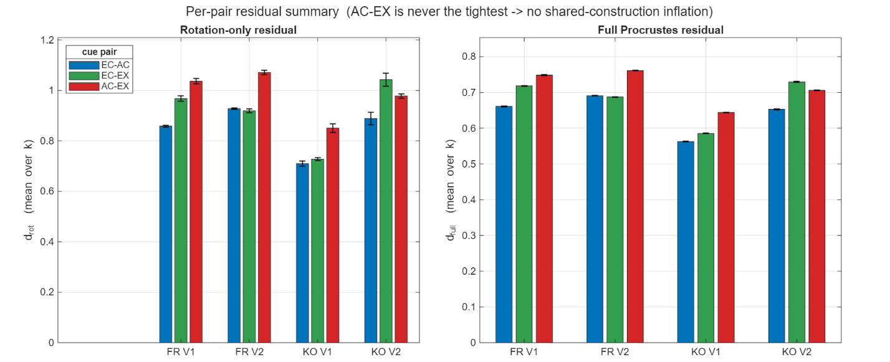
Details:
Rotation-only (left) and full (right) Procrustes residuals of the 50 stimulus means for each unordered rendering pair, averaged over k = 1–49 retained PCs (smaller = tighter alignment).
cue_metrics_per_pair_full (neuron_decoding_rev)
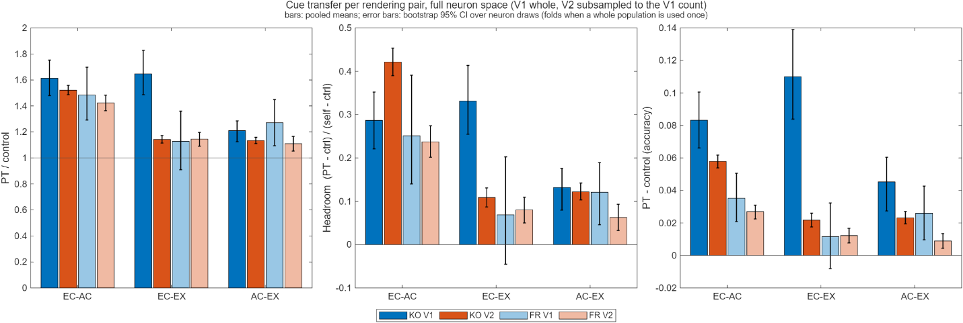
Details:
Cue transfer per rendering pair with the corrected control, full neuron space: PT/control, headroom and PT − control, with bootstrap 95% CIs over neuron draws. The decoder-free geometry per pair is in Point 2-I.
Interpretation:
- (1) The concern predicts AC–EX to be the tightest pair; on all three readouts it never is.
- (2) EC–AC is the most preserved pair: smallest residual, highest angle correlation, and highest headroom in 3 of 4 populations.
The reviewer notes that AC is derived from clusters of the same EX image patches and therefore shares stimulus-level structure with EX by construction. This raises the possibility that the AC–EX correspondence could be artificially inflated. This hypothesis makes a clear prediction: if the shared construction were responsible for the apparent cue invariance, AC–EX should exhibit the strongest geometric alignment among the three rendering pairs.
The data show the opposite. AC–EX is consistently the weakest or near-weakest pair. In KO V1, for example, the decoder-free geometric correlations are AC–EC = 0.43, EC–EX = 0.34, and AC–EX = 0.20 (centroid cosine). Similarly, AC–EX has the largest Procrustes residual in three of four populations, and it is never the pair with the highest transfer headroom. Thus, despite the constructional relationship between AC and EX, it does not produce an anomalously strong AC–EX correspondence. Instead, the strongest correspondence is between AC and EC, which are independently related to the underlying structural content.

Reviewer #2 minor concerns [pending]
1. The cue-transfer decoding methods (lines 552-605) are dense; pseudocode or a numbered step-by-step summary would improve accessibility. 2. Stimuli were 33×33 pixels for V1 and 45×45 for V2; the authors should discuss whether this size difference contributes to V1 > V2 cue-invariance through spatial frequency content differences. 3. Was V2 downsampling to match V1 size (line 181) repeated across multiple random subsamples to verify stability? 4. Procrustes assumes rigid/similarity transformations. Comparing with CCA or CKA would test whether a more general alignment better characterizes the cross-rendering geometric relationship. 5. With 15 figures, the main text is dense. Figures 5, 7, 9, 12, and 13 could be designated supplementary. 6. The 2D PCA projections (Fig. 3a) are visually compelling but Procrustes operates in ~150D; reporting variance captured by the first two PCs would contextualize these visualizations.
[Pending: replies to be written.] Already available: minor 3 (the rerun draws V2 subsamples 20 times) and minor 6 (variance captured per number of PCs: neuron_decoding_rev 08_dimensionality/cumvar_vs_k).

Updated main figures (corrected control)
Paper panel | Replacement | What changes
Fig. 3b | neuron_decoding_rev 02/fig3b_cue_transfer_full (Point 3-I) | Control 0.06–0.22 instead of 0.02; the claim moves from "PT 2–4× non-PT" to PT vs. control.
Fig. 4a | neuron_decoding_rev 02/fig4a_halves_full | Two halves of one area are the same-geometry reference: headroom 0.48–0.68, vs. 0.14–0.25 for cue transfer.
Fig. 4b | neuron_decoding_rev 02/fig4b_across_area_full | PT above the control in both directions; pooled headroom 0.24–0.26.
Fig. 4c | neuron_decoding_rev 03/fig4c_cue_transfer_vs_N (Point 3-II) | The control rises almost as fast as PT with N.
Figs. 12, 13 | neuron_decoding_rev 02/fig12_across_area_all_combos_full, 03/fig13_halves_vs_size | Appendix versions of the above.
Fig. 15 | Gabor_decoding_rev 02/fig15_gabor_cue_transfer_full (Point 9-I) | Gabor PT only 0.04–0.06 above the control.
New panel (option) | neuron_decoding_rev 04/cue_vs_halves_matched_size or 07/pc_headroom_all_comparisons | One-panel summary: cue transfer far above the control, far below the same-geometry reference.

Remaining to do
- Point 1: write the terminology reply.
- Point 7: run the block-structure analysis of the fitted rotation, or drop Prof. Lee's fourth paragraph.
- Point 8: NC-injection simulation (Models 1 and 3, r = 0–0.15).
- Point 9: statistical comparison of neurons vs. Gabor at matched size / PR; noise-matched Gabor variant.
- Reviewer 2 minor concerns.
- Prof. Lee to review the corrected paragraphs (Points 2, 3-II, 9, 10) and the new-draft interpretations (Points 4-II, 5, 6).

