1. Create an expression tree from given infix below:
   1. 5 \* 9 + 7 \* (3 \* 2 / 6 + 4)
   2. 4 \* ( 9 – 7 ) + 2 – 5 \* 6 / 3

The following tree is for number 2:

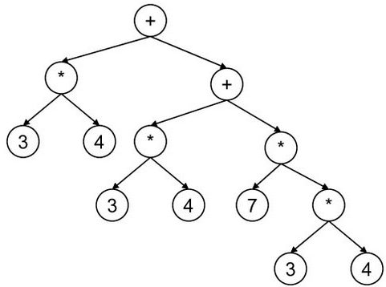

1. From an expression tree above, create:
   1. infix
   2. postfix
   3. prefix

The following tree is for number 3:

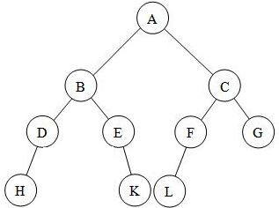

1. From the binary tree above, create:
   1. inorder
   2. postorder
   3. preorder

The following tree is for number 4:

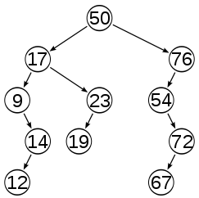

1. From the binary search tree above, do the following operations:
   1. insert: 80, 51, 78
   2. delete: 50, 76, 9
2. Create a BST program with the following menu:
   1. Insert a data
   2. Delete a data
   3. View data in:
      1. Preorder
      2. Postorder
      3. inorder

Data inserted should be distinct.