KAUNAS UNIVERSITY OF TECHNOLOGY INFORMATICS FACULTY

INTRODUCTION TO ARTIFICIAL INTELLIGENCE
DATA ANALYSIS LAB WORK REPORT

Report author: Arsenii Ziubin
Lecturer: doc.dr. Germanas Budnikas

Kaunas, 2026

1. Select (create) a dataset to perform this and other laboratory works. Your choice must be approved by the tutor.

Selected Dataset: Heart Disease Dataset
Link: | https://www.kaggle.com/datasets/johnsmith88/heart-disease-dataset
Description: | This data set dates from 1988 and consists of four databases: Cleveland, Hungary, Switzerland, and Long Beach V. It contains 76 attributes, including the predicted attribute, but all published experiments refer to using a subset of 14 of them
Format:
age: Age in years
sex: (1 = male; 0 = female)
cp: Chest pain type (0-3)
trestbps: Resting blood pressure (in mm Hg)
chol: Serum cholestoral in mg/dl
fbs: Fasting blood sugar > 120 mg/dl (1 = true; 0 = false)
restecg: Resting electrocardiographic results
thalach: Maximum heart rate achieved
exang: Exercise induced angina (1 = yes; 0 = no)
oldpeak: ST depression induced by exercise relative to rest
slope: The slope of the peak exercise ST segment
ca: Number of major vessels (0-3) colored by flourosopy
thal: Thalassemia (3 = normal; 6 = fixed defect; 7 = reversable defect)
target: Diagnosis of heart disease (1 = true; 0 = false)

The columns have the following datatypes:

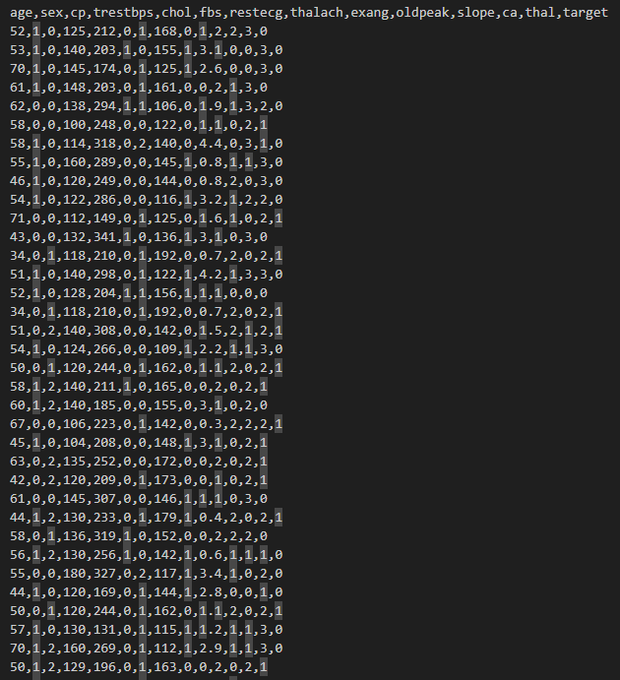
- For each numeric type attribute calculate: • total number of values,
  - percentage of missing values,
  - cardinality,
  - minimum (min) and maximum (max) values,
  - 1st and 3rd quartiles,
  - average,
  - median,
  - Standard deviation.
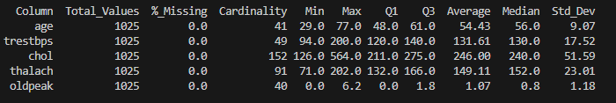
- For each category type attribute calculate:
    - total number of values,
    - percentage of missing values,
    - cardinality,
    - mode,
    - The frequency of the mode
    - Percentage value of the mode
    - Second mode value (mode 2), • Frequency value for Mode 2, • Percentage of Mode 2.
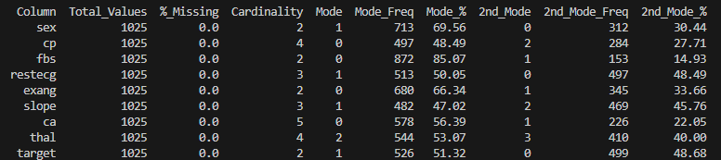

- Draw histograms of attributes. Provide descriptions of the distribution (eg, normal, exponential, etc.) and what conclusions can be drawn from it.

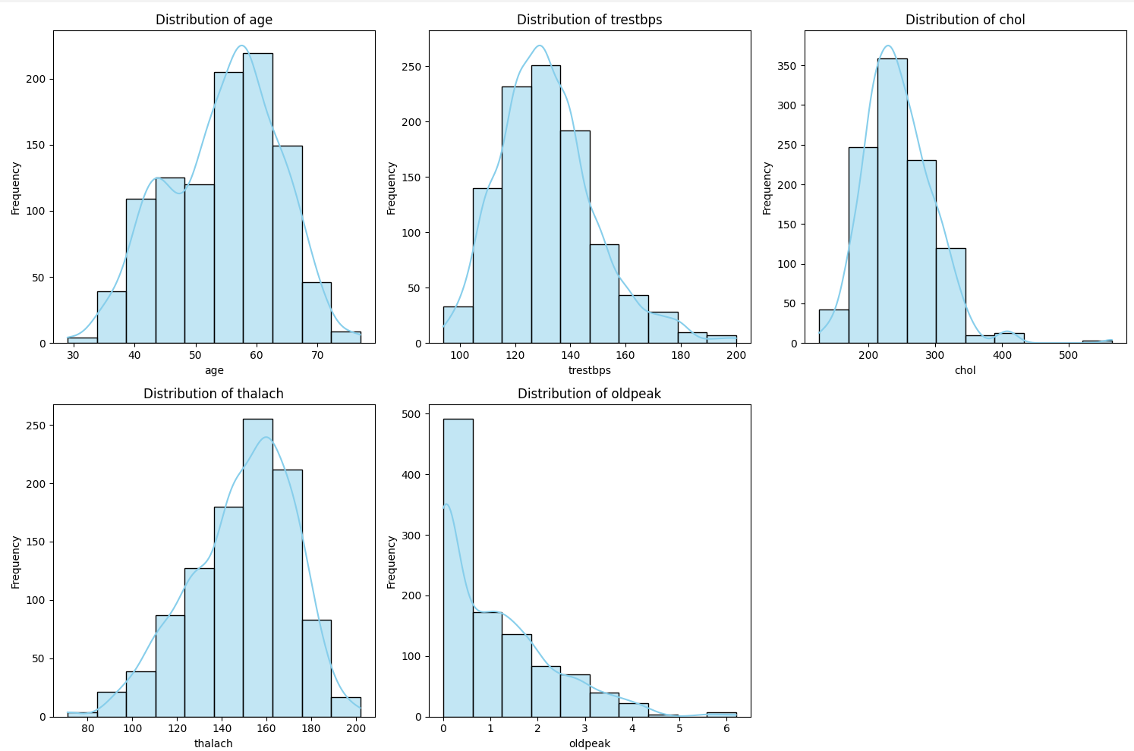
Age: Distribution: Normal distribution.
Observation: The data is roughly bell-shaped and symmetric, centered around 55–60 years old.
Trestbps (Resting Blood Pressure): Skewed right.
Observation: Most values cluster between 120 and 140 mm Hg. The tail extends to the right, indicating some patients have significantly high blood pressure (outliers above 170).
Chol (Cholesterol): Distribution: Skewed right.
Observation: The peak is around 200–250 mg/dl. There are visible outliers on the far right (values above 400 mg/dl) that pull the distribution tail.
Thalach (Maximum Heart Rate): Distribution: Skewed left (Negative skew).
Observation: The tail extends to the left (lower values). The bulk of the data is concentrated on the higher end, with most patients achieving a max heart rate between 140 and 170 bpm.
Oldpeak (ST Depression): Distribution: Strongly skewed right (Exponential-like).
Observation: The highest frequency is at 0, meaning many patients had no exercise-induced ST depression. The frequency drops rapidly as the value increases.
- Identify data quality problems: missing values, cardinality problems, outliers. Provide a plan for resolving these issues, which will be implemented programmatically (e.g., missing values for a categorical attribute based on the attribute estimate of the mode, extreme values being removed or corrected).
Missing Values: I implemented a programmatic check to identify and resolve missing values. My code was designed to handle them as follows:
Categorical Attributes: Missing values are filled with the Mode (most frequent value).
Continuous Attributes: Missing values are filled with the Median to minimize the impact of outliers.
However, upon running the code, no missing values were found in this dataset, so no imputation was actually performed.
Outliers: I identified outliers in the continuous variables using the Interquartile Range (IQR) method. I defined the valid range for data points as:
[Q1 - 1.5 * IQR, Q3 + 1.5 * IQR]
Any values falling outside this range were considered outliers and removed programmatically to prevent skewing the analysis.
Resolution Results: Based on this outlier removal plan, the following data points were removed:
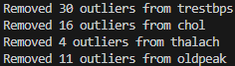

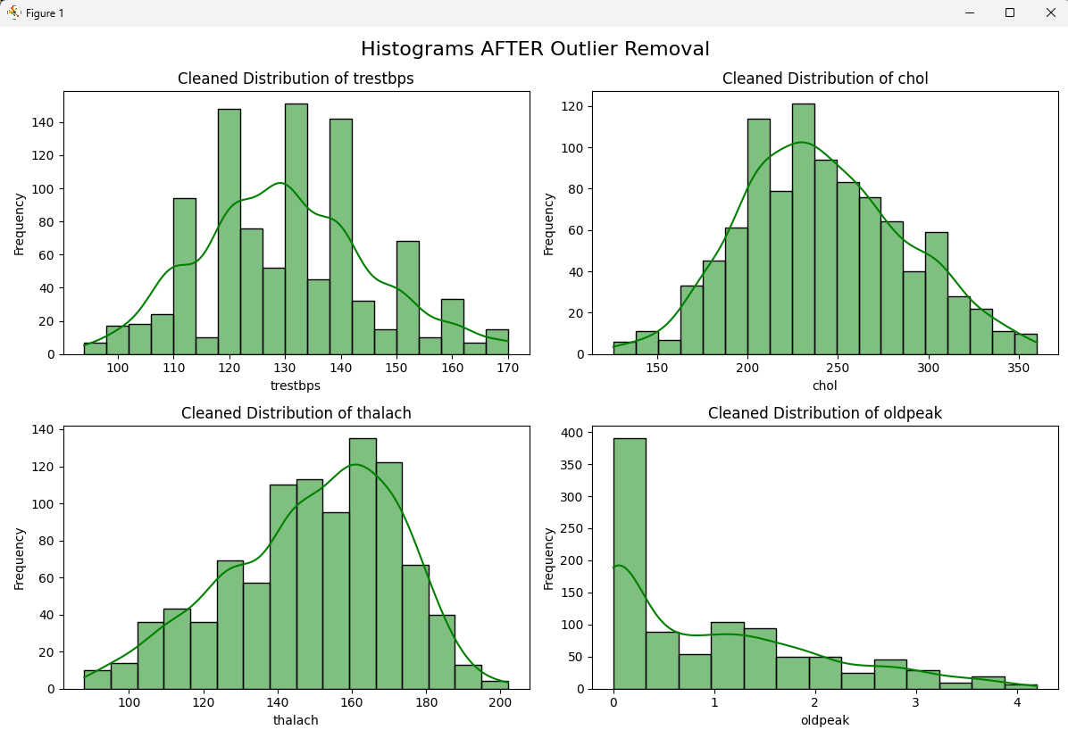

- Establish relationships between attributes using visualization techniques
  - For numeric type attributes: Using a scatter plot type graph, provide multiple (2-3) examples with strong linear attribute dependency (direct or inverse correlation) and multiple examples with non-correlated (weakly correlated) attributes. Comment on results.
  - Provide an SPLOM diagram (Scatter Plot Matrix).

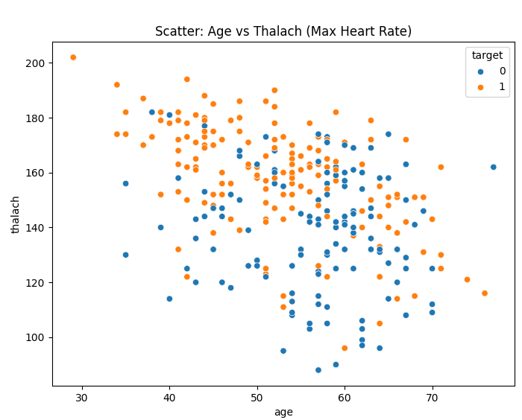
Description:
Inverse Linear Correlation: There is a moderate negative correlation. As the Age of the patient increases, the Maximum Heart Rate (Thalach) achieved tends to decrease.

Target Separation: Patients with heart disease (orange dots) are present across all ages but tend to have slightly higher heart rates relative to their age group compared to healthy patients.

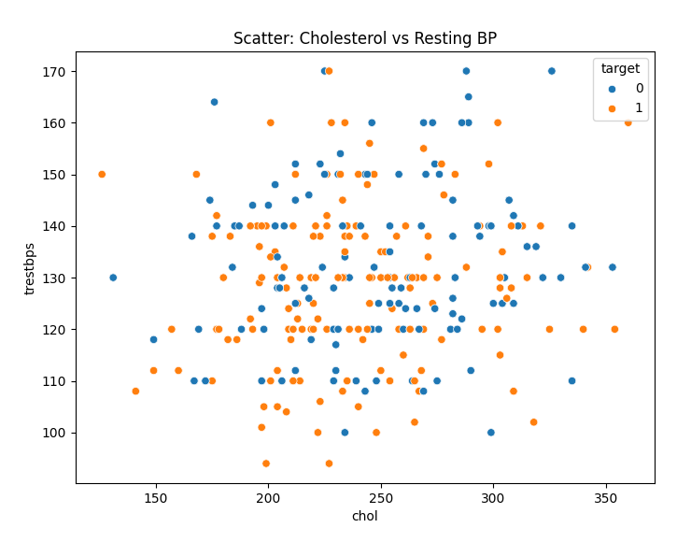
Description:
The data points are scattered widely without a clear linear pattern. This indicates that Cholesterol levels and Resting Blood Pressure are largely independent risk factors in this dataset.

SPLOM-Diagram:
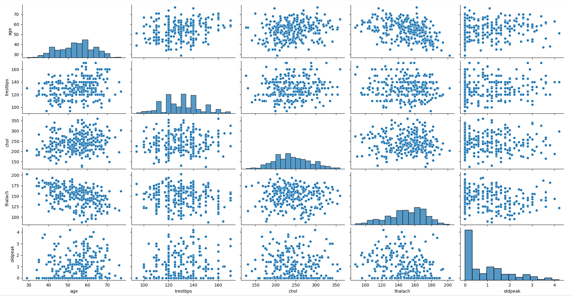
The matrix visualizes relationships between all continuous variables. It confirms the negative correlation between Age and Thalach observed above, while showing that other variables (like Oldpeak and Chol) have skewed distributions but weak linear correlations with each other.

  - For categorical attributes: Using the bar plot type diagram, give some (2-3) examples of attribute frequency and comment on the results.
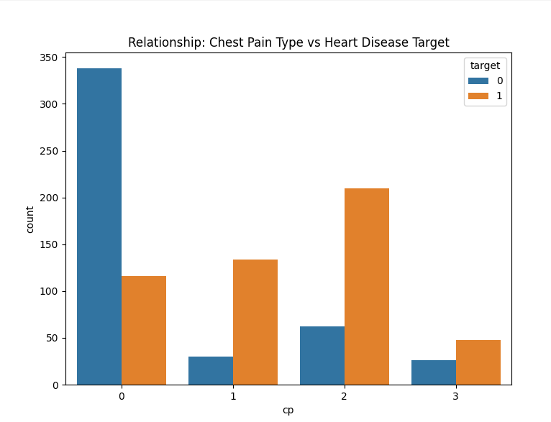
Description:
Type 0: Despite being the most common, it is strongly associated with healthy patients (Target 0). The blue bar is significantly higher than the orange bar.
Type 2 (Non-anginal pain): This category shows the strongest indicator for heart disease. The number of positive diagnoses (orange bar) is more than triple the number of negative cases (blue bar).
Types 1 and 3: Both show a higher ratio of heart disease compared to no disease, though they appear less frequently than Types 0 and 2.
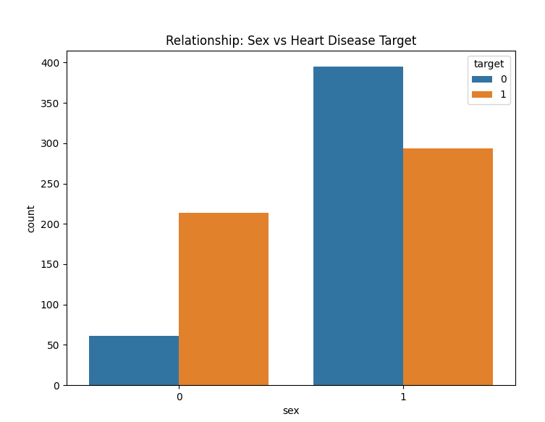
Description:
Females (Sex 0): The Orange bar (Target 1) is noticeably higher than the Blue bar (Target 0). This indicates that a higher proportion of females in this dataset have heart disease.
Males (Sex 1): The Blue bar (Target 0) is higher than the Orange bar (Target 1). This indicates that a higher proportion of males in this dataset do not have heart disease.

Provide some (2-3) examples of histograms and box plot diagrams depicting relationships between categorical and numeric type variables.
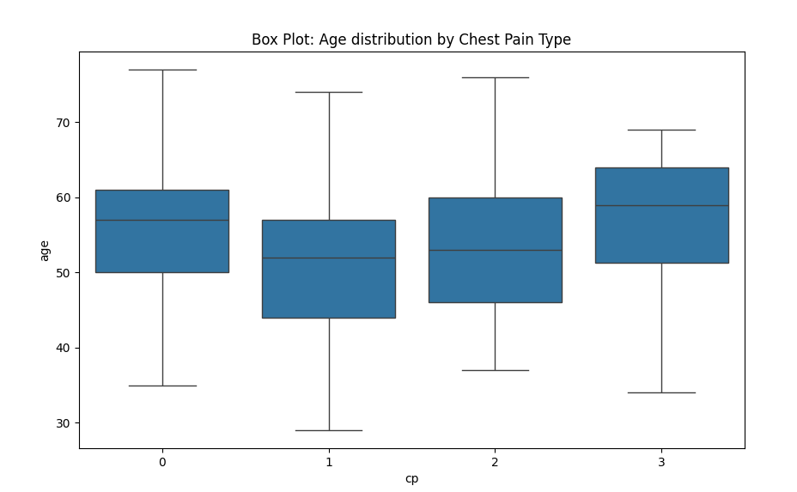
Age Consistency: The age distribution is relatively consistent across all four Chest Pain (CP) types, with the majority of patients falling between 40 and 65 years old.
Median Differences:
Type 1: Has the lowest median age (approx. 52 years), suggesting this pain type is reported slightly more often by younger patients.
Type 3: Has the highest median age (approx. 59 years).
Type 0 (Typical Angina): Shows the widest interquartile range (the height of the box), indicating greater variability in the age of patients reporting this pain type.
Type 2 (Non-anginal pain): The median age is approximately 53 years old.
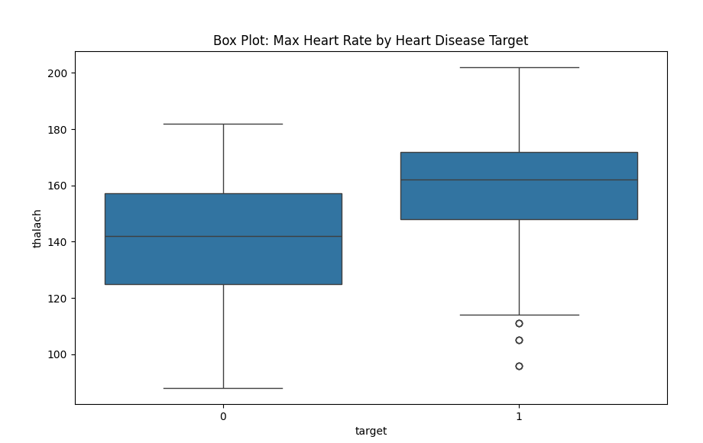
Description:
Heart Rate Differences: There is a clear separation between the two groups regarding Maximum Heart Rate (thalach).
Target 1 (Heart Disease): Patients with heart disease generally achieved a higher maximum heart rate. The median is approximately 162 bpm. There are a few low-value outliers (circles) below 120 bpm.
Target 0 (No Disease): Healthy patients tended to have a lower maximum heart rate. The median is lower, approximately 142 bpm, and the overall range is shifted downwards compared to Target 1.

- Calculate the covariance and correlation values between continuous attributes and graphically represent the correlation matrix. Comments on the results.

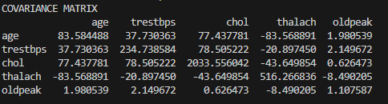
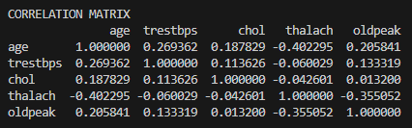
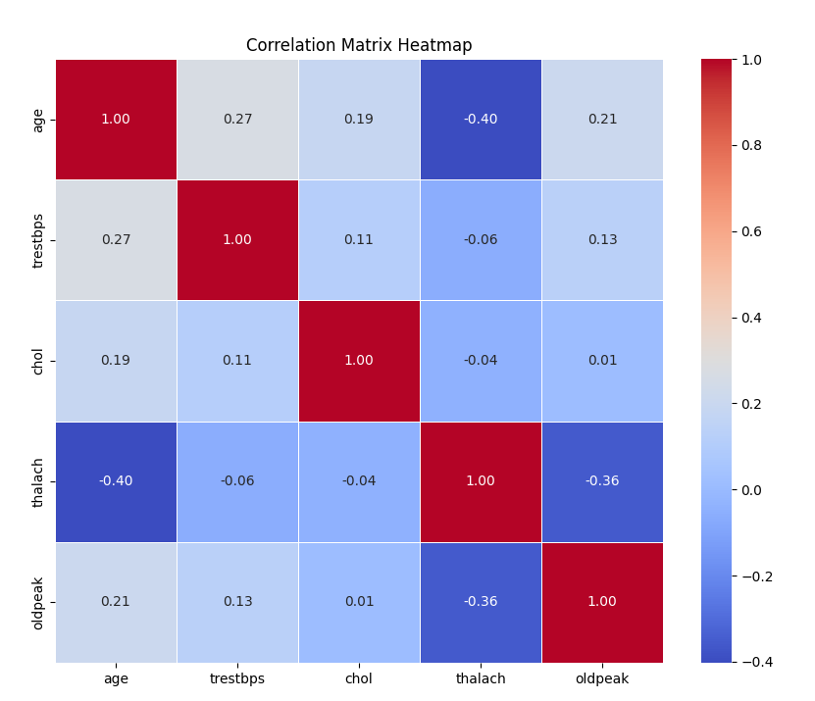

- Perform data normalization.
I converted all values in the continuous columns (age, trestbps, chol, thalach, oldpeak) to a range between 0 and 1. This ensures that all numeric attributes have the same scale, which is important for many machine learning algorithms.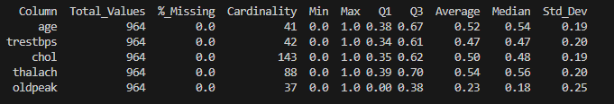
9. Convert categorical variables to numeric type variables.
In many raw datasets, categorical variables are stored as text (e.g., "Male", "Female", "Typical Angina"). To be used in machine learning models, these must be converted into numeric types.
In this specific dataset (heart.csv), the categorical attributes were already pre-converted using Label Encoding before I acquired the data.
