**Formal part:** Arsenii, Ziubin, IFU-3

**Part 1**

Calculation of Intervals

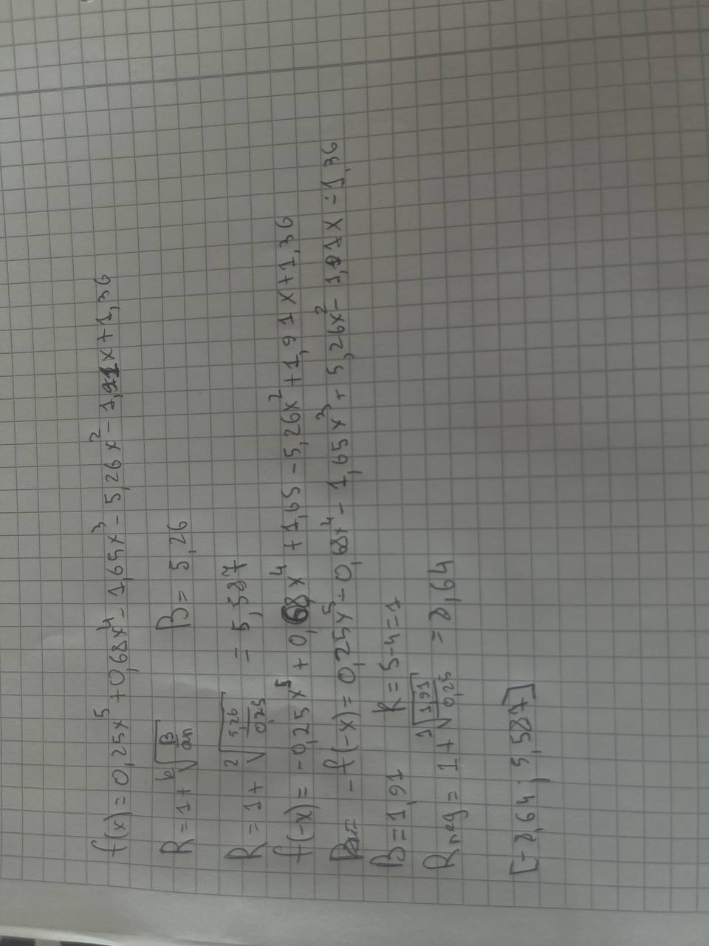

[Visualization of functions f(x) and g(x)]

Here the left function(polynomial is(f(x)) and right is g(x)

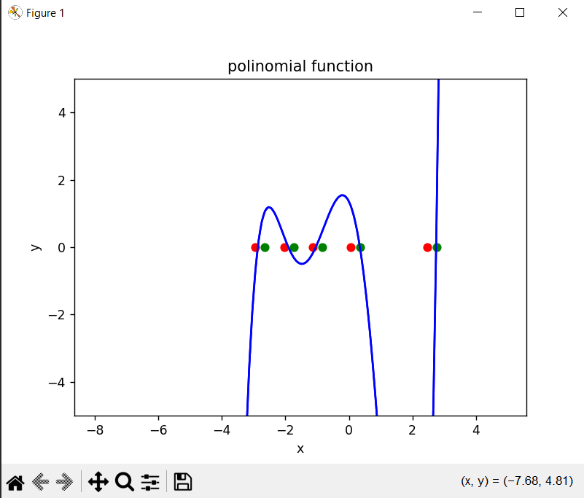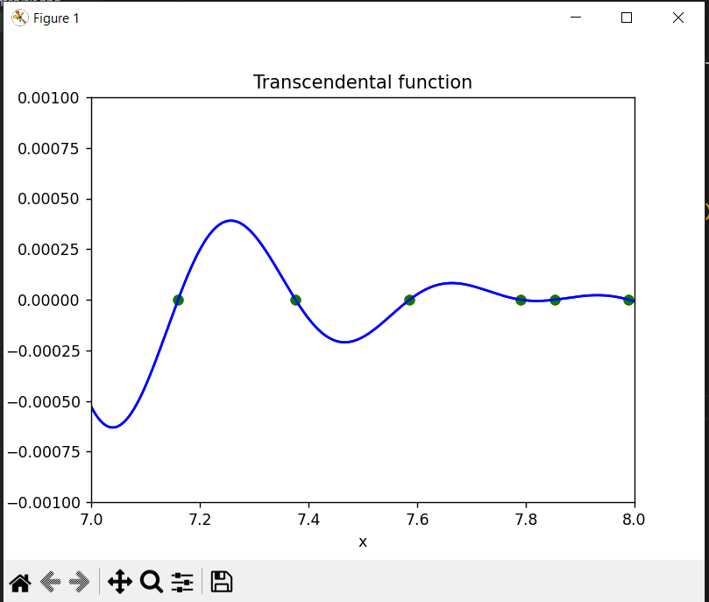

|  |  |
| --- | --- |
| Fig. f(x) visualization and start and end of each root interval represented in different color. If points overlap, different marker size may be used. Scanning step size indicated in description. | Root : [-2.940 ; -2.640]  Root : [-2.040 ; -1.740]  Root : [-1.140 ; -0.840]  Root : [0.060 ; 0.360]  Root : [2.460 ; 2.760]  Step size is 0,3 |

|  |  |
| --- | --- |
| Fig. f(x) visualization and start and end of each root interval represented in different colors. If points overlap, different marker size may be used. Scanning step size indicated in description. | Root : [7.150 ; 7.200]  Root : [7.350 ; 7.400]  Root : [7.550 ; 7.600]  Root : [7.750 ; 7.800]  Root : [7.850 ; 7.900]  Root : [7.950 ; 8.000]  Step size is 0.05 |

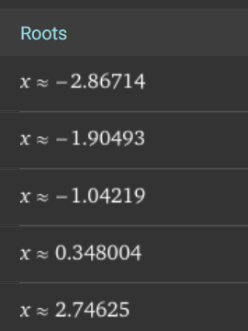

Defined roots by the wolfram alpha for the Polynomial equation

Here Fx represents a very small number that shows us that x is our root.

|  |  |  |  |  |  |
| --- | --- | --- | --- | --- | --- |
| **[chords]** | Initial guess | defined root | Iterations count | Validation | Value of the function in calculated root |
| f(x) | -2.940 | -2.86714 | 10 | correct | Fx = 6.099010851912112e-09 |
| -2.040 | -1.90493 | 7 | correct | Fx = -9.384185206684492e-09 |
| -1.140 | -1.04219 | 8 | correct | Fx = -2.2547015365859124e-09 |
| 0.060 | 0.34800 | 5 | correct | Fx = 7.390201783863404e-10 |
|  | 2.460 | 2.74625 | 6 | correct | Fx = -2.0526980115675997e-10 |
| g(f) | 7.15 | 7.15999 | 3 | correct | Fx = 3.0589692765336706e-09 |
| 7.35 | 7.37612 | 4 | correct | Fx = -8.050906634320769e-10 |
| 7.55 | 7.58609 | 4 | correct | Fx = 3.7231461117618403e-09 |
| 7.75 | 7.79041 | 7 | correct | Fx = -4.5927400893715745e-09 |
|  | 7.85 | 7.85397 | 3 | correct | Fx = -2.273719506233726e-09 |
|  | 7.95 | 7.98948 | 4 | correct | Fx = 6.104890158295009e-10 |

|  |  |  |  |  |  |
| --- | --- | --- | --- | --- | --- |
| **[newton]** | Initial guess | defined root | Iterations count | Validation | Value of the function in calculated root |
| f(x) | -2.940 | -2.867 | 4 | correct | Fx = -0.000 |
| -2.040 | -1.905 | 3 | correct | Fx = 0.000 |
| -1.140 | -1.042 | 3 | correct | Fx = 0.000 |
| 0.060 | 0.348 | 5 | correct | Fx = -0.000 |
| 2.460 | 2.746 | 5 | correct | Fx = 0.000 |
| g(f) | 7.15 | X = 7.160 | 2 | correct | Fx = -0.000 |
| 7.35 | x = 7.376 | 2 | correct | Fx = 0.000 |
| 7.55 | x = 7.586 | 3 | correct | Fx = -0.000 |
| 7.75 | x = 7.790 | 3 | correct | Fx = 0.000 |
|  | 7.85 | X = 7.854 | 2 | correct | Fx = 0.000 |
|  | 7.95 | x = 7.989 | 4 | correct | Fx = -0.000 |

|  |  |  |  |  |  |
| --- | --- | --- | --- | --- | --- |
| **[Quasi-Newton]** | Initial guess | defined root | Iterations count | Validation | Value of the function in calculated root |
| f(x) | -2.940 | -2.867 | 4 | correct | Fx = -1.0438316877525722e-12 |
| -2.040 | -1.905 | 3 | correct | Fx = 2.7602082841582387e-09 |
| -1.140 | -1.042 | 3 | correct | Fx = 7.463486051406676e-09 |
| 0.060 | 0.348 | 5 | correct | Fx = 1.5127898933542383e-12 |
| 2.460 | 2.746 | 5 | correct | Fx = -8.063993917062362e-12 |
| g(f) | 7.15 | 7.1599 | 2 | correct | Fx = -2.9936772688812957e-10 |
| 7.35 | 7.376 | 2 | correct | Fx = 3.782644552786599e-09 |
| 7.55 | 7.586 | 3 | correct | Fx = -1.403313179776122e-12 |
| 7.75 | 7.79 | 3 | correct | Fx = 6.868197839231533e-09 |
|  | 7.85 | 7.85 | 2 | correct | Fx = 9.199100201494893e-11 |
|  | 7.95 | 7.989 | 4 | correct | Fx = -1.399173477500979e-12 |

|  |  |  |  |  |  |
| --- | --- | --- | --- | --- | --- |
| **[secant]** | Initial guess | defined root | Iterations count | Validation | Value of the function in calculated root |
| f(x) | -2.940 | -2.867 | 5 | correct | Fx = -2.2909896202349955e-11 |
| -2.040 | -1.905 | 4 | correct | Fx = 2.9087952047035515e-09 |
| -1.140 | -1.042 | 4 | correct | Fx = 7.726557393894495e-09 |
| 0.060 | 0.348 | 7 | correct | Fx = -5.362377208939506e-13 |
| 2.460 | 2.746 | 7 | correct | Fx = 2.3070434451710753e-13 |
| g(f) | 7.15 | 7.1599 | 3 | correct | Fx = -5.233640753919259e-12 |
| 7.35 | 7.376 | 3 | correct | Fx = 1.7783441119903404e-10 |
| 7.55 | 7.586 | 3 | correct | Fx = -2.4016507108484072e-09 |
| 7.75 | 7.79 | 4 | correct | Fx = 7.1251004349230665e-09 |
|  | 7.85 | 7.8539 | 2 | correct | Fx = -2.3043657377328464e-09 |
|  | 7.95 | 7.989 | 5 | correct | Fx = 1.0799680576093684e-09 |

**Part 2**

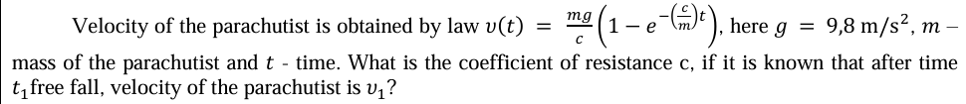

(m * g / c) * (1 - np.exp(-(c / m) * t1)) - v1

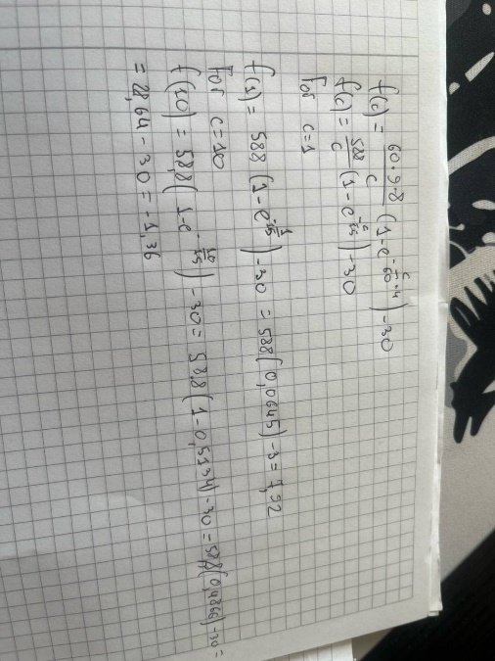

Since the function value is positive at c=1 and negative at c=10, there must be a root within the range [1, 10].

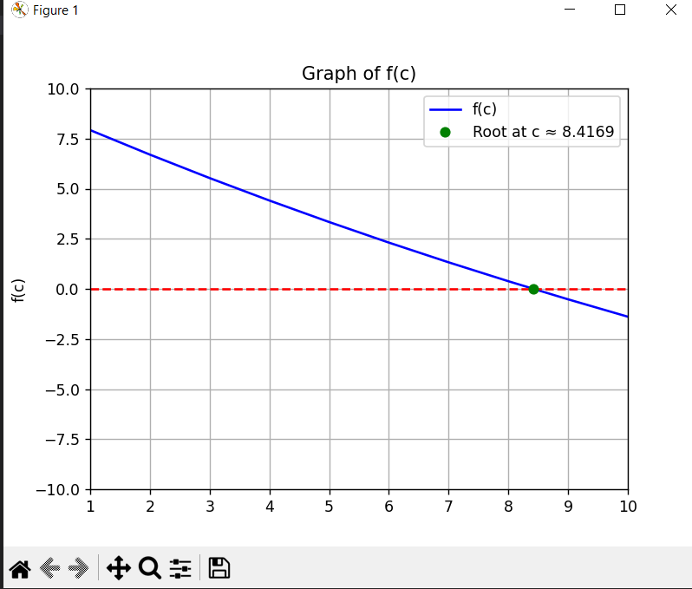

This graph shows us function f(c) and the root which is shown by green dot,

Red line represents the line where y = 0.

I have used Newton method for calculating the root approximately 8.417

**Conclusion**

Based on the data of the analysis I have found the roots of a polynomial function f(x), and a transcendental function g(x). The roots were first isolated using a scanning method with a step size of 0.3 for f(x) and 0.05 for g(x).

I have applied few numerical methods like:

Chords, Newton's, Quasi-Newton, and Secant—to find the exact roots. All methods were successful, with the calculated function values. Newton's and Quasi-Newton methods based on my analysis required fewer iterations to converge. Finally, the Newton's method was used to solve a Task2, finding the coefficient of resistance, c, for a parachutist. The root of the defined function f(c) was determined to be approximately 8.4169, which was confirmed in calculation to be within the initial interval of [1, 10].