**PlanTracker**

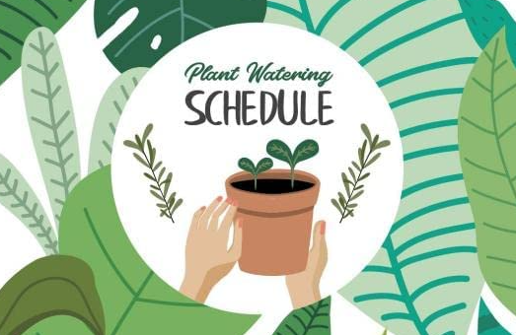

Group 506

Eldar Kerner - [eldar.kerner@mail.huji.ac.il](mailto:eldar.kerner@mail.huji.ac.il)

Ziv Baider - [ziv.baider@mail.huji.ac.il](mailto:ziv.baider@mail.huji.ac.il)

Mentor

Daniella Horan - [daniellah@gmail.com](mailto:daniellah@gmail.com)

Problem Definition

The problem is plants’ death and waste creation because of insufficient knowledge in growing home plants, along with time and money consumption that amplifies frustration among the plants’ growers.

It is important to solve because, by making a simple, affordable and simple device, we can help save plants’ lives and make people happier by helping their plants thrive.

Every home-plant grower may benefit from it because it relieves some difficulties that rely on growing plants.

Background and Related Work

Home plants are usually smaller plants that can fit into a ‘normal’ sized living space, and don’t require special environment conditions like constant aggregation or greenhouses, for example. These plants can be acquired in nurseries and even small supermarkets which makes them accessible and attractive to many people.

In this paper[1], the entire world of indoor planting is discussed. The main factors of growing successful indoor plants are deployed. From this paper, we will take the principles of growing plants and specific instructions for every plant, levels of light, humidity, temperature, and watering that fits the desired plant.

This paper[2] contains a brief history of agriculture from ancient times to these days. It also contains a guide for growing your own plants, as well as a simple design for a kit that is supposed to help children to grow their own plants. From this paper, we would take some design concepts that can help us to design our device and make it as user-friendly as possible.

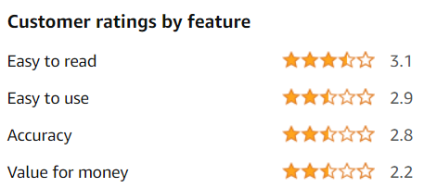

Similar attempts to solve this problem.

* <https://www.amazon.com/Wanfei-Intelligent-Bluetooth-Fertility-Temperature/dp/B09PV3T356?th=1>  
  This product resembles the idea that we have in mind. However, our vision is combining a database in the app that will recognize each plant and suggest appropriate treatment for it as can be found online, like an intelligent agent. We also hope to create a successful device that can satisfy different users more than the mentioned above device, as shown above.
* <https://www.indiegogo.com/projects/lua-the-smart-planter-with-feelings#/>

This product is different from our idea. This plant tracker is the actual pot, and the plant is planted inside it. It has a “face”, and it changes the look on the face by its condition: “sweaty” when hot, “gasping” when thirsty, “vampire” when little light, etc. We want to have a more robust product that can have many plants in use instead of one.

Proposed Solution

We can divide our project into three different aspects, Arduino and sensors, Software, and User experience.  
In the Arduino part, we can use many sensors that will reflect the current state of the plant and its environment, or we can take only a few sensors and conclude advice from them. The first approach is expensive for the user since it involves many sensors but can allow sophisticated agent, while the second approach is more affordable and can provide sufficient advice using a simpler intelligent agent.

In the software part, we want to create an AI-based application that will advise based on the data it receives from the product’s sensors - the hardware part. This agent can make better or worse decisions based on the amount of relevant information it’ll have (number of sensors). This agent will provide the user advice on how to treat the plant to optimize its growth. Another thought is whether to use an app or to have the product come with a screen and be a “stand-alone”. The screen is less dependent on outer components like WIFI or Bluetooth, but the app is more robust and also can support multiple plants by using the kit on several plants with a single app.

The user interface part is part of the software part, but we chose to mention it because it has a huge impact on our product. We wish to make an easy-to-use, convenient application so the users will be appealed to use it and grow their home plants using it. A bad user experience can make our device redundant because our users won’t choose to use it.

We believe in Pareto Principle, 80 percent of the consequences come from 20 percent of the causes. In the research we read, we understood that there are five major principles in indoor/home planting, and we want to focus on them for helping a much larger community that can afford this kit. Therefore, we chose the approach of a small number of sensors that will limit the decisions that the agent will be able to make but we hope that they will still be good enough in order to help people grow their home plants better. We want the product to be as robust as possible so we additionally chose to develop an app that will interact with the kit.

To fulfill this project, we are taking courses in Arduino and Android Development and Databases, to make the project feasible.

More specifically, the Arduino part will have sensors that will examine water levels, light exposure, humidity, and temperature. We’ll write the software of Arduino in C++ and build the kit by ourselves.

We might encounter technical issues, sensors that stop working, integration, and connectivity problems but since we assume it ahead, we’ll order backup parts so we’ll not get stuck in the development, and we’ll check from the beginning the connectivity between the Arduino part and the App part although they will not be fully working.

Evaluation and Verification Scheme

Our project is tricky to verify and evaluate. First, some plants can survive a few months without good treatment, and therefore it can’t be visualized that with our kit the plant is healthier for a longer time. Second, two plants are different, and a comparison test can be contaminated with starting conditions. However, we believe we can evaluate and verify the quality of the project.

We’ll start evaluating by making sure that the advice matches the theoretical knowledge we researched. We’ll also give an unbiased person the kit and two identical ‘sensitive’ plants and they will grow both, one with the kit and the other without. We’ll test for a limited time, depending on how quickly we’ll assemble the kit, and after that, we’ll analyze and compare the results.

We’ll verify the project by testing the sensors and see whether they work as expected, and the app processes the data as expected and gives the best advice for the plant. We’ll also check the app, by letting people use it for testing and see whether it is stable and ready to use and convenient and user friendly.

Annual Work Plan

First Steps:

* Research and learn about different home plants.
* Learn how to write Arduino code and how to work with Arduino hardware.
* Learn how to write an app in Kotlin, and specifically incorporate a database into the app such that it will be able to provide the user with advice for the plant.

MVP:

* Assemble an Arduino device with working sensors.
  + The sensors will be tested into the Arduino device we will build with some indoor plants that we have in our homes or acquire for the project.
* Have a basic app running.
* Test the kit on a single plant specie by an unbiased user.
  + Try and grow two plants by the same person. First p lant using the kit and the second plant without it.

Future Steps:

* Integrate between the hardware kit and the mobile app.
  + Presenting information from the sensors on the finely designed app.
* Connecting the app to a database and a server that will supply the user with informative advice about their plants.
* Create user questionnaires to test the app’s experience and make it as user-friendly as possible.

1. ‘Growing Indoor Plants with Success’ by Georgia University
2. ‘Design of an interactive plant growing device for children’ by Universidad de Navarra