CS6650 Assignment 1
Design and Performance Evaluation
Architecture
The Java 11 load client runs on a local Mac and communicates with a Tomcat 9 server deployed on EC2.
HTTP flow:
SwipeGenerator → BlockingQueue → sender threads →shared HttpClient → EC2 SkierServlet.
WebSocket flow:
EC2 LeaderboardEndpoint → ten persistent LeaderboardSubscriber instances → client metrics.
SkierServlet validates request paths and JSON bodies. Valid ski events receive HTTP 201; invalid requests receive HTTP 400. HealthServlet provides a health-check endpoint.
LeaderboardEndpoint publishes synthetic leaderboard messages approximately every 500 ms. These messages are independent of the submitted events. No database or event aggregation is used in this assignment.
Classes and Threading
SwipeEvent represents one generated ski event.
SwipeGenerator runs on one dedicated thread and places 500,000 events into an ArrayBlockingQueue. Generation finishes before sender execution, so senders do not wait for the generator during the measured ingestion phases.
IngestLoadClient coordinates generation, subscriptions, warmup, the main phase, shutdown, and reporting.
Warmup uses 32 sender threads to send 32,000 events. The main phase sends the remaining 468,000 events. Main thread counts of 64, 128, and 256 were tested.
Each sender task receives a fixed event quota, polls events from the shared queue, and calls SwipeSender. The coordinator waits for all tasks to finish before ending a phase.
SwipeSender shares one HTTP/1.1 HttpClient across sender threads, allowing persistent connection reuse. It uses thread-safe counters and retries unsuccessful requests up to five times with exponential backoff starting at 100 ms.
WebSocket Strategy
Ten LeaderboardSubscriber instances subscribe to resorts 1 through 10 using a shared subscription HttpClient.
Each subscriber has a background worker that establishes the connection, waits for disconnection, and reconnects with backoff. Message callbacks assemble fragmented text, parse JSON, and record update counts and timestamp differences.
Ingestion starts after every subscriber has received an update. Subscribers remain active throughout ingestion and are closed during cleanup.
Metrics include connection attempts, successful connections, reconnections, connection establishment time, and updates.
Measurement Design
SwipeCsvRecorder records each HTTP attempt with timestamp, request type, latency, status code, and resort ID. Writes are synchronized. Network failures use status code zero.
HTTP durations use System.nanoTime(), avoiding dependence on clock alignment between the client and server.
LatencyStats computes mean, median, nearest-rank p95 and p99, minimum, and maximum. SwipeCsvAnalysis reports attempt counts, latency statistics, and successful throughput by resort.
ThroughputBuckets groups successful request completions into 10-second intervals. The final partial interval uses its actual duration. Completion times are approximated from the attempt timestamp plus measured latency.
Generation, warmup, main ingestion, and total runtime are reported separately. Main throughput excludes warmup.
Little's Law and Prediction
The measured sequential HTTP baseline mean was 37.171 ms.
Using L = lambda × W, with L approximated by the number of synchronous sender threads:
Predicted throughput = sender threads / 0.037171 seconds.
Predictions are approximately: 32 threads: 861 events/s; 64 threads: 1,722 events/s; 128 threads: 3,444 events/s; 256 threads: 6,887 events/s.

Part 1 Results
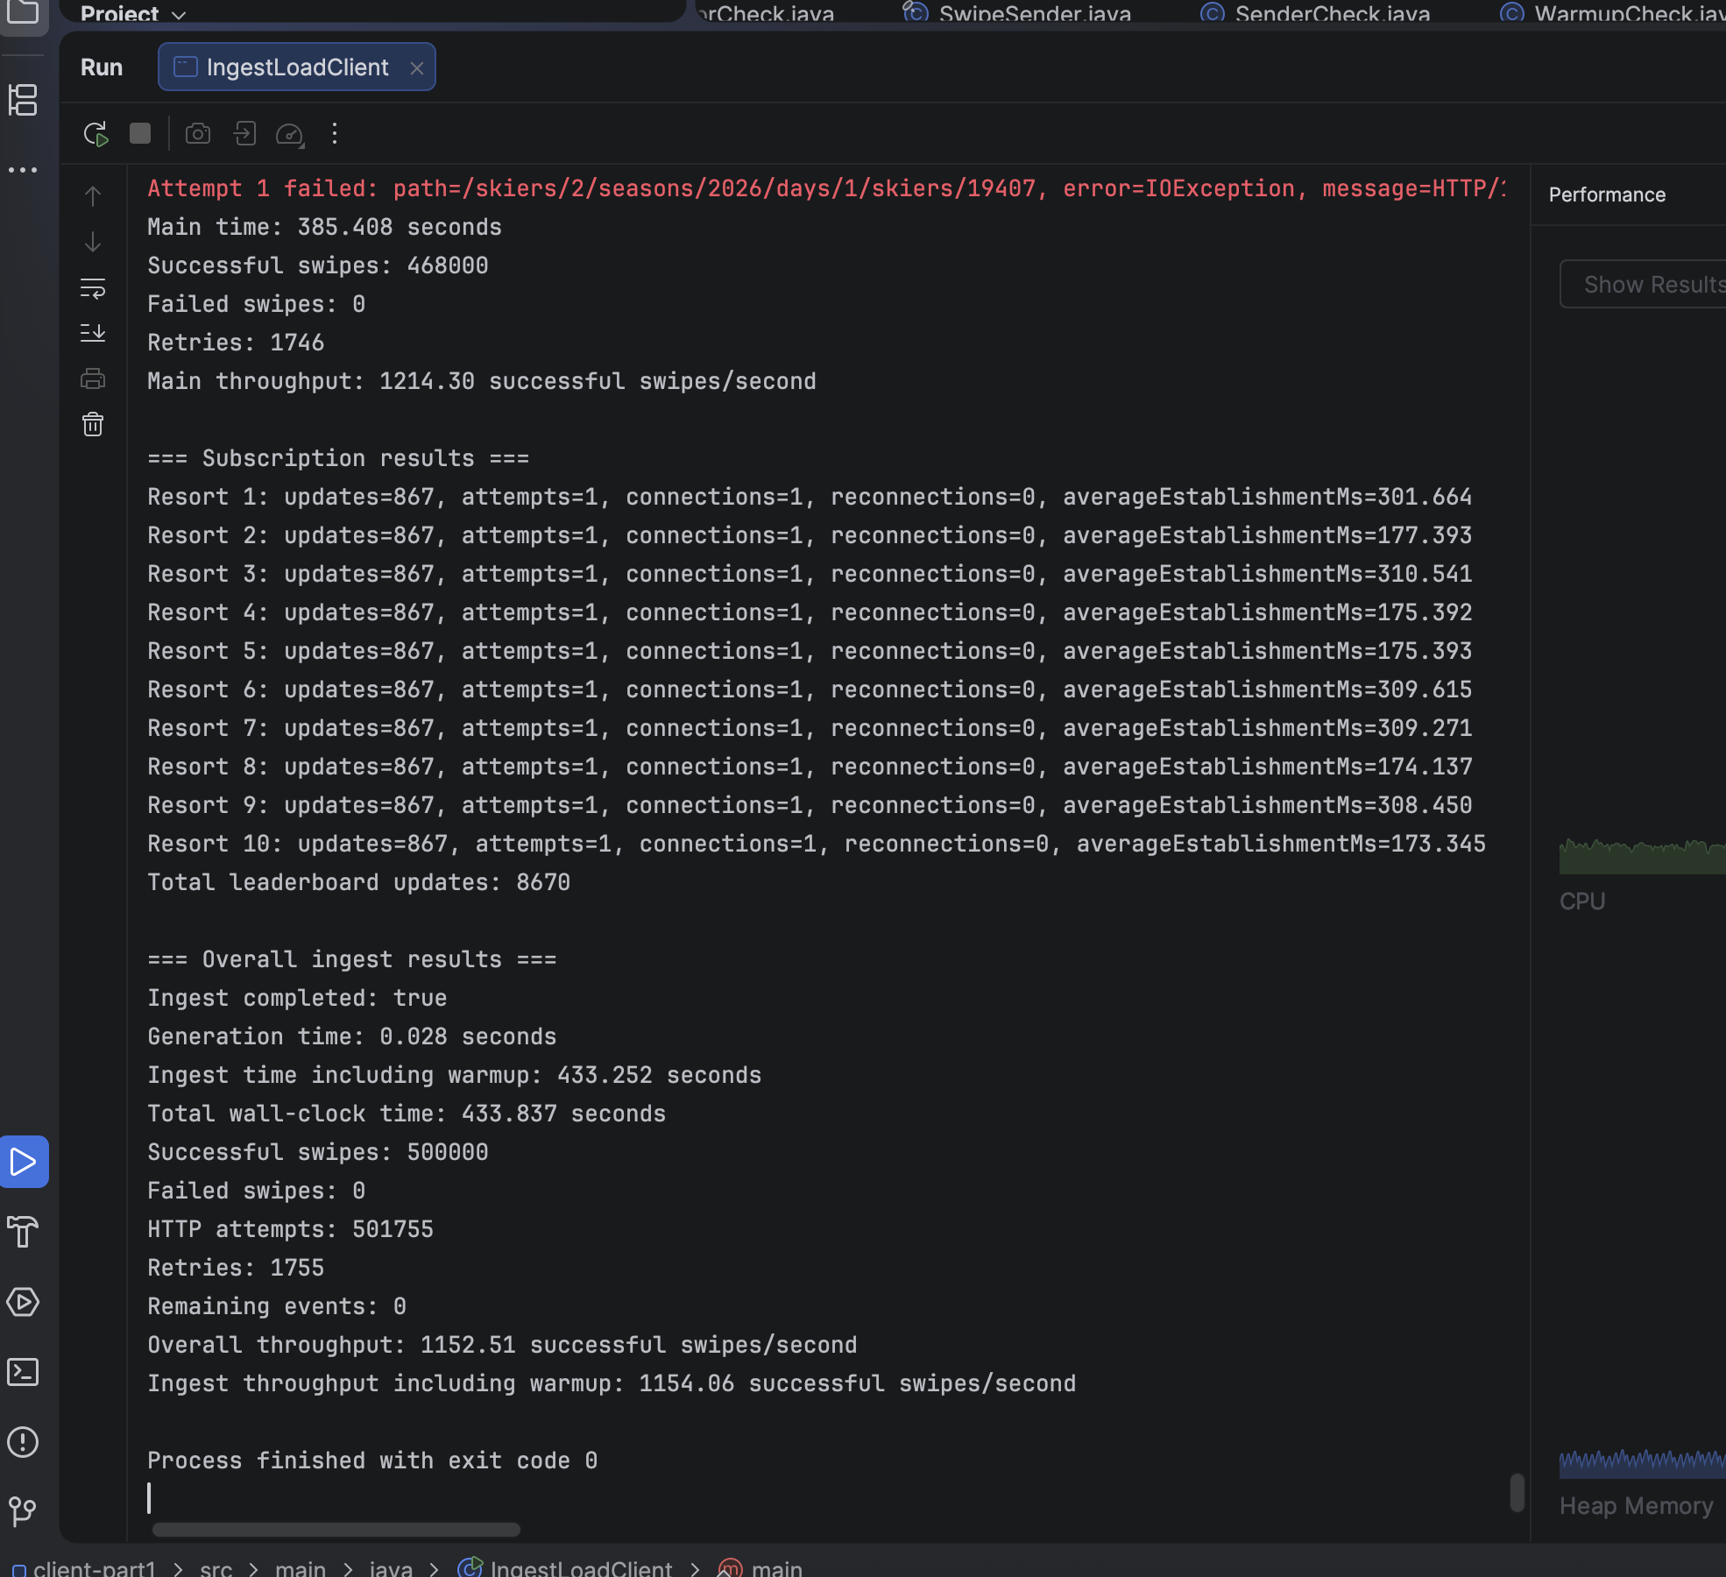
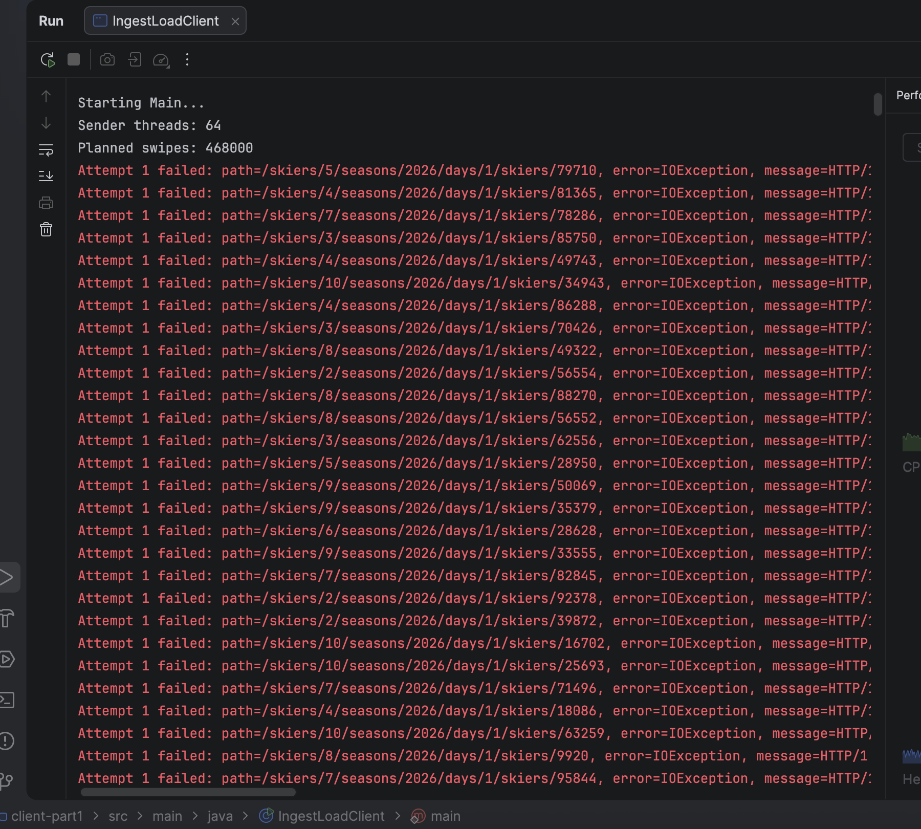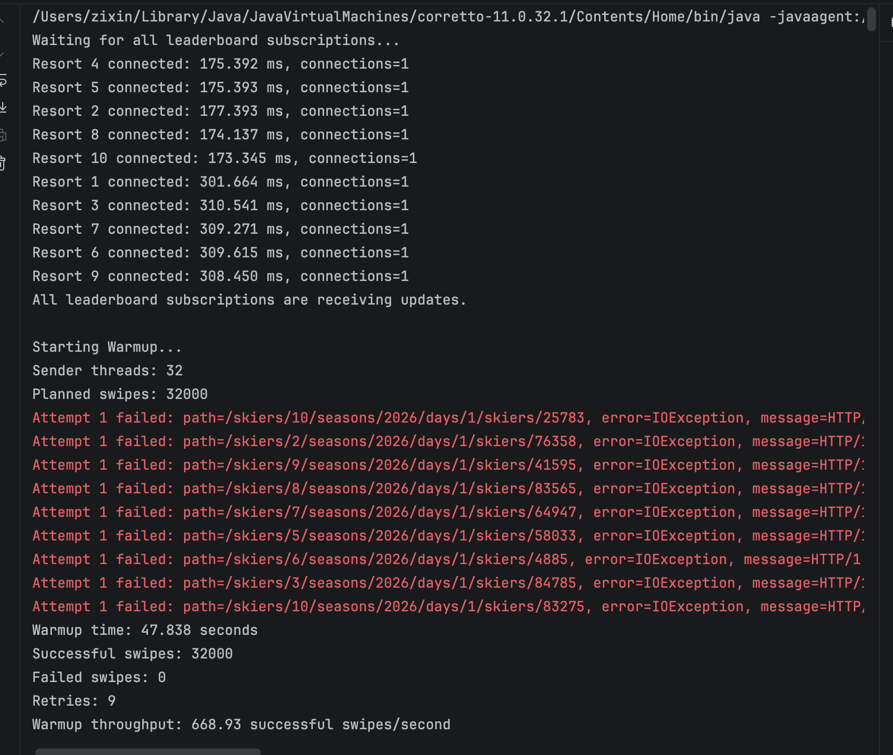

Part 2 Results — 256 Threads, Run 2
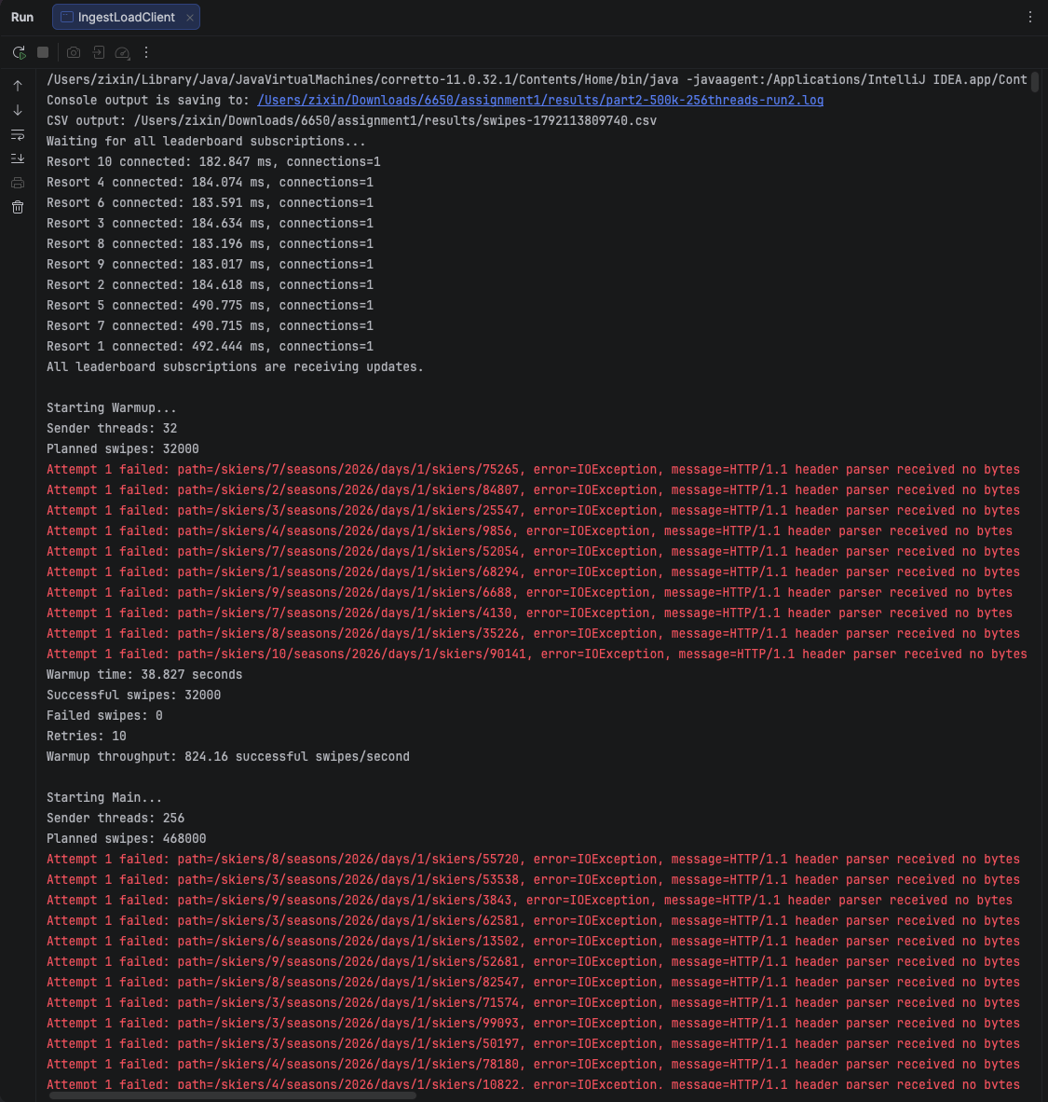
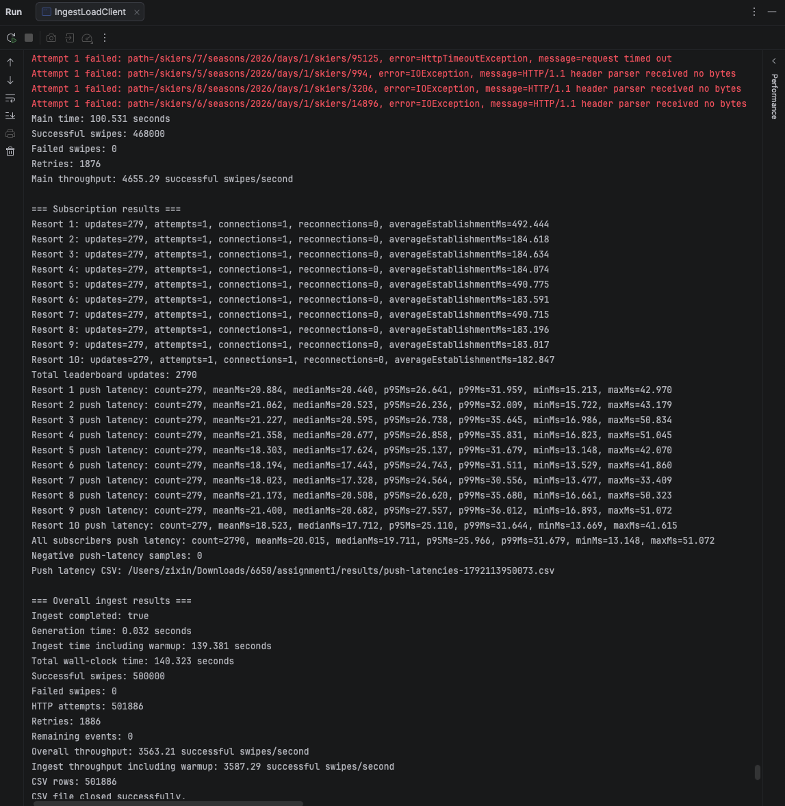
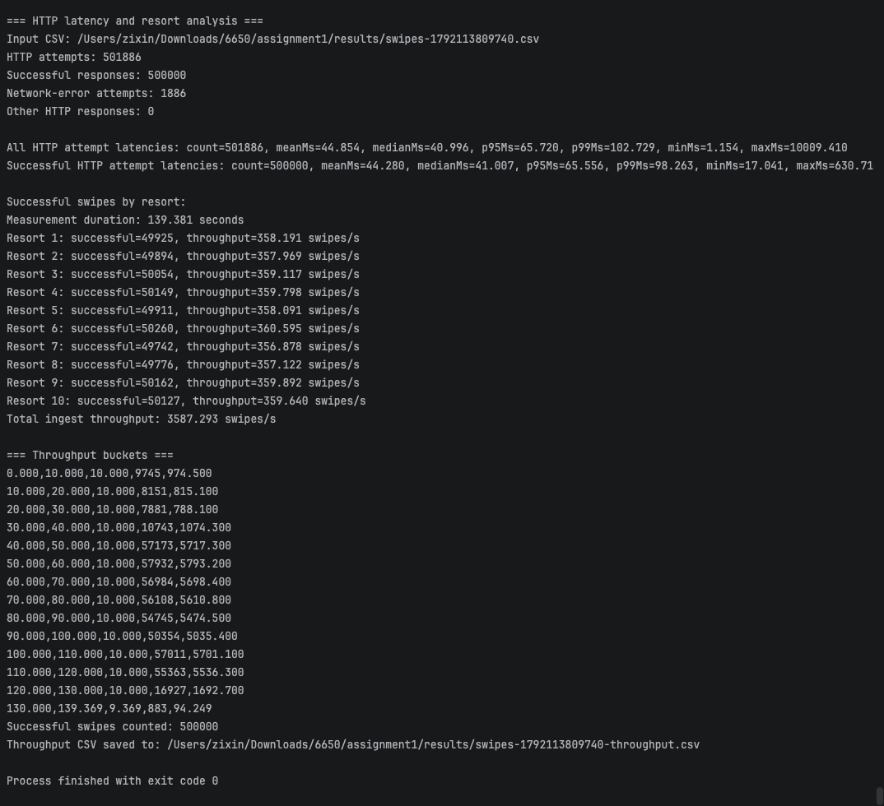

Throughput and Comparison
The second 256-thread run achieved approximately 67.6% of the baseline prediction. The estimate assumes constant response time. Under load, response time, retries, scheduling, logging, and resource limits may change. These measurements do not isolate a single bottleneck.

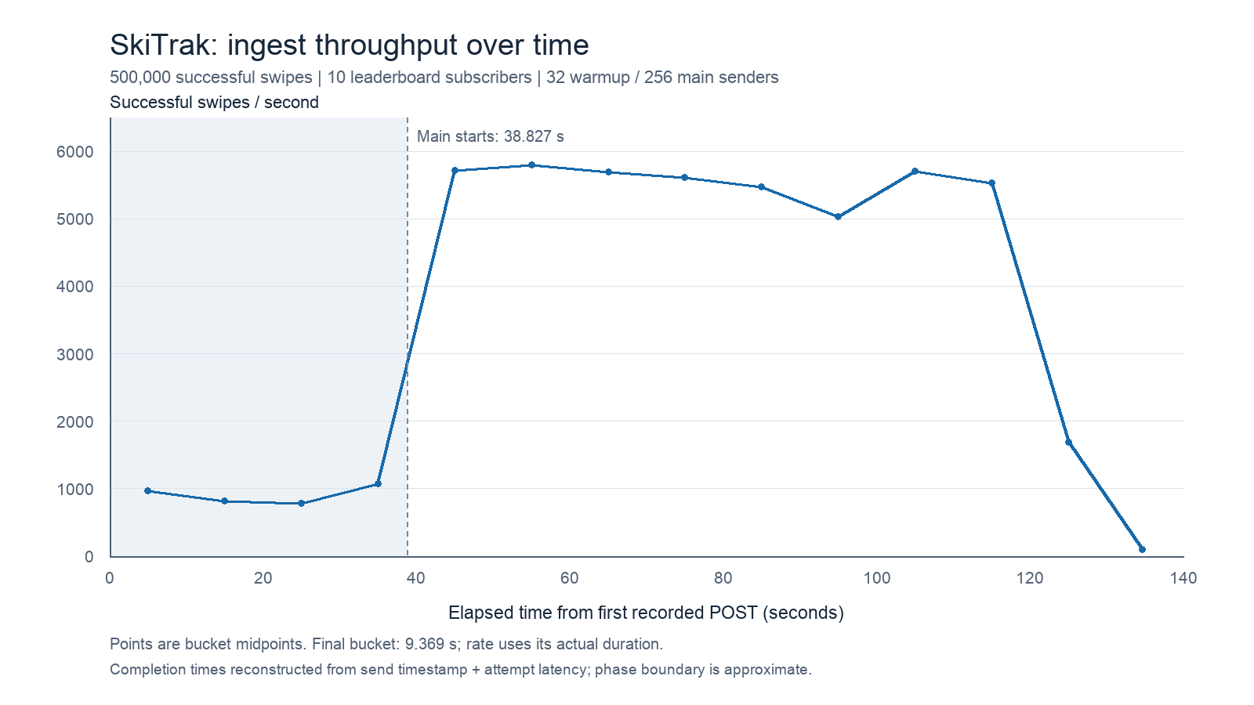
Main threads | Main throughput (events/s)
64 | 1495.52
128 | 2691.50
256-Run1 | 4632.00
256-Run2 | 4655.29

Deployment and WebSocket Verification
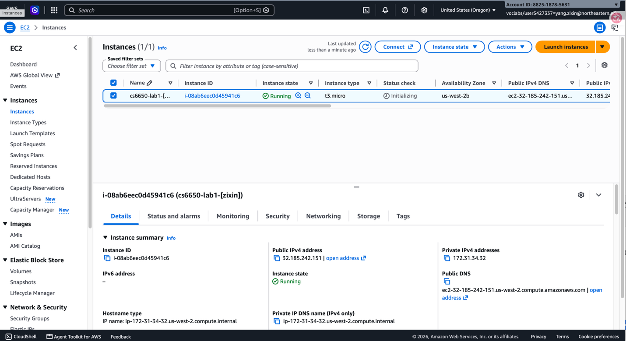
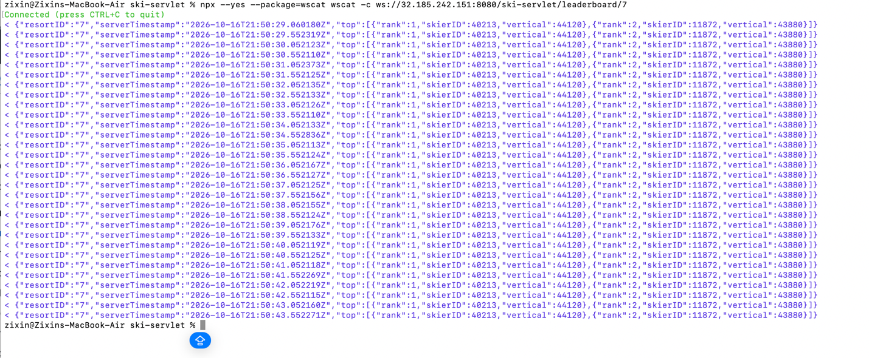

Connection Observation and Clock Limitations
A separate 256-thread run attached an X-Run-ID header. Tomcat logged the client IP and port for matching requests.
The server recorded 500,417 requests across 2,843 distinct client IP:port pairs, averaging 176.02 requests per pair. Every observed pair handled multiple requests, supporting connection reuse. These pairs are not an exact TCP connection count, and HTTP retries are not reconnection counts.
Push latency uses the server timestamp and client receive time, so cross-machine clock error affects the result. Negative samples remained after Mac time synchronization. Raw values were retained without filtering or correction.
Push timestamp differences therefore cannot be interpreted as precise absolute one-way latency. Subscription-only clock checks are reported separately from HTTP load tests.

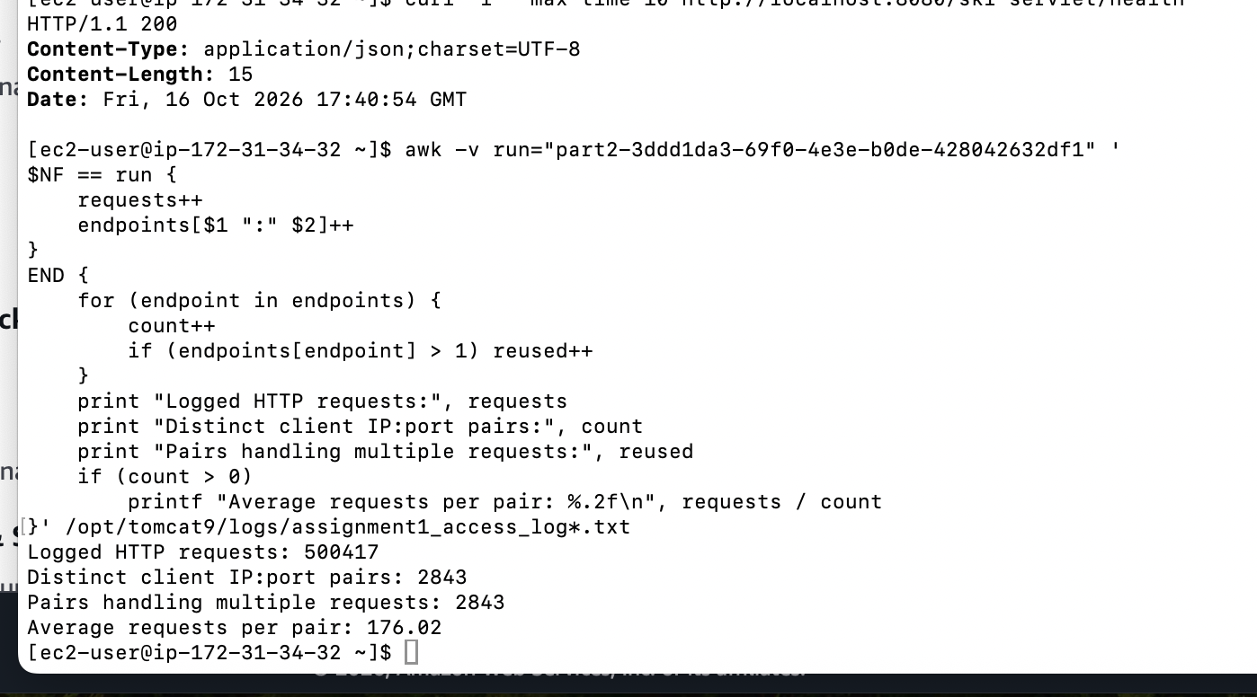
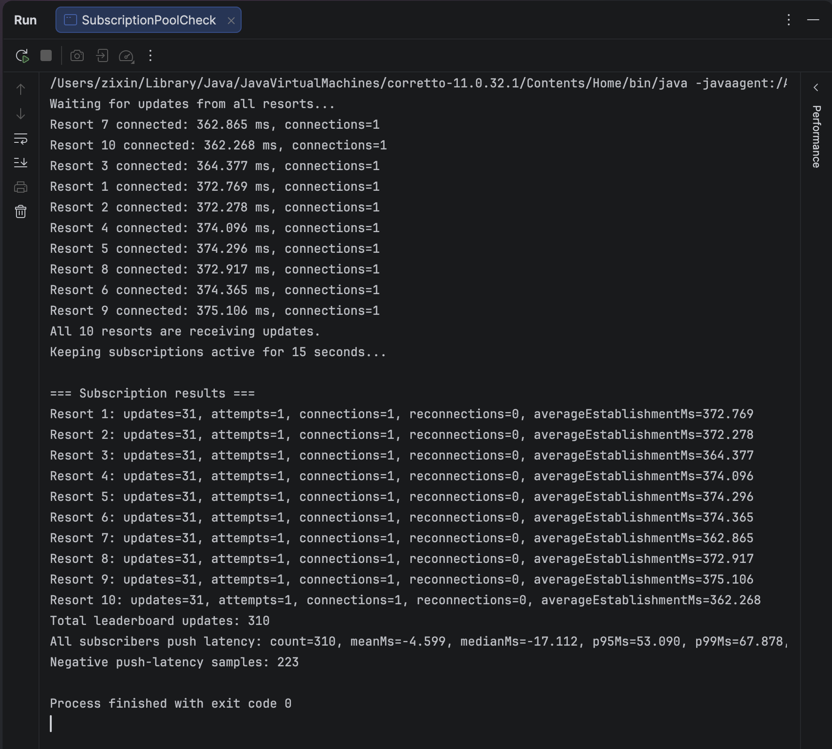
The HTTP connection observation and clock check were separate experiments from the 256-thread Run 2 performance test.

