作业二

实验截图：

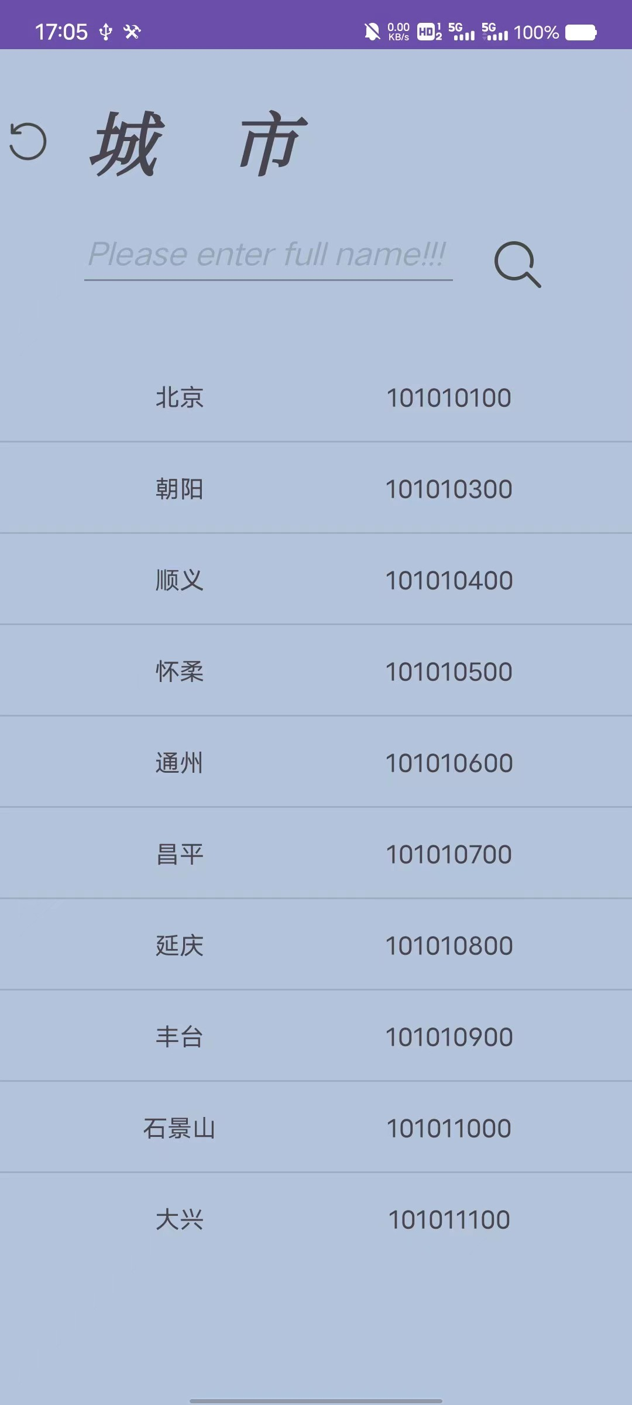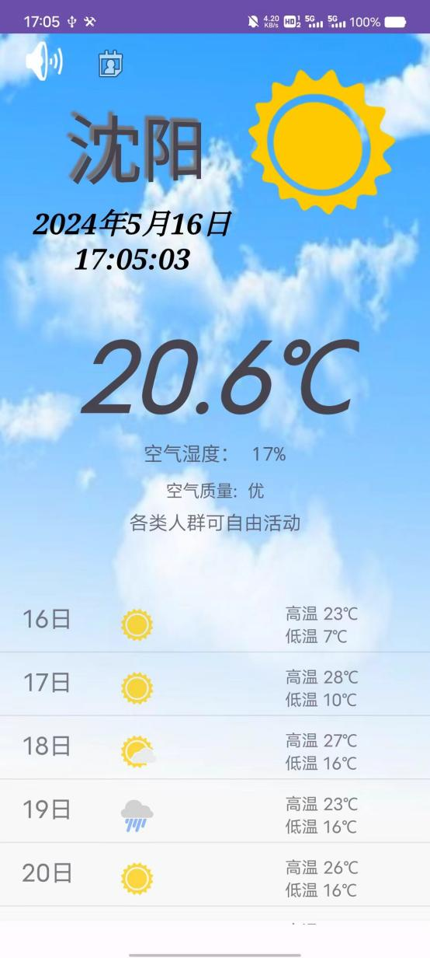

图为以http方式从网络上下载数据并显示 图为文件方式存储文件

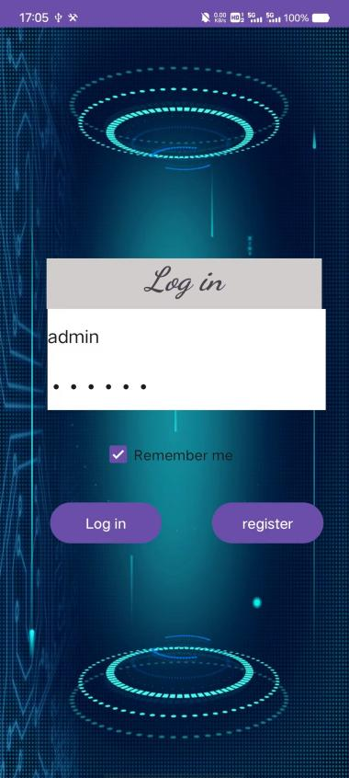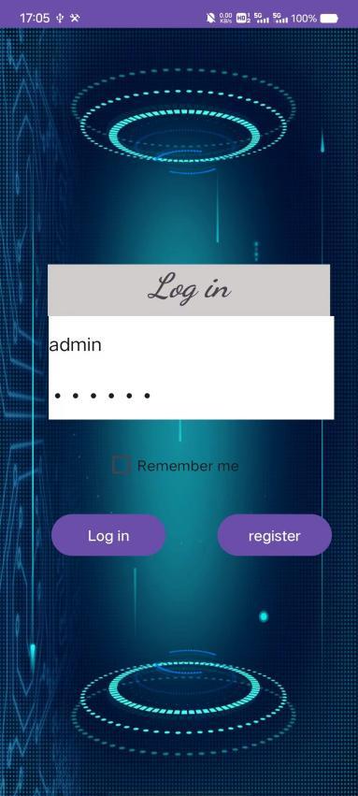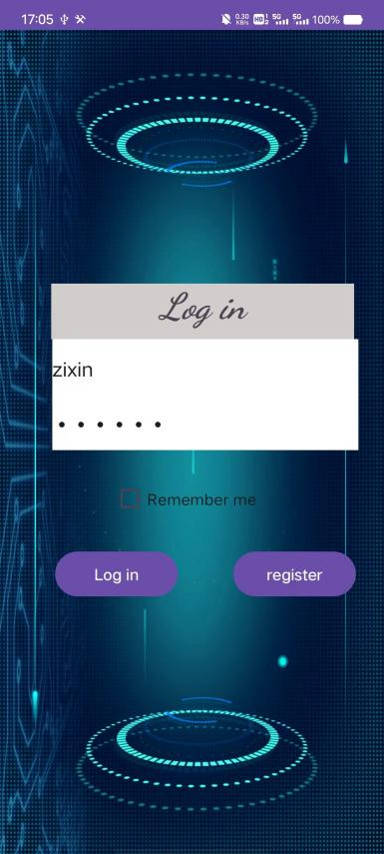

图为通过SQlite存储用户数据，并通过sharePreferences记住密码

关键代码：

①http：

String url = "http://t.weather.itboy.net/api/weather/city/" + City;

try {

String str = NetUtil.net(url, null, "GET");

Log.i("NET", str);

工具类：

public static String net(String strUrl, Map params, String method) throws Exception {

HttpURLConnection conn = null;

BufferedReader reader = null;

String rs = null;

try {

StringBuilder sb = new StringBuilder();

if((method==null || method.equals("GET")) && params != null){

strUrl = strUrl+"?"+urlencode(params);

}

URL url = new URL(strUrl);

conn = (HttpURLConnection) url.openConnection();

if(method==null || method.equals("GET")){

conn.setRequestMethod("GET");

}else{

conn.setRequestMethod("POST");

conn.setDoOutput(true);

}

conn.setRequestProperty("User-agent", userAgent);

conn.setUseCaches(false);

conn.setConnectTimeout(DEF_CONN_TIMEOUT);

conn.setReadTimeout(DEF_READ_TIMEOUT);

conn.setInstanceFollowRedirects(false);

conn.connect();

if (params != null) {

assert method != null;

if (method.equals("POST")) {

try {

DataOutputStream out = new DataOutputStream(conn.getOutputStream());

out.writeBytes(urlencode(params));

} catch (Exception e) {

e.printStackTrace();

// TODO: handle exception

}

}

}

InputStream is = conn.getInputStream();

reader = new BufferedReader(new InputStreamReader(is, DEF_CHATSET));

String strRead;

while ((strRead = reader.readLine()) != null) {

sb.append(strRead);

}

rs = sb.toString();

} catch (IOException e) {

e.printStackTrace();

} finally {

if (reader != null) {

reader.close();

}

if (conn != null) {

conn.disconnect();

}

}

return rs;

}

//将map型转为请求参数型

public static String urlencode(Map<String,String> data) {

StringBuilder sb = new StringBuilder();

for (Map.Entry i : data.entrySet()) {

try {

sb.append(i.getKey()).append("=").append(URLEncoder.encode(i.getValue()+"","UTF-8")).append("&");

} catch (UnsupportedEncodingException e) {

e.printStackTrace();

}

}

return sb.toString();

}

}

②文件方式：

private String load() {  
 String content = null;  
 File file = new File(getFilesDir(), "weatherIcon.txt");  
 try {  
 FileWriter fileWriter = new FileWriter(file);  
 BufferedWriter bufferedWriter = new BufferedWriter(fileWriter);  
 bufferedWriter.write(enter);  
 bufferedWriter.close();  
 } catch (IOException e) {  
 e.printStackTrace();  
 }  
  
  
 try {  
 FileReader fileReader = new FileReader(file);  
 BufferedReader bufferedReader = new BufferedReader(fileReader);  
 StringBuilder builder = new StringBuilder();  
 String line;  
 while ((line = bufferedReader.readLine()) != null) {  
 builder.append(line);  
 }  
 bufferedReader.close();  
 content = builder.toString();  
 } catch (IOException e) {  
 e.printStackTrace();  
 }  
 return content;  
}

③SharePreferences

SharedPreferences sharedPreferences = getSharedPreferences("setting", MODE_PRIVATE);

SharedPreferences.Editor editor = sharedPreferences.edit();

editor.putString("userName", userName.getText().toString());

editor.putString("password", password.getText().toString());

user.username = userName.getText().toString();

user.password = hashPassword(password.getText().toString());

Log.i("Password", user.password);

Log.i("UserName", user.username);

editor.commit();

SharedPreferences.Editor editor = sharedPreferences.edit();

editor.putString("userName", userName.getText().toString());

editor.putString("password", passwords.getText().toString());

editor.commit();

④SQlite

boolean login = mySqlLite.login(username,password);

package com.example.weatherreport.Model;

import android.annotation.SuppressLint;

import android.content.ContentValues;

import android.content.Context;

import android.database.Cursor;

import android.database.sqlite.SQLiteDatabase;

import android.database.sqlite.SQLiteOpenHelper;

import android.util.Log;

import androidx.annotation.Nullable;

public class MySqlLite extends SQLiteOpenHelper {

//数据库名字

private static final String DB_NAME = "User.db";

//创建用户表

private static final String CREATE_USER = "create table user(id integer primary key autoincrement," +

"username varchar(30)," +

"password varchar(30))";

public MySqlLite(@Nullable Context context) {

super(context,DB_NAME,null,1);

}

//运行程序时，Android Studio帮你创建数据库，只会执行一次

//创建数据表

@Override

public void onCreate(SQLiteDatabase sqLiteDatabase) {

sqLiteDatabase.execSQL(CREATE_USER);

}

@Override

public void onUpgrade(SQLiteDatabase sqLiteDatabase, int i, int i1) {

}

public long register(User u){

SQLiteDatabase db = getWritableDatabase();

ContentValues cv = new ContentValues();

cv.put("username ",u.getUsername());

cv.put("password",u.getPassword());

long users = db.insert("user",null,cv);

return users;

}

//登录方法实现

public boolean login(String username,String password){

SQLiteDatabase db = getWritableDatabase();

boolean result = false;

Cursor users = db.query("user", null, "username like?", new String[]{username}, null, null, null);

if(users!=null){

while (users.moveToNext()){

@SuppressLint("Range") String username1 = users.getString(users.getColumnIndex("username"));

Log.i("users", "login: "+username1);

String password1 = users.getString(2);

Log.i("users", "login: "+password1);

result = password1.equals(password);

return result;

}

}

return false;

}

//根据用户名查找当前登录用户信息

public User select(String username){

SQLiteDatabase db = getWritableDatabase();

User SelectUser = new User();

Cursor user = db.query("user", new String[]{"username"}, "username=?", new String[]{username}, null, null, null);

while(user.moveToNext()){

@SuppressLint("Range") String uname =user.getString(user.getColumnIndex("username"));

SelectUser.setUsername(uname);

}

user.close();

return SelectUser;

}

}