Summary:

Comparison of results between Lagrange Interpolation method and Newton’ s Interpolation method.

I have selected the average temperatures daily in 2016 as data. I have set days as xs, AvgTemp as ys. (from <http://climod.unl.edu/> type **Daily Data Listing** area **68508**)

* Data chart

|  |  |  |
| --- | --- | --- |
| date | days | AvgTemp |
| 1/1/2016 | 1 | 24.9 |
| 1/2/2016 | 2 | 24.8 |
| 1/3/2016 | 3 | 24.8 |
| 1/4/2016 | 4 | 24.7 |
| 1/5/2016 | 5 | 24.7 |
| 1/6/2016 | 6 | 24.6 |
| 1/7/2016 | 7 | 24.5 |
| 1/8/2016 | 8 | 24.5 |
| 1/9/2016 | 9 | 24.4 |
| 1/10/2016 | 10 | 24.4 |
| 1/11/2016 | 11 | 24.3 |
| 1/12/2016 | 12 | 24.3 |
| 1/13/2016 | 13 | 24.2 |
| 1/14/2016 | 14 | 24.2 |
| 1/15/2016 | 15 | 24.2 |
| 1/16/2016 | 16 | 24.1 |
| 1/17/2016 | 17 | 24.1 |
| 1/18/2016 | 18 | 24.1 |
| 1/19/2016 | 19 | 24.1 |
| 1/20/2016 | 20 | 24.1 |
| 1/21/2016 | 21 | 24.1 |
| 1/22/2016 | 22 | 24.1 |
| 1/23/2016 | 23 | 24.2 |
| 1/24/2016 | 24 | 24.2 |
| 1/25/2016 | 25 | 24.3 |
| 1/26/2016 | 26 | 24.3 |
| 1/27/2016 | 27 | 24.4 |
| 1/28/2016 | 28 | 24.5 |
| 1/29/2016 | 29 | 24.6 |
| 1/30/2016 | 30 | 24.7 |
| 1/31/2016 | 31 | 24.9 |
| 2/1/2016 | 32 | 25 |
| 2/2/2016 | 33 | 25.2 |
| 2/3/2016 | 34 | 25.4 |
| 2/4/2016 | 35 | 25.6 |
| 2/5/2016 | 36 | 25.8 |
| 2/6/2016 | 37 | 26 |
| 2/7/2016 | 38 | 26.3 |
| 2/8/2016 | 39 | 26.6 |
| 2/9/2016 | 40 | 26.8 |
| 2/10/2016 | 41 | 27.1 |
| 2/11/2016 | 42 | 27.4 |
| 2/12/2016 | 43 | 27.8 |
| 2/13/2016 | 44 | 28.1 |
| 2/14/2016 | 45 | 28.4 |
| 2/15/2016 | 46 | 28.8 |
| 2/16/2016 | 47 | 29.1 |
| 2/17/2016 | 48 | 29.5 |
| 2/18/2016 | 49 | 29.9 |
| 2/19/2016 | 50 | 30.3 |
| 2/20/2016 | 51 | 30.6 |
| 2/21/2016 | 52 | 31 |
| 2/22/2016 | 53 | 31.4 |
| 2/23/2016 | 54 | 31.8 |
| 2/24/2016 | 55 | 32.2 |
| 2/25/2016 | 56 | 32.6 |
| 2/26/2016 | 57 | 33 |
| 2/27/2016 | 58 | 33.4 |
| 2/28/2016 | 59 | 33.8 |
| 2/29/2016 | 60 | 34 |
| 3/1/2016 | 61 | 34.2 |
| 3/2/2016 | 62 | 34.6 |
| 3/3/2016 | 63 | 35 |
| 3/4/2016 | 64 | 35.4 |
| 3/5/2016 | 65 | 35.8 |
| 3/6/2016 | 66 | 36.1 |
| 3/7/2016 | 67 | 36.5 |
| 3/8/2016 | 68 | 36.9 |
| 3/9/2016 | 69 | 37.3 |
| 3/10/2016 | 70 | 37.6 |
| 3/11/2016 | 71 | 38 |
| 3/12/2016 | 72 | 38.3 |
| 3/13/2016 | 73 | 38.7 |
| 3/14/2016 | 74 | 39 |
| 3/15/2016 | 75 | 39.4 |
| 3/16/2016 | 76 | 39.7 |
| 3/17/2016 | 77 | 40 |
| 3/18/2016 | 78 | 40.4 |
| 3/19/2016 | 79 | 40.7 |
| 3/20/2016 | 80 | 41.1 |
| 3/21/2016 | 81 | 41.4 |
| 3/22/2016 | 82 | 41.7 |
| 3/23/2016 | 83 | 42.1 |
| 3/24/2016 | 84 | 42.4 |
| 3/25/2016 | 85 | 42.8 |
| 3/26/2016 | 86 | 43.1 |
| 3/27/2016 | 87 | 43.5 |
| 3/28/2016 | 88 | 43.8 |
| 3/29/2016 | 89 | 44.2 |
| 3/30/2016 | 90 | 44.5 |
| 3/31/2016 | 91 | 44.9 |
| 4/1/2016 | 92 | 45.3 |
| 4/2/2016 | 93 | 45.7 |
| 4/3/2016 | 94 | 46 |
| 4/4/2016 | 95 | 46.4 |
| 4/5/2016 | 96 | 46.8 |
| 4/6/2016 | 97 | 47.2 |
| 4/7/2016 | 98 | 47.6 |
| 4/8/2016 | 99 | 48 |
| 4/9/2016 | 100 | 48.4 |
| 4/10/2016 | 101 | 48.9 |
| 4/11/2016 | 102 | 49.3 |
| 4/12/2016 | 103 | 49.7 |
| 4/13/2016 | 104 | 50.1 |
| 4/14/2016 | 105 | 50.5 |
| 4/15/2016 | 106 | 51 |
| 4/16/2016 | 107 | 51.4 |
| 4/17/2016 | 108 | 51.8 |
| 4/18/2016 | 109 | 52.2 |
| 4/19/2016 | 110 | 52.6 |
| 4/20/2016 | 111 | 53.1 |
| 4/21/2016 | 112 | 53.5 |
| 4/22/2016 | 113 | 53.9 |
| 4/23/2016 | 114 | 54.3 |
| 4/24/2016 | 115 | 54.7 |
| 4/25/2016 | 116 | 55.1 |
| 4/26/2016 | 117 | 55.5 |
| 4/27/2016 | 118 | 55.8 |
| 4/28/2016 | 119 | 56.2 |
| 4/29/2016 | 120 | 56.6 |
| 4/30/2016 | 121 | 56.9 |
| 5/1/2016 | 122 | 57.3 |
| 5/2/2016 | 123 | 57.6 |
| 5/3/2016 | 124 | 58 |
| 5/4/2016 | 125 | 58.3 |
| 5/5/2016 | 126 | 58.6 |
| 5/6/2016 | 127 | 59 |
| 5/7/2016 | 128 | 59.3 |
| 5/8/2016 | 129 | 59.6 |
| 5/9/2016 | 130 | 59.9 |
| 5/10/2016 | 131 | 60.2 |
| 5/11/2016 | 132 | 60.5 |
| 5/12/2016 | 133 | 60.8 |
| 5/13/2016 | 134 | 61 |
| 5/14/2016 | 135 | 61.3 |
| 5/15/2016 | 136 | 61.6 |
| 5/16/2016 | 137 | 61.9 |
| 5/17/2016 | 138 | 62.2 |
| 5/18/2016 | 139 | 62.5 |
| 5/19/2016 | 140 | 62.7 |
| 5/20/2016 | 141 | 63 |
| 5/21/2016 | 142 | 63.3 |
| 5/22/2016 | 143 | 63.6 |
| 5/23/2016 | 144 | 63.9 |
| 5/24/2016 | 145 | 64.2 |
| 5/25/2016 | 146 | 64.5 |
| 5/26/2016 | 147 | 64.9 |
| 5/27/2016 | 148 | 65.2 |
| 5/28/2016 | 149 | 65.5 |
| 5/29/2016 | 150 | 65.8 |
| 5/30/2016 | 151 | 66.2 |
| 5/31/2016 | 152 | 66.5 |
| 6/1/2016 | 153 | 66.9 |
| 6/2/2016 | 154 | 67.3 |
| 6/3/2016 | 155 | 67.6 |
| 6/4/2016 | 156 | 68 |
| 6/5/2016 | 157 | 68.4 |
| 6/6/2016 | 158 | 68.8 |
| 6/7/2016 | 159 | 69.2 |
| 6/8/2016 | 160 | 69.6 |
| 6/9/2016 | 161 | 70 |
| 6/10/2016 | 162 | 70.4 |
| 6/11/2016 | 163 | 70.8 |
| 6/12/2016 | 164 | 71.2 |
| 6/13/2016 | 165 | 71.6 |
| 6/14/2016 | 166 | 72 |
| 6/15/2016 | 167 | 72.4 |
| 6/16/2016 | 168 | 72.8 |
| 6/17/2016 | 169 | 73.2 |
| 6/18/2016 | 170 | 73.6 |
| 6/19/2016 | 171 | 73.9 |
| 6/20/2016 | 172 | 74.3 |
| 6/21/2016 | 173 | 74.6 |
| 6/22/2016 | 174 | 75 |
| 6/23/2016 | 175 | 75.3 |
| 6/24/2016 | 176 | 75.6 |
| 6/25/2016 | 177 | 75.9 |
| 6/26/2016 | 178 | 76.2 |
| 6/27/2016 | 179 | 76.5 |
| 6/28/2016 | 180 | 76.7 |
| 6/29/2016 | 181 | 76.9 |
| 6/30/2016 | 182 | 77.2 |
| 7/1/2016 | 183 | 77.4 |
| 7/2/2016 | 184 | 77.5 |
| 7/3/2016 | 185 | 77.7 |
| 7/4/2016 | 186 | 77.8 |
| 7/5/2016 | 187 | 77.9 |
| 7/6/2016 | 188 | 78.1 |
| 7/7/2016 | 189 | 78.1 |
| 7/8/2016 | 190 | 78.2 |
| 7/9/2016 | 191 | 78.2 |
| 7/10/2016 | 192 | 78.3 |
| 7/11/2016 | 193 | 78.3 |
| 7/12/2016 | 194 | 78.3 |
| 7/13/2016 | 195 | 78.3 |
| 7/14/2016 | 196 | 78.3 |
| 7/15/2016 | 197 | 78.2 |
| 7/16/2016 | 198 | 78.2 |
| 7/17/2016 | 199 | 78.1 |
| 7/18/2016 | 200 | 78 |
| 7/19/2016 | 201 | 77.9 |
| 7/20/2016 | 202 | 77.9 |
| 7/21/2016 | 203 | 77.8 |
| 7/22/2016 | 204 | 77.7 |
| 7/23/2016 | 205 | 77.6 |
| 7/24/2016 | 206 | 77.5 |
| 7/25/2016 | 207 | 77.3 |
| 7/26/2016 | 208 | 77.2 |
| 7/27/2016 | 209 | 77.1 |
| 7/28/2016 | 210 | 77 |
| 7/29/2016 | 211 | 76.9 |
| 7/30/2016 | 212 | 76.8 |
| 7/31/2016 | 213 | 76.7 |
| 8/1/2016 | 214 | 76.6 |
| 8/2/2016 | 215 | 76.5 |
| 8/3/2016 | 216 | 76.4 |
| 8/4/2016 | 217 | 76.3 |
| 8/5/2016 | 218 | 76.2 |
| 8/6/2016 | 219 | 76.1 |
| 8/7/2016 | 220 | 76 |
| 8/8/2016 | 221 | 75.9 |
| 8/9/2016 | 222 | 75.8 |
| 8/10/2016 | 223 | 75.7 |
| 8/11/2016 | 224 | 75.6 |
| 8/12/2016 | 225 | 75.5 |
| 8/13/2016 | 226 | 75.4 |
| 8/14/2016 | 227 | 75.3 |
| 8/15/2016 | 228 | 75.2 |
| 8/16/2016 | 229 | 75 |
| 8/17/2016 | 230 | 74.9 |
| 8/18/2016 | 231 | 74.8 |
| 8/19/2016 | 232 | 74.7 |
| 8/20/2016 | 233 | 74.5 |
| 8/21/2016 | 234 | 74.4 |
| 8/22/2016 | 235 | 74.2 |
| 8/23/2016 | 236 | 74 |
| 8/24/2016 | 237 | 73.8 |
| 8/25/2016 | 238 | 73.6 |
| 8/26/2016 | 239 | 73.4 |
| 8/27/2016 | 240 | 73.2 |
| 8/28/2016 | 241 | 73 |
| 8/29/2016 | 242 | 72.7 |
| 8/30/2016 | 243 | 72.4 |
| 8/31/2016 | 244 | 72.2 |
| 9/1/2016 | 245 | 71.9 |
| 9/2/2016 | 246 | 71.5 |
| 9/3/2016 | 247 | 71.2 |
| 9/4/2016 | 248 | 70.9 |
| 9/5/2016 | 249 | 70.5 |
| 9/6/2016 | 250 | 70.1 |
| 9/7/2016 | 251 | 69.7 |
| 9/8/2016 | 252 | 69.3 |
| 9/9/2016 | 253 | 68.9 |
| 9/10/2016 | 254 | 68.5 |
| 9/11/2016 | 255 | 68.1 |
| 9/12/2016 | 256 | 67.6 |
| 9/13/2016 | 257 | 67.2 |
| 9/14/2016 | 258 | 66.7 |
| 9/15/2016 | 259 | 66.2 |
| 9/16/2016 | 260 | 65.8 |
| 9/17/2016 | 261 | 65.3 |
| 9/18/2016 | 262 | 64.8 |
| 9/19/2016 | 263 | 64.3 |
| 9/20/2016 | 264 | 63.9 |
| 9/21/2016 | 265 | 63.4 |
| 9/22/2016 | 266 | 62.9 |
| 9/23/2016 | 267 | 62.4 |
| 9/24/2016 | 268 | 62 |
| 9/25/2016 | 269 | 61.5 |
| 9/26/2016 | 270 | 61.1 |
| 9/27/2016 | 271 | 60.6 |
| 9/28/2016 | 272 | 60.2 |
| 9/29/2016 | 273 | 59.7 |
| 9/30/2016 | 274 | 59.3 |
| 10/1/2016 | 275 | 58.9 |
| 10/2/2016 | 276 | 58.5 |
| 10/3/2016 | 277 | 58.1 |
| 10/4/2016 | 278 | 57.7 |
| 10/5/2016 | 279 | 57.3 |
| 10/6/2016 | 280 | 56.9 |
| 10/7/2016 | 281 | 56.5 |
| 10/8/2016 | 282 | 56.2 |
| 10/9/2016 | 283 | 55.8 |
| 10/10/2016 | 284 | 55.5 |
| 10/11/2016 | 285 | 55.1 |
| 10/12/2016 | 286 | 54.8 |
| 10/13/2016 | 287 | 54.4 |
| 10/14/2016 | 288 | 54.1 |
| 10/15/2016 | 289 | 53.8 |
| 10/16/2016 | 290 | 53.4 |
| 10/17/2016 | 291 | 53.1 |
| 10/18/2016 | 292 | 52.8 |
| 10/19/2016 | 293 | 52.4 |
| 10/20/2016 | 294 | 52.1 |
| 10/21/2016 | 295 | 51.7 |
| 10/22/2016 | 296 | 51.4 |
| 10/23/2016 | 297 | 51 |
| 10/24/2016 | 298 | 50.7 |
| 10/25/2016 | 299 | 50.3 |
| 10/26/2016 | 300 | 49.9 |
| 10/27/2016 | 301 | 49.5 |
| 10/28/2016 | 302 | 49.1 |
| 10/29/2016 | 303 | 48.7 |
| 10/30/2016 | 304 | 48.2 |
| 10/31/2016 | 305 | 47.8 |
| 11/1/2016 | 306 | 47.3 |
| 11/2/2016 | 307 | 46.9 |
| 11/3/2016 | 308 | 46.4 |
| 11/4/2016 | 309 | 45.9 |
| 11/5/2016 | 310 | 45.4 |
| 11/6/2016 | 311 | 44.9 |
| 11/7/2016 | 312 | 44.3 |
| 11/8/2016 | 313 | 43.8 |
| 11/9/2016 | 314 | 43.3 |
| 11/10/2016 | 315 | 42.7 |
| 11/11/2016 | 316 | 42.1 |
| 11/12/2016 | 317 | 41.6 |
| 11/13/2016 | 318 | 41 |
| 11/14/2016 | 319 | 40.4 |
| 11/15/2016 | 320 | 39.8 |
| 11/16/2016 | 321 | 39.2 |
| 11/17/2016 | 322 | 38.6 |
| 11/18/2016 | 323 | 38.1 |
| 11/19/2016 | 324 | 37.5 |
| 11/20/2016 | 325 | 36.9 |
| 11/21/2016 | 326 | 36.3 |
| 11/22/2016 | 327 | 35.8 |
| 11/23/2016 | 328 | 35.2 |
| 11/24/2016 | 329 | 34.6 |
| 11/25/2016 | 330 | 34.1 |
| 11/26/2016 | 331 | 33.6 |
| 11/27/2016 | 332 | 33.1 |
| 11/28/2016 | 333 | 32.6 |
| 11/29/2016 | 334 | 32.1 |
| 11/30/2016 | 335 | 31.6 |
| 12/1/2016 | 336 | 31.2 |
| 12/2/2016 | 337 | 30.7 |
| 12/3/2016 | 338 | 30.3 |
| 12/4/2016 | 339 | 29.9 |
| 12/5/2016 | 340 | 29.5 |
| 12/6/2016 | 341 | 29.2 |
| 12/7/2016 | 342 | 28.8 |
| 12/8/2016 | 343 | 28.5 |
| 12/9/2016 | 344 | 28.2 |
| 12/10/2016 | 345 | 27.9 |
| 12/11/2016 | 346 | 27.6 |
| 12/12/2016 | 347 | 27.4 |
| 12/13/2016 | 348 | 27.2 |
| 12/14/2016 | 349 | 26.9 |
| 12/15/2016 | 350 | 26.7 |
| 12/16/2016 | 351 | 26.6 |
| 12/17/2016 | 352 | 26.4 |
| 12/18/2016 | 353 | 26.2 |
| 12/19/2016 | 354 | 26.1 |
| 12/20/2016 | 355 | 25.9 |
| 12/21/2016 | 356 | 25.8 |
| 12/22/2016 | 357 | 25.7 |
| 12/23/2016 | 358 | 25.6 |
| 12/24/2016 | 359 | 25.5 |
| 12/25/2016 | 360 | 25.4 |
| 12/26/2016 | 361 | 25.3 |
| 12/27/2016 | 362 | 25.2 |
| 12/28/2016 | 363 | 25.2 |
| 12/29/2016 | 364 | 25.1 |
| 12/30/2016 | 365 | 25 |
| 12/31/2016 | 366 | 25 |

* Comparison in pictures

Overall year

This is also the way I read the data and call the function.

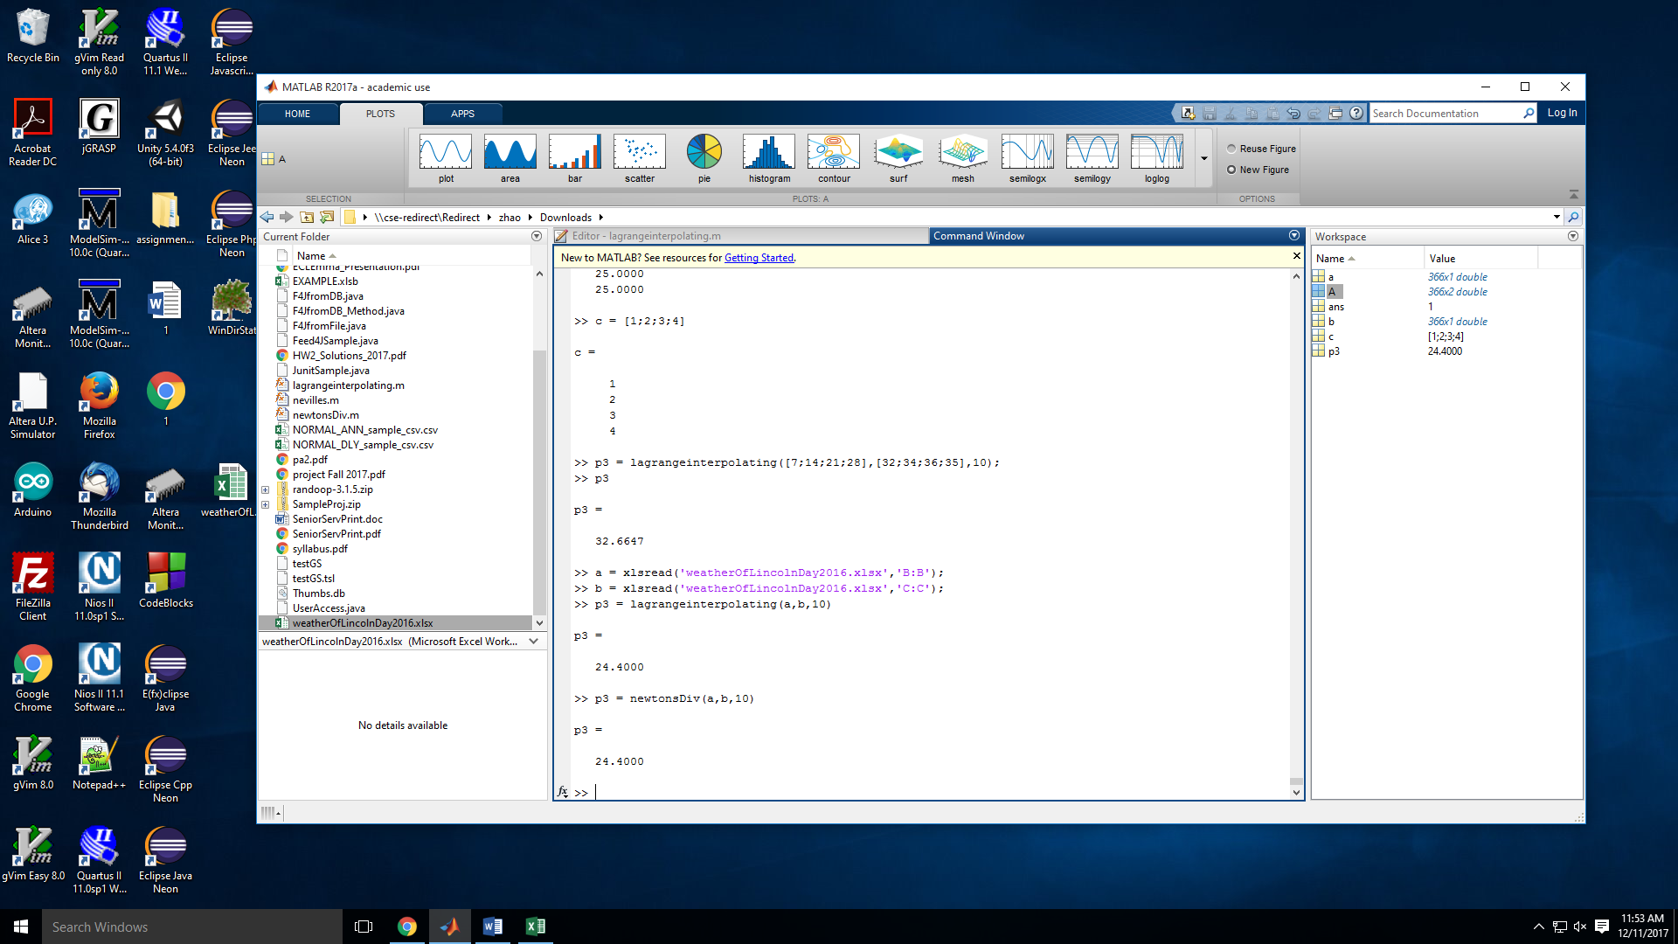

It has given the same number with T = 10;

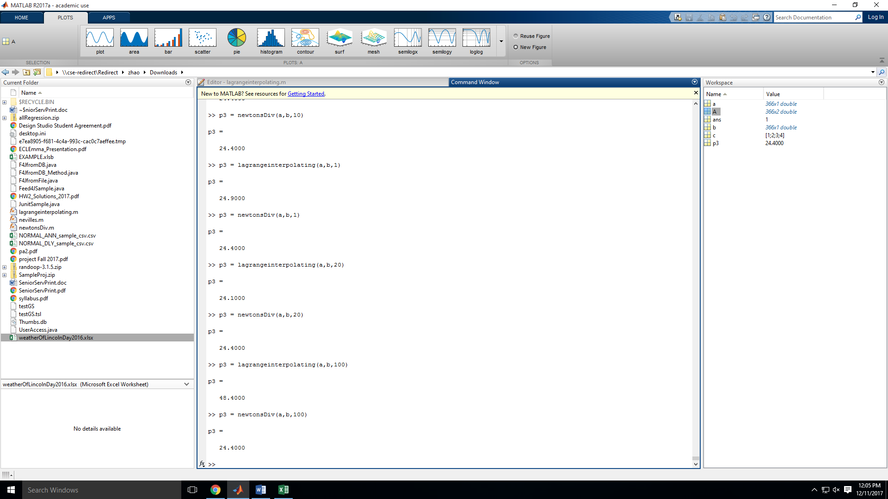

The differences start when T = 1, 20, 100. No big change with Newton’ s Interpolation method. Lagrange Interpolation method has changed a lot every time. I have tried it on our homework data, which gave the same issue. In this case, Newton’ s Interpolation method would support more accurate and stable data compare to Lagrange Interpolation method.

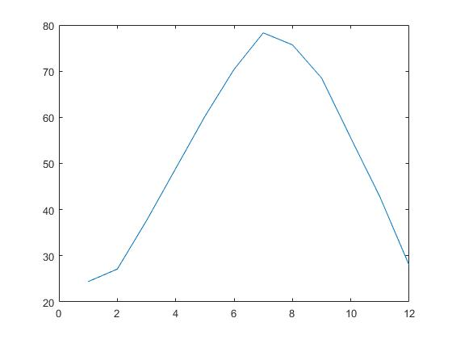

Month Interpolation graph of Lagrange Interpolation method. (T = 10)



Month Interpolation graph of Newton’ s Interpolation method. (T = 10)

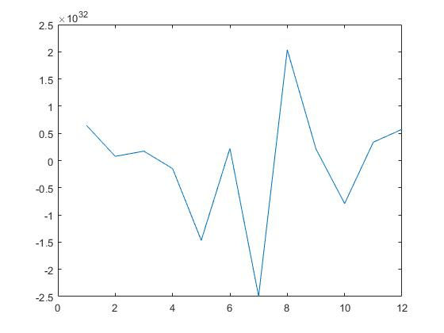

Month Interpolation graph of Lagrange Interpolation method. (T = 100)



Month Interpolation graph of Newton’ s Interpolation method. (T = 100)

It shows that Lagrange Interpolation method is not accurate compare to Newton’ s Interpolation method with the increasing/changing of T’ s value.

According to the calculations have given from the class note, Newton’ s Interpolation method has more advantage in computational complexity.

No big difference with the data I have given on speed.

* Conclusion

Overall, the pictures I have shown supported that Newton’ s Interpolation method tends to have more accurate and constant results for relative large database analysis compare to Lagrange Interpolation method. According to some information I have researched online and our class notes. I would highly recommend to use the Newton’ s interpolation method.