**This website is a chat room website**

***How to use:***

You can sign in in the sign in page.

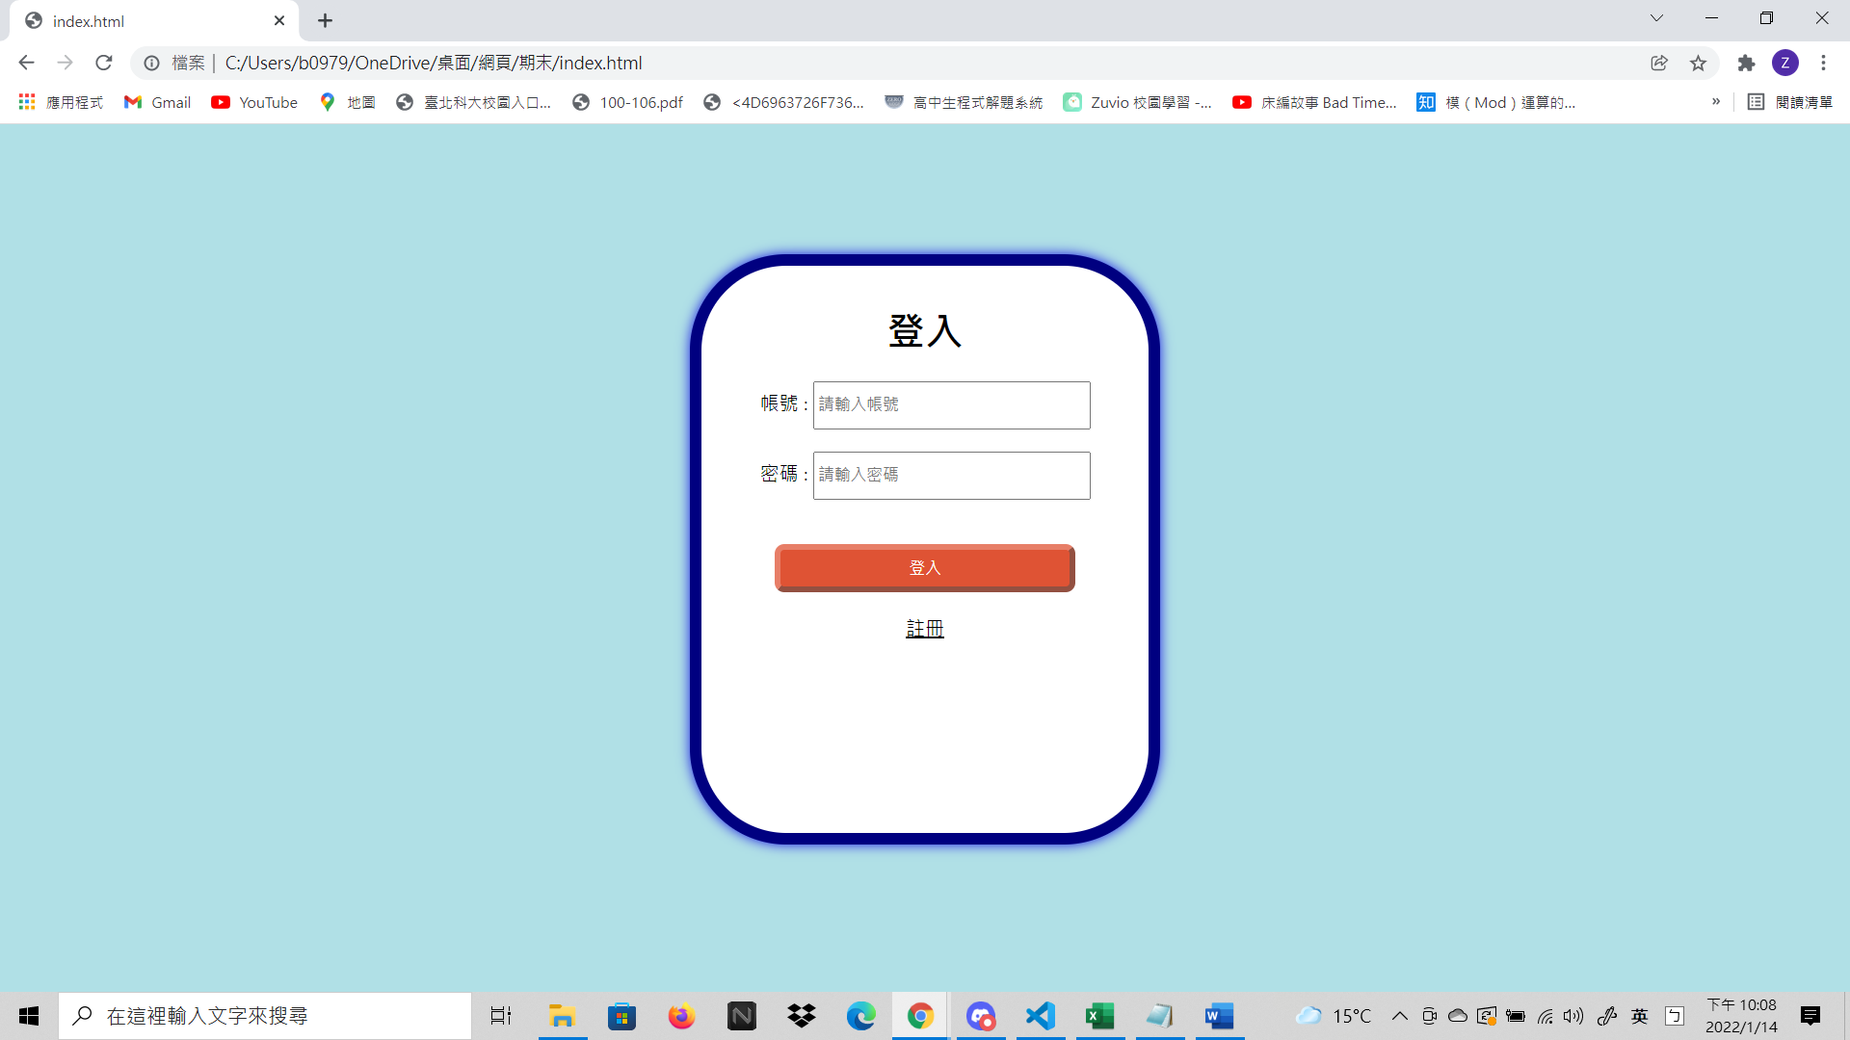

If you don’t have the account, you can register in the register page.

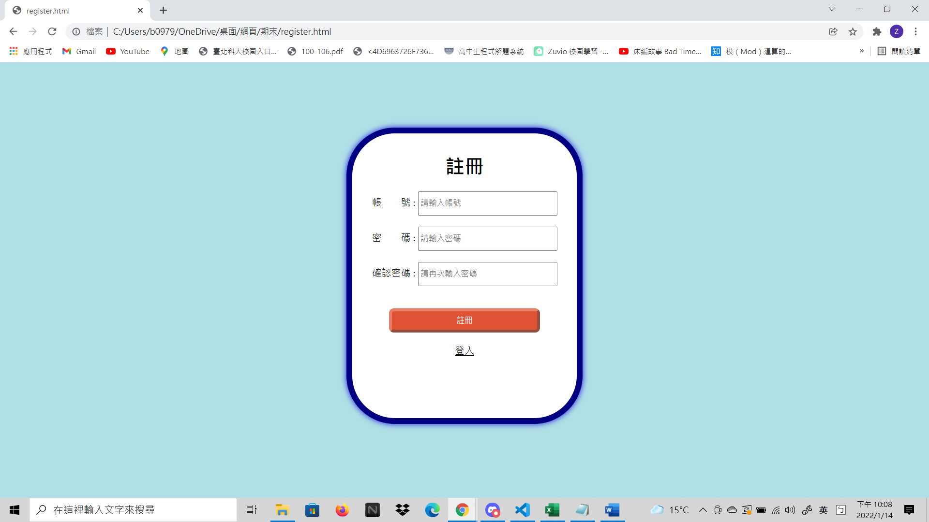

Admin user(**account**:admin@gmail.com, **password**:adminadmin)，another user is visitor.

**一、admin user:**

1. You can see all the users’ data(account and password):

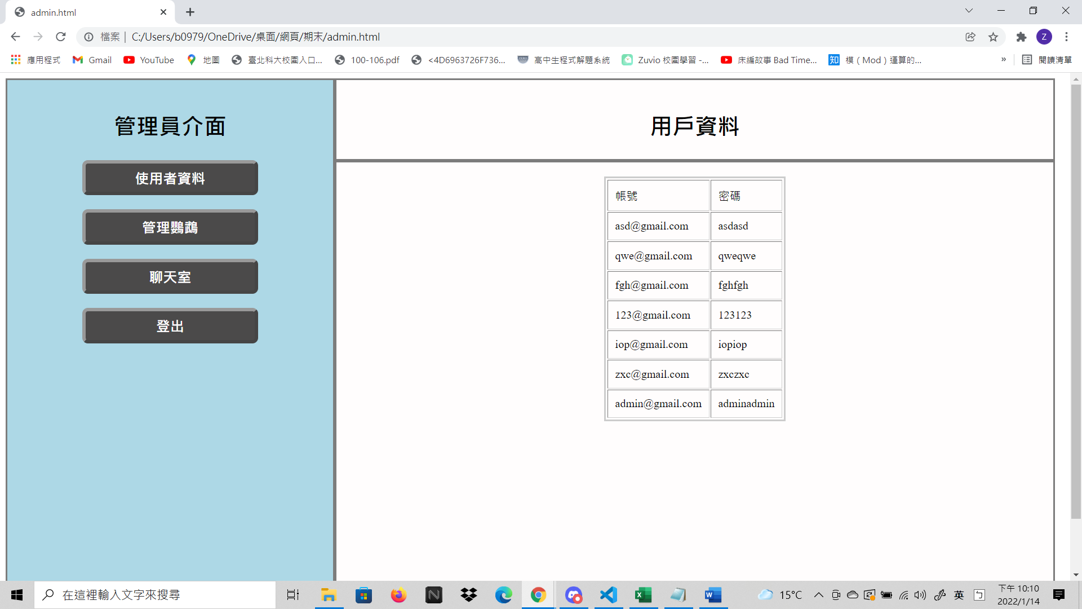

1. Chat room:

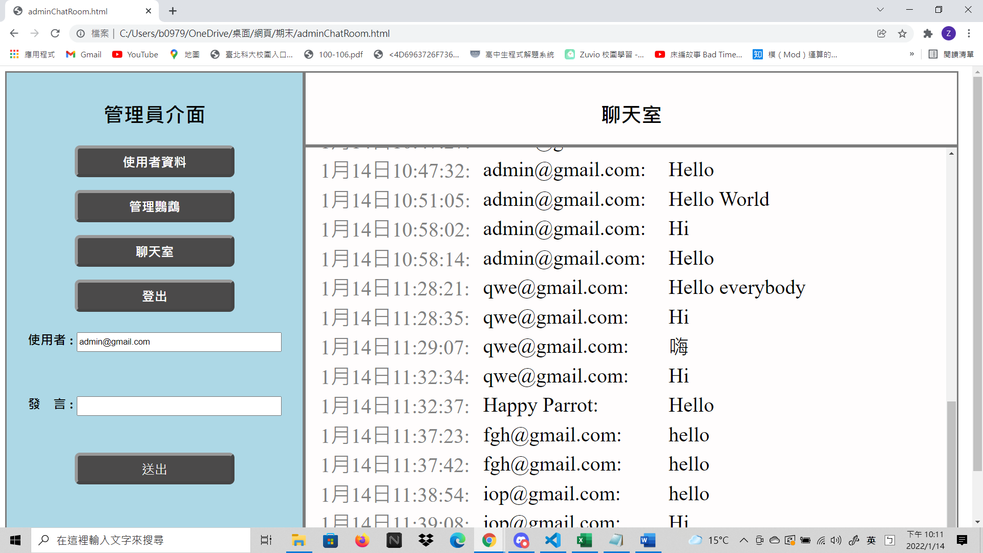

1. Manage Parrot(A robot)(You can use the text box on the left to add conversation)(Parrot will respond you if you say something in “the parrot dictionary”.):

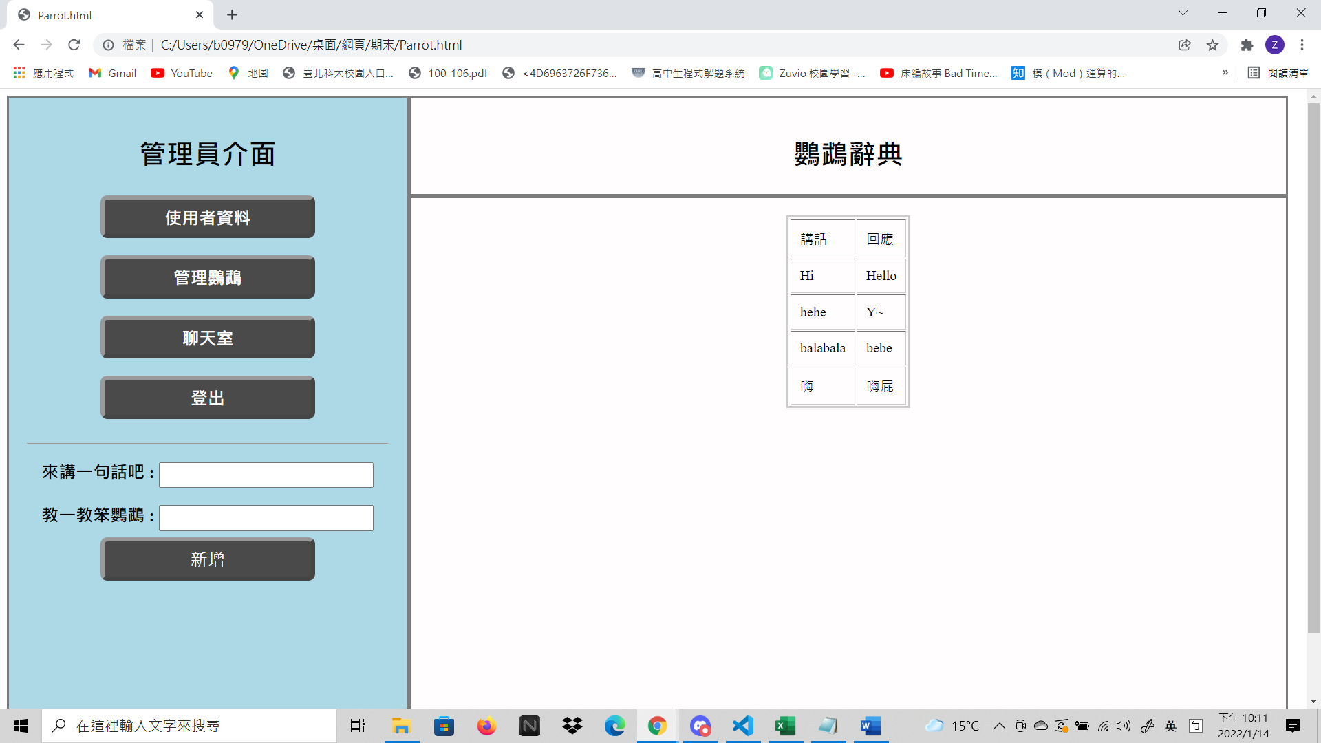

You can use the sign out button to sign out.:

Sign out success:

**二、Visitor:**

1.Chat room(You can use the text box on the left to type what you want to say.):

2. Parrot(Happy Parrot) will respond you if you say something in “the parrot dictionary”.:

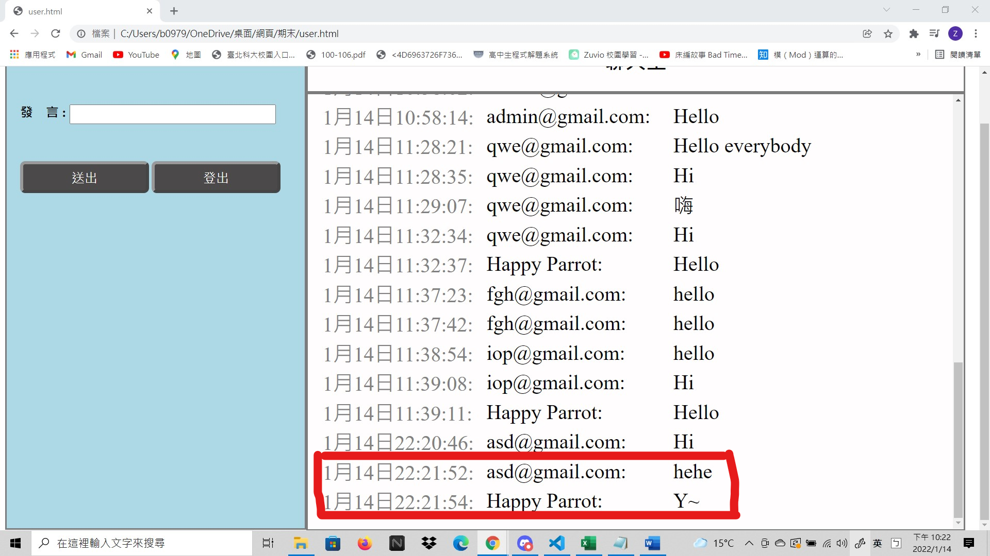

***Difficulties:***

1. How to use firebase to make a sign in system.
2. How to use java script to find the data which I want in the firebase.

***Referent:***

1.Class task

2.Firebase文檔:

<https://firebase.google.com/docs/firestore/quickstart?hl=zh-cn>