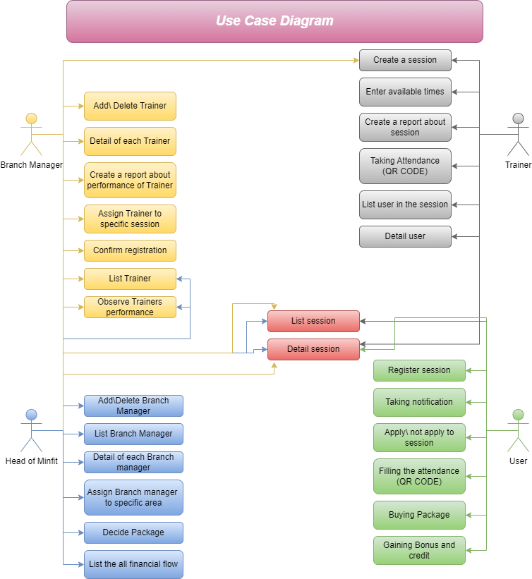

|  |  |
| --- | --- |
| System | Trainer Arrangement system |
| Use Case | Add\Delete Trainer |
| Actors | Branch master |
| Data | A few instances trainer information |
| Stimulus | Add\Delete function successfully implemented. |
| Response | The all function of trainer system can be accurate after the add or delete trainer |
| Comments | Don’t adding same trainer more than one time even if he\she are in different area. |

|  |  |
| --- | --- |
| System | Trainer Arrangement system |
| Use Case | List Trainer |
| Actors | Branch manager, Head of Minfit |
| Data | No data needed |
| Stimulus | Branch master list trainer |
| Response | The whole trainer of branch master must be listed. |
| Comments | Only list trainer in branch master’s area don’t list other branch masters’ trainers |

|  |  |
| --- | --- |
| System | Trainer Arrangement system |
| Use Case | Assign Trainer to specific session |
| Actors | Branch manager |
| Data | Instance session which is already uploaded in the system |
| Stimulus | Branch master assign trainer to specific session |
| Response | Trainers which Branch masters assigned must be showed on the system |
| Comments | Trainers which are assigned see users’ detail if they are shared the same session. |

|  |  |
| --- | --- |
| System | Trainer Arrangement system |
| Use Case | Create a report about performance of Trainer |
| Actors | Branch manager |
| Data | Template report for easy utilization, some example performance |
| Stimulus | Observe the trainer performance on the system and create a report about their efficiency. |
| Response | Trainers which Branch masters assigned must be showed on the system |
| Comments | Trainers which are assigned see users’ detail if they are shared the same session. |

|  |  |
| --- | --- |
| System | Trainer Arrangement system |
| Use Case | Confirm registration |
| Actors | Branch manager |
| Data | Instance of user and their application |
| Stimulus | Users try to buy or session or attend session as many times these must be controlled by Branch master on the system. The all-necessary confirmations are showed as notification then Branch master can confirm or reject |
| Response | Users take notification about the response of confirmation process. |
| Comments | The all-confirmation process only valid for responsible area. |

|  |  |
| --- | --- |
| System | Trainer Arrangement system |
| Use Case | Detail of each Trainer |
| Actors | Branch manager |
| Data | Instance of Trainer performance and their information. |
| Stimulus | The Trainers’ information and their personal performance according to customer feedback are shown. |
| Response | The information shown |
| Comments | Don’t view all information one page please make it easy and separate it max 3 pages. |

|  |  |
| --- | --- |
| System | Trainer Arrangement system |
| Use Case | Observe Trainer performance |
| Actors | Branch manager, Head of Minfit |
| Data | Performance of Trainer |
| Stimulus | The system is creating a table according to spending hour or man day table and their satisfaction score. |
| Response | The information shown |
| Comments | Don’t view all information one page please make it easy and separate it max 3 pages. |

|  |  |
| --- | --- |
| System | Branch manager system |
| Use Case | Add\Delete Branch Manager |
| Actors | Head of Minfit |
| Data | A few branches manager instance information. |
| Stimulus | Head of MinFit add a new Branch Manager to the system with responsible area or delete. |
| Response | The new branch manager can access branch manager system. Also, the head of Minfit can observer new branch master. |
| Comments | Area only must have one branch master. |

|  |  |
| --- | --- |
| System | Branch manager system |
| Use Case | List Branch Manager |
| Actors | Head of MinFit |
| Data | Reaching necessary list section |
| Stimulus | Head of MinFit initiates the request to retrieve the list of Branch Managers in Turkey. |
| Response | List of Branch Manager in Turkey |
| Comments | Branch manager listed with most significant information like name and responsible area |

|  |  |
| --- | --- |
| System | Branch manager system |
| Use Case | Detail of Branch Manager |
| Actors | Head of MinFit |
| Data | There is no need for any necessary information, just reaching the required area is enough. |
| Stimulus | the Minfit president wants to see all branch managers and the areas they are responsible for. |
| Response | The system displays comprehensive details of the requested Branch Manager, including their name, responsibilities, and contact information. |
| Comments | All branch manager information must be showed |

|  |  |
| --- | --- |
| System | Branch manager system |
| Use Case | Assign Branch manager to specific area. |
| Actors | Head of MinFit |
| Data | No data needed. |
| Stimulus | In the detail page or maybe directly listed page, responsible area of branch master should be assigned. |
| Response | Branch master’s responsible area is assigned |
| Comments | Be careful about when changing or assigned the responsible area, collision must be prevented among branch masters |

|  |  |
| --- | --- |
| System | Financial system |
| Use Case | Decide Package |
| Actors | Head of MinFit |
| Data | Example Package |
| Stimulus | Adding some example package which must be accessible to take with money on the system safely. |
| Response | The Package is active on the market. |
| Comments | Package must be look cool therefore please create a selling product template |

|  |  |
| --- | --- |
| System | Financial system |
| Use Case | List all financial flow |
| Actors | Head of MinFit |
| Data | No data needed. |
| Stimulus | All financial flow can be accessible with private password |
| Response | Can observe the money flow. |
| Comments | Don’t list all money transformation just clarify the result like monthly cost and weekly cost. |

|  |  |
| --- | --- |
| System | Trainer system |
| Use Case | Enter available times |
| Actors | Trainer |
| Data | Instance information about timing |
| Stimulus | Trainer must be signed to available ours to system. In this way branch master can assign session according to this. |
| Response | Trainer available times are shown on the branch masters pages |
| Comments | Available time must be obeying the rules of head of Minfit |

|  |  |
| --- | --- |
| System | Trainer system |
| Use Case | Taking attendance with QR code |
| Actors | Trainer |
| Data | Some instance users |
| Stimulus | Trainer should take the attendance with using QR code |
| Response | The list of people who is read QR code and give the system |
| Comments | QR code must be available only first 15 minutes after the session start. |

|  |  |
| --- | --- |
| System | Trainer system |
| Use Case | Create Report about session |
| Actors | Trainer |
| Data | Instance feedback information about users from Trainer |
| Stimulus | If trainer face the problem because of some users, then give feedback about this problem and causing reason, also other information about session must be putted in the report |
| Response | Feedback and other information are the uploaded in the under the session |
| Comments | Use template feedback don’t include personal information only include problem and causing reason. |

|  |  |
| --- | --- |
| System | Trainer system |
| Use Case | List the user in the session |
| Actors | Trainer |
| Data | Instance of users already uploaded |
| Stimulus | The users have already uploaded the session should be shown for Trainer |
| Response | Session users listed from trainer. |
| Comments | After session finished Trainer don’t see any information about that session users |

|  |  |
| --- | --- |
| System | Trainer system |
| Use Case | Detail user |
| Actors | Trainer |
| Data | Instance of users already uploaded |
| Stimulus | The user’s necessary information is viewed, in this way, trainer can reach the customer more easily. |
| Response | Contact information must be shown |
| Comments | Don’t list address or other private information. |

|  |  |
| --- | --- |
| System | Trainer system |
| Use Case | Create a session |
| Actors | Trainer |
| Data | Instance session or event information |
| Stimulus | The trainer can create a session about their education but don’t create a general session.  But branch master can create a general and local session or event. |
| Response | Session should view in all system because sessions are related to all system. |
| Comments | Please force to fill all information about session like location time etc. |

|  |  |
| --- | --- |
| System | User system |
| Use Case | Register session |
| Actors | Users |
| Data | Email and password information of users |
| Stimulus | Check email and password for validation on the system |
| Response | Users can register the application in both platform and register to sessions |
| Comments | To register the session sign in or sign up is mandatory |

|  |  |
| --- | --- |
| System | User system |
| Use Case | Taking notification |
| Actors | Users |
| Data | Instance session information |
| Stimulus | Users take the notification abut confirmation process or opened and closed session on the time |
| Response | Observing the users can see necessary changing on the application |
| Comments | User only can see their own responsible area other notification or other information absolutely is not visible for users. |

|  |  |
| --- | --- |
| System | User system |
| Use Case | Buying a package |
| Actors | Users |
| Data | Users’ money and necessary package information |
| Stimulus | User can buy any package which is available in the application |
| Response | The money is successfully transferred, and package must be shown from users |
| Comments | The selling process must be easy because users can buy more package |

|  |  |
| --- | --- |
| System | User system |
| Use Case | Gaining bonus and credit |
| Actors | Users |
| Data | Users’ attendance session and buy package |
| Stimulus | Users must be encountered about buy or attend the session and package with rewarding |
| Response | Users get the bonus and credit according to their activities |
| Comments | The points and credit must be shown in the main page which improve their attention |

|  |  |
| --- | --- |
| System | User system |
| Use Case | Apply \ not apply session |
| Actors | Users |
| Data | Instance users’ information |
| Stimulus | The users can apply or take application back in the system |
| Response | If the user apply or not apply this changes are viewed by trainer |

|  |  |
| --- | --- |
| System | User system |
| Use Case | Filling attendance (QR CODE) |
| Actors | Users |
| Data | Instance devise and user |
| Stimulus | User can fill the attendance with qr code easily |
| Response | The attendance must be viewed in the trainer system |
| Comments | User can doubt about attend the session therefore they can fill one more time but in the trainer system the application seemed as a one application. |

|  |  |
| --- | --- |
| System | Session system |
| Use Case | List session |
| Actors | Users, Head of Minfit, Branch master and Trainer |
| Data | No data needed |
| Stimulus | Every one can view the available list. |
| Response | Listed should be viewed |
| Comments | Only available list view for user, not available list can viewed by others |

|  |  |
| --- | --- |
| System | Session system |
| Use Case | Detail session |
| Actors | Users, Head of Minfit, Branch master and Trainer |
| Data | Instance session detail |
| Stimulus | The all information about session must be viewed |
| Response | Session information successfully viewed |
| Comments | The detail page could make like pop up |

*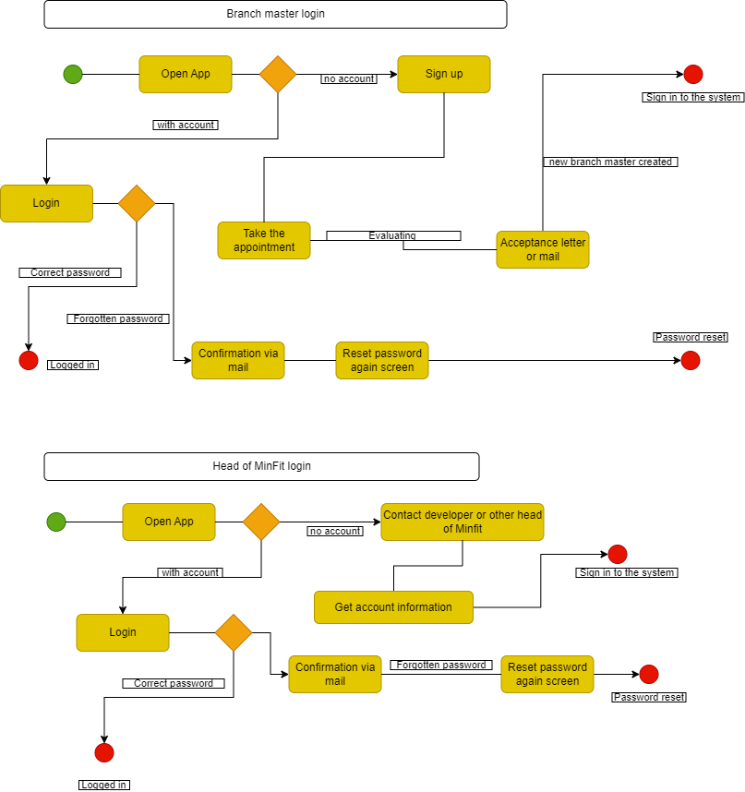****Process Models***

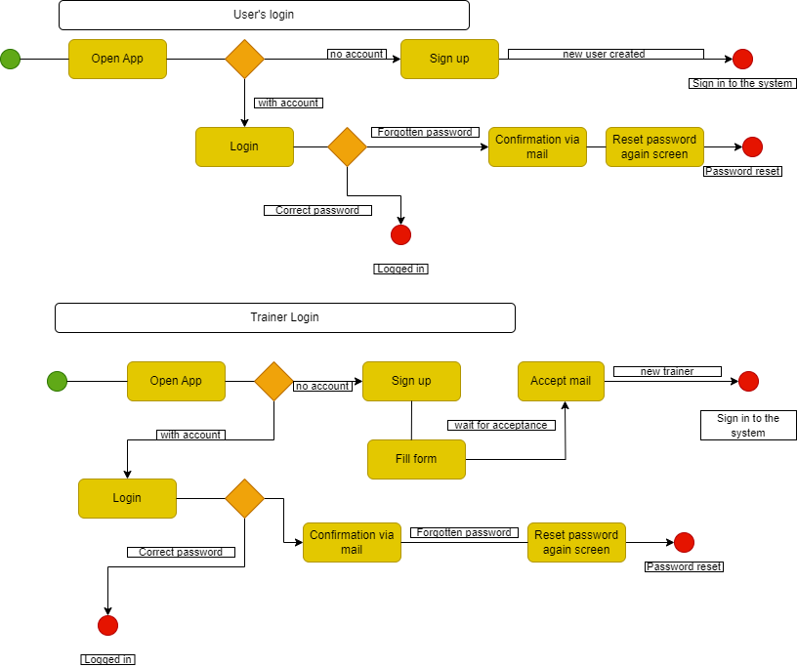

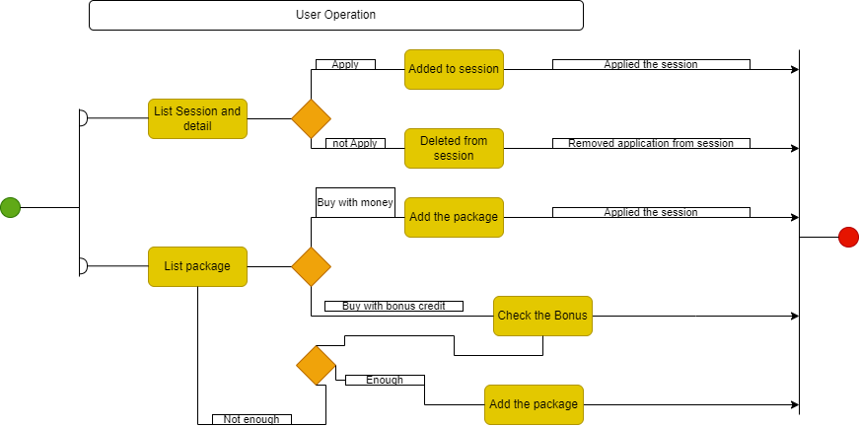

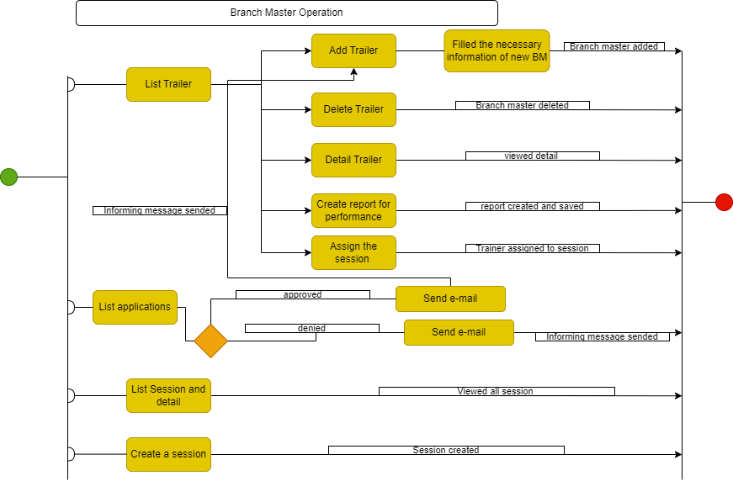

***Sequence Diagrams***

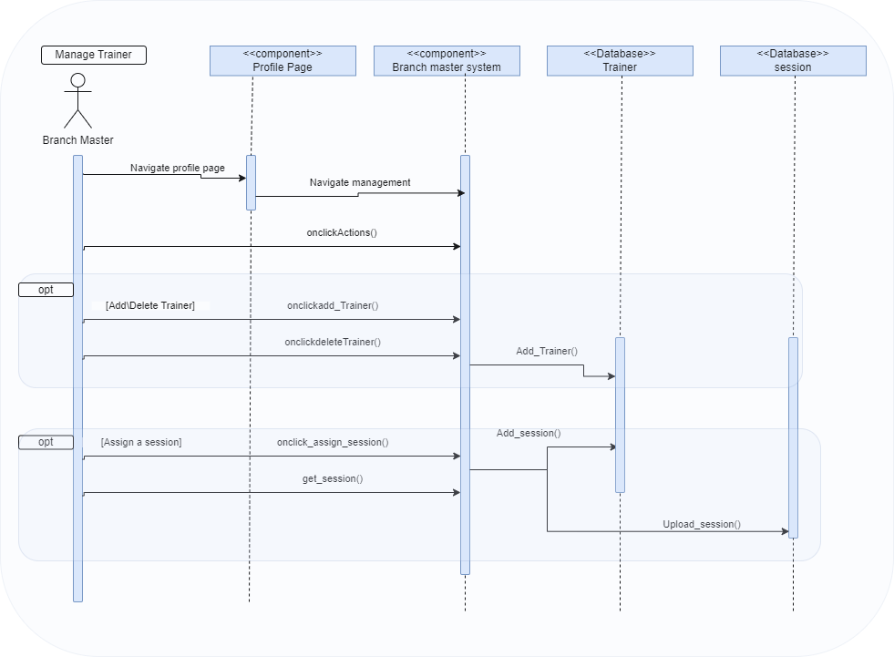

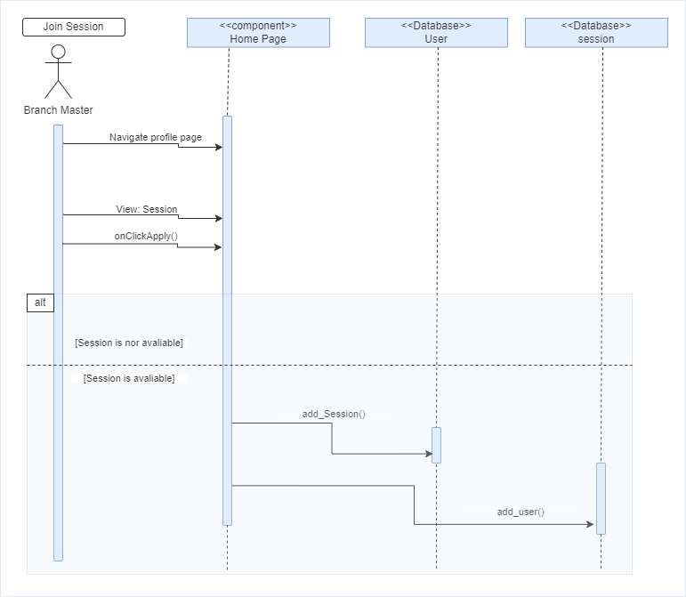

***Class Diagrams***

|  |
| --- |
| Class Head of MinFit |
| 1. ID 2. Name 3. Surname 4. Phone_number 5. E-posta 6. Password 7. Date_of_Birth 8. Gender 9. Num_branch (responsible branch masters number) |
| Get_branch()  Add_head()  Delete_head()  Updae_head() |

|  |
| --- |
| Class Branch Master |
| 1. ID 2. Name 3. Surname 4. Phone_number 5. E-posta 6. Password 7. Date_of_Birth 8. Gender 9. Num_Trainer (responsible trainer number) 10. Start_date 11. End_Date |
| Get_Trainer()  Calculate_indemnity()  Add_branch()  Delete_branch()  Update_branch()  Assign_area() |

|  |
| --- |
| Class Trainer |
| 1. ID 2. Name 3. Surname 4. Phone_number 5. E-posta 6. Password 7. Date_of_Birth 8. Gender 9. Sport_branch (what branch is proffesion for teaching) |
| Get_sports()  Calculate_indemnity()  Add Trainer()  Delete Trainer()  Update Trainer()  Assign_session() |

|  |
| --- |
| Class User |
| 1. ID 2. Name 3. Surname 4. Phone_number 5. E-posta 6. Password 7. Date_of_Birth 8. Gender 9. Point 10. Package |
| Add_user()  Delete_user()  Update_user()  Get_user() Get_point()  Set_point()  Get_Package()  Set_Package() |

|  |
| --- |
| Class Package |
| 1. Cost 2. Name 3. Photo 4. Stock 5. Product 6. Start Date 7. End Date 8. Description |
| Add_Package()  Delete_Package()  Update_Package()  GetPackage() |

|  |
| --- |
| Class Session |
| Title  Start_Date  End_Date  Number  Attend  Not_attend  Location  Trainer  Cost |
| Add_Session()  Delete_Session()  Update_Session()  Get_num()  Set_attend()  Get_attend() |