### **Medical Application Hospital information system**

We Used Sql Server In Our Project. **SQL SERVER** is a relational database management system (RDBMS) developed by Microsoft. SQL Server supports ANSI SQL, which is the standard SQL (Structured Query Language) language. However, SQL Server comes with its own implementation of the SQL language, T-SQL (Transact-SQL).

**T-SQL** is a Microsoft propriety Language known as **Transact-SQL.** It provides further capabilities of declaring variable, exception handling, stored procedure, etc.

SQL Server Management Studio (SSMS) is the main interface tool for SQL Server, and it supports both 32-bit and 64-bit environments.

**Version History SQL Server**

* Microsoft and Sybase released version 1.0 in 1989.
* However, the partnership between these two ended in the early 1990s.
* Microsoft maintained ownership rights to the name SQL Server.
* Since the 1990s, subsequent versions of SQL Server have been released including SQL Server 2000, 2005, 2008, 2012, 2014, 2016, 2017, and 2019

**The next that aScema and Relationships on database tables**

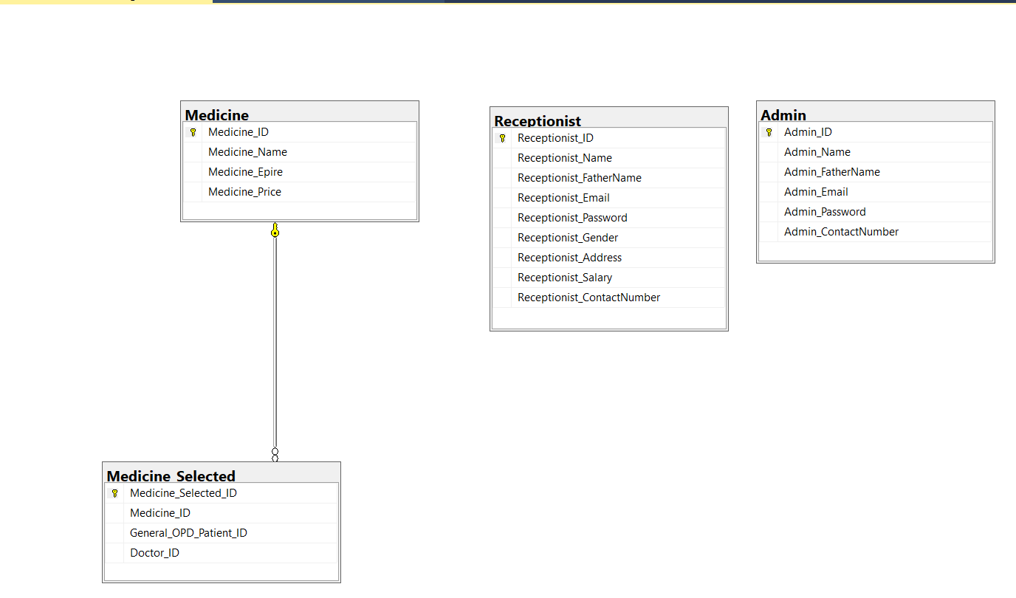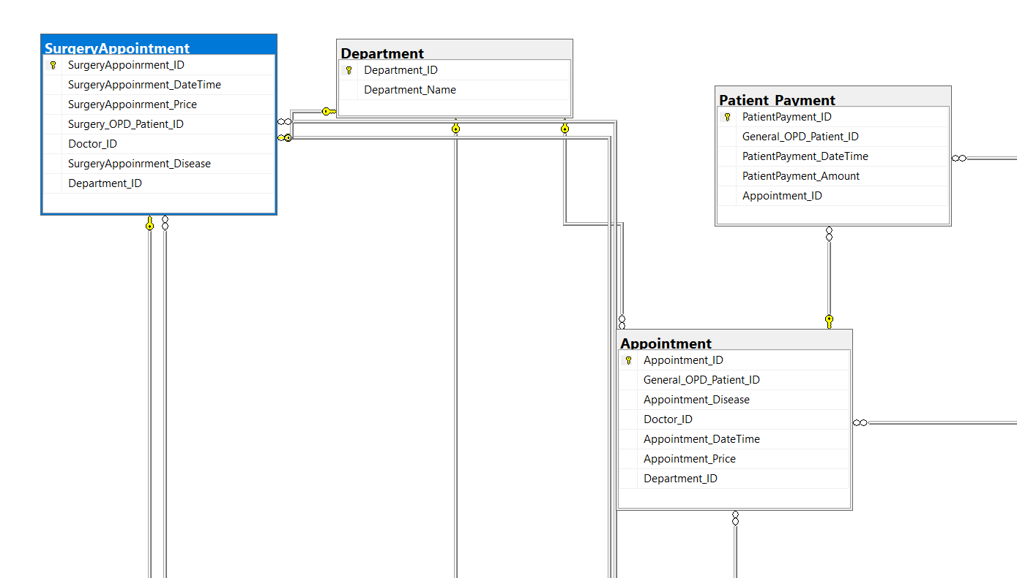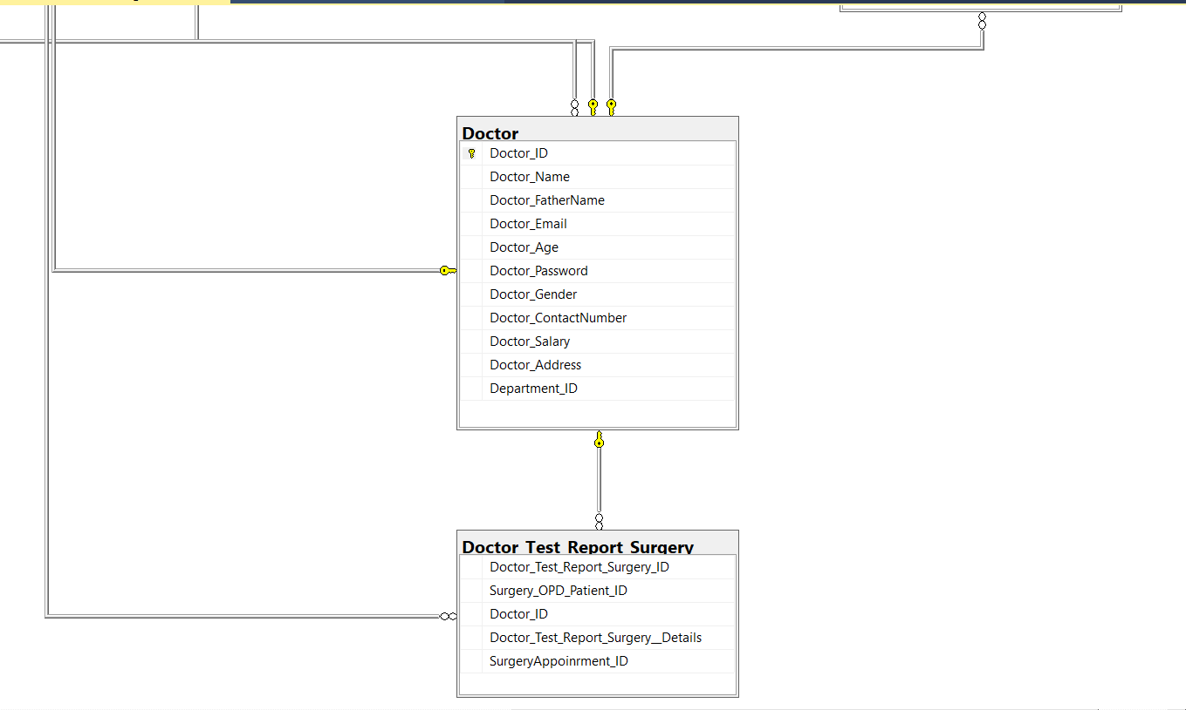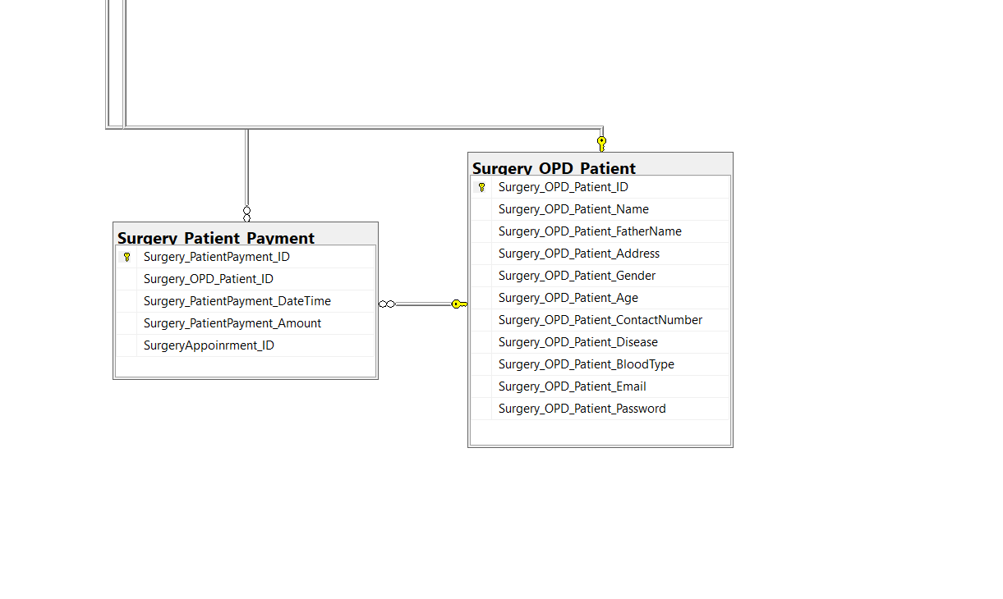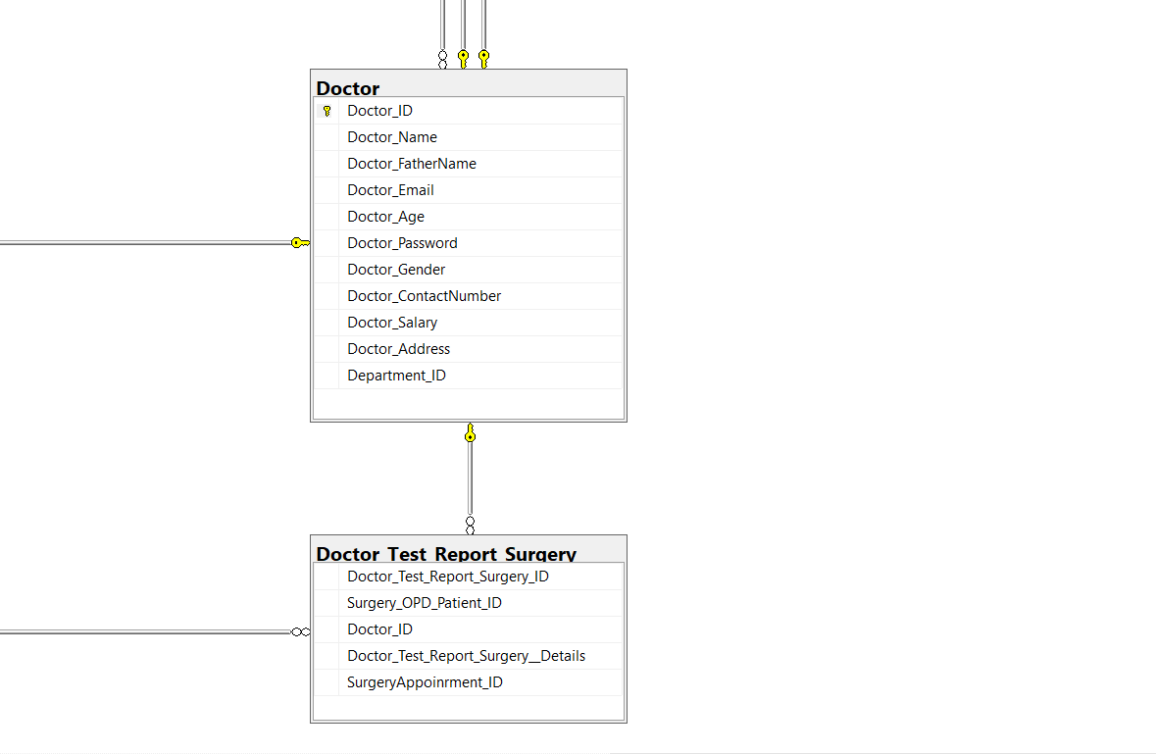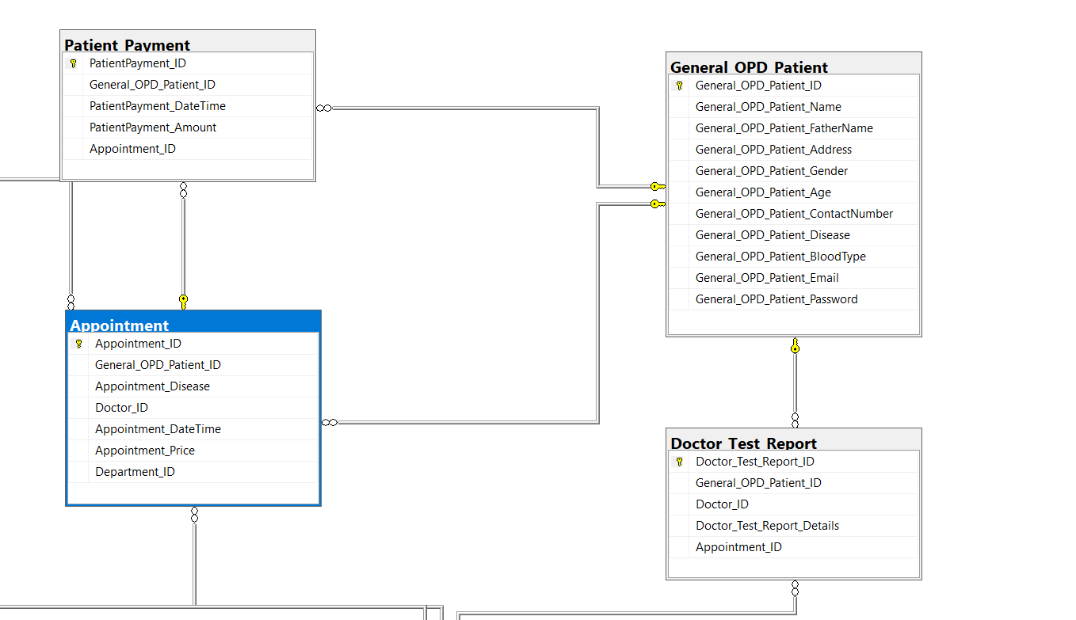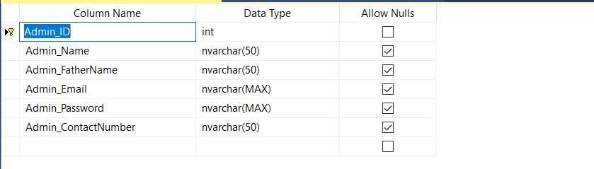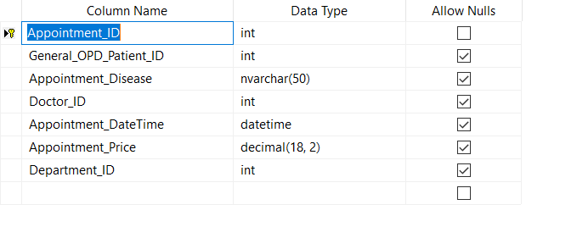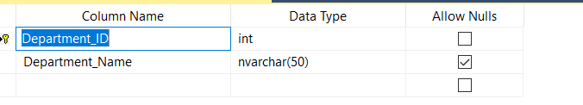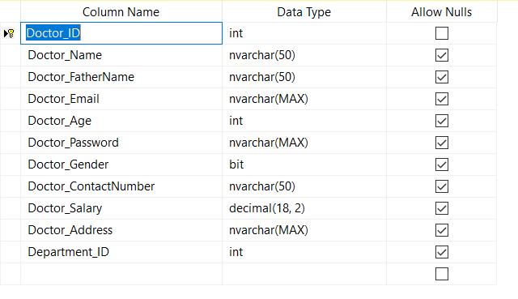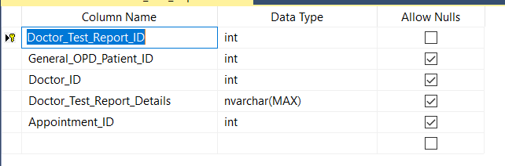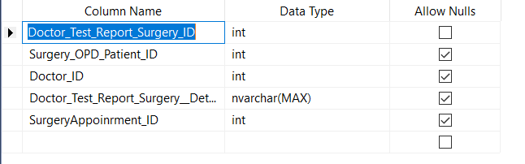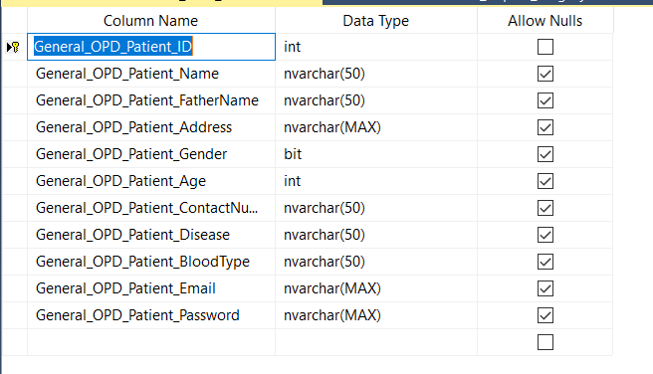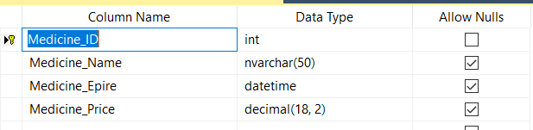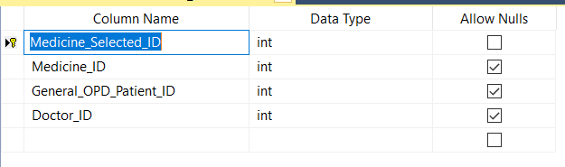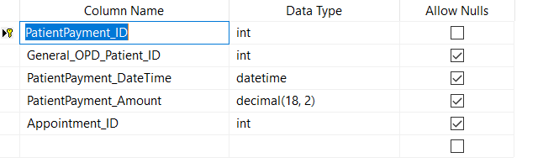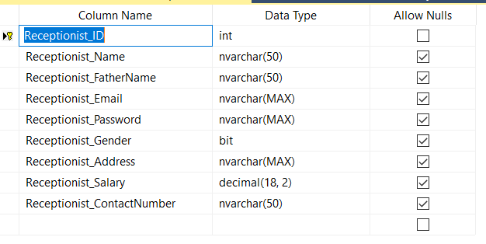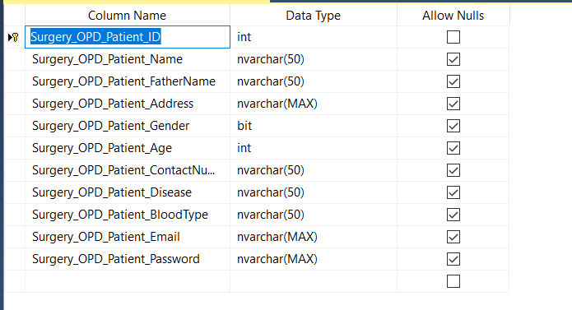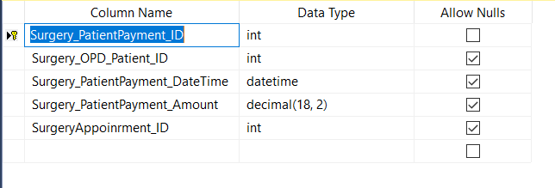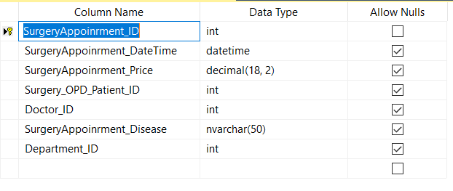

# **What is Medical Application**

Software developed for **medical** purposes, including home **medical** monitoring system, **medical** databases for healthcare professionals, etc. [Learn more in: A Proposed Scalable Environment for Medical Data Processing and Evaluation](https://www.igi-global.com/chapter/proposed-scalable-environment-medical-data/40667)

Introduction

Computers are becoming increasingly popular every passing day amongst a wide section of people. With the advent of microcomputers in late seventies and their subsequent performance enhancement in eighties, computers have reached our homes. Computers have undoubtedly revolutionized our whole life style. Computer techniques have tremendous applications in medical field, where it has the largest amount of social impact. Computers are playing an important role in the running of large hospitals.

Computer facilities are now regarded as integral to much diagnostic equipment. Major uses of computers in medicine include hospital information system, data analysis in medicine, medical imaging laboratory computing, computer assisted medical decision making, care of critically ill patients, computer assisted therapy and so on.

The word computer comes from the word “compute”, which means to calculate. Computer can be defined as an electronic device that is designed to automatically accept data, store and process then producing output results. Computers are used to store and process large amount of data and provide information to the user and to perform large number of calculations rapidly and accurately. Charles Babbage is considered to be father of modern computer

### **Hospital information system**

Medical informatics is a rapidly growing discipline. It seeks to organize and manage information in support of patient care, biomedical research and education through the aid of computer and information networks A computerized hospital information system can establish consistent standards in the transmission and storage of data and continuously monitor all transactions. It provides easy access to valuable patient care information. The physicians can have direct access to all the information of his/her patient through the use of computer. A hospital information system generally covers areas like registration, admission/transfer/discharge, billing, medical record, index, wards, operation theater scheduling, stores/inventory, pharmacy, diet, CSSD, bio-medical maintenance, payroll, accounts, etc.

To date, several software vendors have developed hospital systems relating to managing hospitals . Generally hospital administrators prefer to buy ready made package and customize the same to suit their needs.

**SYSTEM ANALYSIS**

Outpatient service analysis We can take the outpatient service as an example, analyzed the flow based on UML model. The outpatient management includes some subsystems, such as outpatient registration subsystem, outpatient pharmacy subsystem and outpatient fee subsystem (Lee et al., 2013). Different subsystems have different functions. The registration subsystem (Lee et al., 2013) is related with registration process, registration number, information of the registration, providing expert information and so on. The outpatient pharmacy subsystem is related with medical supplies, medical information, etc. The outpatient fee subsystem is mainly responsible for integrating the price, confirming the charges, entering the related requisition, providing invoices and receipts and so on. FIG. 1 The diagram of patients’ registration processes. Use case diagrams A use case diagram is made up of actors, use cases, boundaries, and a relationship between them. Use case diagram is used to describe the function of a system. A use case diagram (User Case) is a model diagram of the system functionality that an external user (known as a participant) can observe. Use case diagrams are the blueprints of the system. The use case diagram presents some participants, some use cases, and their relationships, which are mainly used to model the function and behavior of the system, subsystem or class. In UML modeling, people or things that interact with the system are called roles (Epstein et al., 1999). The roles can send the system information, receive messages from the system, and exchange information. According to the previous HIS requirements (Kim et al., 2009; Lu et al., 2011; Muller-Albrecht, 2000), the use case diagram is shown in Fig.2. Although the registration, payment, medicine taking and some other operations are carried out by the patient self, but in the HIS, these operations above are operated by the outpatient registered stuff, the toll collector and the pharmacists, respectively. Therefore, there are close relationships between the role “patient”, “he outpatient registered stuff”, “the toll collector” and “pharmacists”. That means the registration, payment, medicine taking and some other operations of the “patient” are finished under the help of the “he outpatient registered stuff”, “the toll collector” and “pharmacists”. So the patient can not get the medicines without them.

**SYSTEM DESIGN**

According to the practical workflow of hospital (Fanti et al., 2013), we can make the module design and the data bank of the system, after the requirement analysis of the HIS. The goal of the hospital information management system is to promote the hospital administration and transaction processing capacity, alleviate the intensity of hospital staffs. Therefore, we can use UML model to make the HIS after analyzing the system.

**Database design**

The design of a database is mainly based on the requirement analysis and system design of the system, we need plan the database entity of the system, so as to set up the abstract data model. The concept data model is described as the E-R (Entity-Relation) diagram, which is composed of entities and their interconnected schematic diagrams. A logical design of a database is to design the E-R diagram into a logical mode of database, that is, a logical data mode conforms to a certain database management system. The physical design of database is to select the best physical storage structure for logical data mode, based on a specific database management system. A good software system is inseparable from a good database management system, so as the same as the hospital information system. Database system is the core system of the hospital information system. An ideal database system can reduce the difficulty of the programming and the maintenance of the application. It can also improve the actual running performance of the software system. Therefore, in the database design phase of a hospital information system, we must design the database according to the design principles and steps.

Well-tuned hospital management workflow involves lots of important decisions that should be made in the most efficient and quick way. Nowadays it is hard to implement it without the distinct hospital management system. In this article, we’ll explore what is HMS software, what functions it performs and how it helps the healthcare industry be more effective and patient-centric

## HOSPITAL MANAGEMENT SYSTEM ADVANTAGES

The implementation of hospital management system project provides the institution with different advantages that improve the service quality and efficiency. As mentioned above it is created for three groups of users: patients, hospital staff and management, and third-parties like drug suppliers and insurance companies. The interaction between them conveys the general performance. The benefits received by a certain group of users also positively influence the work of the others. Cooperation and communication are the fundamental requirements here.

### **Facility management**

Hospitals authorities are able to manage their available resources, analyze staff work, reduce the equipment downtime, optimize the supply chain, etc. Another fact to mention is that hospital staff deal with the digital data instead of endless paperwork.

## HOSPITAL MANAGEMENT SYSTEM FUNCTIONS

The hospital management system organizes the stable functioning of daily tasks and interactions. This is a special tool to support the smooth operating of the software components that are vital for the clinic administration. The hospital records management software keeps a track of all the operations, stores the users’ data, performs its analysis and generates the reports. The medical institution is given the opportunity to collect its information in one place. It includes the patient and doctors’ records as well as the data concerning financial affairs, supply management, etc. Furthermore, it is only processed, classified and accessible for authorized users. The hospital database management system provides users with data security due to all regulations. Implementation of different functions empowers smooth and clear functionality.

The hospital records management software tracks the number of available doctors and their working hours. This allows to have the accurate schedule of each employee, manage your facility abilities and the supply chain in order to meet all the needs of the patients. It helps to arrange the appointments for both the staff and patients’ convenience.

Any clinic should store medical histories, test results, prescribed treatments, etc. The good hospital database management system will do it for you. All the details are securely stored for the access of the doctor and can be provided to the patients by their requests. They can receive the test results or medical reports by email or the user account. When the written form is required, printing will take only a few minutes for the clinic staff.

Another function is connected with managing finances. The hospital accounting software estimates the patients’ payments. It might remind the bank account where you can check performed operations and the billing status of each customer.

Moreover, the hospital record management system is capable of generating regular reports of the tracked data including healthcare, staff efficiency, finances, [inventory](https://smallbusiness.chron.com/advantages-inventory-control-healthcare-organization-3201.html), and facility utilization, etc. This greatly helps the clinic authorities in making reasonable policy decisions. Therefore, any of these functions are designed to make the clinic management system easy to use, comprehensive, powerful and reliable.

**COMPONENTS OF HOSPITAL INFORMATION SYSTEM**

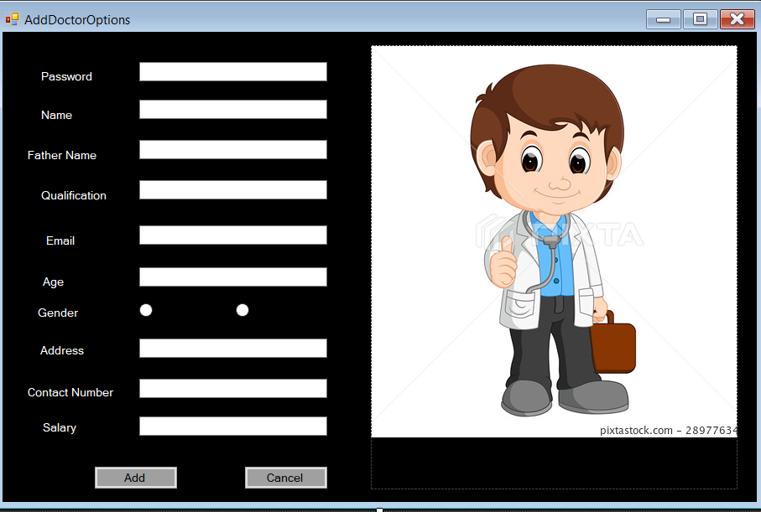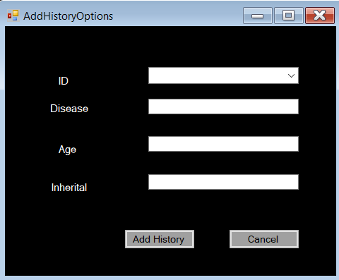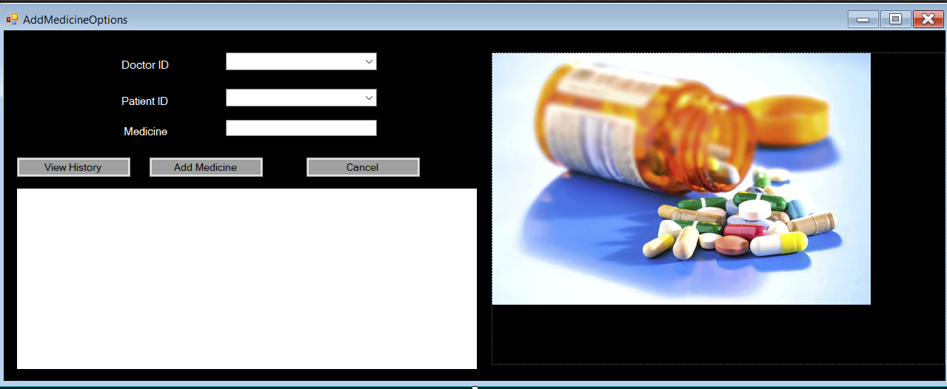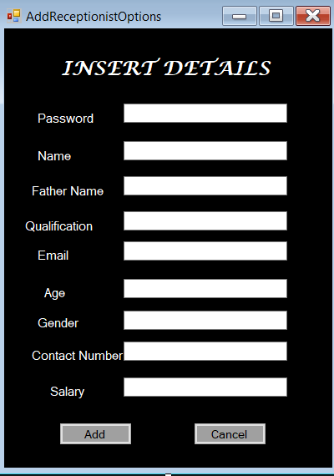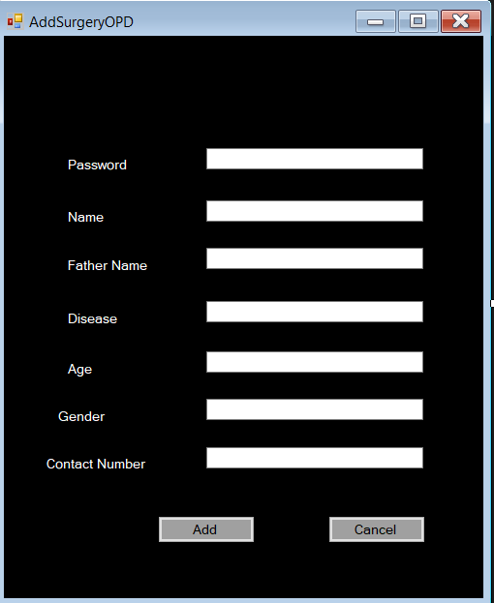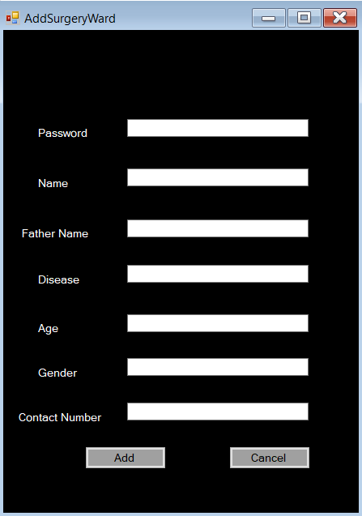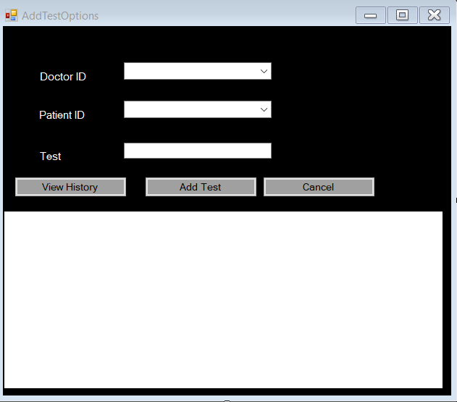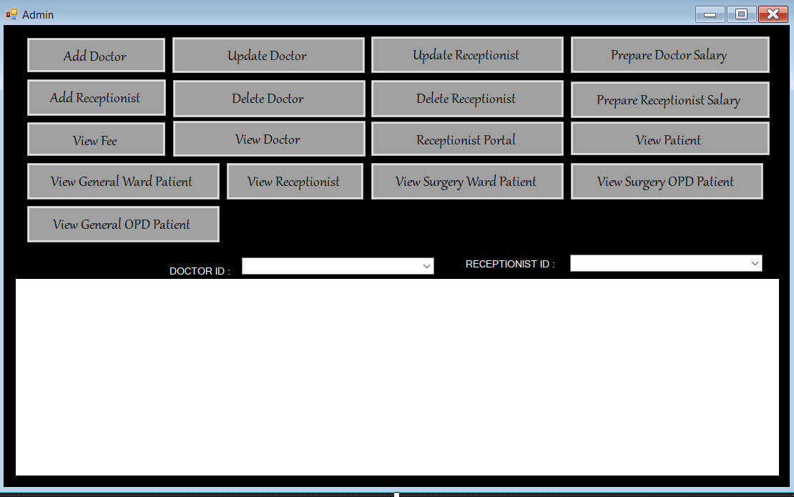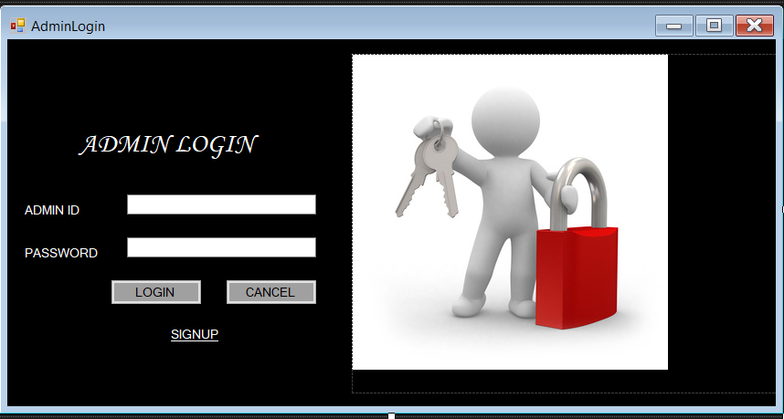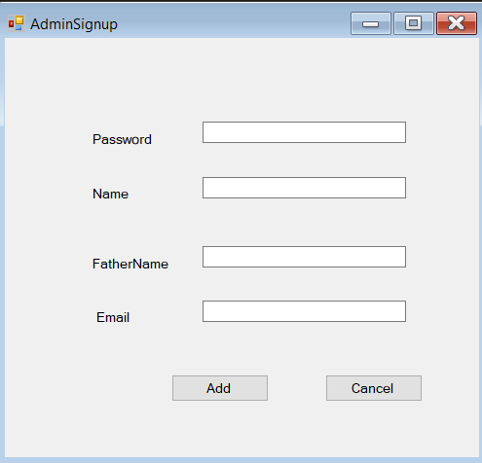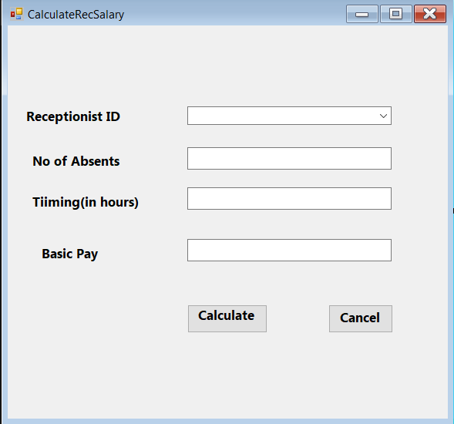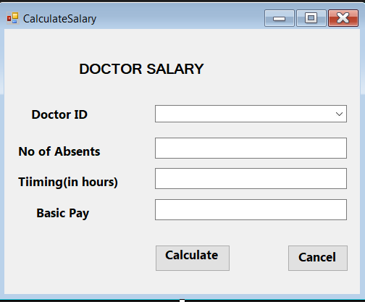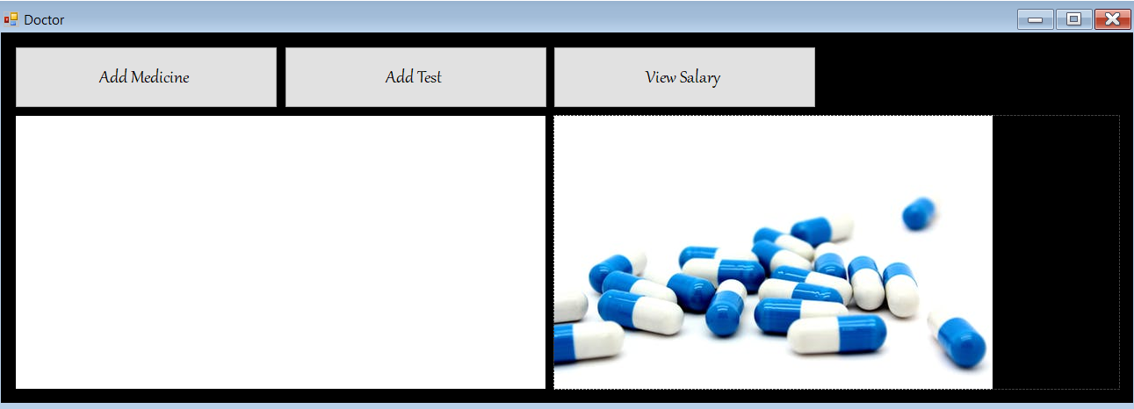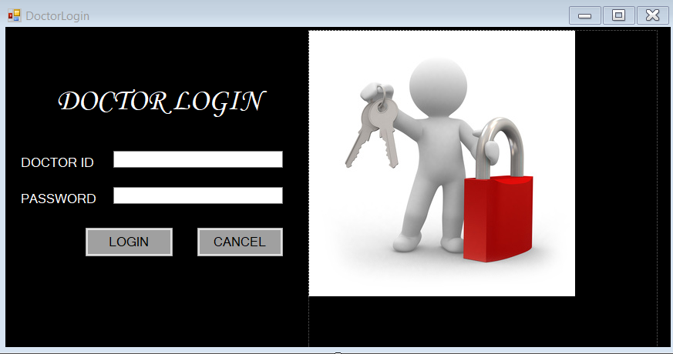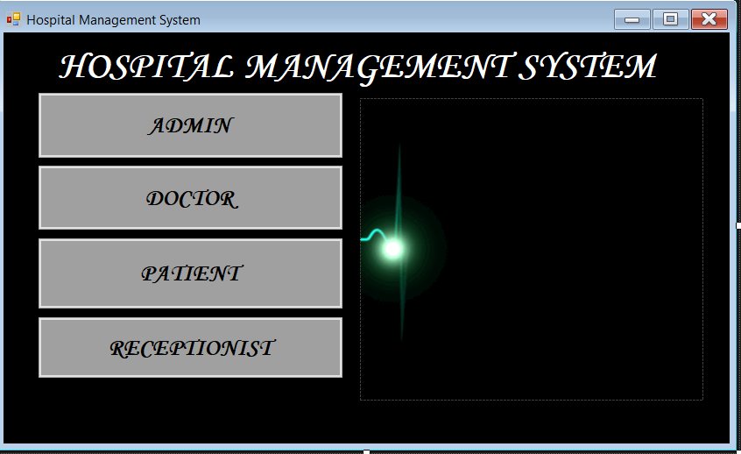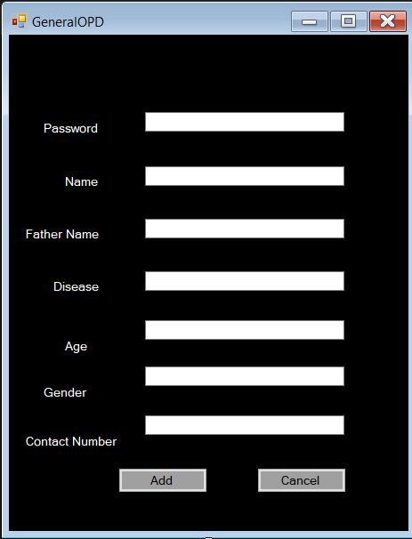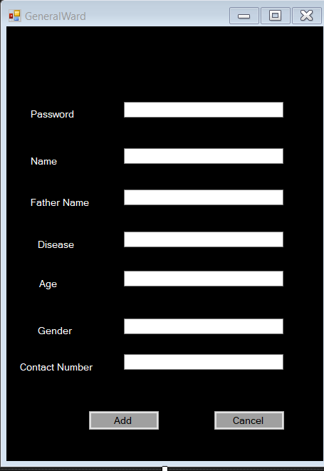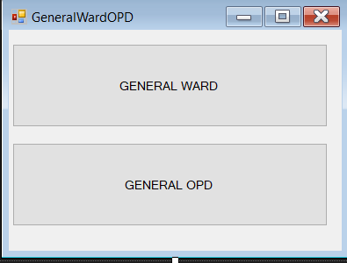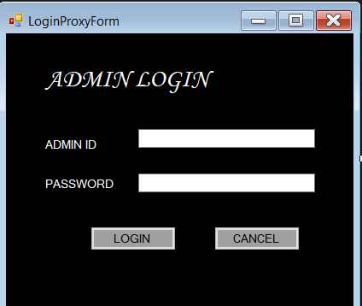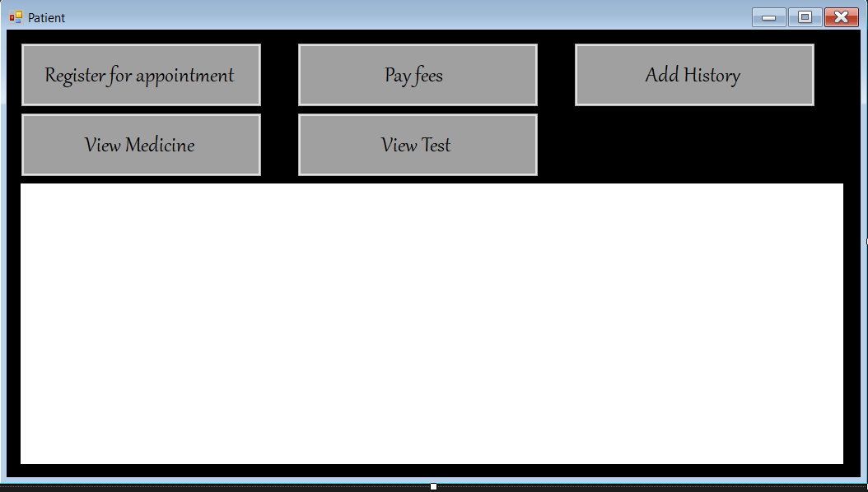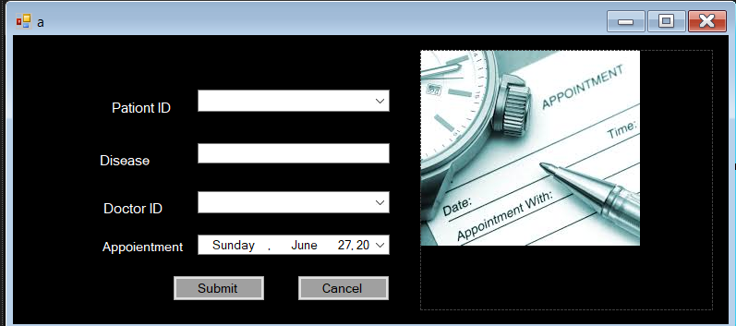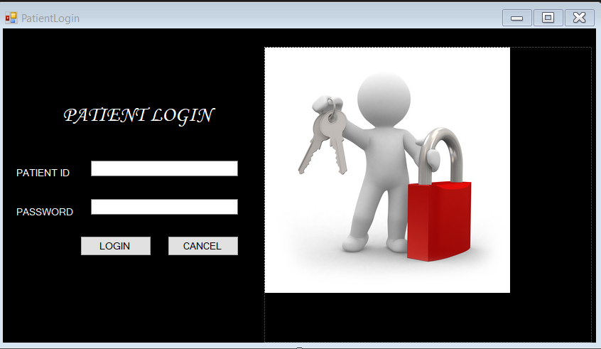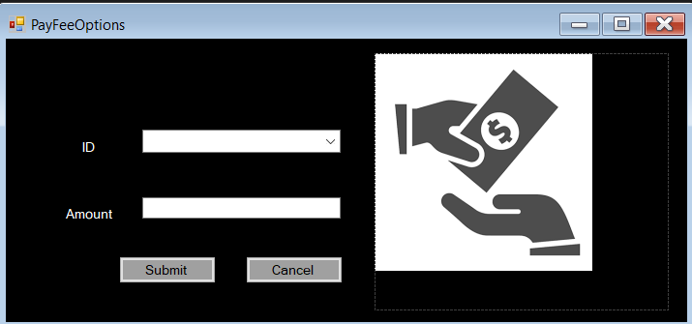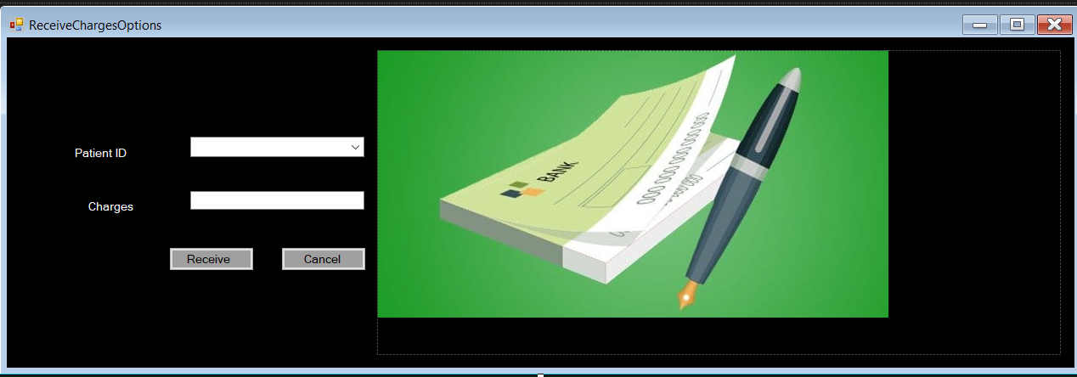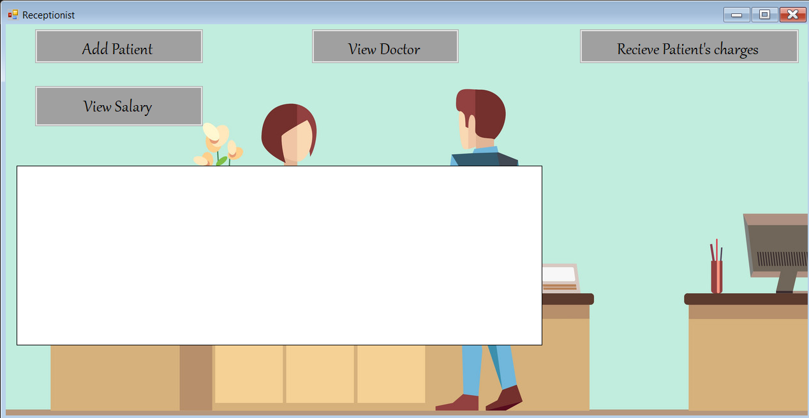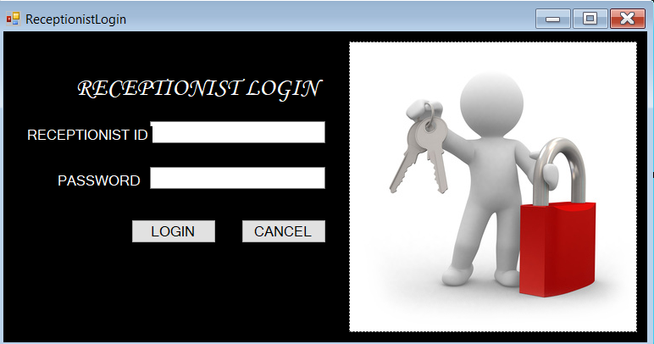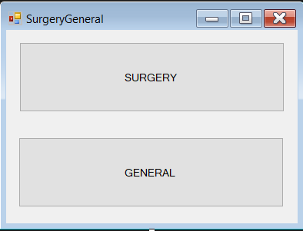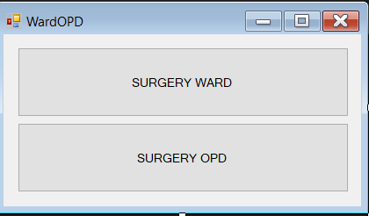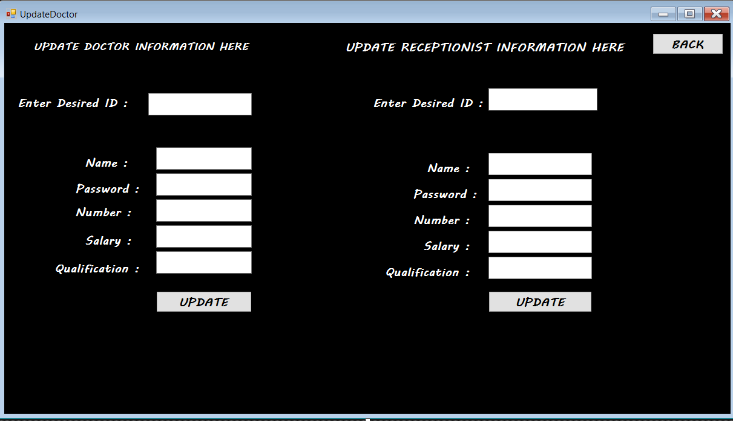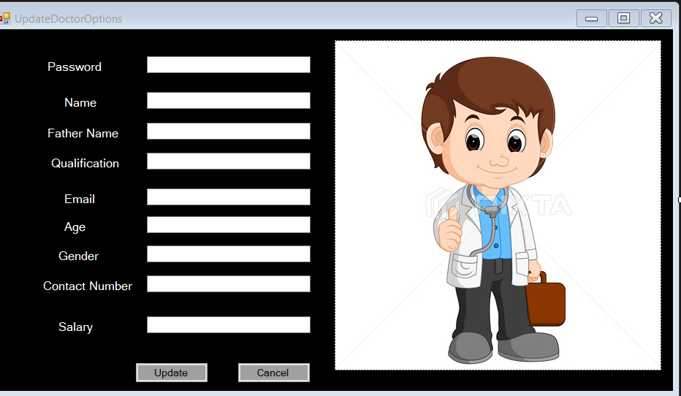

## IN CONCLUSION

Taking into account all the mentioned details, we can make the conclusion that the hospital management system is the inevitable part of the lifecycle of the modern medical institution. It automates numerous daily operations and enables smooth interactions of the users. Developing the hospital system software is a great opportunity to create the distinct, efficient and fast delivering healthcare model. Implementation of hospital management system project helps to store all the kinds of records, provide coordination and user communication, implement policies, improve day-to-day operations, arrange the supply chain, manage financial and human resources, and market hospital services. This beneficial decision covers the needs of the patients, staff and hospital authorities and simplifies their interactions. It has become the usual approach to manage the hospital. Many clinics have already experienced its advantages and continue developing new hospital management system project modules.