Data Base Tables

Admin Table

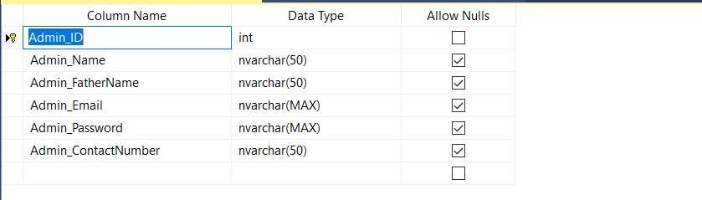

Appoinment Tabel to Taking a date for the visit

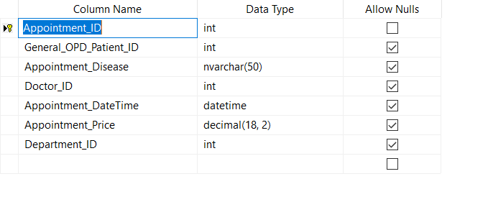

Departements Tabel for all Doctors in the hospital

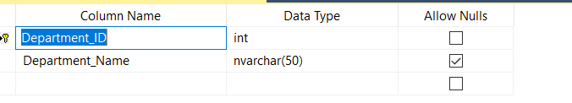

Doctors Tabel with their Attributes

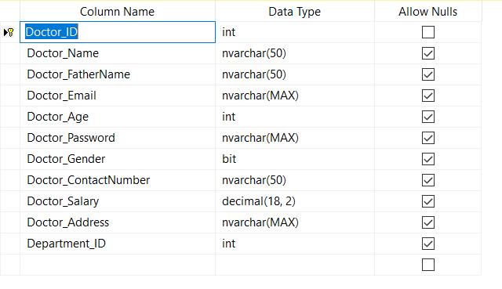

Test Reports Tabel that doctors can add for patients

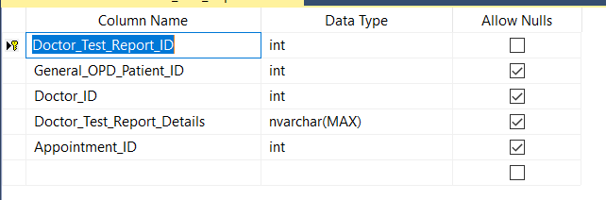

General Out Patient Clinics Tabel for Patients by their IDs

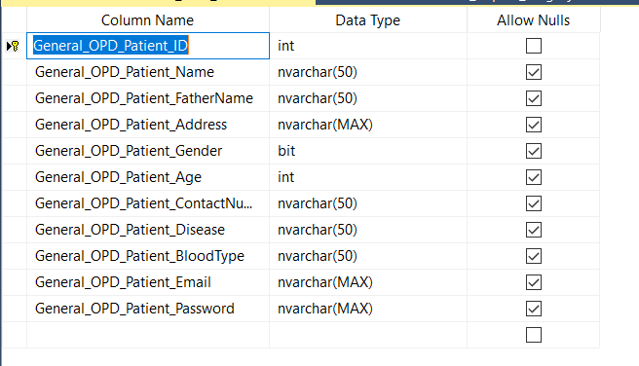

Tabel for Medicines in the hospital

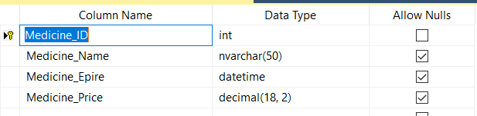

How to selecet a medicines for a spasicif patient Tabel

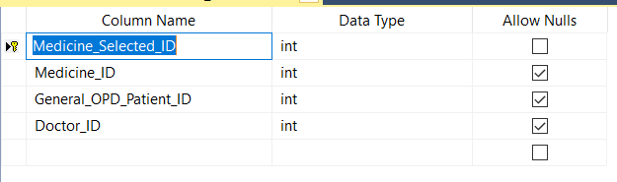

How the patient can pay on our system

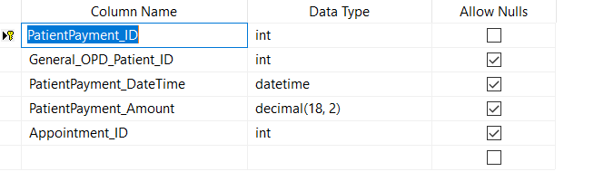

About the Receptionist attributes it's

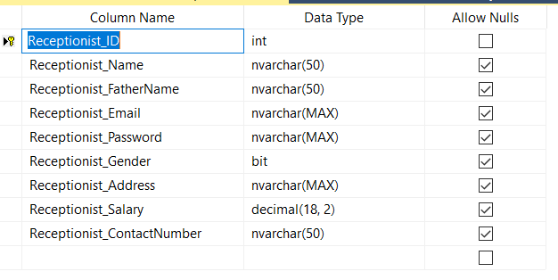

DataBase Ended….

Relation Data base

between Medicine & selected medicine Tabe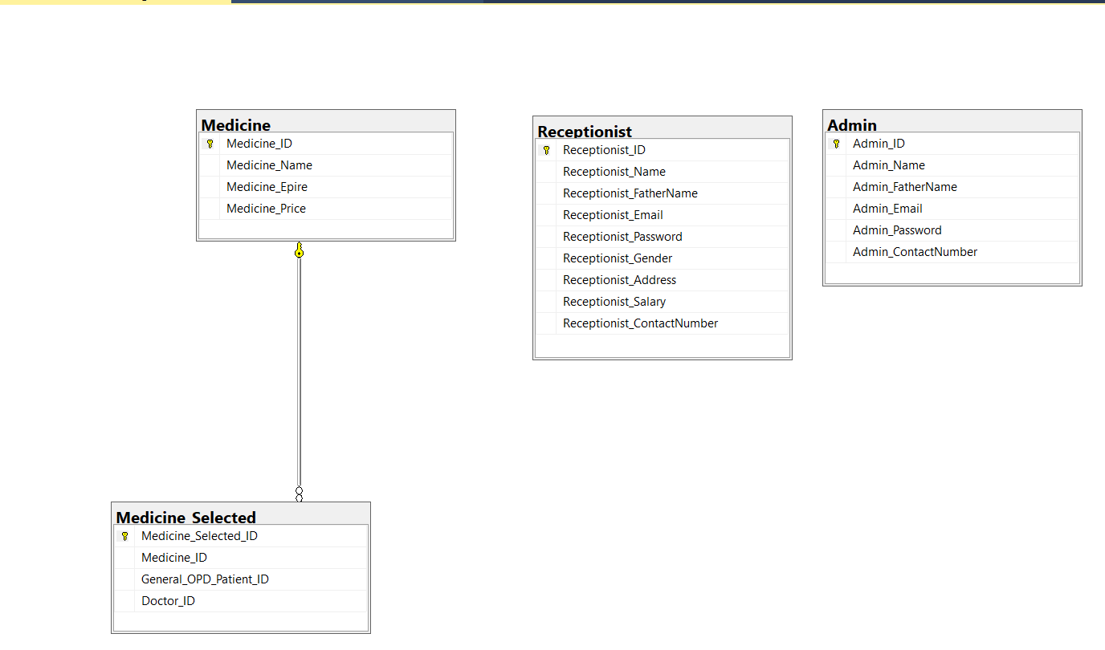

Relation for Patient payment & Appoinement Tabels

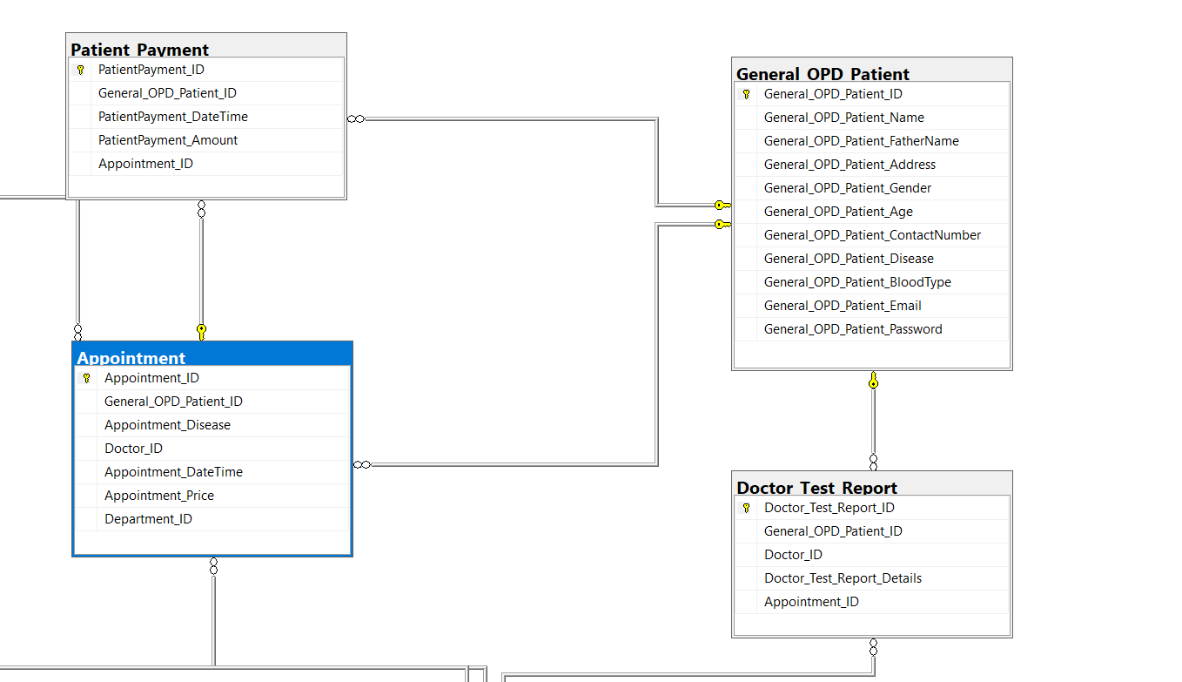

……………………

Desktop Application Forms

Start Form when opening the application at first time

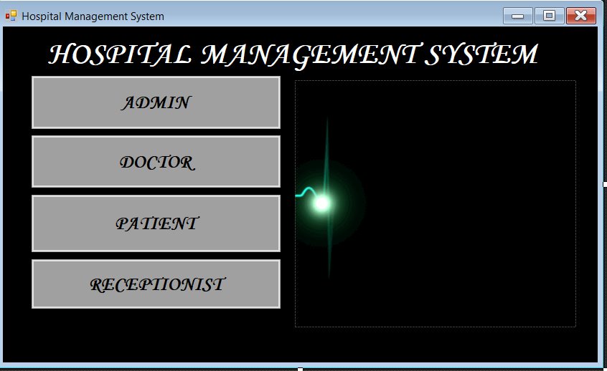

Doctor Login Form

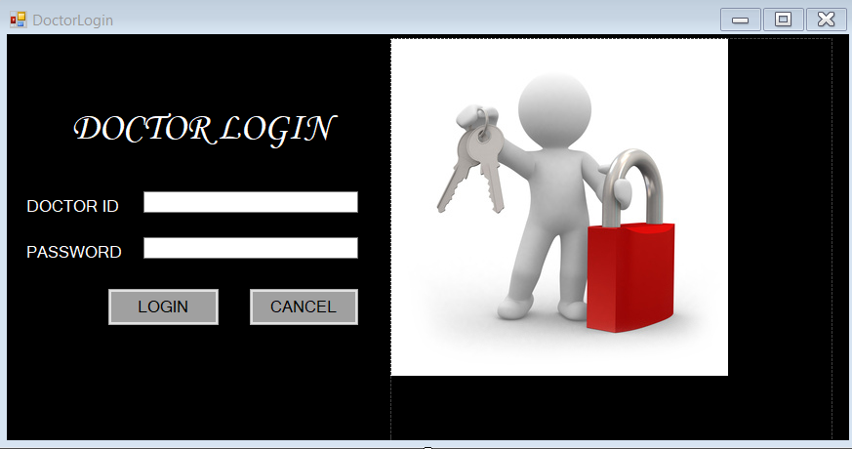

update Doctor Options Forms

Doctors view form for patient options

Add Test Options form

Add History Options , to add disease for the patient's profile history

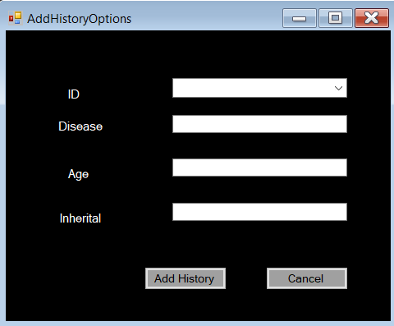

Add Medicine Form

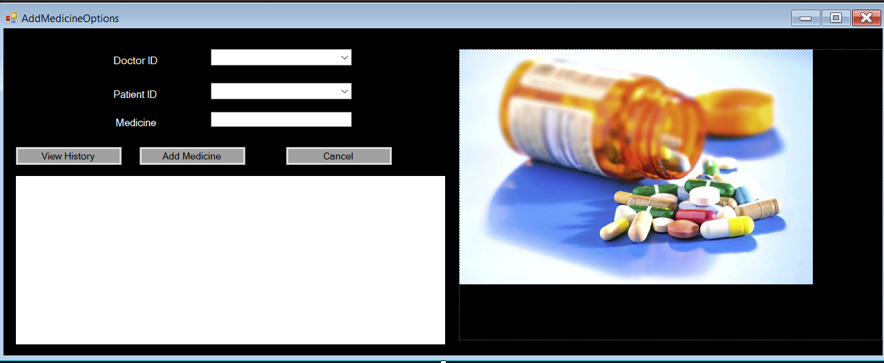

Receptionist Login Form

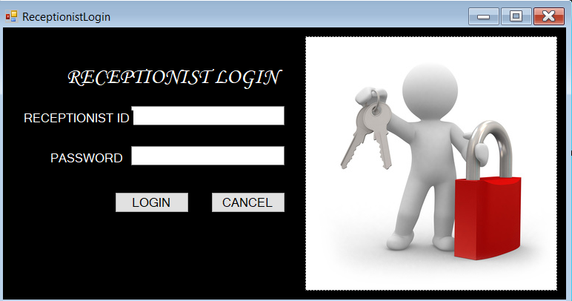

Receptionist View Form

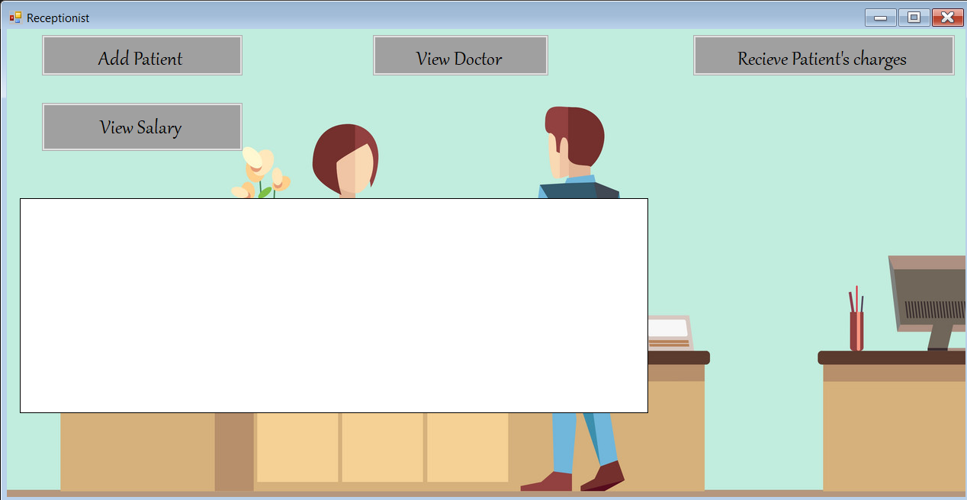

Receptionist receving mony from the patient Form

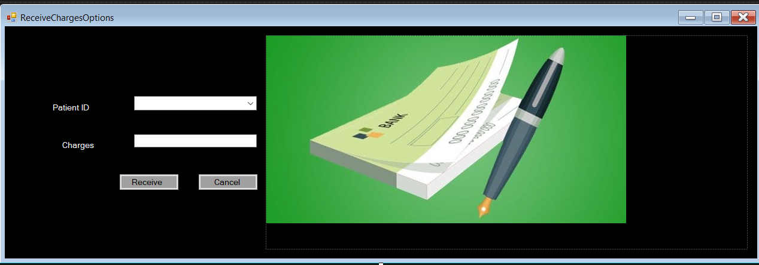

Add Receptionist Form

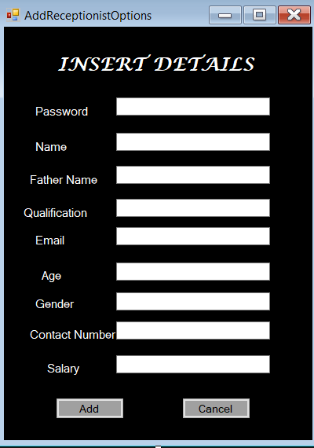

Admin Login Form

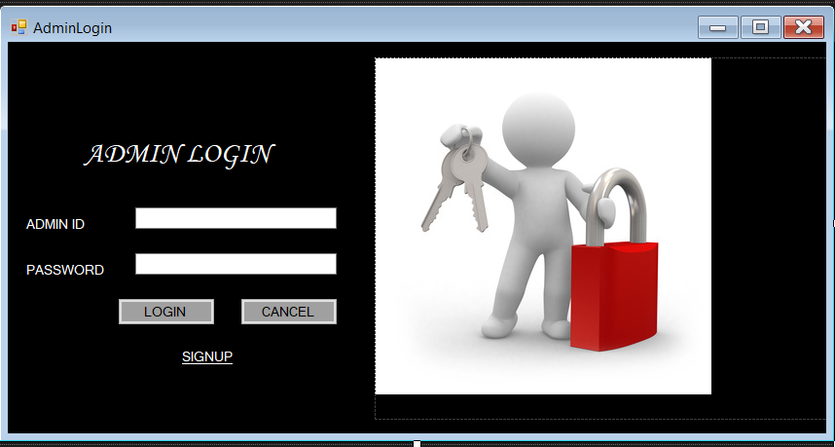

Admin Sing up Form

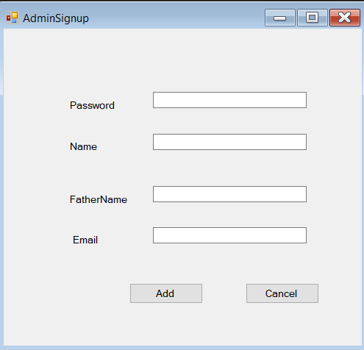

admin Option for powers they have

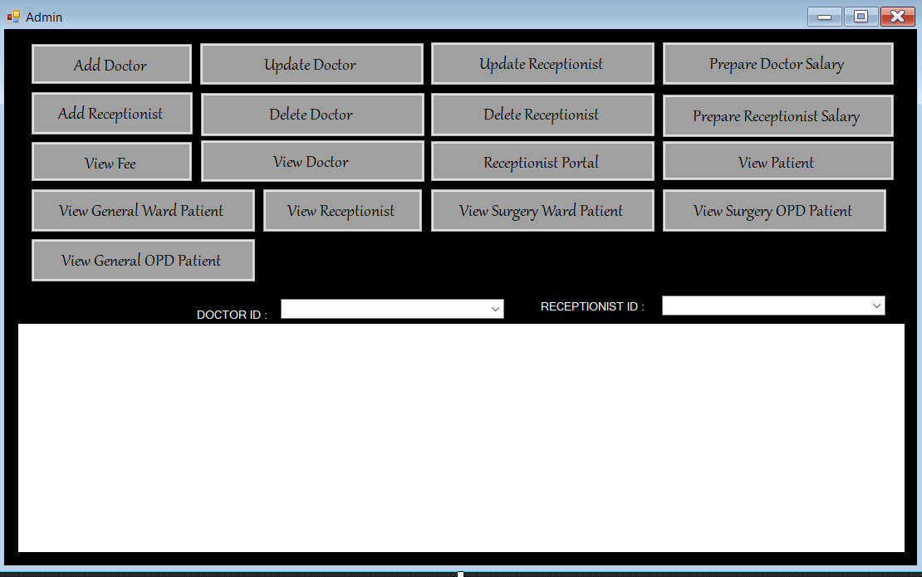

Admin Power for Edit/delete Doctors – Receptionist Form

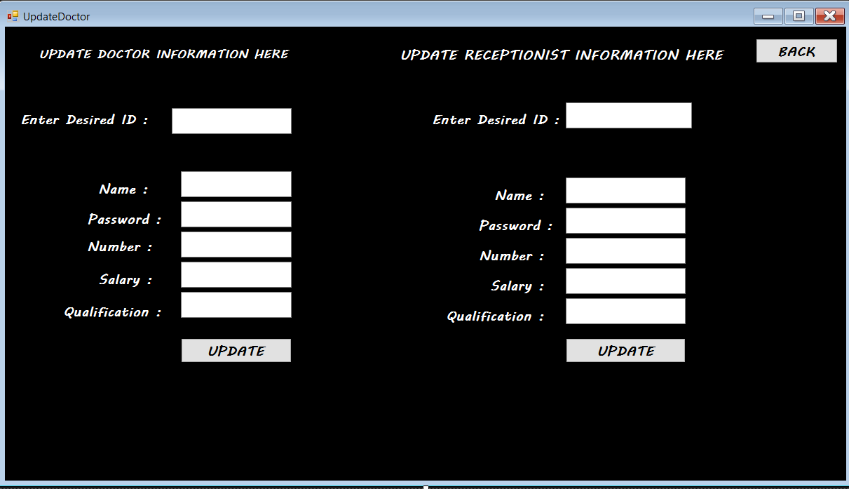

form for adding doctors informations

Patient Login Form

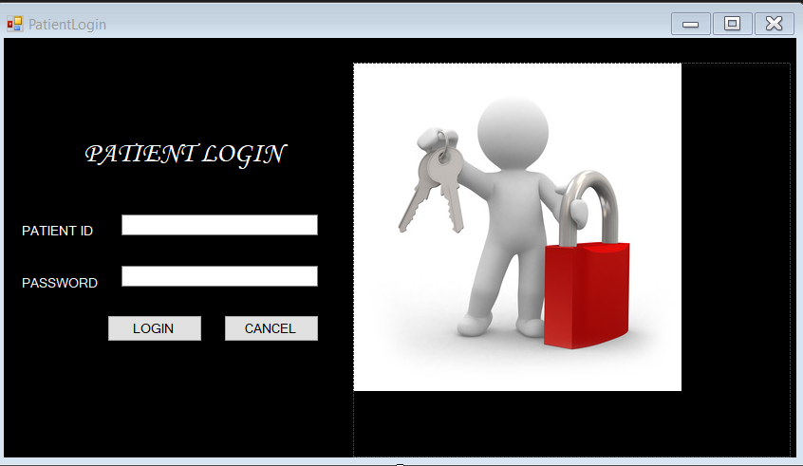

Patient powers he has on the application

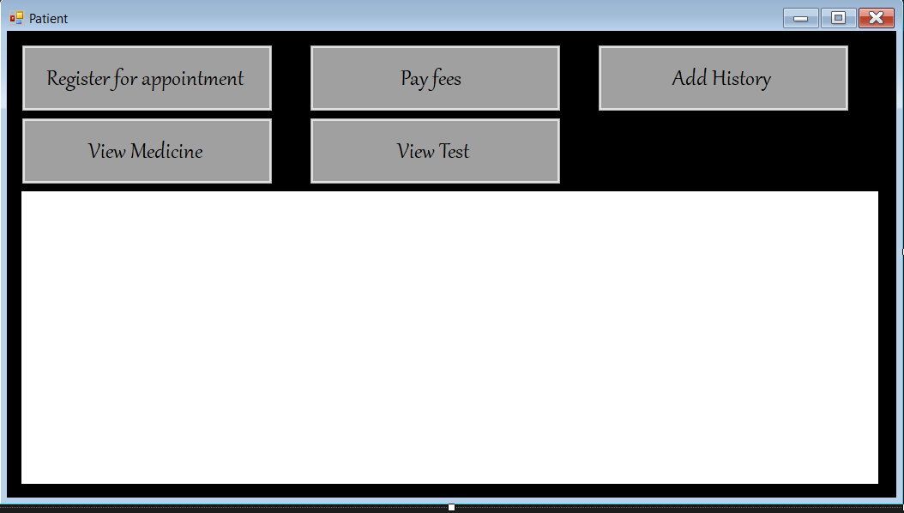

Patient Appoinement form

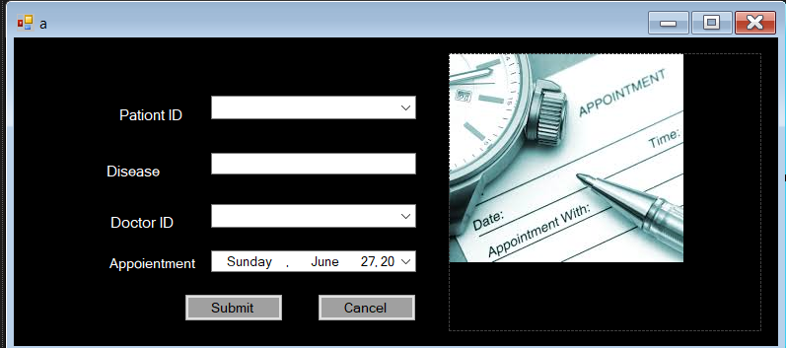

Patient form for payfee

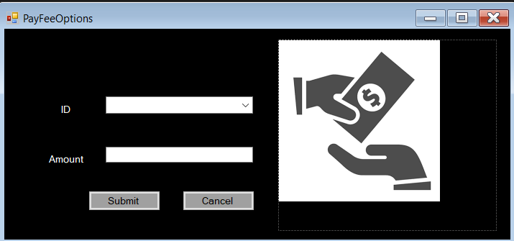

aaaa