Business Model Canvas -
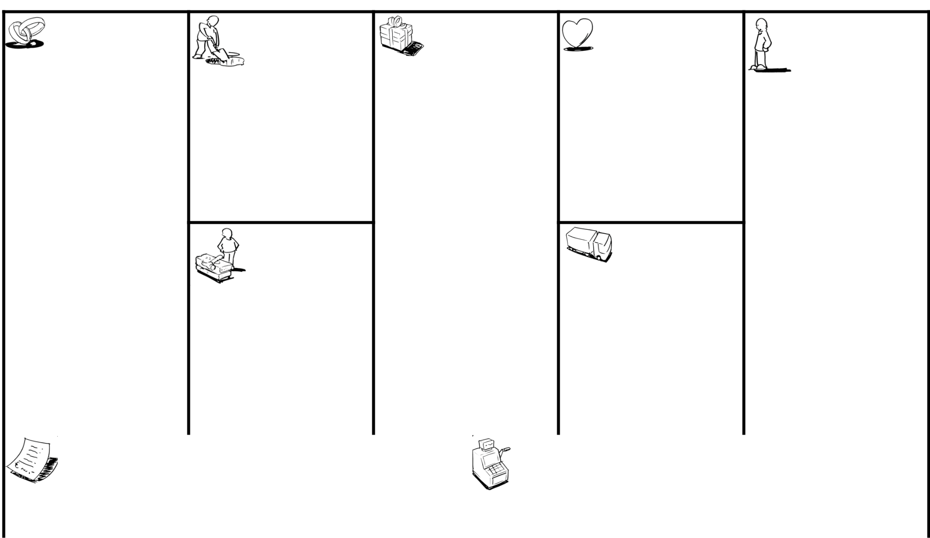

Key Partners | Key Activities | Value Propositions | Customer | Customer Segments
 |  |  | Relationships

Editable User information page prevent medical theft- (Self/Automated)service
Government less crowding Installing and Training for
Clinic Reservation EHR for Each Patient & one administration & Doctors
Suppliers place for all diseases & drugs Governmental Hospital | View & Edit Patient History & that they have previously been Testing and Maintenance
Hospitals Stuff Prescriptions exposed to periodically

Hospitals Management Add/Delete/Edit :- Doctors - Recommending a clinic for the
Receptionist– Directors -Admin patient Ccommunicate with all users Private Hospital
Create E-System
Training Employee Prescription along patient's life
Key Resources Online booking | Channels

Patients - citizens
Physical Virtual

Development Team Control the whole Organization Advertising Sponsor :- | actions by Administrations Panels
Server & Hosting Domain & Directors Web/Mob/
Meetings Channels
Suppliers Recommending a clinic for patient
-Cost reduction- Organization/ (Digital
Programming tools Citizen satisfaction Marketing)

Control all employees permissions
Improve QoS
Cost Structure  - Development team salary  - Maintenance – Security – Digital Marketing  - Rent server & hosting domain | Revenue Streams  - Automatic Reception department which saves the worker salary .  - Increase our health classification  - Advertisement on Website/Mob/Server .  - Doctors Recommendations  - Reducing the rate of mistake in diagnosing medicines & preserving patients' lives

Social & Environmental Cost | Social & Environmental Benefit



