Business Model Canvas -
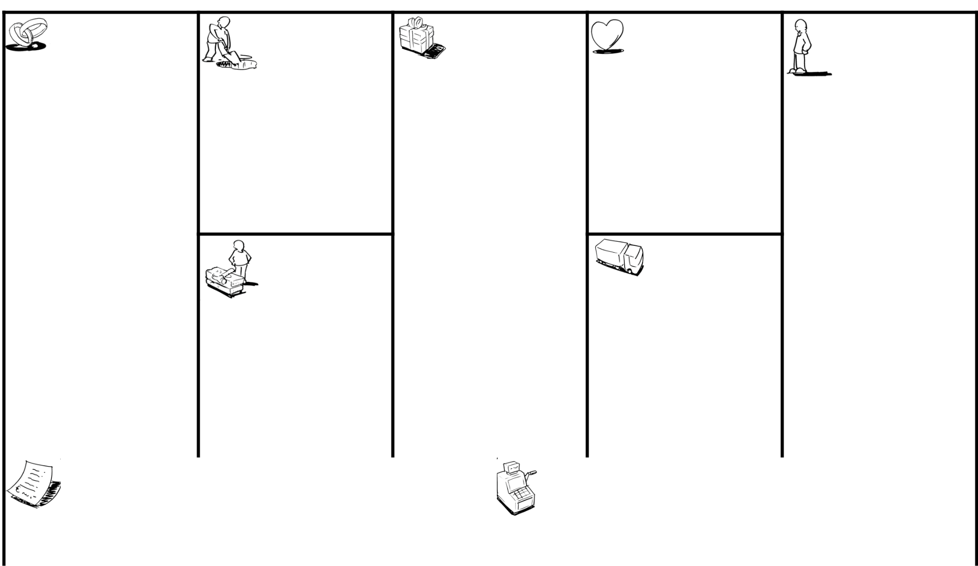

Key Partners | Key Activities | Value Propositions | Customer | Customer Segments
 |  |  | Relationships

* Editable User information page * prevent medical theft- > (Self/Automated)service
1- Government * less crowding > Installing and Training for
* Clinic Reservation * EHR for Each Patient & one > administration & Doctors
2- Suppliers place for all diseases & drugs a- Governmental Hospital | * View & Edit Patient History & that they have previously been > Testing and Maintenance
3- Hospitals Stuff Prescriptions exposed to periodically

4- Hospitals Management * Add/Delete/Edit :- Doctors - * Recommending a clinic for the
Receptionist– Directors -Admin patient > Ccommunicate with all users b- Private Hospital
* Create E-System
* Training Employee * Prescription along patient's life
Key Resources * Online booking | Channels

c- Patients - citizens
1- Physical 2- Virtual

* Development Team * Control the whole Organization * Advertising * Sponsor :- | actions by Administrations Panels
* Server & Hosting Domain & Directors Web/Mob/
* Meetings Channels
* Suppliers * Recommending a clinic for patient
* -Cost reduction- Organization/ * (Digital
* Programming tools * Citizen satisfaction Marketing)
* Improve QoSs
* Control all employees permissions
Cost Structure  - Development team salary  - Maintenance – Security – Digital Marketing  - Rent server & hosting domain | Revenue Streams  - Automatic Reception department which saves the worker salary .  - Increase our health classification  - Advertisement on Website/Mob/Server .  - Doctors Recommendations  - Reducing the rate of mistake in diagnosing medicines & preserving patients' lives

Social & Environmental Cost | Social & Environmental Benefit



