**Analysis Chapter :-**

**1- Introduction**

**2- Functional Requirements**

**4- Non- Functional Requirements**

**5- Actors & Entities**

**6- Use Cases Diagrams >> 6.1 General , 6.2 UseCase1 , 6.3UseCase2**

**7- Class Diagram**

**8- Activity Diagram**

**9- DFD (Data Flow Diagram) >> 9.1 DFD LEVEL 0 , 9.2 DFD level 1 , 9.2 DFD level 2**

**10- ERD Diagram**

**11-Matching System >> 11.1 Flow Chart , 11.2 Relational database diagram**

**12- Matching Algorithm >> 12.1 (User Side) , 12.2 (System Side)**

**Requirements**

**Functional Needs:(Registration Process of Software Requirements Specification)**

**Purpose**

The purpose is to describe all the requirements for the

Hospital Management System. The following are some of the

stake holders:

· administrative staff

· doctors

· Patient

· Vistors

· Receptionist .

**Functional Requirements :-**

* ●**Adding Patients:**The Hospital Management allows the team in the front workdesk to consist of brand-new clients to the system. They can Sign up on Website need Activation

● **Activation an ID to the patient**: The HMS enables the personnel in the front workdesk to give an one-of-a-kind ID for each and every individual and then include them to the record sheet of the individual. The individuals can use the ID throughout their medical facility keep.

**● Deleting Patient**: The Top Manger of the Hospital can delete the patient from the system

* **● Emergency Case:** In an emergency case, the administrative staff shall use

system to assign an emergency room, doctors and

nurses to the patient immediately.

* **Record procedure:-** The whole treatment procedure for the patient shall be

recorded by the system.

Database

* **Patient Mandatory Information**

Each patient shall have the following mandatory

information: first name, last name, phone number,

personal health number, address, postal code, city,

country, patient identification number.

* **Update Patient Information**

The system shall allow the user to update any of the

patient’s information

* **Search for Patient**

The system shall allow the user to search for patient’s

information by last name or PHN or National ID.

* **Staff Mandatory Information**

Each staff in hospital shall have the following

mandatory information: identification number, first

name, last name, phone number, address, postal code,

city, country, employee type, duty schedule.

**Non-functional**

requirements can be used to improve the

functioning of the computer system, but not the management of

the hospital as a whole:

Safety

Security

Efficiency

Maintainability

Dependability

Availability

**Safety:**

**Patient Recognition**: The system requires the individual to acknowledge herself or himself making use of the phone.

**Logon ID**: Any kind of customers that utilize the system require to hold a Logon ID as well as password.

**Alterations**: Any adjustments like insert, erase, update, etc. for the data source can be integrated promptly as well as executed only by the manager

**Administrator legal rights**: The manager can consider as well as alter any kind of info in the Health center Management System.

**Efficiency:**

Action Time: The system offers acknowledgment in simply one 2nd once the ‘individual’s details is inspected

 Capacity: The system needs to sustain at the very least 1,000,000,000 individuals at once. And more in feature

 Consistency: The system requires to make certain that the standards of the accessibilities are complied with

**Maintainability:**

 Back-Up: The system uses the efficiency servers for data back up.

Growing up: Using Evolution term to define the dynamic growth

Mistakes: The system will certainly track every mistake along with maintain a log of it.

Feedback: Analysis Feedback from System Performance & Data

**Integrity**:

 Schedule: The system is offered constantly evolution

Database: Related on (Website – Mobile – Desk)

**Security**:

**Logon ID**

Any user who uses the system shall have a Logon ID and

Password.

**Modification**

Any modification (insert, delete, update) for the Database

shall be synchronized and done only by the administrator in

the ward.

**Front Desk staff Rights**

Front Desk staff shall be able to view all information in

system, add new patients to system but shall not be able to

modify any information in it.

**Administrators**' **Rights**

Administrators shall be able to view and modify all

information in system

**Availability:**

The system shall be available all the time.

**Design Constraints**

**Database**

The system shall use the MySQL Database, which is open

source and free.

**Operating System**

The Development environment shall be Windows 2000.

**Web-Based**

The system shall be a Web-based application.

Introdicttion :-

The Project Hospital Management System (HMS) IS for Computerizing the working in a hospital .

The software takes care of all then the requirements of a hospital and is capable to provide easy and effective storage of information related to patients that come up to the hospital .

Entities :- 

ـــــــــــــــــــــــــــــــــــــــــــــــــــــــــــــــــــــــــــــــــــــــــــــــــــــــــــــــــــــــــــــــــــــــــــــــــــــــــــــــــــــــــــــــــــــــــــــــــــــــــــــ

Actors : 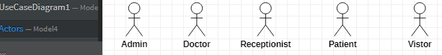

**Use Case (General)**

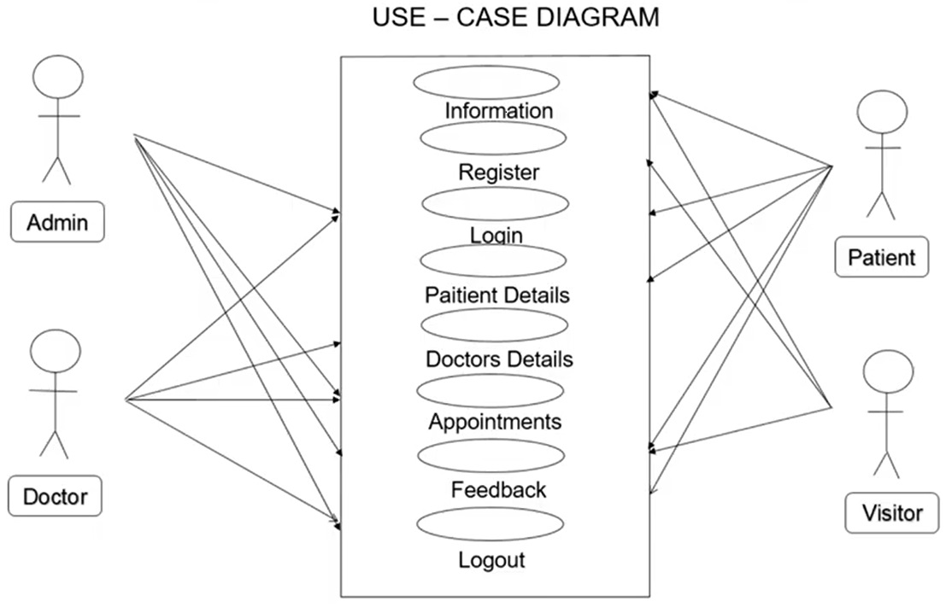

Use – Case Diagram 1

Use - Case Diagram 2

**Class Diagram Class**

**Activity Diagram**

**DataFlowDiagram (DFD):-**

In this data flow diagram you will see the general process done in Hospital management. This will also serve as a guide as you go through the deeper processes of the Hospital management system data flow diagrams.

when you build the levels of data flow diagrams, the connections of the transactions and data also broadens and gets more specific. DFD for Hospital Management System Level 1 Next to the context diagram is the level 1 data flow diagram. The content of Hospital management system DFD level 1 must be single process node from the context diagram and is broken down into sub processes In this level,

the system must display or reveal further processing information. And the actors that are going to use this system is were the patients, hospital administrator and the hospital employees.

### . The following are the flows that the System can generate:

### Managing Patient

### Assigning Medicine

### Managing Employees /Doctors

### Assigning Facilities

* **DFD for Hospital Management System Level 0**

To start with, let us familiarize what is Hospital management system level 0.  
  
The hospital management system level 0 is also known as context diagram. It’s supposed to be an abstract view, with the mechanism represented as a single process with external parties.  
  
This DFD for the system depicts the overall structure as a single bubble. It comes with incoming/outgoing indicators showing input and output data.

Level 0

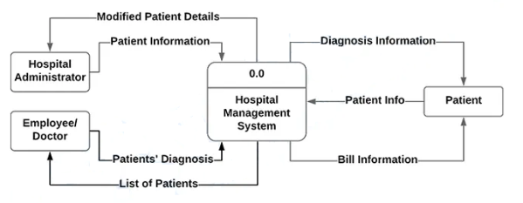

* **DFD for Hospital Management System Level 1**

Next to the context diagram is the level 1 data flow diagram.  
  
The content of Hospital management system DFD level 1 must be single process node from the context diagram and is broken down into sub processes  
  
In this level, the system must display or reveal further processing information. And the actors that are going to use this system is were the patients, hospital administrator and the hospital employees.

The following are essential data to accommodate:  
• Patient Information  
• Employees Information  
• Medicines  
• Facilities

Level 1

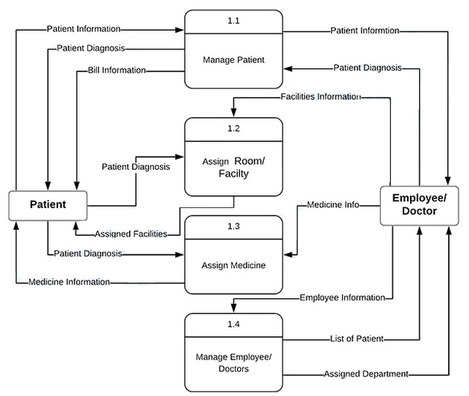

These procedures require information such as a list of patients, medicines, employees/doctors, and facilities from which served as the bases for admin to manage hospital transactions. This type of data is represented by a data store.  
  
With being knowledgeable about the DFD level 1 of the Hospital Management System, you will know then its broaden context terms.  
  
In addition to that, this may also serve as your reference on how the inputs or data fed on the system. Then you will be also informed about the outputs that the system gives.  
  
These processes shown in the DFD were all based on the concept of Hospital Management System.

**DFD for Hospital Management System Level 2**

After presenting the Hospital management system DFD levels 0 and 1, next to that is level 2.  
  
Here’s what you need to consider in creating data flow diagram level 2 for Hospital management system.  
• The Level 2 DFD for the system should represent the basic modules as well as data flow between them.  
• Since the DFD level 2 is the highest abstraction level, its Hospital management system processes must be detailed that is based on the DFD level 1.  
  
Finally, after figuring the processes given in the system, the user will now have their request being processed.  
  
The Processes that the system should prioritize are as follows:  
• Managing Patient  
• Assigning Medicine  
• Managing Employees/Doctors  
• Assigning Facilities

Level 2

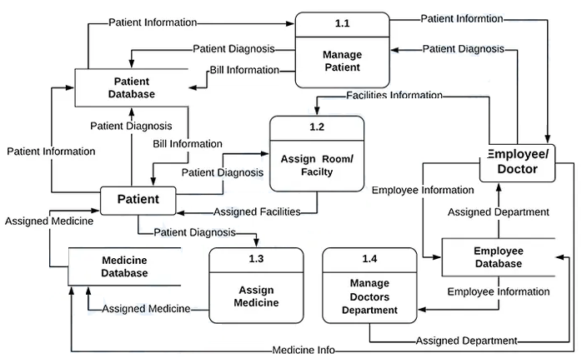

DFD .. Ref >>> <https://itsourcecode.com/uml/dataflow-diagrams-hospital-management-system-dfd-level-0-1-2/>

**ERD Diagram**

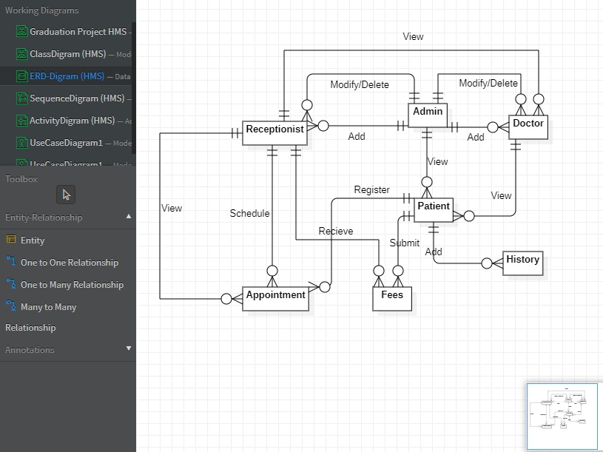

We Use Matching System to Recommend a clink for the patient buy taking diseases from him

Matching System :-

**Flow Chart**

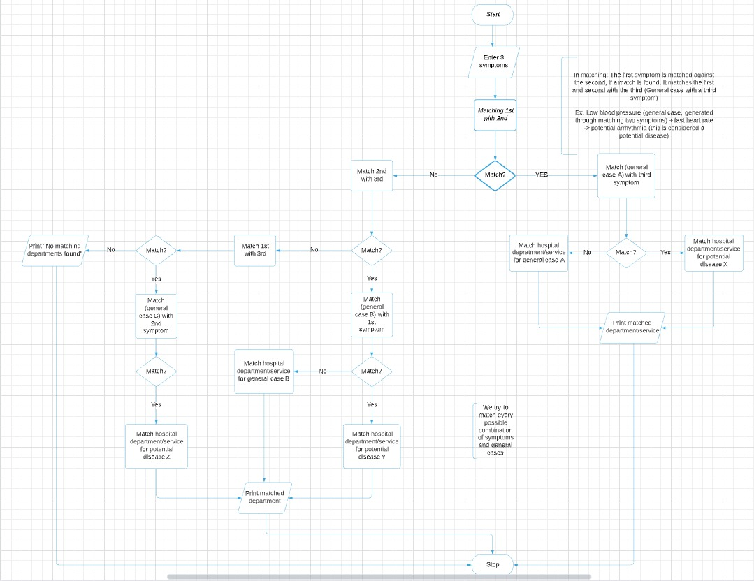

**ـــــــــــــــــــــــــــــــــــــــــــــــــــــــــــــــــــــــــــــــــــــــــــــــــــــــــــــــــــــــــــــــــــــــ**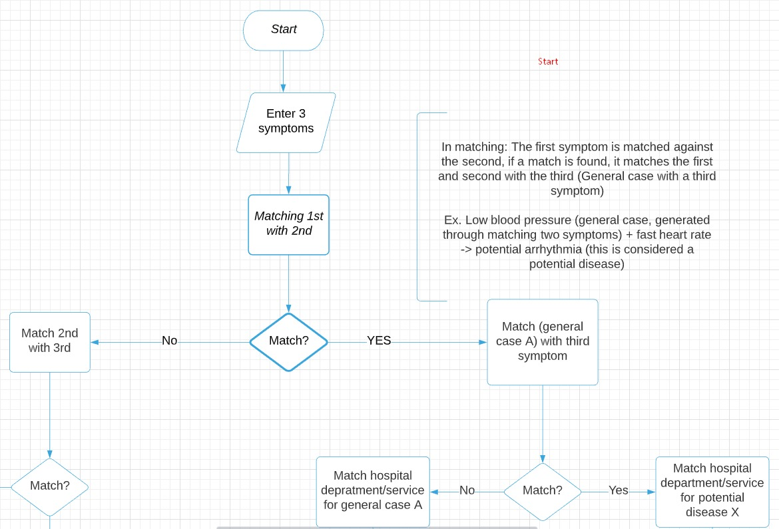

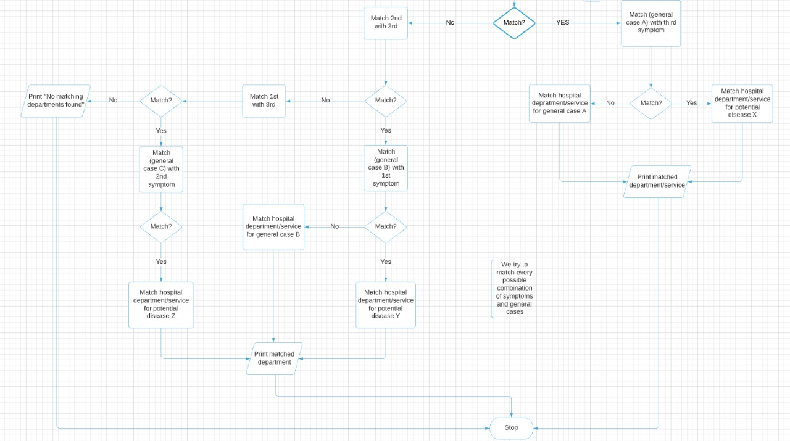**ـــــــــــــــــــــــــــــــــــــــــــــــــــــــــــــــــــــــــــــــــــــــــــــــــــــــــــــــــــــــــــــــــــــــــــــــــــــــــــــــــــــــــــــــــــــــــــــــــ**

**Relational database diagram**

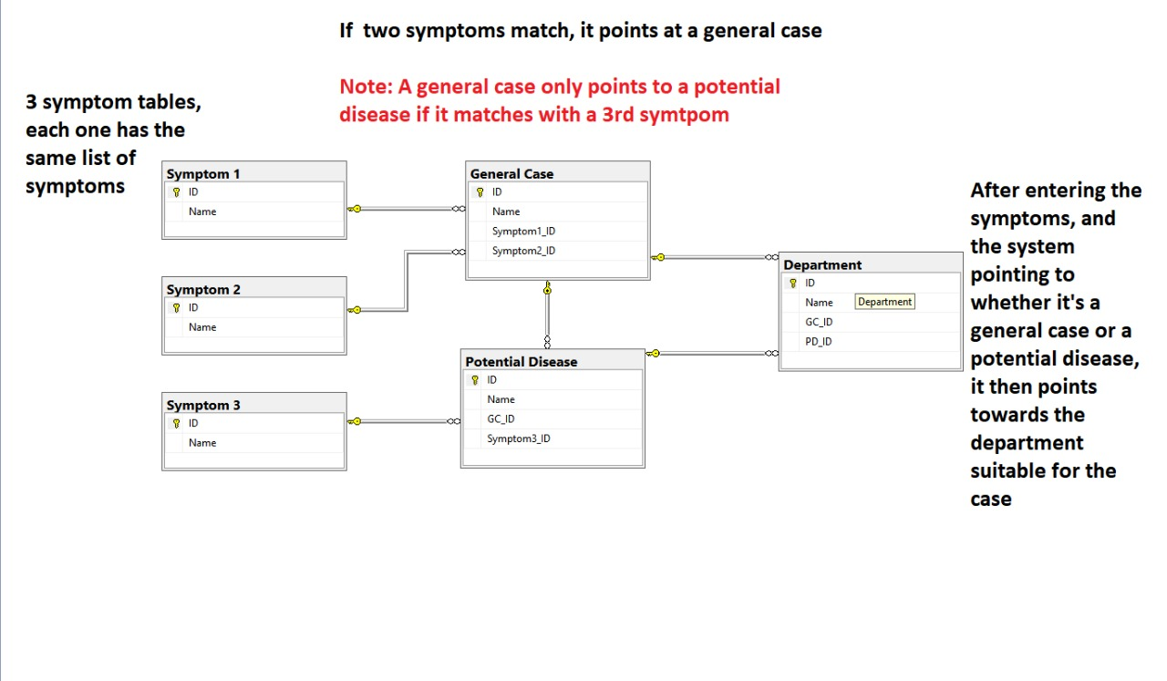

**ــــــــــــــــــــــــــــــــــــــــــــــــــــــــــــــــــــــــــــــــــــــــــــــــــــــــــــــــــــــــــــــــــــــــ**

**Matching** **Algorithm**

Algorithm (User side)

1. Start
2. Enter 1st, 2nd and 3rd symptom
3. Read matched department output
4. End

ـــــــــــــــــــــــــــــــــــــــــــــــــــــــــــــــــــــــــــــــــــــــــــــ

Algorithm (System side)

1. Start
2. Read 1st,2nd and 3rd symptom
3. If 1st and 2nd symptoms match
   1. Then
      1. Read DB and summon the general case those two symptoms are indicative of, placeholder name DB_gc_A
      2. If DB_gc_A and 3rd symptom match
         1. Then
            1. Read DB and summon the potential disease that the general case and third symptom are indicative of, Placeholder name DB_pd_X
            2. Read DB and summon department for DB_pd_X
            3. Print department
         2. Else
            1. Read DB and summon the general case DB_gc_A
            2. Read DB and summon department for DB_gc_A
            3. Print department
   2. Else if 2nd and 3rd symptoms match
      1. Then
         1. Read DB and summon the general case those two symptoms are indicative of, placeholder name DB_gc_B
         2. If DB_gc_B and 1st symptom match
            1. Then

Read DB and summon the potential disease that the general case and third symptom are indicative of, Placeholder name DB_pd_Y

Read DB and summon department for DB_pd_Y

Print department

* + - * 1. Else

Read DB and summon the general case DB_gc_B

Read DB and summon department for DB_gc_B

Print department

* + 1. Else if 1st and 3rd symptoms match
       1. Then
          1. Read DB and summon the general case those two symptoms are indicative of, placeholder name DB_gc_C
          2. If DB_gc_C and 2nd symptom match

Then

Read DB and summon the potential disease that the general case and symptom are indicative of, Placeholder name DB_pd_Z

Read DB and summon department for DB_pd_Z

Print department

Else

Read DB and summon the general case DB_gc_C

Read DB and summon department for DB_gc_C

Print department

* + - 1. Else
         1. Print “Could not find a suitable department, please check with a general physician”

ـــــــــــــــــــــــــــــــــــــــــــــــــــــــــــــــــــــــــــــــــــــــــــــــــــــــــــــــــــــــــــــــــــــــــــــ