

Faculty of Computers and Information Sciences Mansoura University

Dep: (Software Engineering – Bioinformatics) Depts

Hospital Management System

Project **(HMS)**



**Hospital management system**

**Faculty of Computers & Information Sciences**

**Mansoura University**

**Bioinformatics department**

**Acknowledgement**

**In the name of Allah, the most gracious and the most merciful meeply we acknowledge, with deep gratitude and appreciation, our supervisor, we would like to express our appreciation to him for his effort, continuous support and encouragement during the work in this project We must give respectful gratitude to our supervisor:**

**Professor Dr: Hazem Elbakry, For his encouragement, guidance, and valuable time.**

**He really showed our way of thinking and developing the project ideas adopted in this idea.**

**Finally, we have successfully accomplished this work**

**Supervised By:**

**Professor Dr :Hazem El-bakry**

**Head of IS Dept**

**For plenty of time and effort she has devoted for us. Interested in solving project ERROR! Words can’t express our thanks towards her.**

**Eng. Nourmeen lotfy Mohamed**

**( Our Team Members )**

**Software engineering**

* [**Ziyad Ahmed El-Sayed Hamed**](https://www.facebook.com/ziyadhamed74)
* **El-Sayed Ahmed Ragab El-sayed**
* **Mohamed Gaber Ali Abd elsalam**
* **Hamed Samy El-saeed Eldesouki**
* **Osama Rabie Mohamed Mosaad**

**ـــــــــــــــــــــــــــــــــــــــــــــــــــــــــــــــــــــــــــــــــــــــــــــــــــــــــــ**

**Bioinformatics**

* **Mohamed Ebrahem Abd elaziz Abd elghany**
* **Alaa Abd el-rafea Megahed Abd el-rafea Nossier**
* **Reem Hesham Ahmed Ali Awad**
* **Aya Ayman Mahmoud Atya**
* **Ghada Tarek El-sayed El-sharkawy**
* **Hend Elsayed Helmy Salah**
* **Alaa Hashem Abo zid**
* **Amira mostafa Mohamed kamel**

**Abstract**

Medical projects are one of the most wanted programs in the world and there is no doubt about that because they serve a large group of citizens in the country, and this gives us the motivation to participate in this field of business.

Our project deals with a set of criteria to raise the efficiency of the health system in Egypt and promote it to a global level. Egyptian society suffers from many problems in the health sector like lack of medicines, congestion in governmental hospitals, and lack of cultural and medical awareness of citizens.

When we searched about the reasons for this, we reached that the main reason for that, there is no integration between governmental hospitals in the country. There is no system to manage hospitals and record all patient data.

So, our first goal is to make a system that integrates all governmental hospitals in the state, where any process or transaction that occurs in any hospital will record and appear in other hospitals.

The second goal is making a medical and personal account on this system for each citizen in the country, through the application or website

this account will record personal information like citizen’s national ID, name,address,gender and age, the account will also record any medicines that citizen had, any surgery that has done to him and analysis and medical radiology of the citizen as well as demographics, progress notes, problems, medications, vital signs, past medical history, immunizations, laboratory data, and radiology. This account will guarantee that medicines will reach to people who deserve them since any medicines the patient will take from any hospital or pharmacy will record in his account, so when he moves to another hospital or pharmacy to ask for medicine again, the pharmacist will check his account to see whether he deserve the medicines or not, the citizen also can receive an appointment with a physician in the hospital through his account on the system, so everyone will know the time he must go to the hospital to be examined by a physician, this will solve the problem of overcrowding in hospitals.

**Contents**

|  |
| --- |
|  |

|  |  |  |  |  |  |  |  |
| --- | --- | --- | --- | --- | --- | --- | --- |
| **Title page** | | | **…………………………………..** | | | **i** | |
| **Team work** | | | **…………………………………..** | | | **ii** | |
| **Acknowledgements** | | | **…………………………………..** | | | **iii** | |
| **Abstract** | | | **…………………………………..** | | | **v** | |
| **List of contents** | | | **…………………………………..** | | | **vi** | |
| **List of figures** | | | **…………………………………..** | | | **x** | |
| **List of tables** | | | **…………………………………..** | | | **xiii** | |
| **List of abbreviations** | | | **…………………………………..** | | | **xiv** | |
| **Chapter 1: Introduction** | | |  | | | |  | |
| **1.1** | **Problem Statements** | | | **…………………………………..** | | | **1** | | |
| **1.2** | **Project definition** | | | **…………………………………..** | | | **1** | | |
| **1.3** | **Goals of the project** | | | **…………………………………..** | | | **1** | | |
| **1.4** | **The targeted segment of society** | | | **…………………………………..** | | | **1** | | |
| **1.5** | **Features of the website and application** | | | **…………………………………..** | | | **2** | | |
| **1.6** | **Similar systems** | | | **…………………………………..** | | | **3** | | |
| **1.7** | **HMS definition and benefits** | | | **…………………………………..** | | | **3** | | |
| **1.8** | **Chapter conclusion** | | | **…………………………………..** | | | **4** | | |
| **1.9** | **Document Organization** | | | **…………………………………..** | | | **4** | | |

**Chapter 2: Background**

|  |  |  |  |
| --- | --- | --- | --- |
| **2.1** | **EHR definition** | **…………………………………..** | **6** |
| **2.2** | **Functions of EHR** | **…………………………………..** | **6** |
| **2.3** | **Significance of EHR** | **…………………………………..** | **8** |
| **2.4** | **Factors affecting implementation of EHR** | **…………………………………..** | **9** |
| **2.5** | **HIS definition** | **…………………………………..** | **11** |
| **2.6** | **Benefits of using HIS** | **…………………………………..** | **12** |
| **2.7** | **Disadvantages of using HIS** | **…………………………………..** | **13** |
| **2.8** | **Chapter conclusion** | **…………………………………..** | **13** |

**Chapter 3: System analysis**

|  |  |  |  |
| --- | --- | --- | --- |
| **3.1** | **Introduction about system analysis** | **…………………………………..** | **15** |
| **3.2** | **System development life cycle (SDLC)** | **…………………………………..** | **16** |
| **3.3** | **UML diagrams** | **…………………………………..** | **16** |
| **3.4** | **Chapter conclusion** | **…………………………………..** | **31** |

**Chapter 4: System design**

|  |  |  |  |
| --- | --- | --- | --- |
| **4.1** | **Introduction about system design** | **…………………………………..** | **33** |
| **4.2** | **Entity relationship diagram (ERD)** | **…………………………………..** | **33** |
| **4.3** | **Class diagram** | **…………………………………..** | **37** |
| **4.4** | **Activity diagram** | **…………………………………..** | **40** |
| **4.5** | **Matching system algorithm Business model** | **…………………………………..** | **43** |
| **4.6** | **Chapter conclusion** | **…………………………………..** | **45** |

**Chapter 5: Implementation**

|  |  |  |  |  |
| --- | --- | --- | --- | --- |
| **5.1** | **Implementation of health care project** | | **…………………………………..** | **47** |
| **5.2** | **Hospital management pages (Mobile application)** | | **…………………………………..** | **49** |
| **5.3** | **Hospital management pages (Website)** | | **…………………………………..** | **50** |
| **5.4** | **Method and Technology** | | **…………………………………..** | **53** |
| **5.5** | **Some Code Samples** | | **…………………………………..** | **58** |
| **5.6** | **Chapter conclusion** | | **…………………………………..** | **64** |
|  | |

**Chapter 6: Future work and conclusion**

|  |  |  |  |
| --- | --- | --- | --- |
| **6.1** | **Project conclusion** | **…………………………………..** | **70** |
| **6.2** | **Project future work** | **…………………………………..** | **71** |

**List of abbreviations**

|  |  |
| --- | --- |
| **HIS** | **Hospital information system** |
| **HMS** | **Hospital management system** |
| |  | | --- | | **QOS** | | **Quality Of Service** |
| **IS** | **Information Systems** |
| **EHR** | **Electronic Health Records** |
| **ID** | Identification |
| **CDS** | Clinical Decision Support |
| EMR | Electronic Medical Record |
| CPR | Computer-Based Patient Record |
| PHR | Personal Health Record |
| EPR | Electronic Patient Record |
| **ROI** | Return on Investment |
| **HIMSS** | Health Information and Management Systems Society |
| ISO | International Organization for Standardization |
| ISO/DTR | International Organization for Standardization/ Draft Technical Report |
|  |  |
| **LIS** | **laboratory information system** |
| **RIS** | **radiology information system** |
| **PACS** | **picture archiving and communication system** |

**Chapter1**

**Introduction**

**In this chapter you’ll get a general knowledge about the project.**

**Detailed knowledge will come later.**

* 1. **Introduction**

Use of Information Technology (IT) is common in all areas, including healthcare and health management.

Many healthcare organizations use IT-enabled healthcare applications for simplifying healthcare processes such as administration, managing health records across departments, and billing.

Electronic websites and Smartphones have become the users' favorite companions over desktop computers.

Using smartphones and electronic websites to help doctors and facilitate the process of diagnosis and providing many services to the patient has become one of the most important challenges that will constitute a major transition in the medical world.

Using a mobile phone to facilitate the diagnosis of patients, as well as following the patients' health patient record

every day, and providing him with all the advice that he must follow During the treatment phase.

as well as providing a group of suitable appointments to book for going to doctors at any time and follow his health.

**Problem Statements**

The provision of adequate health care services is a major problem in developing countries.

Increase in population, complemented with new and complex treatments for diseases, and involving multiple healthcare providers due to the complexity of the health problems have increased demand for better and more efficient healthcare services and health management globally.

Need for complete health information of a patient,such as patient’s history, allergies, laboratory tests, medication, and so on,at one place for his/her better care is increasing.

Accordingly: Researchers have now realized that increased application of IT to healthcare and health management with Electronic Health Record (EHR) is a way to deal with these issues.

**Project definition:**

Our project is to build an accurate application and electronic website for all patients that included a single electronic health record for every individual in a nation.

enables them to check on their health, booking appointments with doctors, at any time and from any location without the need to visit them to the hospital.

The project includes a system for organizing medical procedures. The system is basically a hospital's website and has many functions. As the outer shell of the system, there is an application that can help users make better use of the system and make online reservations.

**Goal of project**

the main goal is building a system for organizing health management in hospitals

and to organize the entry of patients into the departments.

Nomination of the best clinics.

Abolishing the paper system and replacing it with the digital system. creating an account on the application for every patient to record personal information like citizen’s national ID, name, address, gender, and age. the patient can access his profile that includes his entire past medical history on his account of the application by its national ID . Connecting public hospitals, building single electronic health record (EHR) for every individual in a nation and band assistance in emergencies, ensure the concept of cloud computing, reduce drug consumption,reduce drug theft, increase awareness of the medical field , thereby control the budget allocated to it and improve the QoS.

**the targeted segment of society**

The system was designed for Egyptian government hospitals and Egyptian people in general including all categories (rich/poor), as well as consisting of a set of records include the entire health history of the patient, from birth to death.

**Features of the website and application**

The main feature is the replacement of the paper system with the electronic system. The responsive application and website aim to promote the entire medical process. allowing patients to display on their personal files, As there are records for every individual or patient in the country that include the patient's complete health history. The patient can book an appointment with the doctor online, as the patient does not need to go to the hospital and it will reduce the crowding in hospitals. preventing manipulation of the quantity, usage, and price of drugs, allowing hospitals to contact each other to get the most benefit, and allowing doctors in different hospitals to view the patient's entire medical history. Help in emergencies, as there is an emergency department on the site or application that helps the patient quickly reach the emergency. The doctor writes the patient’s prescription and it is uploaded to the patient’s page, whether on the application or the site, and the patient can obtain the medicine in that prescription via the patient’s national ID, so the pharmacist gives him the medicine in that prescription.

**Similar systems**

1.5.1 Health management System in United States.

the American management system is very similar to our targeted system, The system is concerned with organizing the health administration as well as health care.

Adroit Infosystems as shown in figure (1.1)-, is a South Jordan, United States-based Healthcare Software company with the vision to provide world-class healthcare software products at affordable prices.

the product portfolio includes electronic health system products eHospital, eClinic, ePharmacy, eLaboratory, and eRadiology Systems.

All software products are multi-lingual and come with a built-in on-screen editor that allows our implementation team to localize the software as per country-specific needs.

this website has EHR, TeleHealth Software, iOS, and Android Apps, Tablet Version of Nurse Station, Patient and Family Portal, Lab Device Integrations, Financial Software Integration (SAP, Microsoft Dynamics, QuickBooks)

eHospital Systems is a hospital management system software which includes OPD and IPD Management, Pharmacy, Laboratory, Radiology, Ward Management, Mobile Application, Online Appointments Scheduling, Secured Messaging, Doctor Portal, Patient and Family Portals, Medical Electronic Billing, Accounting, HR/Payroll, and HL7/Integrated PACS System.

eClinic Systems is a medical practice management software to manage all aspects of clinic operation. This customizable clinic information system is an integrated healthcare solution which includes OPD Management, Pharmacy, Laboratory, Radiology, Mobile Application, Online Appointments Scheduling, Secured Messaging, Doctor Portal, Patient and Family Portals, Medical Electronic Billing, Accounting, HR/Payroll, and HL7/Integrated PACS System.

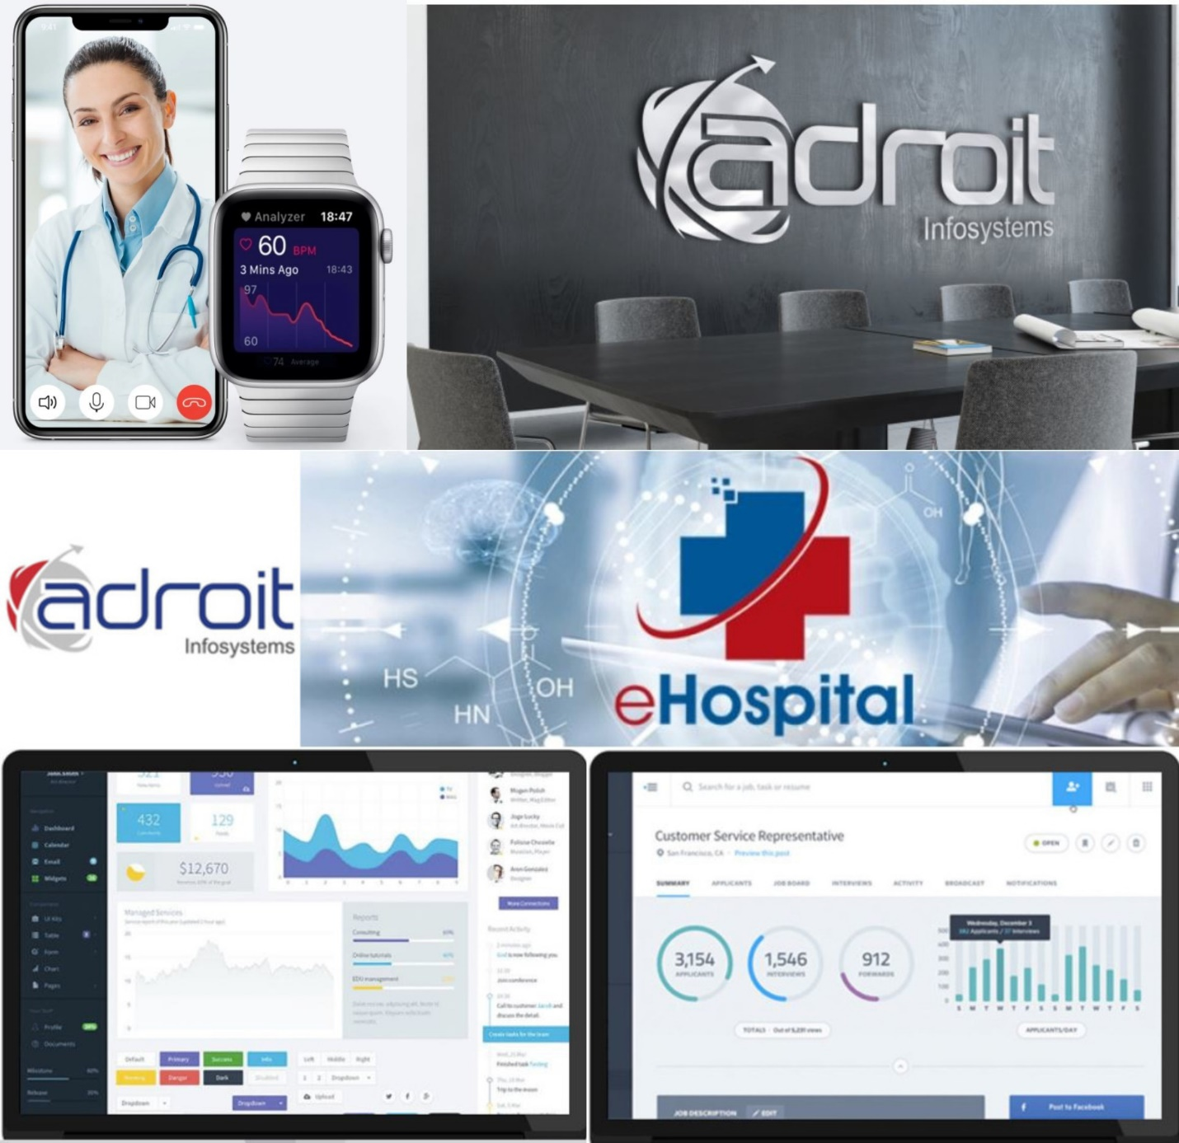

Figure (1.1):adroit infosystems website

**1.5.2 Health management system in india:**

**Indian system has some criteria close to ours.** **HMSDESK as shown in figure (1.2)-, site is meant to seek out easily doctors, hospitals, treatment costs Etc. it helps find the best doctors at the simplest hospitals, at prices that fit your budget. site customer support team 24x7 helps the international patient for getting Visa, continuous support for each need like accommodation arrangements, and pre & post-treatment.**

**HMSDESK is one of the brands and projects developed and promoted by Logic Research and Solutions. HMSDESK is a platform for their patients that can get healthcare services from doctors, hospitals, clinics, and diagnostic centers in the easiest way. No one can say that when the person will need medical care for a serious health issue. Now each and everything is on fingertips online. HMSDESK will help to find perfect the hospital or doctor is easy so that you will get an idea where is quality medical care available, treatment cost as per your budget.**

**this site offers all of the pertinent information onto a single platform and makes it available to our patients so that they can focus on resolving their medical issues. Due to our great experience in travel industry services, the site can support the patient to get medical travel Visa, stay in a hotel for the patient's relative. Provide information about the tourist and visiting places so that patient or/and his/her relative can visit some of the places if possible before or after the treatment.**

**site is working with over 1200+ Doctors and 150+ hospitals across India, irrespective of the state and region you want to obtain the consultation/ treatment. Almost all the hospitals the site is working with are JCI, NABH, NABL, and ISO accredited, strengthening its view of No-Compromise with our patient's health.**

**Along with Medical Tourism, this area of work includes Telemedicine, Hospital Management System, Lab Management System, and many others.**

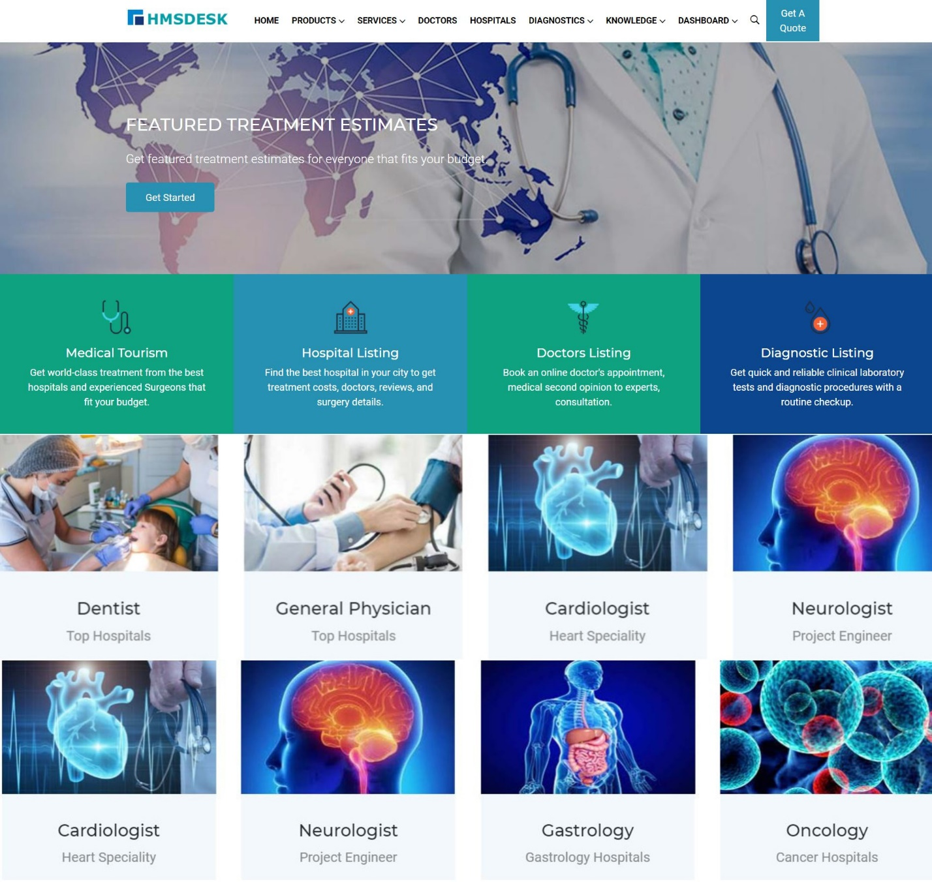

Figure (1.2): **HMSDESK website**

**HMS** **definition and benefits**

**A Hospital Management System is an integrated information system for managing all aspects of a hospital’s operations such as medical, financial, administrative, legal, and compliance. It includes electronic health records, business intelligence, and revenue cycle management. Hospitals and healthcare facilities improve the quality of healthcare services, reduce operating costs, and improve the revenue cycle by using such hospital management systems. Hospital Management System typically includes Outpatient and Inpatient Management, Pharmacy, Laboratory, Radiology, Inventory, eClaim, Mobile Apps, Tablet Versions, Online Scheduling, Secured Messaging, Doctor and Patient Portals, Accounting, HR/Payroll, Blood Bank, Mortuary, Alert Software, Dietary, Feedback, Lab Machines, and Biometric Integration, HL7/Integrated PACS, and Business Intelligence.**

Online Hospital Management System V/S Offline Hospital Management System

* Since the Online HMS is electronically digitized, a click in the appropriate button will give the enquiring person access to the data of a patient.
* In the earlier offline HMS, the names of the patients used to be recorded via alphabet synchronization. Finding the appropriate name in times of urgency was a tentative squire.
* Online HMS offers improved access to patient data and transparent information about the care process involved. Through acute analysis of the methods, the level of care thus provided could easily be estimated.
* The online HMS involves much less cost and time effort than the earlier offline HMS.
* As the finding of data has been much more convenient, the efficiency level has certainly been enhanced.
* The manual recording leaves much more scopes of making errors. The implementation of online HMS has reduced the possibility of making errors.
* Since appropriate encryption has been involved in online HMS, the security of the data has been increased. The prospects of losing data are reduced to a large extent.

Hospital Management System necessary

* Enables tracking financials better: An appropriately integrated HMS helps in tracking revenues, outflows, debts, and receivables in a better way. The financial report generated in the system helps the hospital administration avail an accurate scenario of the health of a hospital.
* Data Security: Unauthenticated people will never be able to steal data from the healthcare unit as everything will be secured with appropriate usernames and passwords. The possibility of data theft has reduced to almost zero.
* Eliminating Errors: As the system is entirely automated, the chance of human errors is null. This property has enhanced the confidentiality of the system manifold.
* Enhancing competency of the Laboratory management Systems: Implementation of the hospital management system has worked in increasing the skill of the diagnostics system too.
* The doctors are now getting faster access to patient records as the methods for testing has become more comfortable. With better results, overall clinical competency boosts up.
* Patients are much satisfied: Since the procedures and procedures at various stages of patient interaction, e.g., registration, billing, and discharge, have been improved, customers feel happier than earlier times

Major Hospital Management System Features

* Digital archive and file classification management
* Organizational and user management
* Hospital Logo, Signature, initials and timestamp support
* Well maintained and detailed reporting
* Electronic document
* Improved referral options
* Access control and security
* Search engine Friendly
* Workflow design and management
* Email integration
* SMS integration
* Built-in rich text editorv
* Warning system
* Mandate system
* Calendar module

benefits of a Hospital Management System

* The Hospital Management Information System Software allows easy access to patient data to generate various records, including classification based on demographic, gender, age, and so on. It is especially beneficial at the ambulatory point, hence enhancing continuity of care. Internet-based access improves the ability to access such data remotely.
* It helps as a decision support system for the hospital authorities for developing comprehensive health care policies.
* It efficiently engenders the running of finance, the diet of patients, and also the distribution of medical aid. It gives a vivid picture of future hospital growth.
* It reflects an improved drug usage monitoring system, including its effectiveness. It relegates adverse drug interaction to the background and gives a push to appropriate pharmaceutical utilization.
* Integrated Inventory Management keeps track of all hospital stocks from medicines to linens and helps you keep the optimum level of stock all the time. It also minimizes the lost stock due to theft and misplacement.
* It enhances information integrity by a reduction in transcription errors and duplication of information entries.
* Hospital Management System is easy to use and eliminates errors caused by handwriting.
* The latest technology gives perfect performance to pull up information from hosted or cloud servers.
* It provides all data in a single platform, hence enables Business Intelligence Module to provide valuable insights into hospital operations and the quality of patient care.
* It enhances the overall health care experience in a healthcare facility.
* It improves the communication and interaction of doctors with their patients.
* It reduces expenses of an organization because of less paperwork, improved safety, and reduced duplication of testing.

the main elements of HMS shown in figure**(1.3).**

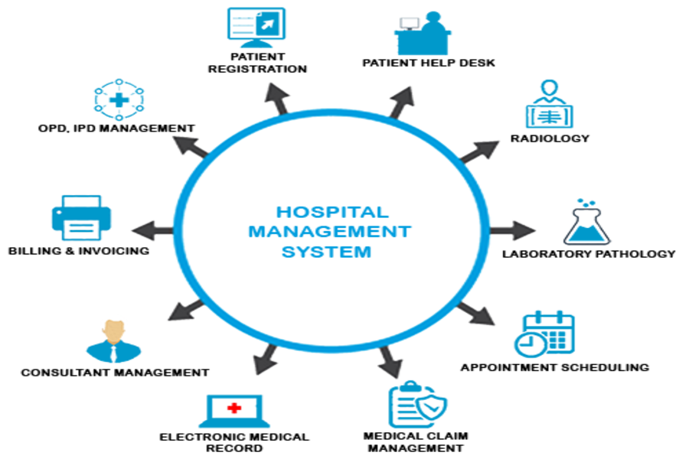

figure**(1.3).** Hospital Management System(HMS)

**Chapter conclusion**

**finally, Headlines in this chapter:**

**Problem Statements, Project definition, Goals of the project, the targeted segment of society, features of the website and application,Similar systems and HMS definition and benefits**

**Document Organization**

Chapter 1: represents an introduction for our project that includes a discussion about the problems that can be solved by this project and the goal that we aim to achieve.

Chapter 2: this chapter offers an overview about Definition of EHR ,Terminologies related to EHR , Functions and Significance of EHR, EHR standards , HIS definition

and Benefits and Disadvantages of using HIS

Chapter 3: Introduces our project’s analysis that includes an observation for the functions to be used in our project and a bunch of diagrams that can help in establishing the analysis process of our project (use case, Activity, sequence…).

Chapter 4: this chapter contains a detailed explanation of the system design.

Chapter 5: describes the project’s implementation process, its software requirements, the environment that has been used to accomplish this process, and the sequence that we followed to produce our project.

Chapter 6: Introduces the conclusion of our project and the future work that can be accomplished depending on this project as an infrastructure.

**Chapter 2**

**ELECTRONIC HEALTH RECORDS (EHR)**

The concept of electronic health records(EHR) is closely related to our idea of the project.

EHR can be a comprehensive tool containing medical records or similar documentation of the past and present physical and mental state of health of an individual in electronic form, and providing better care.

The increase in the mobility of the population and of health professionals necessitates that health records are available on how and when’ basis from more locations. EHRs have the potential to empower consumers and patients by providing them with easier access to their health information, allowing them to exert more control over their health records, thereby becoming more responsible and more active in their own care while facilitating communication with their health professional. an EHR includes contact information, allergies, family history, list of medications, information regarding previous surgeries and procedures, and other relevant patient information.

In general, there are two specific goals with the conventional medical records which are: Preserving course of a disease. Indicating probable cause of a disease.

The application of the EHR keeps these goals besides other goals such as: Securing and authorizing access to health information. Faster access to health records irrespective of place and time. Depicting healthcare workflow. Etc.

**DEFINITION OF EHR**

* 1. Some definitions of EHR and associated terminologies as found in the literature are: 1. An Integrated Care EHR defined by ISO/DTR 20514: “A repository of information regarding the health of a subject of care in computer processable form, stored and transmitted securely, and accessible by multiple authorized users. It has a standardized information model, which is independent of EHR systems. Its primary purpose is the support of continuing efficient and qualityintegrated healthcare and it contains information,which is retrospective,concurrent, and prospective” [ISO/TR 20514]
  2. An EHR defined by Health Information and Management Systems Society (HIMSS): “EHR is a longitudinal electronic record of patient health information generated by one or more encounters in any care delivery setting. Included in this information are patient demographics, progress notes, problems, medications, vital signs, past medical history, immunizations, laboratory data, and radiology reports. The EHR automates and streamlines the clinician’ s workflow. The EHR has the ability to generate a complete record of a clinical patient encounter, as well as supporting other care-related activities directly or indirectly via interface including evidencebased decision support, quality management, and outcomes reporting” [HIMSS 2011]

the main elements of EHR shown in figure**(2.1).**

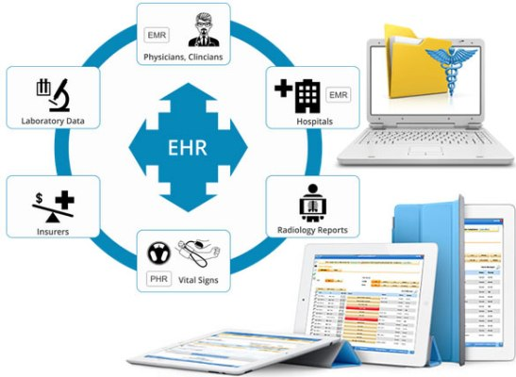

**Figure (2.1):** electronic health record (EHR)

**DEFINITION OF EHR (CONT.)**

There are many terminologies that have evolved together with EHR. These terminologies are either subsets of EHR or used by different groups to mean the same thing. Some of the commonly used related terminologies found in the literature are:

* 1. Electronic Medical Record (EMR): EMR is often used in parallel with EHR. It is a fully interoperable electronic health record of a patient within a healthcare organization. However, some people consider EMR as a set of records of a patient related to a single encounter or a single care episode. Accordingly, considers an EHR to be sum total of all EMRs of a patient where EMR in this case is a point-in-time view of a larger EHR
  2. Computer-Based Patient Record (CPR): CPR was first used to conceptualize the idea of EHR. It is a lifetime health record of a patient, which includes information from all specialties. It requires full interoperability (potentially international interoperability) that may be achieved in the near future.
  3. Electronic Patient Record (EPR): EPR is similar to CPR, but does not necessarily contain a lifetime record and focuses on relevant information only.
  4. Personal Health Record (PHR): PHR is managed and controlled by a patient. It is mostly considered to be web-based. Usually, PHR is another patient-side view of an EHR/EMR maintained by a particular group of healthcare providers.

the difference between terminologies EHR , PHR and EMR shown in figure**(2.2).**

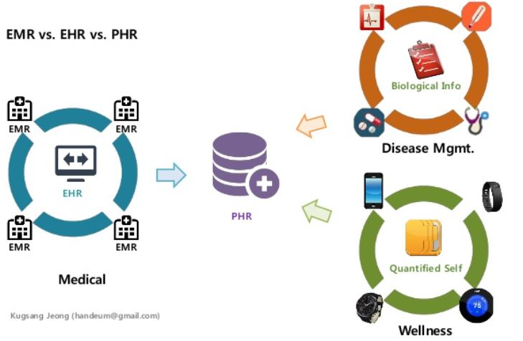

**Figure (2.2):** EHR VS PHR VS EMR

**FUNCTIONS OF EHR**

EHR as a system of hardware, software, people, policy, and processes that work together to collect data from multiple resources, thus providing information and decision support to multiple healthcare providers irrespective of time and place. [Margaret and Steven [2005]]

Accordingly, an EHR system should offer the following basic functions:

1. Health Information and Data:

• Store and provide access to health information of patients to healthcare providers to take appropriate clinical decisions.

• Integrate data from various sources and make it available to the people involved in the care of a patient.

1. Replicate theWorkflow:

• It should be able to work in-sync with the original workflow of the healthcare organization

* 1. Efficient Interaction:

• It should be able to work effectively,saving time of care providers by keeping things concise.

4-Clinical Decision Support (CDS):

• It should support provision of reminders, prompts, and alerts to help in improving clinical and preventive practices and reducing frequency of adverse events.

5. Patient Support:

• It should empower patients to access their health information, enabling them to be involved in their own healthcare

* 1. Messaging and Data Processing Capability:

• It should enable exchange of data in known/standard formats for interoperability of healthcare applications.

• Additionally, it should enable processing of incoming data in known/standard formats.

* 1. Administrative Tools:

• It should provide administrative tools, such as scheduling systems, for improving efficiency of clinical practices and timely service to patients.

**SIGNIFICANCE OF EHR**

An EHR system helps to provide an integrated view of healthcare records by enabling integration of various healthcare applications such as Hospital Information Systems (HIS), Pharmaceutical Systems, Imaging Systems, and Health Insurance Systems.Therefore, offering the following advantages:

1. **Ease of Maintaining Health Information of Patients:**

• Enables paperless medical treatment with less space required for storing health data of patients.

• Also, with proper backup policies,the lifespan of EHRs can be increased.

1. **Efficient in Complex Environments**:

• An EHR system helps in improving clinical processes or workflow efficiency across the healthcare organization units.

• For example, it enables an administrator to obtain data for billing, a physician to see progress of treatments, a nurse to report an adverse reaction, and a researcher to analyze efficacy of medications on patients.

1. **Better Patient Care**:

• An EHR system allows sharing of the patient’s information among the healthcare providers.

• Enables point-in-time data insertion, retrieval, and update, thereby providing immediate access of patient data from any specialty center whenever required.

• Availability of health information, such as past medical history, family medical history, and immunization, through EHR helps in taking preventive measures and managing chronic diseases more effectively

1. **Improve Quality of Care:**

• EHR helps to decrease reporting and charting time during treatment,thereby improving quality of care.

• EHR also helps in improving risk management and accurate diagnosis,thereby improving quality of care.

1. **Reduce Healthcare Delivery Costs**:

• Due to the availability of health information data from all healthcare organizations, a healthcare provider can refer to the required test reports,thus avoiding repetition of expensive tests.

1. **Accelerates Research and Helps Build Effective Medical Practices**:

• EHR provides a large database at one place, enabling its use for disease surveillance for providing preventive measures.

• Also helps in analyzing treatment patterns of medicine,providing new ideas and ways of drug discovery.

• Decision support with EHR enables effective medical practices.

1. **Better Safety:** • Through access, audit, and authorization control mechanisms, an EHR system provides better safety to a patient’s health records as compared to a paper-based system.

**FACTORS AFFECTING IMPLEMENTATION OF EHR**

An EHR system needs to deal with multiple healthcare and health management applications and various types of healthcare providers. Hence, its implementation is a complex task that usually requires more time and effort than implementation of several other IT applications. The following factors usually affect the implementation of an EHR system and need to be dealt with properly:

1. Significant Changes in ClinicalWorkflow:

• Implementing an EHR system in a healthcare organization often requires significant changes in the organization’s clinical workflow. It is always good to make EHR a part of the strategic vision of the organization. Design of the system needs involvement of clinical staff with inclusion of organization’s policies and workflow processes Clinical workflow varies from one specialty to another. Thus, an EHR having a specific workflow for practicing medicine is usually not adaptable easily.

2. Privacy and Security:

• An EHR implementation must deal with privacy and security issues with great care. Healthcare providers are concerned about alteration of EHR without their knowledge, and Patients are concerned about unauthorized access to their private data.

• An EHR system must also meet the privacy and security regulations for health data imposed by regulatory bodies in the country.

3.Unique Identification:

• While integrating patient’s data that is often collected from various healthcare organizations, an EHR system must properly link all data of a patient to create his/her single HER

.4. Interoperability:

• The EHR system should enable interoperability among various healthcare applications and systems that are developed independently.

* 1. Consistent Use of Standards:

• An EHR system requires consistent use of standards such as clinical vocabulary, standardized data formats and security and data integrity standards.

• It must also be upgraded consistently to newly developed standards for addressing these issues.

* 1. Ethical and Legal Issues:

• An EHR system must also carefully handle ethical and legal issues that are linked to accuracy, confidentiality and access rights of healthcare data.

* 1. Unknown Return on Investment (ROI):

• Convincing an organization’s decision makers to invest in implementing an EHR system on the basis of intangible benefits or related saving only is rather difficult.

* 1. Difficult to Operate:

• Some healthcare providers find it more difficult and time-consuming to use computers for data entry than handwriting. • Therefore,they need special training, which adds to the cost of implementing an EHR system.

* 1. Some superior advantages of paper-based records:

• Less structured and hence offer more flexibility in terms of writing text and putting diagrams.

• Also,reading text on paper is 40% faster than reading text on a computer screen.

Despite all of these issues, the whole world is moving toward implementing the EHR system and several implementation issues are being addressed gradually.

**HIS definition**

A **hospital information system** (**HIS**) is an element of health informatics that focuses mainly on the administrational needs of hospitals. In many implementations, a HIS is a comprehensive, integrated information system designed to manage all the aspects of a hospital's operation, such as medical, administrative, financial, and legal issues and the corresponding processing of services. Hospital information system is also known as **hospital management software** (**HMS**) or **hospital management system**. Wikipedia

Hospital information systems provide a common source of information about a patient's health history. The system has to keep data in a secure place and controls who can reach the data in certain circumstances. These systems enhance the ability of health care professionals to coordinate care by providing a patient's health information and visit history at the place and time that it is needed. Patient's laboratory test information also includes visual results such as [X-ray](https://en.wikipedia.org/wiki/X-ray), which may be reachable by professionals. HIS provide internal and external communication among health care providers. Portable devices such as [smartphones](https://en.wikipedia.org/wiki/Smartphone) and [tablet computers](https://en.wikipedia.org/wiki/Tablet_computer) may be used at the bedside.

Hospital information systems are often composed of one or several [software components](https://en.wikipedia.org/wiki/Software_component) with specialty-specific extensions, as well as of a large variety of sub-systems in medical specialties from a multi-vendor market. Specialized implementations name for example [laboratory information system](https://en.wikipedia.org/wiki/Laboratory_information_system) (**LIS**), Policy and Procedure Management System,[[1]](https://en.wikipedia.org/wiki/Hospital_information_system#cite_note-1) [radiology information system](https://en.wikipedia.org/wiki/Radiology_information_system) (**RIS**) or [picture archiving and communication system](https://en.wikipedia.org/wiki/Picture_archiving_and_communication_system) (**PACS**).

**Potential benefits of hospital information systems include:**

* Efficient and accurate administration of finance, diet of patient, engineering, and distribution of medical aid. It helps to view a broad picture of hospital growth
* Improved monitoring of drug usage, and study of effectiveness. This leads to the reduction of adverse drug interactions while promoting more appropriate pharmaceutical utilization.
* Enhances information integrity, reduces transcription errors, and reduces duplication of information entries.
* Hospital software is easy to use and eliminates error caused by handwriting. New technology computer systems give perfect performance to pull up information from server or cloud servers.

**Disadvantages of using** **hospital information system (HIS):**

Adding computers or going electronic can make everything from billing to keeping track of patient records quicker in a hospital, but computers also bring disadvantages to the hospital environment. As technology and computers become more advanced, additional elements will appear in the hospital setting, but whether the advances are really improvements is open for some debate. One of the biggest drawbacks of adding computers to hospitals is the cost. Computers cost money, and a large hospital needs many computers to keep the system running smoothly. Creating a network to transfer medical records or keep track of billing is an additional initial cost. Unlike paper records, which simply require a few more copies, electronic record keeping requires constant upkeep of computers, computer software and other electronic elements, which can cost even more. Another problem is, if your doctor or hospital is switching to computers or electronic record keeping, you're probably worried about the security of your medical records. Paper records are kept in a doctor's office or a warehouse, but once computers are added to a hospital, electronic record keeping typically follows. Once electronic record keeping is begun, medical information is usually added to a closed computer network, but as long as an Internet connection comes into the network, the system is vulnerable to outside sources, opening the debate to questions. One of the biggest disadvantages of adding computers and electronic records to a hospital is the lack of standardization through the medical field. Different hospitals use different shorthand abbreviations or symbols on medical records than Mutation in

others. Even the codes called out during emergencies don't always mean the same thing in every hospital. If a medical record is transferred from another hospital or the system becomes open so hospitals can share information, the lack of standardization in hospital notes and records could cause problems when it comes to a medical professional's understanding of the medical record.

the main function of HIS shown in figure**(2.3).**

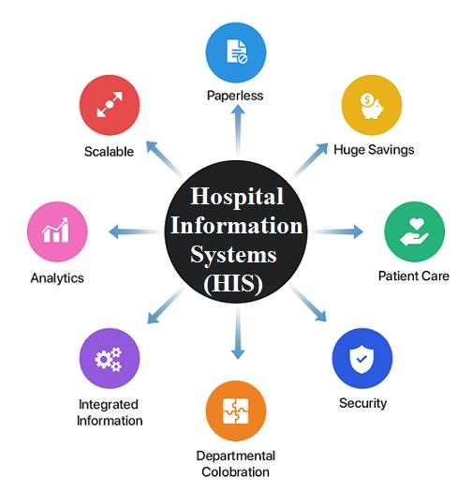

figure(2.3). hospital information system (HIS)

**Chapter conclusion**

At the end of this chapter the reader will know exactly what is the EHR functions and types and what is the HIS , specifically pros and cons of usage.