
NEA WRITEUP
Driving Instructor Booking System

January 1, 2025
Beauchamp College - 25280
Ziyad Shafi
QUALIFICATION CODE - 7517

Contents
Analysis 4
Research Method 4
Research Data 4
Interview TRANSCRIPT: 4
Questionnaire Data: 7
Questionnaire Data Analysis 8
Summary: 8
Identification of Key Contacts 9
Identification of client 9
Identification of Prospective users 9
Identification of Audience 10
Problem Identification 11
Overview of the business 11
Overview of the problem 11
Limitations and Constraints 12
Hardware requirements 12
Software Requirements 12
User Skills 12
Model of the existing system 12
IPSO Chart 12
Data Volumes 12
Data Flow Diagram Level 0 13
Data Flow Diagram Level 1 13
Entity relationship diagram 13
Solution to the problematic, outdated current system. 14
List of specific objectives 17
Design 26
Overall System Design 26
Top-Down Diagram 26
Structure Diagram of UI 26
Description Of Algorithms 26
Merge Sort 26
Regular Expressions 29
Description of Data Structures 31
IPSO Chart 31
Data Dictionary for each table 31
OOP Class Diagram 33
Database Design 33
PRE-NORMALISED ENTITY RELATIONSHIP DIAGRAM 33
Post-normalised Proposed entity relationship diagram 34
SQL STATEMENTS 34
Data Flow Diagrams 37
Design of User Interface 37
Main Screen 37
Sub Screens 39
Use of Widgets 45
Aesthetics (look and feel) and suitability for user 46
Initial Designs with rationale annotated 47
System security and integrity of data 56
Login Screens with annotations 56
Access rights/User Levels 57
Validation 58
Technical Solution 58
Completeness Of Solution 58
Technical Skills Used 58
Screenshots of Final UI Annotated 58
Code Explained and fully annotated 80
Code Listings 153
Table Listing all methods, attributes, variables per class 214
Evaluation 235

Analysis

Research Method
I am collecting information directly from my main client Zubair, with an interview to learn about the current system in place. The reason I am conducting an interview rather than any other method of data collection is the fact that it will allow me to ask to follow up questions to the client. This will allow me to ask specific questions regarding the current system to my client and if I am not satisfied with the answer, for example the answer is too vague and not as useful, I can ask them to clarify or ask a more specific question. An interview will allow me to obtain specifics about the current system that I can use when I develop the new system, for example, it will allow me to assess the skill level of individual users, the amount of data to store, it will allow me to identify requested features from the client, and it will allow me to identify shortcomings in the current system, I can then ensure my proposed solution will fix these shortcomings. As my proposed system will have 2 different types of users, I am collecting data from both, driving instructors and driving students. The interview with Zubair already covers instructors and for Students, I have asked Zubair and Roadsense will distribute a digital questionnaire using Google Forms that I will create to collect data from students, for me to base the proposed solution on. By collecting data from both types of users directly, I can ensure that it is mostly reliable and little to no underlying assumptions were made.

Research Data

Interview TRANSCRIPT:
Could you explain your business, its goals and services that it provides?
Key:
Ziyad Shafi
Zubair Roadsense
Roadsense Driving School was founded by myself 17 years ago, we aim to provide driving lessons for students of the highest quality and our aim is to teach students of all age groups and demographics, our goal isn’t just to teach students how to pass the test but rather to teach them to drive to a very high standard.
How do you currently arrange/create bookings with students for driving lessons?
Currently, each instructor has their own diary and independently manages their own lesson bookings. They store all the dates and times for each students’ lessons in this paper diary. Now, at the end of each lesson the instructor will open the diary for the following week and view what time slots are available. The way they determine if a session is available is by first looking at the date and time and checking there are no other ongoing sessions at the time, then they will check the previous session and check how far away it is, they will estimate how long it will take to get to the students pickup point and then ask the student if they are available. They must keep doing this till they find a slot that works for the student.
What days and hours of the week are lessons provided?
Currently, we operate from Monday to Saturday and provide 1 hour lesson slots from 10am to 5pm. So we each instructor provides a maximum of 7, 1 hour slots.
Follow up question: In reality are there really 7, 1 hour slots a day that are taught?
Because of other factors such as a 1 hour break for all instructors and travel times in between student locations, we usually teach around 5 hours of driving per day.

Follow up question: Do all of the instructors have the same fixed days and hours?
Yes, all of our instructors have the same fixed days and hours, all that may differ is when they decide to take their break.
What would you say are the current issues with the current diary system you have in place?
Well, the main issues come from the way the booking system works.
Because we use a physical diary per instructor, if an instructor loses a diary, leaves it behind at home, or it simply gets ruined by a spilled water bottle in a bag, the instructor loses all information about their schedule and therefore cannot carry out their job. The physical diary also collides with some of our company values, we value sustainability and the health of the environment, and physical solutions like these diaries provide waste year on year.
The current booking system also makes it very hard for an instructor to find lesson slots for each student, they have to check hours that are even available to begin with and then try to calculate the distance from the previous slot and whether they would make it to the pickup spot in time, and then contact the student and agree on a suitable slot. The process is very mentally demanding and not very efficient. Searching for lesson availability is hard for the instructor.
The other issue comes from students who cancel lessons or want to rearrange at short notice as this then requires for them to liaise with the instructor directly in order to find another available slot and may interfere with the instructor’s current schedule. This requires a large amount of back-and-forth communication between instructor and student and can get messy.
Within what time frame are students allowed to cancel driving lessons or change things such as pickup location?
Students are allowed to cancel lessons up to 72 hours before a lesson. This is in order to prevent things such as mis scheduling or poor route planning which will make the schedule less efficient for all students.
Follow up Question: If there were a way to make the schedule system update by itself so that students could change things such as pickup location but only if the travel distance from the previous slot and to the next slot was similar would you change this policy?
Yes if the System would automatically correct the route planning, or only ensure people can change the pickup location without affecting other slots, we could potentially reduce the time frame to 36 hours.

How much data can each student access regarding lesson slots?
What types of data are you referring to, could you rephrase what you’re trying to say?
Follow up Question: Can the students see when other people have lessons or even when they have, and have had lessons in the past?
No, currently the only people who can view the details of other lesson slots are instructors and the students themselves cannot see when other students have lessons
Further Follow up Question: Would you be opposed to a solution that allowed for students to see when other students have lessons?
As a company, we would be opposed to a solution that let students see the details of other lesson slots, for example the Name, address, Age of the student who has that slot booked, as it goes against of privacy values and beliefs. As long as each slot does not contain details of the student, it would be fine if students can view the overall schedule.
How many instructors are there in the company?
We currently have 4 instructors.
How many Students on average does the company teach at a given time?
There are roughly 20 students per instructor at a given time, so across the company there are roughly 80 students at a time.

How many hours does each student typically book per week?
Typically, each students’ books between 1 to 2 hours per week. But as they approach their test week this may even ramp up to 3 or 4 hours in a week.
What is the average amount of hours each student requires before passing their test?
Well, the DVSA recommend 45 hours with an Approved Driving Instructor, we recommend around 50 hours of driving in order to guarantee passing, and becoming a stellar driver on the roads.
Follow up question: In reality how many lessons on average do people take before passing?
I would say our average would be 35 hours of driving with one of our instructors before a student passes.
If you could create the perfect booking system, how would it work?
Our perfect booking system would allow both instructors and students to book lessons. It would figure out suitable slots using the students’ pickup locations and allow for them to book directly which would be great as it would stop unnecessary communication between instructor and student. It would also store all of the details and schedules on a computer or phone to address the other issues that unlike the diary system we have now, it cannot get lost or destroyed. As per our company values, we also like to incorporate a direct feedback system with the student, at the end of each lesson we tend to note down feedback and deliver it to the student at the end. I think perfect booking system would allow for instructors to create feedback reports on each lesson, and it would save and allow for the students to view said feedback reports.
Follow up Question: Would there be any extra features you would like if there is extra development time?
If there is any extra time, it would be good if we could develop a learning resource portal the students and instructors can access. It would be full of resources demonstrating things such as manoeuvres, junctions, roundabouts, etc.
Would you be open to a digital booking system solution?
Yes, we would be open to a digital solution.
Follow up Question: What devices would you like the system to work on/support?
We would like the system to work on Windows computers and laptops, as all of our instructors have them and it’s the most common computer device for students.
Follow up Question: For a digital solution we need to tailor it to technical ability. On average how technically savvy would you say the instructors are?
I would say each instructor has an average level of technical savviness, and can work their way around a Windows computer, however they are not incredibly knowledgeable and experienced.
Further Follow up Question: If you had to rank the average skill on a scale of 1-10, 1 being absolutely no knowledge about a computer, and 10 being complete mastery of how to use the device, what number would you give?
I would say our instructors due to age and usage are on average a 5.

Questionnaire Data:
Question 1: What is your age?
Question 2: Is English your first Language?
Yes ☐ No ☐
Question 3: What Operating System does your computer use?
Windows ☐ MacOS ☐
Question 4: If you could rank your computer skill on a scale from 1-10, 1 being ‘I have no idea how to even use a computer’ and 10 being ‘I can easily use a computer and know exactly how everything works’. Where would you rank your skill level?
- ☐ 2) ☐ 3) ☐ 4) ☐ 5) ☐ 6) ☐ 7) ☐ 8) ☐ 9) ☐ 10) ☐

Questionnaire Data Analysis
We received 40 questionnaire responses.
Question 1: The average age discovered from the data was 24 years old, however upon further analysis, the large majority (75 percent) of the responses yielded ages between 17-19. However, due to a number of extraneous outliers, some data points including people of ages 33-38 the data is skewed therefore the average is higher.
Question 2: As expected, the large majority of responses indicated that English was their first language. 90% of responses indicated so. This means that when creating the new system, we should target an English-speaking audience, however it would be best to use very basic English terms so that even people whose first language is not English, still find the system easily accessible.
Question 3: The results for this were 92.5% Windows and 7.5% MacOS. Therefore, I now know to prioritise development of the system for Windows devices, however we also know that cross compatibility with MacOS will be necessary at some point as not all the devices use Windows.
Question 4: The results for this determine an average of a skill level ranked 7.5. One correlation we have determined from the data points is that the higher age outliers had a direct correlation with a lower rating. We can also compare this average ranking with the data collected in the interview about the instructors. We can use this data to develop a more technically savvy interface for the students as they are better with computers on average.

Summary:
To conclude, from my communication with both the Main Client Zubair, the head of Road sense, via an interview, and the questionnaire sent out to the students at present, I can determine that a digital booking system would be vastly more efficient due to multiple reasons.
One, we have determined that the volume of data inputted via the current system is massive, there are an average of 80 students, 20 per instructor, who will book between 1 to 2 hours of lesson time per week. Each booking also requires many calculations and estimations to be carried out, determining whether a lesson is possible because of pickup location and other geographical logistics, by instructors and therefore is inefficient and time consuming. The digital booking system would allow for the booking process to be much easier for both instructors to manually book slots for students, but also for students to book lessons for themselves minimising the amount of communication each student must have with instructor.
Some major features to focus on are that the scheduling/booking system takes pickup location into account, I can use the Google Distance Matrix API in order to find distance between locations to determine a slot is available to a student, another feature is to ensure that each button is labelled clearly using basic English as from the questionnaire I have determined that English is not the first language for all students. One other feature to ensure is added, is a clearly labelled GUI especially for the driving instructor portal as there average ranking for computational literacy is a 5 as determined per the interview and therefore in order to reduce the barrier to entry for using this new system and for it to be as efficient as possible, I will ensure to follow clear GUI design principles and avoid hiding common features in submenus.
Finally, to maximise compatibility for students and to widen accessibility to the system, I will develop the system with a cross-platform programming language so that it is supported by both Windows and MacOS, as we have discovered in the questionnaire data that a small number of students use MacOS.

Identification of Key Contacts

Identification of client
I will be developing this solution for Zubair at Roadsense Driving School. Zubair is the main driving instructor and currently must manage clients and the logistics for each individual lesson so that timings line up at the correct timings. This scheduling is a tough task and requires a lot of time and logical thinking, paired with contacting clients and can be a very time-consuming process. Zubair is my client as he has the largest role within the Roadsense Driving School, and therefore for the solution I am developing I have allocated him the largest role when it comes to controlling the creation of the current system, as he has the most experience and influence within the school and therefore will make the most informed decisions about the direction the system I will be developing should take.

Identification of Prospective users
The Users for the solution/system would be:
Zubair and other driving instructors within the company. These Instructors will be able to view their schedule portably and conveniently from a device rather than a physical diary manually book, move/manage, and remove lessons from their personal teaching schedule. It will also allow for them to create a feedback report which would be linked to a specific lessonID, which will allow the student to access and gain feedback on for a more developed, feedback loop, learning system, which pairs with the currently existing foundations of the teaching principals within Roadsense Driving School, and it will allow them to easily book said driving lessons without the stress of calculating distance between lessons and working out the geographical logistics as this will become automated
Whitelisted registered students who have accounts created already will be able to access the system at a different (lower) privilege level. They will be able to access the feedback that has been assigned to individual past lessons, they will be able to view their lesson history, and book lessons with automatic location accommodating slots. This will ensure that they cannot book a slot that will be unreasonable logistically for the instructor.
Administrators who will be able to manage and maintain the system. They will be able to Create accounts for both students and instructors, remove accounts for students and instructors, and modify details for students and instructors. They will also be able to modify, book and delete driving lessons. They also will have access to all schedules for each instructor rather than just for one instructor. These features are created in mind that the administrator will need to have higher access to certain data fields in order to maintain the system and provide support if needed by any of the other users, instructors or students. All 3 Users will have different privilege/access levels to the Driving Instructor Booking System.

Identification of Audience
To identify the audience for the system we need to view both prospective users of the system, and any other potential stakeholders (people that are affected by the system).
Driving Instructors play a major role in making up the audience that the system caters toward. Their role within the system is read data for example reading their schedules, input data for example booking a lesson manually for a student or inputting the data for the feedback report for the lesson. the main data they receive from the system would be their up-to-date schedules, and as mentioned in the interviews, potential driving manoeuvre resources.
Driving students also make up a large part of the audience that the system caters toward. Their role typically within the system would be to view the schedule and input pickup and destination location, and book driving lesson slots. The data that driving students receive from the system would be all the feedback reports created by the driving instructor for them, other data they would receive would be a list of when there future driving are, and a history of their previous driving lessons.
Parents of the younger driving students may also make up a part of the audience. Their role may involve booking lessons for their child. The data they may receive/view can include the feedback reports created by the driving instructor for the students, they may view this to track how well their child is progressing.
Administrators of the system play a role within the audience as their main job is to keep the system operational/functional. The data they would receive from the system would involve the number of user accounts created, the type of account each account is, the schedules of each instructor, and the ability to create/remove accounts.
Another interested party within the system may include accountants. Accounts may request data such as copies of instructor’s lesson history, to monitor data such as frequency of lessons, average duration of lessons etc. This would be to calculate turnover and potentially create receipts in case there are other future interested parties such as HMRC, who may request copies of the lesson history data to verify the amount of tax the corporation is paying.
Some more parties may include shareholder, or potential shareholders/directors of the company. They may also request data such as instructors lesson history to monitor and potentially adapt the company’s policies for them to maximise profits.

Problem Identification

Overview of the business
Roadsense Driving School provides driving lessons for students, with a great emphasis on creating great drivers rather than creating drivers who can ‘get by’ for the test. To ensure this, they provide paired feedback with tailored lessons, to target weaknesses and allow the student to prioritise and focus on their current shortcomings. The company has 4 driving instructors each with an average of 20 students, my client is Zubair, the main driving instructor.

Overview of the problem
The standard practice currently carried out in the driving instructor industry is by using a physical diary and manual route and lesson planning/scheduling. This would involve the instructor contacting each student and requesting information such as where they would like to start and end their lesson, what times they are free and what lesson duration they would like. They would then note down this information, once all the clients have been contacted, they would then have to place students in slots depending on multiple factors, such as comparing the distance between the end location of one lesson and the start location of the lesson directly after, and if it falls within a reasonable amount of time book in the students for each slot, and then finally once a proposed schedule is created they will have to follow up with each student to confirm that they can attend that lesson, and if not further rearrange the timetable, and contact the student again. This current system displays many issues:
1) Contacting Students:
-It requires the instructor to contact the student a minimum of 2 times, which initially may not sound like an issue, however when this is multiplied across 30 students, it becomes a large volume of data for the instructor to store regarding when certain students are free.
2) Major Logical and arithmetic operations, heavily increasing workload.
-It requires the instructor to calculate and carry out many arithmetic operations on the data set they are given by the individual students, they need to plan routes and build a schedule around lessons that are geographically on route to each other in order to maximise efficiency, this requires comparing each individual students timing availabilities, their start address to the end address of the previous students lesson, and their end address to the start address of the next students lesson after them. This means that there are many logical operations that the instructor must carry out which are very time-consuming and are not an efficient process and will lead to the instructor spending too much time on scheduling.
3) Lack of portability and accessibility, and potential harmful environmental effects.
-One final issue is the accessibility of the schedule, by having the finalised schedule be stored on a physical timetable/diary, it means that they instructor constantly has to carry around this timetable/diary, therefore making the current system much less portable, less convenient, less durable and more prone to being lost. Also, in an era where environmental friendliness is becoming a more important principal within businesses, this does not allow them to use a paperless system, and once a schedule is used is will become useless, leading to lots of waste generated.

Limitations and Constraints

Hardware requirements
A Laptop/Desktop computer, although a laptop would be ideal in order to reap the portability and easier accessibility benefits of my proposed solution. With a minimum of:
CPU: An x86 architecture CPU with a minimum of 1GHz and 2 cores.
Memory : A minimum of 4GB
Storage : A minimum of 5GB of storage.
It would also require an active internet connection in order to connect to the SQL database and obtain updated data and write new data to the updated system.

Software Requirements
Operating System : macOS 10.13 or Windows 7.
Python is required to be installed.

User Skills:
As determined by the interview the skill level hierarchy is as follows. Administrators, then Students, then Instructors. Therefore, to accommodate this I have to ensure that the GUI is easily accessible to lower skilled users, however the administrator and students portals can be more complex.

One potential limitation with the proposed system I want to develop are with the Hardware requirements. As a current internet connection is required, if the instructor would like to access the database on the go it may be hard to find a connection. This issue however is limited as this can easily be circumvented via mobile phone tethering/hotspots.
Another potential limitation would be with the fact that the processor has to be of x86 architecture and cannot use an ARM architecture. Modern lower-end computers such as Chromebooks and lower powered windows devices now use ARM based processors, these however are not compatible. This issue however is acceptable as when contacting Zubair from Roadsense Driving School in the interview, we had run through the laptop specifications that the instructors will be using and they all meet the hardware requirements.

Model of the existing system

IPSO Chart

Data Volumes

Data | Volume of Data
Number of Instructors | There are currently 4
Number of Students Per Instructor | Average at a given time is 20
Number of Students at Roadsense | Average at a given time is 40
Number of Lessons for each Student | Average per student is 1-2 hours per week
Number of slots booked each working day | Average is 5 lesson hours per working day

Data Flow Diagram Level 0
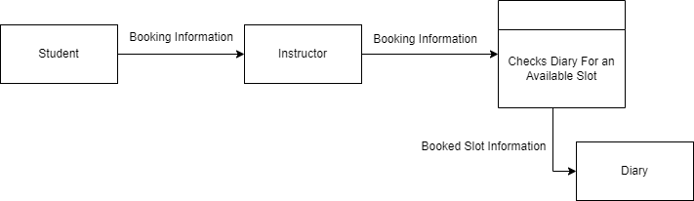

Data Flow Diagram Level 1
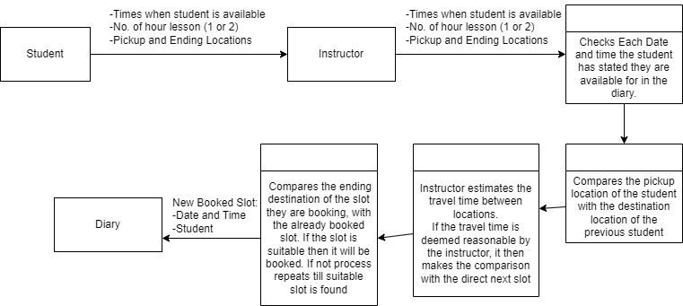

Entity relationship diagram
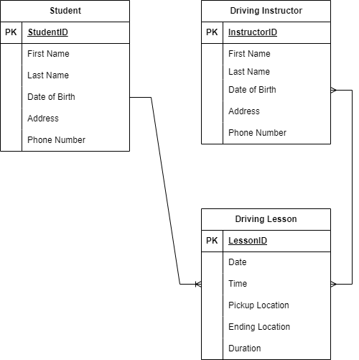

Solution to the problematic, outdated current system.
The system I am proposing to design would be created in python in order to maximise compatibility with all types of users. This is because as part of the data collection process we have determined that many of the users are Windows users however there are still a number of MacOS users. The system will work as follows; each student is provided access to a booking timetable system. Within this timetable, they will be given 2 fields to enter start location and end location. These refer to the location in which the student would like to be picked up for their lesson and the location in which the student would like to end the lessons. Although these 2 fields would be the same location in most cases, I have included both fields separately in order to minimise the number of manual bookings as possible, which will minimise the amount of external contact each student would need with their instructor. Once these 2 fields have been entered, the student will be provided with an updated timetable which only provides them with slots available to them. This is calculated based of off the geographical logistics. It will compare the start and end destinations with other bookings and use the Google Matrix API to calculate the time taken, and will determine the slots this student can book in for. This system would allow for each instructor to view the upcoming schedules/lesson timings all in one place and if necessary, manually intervene and change appointment timings.
Additionally, the system will provide other helpful features, students will have options to, view feedback reports assigned by the instructor, book lessons, and view upcoming lessons and previous lesson history.
For instructors, it will additionally provide a portal for them to access their dedicated learning resources for easier teaching and modelling issues, for example teaching a manoeuvre such as parallel park.
For Administrators, it will allow them to maintain and manage the operation of the whole system in order to provide support for the other users.
To provide a useful updated system, the new system must tackle the main issues with the current system, so I will be referring to the main issues previously outlined in my overview of the problem:
- The solution for having to contact students’ multiple times frequently about booking their lessons:

By having a system which automatically allows students to book in and holds the data about start destinations end destinations and availability, this reduces the amount of contact the instructor needs to have with the student prior to the driving lesson as the system is more automated and allows the student to book a lesson when they are free, depending on whether that slot has been calculated to be geographically feasible for the instructor to travel to within the current schedule.

The solution for Major Logical and arithmetic operations, heavily increasing the workload for the instructor:

- Searching for lesson availability is very difficult for the instructor, therefore I am creating a system that calculates available slots for each students using distance matrix data from the Google API, it automates the large workload the instructors would previously have. This is because it will calculate all logic and arithmetic operations when it comes to logistically planning a driving lesson schedule and it will all be on the students’ terms. This eliminates the issue of the schedule creating being a major time consuming and inefficient back and forth process.

Lack of portability and accessibility, and potential harmful environmental effects Solution:

- As the system will provide a SQL database for the timetable with each student having their own data assigned to themselves. It will provide a more organised method of storing data and the lesson schedule and most importantly will solve the previously outlined issues, being that physical diaries/schedules are less portable and less convenient and are also less durable, and prone to being lost, as these things cannot happen with a SQL database, opposed to a diary. It will also aid the environment by moving to a paperless database/schedule.

List of specific objectives
 | Objective | Performance Criteria | Potential Skills:
1) | The driving instructor booking system will provide a clear login interface and system for the 3 different types of users. The login system will store all information for the 3 different types of users, in a SQL database table, using such as a hashing algorithm, to ensure that the security of the user is maximised. | Upon opening the program, using the Python Tkinter library, a menu will be provided, which prompts the user to choose a role, Student, Instructor, or administrator.  Once a role is chosen, it will provide a username, and password input widget for the user to enter their details, and a button below which will be labelled login.  Once the credentials are entered and the login button is clicked, the program will run the hashing algorithm on the password that the user has entered and search the SQL database table for the username entered, the correlating password in the database, (which has already been hashed), to the hashed version of the inputted password by the user.  If they match the user will be granted access to the portal they have logged into, student, instructor or administrator, however if the details are either not found in the database, or do not match, they are prompted that the username/password is incorrect and they should attempt login again.  If the incorrect details are entered 3 times, it will prompt the user with a widget displaying contact administrator followed by the contact phone number for the administrator.  For the user to log in again the account must now be unlocked by the administrator. This prevents an efficient brute force attack. | Tkinter Library Understanding.  Use of an SQL Database  Hashing Algorithms  Object Orientated Programming
2) | Create Password reset system that will have identity verification via memorable questions, and for the potential future an email password reset verification system. | Within the Login GUI that the user is presented with once that they click on one of the 3 options, to login, Instructor, Administrator or Student, within the login window will be a Tkinter widget, button, which will clearly be labelled Forgot Password. When the Button is clicked, it will prompt the user to enter their username, and will ask them 2 random memorable questions from the 3 predetermined questions that user initially set with the administrator. The answer fields will be non-case sensitive as the majority of answers will remain the same whether they contain capital letters or not. If the 2 questions are answered correctly it will provide the user with a new window with 2 input fields, the first to enter the new password, and the second to confirm it, this acts a confirmation mechanism to ensure the user does not enter a password they did not intend to enter. If the user however gets any of the questions incorrect, the program will prompt them that they got it incorrectly, and the user will only have 4 more attempts to enter the correct answers. I have chosen 5 attempts, as it gives the user a margin of error as they sometimes may forget the answers they have inputted with the administrator, however it is not more than 5 in order to prevent against a brute force attack. | Tkinter Library Understanding.  Use of an SQL Database  Object Orientated Programming
3) | The driving instructor booking system will contain a clear Graphical User Interface for Students, that adapts based on the required features for students and their user skills. | This feature will adapt to the required tasks for Students. It will provide a menu with 5 main options: View Previous Report/Feedback, View Lesson History, View Upcoming Lessons, book a lesson, Change Pickup Address. Via the questionnaire that was issued to all of the clients, I was able to gage the skill level of the user to be on the above average side. On a scale of 1 to 10 the average score was 7. However, in order to maximise accessibility, but likely will make the application simpler, with larger buttons and less submenus to cater to a wider array of students, allowing for the app to be more accessible. | Tkinter Library Understanding.  Object Orientated Programming
4) | Create a Feature that will allow the student to View Previous Report/Feedback, that has been assigned by the instructor. | Once the Tkinter Button Widget is clicked,  this feature will form a SQL search query to the database, and will search using the UserID of the user as a parameter, and will find all of the LessonID’s and will search those lessonID’s for dates and times of each lesson and will display the dates and times all previous reports/feedback to the student in a list format. The User will then be able to click on each individual date and time, and upon clicking will be displayed with feedback that the instructor has assigned to that specific lesson. It will do this by using LessonID as the primary key for the lesson and search querying that specific lesson ID and displaying the associated feedback in the record for that lesson. | Tkinter Library Understanding.  Use of an SQL Database  Object Orientated Programming
5) | Create a Feature that will allow the student to View Lesson History and upcoming lessons. | Once the Tkinter Button Widget labelled, ‘View Lesson History’ is clicked, this feature will form a SQL search query using the userID assigned to the student User, and will search all lesson ID’s associated with the UserID and will search all of these LessonID’s for dates and times, and once this date is obtained, it will display the date and times for each previous lesson in a list format. | Tkinter Library Understanding.  Use of an SQL Database  Object Orientated Programming
6) | Create a Feature that will allow the student to access a lesson timetable, and book lessons in set slots. These slots will only become available if within a certain distance/time of the previous slot’s destination. | Once the Tkinter Button Widget labelled, ‘Book a Lesson’ is clicked, this feature will display a timetable of the week and 1-hour slots ranging from 10am till 6pm. With a 10-minute interval between lessons as these are the hours the client has specified; slots are available for in the week. At the top of the timetable will be buttons which allow the student to go forward and backward in time. There will also be 2 buttons which are labelled Start Locations and End location. When these Tkinter button widgets are clicked it will provide a window with a field that allows the user to enter the address where they would like to be picked up from by the instructor and an address where they would like to finish the lesson at. Now using the Google Distance Matrix API, it will compare the start location with every slot and if within a projected 10-minute distance calculated by the Google Matrix API, it will then allow for the lesson to be booked. However, if the lesson is not within a 10-minute travelling distance, it will check if there is a lesson booked 1 hour later, if there is not it will allow the student to book the lesson and will offset all of the other slots by the travel distance, so if it taken an additional 10 minutes on top of the previous 10 minutes, it will offset all of the other slots by the 10 minutes. | Tkinter Library Understanding.  Use of an SQL Database  Object Orientated Programming  Google Matrix API usage
7) | Create a Feature that will allow the student to View all upcoming Lessons, Cancel Driving Lessons or modify details (such as pickup location) for the booked slot. | Once the Tkinter Button Widget labelled, ‘View upcoming lessons’ is clicked a new window will appear which lists each lesson/upcoming slot that is booked, and is assigned to the specific students UserID. It will list all of the lessons in upcoming chronological order, from this menu the student can click on each individual booked slot and a submenu will appear, there will be 2 buttons, 1 which will allow for the user to delete the slot, only if they are within 72 hours. There will also be a modify button which will allow for the user to change the pickup and ending location for the driving lesson. However, this pickup and ending location will only be able to be modified as long as the distance between the updated location and the previous slot and slot after the lesson are within a time frame within 2 minutes of the old pickup and ending location. | Tkinter Library Understanding.  Use of an SQL Database  Object Orientated Programming  Google Matrix API usage
8) | Create a Feature that will allow the student to access all previous feedback reports that were created by their instructor and assigned to their previous lessons. | Once the Tkinter Button Widget labelled, ‘Book a Lesson’ is clicked, this feature will display a list of all lessons the student has previously taken, in a list format. The student will then be able to click each individual lesson and view the feedback checklist and notes that the instructor has provided for them. It will do this by searching for all slotID’s that contain the matching UserID of the student and then displaying all associated feedback reports with those slotID’s. | Tkinter Library Understanding.  Use of an SQL Database
9) | The driving instructor booking system will contain a clear Graphical User Interface for Instructors, that adapts based on the required features for an instructor and their user skills. | This feature will adapt to the required tasks for instructors. It will provide a menu with 6 main options: View Learning Recourses, Create Feedback Report, View Upcoming Lessons, Book/remove/modify a lesson.  (Manually), Create a route, Start a route. From the interview with the main instructor Zubair, I have come to the conclusion that the instructor computer skill level is that of the average user, if not lower, ranking 5 on a scale of one to 10. As the client has feedbacked a lower skill level, the Graphical User interface will have clearly labelled larger buttons, with less submenus, and rather will display all options on the main page. We will have less submenu’s in order to prevent the user from getting “lost in the submenu’s” and so that they can easily access all options. | Tkinter Library Understanding.  Object Orientated Programming
10) | Create a Feature that will allow the instructor to View Learning Recourses. | Once the Tkinter Button Widget labelled, ‘View Learning Recourses’ is clicked it will display a new menu with options as button widgets for Junctions, Roundabouts and Manoeuvres. Within each widget, a new menu would open displaying learning videos, photos and diagrams for teaching purposes for the instructor. | Tkinter Library Understanding.  Use of an SQL Database
11) | Create a Feature that will allow the instructor Create a Feedback Report. | Once the Tkinter Button Widget labelled, ‘Create Feedback Report’ is clicked it will display a new menu this menu will display a list of the instructor’s lessons on the day, at the top it will contain 2 buttons to change the date, to either go forward or backwards in time. This list will display all of the lessons and will allow for the instructor to click on any of the lessons, They then, will be prompted will a list of the marking sheet used by the DVSA driving examiners and they can tick any major or minor mistakes made my the student, there will also be a textbox that will allow for the instructor to provide additional feedback. | Tkinter Library Understanding.  Use of an SQL Database
12) | Create a Feature that will allow the instructor to View Upcoming Lessons. | Once the Tkinter Button Widget labelled, ‘View Upcoming Lessons’ is clicked it simply will display a list of all upcoming driving lessons that students have booked in with the instructor, and beside each lesson it will display the date, time, and pickup and ending location. This provides the instructor with a list style organiser for their future lessons. | Tkinter Library Understanding.  Use of an SQL Database
13) | Create a Feature that will allow the instructor to Book/remove/modify a lesson.  (Manually) | Once the Tkinter Button Widget labelled, ‘Book/remove/modify a lesson (Manual)’ This feature will provide the timetable almost identical to the one that the students will have as stated previously. It will allow for instructors to manually select timings/slots and assign a student’s UserID, pickup and destination address, it will use the Google Matrix API to compare the pickup distance with the destination distance of the previous slot and compare the destination distance to the pickup distance of the next slot, it will follow the same 10 minute distance rule, as stated previously for students. However, at the bottom of the data entry field there will be a button to override the distance matrix API in the instance that the instructor would like to manually book in that lesson regardless of distance, even if the algorithm states it will not be possible. | Tkinter Library Understanding.  Use of an SQL Database
14) | The driving instructor booking system will contain a clear Graphical User Interface for Administrators, that adapts based on the required features for an administrator and their user skills. | This feature will adapt to the required tasks for administrators. Only if administrator login is clicked and correct credentials are entered, the system will provide an interface with 4 options, Create an Account, Remove an Account, view upcoming lessons and Book/remove/modify lessons.  The administrator is provided with more advanced options which are necessary for their job, and each option has many more input fields and will be less technical friendly. This is because an administrator will be more technically savvy, and would rather have a more advanced powerful GUI, then a simple one. | Tkinter Library Understanding.  Object Orientated Programming
15) | The driving instructor booking system will create a feature that will allow for Administrators to create and remove accounts for both Instructors and Students.  Only Administrators will be allowed to create accounts as this is a closed/private service that not everyone can register for. Rather they must register through the company directly; by having an administrator register users, it makes the system more secure and provides a layer of protection as it prevents unwanted accounts from being created. | As this system is for a smaller local company it makes sense that the administrators create the accounts for the users, as it allows them to ‘whitelist’ who is allowed access to the system, booking appointments, etc.  The feature must allow the administrator to input the Username, a randomly generated password, Account Type (Instructor or student) and the other following details:  Full Name, Date of Birth, Sex, Home address, which will be used for the location, when route planning and booking for students, and finally the instructor they will be assigned to, this may vary depending on whether the user has requested a specific instructor. It will also allow for Administrators to add 3 memorable questions from a memorable question list and allow them to input the answers that the students provide them with. This will allow for future identity verification when the user wants to change their password.  Administrators will also have access to view the current timetable, there will be a menu for them to modify and current appointments, delete appointments and create appointments.  These features will be accessed as follows: once the Administrator is signed in there will be 4 different Tkinter button widgets, one labelled create an account, another labelled remove an account, another labelled ’View Upcoming Lessons (All instructors)’ and another labelled ‘Book/remove/modify a lesson. (Manually)’. Each button will lead you to the menu that allows for you to carry out the function it is labelled by. | Tkinter Library Understanding.  Use of an SQL Database  Object Orientated Programming

Design

Overall System Design

Top-Down Diagram

Structure Diagram of UI

Description Of Algorithms

Merge Sort

When the user is presented with a dropdown to select an account, this may be instructors, students, or administrators, by default the dropdown is ordered in ID order from low-to-high, as this is the order they are fetched in, for the dropdown. However, for the user to filter by Alphabetical order, either ascending or descending, we need to use a sorting algorithm. Due to being an efficient sorting algorithm with a time complexity of O (nlogn), I have selected merge sort.
A merge sort algorithm works as follows; the original list/array is passed into the algorithm. The algorithm then spits the list in half, and each half into another half, repeated till the list cannot be split into any further sublists.
Then the algorithm compares the first element from the left sublist with the first element from the right sublist. It takes the smaller element and adds it to a new merged list. Next, it compares the next element from the sublist where the element was taken with the current element in the other sublist, and adds the smaller one to the merged list. This continues until one of the sublists is empty, at which point it simply appends the remaining elements from the other sublist.
After merging each pair of sublists this way, you'll have two sorted sublists—a left side and a right side. Since these sublists have already been sorted by previous merges, the algorithm only needs to compare the first elements of the two lists, add the smallest one back to the original list, and move on to the next element. It carries on doing this recursively until every item is merged back into the original list, which is now completely sorted.
As stated earlier, a merge sort algorithm is more useful than other sorting algorithms such as bubble sort, or bogo sort, due to having a time of O (nlogn), opposed to bubble sort with a time complexity of O (n^2).
Due to the nature of the data being passed into the algorithm (List of Accounts), the volume of this data will be high, and therefore using a more time-efficient algorithm with future proof the system further.

PSEUDOCODE
def merge_sort(array):
if len(array)>1:
leftarray = array[0:len(array)//2]
rightarray = array[len(array)//2:len(array)]

##Recursion Part
merge_sort(leftarray)
merge_sort(rightarray)

##Merging

lmeleftarray = 0##Leftarray index
lmerightarray = 0 ##rightarray index
mergedindex = 0 ##Merged array index
while lmeleftarray < len(leftarray) and lmerightarray < len(rightarray):
if leftarray[lmeleftarray] < rightarray[lmerightarray]:
array[mergedindex] = leftarray[lmeleftarray]

lmeleftarray += 1
else:
array[mergedindex] = rightarray[lmerightarray]
lmerightarray += 1

mergedindex += 1

while lmeleftarray < len(leftarray):
array[mergedindex] = leftarray[lmeleftarray]
lmeleftarray +=1
mergedindex +=1

while lmerightarray < len(rightarray):
array[mergedindex] = rightarray[lmerightarray]
lmerightarray +=1
mergedindex +=1

Flowchart

Due to the complex nature of this algorithm, I have also created a flowchart to visualise how it sorts an array.

Merge Sort Flowchart
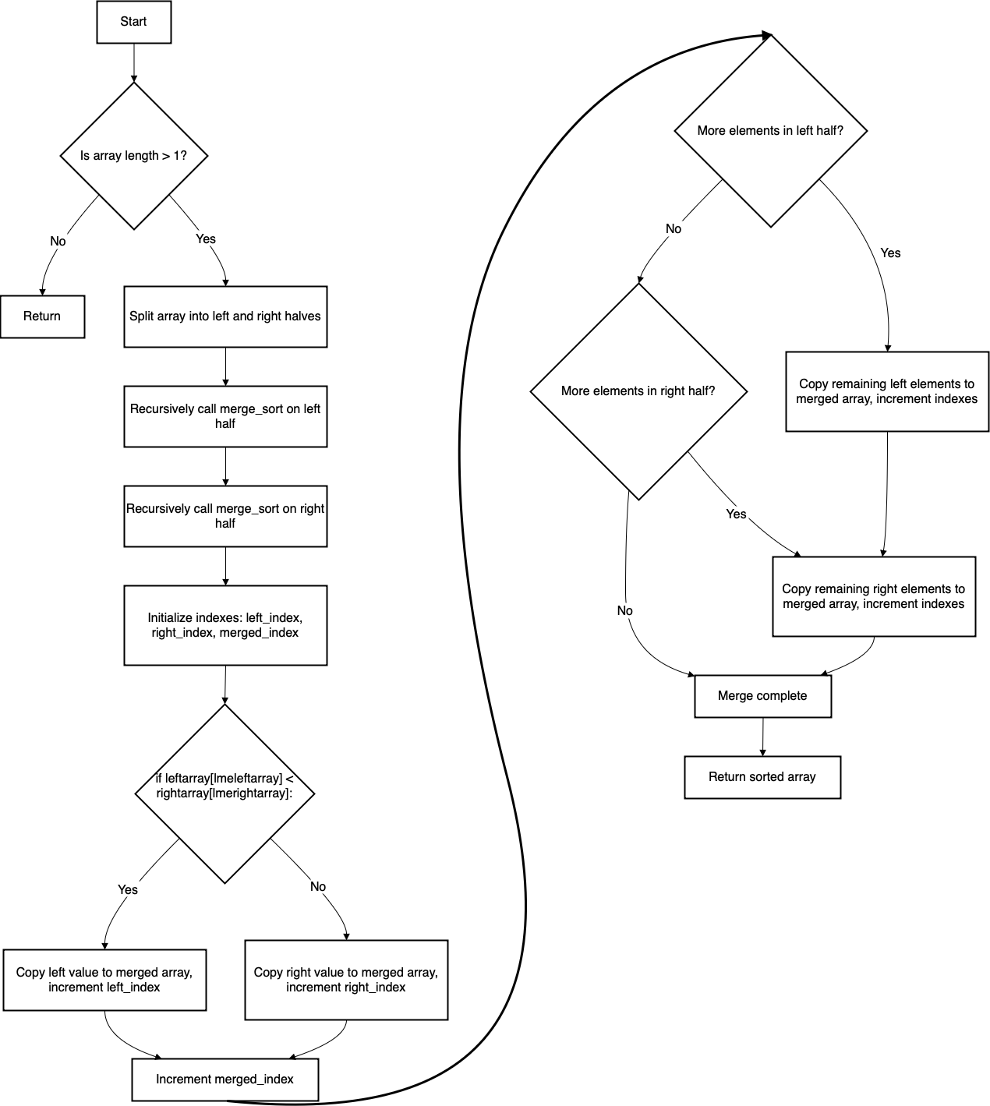

Regular Expressions
For the Validation of many input fields, regular expressions will be used, to ensure that information that is entered by the user follows the correct formatting. The following types of fields will be validated using regular expressions, Valid Dates following (DD/MM/YYYY), Valid UK postcodes, Valid First Names and Surnames, and Valid Email Addresses. This validation method works by applying the input to be checked, against the regular expression for its target field, it works through the input character by character and tries all possible acceptance regions of the regular expression, if all acceptance regions fail, it iterates to the second character. This process repeats itself till all characters have been iterated through.

Date Validation Pseudocode
def validatedate(self,date):
# Define the regex pattern for Date Validation
pattern = r'^(0[1-9]|[12][0-9]|3[01])/(0[1-9]|1[0-2])/(19[0-9]{2}|20[0-2][0-9])$'

# Use re.match to check if the input matches the pattern for date validation.
if re.match(pattern, dob):
return True
else:
return False

UK Postcode Validation PSEUDOCODE
def validatepostcode(self,dob):
# Define the regex pattern for UK Postcode validation
pattern = r'^([A-PR-UWYZ][A-HK-Y]?[0-9][0-9A-HJKMNP-Z]? ?[0-9][ABD-HJLNP-UW-Z]{2})$'

# Use re.match to check if the input matches the pattern
if re.match(pattern, dob):
return True
else:
return False

First Name and Surname Validation PSEUDOCODE
def validatenames(self,name):
# Define the regex pattern for name validation
pattern = r'^[A-Za-z]+$'

# Use re.match to check if the name matches the pattern
if re.match(pattern, name):
return True
else:
return False

Email Address Validation PSEUDOCODE
def validate_email(self,email):
# Define the regex pattern for email validation
pattern = r'^[a-zA-Z0-9_.+-]+@[a-zA-Z0-9-]+\.[a-zA-Z0-9-.]+$'

# Use re.match to check if the email matches the pattern
if re.match(pattern, email):
return True
else:
return False

Description of Data Structures

IPSO Chart

Data Dictionary for each table
Table Name | admins
Primary Key | adminid
Foreign Keys
Data Item | Data Type | Validation | Sample Data
adminid | INTEGER | >0 | 1
username | TEXT | NotNull | James
password | TEXT | NotNull | 5e884898da28047151d0e5
emailaddress | TEXT | NotNull | James@gmail.com
accounttype | TEXT | NotNull | Administrator
firstname | TEXT | NotNull | James
surname | TEXT | NotNull | Smith
dob | DATE | NotNull | 12/05/2004
sex | CHAR | NotNull | Male
postcode | TEXT | NotNull | LE2 5TP

Table Name | students
Primary Key | studentid
Foreign Keys | instructorid
Data Item | Data Type | Validation | Sample Data
studentid | INTEGER | >0 | 1
username | TEXT | NotNull | James
password | TEXT | NotNull | 5e884898da28047151d0e5
emailaddress | TEXT | NotNull | James@gmail.com
accounttype | TEXT | NotNull | Administrator
firstname | TEXT | NotNull | James
surname | TEXT | NotNull | Smith
dob | DATE | NotNull | 12/05/2004
sex | CHAR | NotNull | Male
postcode | TEXT | NotNull | LE2 5TP
instructorid | INTEGER | >0 | 2

Table Name | instructors
Primary Key | instructorid
Foreign Keys
Data Item | Data Type | Validation | Sample Data
instructorid | INTEGER | >0 | 1
username | TEXT | NotNull | James
password | TEXT | NotNull | 5e884898da28047151d0e5
emailaddress | TEXT | NotNull | James@gmail.com
accounttype | TEXT | NotNull | Administrator
firstname | TEXT | NotNull | James
surname | TEXT | NotNull | Smith
dob | DATE | NotNull | 12/05/2004
sex | CHAR | NotNull | Male
postcode | TEXT | NotNull | LE2 5TP

Table Name | bookings
Primary Key | bookingid
Foreign Keys | studentid, instructorid
Data Item | Data Type | Validation | Sample Data
bookingid | INTEGER | >0
date | DATE | NOTNULL
time | TIME | NOTNULL
studentid | INTEGER | NOTNULL
instructorid | INTEGER | NOTNULL
startpostcode | TEXT | NOTNULL
endpostcode | TEXT | NOTNULL

OOP Class Diagram

Database Design

PRE-NORMALISED ENTITY RELATIONSHIP DIAGRAM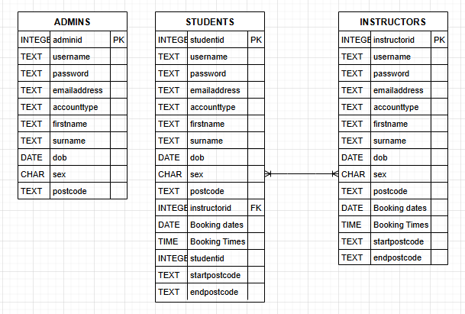
This pre-normalised approach breaks many rules a normalised database follows:
All columns do not contain atomic values, with booking dates and booking times containing multiple values.
There are repeating groups also across tables, with booking dates and booking times being repeated.
There are many-to-many relationships

Post-normalised Proposed entity relationship diagram
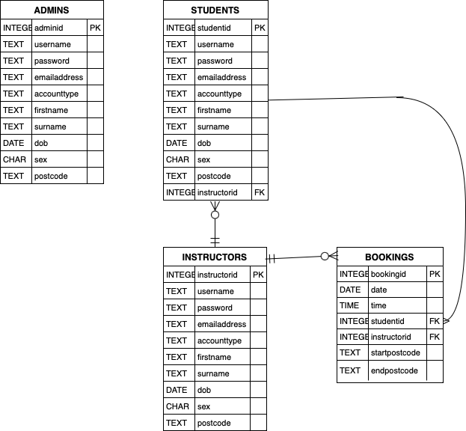
This approach is fully normalised, making it more functional, more efficient and better to implement into the system. It removes non atomic data and a many-to-many relationship with a singular linking ‘bookings’ table. This also reduces the amount of data the database is required to store as data is repeated much less.

SQL STATEMENTS

Data Definition Language (DDL)
CREATE TABLE IF NOT EXISTS "admins" (
"adminid" INTEGER,
"username" TEXT NOT NULL,
"password" TEXT NOT NULL,
"emailaddress" TEXT NOT NULL,
"accounttype" TEXT NOT NULL,
"firstname" TEXT NOT NULL,
"surname" TEXT NOT NULL,
"dob" DATE NOT NULL,
"sex" CHAR NOT NULL,
"postcode" TEXT NOT NULL,
PRIMARY KEY("adminid" AUTOINCREMENT)

The ‘admins’ table is used to hold all data/information about admins.

This transaction creates the admins table. It contains the primary key adminid which is also set to autoincrement ensuring upon account creation, each admin has a unique identifier. This identifier is also useful as it can be used to measure when an account was created.
CREATE TABLE IF NOT EXISTS "instructors" (
"instructorid" INTEGER,
"username" TEXT NOT NULL,
"password" TEXT NOT NULL,
"emailaddress" TEXT NOT NULL,
"accounttype" TEXT NOT NULL,
"firstname" TEXT NOT NULL,
"surname" TEXT NOT NULL,
"dob" DATE NOT NULL,
"sex" CHAR NOT NULL,
"postcode" TEXT NOT NULL,
PRIMARY KEY("instructorid" AUTOINCREMENT)
The ‘instructors’ table is used to hold all data/information about instructors.
This transaction creates the ‘instructors’ table. It contains the primary key ‘instructorid’ which is also set to autoincrement ensuring upon account creation, each instructor has a unique identifier. This identifier is also useful as it can be used to measure when an account was created. This will be helpful when filtering accounts within other functions of the program. For example, sort by account creation.

CREATE TABLE IF NOT EXISTS "students" (
"studentid" INTEGER,
"username" TEXT NOT NULL,
"password" TEXT NOT NULL,
"emailaddress" TEXT NOT NULL,
"accounttype" TEXT NOT NULL,
"firstname" TEXT NOT NULL,
"surname" TEXT NOT NULL,
"dob" DATE NOT NULL,
"sex" CHAR NOT NULL,
"postcode" TEXT NOT NULL,
"instructorid" INTEGER NOT NULL,
PRIMARY KEY("studentid" AUTOINCREMENT),
FOREIGN KEY("instructorid") REFERENCES "instructors"("instructorid")
The ‘students’ table is used to hold all data/information about students.
This transaction creates the ‘students’ table. It contains the primary key ‘studentid’ which is also set to autoincrement ensuring upon account creation, each instructor has a unique identifier. This identifier is also useful as it can be used to measure when an account was created. It also contains the foreign key ‘instructorid’ this is in order to link the student to an instructor.

CREATE TABLE IF NOT EXISTS "bookings" (
"bookingid" INTEGER,
"date" DATE NOT NULL,
"time" TIME NOT NULL,
"studentid" INTEGER NOT NULL,
"instructorid" INTEGER NOT NULL,
"startpostcode" TEXT NOT NULL,
"endpostcode" TEXT NOT NULL,
PRIMARY KEY("bookingid" AUTOINCREMENT),
FOREIGN KEY("instructorid") REFERENCES "instructors"("instructorid"),
FOREIGN KEY("studentid") REFERENCES "students"("studentid")
This transaction creates the ‘bookings’ table. This table holds all information about a particular booking/lesson. It contains the primary key ‘bookingid’ which is also set to autoincrement ensuring upon account creation, each instructor has a unique identifier. It also contains multiple foreign keys ‘instructorid’ and ‘studentid’ this is to link the each booking a specific student and instructor.

Data Manipulation Language (DML)
The following data manipulation language statements all use parameterised SQL. It is important that parameterised SQL practices are used to prevent an SQL injection attack. An SQL injection attack occurs where the user input SQL commands to execute unauthorised transactions on the database. Parameterised SQL prevents an SQL injection attack. The Parameterized SQL prevents SQL injection by keeping user input separate from the SQL query structure, ensuring that input is treated as data/values rather than executable code.
("SELECT * FROM instructors
WHERE username = ? AND password = ?", (username, hashed_password))

This statement simply selects the entire record from the instructors table where the username and password match what the user has entered. This is used to fetch data to validate an instructor login.
("SELECT * FROM students
WHERE username = ? AND password = ?", (username, hashed_password))
This statement simply selects the entire record from the students table where the username and password match what the user has entered. This is used to fetch data to validate a student login.
("SELECT * FROM admins
WHERE username = ? AND password = ?", (username, hashed_password))
This statement simply selects the entire record from the admins table where the username and password match what the user has entered. This is used to fetch data to validate a admin login.

(“SELECT
bookingid,
date,
time,
(SELECT username FROM students WHERE students.studentid = bookings.studentid),
(SELECT username FROM instructors WHERE instructors.instructorid = bookings.instructorid),
startpostcode,
endpostcode
FROM bookings
WHERE date = ? AND instructorid = ?
", (self.selecteddate, selectedinstructorid))

This statement simply selects the booking/lesson details from the ‘bookings’ table where the date and instructor match what the user has inputted. This is used to fetch the data for all bookings for a certain instructor on a given date. This statement however differs from the other DML statements above as it uses cross-table SQL statements. To simplify the details for the user, the statement above rather than fetching ‘studentid’ and ‘instructorid’, selects the username from the corresponding ‘students’ and ‘instructors’ tables and fetches and returns the student username and instructor username instead. This makes it easier for the user to understand who the corresponding student and instructor is for a given lesson.

('UPDATE students
SET password = ?
WHERE emailaddress = ?', (hashed_password, self.to_mail))
This statement is used to update the password for a student, via the change password feature. This will only be updated once the user has verified themselves, via email.

Data Flow Diagrams

Ss

Design of User Interface

Main Screen
Below is the Main Menu that the user is greeted with upon the launch of the program.
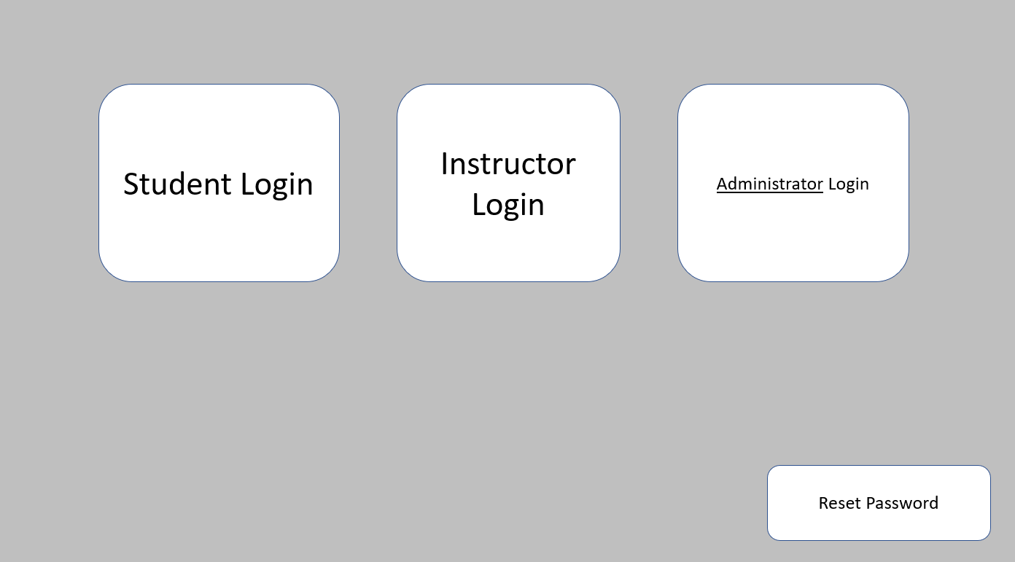
Below is the Student Portal that the student is greeted with upon login.
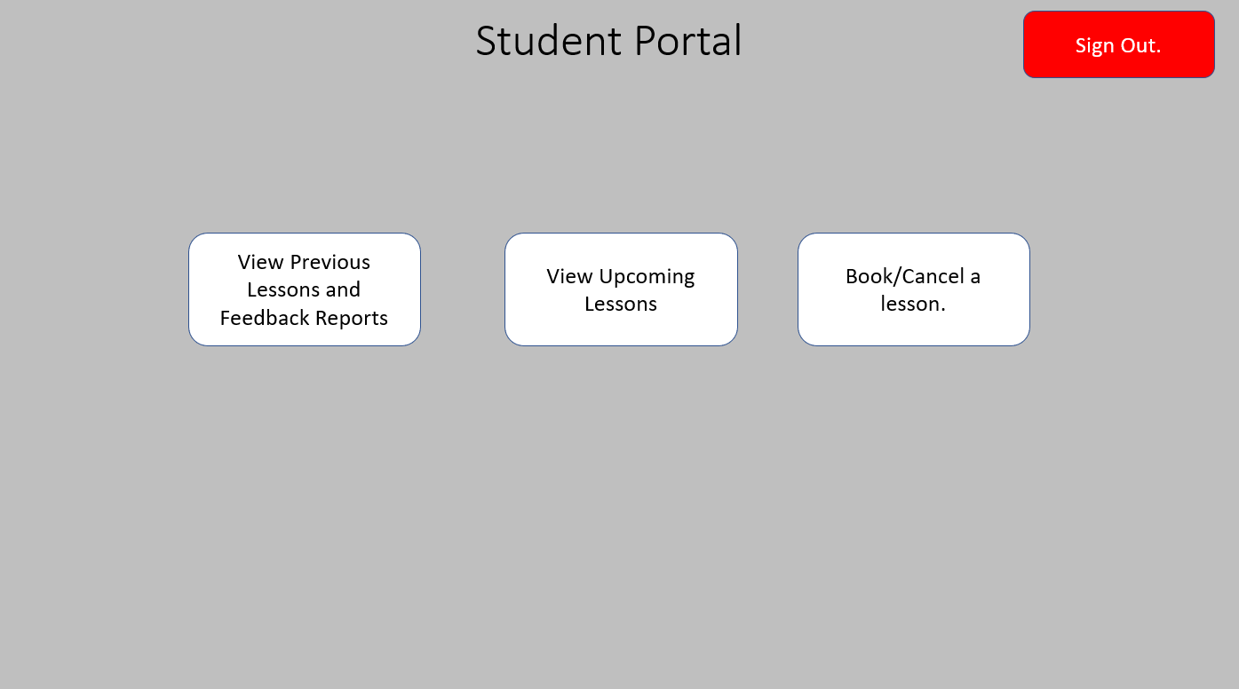

Below is the Instructor Portal that the instructor is greeted with upon login.
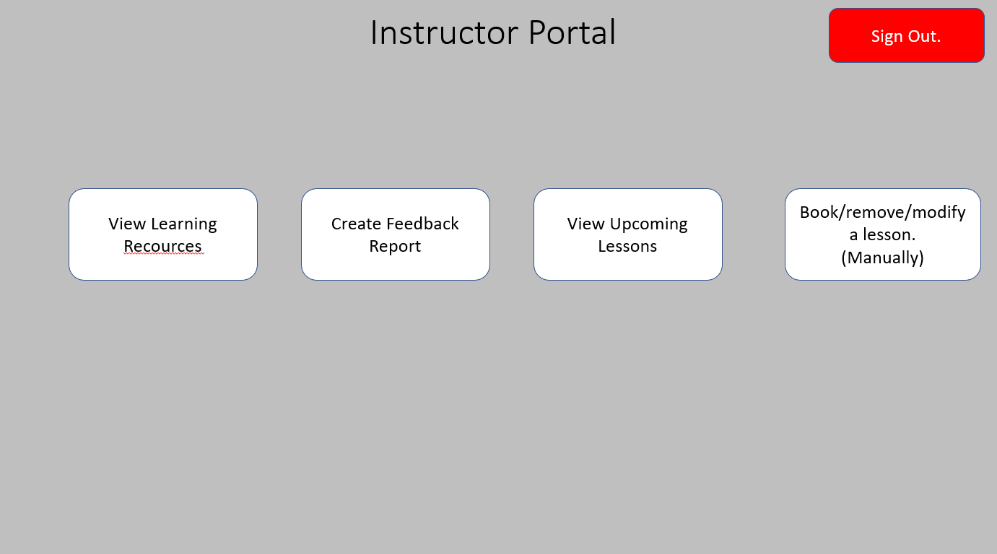
Below is the Administrator Portal that the administrator is greeted with upon login.
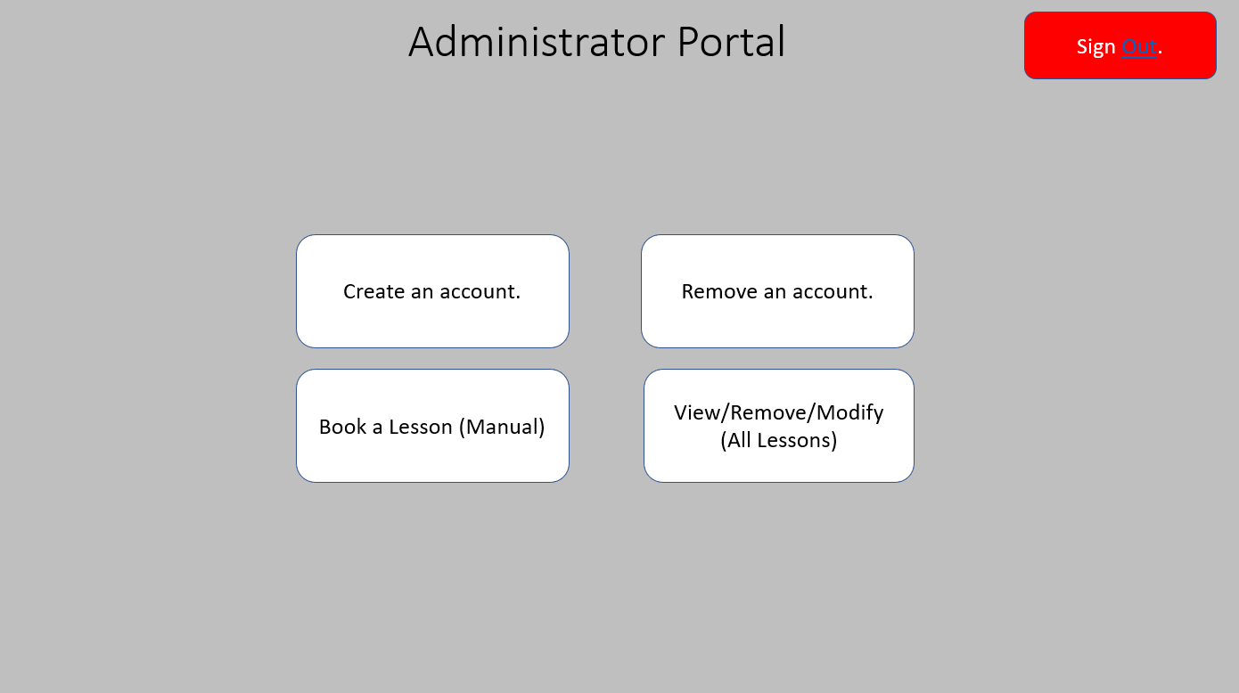

Sub Screens
When the student, clicks the ‘View Previous Lessons and Feedback Reports’ button they are presented with:
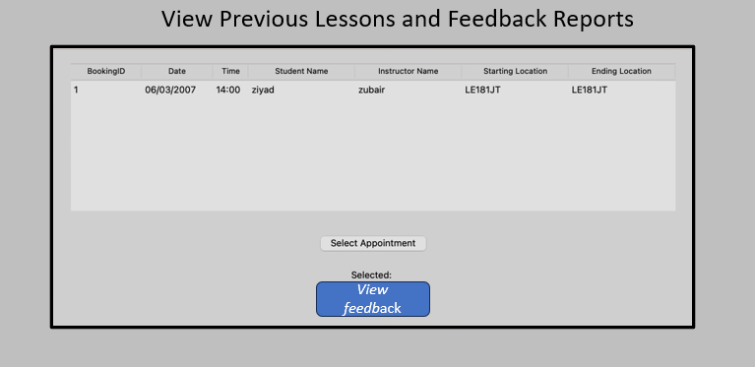
When the student, clicks the ‘View Upcoming Lessons’ button they are presented with:
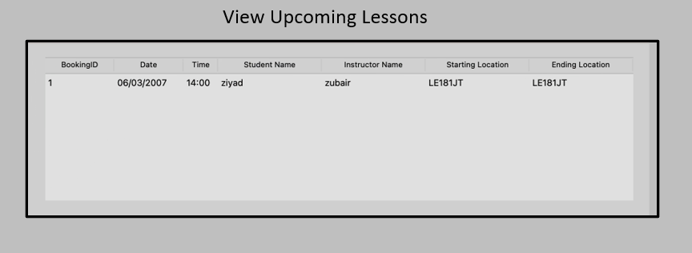

When the student, clicks the ‘Book/Cancel a lesson’ button they can access these submenu’s:
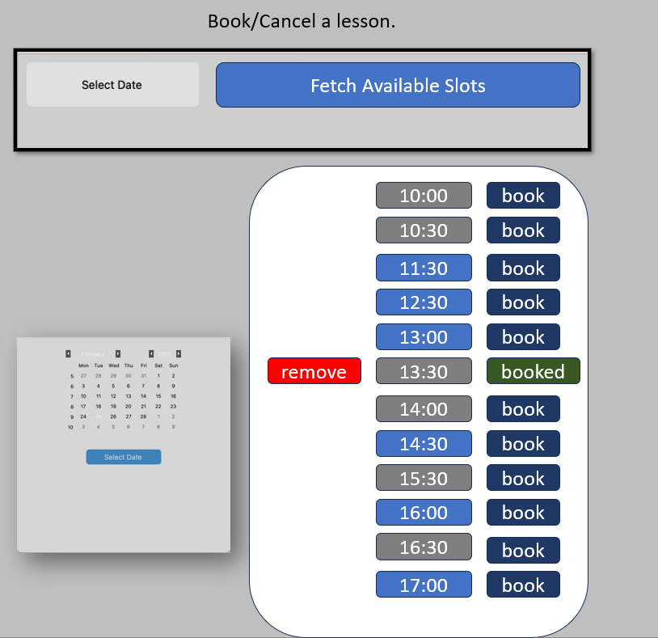
When the instructor, clicks the ‘View Learning Recourses’ button they can access this submenu:
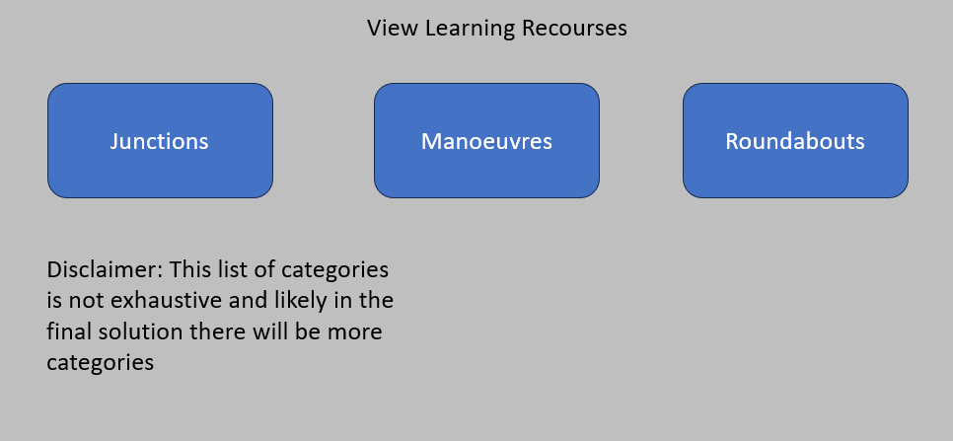

When the instructor, clicks the ‘Create Feedback Report’ button they can access this submenu/window:
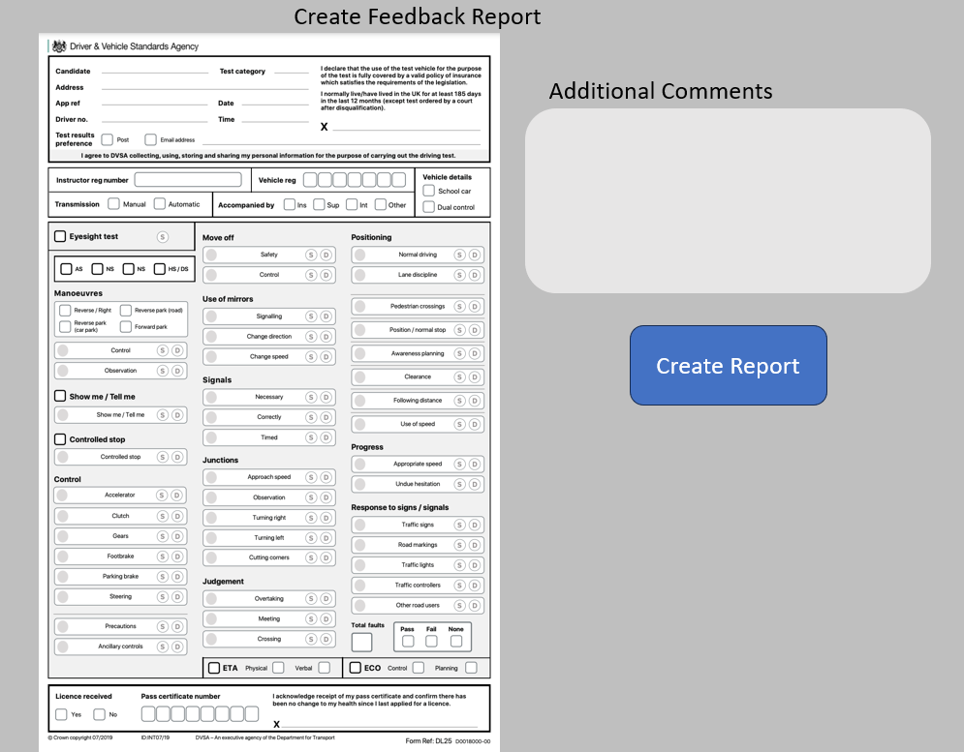
When the instructor, clicks the ‘View Upcoming Lessons’ button they can access this submenu/window:
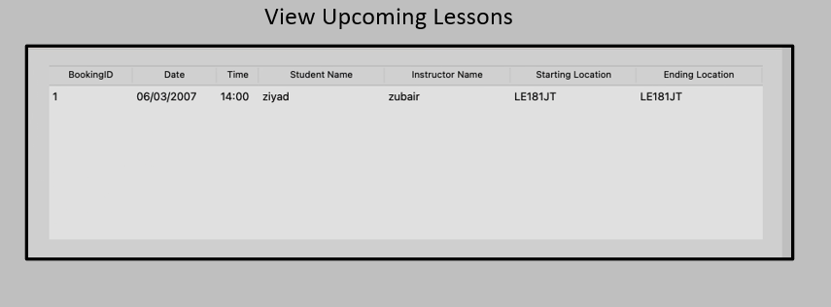

When the instructor, clicks the ‘Book/remove/modify a lesson (Manually)’ button they can access this submenu/window:
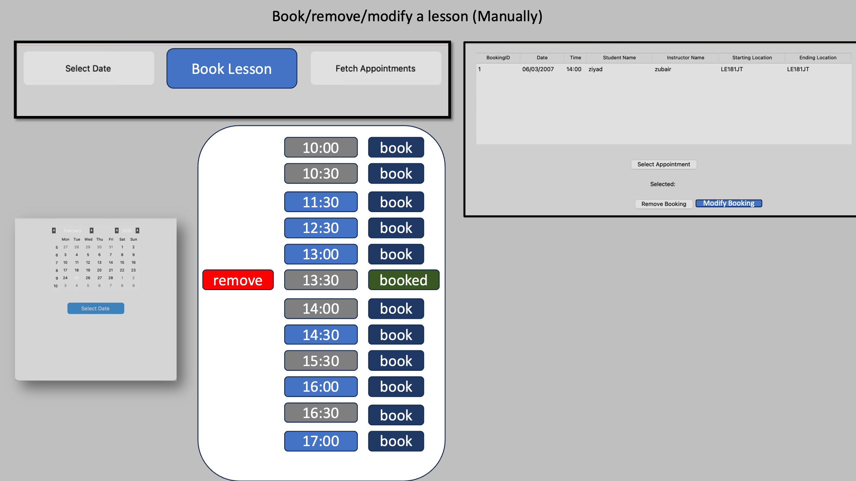

When an Administrator Clicks the ‘Create an Account Button’ the following is displayed:
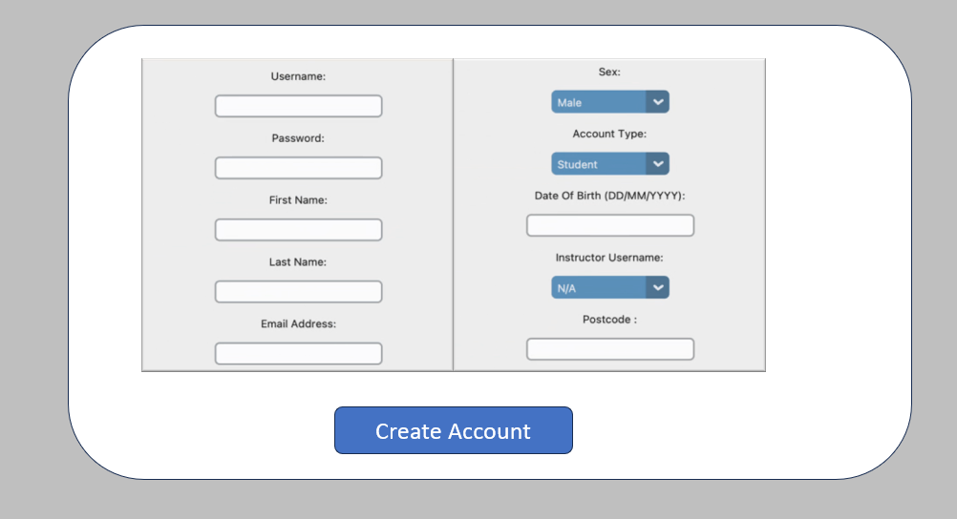

When an Administrator Clicks the ‘Remove an Account’ Button the following menus are displayed:
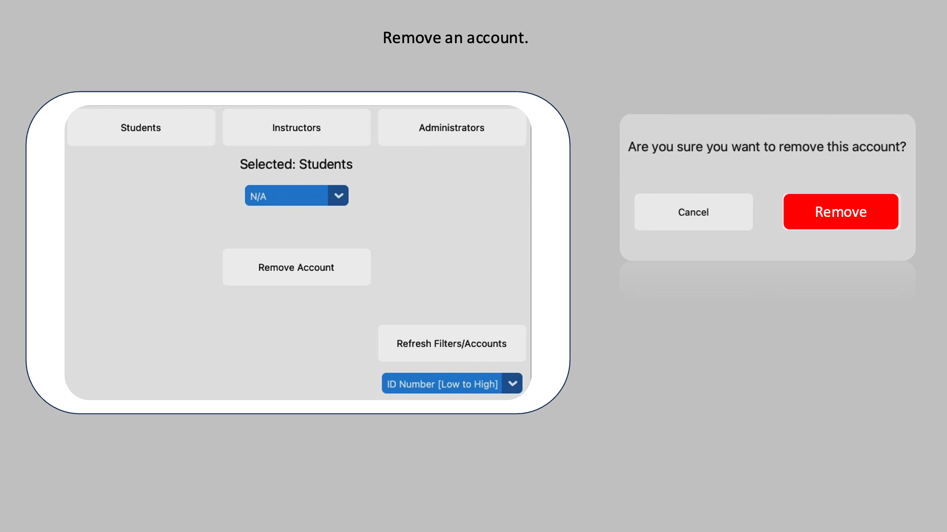
When an Administrator Clicks the ‘View/Remove/Modify (All Lessons)’ Button the following menus are displayed:
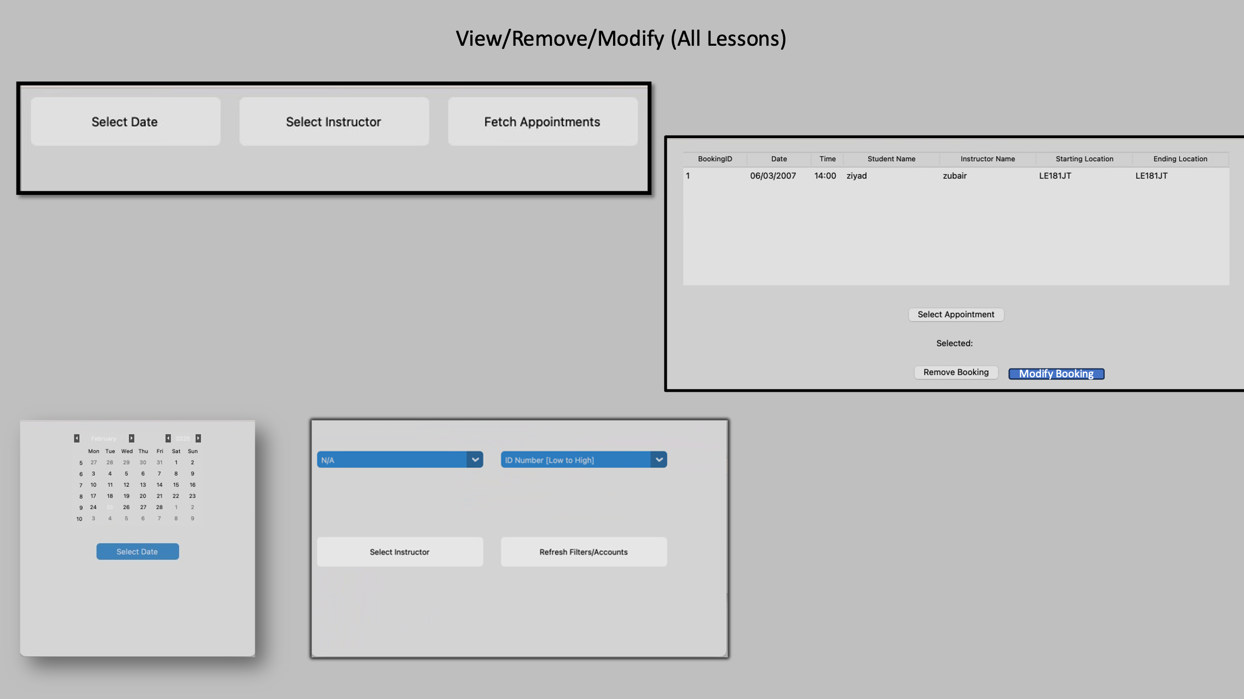

When an Administrator Clicks the ‘Book/remove/modify a lesson (Manually)’ Button the following menus are displayed:
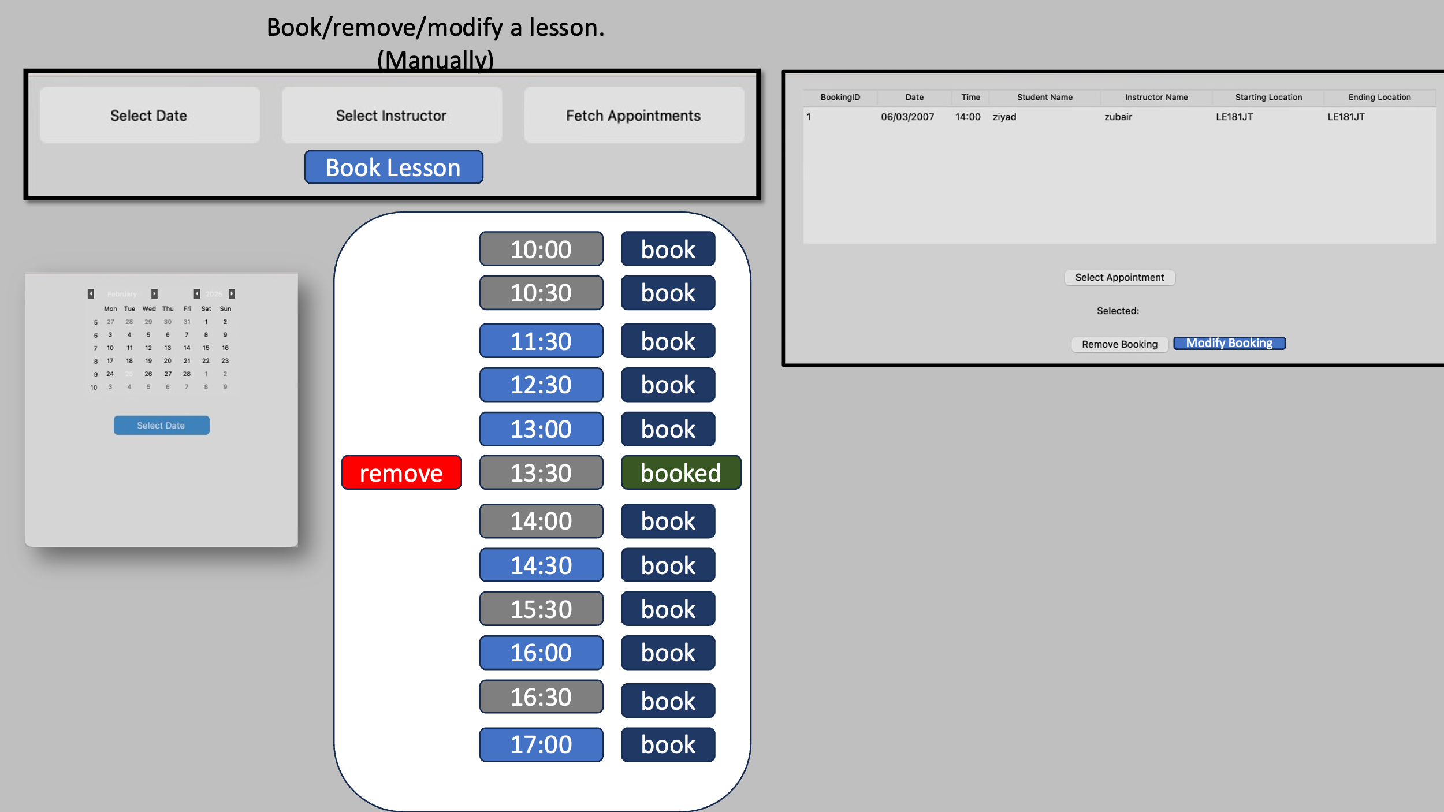

Use of Widgets
The Graphical User Interface will be made up of numerous widgets, both from the Tkinter and Custom Tkinter Libraries.
Widget Type 1: CTkButton
Throughout the program there will be various different buttons that the user can click to interact with. In order to accomplish this, using Custom Tkinter, we can use the CTKButton Widget. (Example Pictured Below)
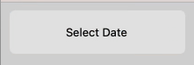
Since I would like for the program to follow a cohesive design language, I would like all of the buttons to use the same colours when hovered above, and interacted with. I would also like for them to use the same width and height cohesion and simpler aesthetics. As established by the interview with the client, the majority of those using the Driving Instructor Booking System will not be entirely computer literate therefore, simplifying the GUI, aims to bridge the gap for those with less computer experience. Therefore, expanding the potential users my application can cater to.
To prevent repetition for each instance a button is created, I will create a subroutine which creates the button with these set parameters.
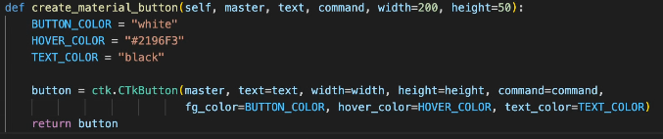
Widget Type 2: CTKEntry Widget
Throughout the program there will be various different fields that the user can input into. In order to accomplish this, using Custom Tkinter, we can use the CTKEntry Widget. (Example Pictured Below)
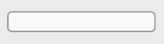
When entering non-sensitive information such as a username, when typing into the field the user will be able to what they are entering. However, when typing into a sensitive field, in the case of the Driving Instructor Booking System, passwords, the user will see ‘***’ for each character entered. This aims to improve security as it prevents ‘shoulder surfing’ attacks, where passwords are obtained by taking a glance whilst it is being entered.

Widget Type 3: CTKOptionMenu Widget
Throughout the program there will be various different dropdowns that the user can select options from. In order to accomplish this, using Custom Tkinter, we can use the CTKOptionMenu Widget. (Example Pictured Below)
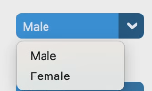
A dropdown menu ensures that the user is limited to what they can enter, and will work best in the following scenarios: Selecting Sex, Selecting Corresponding Instructor when creating an account, Selecting an account to delete, etc.
Widget Type 4: CTkCheckBox
Within the Feedback report menu, inspired by the DVSA’s marking sheet the instructor can tick faults that have occurred in the lesson. In order to accomplish this, using Custom Tkinter, we can use the CTkCheckBox Widget. (Example Pictured Below)
This shows the two states a checkbox can be in, on or off. These are particularly useful for emulating the ‘mock test feel’ for students and the instructor, and are more memory efficient as they can only store 2 states.

Aesthetics (look and feel) and suitability for user
As stated above, the most important aspect regarding aesthetics within this project is cohesion and consistency. In order to accomplish this, the majority of buttons will follow the same width, height, colour scheme, and hover colour.
The only exceptions will include, Sign Out buttons, and ‘Are you sure?’ buttons.
The application will follow a simple grey and white colour scheme, the background a light grey, the buttons a white colour. Upon hovering over each button, they will change to a blue.
This is helpful, as from the interview we have concluded that the program has to be as user friendly as possible, and buttons changing colour clearly indicates to the user that the button has a clear function.
I learned more about this design language, via this article
https://uxplanet.org/hover-effect-in-ui-design-tips-tricks-9c91d1a2bf22

One key aspect, I am prioritising the development of is a dynamically changing GUI, for the user depending on what user type they are. Below in my Annotated Initial Designs, it will be evident that the administrator has the most ‘complex’ user interface, with lots more submenus for more precise control over the program. This is because they are more likely to have had plenty experience with computers, and this therefore suits there needs more. Whereas the students and instructors have a simpler interface with less submenus. Again, the main reason I am emphasising on this when creating the GUI, is that the client has specifically stated that the majority of users will lack computer experience, and therefore the program needs to be able to tailor to them also.

Initial Designs with rationale annotated
Below are the initial designs for all Main menus and submenus completely annotated.
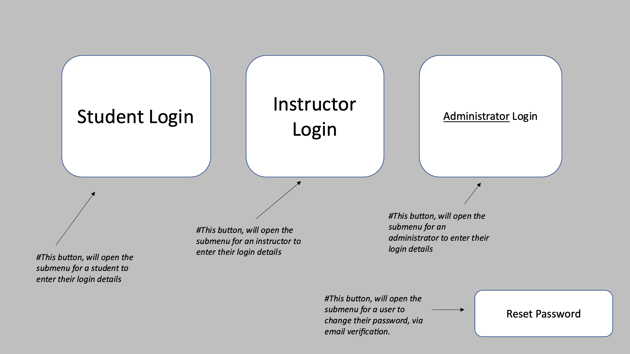
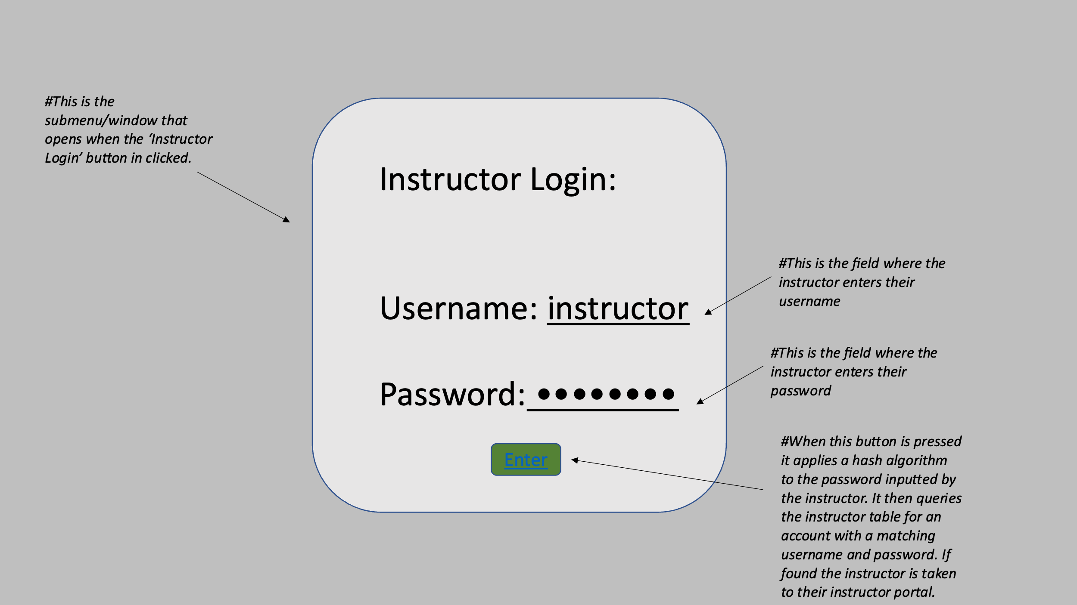
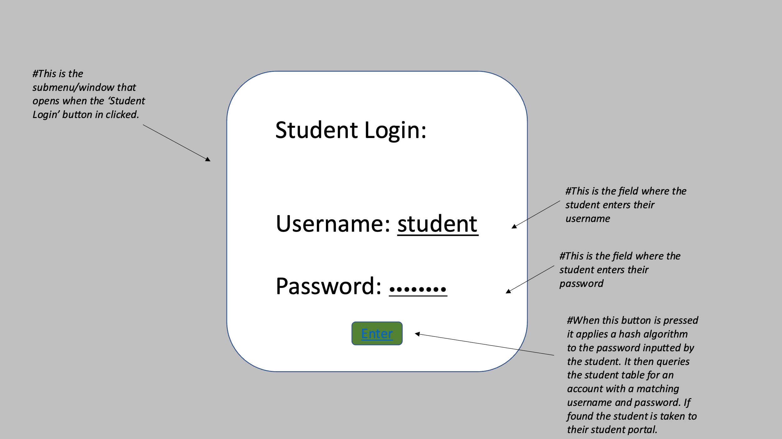
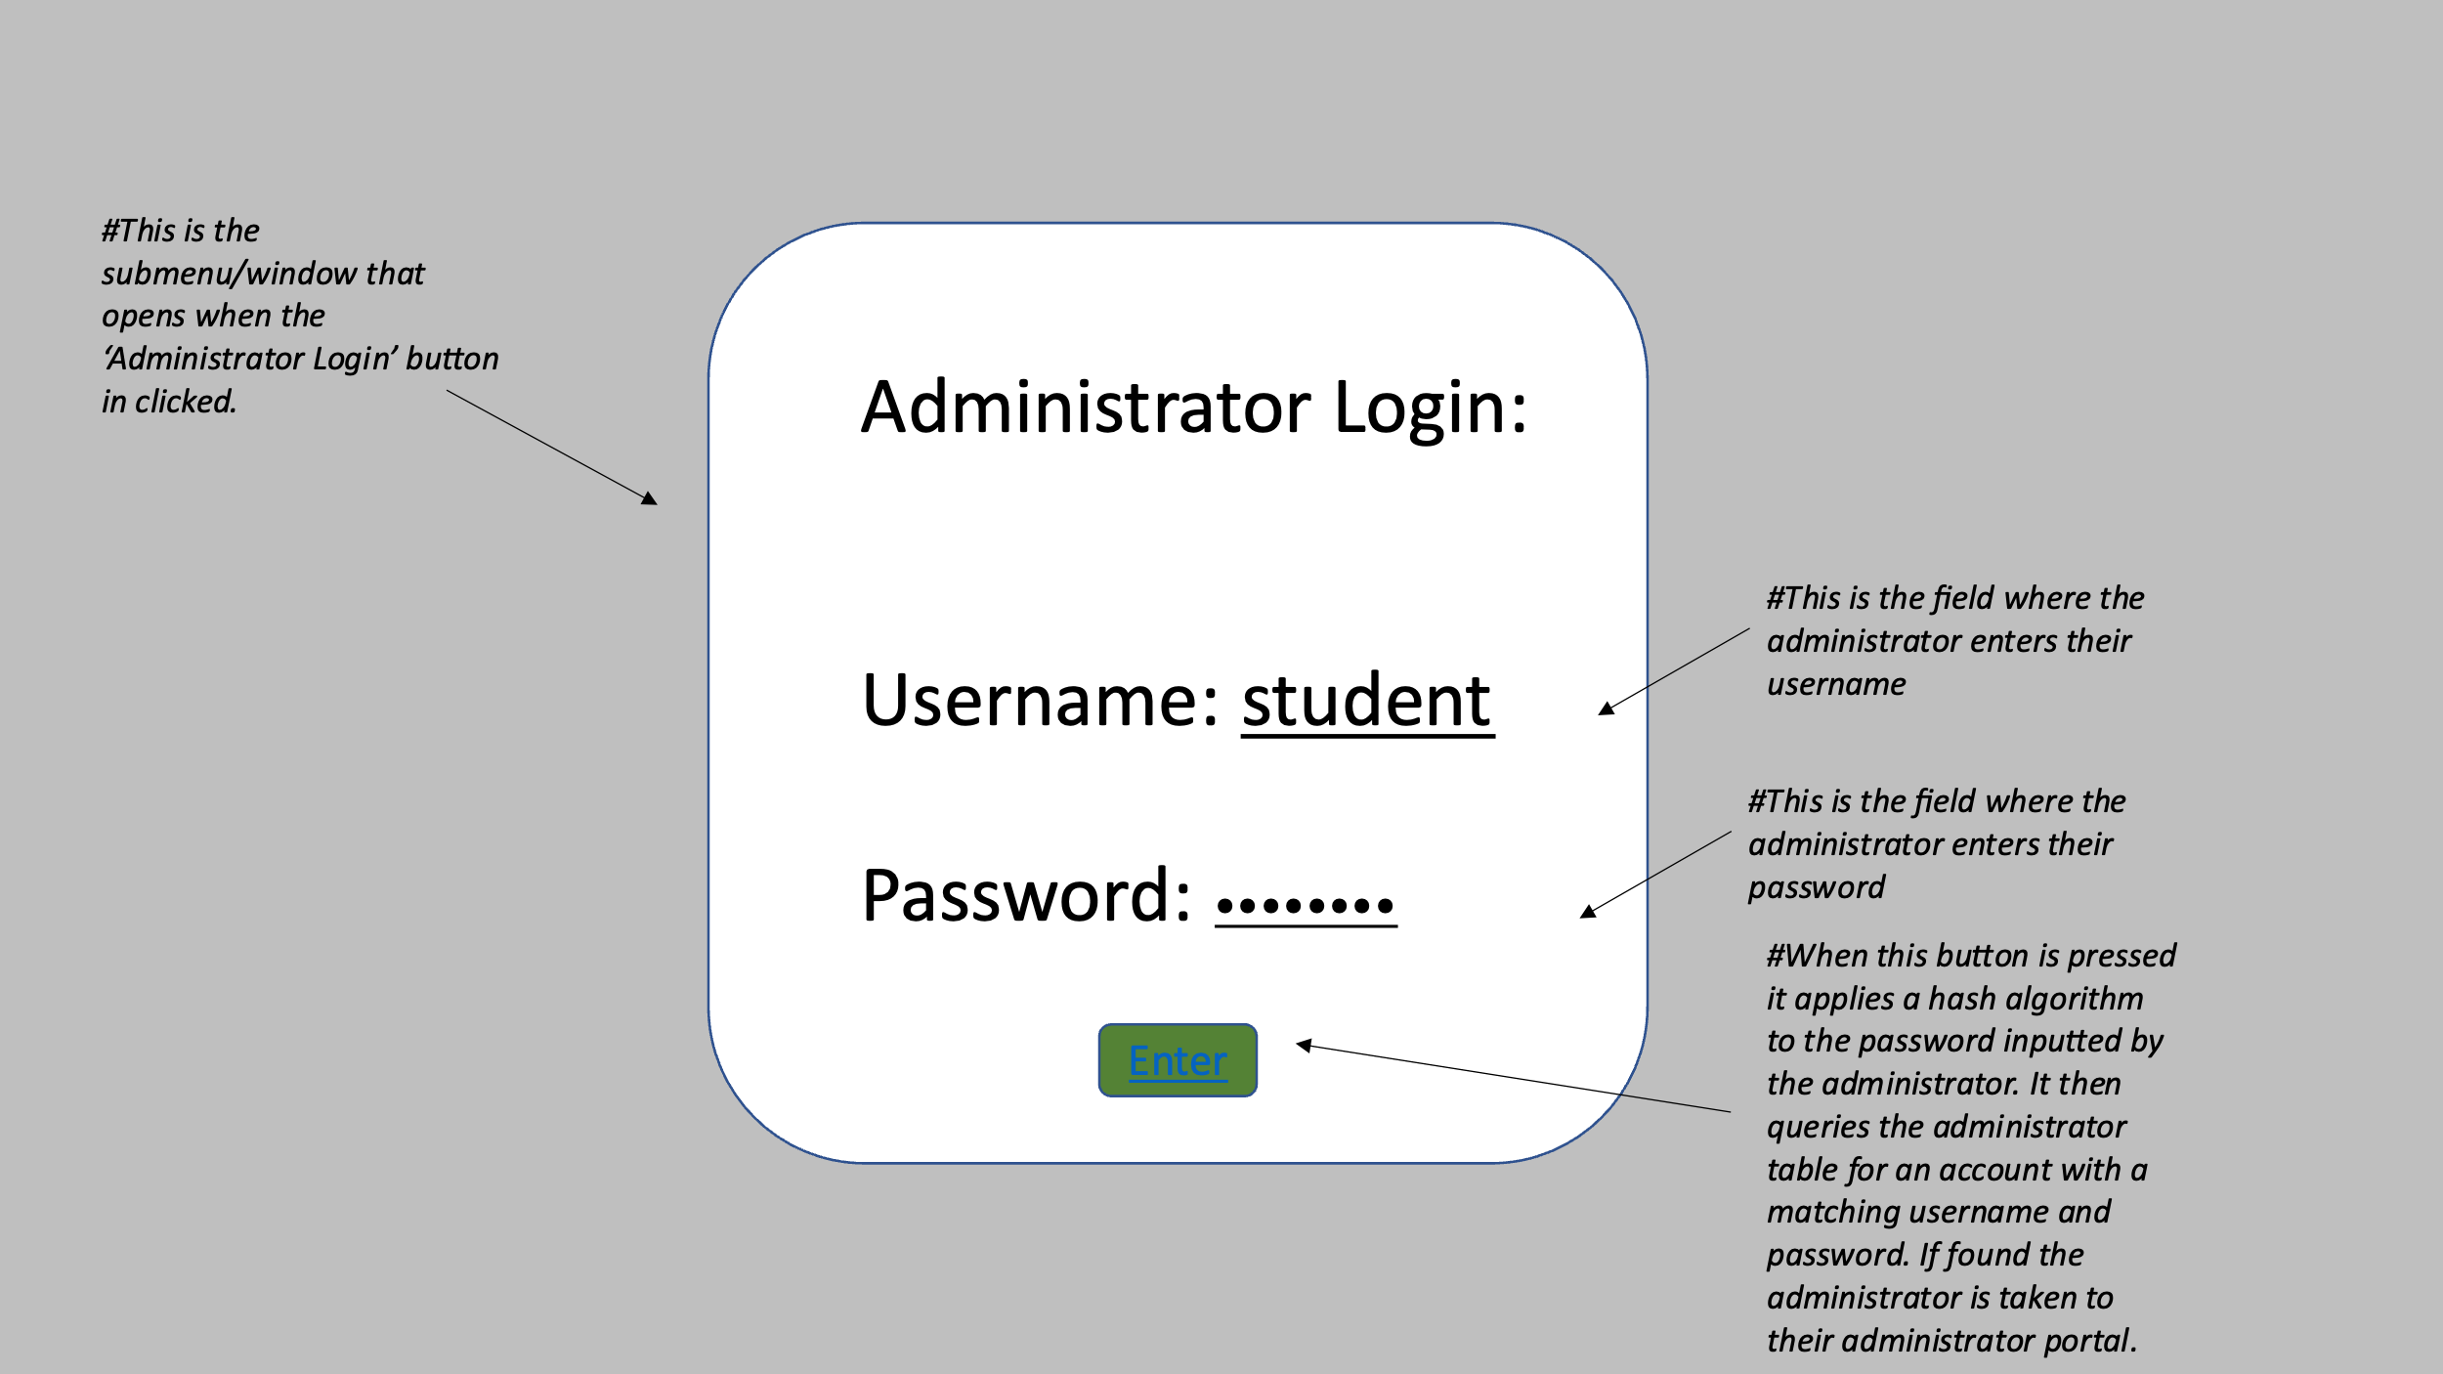
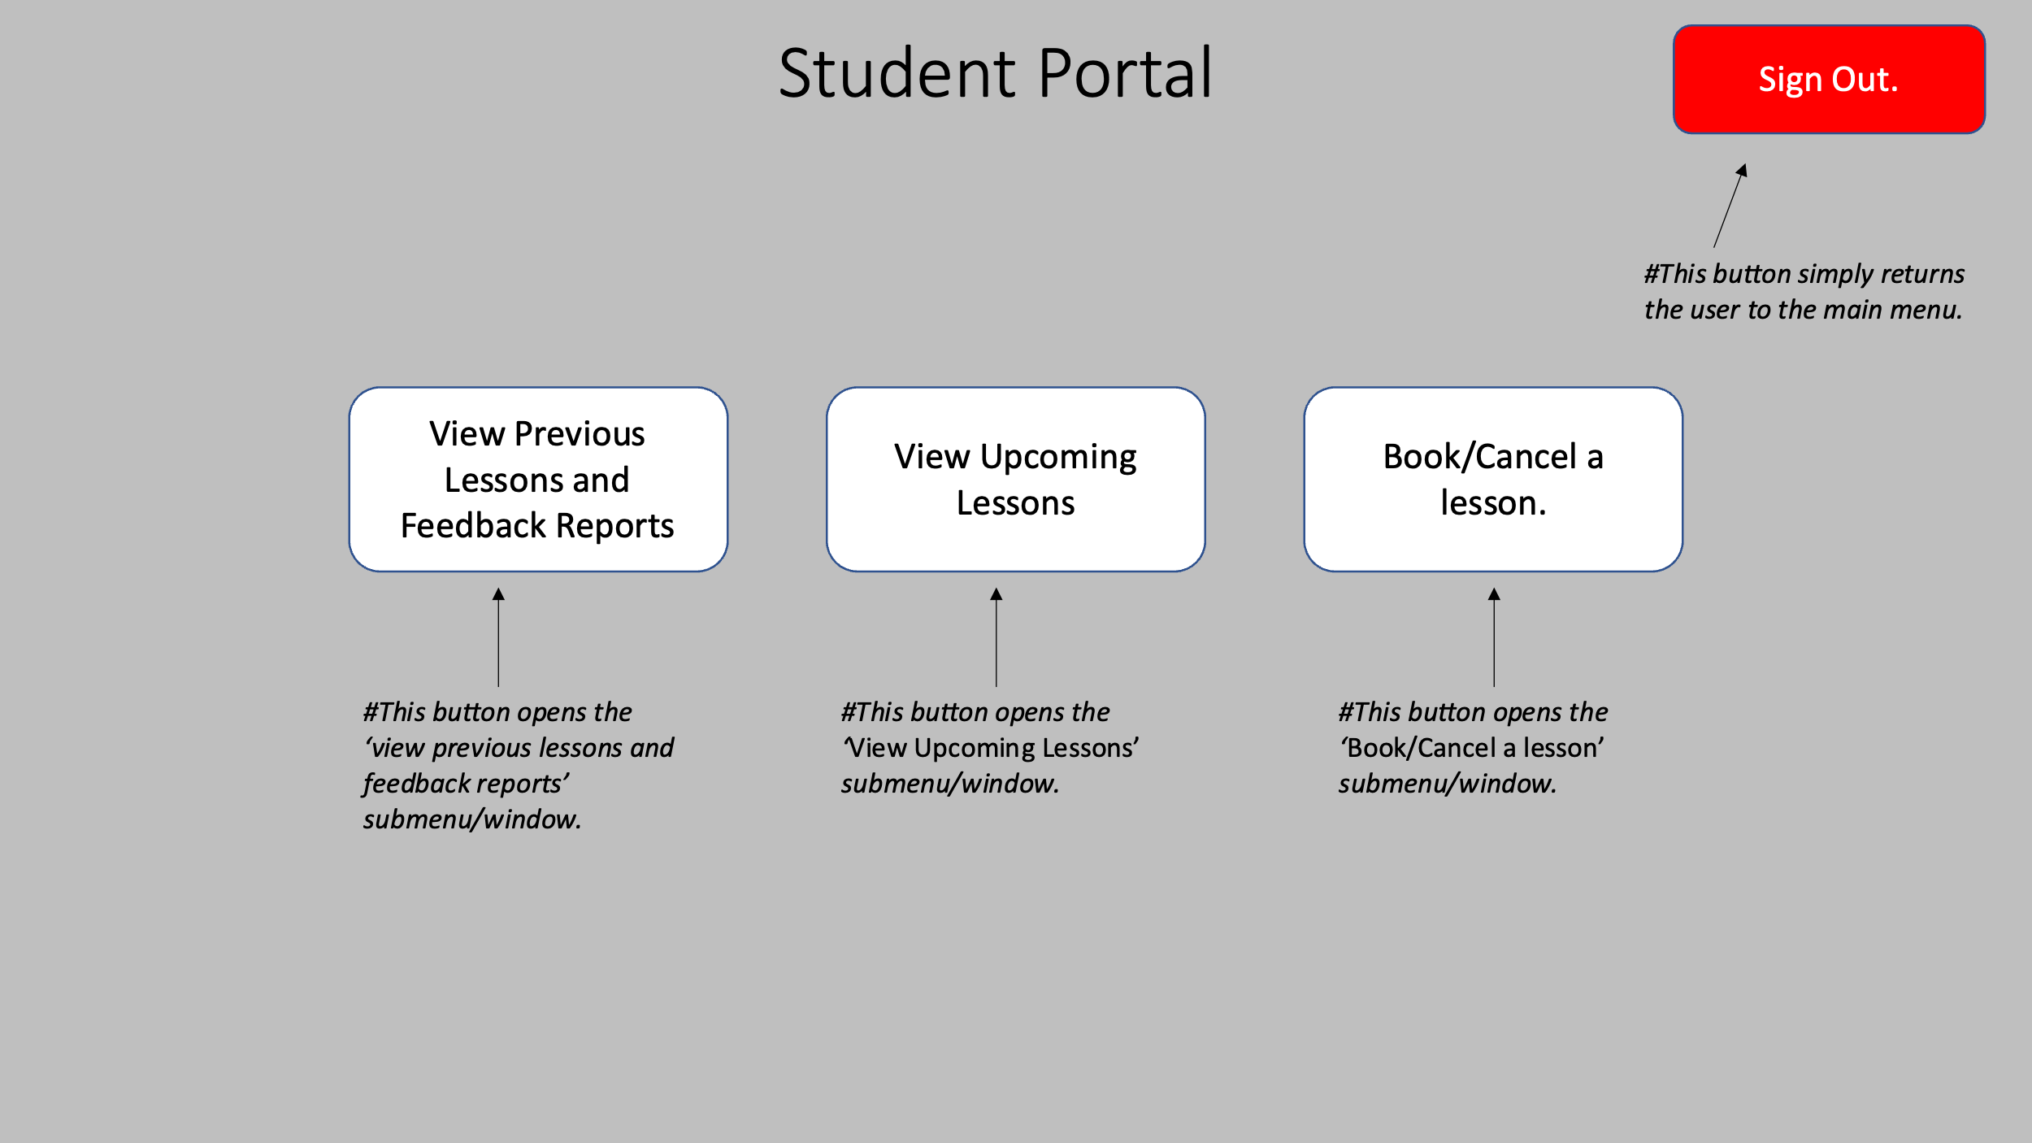
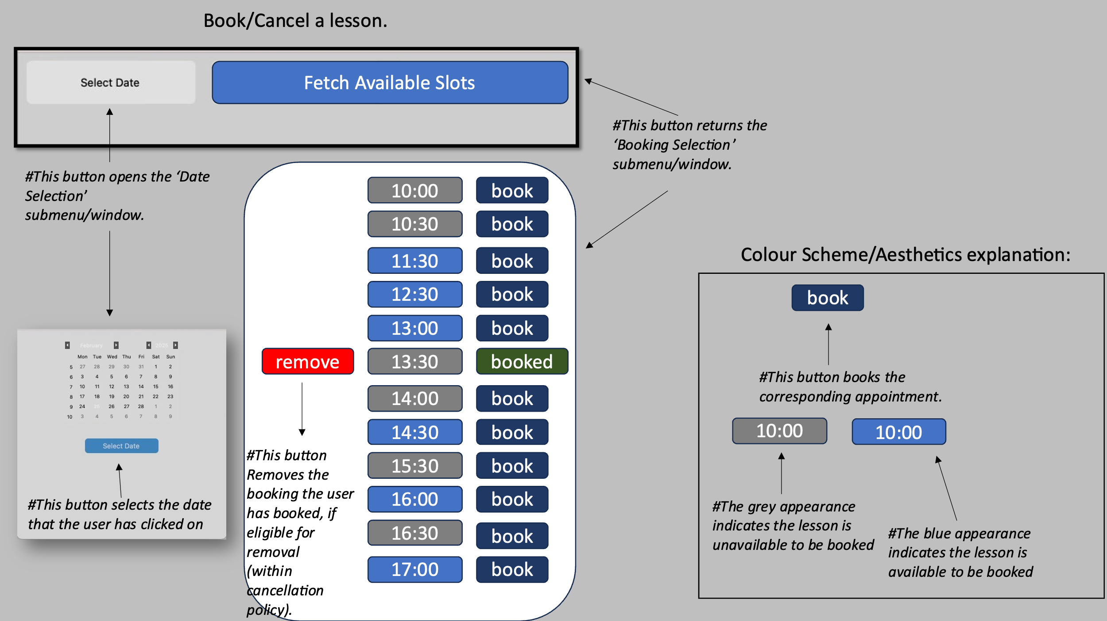
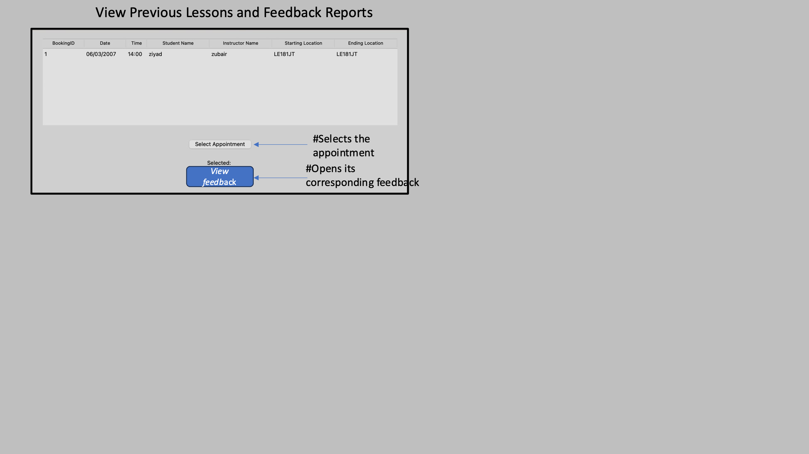
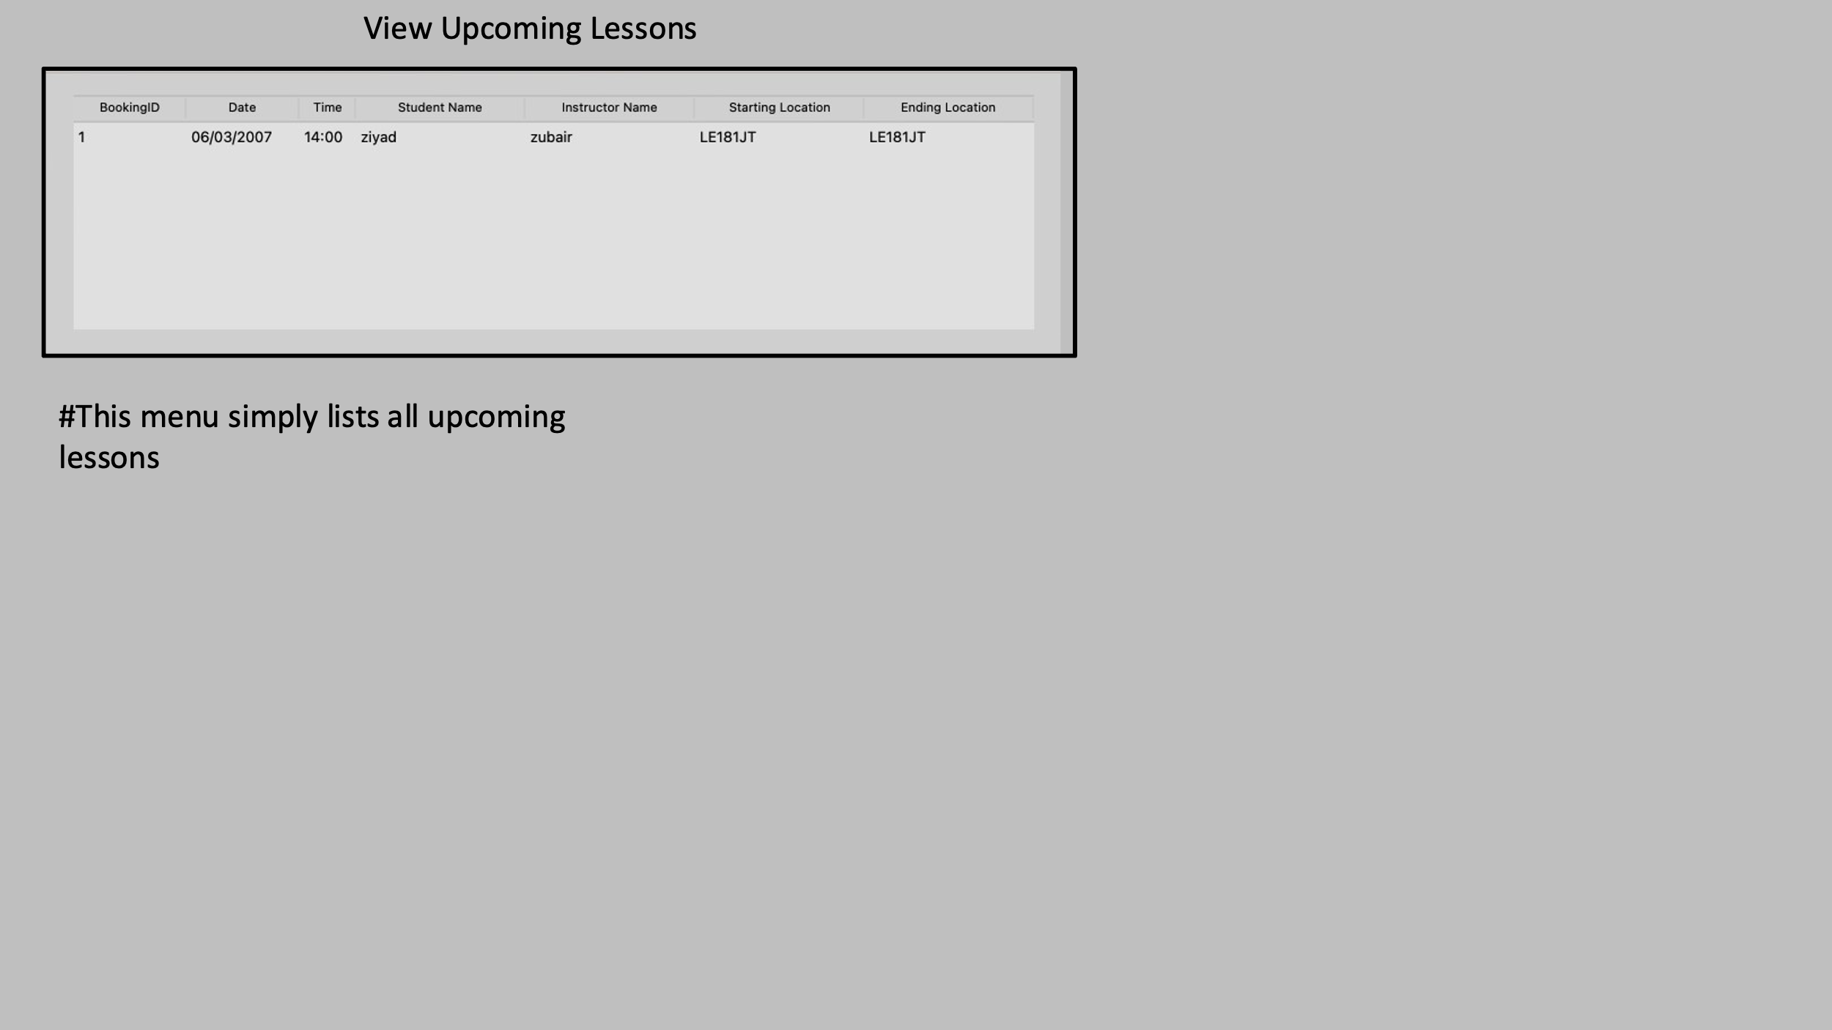
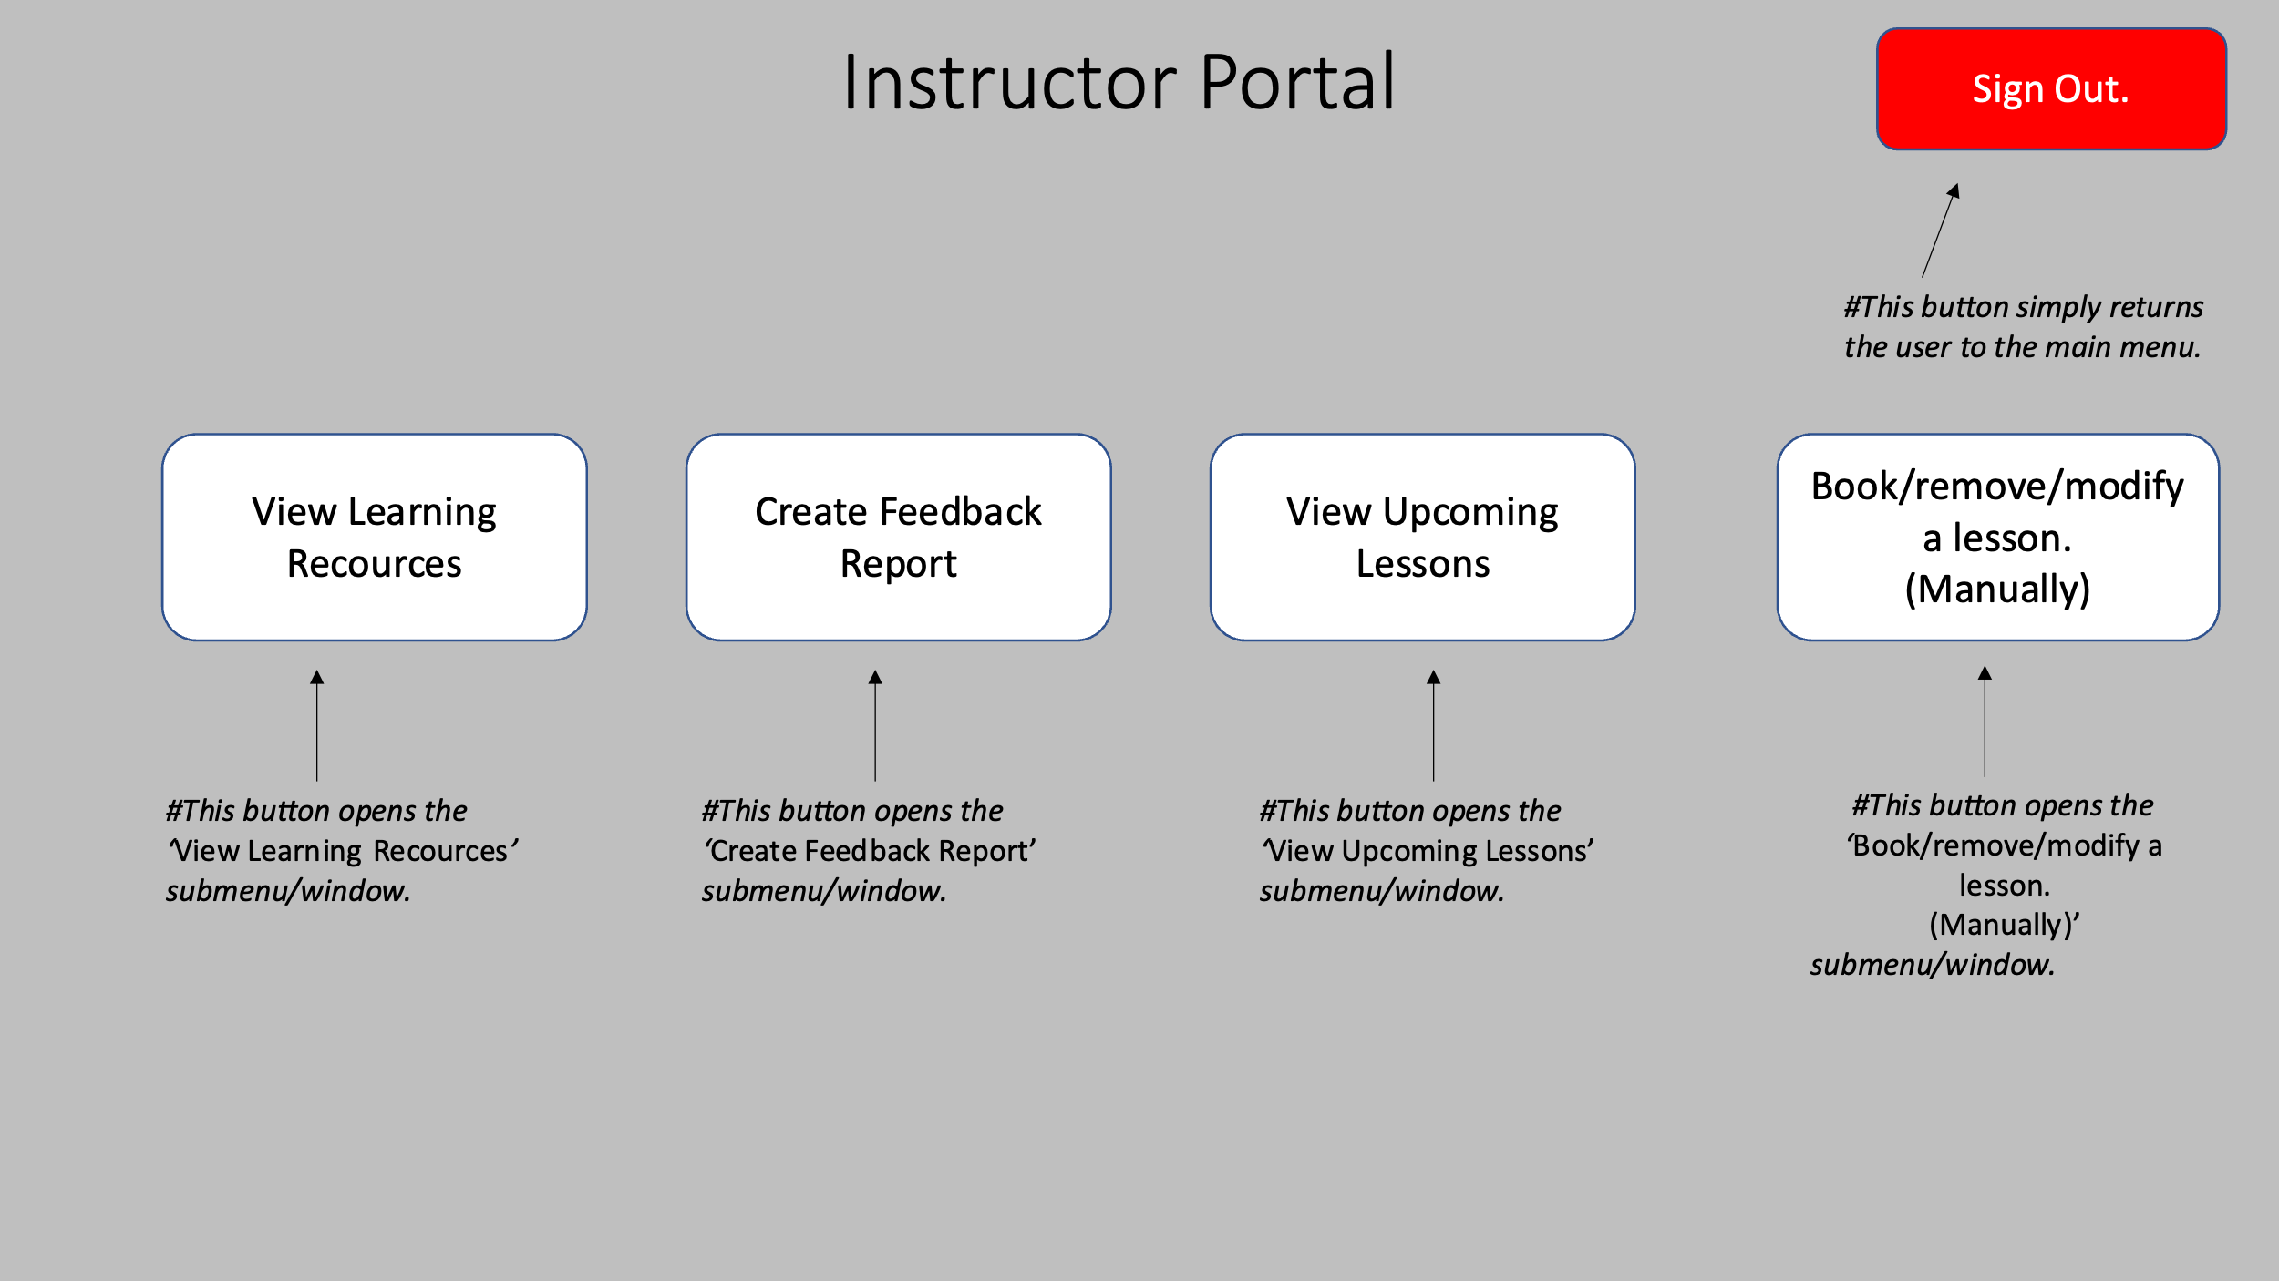
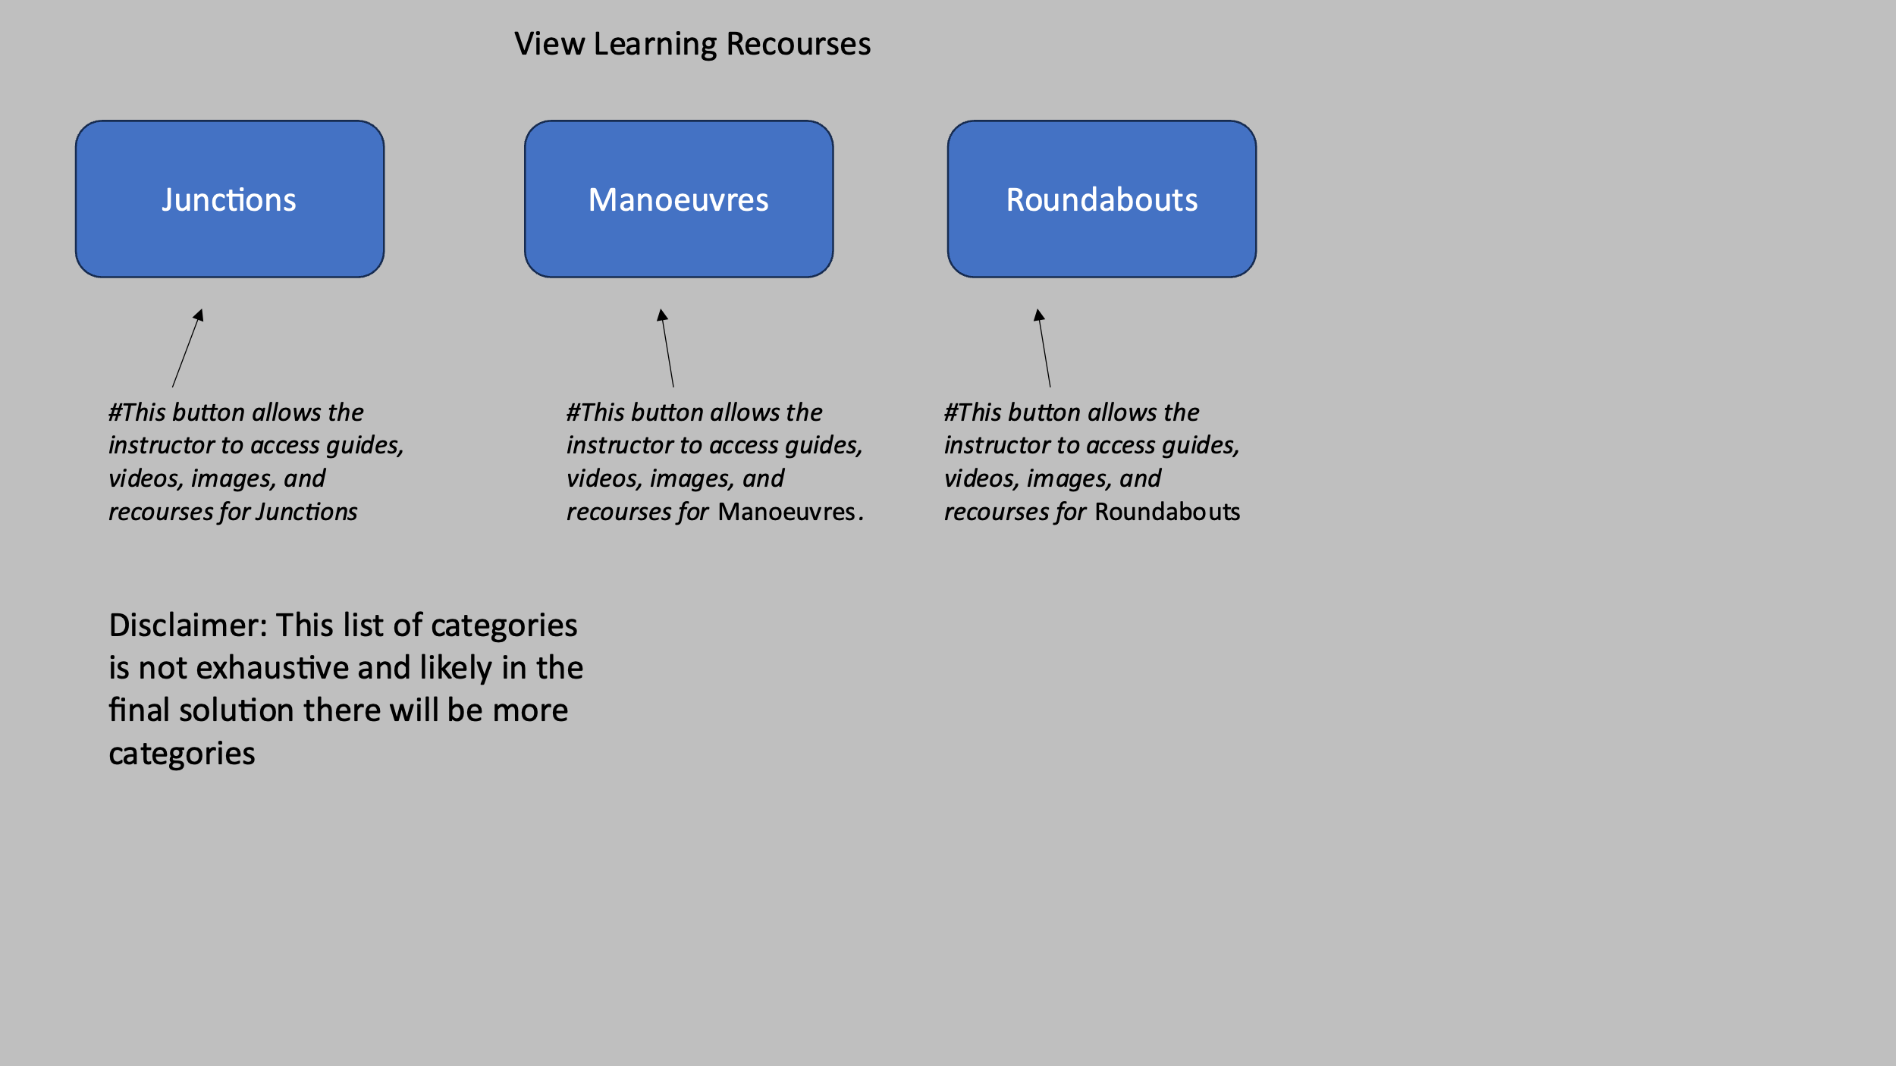
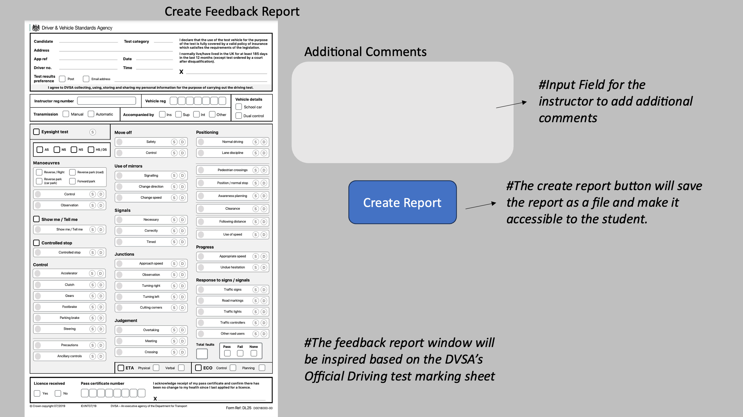
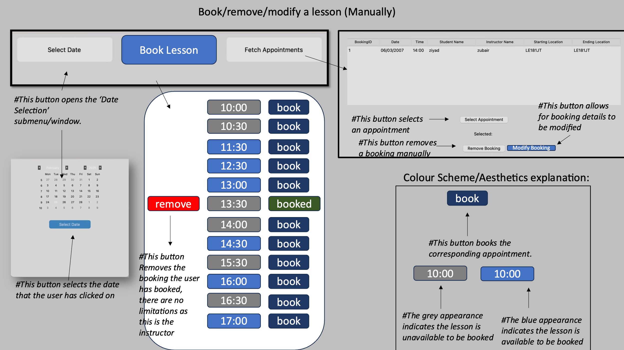
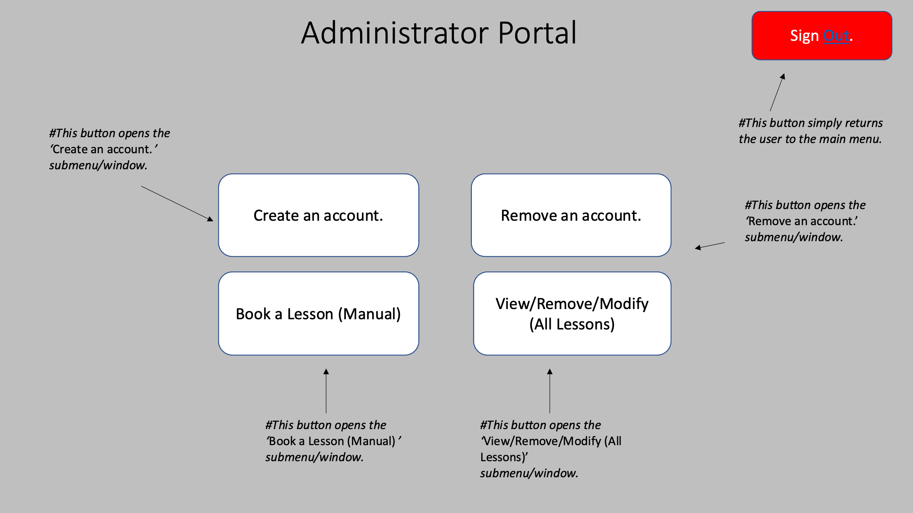
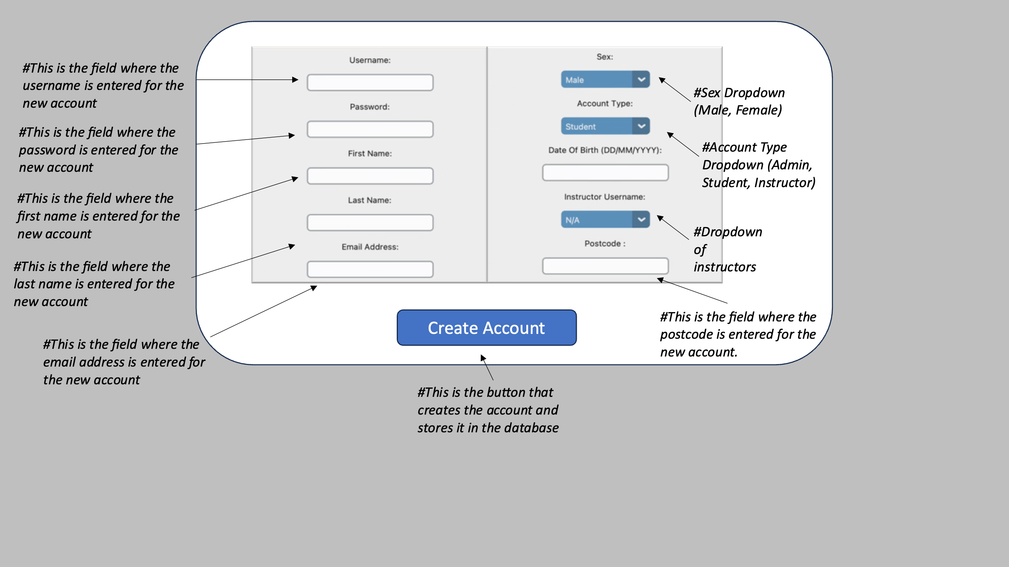
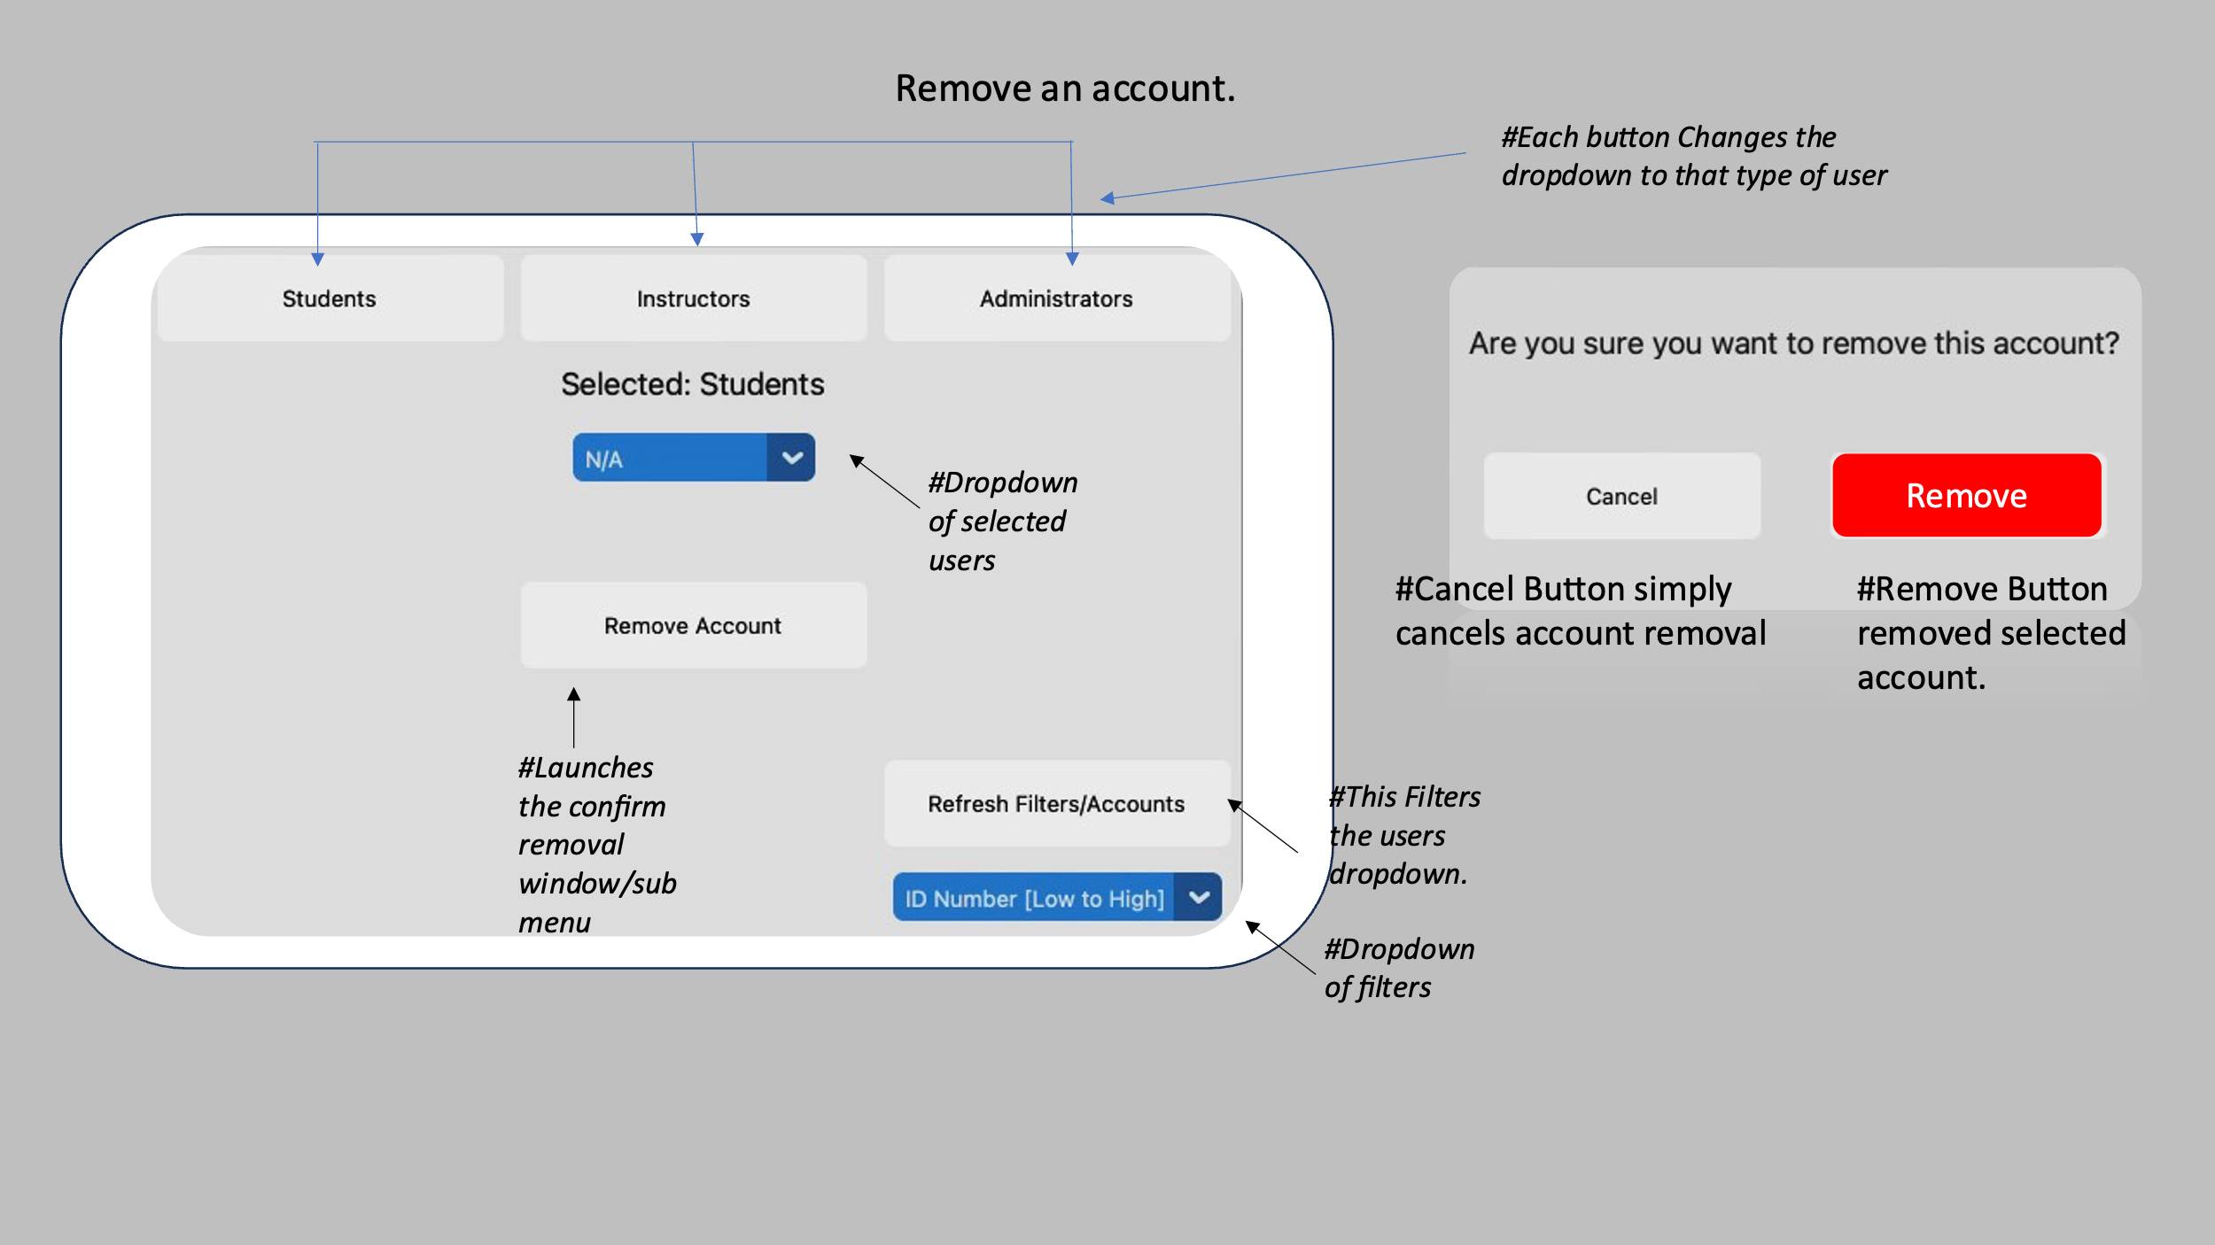
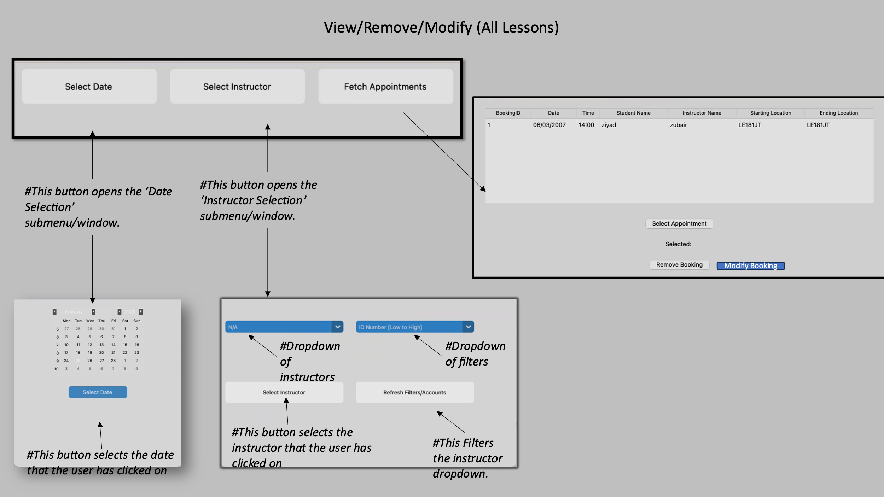
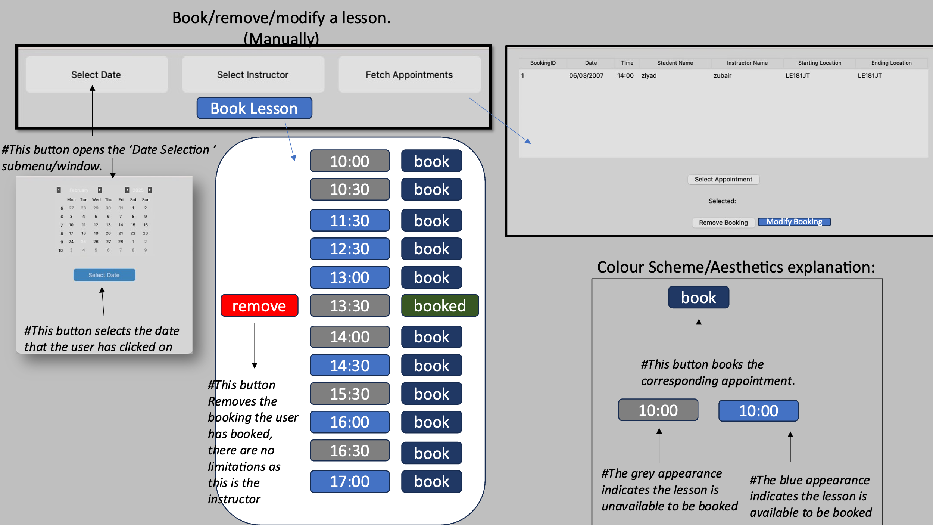

Suitability for the User

System security and integrity of data

Login Screens with annotations

Access rights/User Levels
As stated within my objectives in my analysis, I am to create a system in which there are 3 different types of users, all with varying access rights to the program.
 | Administrators | Instructors | Students
Ability to Create Accounts | ✅ | ❌ | ❌
Ability to Remove Accounts | ✅ | ❌ | ❌
Ability to book lessons for any instructor | ✅ | ❌ | ❌
Ability to view/remove/modify lessons for any instructor | ✅ | ❌ | ❌
Ability to view learning resources | ❌ | ✅ | ❌
Ability to create feedback reports | ❌ | ✅ | ❌
Ability to book/remove/modify your own upcoming lessons (without restriction) | ✅ | ✅ | ❌
Ability to view your own upcoming lessons | ✅ | ✅ | ✅
Ability to your view own feedback reports and previous lessons. |  | ❌ | ✅
Ability to book/cancel lessons. (Restrictions Apply) | ✅ | ❌ | ✅

Validation
When referring to regular expressions earlier in the design section, it displays how they have been used to validate input and the importance of input validation.
It is stated here. PUT PAGE REFERNCE
It is important for data to be validated to prevent both syntax and logic errors from occurring, but also to prevent security threats/attacks.
A very important threat to protect against is SQL injection, I refer to how I combatted this issue using parameterized SQL here. PUT PAGE REFERNCE

Technical Solution

Completeness Of Solution
After revisiting my set objectives, it is safe to say that they have all been accomplished, if not bettered in some aspects. Objective 2, to create a password reset system based on memorable questions, has in fact been improved to use an email address password reset system instead, sending the user a verification code to prove authenticity. After a brief discussion with my client, they were more than pleased with this change, in fact they were happier as it involved storing less data on there end and the email system is much more secure, and the One-Time Code cannot be easily guessed, unlike answers to memorable questions which the original objective proposed.
Another Change was the move from the GoogleDistanceMatrixAPI to the OpenRouteServiceAPI, this is simply due to a restricted free bandwidth quota the GoogleAPI has and therefore it would not be feasible for the project, so to counteract this I persevered and changed the API to the OpenRouteServiceAPI.

Technical Skills Used

Screenshots of Final UI Annotated

Main Page
Upon Launching the application, this is the main window that the user is greeted with.
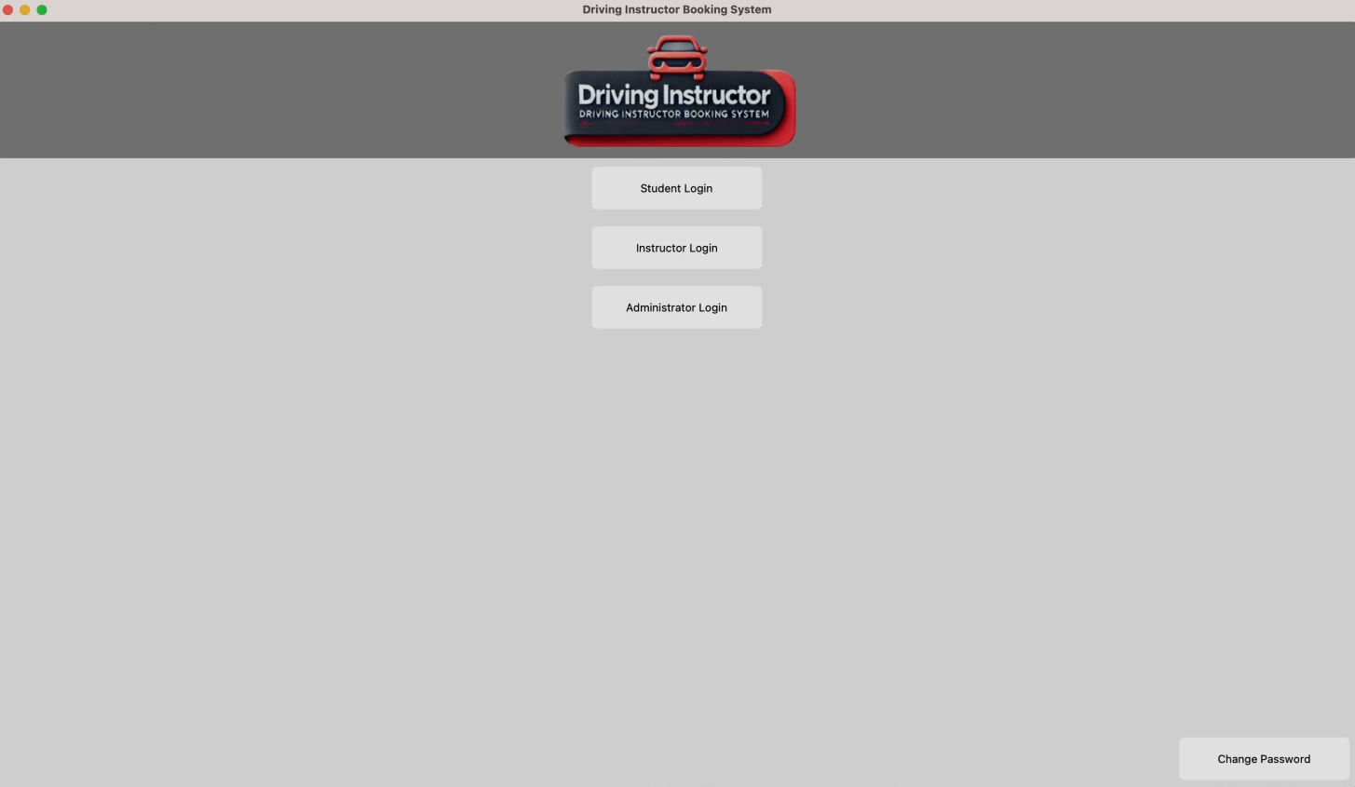
The window displays four buttons providing the function for ‘Student Login’, ‘Instructor Login’, ’Administrator Login’, and ‘Change Password’. When clicked each of the following will open a new corresponding window.
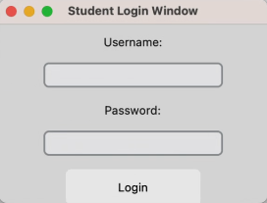
The Student Login Window opens, when the Student Login Button is pressed, it contains 2 labels, 2 fields and a login button. The first label highlights the field the user should enter their username. The second label, highlights the field the user should enter their password. These act as visual cues to guide the user as to where they should input certain data.
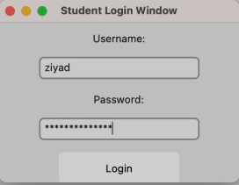
The password entry field does not display user input and rather hides it with’**’ symbols. As referenced in my initial GUI design within the design section this is to counteract ‘shoulder surfing’ cyber-attacks and increase the overall security of the program.

Student Portal
Once correct student credentials are entered, the student is greeted with this main menu/window.
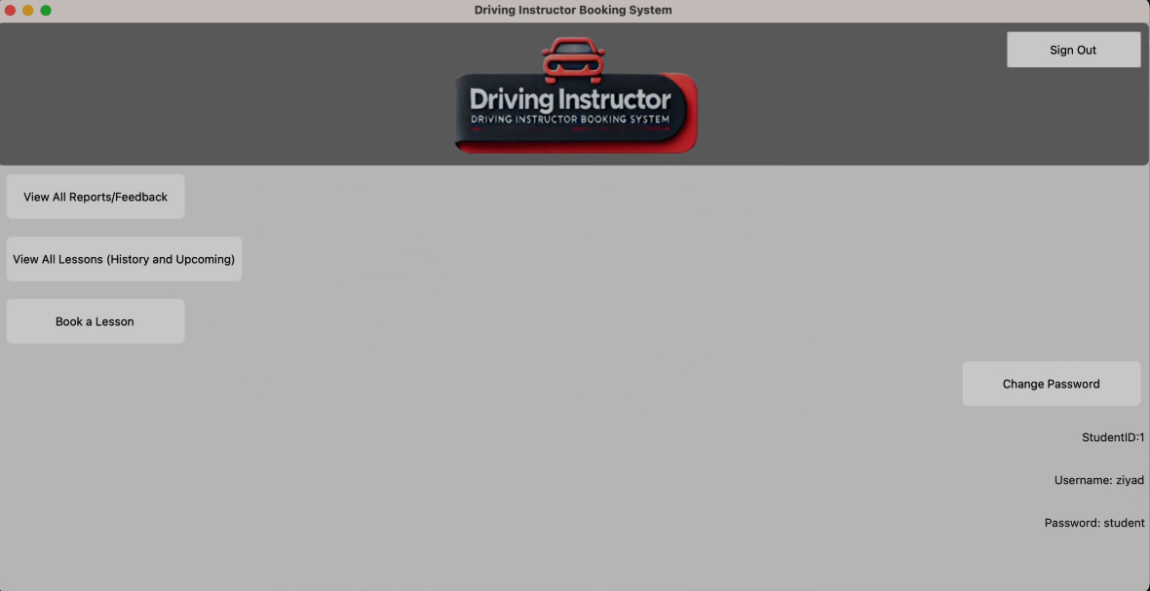
This menu contains 5 buttons and 3 labels.
Buttons:
View All Reports/Feedback:
This opens a new submenu allowing for students to select from all of there previous lessons, assigned feedback reports created by their instructor.
View All Lessons (History and Upcoming):
This opens a new submenu that displays all lessons, past and upcoming, for the student to view.
Book A lesson:
This opens a new submenu to book a driving lesson.
Change Password: This opens the window for a user to change their password.
Sign Out: This returns the user to the main menu with all 3 login buttons.

View All Reports/Feedback:
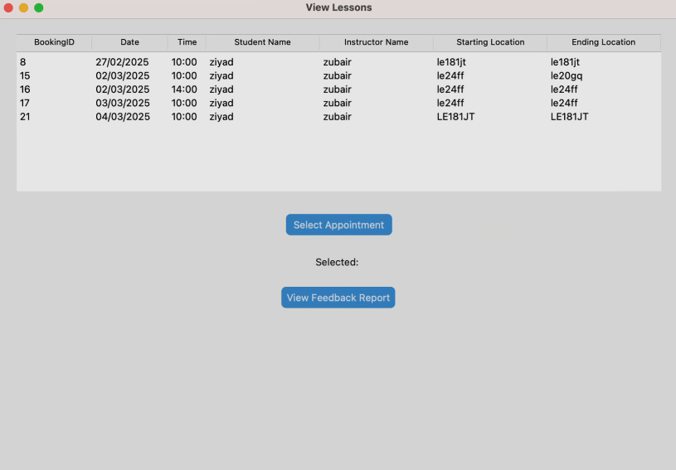
When clicked this is the submenu that is launched. It contains a tkinter treeview widget, and 2 CustomTkinter buttons, labelled: Select Appointment, View Feedback Report.
Below is the result of clicking on an appointment and clicking select appointment:
The label changes to display the row selected and the row turns blue.
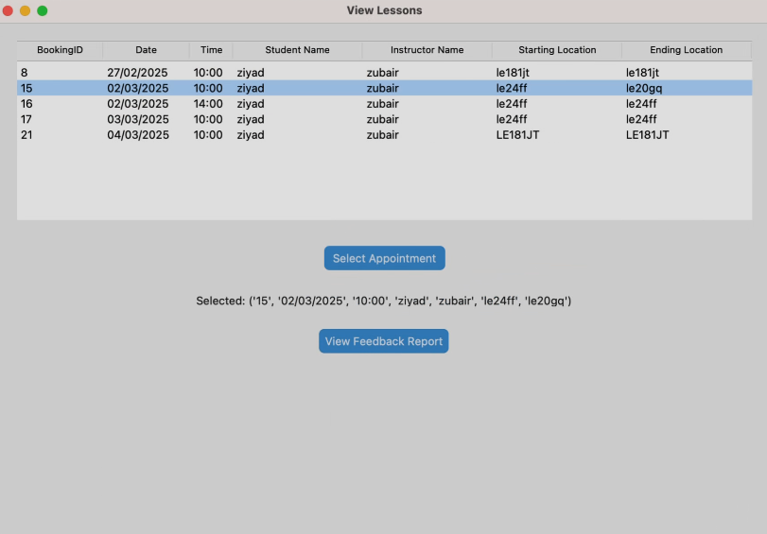
After selection once the View Feedback Report Button is clicked, if there is an associated report, it is subsequently launched to be read in another window.
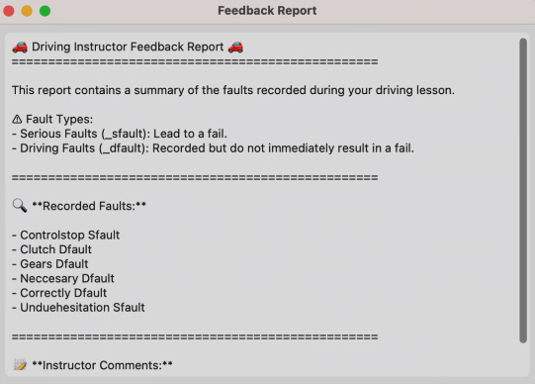
If there is no associated report, then the following message is shown:
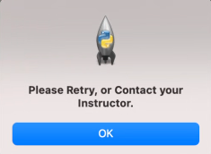

View All Lessons (History and Upcoming):
This button launches this submenu. Within this submenu contains a Tkinter Treeview Widget, this contains all lessons both past and upcoming for the student.
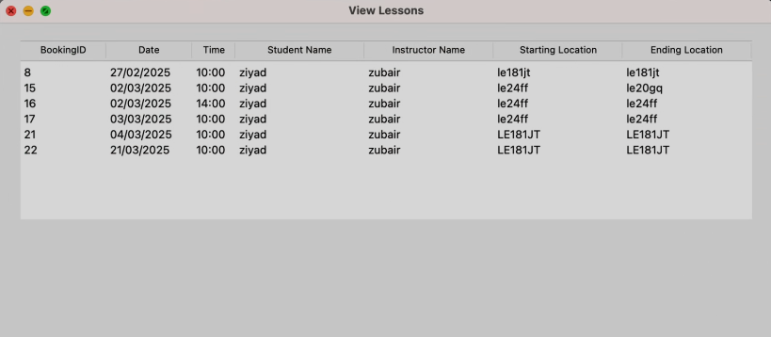

Book a Lesson
This button launches the following submenu:
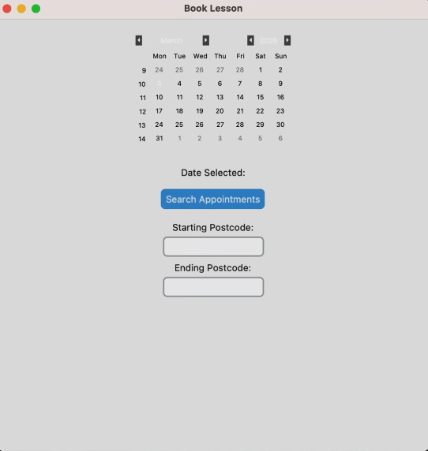
This Contains the TkinterCalendar Widget which allows the student to easily select a date to book on/find slots for.
It also contains the Search Appointments Button which queries the database for slots that have not been booked. It then cross-references these un-booked appointments with the starting and ending locations entered by the user, in order to find slots within a suitable (20 minute), travel distance for the student.

When Search Appointments is clicked, and both starting and ending postcodes have been entered, the following is returned:
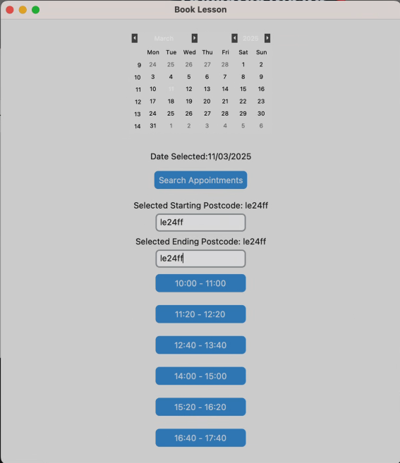
It returns the following ‘available slots’ as deemed by the criteria mentioned above.
When a slot is clicked on another submenu is opened, requesting the details of said slot to be entered.

Slot Details Submenu:
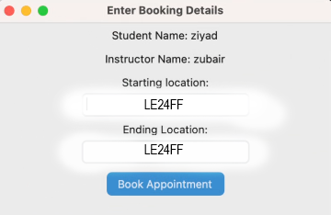
This Submenu Contains 4 fields, it acts as a confirmation to the student of there booking. It prefills all fields from what was previously entered when searching for the booking.
The Book Appointment Button Confirms the booking and inserts it into the database.

Instructor Portal
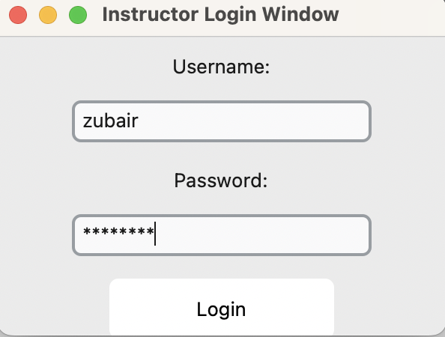
The Instructor Login Window opens, when the Student Login Button is pressed, it contains 2 labels, 2 fields and a login button. The first label highlights the field the user should enter their username. The second label highlights the field the user should enter their password. These act as visual cues to guide the user as to where they should input certain data.
‘**’ Symbols are used like as stated previously to prevent ‘shoulder-surfing’ cyber-attacks.
Once correct credentials are entered, the user is greeted with the Instructor Portal Window, which looks like this.
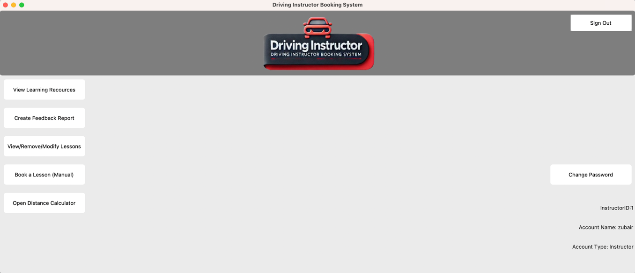
This Window Contains 7 buttons:
View Learning Recourses: Opens the View Learning Recourses window
Create Feedback Report: Opens the Create Feedback Report window.
View/Remove/Modify Lessons: Opens the window that allows the instructor to view bookings, select them and subsequently delete or modify them.
Book a lesson: Opens the window for an instructor to manually book a lesson with no distance guiding.
Open Distance Calculator: Opens the window for an instructor to quickly compare 2 postcodes and find the ETA.
Sign Out: Returns the instructor to the main page.
Change Password: Opens the submenu to Change Password.

View Learning Recourses: Opens the View Learning Recourses window
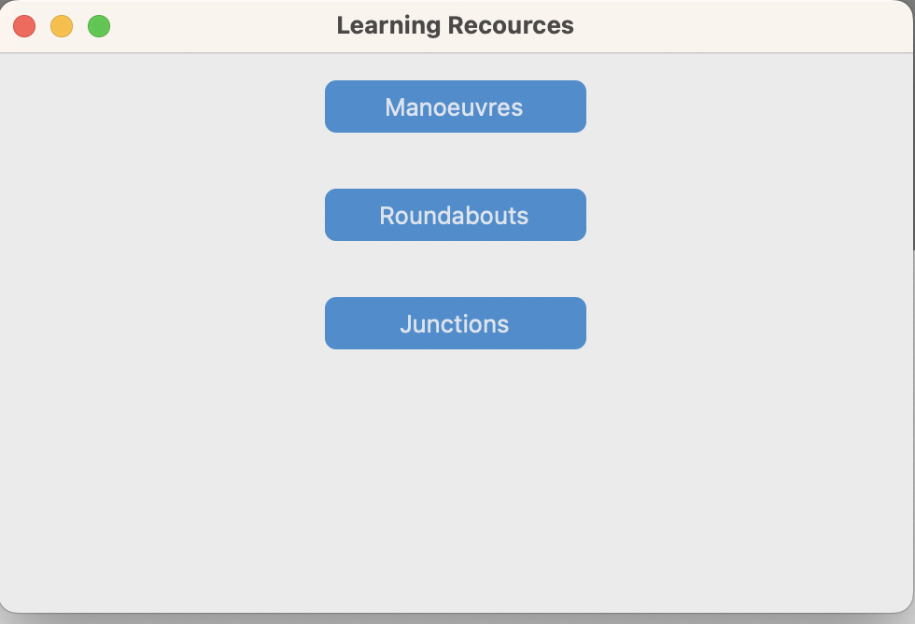
This menu contains 3 buttons, when each are clicked the return the same menu, a dropdown paired with a select recourse button, however the dropdown fetches different recourses based on the button that is clicked. Each Button represents a folder within the learning recourses folder in the program.

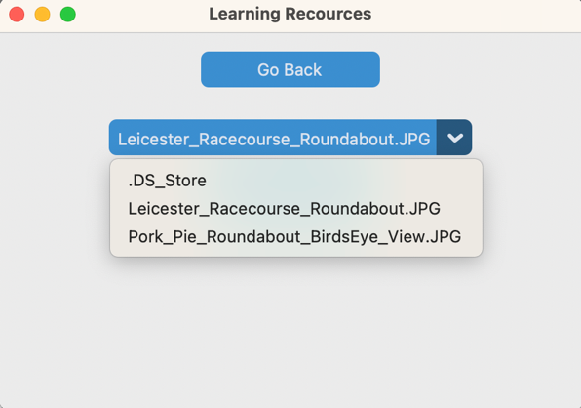

When a button is clicked, the submenu is changed to a dropdown to select a recourse paired with a select recourse button.
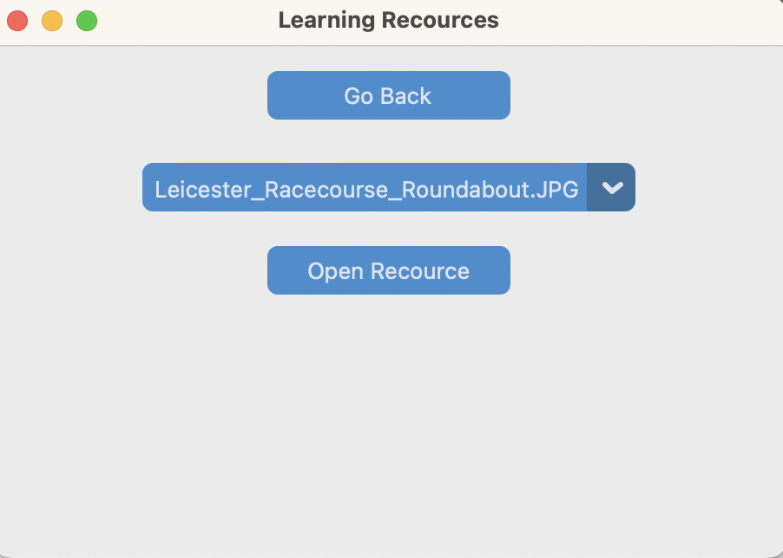
Create Feedback Report: Opens the Create Feedback Report window.
View/Remove/Modify Lessons: Opens the window that allows the instructor to view bookings, select them and subsequently delete or modify them.
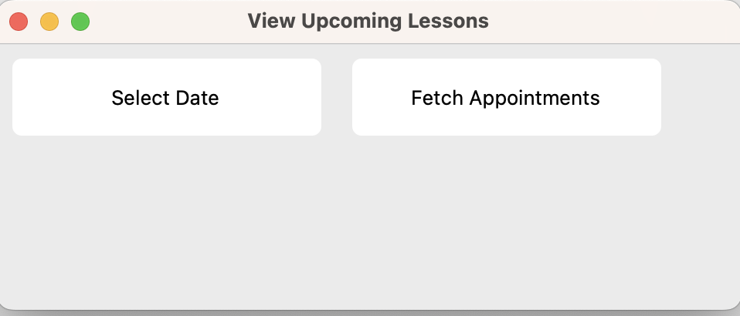
When clicked the following window opens. Prompting the instructor to select a date and to fetch appointments.

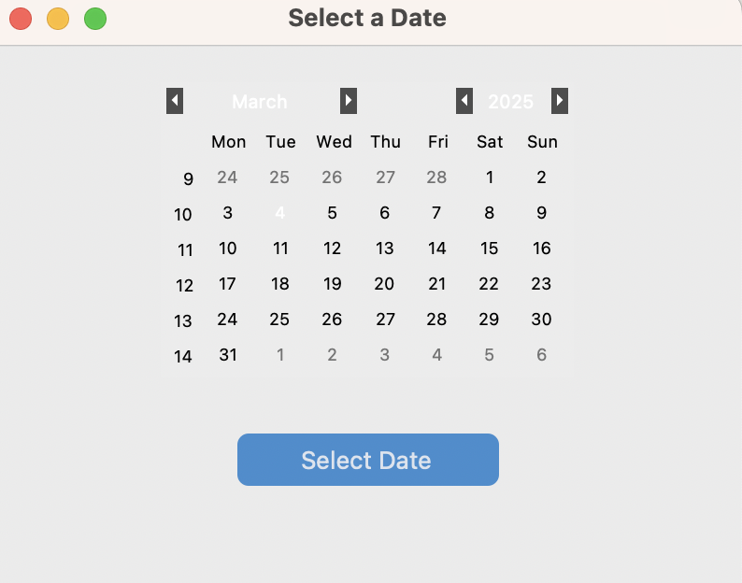

When ‘Select Date’ is clicked the following submenu is returned displaying the tk.calendar widget. This displays an interactive calendar the user can use to search and select a date.
Once a date is selected the visual indicator is as follows:
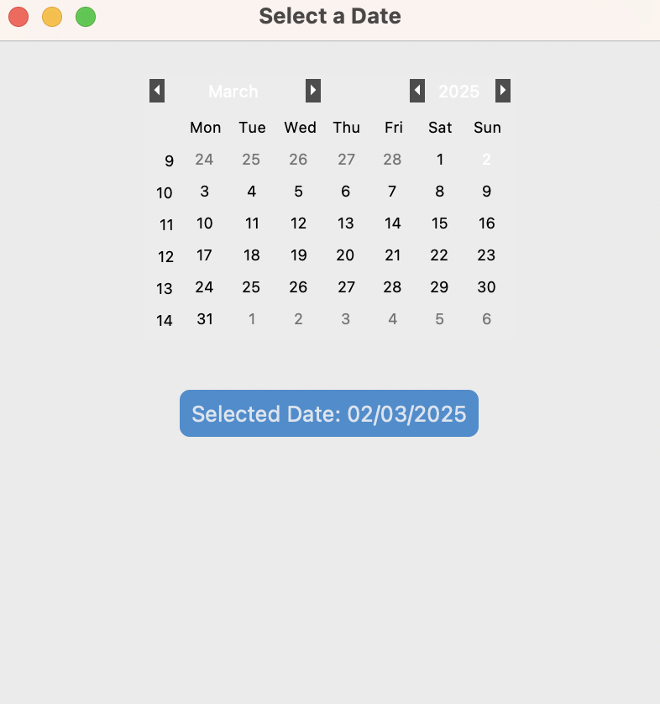
Now when the fetch appointments button is clicked a view lessons window opens:
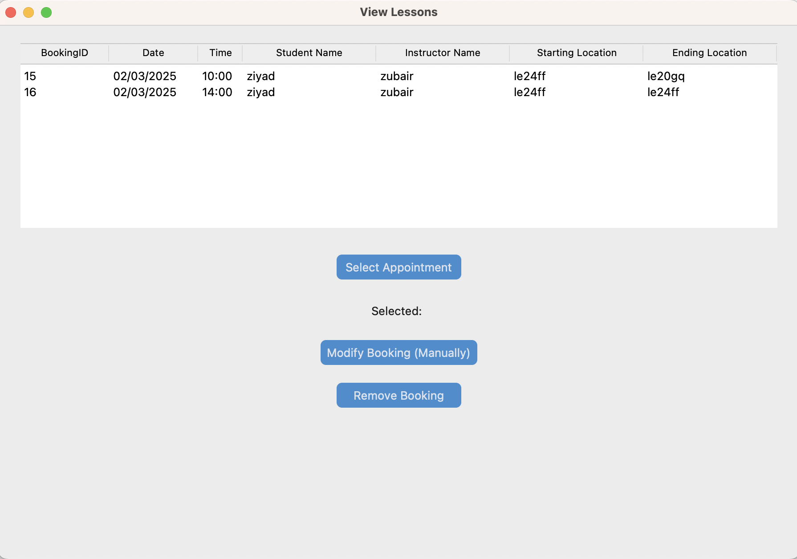
It contains three buttons, one to select a booking, another to modify a booking, another to remove a booking.
When selected, the selected row is indicated by the ‘selected:’ label. 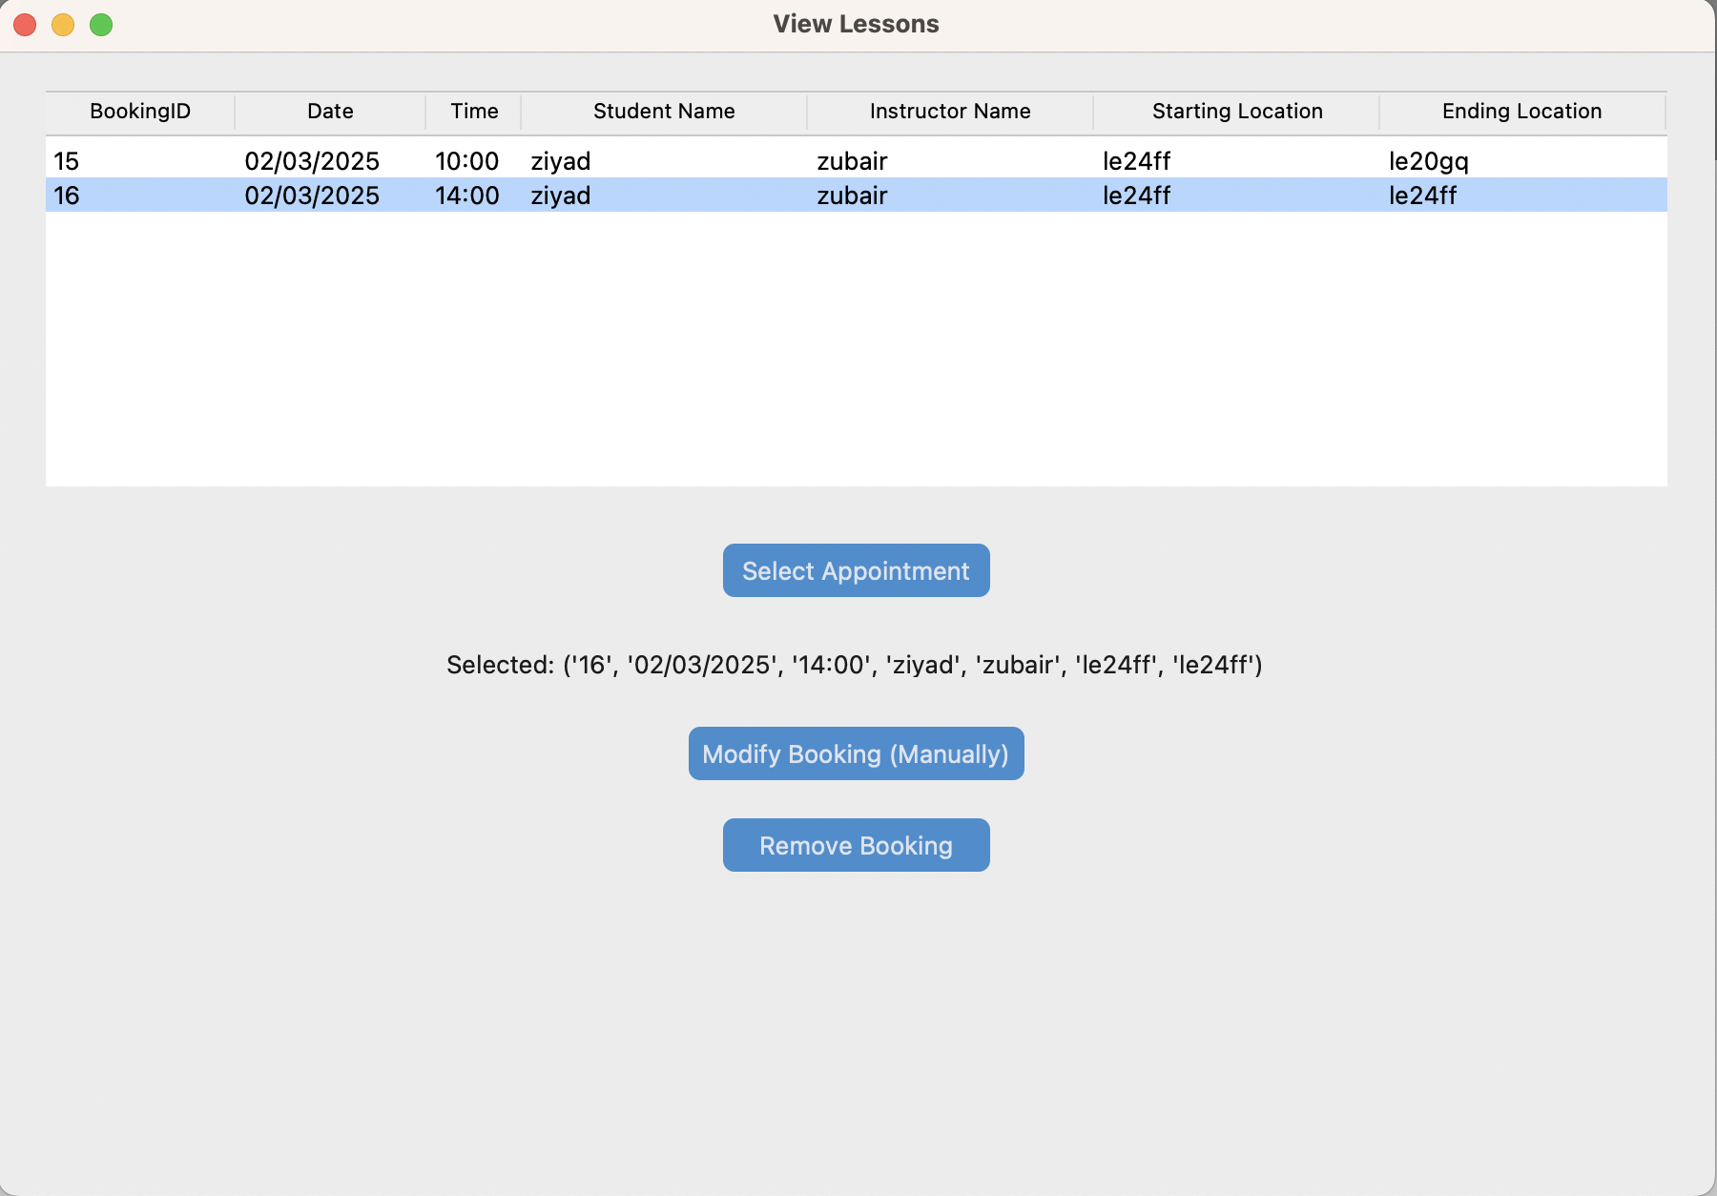
Now once selected, if the modify booking button is pressed this window opens prompting the user to enter new details:
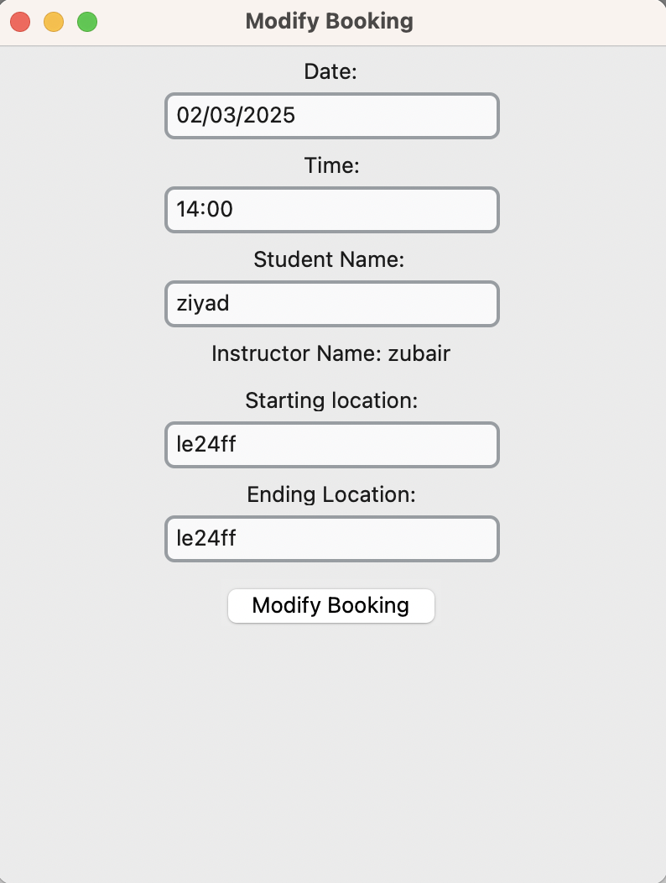
These input fields are all validated such that a valid date, valid time, valid student name, and valid UK postcodes are entered.

Book a lesson: Opens the window for an instructor to manually book a lesson with no distance checking, as the instructor has the power to override this how they see fit.
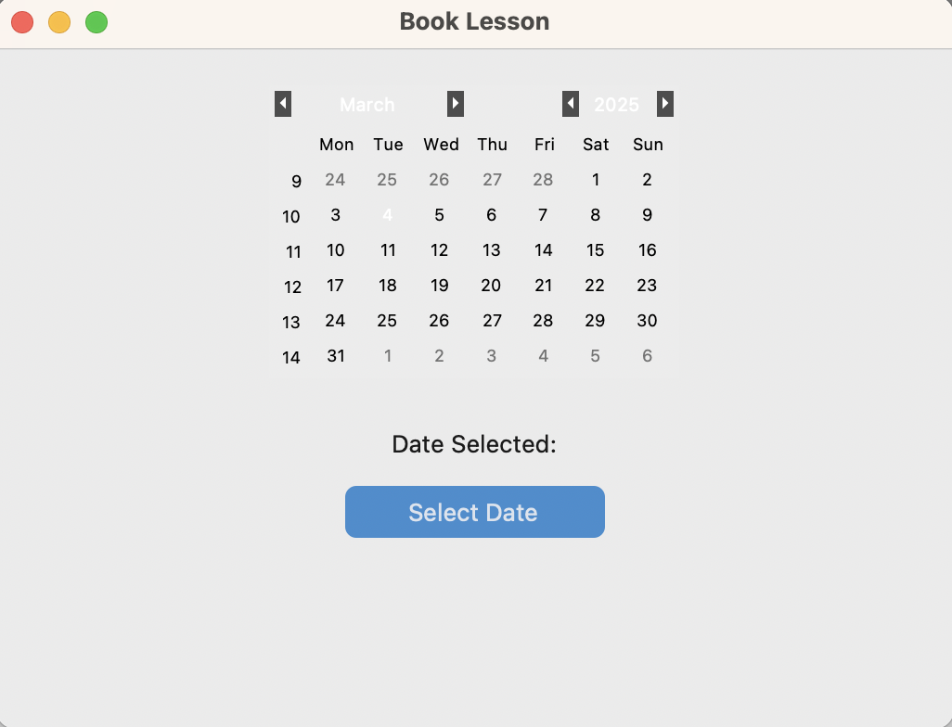
Initially this window is displayed:
This displays a calendar like view for a date to be selected using tk.calendar.
This is very similar to the student booking window, except it does not contain location checking.
Once a date is selected the subsequent ‘unbooked/free’ slots are displayed:
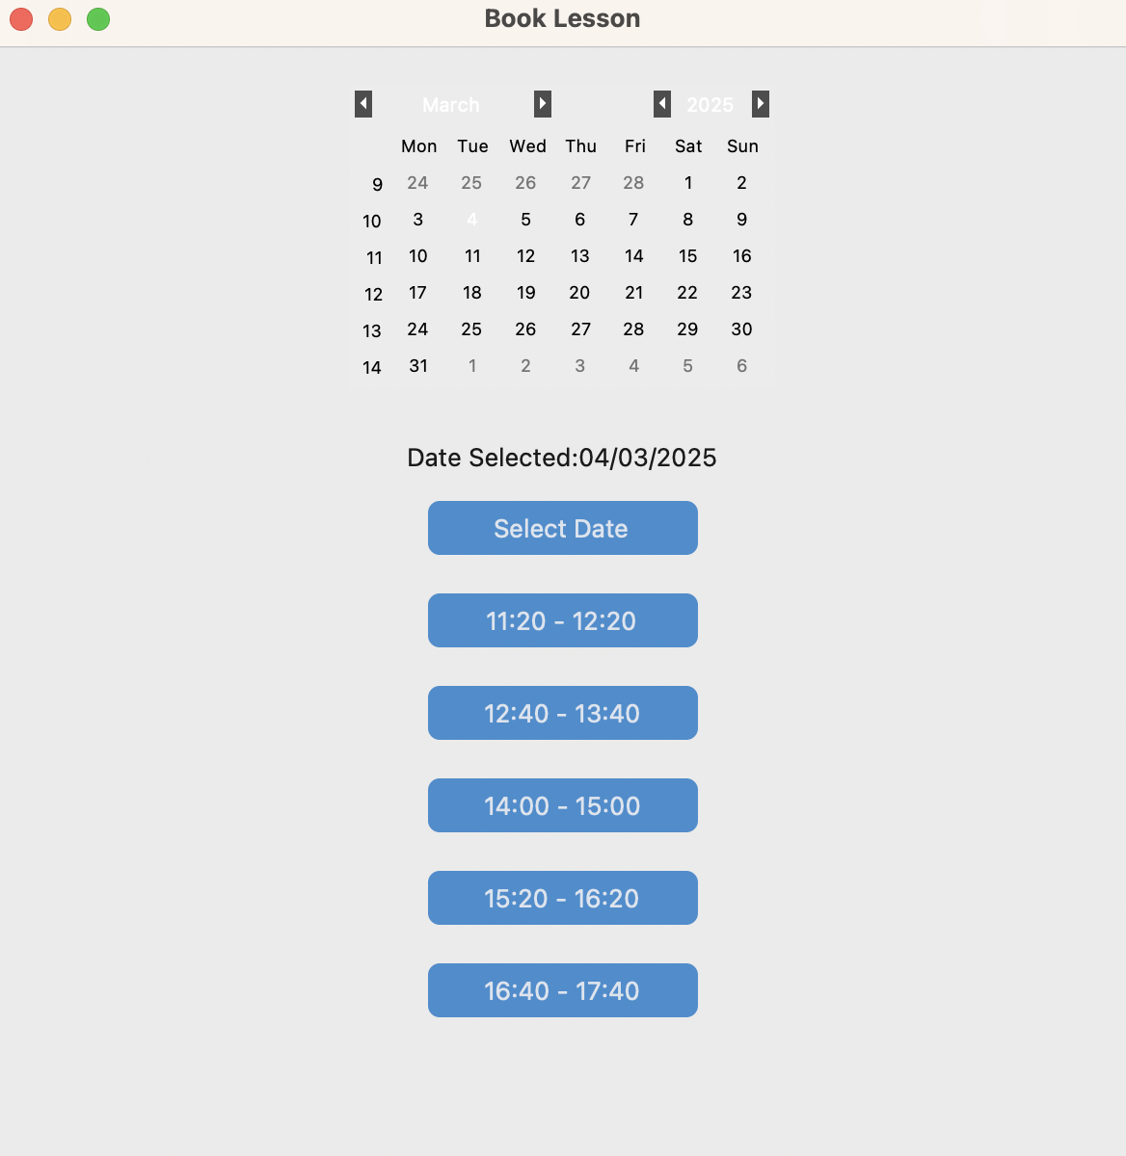
The free slots are displayed as buttons that the user can click on to select.
Once selected, the final confirmation window opens:
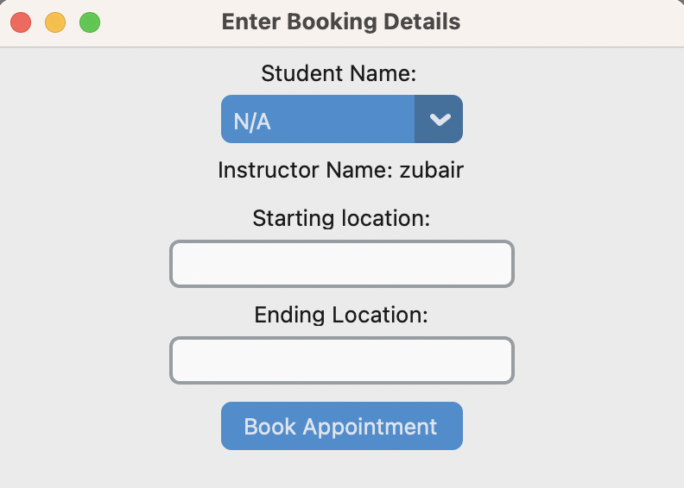
It contains:
- A dropdown for the student’s name to be selected.
- 2 fields, for starting and ending location.
- These location fields are validated so that only a valid UK postcode can be entered.
- Once these fields are entered and book appointment is clicked, the appointment is booked and inserted into the database.

Open Distance Calculator: Opens the window for an instructor to quickly compare 2 postcodes and find the ETA.
This is the window that opens:
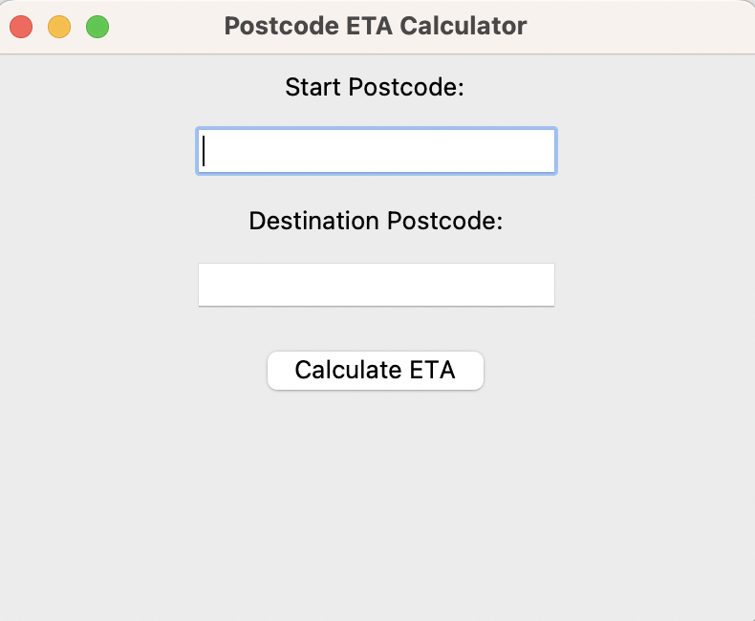
-It contains 2 fields for the instructor to swiftly enter the starting and destination postcode, and a button labelled calculate ETA.
- Once clicked the ETA is calculated and displayed at the bottom of the window.

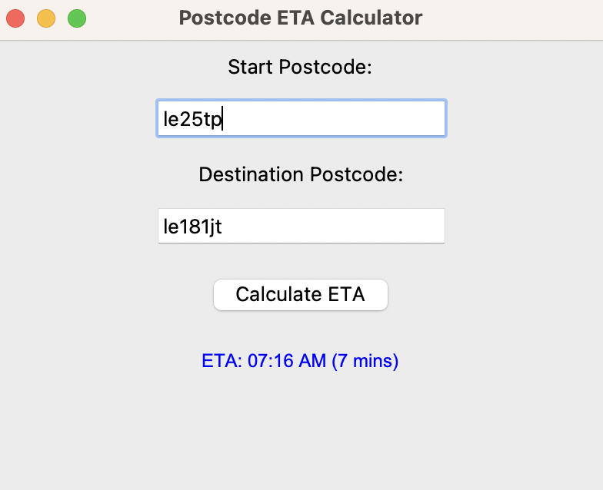

Administrator Portal
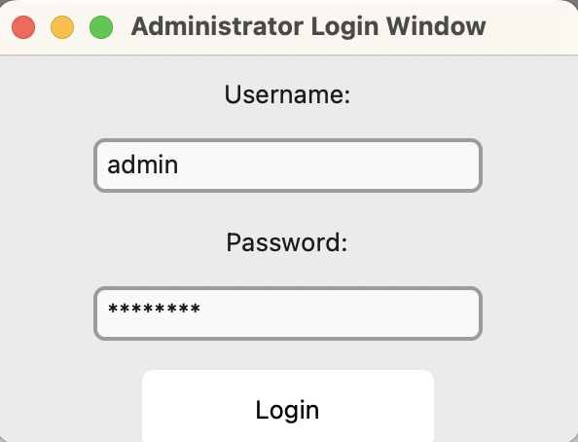

Upon the entry of correct administrator login details, the login button will launch the Administrator Portal.

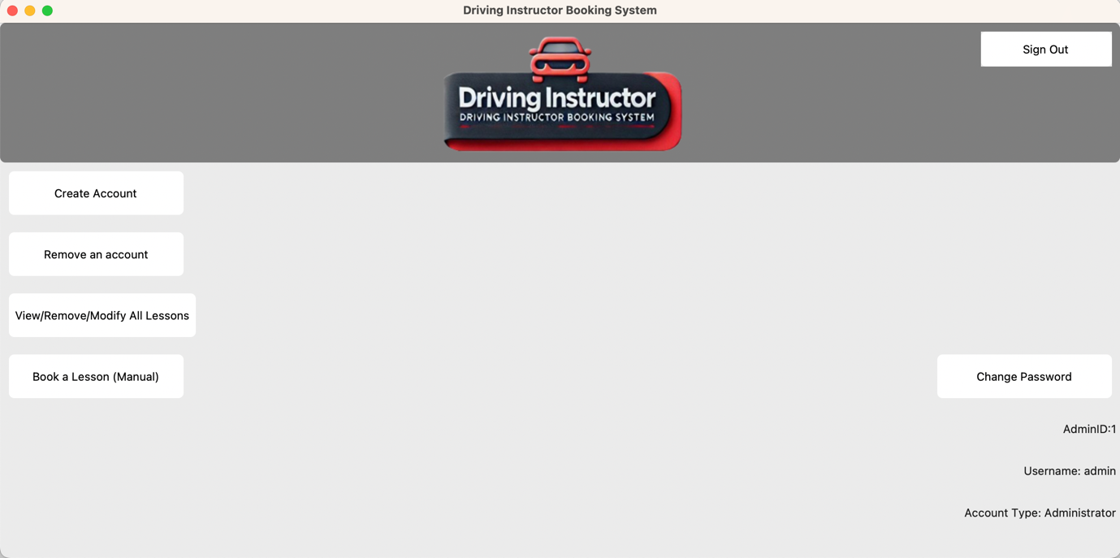
It contains 6 buttons:
Create Account
Remove an Account
View/Remove/Modify All lessons
Book A Lesson (Manual)
Change Password
Sign Out

Create Account:
Launches the following window:
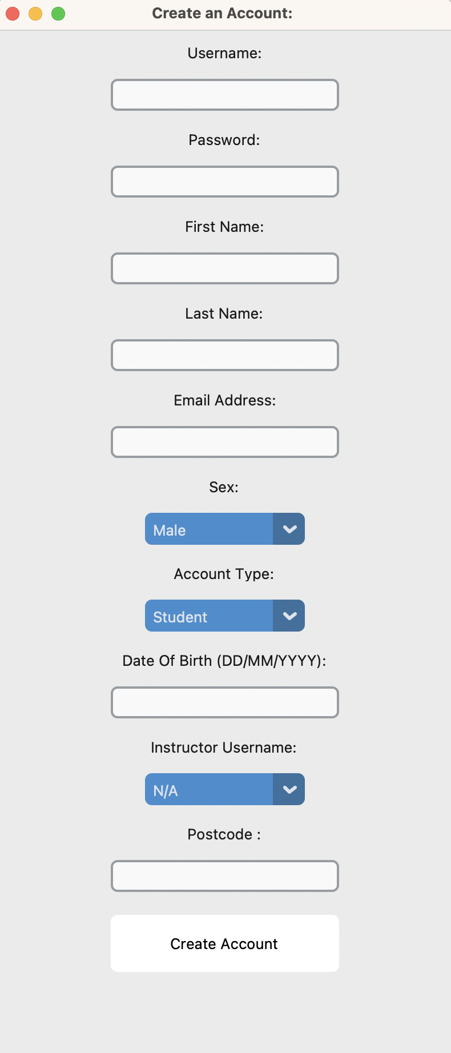
This contains 7 input fields and 3 dropdowns. They allow the administrator to enter the details for the new account to be created.
Each input field is validated completely as shown in the next screenshot below.
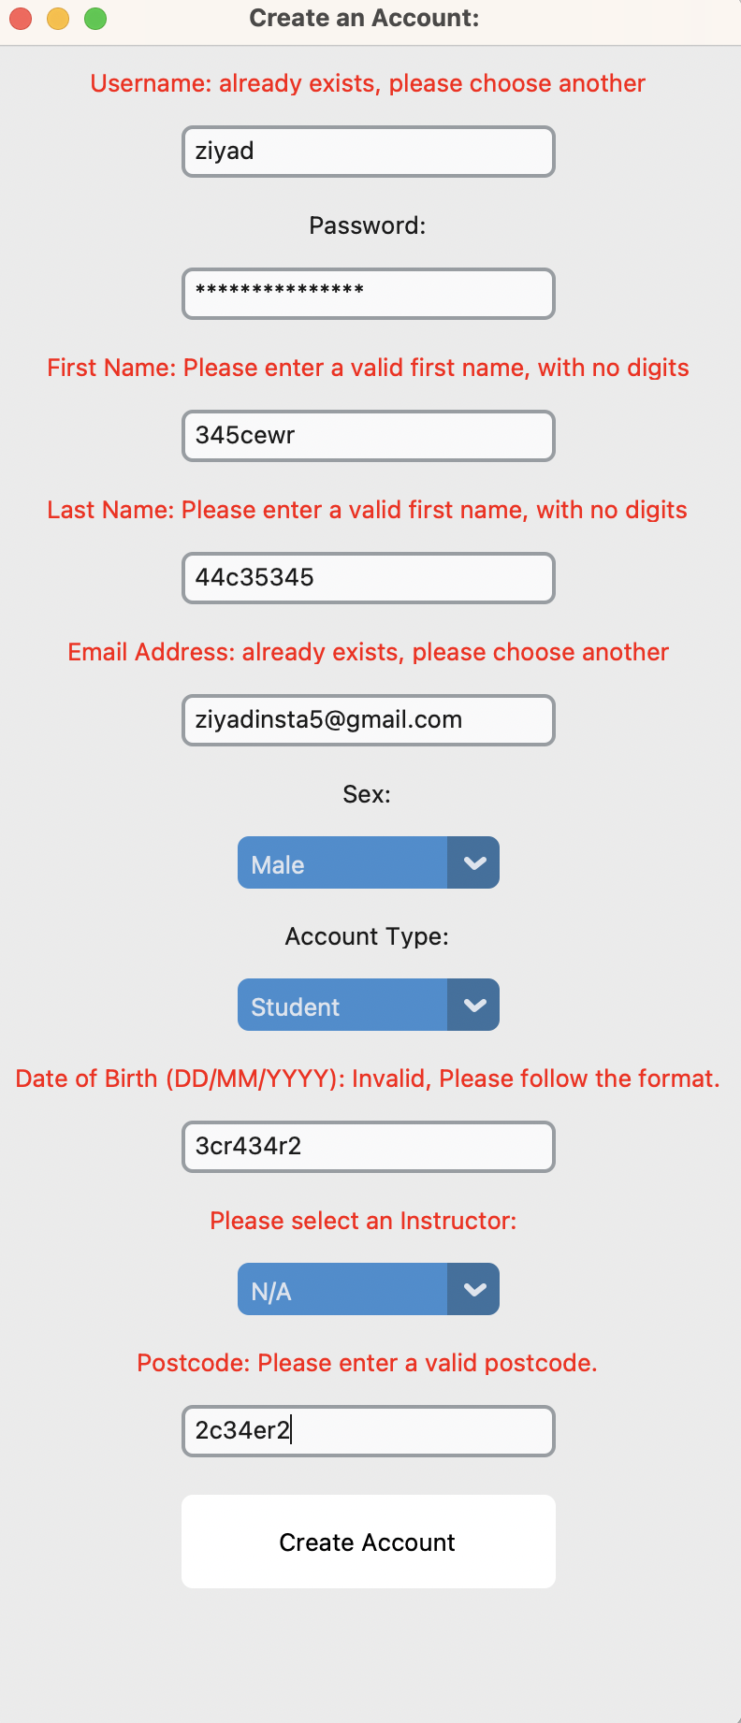
After Unsuitable data is inputted, and the administrator attempts to ‘Create Account’, the label above each incorrect input will display a meaningful error message, till the data inputted is suitable.

Remove an Account:
When the button is clicked it opens the following window:
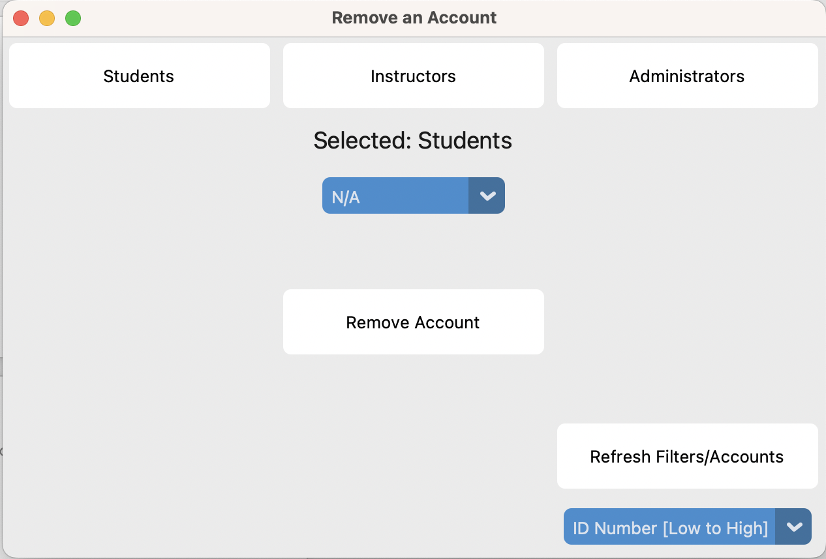
Each of the 3 buttons at the top labelled, ‘Students’, ‘Instructors’, ‘Administrators’, changes the ‘selected:’ label and the dropdown menu below it.

In the bottom right is a refresh filters/accounts button paired with a dropdown allowing for the accounts to be filtered in a certain way. This is to make it easier for the administrator to find the account they are looking to remove.
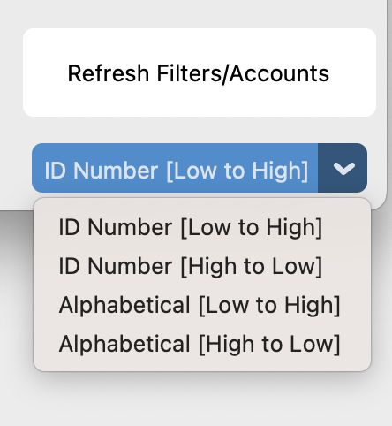
Once an account is selected in the dropdown, if the remove account button is clicked, then a confirmation menu is launched:
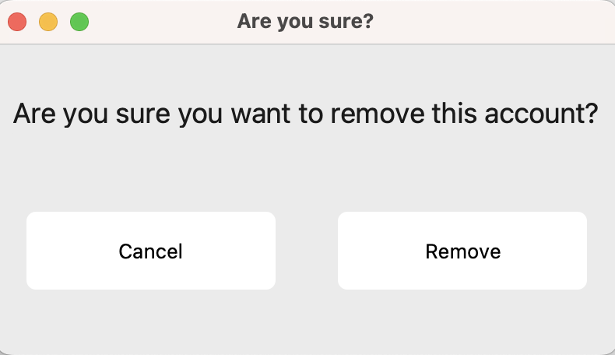
If cancel is clicked then nothing happens, however if confirm is clicked then the account is removed. In order to highlight to the administrator, the permanent effect of the removal, I added a confirmation window, and when the remove button is hovered over is turns red.
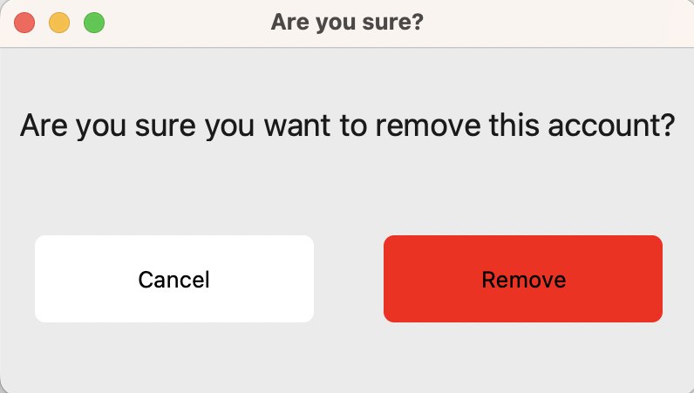

View/Remove/Modify Lessons: Opens the window that allows the administrator to view bookings, select them and subsequently delete or modify them. This differs from the instructor menu, as the administrator can view the lessons of any instructor, whereas the instructor can only view their own.
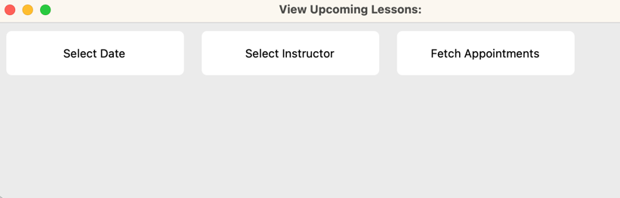
When clicked the following window opens. Prompting the instructor to select a date, select an instructor and to fetch appointments

When ‘Select Date’ is clicked the following submenu is returned displaying the tk.calendar widget. This displays an interactive calendar the user can use to search and select a date.
Once a date is selected the visual indicator is as follows:
When ‘Select Instructor’ is clicked the following window is returned.
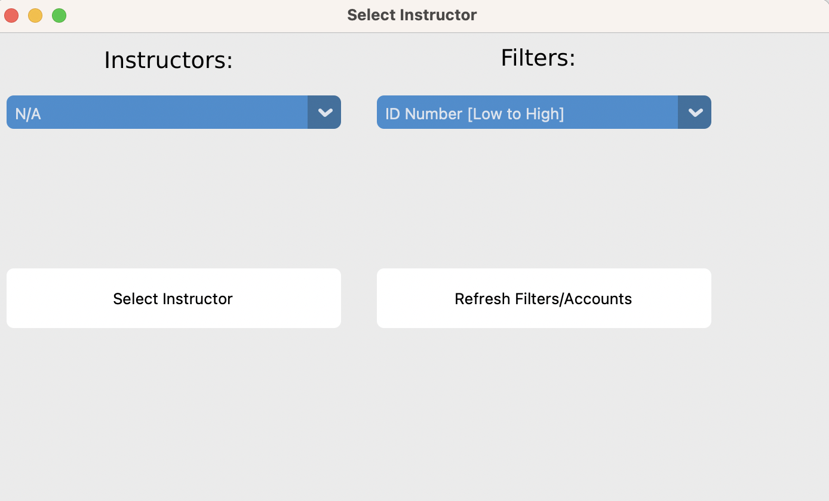
It contains a dropdown of all instructors in the system. It also contains a dropdown of filters which make it easier to find instructors.
Once the Select instructor button is clicked it is indicated to the user by the original ‘Select Instructor’ Button indicating so.
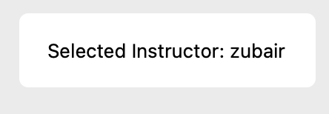

Now when the fetch appointments button is clicked a view lessons window opens:
It contains three buttons, one to select a booking, another to modify a booking, another to remove a booking.
When selected, the selected row is indicated by the ‘selected:’ label.
Now once selected, if the modify booking button is pressed this window opens prompting the user to enter new details, this differs from the instructors modify menu, as tha administrator can also change the instructor for a lesson:
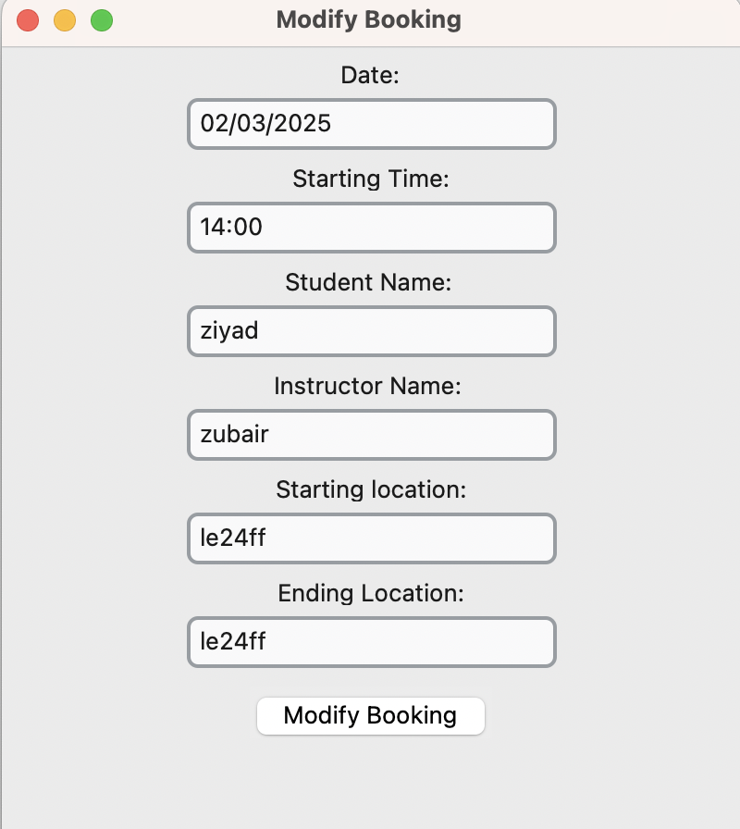
These input fields are all validated such that a valid date, valid time, valid student name, valid instructor name and valid UK postcodes are entered.

Book a lesson:
Opens the window for an instructor to manually book a lesson with no distance checking, as the administrator has the power to override this how they see fit.
Initially this window is displayed:
This displays a calendar like view for a date to be selected using tk.calendar.
This is very similar to the student booking window, except it does not contain location checking.
Once a date is selected the subsequent ‘unbooked/free’ slots are displayed:
The free slots are displayed as buttons that the user can click on to select.
Once selected, the final confirmation window opens:
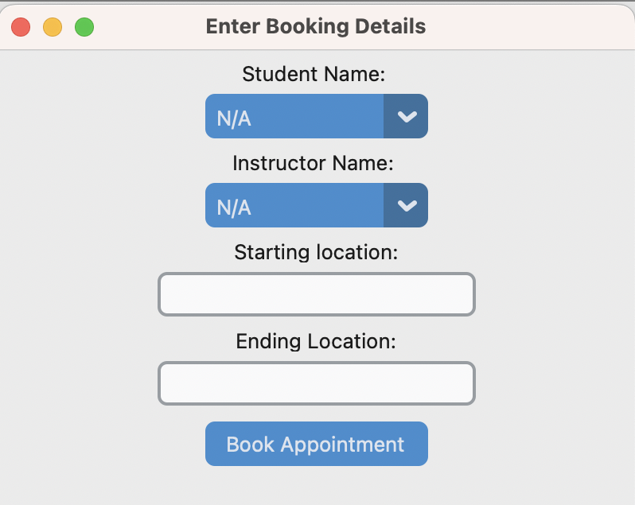
Similarly to the instructor confirm booking contains:
- A dropdown for the student’s name to be selected.
- 2 fields, for starting and ending location.
- These location fields are validated so that only a valid UK postcode can be entered.
- Once these fields are entered and book appointment is clicked, the appointment is booked and inserted into the database.
- However, it also additionally contains a dropdown for instructor name to be selected, as administrators can book appointments for all instructors.

Code Explained and fully annotated

The following code has been annotated and explained both via comments in the code and paragraphs below blocks of code. This serves to create a detailed explanation of the logic of the code. In order to assist with clearer explanations ChatGPT was used to make my original comments more concise and clear for the explanation.

import tkinter as tk
from tkinter import ttk
from tkinter import messagebox
from tkcalendar import Calendar
import sqlite3
import os
import customtkinter as ctk
from PIL import Image
import hashlib
import random
import smtplib
from email.message import EmailMessage
import re
from datetime import datetime, timedelta
import requests

This block of code imports all the libraries used in the program.
Below is brief rundown of each imported library and what it does and where it is usedin this code:

1. **tkinter** (`import tkinter as tk`):
- The standard Python library for creating graphical user interfaces. It provides basic windows, labels, entry fields, and other widgets.

2. **ttk** (`from tkinter import ttk`):
- A submodule of `tkinter` that provides themed widgets (like `Treeview`, `Combobox`, etc.) with a more modern look and feel.

3. **messagebox** (`from tkinter import messagebox`):
- Another submodule of `tkinter` specifically for showing pop-up messages (info boxes, warning boxes, error boxes, etc.).

4. **Calendar** (`from tkcalendar import Calendar`):
- A third-party widget library that adds a calendar widget to `tkinter`, allowing users to select dates easily.

5. **sqlite3**:
- Provides an interface to the SQLite database engine. Used to create and manage the local database (tables, queries, etc.). Used to access login details, user details, and booking details, and saves them.

6. **os**:
- A built-in Python module that helps with operating system tasks such as file paths (`os.path.join`) and checking file existence.

7. **customtkinter** (`import customtkinter as ctk`):
- A custom extension of `tkinter` providing modern-looking UI elements (buttons, frames, etc.) with additional styling options.

8. **PIL** (`from PIL import Image`):
- The Python Imaging Library (Pillow). Used here to open and manipulate image files (for instance, loading a logo).

9. **hashlib**:
- A module for secure hashing algorithms (like SHA-256). The code uses it to hash passwords for safe storage.

10. **random**:
- Used to generate random numbers or strings (e.g., generating a 6-digit OTP for email verification).

11. **smtplib**:
- A module for sending emails using the Simple Mail Transfer Protocol. Here, it’s used to send verification codes to users who want to reset their password.

12. **email.message** (`from email.message import EmailMessage`):
- Used alongside `smtplib` for constructing and formatting the email content (subject, body, sender, recipient).

13. **re**:
- A module that provides regular expression matching. Used in the code for validating email formats, postcodes, names, etc.

14. **datetime, timedelta** (`from datetime import datetime, timedelta`):
- For dealing with dates and times—calculating ETAs, comparing times, or generating timestamps.

15. **requests**:
- A popular third-party library for making HTTP requests. Used in the code for calling the OpenRouteService API to get geolocation and route information (to calculate travel times between postcodes).

class MainWindow(ctk.CTk):
def __init__(self, title, size):

#Main Setup
super().__init__()
self.title(title)
self.geometry(f'{size[0]}x{size[1]}')
self.CreateDatabase()
self.CreateMainMenu()

This creates the class MainWindow,
Below is the constructor for the `MainWindow` class. It does the following:

1. Calls the parent constructor: By calling `super().__init__()`, it initializes the underlying `ctk.CTk` window.

2. Sets up the window: It sets the title and window dimensions (via `self.title(title)` and `self.geometry(...)`).

3. Initializes the application’s database: By calling `self.CreateDatabase()`, it makes sure the SQLite database and required tables exist or are created.

4. **Creates the main menu**: By calling `self.CreateMainMenu()`, it sets up and displays the primary menu widgets for the application.

def CreateMaterialButton(self, master, text, command, width=200, height=50):
BUTTON_COLOR = "white"
HOVER_COLOR = "#2196F3"
TEXT_COLOR = "black"

button = ctk.CTkButton(master, text=text, width=width, height=height, command=command,
fg_color=BUTTON_COLOR, hover_color=HOVER_COLOR, text_color=TEXT_COLOR)
return button

- CreateMaterialButton is basically a method that makes a visually appealing button with some preset styles (like colours and size).

- It takes in things like `master` (where the button should show up), `text` (the label on the button), and `command` (what the button does when you click it).

- It sets a few colour variables at the top—like `BUTTON_COLOR`,
`HOVER_COLOR`, and `TEXT_COLOR`—so the button has a nice look and feel (white when you see it, changes to a cool blue when you hover over it, etc).

- Finally, it actually creates the CTkButton (a custom tkinter button with those styles), and returns it. This way, you can just call this function whenever you need a button, and it’ll automatically look consistent throughout the app.
def CreateLogoutButton(self, master, text, command, width=200, height=50):
BUTTON_COLOR = "#FFFFFF"
HOVER_COLOR = "red"
TEXT_COLOR = "#000000"

button = ctk.CTkButton(master, text=text, width=width, height=height, command=command,
fg_color=BUTTON_COLOR, hover_color=HOVER_COLOR, text_color=TEXT_COLOR)
return button

Create Logout Button:
Essentially, a method that makes a custom button (called a CTkButton) specifically for logging out and permanent tasks. It sets the colors for the button, including a white background, a red hover color, and black text, then returns that button object so you can place it wherever you want in the window.
def CreateMainMenu(self):
self.ClearAllWidgets()

BannerFrame = ctk.CTkFrame(self, fg_color="#7e7e7e")
BannerFrame.grid(row=0, column=0, columnspan=2, sticky="nsew")
BannerFrame.grid_rowconfigure(0, weight=1)
BannerFrame.grid_columnconfigure(0, weight=1)

LogoPath = os.path.join(os.getcwd(), 'logo.png')
PilImage = Image.open(LogoPath)
LogoImage = ctk.CTkImage(light_image=PilImage, size=(350, 140))
LogoLabel = ctk.CTkLabel(BannerFrame, image=LogoImage, text="")
LogoLabel.grid(row=0, column=0, pady=10, padx=10)

self.StudentLoginButton = self.CreateMaterialButton(self, "Student Login", self.StudentLoginWindow)
self.InstructorLoginButton = self.CreateMaterialButton(self, "Instructor Login", self.InstructorLoginWindow)
self.AdminLoginButton = self.CreateMaterialButton(self, "Administrator Login", self.AdminLoginWindow)
self.ChangePasswordButton = self.CreateMaterialButton(self, "Change Password", self.ChangePassword)

self.StudentLoginButton.grid(row=1, column=1, pady=10)
self.InstructorLoginButton.grid(row=2, column=1, pady=10)
self.AdminLoginButton.grid(row=3, column=1, pady=10)
self.ChangePasswordButton.grid(row=4, column=1, pady=10, padx = 10,sticky = "se")
self.grid_columnconfigure(0, weight=1)

self.columnconfigure(0, weight = 0)
self.columnconfigure(1, weight = 1)
self.rowconfigure(4, weight = 1)

It starts by clearing all existing widgets on the window. Then it creates a banner area (BannerFrame) at the top, with a grey background to hold the main logo. After that, it looks for a file called logo.png in the current working directory, opens it with the Pillow library, and makes a custom CTkImage out of it, which it then places into the banner using a CTkLabel.

Below that, it sets up four buttons (Student Login, Instructor Login, Administrator Login, and Change Password) using the previously defined CreateMaterialButton method. Each button is positioned on the grid and linked to a specific command function. Finally, it does a bit of grid configuration to make everything scale properly if the window is resized.

def StudentLoginWindow(self):
self.CreateLoginWindow("Student Login Window",self.ValidateStudentLogin)

def InstructorLoginWindow(self):
self.CreateLoginWindow("Instructor Login Window",self.ValidateInstructorLogin)

def AdminLoginWindow(self):
self.CreateLoginWindow("Administrator Login Window",self.ValidateAdminLogin)

All three methods do basically the same thing for different user types. StudentLoginWindow calls CreateLoginWindow with the title "Student Login Window" and links it to ValidateStudentLogin. InstructorLoginWindow sets a similar window labeled "Instructor Login Window" and uses ValidateInstructorLogin. AdminLoginWindow repeats the process for "Administrator Login Window" and points to ValidateAdminLogin.

def CreateLoginWindow(self,title, userfunction):
self.LoginWindow = ctk.CTkToplevel(self)
self.LoginWindow.title (title)
self.LoginWindow.geometry("300x200")

self.AddLoginWidgets(self.LoginWindow,userfunction)
self.LoginWindow.wm_attributes("-topmost", True)

##CreateLoginWindow creates a new top-level window (self.LoginWindow) with a given title and size,
## then calls AddLoginWidgets to fill that window with the necessary login UI elements.
## Finally, it sets the new window to always be on top of other windows using wm_attributes.

def CreateDatabase(self):

conn = sqlite3.connect('database.db')
cursor = conn.cursor()

cursor.execute('''CREATE TABLE IF NOT EXISTS instructors (
instructorid INTEGER PRIMARY KEY AUTOINCREMENT,
username TEXT NOT NULL,
password TEXT NOT NULL,
emailaddress TEXT NOT NULL,
accounttype TEXT NOT NULL,
firstname TEXT NOT NULL,
surname TEXT NOT NULL,
dob DATE NOT NULL,
sex CHAR NOT NULL,
postcode TEXT NOT NULL)''')

cursor.execute('''CREATE TABLE IF NOT EXISTS students (
studentid INTEGER PRIMARY KEY AUTOINCREMENT,
username TEXT NOT NULL,
password TEXT NOT NULL,
emailaddress TEXT NOT NULL,
accounttype TEXT NOT NULL,
firstname TEXT NOT NULL,
surname TEXT NOT NULL,
dob DATE NOT NULL,
sex CHAR NOT NULL,
postcode TEXT NOT NULL,
instructorid INTEGER NOT NULL,
FOREIGN KEY(instructorid) REFERENCES instructors(instructorid))''')

cursor.execute('''CREATE TABLE IF NOT EXISTS admins (
adminid INTEGER PRIMARY KEY AUTOINCREMENT,
username TEXT NOT NULL,
password TEXT NOT NULL,
emailaddress TEXT NOT NULL,
accounttype TEXT NOT NULL,
firstname TEXT NOT NULL,
surname TEXT NOT NULL,
dob DATE NOT NULL,
sex CHAR NOT NULL,
postcode TEXT NOT NULL)''')

cursor.execute('''CREATE TABLE IF NOT EXISTS bookings (
bookingid INTEGER PRIMARY KEY AUTOINCREMENT,
startpostcode TEXT NOT NULL,
endpostcode TEXT NOT NULL,
date DATE NOT NULL,
time TIME NOT NULL,
studentid INTEGER NOT NULL,
instructorid INTEGER NOT NULL,
FOREIGN KEY(instructorid) REFERENCES instructors(instructorid),
FOREIGN KEY(studentid) REFERENCES students(studentid))''')

cursor.execute("SELECT * FROM admins WHERE accounttype = ?", ('Administrator',))
if cursor.fetchone() is None:
cursor.execute("INSERT INTO admins (username, password, emailaddress, accounttype, firstname, surname, dob, sex, postcode) VALUES (?, ?, ?, ?, ?, ?, ?, ?, ?)", ('admin', '5e884898da28047151d0e56f8dc6292773603d0d6aabbdd62a11ef721d1542d8','admin@roadsense.com','Administrator', 'Admin', 'Admin', '04/03/2020', 'm', 'LE22HL', '2'))
conn.commit()
conn.close()

It connects to database.db (or creates it if it’s missing), then checks if certain tables exist and creates them if they don’t (instructors, students, admins, bookings). Finally, it does a quick check to see if there’s already an administrator. If not, it inserts a default admin account into the admins table, commits the changes, and closes the connection.

def AddLoginWidgets(self, window, usertype):

UsernameLabel = ctk.CTkLabel(window, text="Username:")
UsernameLabel.grid(row=0, column=0,pady=5)

self.UsernameField = ctk.CTkEntry(window, width=200)
self.UsernameField.grid(row=1, column=0,pady=5)

PasswordLabel = ctk.CTkLabel(window, text="Password:")
PasswordLabel.grid(row=2, column=0,pady=5)

self.PasswordField = ctk.CTkEntry(window, width=200, show="*")
self.PasswordField.grid(row=3, column=0,pady=5)

LoginButton = self.CreateMaterialButton(window, "Login", usertype, width=150, height=40)
LoginButton.grid(row=4, column=0,pady=10)
window.grid_columnconfigure(0, weight=1)

This method essentially adds all the login widgets when creating a login window. This is helpful as all login windows essentially follow the same format.

def ValidateStudentLogin(self):
Username = self.UsernameField.get().lower()
Password = self.PasswordField.get()

HashVar = hashlib.new("SHA256")
HashVar.update(Password.encode())
HashedPassword = (HashVar.hexdigest())

conn = sqlite3.connect('database.db')
cursor = conn.cursor()
cursor.execute("SELECT * FROM students WHERE username = ? AND password = ?", (Username, HashedPassword))
user = cursor.fetchone()

if user:
self.AccountType = str(user[4])
self.StudentID = str(user[0])
self.AccountName = str(user[1])

if user and self.AccountType == "student":
tk.messagebox.showinfo("Student Login Success", f"Welcome {Username}!")
self.LoginWindow.destroy()
self.ShowStudentPortal()

else:
tk.messagebox.showerror("Login Failed", "Invalid username or password.")

This method takes the username and password from the entry fields and converts the password to a SHA256 hash. Then it looks in the students table for a record with that username and hashed password. If there’s a match, it sets some variables like AccountType, StudentID, and AccountName, then checks if the user is actually a student. If so, it pops up a success message, closes the login window, and calls ShowStudentPortal. If it doesn’t find a match or the user type doesn’t match, it shows a “Login Failed” error.

def ValidateInstructorLogin(self):
Username = self.UsernameField.get().lower()
Password = self.PasswordField.get()
HashVar = hashlib.new("SHA256")
HashVar.update(Password.encode())
HashedPassword = (HashVar.hexdigest())

conn = sqlite3.connect('database.db')
cursor = conn.cursor()
cursor.execute("SELECT * FROM instructors WHERE username = ? AND password = ?", (Username, HashedPassword))
user = cursor.fetchone()

if user:
self.AccountType = str(user[4])
self.InstructorID = str(user[0])
self.AccountName = str(user[1])

if user and self.AccountType == "Instructor":
tk.messagebox.showinfo("Instructor Login Success", f"Welcome {Username}!")
self.LoginWindow.destroy()
self.ShowInstructorPortal()
else:
tk.messagebox.showerror("Login Failed", "Invalid username or password.")

Essentially the same as validatestudentlogin, but checks for a valid instructor login, and if credentials are valid, shows instructor portal.

def ValidateAdminLogin(self):
Username = self.UsernameField.get().lower()
Password = self.PasswordField.get()
HashVar = hashlib.new("SHA256")
HashVar.update(Password.encode())
HashedPassword = (HashVar.hexdigest())

conn = sqlite3.connect('database.db')
cursor = conn.cursor()
cursor.execute(""" SELECT * FROM admins
WHERE username = ? AND password = ?""", (Username, HashedPassword))
user = cursor.fetchone()

if user:
self.AccountType = str(user[4])
self.AdminID = str(user[0])
self.AccountName = str(user[1])

if user and self.AccountType == "Administrator":
tk.messagebox.showinfo("Admin Login Success", f"Welcome {Username}!")
self.LoginWindow.destroy()
self.ShowAdminPortal()

else:
tk.messagebox.showerror("Login Failed", "Invalid username or password.")

Essentially the same as validateinstructorlogin, but checks for a valid administrator login, and if credentials are valid, shows administrator portal.

def MergeSort(self, Array):
if len(Array)>1:
LeftArray = Array[0:len(Array)//2]
RightArray = Array[len(Array)//2:len(Array)]

##Recursion Part
self.MergeSort(LeftArray)
self.MergeSort(RightArray)

##Merging

LMELeftArray = 0##Leftarray index
LMERightArray = 0 ##rightarray index
MergedIndex = 0 ##Merged array index
while LMELeftArray < len(LeftArray) and LMERightArray < len(RightArray):
if LeftArray[LMELeftArray] < RightArray[LMERightArray]:
Array[MergedIndex] = LeftArray[LMELeftArray]

LMELeftArray += 1
else:
Array[MergedIndex] = RightArray[LMERightArray]
LMERightArray += 1

MergedIndex += 1

while LMELeftArray < len(LeftArray):
Array[MergedIndex] = LeftArray[LMELeftArray]
LMELeftArray +=1
MergedIndex +=1

while LMERightArray < len(RightArray):
Array[MergedIndex] = RightArray[LMERightArray]
LMERightArray +=1
MergedIndex +=1

MergeSort
It takes a list (Array) and sorts it in ascending order using the classic “divide and conquer” approach. It splits the list into two halves, recursively sorts each half, then merges them back together into one sorted list.
def MergeSortReverser(self,array):
self.MergeSort(array)
array.reverse()
MergeSortReverser
It calls MergeSort on the array (which sorts it in ascending order) and then reverses the list, effectively giving you a descending order sort.

##Change Password Stuff
def ChangePassword(self):
changepassword(self)
ChangePassword:
It creates a new instance of the changepassword class, passing in self, so that the user can go through the password reset process (sending emails, verifying codes, etc).

def ClearAllWidgets(self):

for widget in self.winfo_children():
widget.grid_forget()
widget.pack_forget()
widget.place_forget()

Clears all widgets in target window.
def ShowStudentPortal(self):
self.StudentLoginButton.grid_forget()
self.InstructorLoginButton.grid_forget()
self.AdminLoginButton.grid_forget()
self.rowconfigure(4, weight = 0)

self.ViewFeedbackButton = self.CreateMaterialButton(self, "View All Reports/Feedback", self.ViewFeedbackReports)
self.ViewFeedbackButton.grid(row=1, column=0, pady=10,padx = 10,sticky="W")
self.ViewLessonHistoryButton = self.CreateMaterialButton(self, "View All Lessons (History and Upcoming)", self.ViewHistory)
self.ViewLessonHistoryButton.grid(row=2, column=0, pady=10, padx = 10, sticky="W")

self.BookLessonButton = self.CreateMaterialButton(self, "Book a Lesson", command=self.OpenStudentBooking)
self.BookLessonButton.grid(row=3, column=0, pady=10, padx = 10, sticky="W")

self.SignOutButton = self.CreateLogoutButton(self, "Sign Out", self.CreateMainMenu, width=150, height=40)
self.SignOutButton.grid(row=0, column=1, padx=10, pady=10, sticky="NE")

IDText = "StudentID:"+(self.StudentID)
self.AccountIdLabel = ctk.CTkLabel(self, text=IDText)
self.AccountIdLabel.grid(row=5, column=1, pady=10, padx = 5, sticky="SE")

AccountText = "Username: "+(self.AccountName)
self.AccountNameLabel = ctk.CTkLabel(self, text=AccountText)
self.AccountNameLabel.grid(row=6, column=1, pady=10, padx = 5, sticky="SE")

AccountTypeText = "Account Type: "+(self.AccountType)
self.AccountNameLabel = ctk.CTkLabel(self, text=AccountTypeText)
self.AccountNameLabel.grid(row=7, column=1, pady=10, padx = 5, sticky="SE")
Creates the student portal:
It hides the login buttons and sets up a new layout specifically for students. That includes buttons to view feedback reports, lesson history, and book a lesson. It also shows some labels with the student’s ID, username, and account type.

def ViewHistory(self):
self.FetchAllStudentBookings()
root = tk.Tk()
app = TableViewingApp(root, self.ReturnedBookings)
root.mainloop()
Calls FetchAllStudentBookings to get a list of all the student’s bookings, then opens a new small app (TableViewingApp) in a separate Tk window to show those bookings in a table.
def FetchAllStudentBookings(self):
conn = sqlite3.connect('database.db')
cursor = conn.cursor()

##Use crosstable SQL to select student name and instructor name
cursor.execute("""SELECT bookingid, date, time,
(SELECT username FROM students WHERE students.studentid = bookings.studentid),
(SELECT username FROM instructors WHERE instructors.instructorid = bookings.instructorid),
startpostcode, endpostcode
FROM bookings
WHERE studentid = ?
""", (self.StudentID))

FetchAllStudentBookings
Queries the bookings table, joining it to student and instructor usernames. It only selects records for the current student (using studentid), and stores them in self.ReturnedBookings so it can be displayed elsewhere.

def OpenStudentBooking(self):
self.FetchAllStudentUsernames()
self.FetchAllInstructorUsernames()

conn = sqlite3.connect('database.db')
cursor = conn.cursor()
cursor.execute("SELECT instructorid FROM students WHERE studentid = ?",(self.StudentID))
instructorid = cursor.fetchone()[0]
cursor.execute("SELECT username FROM instructors WHERE instructorid = ?",(instructorid,))
instructorname = cursor.fetchone()[0]
print(instructorname)
print(instructorid)
conn.close

root = ctk.CTk()
app = StudentBookLessonApp(root,self.InstructorsList,self.StudentsList,instructorid,instructorname,self.AccountName,self.StudentID)
root.mainloop()

OpenStudentBooking
First fetches all students and instructors, then looks up the specific instructor assigned to the current student. After that, it opens a new window (StudentBookLessonApp) where the student can pick a date, time slot, and postcodes to book a lesson.

def ViewFeedbackReports(self):
self.FetchAllStudentBookings()
root = ctk.CTk()
app = ViewFeedbackReports(root, self.ReturnedBookings)
root.mainloop()
ViewFeedbackReports
Again fetches all student bookings, then opens a window (ViewFeedbackReports) so the student can see instructor feedback or lesson reports stored in text files.

def ShowAdminPortal(self):
self.StudentLoginButton.grid_forget()
self.InstructorLoginButton.grid_forget()
self.AdminLoginButton.grid_forget()
self.rowconfigure(4, weight = 0)

self.CreateAccountButton = self.CreateMaterialButton(self, "Create Account", self.OpenCreateAccount)
self.CreateAccountButton.grid(row=1, column=0, pady=10, padx = 10, sticky="W")

self.RemoveAccountButton = self.CreateMaterialButton(self, "Remove an account", self.RemoveAccountMenu)
self.RemoveAccountButton.grid(row=2, column=0, pady=10, padx = 10, sticky="W")

self.ViewAllUpcomingButton = self.CreateMaterialButton(self, "View/Remove/Modify All Lessons", self.OpenViewUpcomingWindow)
self.ViewAllUpcomingButton.grid(row=3, column=0, pady=10, padx = 10, sticky="W")

self.OpenBookLessonManual = self.CreateMaterialButton(self, "Book a Lesson (Manual)", self.BookaLesson)
self.OpenBookLessonManual.grid(row=4, column=0, pady=10, padx = 10, sticky="W")

self.SignOutButton = self.CreateLogoutButton(self, "Sign Out", self.CreateMainMenu, width=150, height=40)
self.SignOutButton.grid(row=0, column=1, padx=10, pady=10, sticky="NE")

idtext = "AdminID:"+(self.AdminID)
self.AccountIdLabel = ctk.CTkLabel(self, text=idtext)
self.AccountIdLabel.grid(row=5, column=1, pady=10, padx = 5, sticky="SE")

accounttext = "Username: "+(self.AccountName)
self.AccountNameLabel = ctk.CTkLabel(self, text=accounttext)
self.AccountNameLabel.grid(row=6, column=1, pady=10, padx = 5, sticky="SE")

accounttypetext = "Account Type: "+(self.AccountType)
self.AccountNameLabel = ctk.CTkLabel(self, text=accounttypetext)
self.AccountNameLabel.grid(row=7, column=1, pady=10, padx = 5, sticky="SE")

ShowAdminPortal
Hides the login buttons and loads up the admin dashboard. This includes options for creating accounts, removing accounts, viewing or modifying lessons, and manually booking lessons for someone else. It also displays the admin’s ID, username, and account type.

def RemoveAccountMenu(self):
self.RemoveAccountWindow = ctk.CTkToplevel(self)
self.RemoveAccountWindow.title("Remove an Account")
self.RemoveAccountWindow.geometry("631x400")
self.RemoveAccountWindow.wm_attributes("-topmost", True)

selectstudent = self.CreateMaterialButton(self.RemoveAccountWindow, "Students", self.RemoveStudents)
selectstudent.grid(row=1, column=1,padx=5,pady=5)

selectinstructor = self.CreateMaterialButton(self.RemoveAccountWindow, "Instructors", self.RemoveInstructors)
selectinstructor.grid(row=1, column=2,padx=5,pady=5)

selectadministrators = self.CreateMaterialButton(self.RemoveAccountWindow, "Administrators", self.RemoveAdmins)
selectadministrators.grid(row=1, column=3,padx=5,pady=5)

self.UserTypeLabel = ctk.CTkLabel(self.RemoveAccountWindow, text='',font=(None,18))
self.UserTypeLabel.grid(row=2, column=2, pady=5)

removeaccountbutton = self.CreateLogoutButton(self.RemoveAccountWindow, "Remove Account", self.OpenConfirmAccount)

removeaccountbutton.grid(row=4, column=2,padx=5,pady=10)
self.RemoveAccountWindow.rowconfigure(4, weight = 4)

updatefilter = self.CreateMaterialButton(self.RemoveAccountWindow, "Refresh Filters/Accounts", self.UpdateFilter)
updatefilter.grid(row=5, column=3,padx=5,pady=5)
self.FiltersDropdown = ctk.CTkOptionMenu(
self.RemoveAccountWindow, values=['ID Number [Low to High]','ID Number [High to Low]','Alphabetical [Low to High]','Alphabetical [High to Low]']
)
self.FiltersDropdown.grid(row=6, column=3, pady=10)

RemoveAccountMenu
Creates a new top-level window for removing an account. There are buttons for selecting whether you want to remove a student, instructor, or admin, plus an option to choose how you want to filter or sort the list. When you pick someone, it keeps track in self.AccountsDropdown.

def RemoveStudents(self):
self.UserTypeLabel.configure(text = 'Selected: Students')
self.FetchAllStudentUsernames()
self.SelectedListIDOrder = self.StudentsList
self.SelectedList = self.StudentsList
self.AccountsDropdown = ctk.CTkOptionMenu(
self.RemoveAccountWindow, values=self.SelectedList
)
self.AccountsDropdown.grid(row=3, column=2, pady=10)

RemoveStudents
Updates the label to say “Selected: Students,” fetches all student usernames, and puts them in a dropdown so you can pick which one to remove.

def UpdateFilter(self):
IDOrderUsers = self.SelectedListIDOrder.copy()
AlphabeticalOrderUsers = self.SelectedList.copy()
self.MergeSort(AlphabeticalOrderUsers)
IDOrderUsersReverse = IDOrderUsers.copy()
IDOrderUsersReverse.reverse()

AlphabeticalOrderUsersReverse = self.SelectedList.copy()
self.MergeSortReverser(AlphabeticalOrderUsersReverse)
AlphabeticalOrderUsersReverse.remove

if self.FiltersDropdown.get() == ('ID Number [Low to High]'):
self.SelectedList = IDOrderUsers
self.AccountsDropdown.configure(values = self.SelectedList)

elif self.FiltersDropdown.get() == ('ID Number [High to Low]'):
self.SelectedList = IDOrderUsersReverse
self.AccountsDropdown.configure(values = self.SelectedList)

elif self.FiltersDropdown.get() == ('Alphabetical [Low to High]'):
self.SelectedList = AlphabeticalOrderUsers
self.AccountsDropdown.configure(values = self.SelectedList)

elif self.FiltersDropdown.get() == ('Alphabetical [High to Low]'):
self.SelectedList = AlphabeticalOrderUsersReverse
self.AccountsDropdown.configure(values = self.SelectedList)

UpdateFilter
Depending on the dropdown choice, it either sorts the user list by ID (low to high or high to low) or alphabetically (low to high or high to low). Then it updates the AccountsDropdown so you can see the new ordering.

def RemoveInstructors(self):
self.UserTypeLabel.configure(text = 'Selected: Instructors')
self.FetchAllInstructorUsernames()
self.SelectedListIDOrder = self.InstructorsList
self.SelectedList = self.InstructorsList
self.AccountsDropdown = ctk.CTkOptionMenu(
self.RemoveAccountWindow, values=self.SelectedList
)
self.AccountsDropdown.grid(row=3, column=2, pady=10)

RemoveInstructors
Similar to RemoveStudents, except it fetches the instructor list from the database and sets them in the dropdown.

def RemoveAdmins(self):
self.UserTypeLabel.configure(text = 'Selected: Administrators')
self.FetchAllAdminUsernames()
self.SelectedListIDOrder = self.AdminsList
self.SelectedList = self.AdminsList
self.AccountsDropdown = ctk.CTkOptionMenu(
self.RemoveAccountWindow, values=self.SelectedList
)
self.AccountsDropdown.grid(row=3, column=2, pady=10)

RemoveAdmins
Same idea, but for administrators. Shows a dropdown of all admin usernames.

def OpenConfirmAccount(self):
if self.AccountsDropdown.get() == ("N/A"):
tk.messagebox.showerror("Account Deletion FAILED", "Please Select a User.")
else:

self.ConfirmAccountWindow = ctk.CTkToplevel(self)
self.ConfirmAccountWindow.title("Are you sure?")
self.ConfirmAccountWindow.geometry("400x200")
self.ConfirmAccountWindow.wm_attributes("-topmost", True)
self.AccountToRemove = self.AccountsDropdown.get()

# Configure grid layout
self.ConfirmAccountWindow.rowconfigure(0, weight=1)
self.ConfirmAccountWindow.rowconfigure(1, weight=1)
self.ConfirmAccountWindow.rowconfigure(2, weight=1)
self.ConfirmAccountWindow.columnconfigure(0, weight=1)
self.ConfirmAccountWindow.columnconfigure(1, weight=1)
self.ConfirmAccountWindow.columnconfigure(2, weight=1)

# Confirmation message
areyousurelabel = ctk.CTkLabel(self.ConfirmAccountWindow, text='Are you sure you want to remove this account?', anchor="center",font=(None,18))
areyousurelabel.grid(row=0, column=0, columnspan=3, pady=20)

# Buttons

cancel = self.CreateMaterialButton(self.ConfirmAccountWindow, 'Cancel', self.CloseConfirmWindow)
cancel.grid(row=1, column=0, padx=20, pady=10, sticky="ew")

confirm = self.CreateLogoutButton(self.ConfirmAccountWindow, 'Remove', self.ConfirmedRemoval)
confirm.grid(row=1, column=2, padx=20, pady=10, sticky="ew")

OpenConfirmAccount
If “N/A” is selected, it warns the user that no account was chosen. Otherwise, it opens a confirmation window asking if you’re sure you want to remove this account. If you confirm, it calls ConfirmedRemoval.

def CloseConfirmWindow(self):
self.ConfirmAccountWindow.destroy()
CloseConfirmWindow
Closes the “Are you sure?” confirmation window without removing anything.

def ConfirmedRemoval(self):

conn = sqlite3.connect('database.db')
cursor = conn.cursor()
cursor.execute("DELETE FROM students WHERE username = ?", (self.AccountToRemove,))
cursor.execute("DELETE FROM instructors WHERE username = ?", (self.AccountToRemove,))
cursor.execute("DELETE FROM admins WHERE username = ?", (self.AccountToRemove,))
conn.commit()

self.ConfirmAccountWindow.destroy()

ConfirmedRemoval
Actually deletes the chosen username from all three tables (students, instructors, admins), then closes the confirmation window.

def OpenCreateAccount(self):
self.CreateAccountWindow = ctk.CTkToplevel(self)
self.CreateAccountWindow.title("Create an Account: ")
self.CreateAccountWindow.geometry("400x900")
self.CreateAccountWindow.wm_attributes("-topmost", True)

self.UsernameLabel = ctk.CTkLabel(self.CreateAccountWindow, text="Username:")
self.UsernameLabel.grid(row=0, column=0,pady=5)

self.UsernameField = ctk.CTkEntry(self.CreateAccountWindow, width=200)
self.UsernameField.grid(row=1, column=0,pady=5, padx=100)

self.PasswordLabel = ctk.CTkLabel(self.CreateAccountWindow, text="Password:")
self.PasswordLabel.grid(row=2, column=0,pady=5)

self.PasswordField = ctk.CTkEntry(self.CreateAccountWindow, width=200, show="*")
self.PasswordField.grid(row=3, column=0,pady=5)

self.FirstNameLabel = ctk.CTkLabel(self.CreateAccountWindow, text="First Name:")
self.FirstNameLabel.grid(row=4, column=0,pady=5)

self.FirstNameField = ctk.CTkEntry(self.CreateAccountWindow, width=200)
self.FirstNameField.grid(row=5, column=0,pady=5, padx=100)

self.LastNameLabel = ctk.CTkLabel(self.CreateAccountWindow, text="Last Name:")
self.LastNameLabel.grid(row=6, column=0,pady=5)

self.LastNameField = ctk.CTkEntry(self.CreateAccountWindow, width=200)
self.LastNameField.grid(row=7, column=0,pady=5, padx=100)

self.EmailLabel = ctk.CTkLabel(self.CreateAccountWindow, text="Email Address:")
self.EmailLabel.grid(row=8, column=0,pady=5)

self.EmailField = ctk.CTkEntry(self.CreateAccountWindow, width=200)
self.EmailField.grid(row=9, column=0,pady=5)

self.SexLabel = ctk.CTkLabel(self.CreateAccountWindow, text="Sex:")
self.SexLabel.grid(row=10, column=0, pady=5)

self.SexDropdown = ctk.CTkOptionMenu(
self.CreateAccountWindow, values=["Male", "Female"]
)
self.SexDropdown.grid(row=11, column=0, pady=5)

self.AccountTypeLabel = ctk.CTkLabel(self.CreateAccountWindow, text="Account Type:")
self.AccountTypeLabel.grid(row=12, column=0, pady=5)

self.AccountTypeDropdown = ctk.CTkOptionMenu(
self.CreateAccountWindow, values=["Student", "Instructor", "Administrator"]
)
self.AccountTypeDropdown.grid(row=13, column=0, pady=5)

self.DOBLabel = ctk.CTkLabel(self.CreateAccountWindow, text="Date Of Birth (DD/MM/YYYY):")
self.DOBLabel.grid(row=14, column=0,pady=5)

self.DOBField = ctk.CTkEntry(self.CreateAccountWindow, width=200)
self.DOBField.grid(row=15, column=0,pady=5)

self.FetchAllInstructorUsernames()
self.InstructorLabel = ctk.CTkLabel(self.CreateAccountWindow, text="Instructor Username:")
self.InstructorLabel.grid(row=16, column=0,pady=5)

self.InstructorsDropdown = ctk.CTkOptionMenu(
self.CreateAccountWindow, values=self.InstructorsList
)
self.InstructorsDropdown.grid(row=17, column=0, pady=5)

self.PostcodeLabel = ctk.CTkLabel(self.CreateAccountWindow, text="Postcode :")
self.PostcodeLabel.grid(row=18, column=0,pady=5)

self.PostcodeField = ctk.CTkEntry(self.CreateAccountWindow, width=200)
self.PostcodeField.grid(row=19, column=0,pady=5)

self.SignUpButton = self.CreateMaterialButton(self.CreateAccountWindow, "Create Account", self.InsertAccount)
self.SignUpButton.grid(row=20, column=0,pady=15)

OpenCreateAccount
Opens a big top-level window with many form fields: username, password, first/last name, email, sex, account type, date of birth, assigned instructor, and postcode. It also sets up a “Create Account” button that calls InsertAccount once you fill everything out.

def InsertAccount(self):
SelectedUsername = self.UsernameField.get().lower()
SelectedPassword = self.PasswordField.get()
selectedfirstname = self.FirstNameField.get()
SelectedLastname = self.LastNameField.get()
SelectedEmail = self.EmailField.get()
SelectedSex = self.SexDropdown.get()
SelectedDOB = self.DOBField.get()
SelectedInstructorUsername = self.InstructorsDropdown.get()
SelectedPostcode = self.PostcodeField.get()
self.SelectedAccountType = self.AccountTypeDropdown.get() ##USE THIS TO GRAB THE DATA FROM DROPDOWN
conn = sqlite3.connect('database.db')
cursor = conn.cursor()

##Grab instructor id from selection:
if SelectedInstructorUsername != ("N/A"):
cursor.execute("""SELECT instructorid FROM instructors WHERE username = ?""", (SelectedInstructorUsername,))
SelectedInstructorID = cursor.fetchone()[0]

##### Validation
if self.ValidateEmail(SelectedEmail) == True:

valid_email = True
self.EmailLabel.configure(text_color = 'black', text = 'Email Address: ')
else:
valid_email = False
self.EmailLabel.configure(text_color = 'red', text = 'Email Address: Please enter a valid email address.')

if self.ValidateDob(SelectedDOB) == True:
valid_dob = True

self.DOBLabel.configure(text_color = 'black', text = 'Date of Birth (DD/MM/YYYY):')
else:
valid_dob = False

self.DOBLabel.configure(text_color = 'red', text = 'Date of Birth (DD/MM/YYYY): Invalid, Please follow the format.')

if self.ValidatePostcode(SelectedPostcode.upper()) == True:
valid_postcode = True

self.PostcodeLabel.configure(text_color = 'black', text = 'Postcode: ')
else:
valid_postcode = False

self.PostcodeLabel.configure(text_color = 'red', text = 'Postcode: Please enter a valid postcode.')

if self.ValidateNames(selectedfirstname) == True:
valid_firstname = True

self.FirstNameLabel.configure(text_color = 'black', text = 'First Name: ')
else:
valid_firstname = False

self.FirstNameLabel.configure(text_color = 'red', text = 'First Name: Please enter a valid first name, with no digits')

if self.ValidateNames(SelectedLastname) == True:
valid_lastname = True

self.LastNameLabel.configure(text_color = 'black', text = 'Last Name:')
else:
valid_lastname = False

self.LastNameLabel.configure(text_color = 'red', text = 'Last Name: Please enter a valid first name, with no digits')

if self.CheckUsernameExists(SelectedUsername) == False:
valid_username = True

self.UsernameLabel.configure(text_color = 'black', text = 'Username:')

else:

valid_username = False

self.UsernameLabel.configure(text_color = 'red', text = 'Username: already exists, please choose another')

if self.CheckEmailExists(SelectedEmail) == False:
valid_email = True

self.EmailLabel.configure(text_color = 'black', text = 'Email Address:')
if self.ValidateEmail(SelectedEmail) == False:
valid_email = False
self.EmailLabel.configure(text_color = 'red', text = 'Email Address: Please enter a valid email address.')

else:
valid_email = True

self.EmailLabel.configure(text_color = 'red', text = 'Email Address: already exists, please choose another')

if self.SelectedAccountType == ("Student") and SelectedInstructorUsername == ("N/A"):
valid_instructor_select = False

self.InstructorLabel.configure(text_color = 'red', text = 'Please select an Instructor: ')
else:
self.InstructorLabel.configure(text_color = 'black', text = 'Instructor: ')
valid_instructor_select = True

if valid_lastname == True and valid_dob == True and valid_email == True and valid_firstname == True and valid_postcode == True and valid_instructor_select:
hashvar = hashlib.new("SHA256")
hashvar.update(SelectedPassword.encode())
hashed_password = (hashvar.hexdigest())

if self.SelectedAccountType == ("Student"):
cursor.execute("""SELECT * FROM students WHERE username = ?
AND password = ?""", (SelectedUsername,hashed_password))
if cursor.fetchone() is None:
cursor.execute("INSERT INTO students (username, password, emailaddress, accounttype, firstname, surname, dob, sex, postcode, instructorid) VALUES (?, ?, ?, ?, ?, ?, ?, ?, ?, ? )", (SelectedUsername, hashed_password, SelectedEmail, 'student', selectedfirstname, SelectedLastname, SelectedDOB, SelectedSex, SelectedPostcode,SelectedInstructorID))
conn.commit()
tk.messagebox.showinfo("Account Created", f"Account Created!")
self.CreateAccountWindow.destroy()
else:
tk.messagebox.showerror("Account Creation Failed", "User already Exists.")

if self.SelectedAccountType == ("Administrator"):
cursor.execute("""SELECT * FROM admins WHERE username = ?
AND password = ?""", (SelectedUsername,hashed_password))
if cursor.fetchone() is None:
cursor.execute("INSERT INTO admins (username, password, emailaddress, accounttype, firstname, surname, dob, sex, postcode,instructorid) VALUES (?, ?, ?, ?, ?, ?, ?, ?, ?)", (SelectedUsername, hashed_password, SelectedEmail, 'Administrator', selectedfirstname, SelectedLastname, SelectedDOB, SelectedSex, SelectedPostcode))
conn.commit()
tk.messagebox.showinfo("Account Created", f"Account Created!")
self.CreateAccountWindow.destroy()
else:
tk.messagebox.showerror("Account Creation Failed", "User already Exists.")

if self.SelectedAccountType == ("Instructor"):
cursor.execute("""SELECT * FROM instructors WHERE username = ?
AND password = ?""", (SelectedUsername,hashed_password))
if cursor.fetchone() is None:
cursor.execute("INSERT INTO instructors (username, password, emailaddress, accounttype, firstname, surname, dob, sex, postcode) VALUES (?, ?, ?, ?, ?, ?, ?, ?, ? )", (SelectedUsername, hashed_password, SelectedEmail, 'Instructor', selectedfirstname, SelectedLastname, SelectedDOB, SelectedSex, SelectedPostcode))
conn.commit()
tk.messagebox.showinfo("Account Created", f"Account Created!")
self.CreateAccountWindow.destroy()
else:
tk.messagebox.showerror("Account Creation Failed", "User already Exists.")

InsertAccount
Collects all the form inputs, does some validation, hashes the password with SHA256, and if everything is valid, inserts the new record into the right database table (students, instructors, or admins) depending on the selected account type.

def ValidateEmail(self,email):
# Define the regex pattern for email validation
pattern = r'^[a-zA-Z0-9_.+-]+@[a-zA-Z0-9-]+\.[a-zA-Z0-9-.]+$'

# Use re.match to check if the email matches the pattern
if re.match(pattern, email):
return True
else:
return False

ValidateEmail
Checks if the email string matches a simple regex pattern (example@gmail.com). If it does, returns True, otherwise False.

def ValidatePostcode(self,dob):
# Define the regex pattern for postcode validation
pattern = r'^([A-PR-UWYZ][A-HK-Y]?[0-9][0-9A-HJKMNP-Z]? ?[0-9][ABD-HJLNP-UW-Z]{2})$'

# Use re.match to check if the postcode matches the pattern
if re.match(pattern, dob):
return True
else:
return False

ValidatePostcode
Checks if a string is a valid UK postcode (regex-based). Returns True if it matches, otherwise False.
def ValidateDob(self,dob):
# Define the regex pattern for dob validation
pattern = r'^(0[1-9]|[12][0-9]|3[01])/(0[1-9]|1[0-2])/(19[0-9]{2}|20[0-2][0-9])$'

# Use re.match to check if the dob matches the pattern
if re.match(pattern, dob):
return True
else:
return False

ValidateDob
Verifies that the date string follows the format DD/MM/YYYY (within certain year ranges). Returns True if it fits, otherwise False.

def ValidateNames(self,name):
# Define the regex pattern for names validation
pattern = r'^[A-Za-z]+$'

# Use re.match to check if the names matches the pattern
if re.match(pattern, name):
return True
else:
return False
ValidateNames
Checks that a name only has letters (no digits or symbols). Returns True if it’s valid, otherwise False.
def CheckUsernameExists(self, username):
conn = sqlite3.connect('database.db')
cursor = conn.cursor()

# Check if email exists in any of the three tables
cursor.execute("SELECT 1 FROM students WHERE username = ? LIMIT 1", (username,))
student = cursor.fetchone() is not None

cursor.execute("SELECT 1 FROM admins WHERE username = ? LIMIT 1", (username,))
admin = cursor.fetchone() is not None

cursor.execute("SELECT 1 FROM instructors WHERE username = ? LIMIT 1", (username,))
instructor = cursor.fetchone() is not None

# If the email exists in ANY of the tables, return True
return student or admin or instructor
Checks if any given username exists.

def CheckEmailExists(self, email):

conn = sqlite3.connect('database.db')
cursor = conn.cursor()

# Check if email exists in any of the three tables
cursor.execute("SELECT 1 FROM students WHERE emailaddress = ? LIMIT 1", (email,))
student = cursor.fetchone() is not None

cursor.execute("SELECT 1 FROM admins WHERE emailaddress = ? LIMIT 1", (email,))
admin = cursor.fetchone() is not None

cursor.execute("SELECT 1 FROM instructors WHERE emailaddress = ? LIMIT 1", (email,))
instructor = cursor.fetchone() is not None

conn.close

# If the email exists in ANY of the tables, return True
return student or admin or instructor
CheckEmailExists:
Checks if an account with that email address exists.

def BookaLesson(self):
self.FetchAllStudentUsernames()
self.FetchAllInstructorUsernames()
root = ctk.CTk()
app = BookLessonApp(root,self.InstructorsList,self.StudentsList)
root.mainloop()

BookaLesson
Fetches all student and instructor usernames, then opens the BookLessonApp window so the admin can manually schedule a lesson for a given date, time, student, and instructor.

def FetchAllInstructorUsernames(self):
# Queries the instructors table for all instructor usernames,
# stores them in a list, and inserts "N/A" at the start
conn = sqlite3.connect('database.db')
cursor = conn.cursor()
cursor.execute("SELECT username FROM instructors WHERE accounttype = ?", ('Instructor',))
instructor_fetch = cursor.fetchall()
self.InstructorsList = [sublist[0] for sublist in instructor_fetch]
self.InstructorsList.insert(0, "N/A")

def FetchAllStudentUsernames(self):
# Retrieves usernames for all students, converts them into a list,
# and adds "N/A" at the beginning for default selection.
conn = sqlite3.connect('database.db')
cursor = conn.cursor()
cursor.execute("SELECT username FROM students WHERE accounttype = ?", ('student',))
StudentsFetch = cursor.fetchall()
self.StudentsList = [sublist[0] for sublist in StudentsFetch]
self.StudentsList.insert(0, "N/A")

def FetchAllAdminUsernames(self):
# Grabs usernames for all admin accounts, builds a list,
# then inserts "N/A" in the first position to allow a default option.
conn = sqlite3.connect('database.db')
cursor = conn.cursor()
cursor.execute("SELECT username FROM admins WHERE accounttype = ?", ('Administrator',))
AdminsFetch = cursor.fetchall()
self.AdminsList = [sublist[0] for sublist in AdminsFetch]
self.AdminsList.insert(0, "N/A")

def OpenViewUpcomingWindow(self):
# Opens a top-level window for viewing upcoming lessons,
# with buttons to select a date, select an instructor, and fetch appointments.
self.ViewUpcomingWindow = ctk.CTkToplevel(self)
self.ViewUpcomingWindow.title("View Upcoming Lessons: ")
self.ViewUpcomingWindow.geometry("800x200")
self.ViewUpcomingWindow.wm_attributes("-topmost", True)

self.SelectDateButton = self.CreateMaterialButton(self.ViewUpcomingWindow, "Select Date", self.OpenCalendarWindow)
self.SelectDateButton.grid(row=0, column=0, pady=10, padx=10)

self.SelectInstructorButton = self.CreateMaterialButton(self.ViewUpcomingWindow, "Select Instructor", self.SelectInstructorWindow)
self.SelectInstructorButton.grid(row=0, column=2, pady=10, padx=10)

self.FetchAppointmentsButton = self.CreateMaterialButton(self.ViewUpcomingWindow, "Fetch Appointments", self.OpenAppointmentsWindow)
self.FetchAppointmentsButton.grid(row=0, column=3, pady=10, padx=10)

def OpenAppointmentsWindow(self):
# After selecting a date and instructor, fetches bookings from the database
# and displays them in a separate window using TableApp.
self.FetchBookingsAdmin()
root = tk.Tk()
app = TableApp(root, self.ReturnedBookings)
root.mainloop()

def OpenCalendarWindow(self):
# Pops up a new window with a Calendar widget for picking a date.
# Also adds a button to confirm the chosen date.
self.CalendarWindow = ctk.CTkToplevel(self)
self.CalendarWindow.title("Select a Date")
self.CalendarWindow.geometry("400x400")
self.CalendarWindow.wm_attributes("-topmost", True)

self.Calendar = Calendar(
self.CalendarWindow,
selectmode="day",
weekendbackground="white",
weekendforeground="black",
date_pattern="dd/mm/yyyy"
)
self.Calendar.pack(pady=20)

self.SelectDateButton = ctk.CTkButton(self.CalendarWindow, text="Select Date", command=self.ReturnSelectedDate)
self.SelectDateButton.pack(pady=10)

def ReturnSelectedDate(self):
# Captures the date chosen in the Calendar widget
# and updates the text on the Select Date button to display that date.
self.SelectedDate = str(self.Calendar.get_date())
self.SelectDateButton.configure(text="Selected Date: " + self.SelectedDate)

def SelectInstructorWindow(self):
# Lets the user choose an instructor from a dropdown list
# and optionally reorder or filter that list.
self.SelectInstructorWindow = ctk.CTkToplevel(self)
self.SelectInstructorWindow.title("Select Instructor")
self.SelectInstructorWindow.geometry("700x400")
self.SelectInstructorWindow.wm_attributes("-topmost", True)

self.FetchAllInstructorUsernames()
self.SelectedListIDOrder = self.InstructorsList
self.SelectedList = self.InstructorsList

# Configure grid layout
self.SelectInstructorWindow.columnconfigure(0, weight=1)
self.SelectInstructorWindow.columnconfigure(1, weight=1)
self.SelectInstructorWindow.columnconfigure(2, weight=1)
self.SelectInstructorWindow.rowconfigure(0, weight=1)
self.SelectInstructorWindow.rowconfigure(1, weight=1)
self.SelectInstructorWindow.rowconfigure(2, weight=1)

self.AccountsDropdown = ctk.CTkOptionMenu(self.SelectInstructorWindow, values=self.SelectedList)
self.AccountsDropdown.grid(row=0, column=0, padx=10, pady=10, sticky="ew")

updatefilter = self.CreateMaterialButton(self.SelectInstructorWindow, "Refresh Filters/Accounts", self.UpdateFilter)
updatefilter.grid(row=1, column=1, padx=20, pady=20, sticky="ew")

self.FiltersDropdown = ctk.CTkOptionMenu(
self.SelectInstructorWindow,
values=[
'ID Number [Low to High]',
'ID Number [High to Low]',
'Alphabetical [Low to High]',
'Alphabetical [High to Low]'
]
)
self.FiltersDropdown.grid(row=0, column=1, padx=20, pady=10, sticky="ew")

SelectButton = self.CreateMaterialButton(self.SelectInstructorWindow, "Select Instructor", self.ReturnSelectedInstructor)
SelectButton.grid(row=1, column=0, padx=10, pady=10, sticky="ew")

def ReturnSelectedInstructor(self):
# Fetches the currently chosen instructor from the dropdown
# and updates the main button text in the parent window.
self.SelectedInstructor = self.AccountsDropdown.get()
self.SelectInstructorButton.configure(text="Selected Instructor: " + self.SelectedInstructor)

def FetchBookingsAdmin(self):
# Queries bookings for the selected date and instructor,
# then stores them in self.ReturnedBookings so they can be displayed in a table.
conn = sqlite3.connect('database.db')
cursor = conn.cursor()

if self.SelectedInstructor != ("N/A"):
cursor.execute("""SELECT instructorid FROM instructors WHERE username = ?""", (self.SelectedInstructor,))
SelectedInstructorID = cursor.fetchone()[0]

cursor.execute("""SELECT bookingid, date, time,
(SELECT username FROM students WHERE students.studentid = bookings.studentid),
(SELECT username FROM instructors WHERE instructors.instructorid = bookings.instructorid),
startpostcode, endpostcode
FROM bookings
WHERE date = ? AND instructorid = ?
""", (self.SelectedDate, SelectedInstructorID))

self.ReturnedBookings = cursor.fetchall()

def ShowInstructorPortal(self):
# Sets up the instructor’s main screen, hiding the login buttons
# and offering functionality like viewing resources, creating feedback reports,
# viewing lessons, booking lessons, or calculating distance.
self.StudentLoginButton.grid_forget()
self.InstructorLoginButton.grid_forget()
self.AdminLoginButton.grid_forget()
self.rowconfigure(4, weight=0)

self.OpenViewRecourcesButton = self.CreateMaterialButton(self, "View Learning Recources", lambda: self.ViewLearningRecources())
self.OpenViewRecourcesButton.grid(row=1, column=0, pady=10, padx=10, sticky="W")

self.OpenCreateFeedbackReportButton = self.CreateMaterialButton(self, "Create Feedback Report", lambda: self.InstructorViewUpcomingWindow(self.FeedbackReportWindow))
self.OpenCreateFeedbackReportButton.grid(row=2, column=0, pady=10, padx=10, sticky="W")

self.OpenViewUpcomings = self.CreateMaterialButton(self, "View/Remove/Modify Lessons", lambda: self.InstructorViewUpcomingWindow(self.InstructorViewLessons))
self.OpenViewUpcomings.grid(row=3, column=0, pady=10, padx=10, sticky="W")

self.OpenBookLessonManual = self.CreateMaterialButton(self, "Book a Lesson (Manual)", self.InstructorBookLesson)
self.OpenBookLessonManual.grid(row=4, column=0, pady=10, padx=10, sticky="W")

self.OpenDistanceCalculatorButton = self.CreateMaterialButton(self, "Open Distance Calculator", self.DistanceCalculator)
self.OpenDistanceCalculatorButton.grid(row=5, column=0, pady=10, padx=10, sticky="W")

self.SignOutButton = self.CreateLogoutButton(self, "Sign Out", self.CreateMainMenu, width=150, height=40)
self.SignOutButton.grid(row=0, column=1, padx=10, pady=10, sticky="NE")

IDText = "InstructorID:" + (self.InstructorID)
self.AccountIdLabel = ctk.CTkLabel(self, text=IDText)
self.AccountIdLabel.grid(row=5, column=1, pady=10, padx=5, sticky="SE")

AccountText = "Account Name: " + (self.AccountName)
self.AccountNameLabel = ctk.CTkLabel(self, text=AccountText)
self.AccountNameLabel.grid(row=6, column=1, pady=10, padx=5, sticky="SE")

AccountTypeText = "Account Type: " + (self.AccountType)
self.AccountNameLabel = ctk.CTkLabel(self, text=AccountTypeText)
self.AccountNameLabel.grid(row=7, column=1, pady=10, padx=5, sticky="SE")

def FeedbackReportWindow(self):
# Lets the instructor pick from today’s bookings and fill out
# /generate a feedback report for each lesson.
self.FetchBookingsInstructor()
root = ctk.CTk()
FeedbackreportApp(root, self.ReturnedBookings)
root.mainloop()

def InstructorBookLesson(self):
# Similar to the admin’s “Book a Lesson” feature, but pre-fills
# the instructor ID and name with the current user’s details as instructors can only access there own lessons
self.FetchAllStudentUsernames()
self.FetchAllInstructorUsernames()
root = ctk.CTk()
app = InstructorBookLessonApp(root, self.InstructorsList, self.StudentsList, self.InstructorID, self.AccountName)
root.mainloop()

def InstructorViewUpcomingWindow(self, fetchmethod):
# Opens a small window so the instructor can select a date
# and then pull up their lessons (or create feedback) based on the chosen day.
self.ViewUpcomingWindow = ctk.CTkToplevel(self)
self.ViewUpcomingWindow.title("View Upcoming Lessons")
self.ViewUpcomingWindow.geometry("800x200")
self.ViewUpcomingWindow.wm_attributes("-topmost", True)

self.SelectDateButton = self.CreateMaterialButton(self.ViewUpcomingWindow, "Select Date", self.OpenCalendarWindow)
self.SelectDateButton.grid(row=0, column=0, pady=10, padx=10)

self.FetchAppointmentsButton = self.CreateMaterialButton(self.ViewUpcomingWindow, "Fetch Appointments", fetchmethod)
self.FetchAppointmentsButton.grid(row=0, column=2, pady=10, padx=10)

def InstructorViewLessons(self):
# Shows a table with all lessons for the chosen date,
# allowing the instructor to remove or modify them.
self.FetchBookingsInstructor()
root = tk.Tk()
app = TableAppInstructor(root, self.ReturnedBookings)
root.mainloop()

def FetchBookingsInstructor(self):
# Retrieves the bookings for the instructor’s ID on a particular date
# and stores them for display.
conn = sqlite3.connect('database.db')
cursor = conn.cursor()

cursor.execute(
"""
SELECT bookingid, date, time,
(SELECT username FROM students WHERE students.studentid = bookings.studentid),
(SELECT username FROM instructors WHERE instructors.instructorid = bookings.instructorid),
startpostcode, endpostcode
FROM bookings
WHERE date = ? AND instructorid = ?
""",
(self.SelectedDate, self.InstructorID)
)

self.ReturnedBookings = cursor.fetchall()
conn.commit()
conn.close()

def ViewLearningRecources(self):
# Opens the LearningRecourcesApp window so the instructor can browse
# lesson resources like images or files.
root = ctk.CTk()
LearningRecourcesApp(root)
root.mainloop()

def DistanceCalculator(self):
# Creates an ETAApp, letting the instructor find travel times
# between two postcodes.
root = tk.Tk()
app = ETAApp(root)
root.mainloop()

class TableApp:
def __init__(self, root, data):
# This initializes a new window (root) to display lesson bookings in a Treeview table,
# along with buttons for selecting, modifying, or removing a booking.
self.root = root
self.root.title("View Lessons")
self.root.geometry("900x600")
self.root.wm_attributes("-topmost", True)

# Create Treeview (Table)
self.tree = ttk.Treeview(root, columns=("Column1", "Column2", "Column3","Column4",'Column5','Column6','Column7'), show="headings")

# Define Column Headings
self.tree.heading("Column1", text="BookingID")
self.tree.heading("Column2", text="Date")
self.tree.heading("Column3", text="Time")
self.tree.heading("Column4", text="Student Name")
self.tree.heading("Column5", text="Instructor Name")
self.tree.heading("Column6", text="Starting Location")
self.tree.heading("Column7", text="Ending Location")

# Set Column Widths
self.tree.column("Column1", width=100)
self.tree.column("Column2", width=100)
self.tree.column("Column3", width=50)
self.tree.column("Column4", width=150)
self.tree.column("Column5", width=150)
self.tree.column("Column6", width=150)
self.tree.column("Column7", width=150)

# Pack the table
self.tree.pack(pady=20)

# Insert Data from the List
self.InsertData(data)

# Button to select a booking
self.SelectButton = ctk.CTkButton(root, text="Select Appointment", command=self.RowSelected)
self.SelectButton.pack(pady=10)

# Label to show which booking is selected
self.SelectedLabel = ctk.CTkLabel(root, text="Selected: ")
self.SelectedLabel.pack(pady=10)

# Button to open the Modify Booking menu
self.ModifyButton = ctk.CTkButton(root, text="Modify Booking (Manually)", command=self.ModifyBookingMenu)
self.ModifyButton.pack(pady=10)

# Button to remove a booking
self.RemoveButton = ctk.CTkButton(root, text="Remove Booking", command=self.RemoveBooking)
self.RemoveButton.pack(pady=10)

def InsertData(self, data_list):
# Takes a 2D list of booking data (data_list) and inserts each row into the Treeview.
for row in data_list:
self.tree.insert("", "end", values=row)

def RemoveBooking(self):
# Attempts to remove the currently selected booking from the database.
# If successful, destroys this window; otherwise shows an error.
try:
conn = sqlite3.connect('database.db')
cursor = conn.cursor()
cursor.execute("DELETE FROM bookings WHERE bookingid = ?", (int(self.SelectedBookingID),))
conn.commit()
conn.close()
tk.messagebox.showinfo("Booking Removed", "Remove Booking!")
self.root.destroy()
except:
tk.messagebox.showerror("Failed Deletion", "Could not remove the selected booking.")

def ModifyBookingMenu(self):
# Opens a top-level window with fields to update the selected booking’s date, time,
# student name, instructor name, and postcodes. Prefills those fields with existing data.
try:
self.ModifyBookingWindow = ctk.CTkToplevel(self.root)
self.ModifyBookingWindow.title("Modify Booking ")
self.ModifyBookingWindow.geometry("400x500")
self.ModifyBookingWindow.wm_attributes("-topmost", True)

DateLabel = ctk.CTkLabel(self.ModifyBookingWindow, text="Date:")
DateLabel.pack()

self.DateField = ctk.CTkEntry(self.ModifyBookingWindow, width=200)
self.DateField.pack()
self.DateField.insert(0, str(self.SelectedRowDate))

TimeLabel = ctk.CTkLabel(self.ModifyBookingWindow, text="Starting Time:")
TimeLabel.pack()

self.TimeField = ctk.CTkEntry(self.ModifyBookingWindow, width=200)
self.TimeField.pack()
self.TimeField.insert(0, str(self.SelectedRowTime))

self.StudentNameLabel = ctk.CTkLabel(self.ModifyBookingWindow, text="Student Name: ")
self.StudentNameLabel.pack()

self.StudentNameField = ctk.CTkEntry(self.ModifyBookingWindow, width=200)
self.StudentNameField.pack()
self.StudentNameField.insert(0, str(self.SelectedStudentName))

self.InstructorNameLabel = ctk.CTkLabel(self.ModifyBookingWindow, text="Instructor Name: ")
self.InstructorNameLabel.pack()

self.InstructorNameField = ctk.CTkEntry(self.ModifyBookingWindow, width=200)
self.InstructorNameField.pack()
self.InstructorNameField.insert(0, str(self.SelectedInstructorName))

self.StartLocationLabel = ctk.CTkLabel(self.ModifyBookingWindow, text="Starting location:")
self.StartLocationLabel.pack()

self.StartLocationField = ctk.CTkEntry(self.ModifyBookingWindow, width=200)
self.StartLocationField.pack()
self.StartLocationField.insert(0, str(self.SelectedStartPostcode))

self.EndLocationLabel = ctk.CTkLabel(self.ModifyBookingWindow, text="Ending Location:")
self.EndLocationLabel.pack()

self.EndLocationField = ctk.CTkEntry(self.ModifyBookingWindow, width=200)
self.EndLocationField.pack()
self.EndLocationField.insert(0, str(self.SelectedEndPostcode))

self.ModifyButton = tk.Button(self.ModifyBookingWindow, text="Modify Booking", command=self.ModifyBooking)
self.ModifyButton.pack(pady=10)
except:
tk.messagebox.showerror("Couldn't Modify Booking", "Couldn't Modify Booking, Please Ensure you have selected a booking.")

def ModifyBooking(self):
# Performs the actual database update for the chosen booking, changing any fields
# that were edited in the ModifyBookingWindow. If successful, it closes this window.
conn = sqlite3.connect('database.db')
cursor = conn.cursor()

try:
cursor.execute("SELECT studentid FROM students WHERE username = ?", (str(self.StudentNameField.get()),))
StudentID = cursor.fetchone()[0]

cursor.execute("SELECT instructorid FROM instructors WHERE username = ?", (str(self.InstructorNameField.get()),))
InstructorID = cursor.fetchone()[0]

cursor.execute(
'''UPDATE bookings
SET date = ?, time = ?, studentid = ?, instructorid = ?, startpostcode = ?, endpostcode = ?
WHERE bookingid = ?''',
(
str(self.DateField.get()),
str(self.TimeField.get()),
StudentID,
InstructorID,
str(self.StartLocationField.get()),
str(self.EndLocationField.get()),
int(self.SelectedBookingID)
)
)

conn.commit()
conn.close()
self.root.destroy()
except:
tk.messagebox.showerror("Error", "Could Not Modify Booking.")

def RowSelected(self):
# When the user clicks “Select Appointment,” this grabs the highlighted row
# from the Treeview, storing the booking’s data in class variables so it can be modified or removed.
SelectedItem = self.tree.selection()
RowData = self.tree.item(SelectedItem, "values")
self.SelectedBookingID = RowData[0]
self.SelectedRowDate = RowData[1]
self.SelectedRowTime = RowData[2]
self.SelectedStudentName = RowData[3]
self.SelectedInstructorName = RowData[4]
self.SelectedStartPostcode = RowData[5]
self.SelectedEndPostcode = RowData[6]
self.SelectedLabel.configure(text='Selected: ' + str(RowData))

class TableViewingApp(TableApp):
def __init__(self,root,data):
super().__init__(root,data)
self.RemoveButton.pack_forget()
self.ModifyButton.pack_forget()
self.SelectButton.pack_forget()
self.SelectedLabel.pack_forget()

Inherits the TableApp Class, however removes the remove lesson feature, the modify lesson feature, the select lesson feature, and the selected label. This is because this class is used to simply just view the lessons and nothing more.

class TableAppInstructor(TableApp):
def __init__(self,root,data):
super().__init__(root,data)

def ModifyBookingMenu(self):
try:
self.ModifyBookingWindow = ctk.CTkToplevel(self.root)
self.ModifyBookingWindow.title("Modify Booking ")
self.ModifyBookingWindow.geometry("400x500")
self.ModifyBookingWindow.wm_attributes("-topmost", True)

DateLabel = ctk.CTkLabel(self.ModifyBookingWindow, text="Date:")
DateLabel.pack()

self.DateField = ctk.CTkEntry(self.ModifyBookingWindow, width=200)
self.DateField.pack()
self.DateField.insert(0,str(self.SelectedRowDate))

TimeLabel = ctk.CTkLabel(self.ModifyBookingWindow, text="Time:")
TimeLabel.pack()

self.TimeField = ctk.CTkEntry(self.ModifyBookingWindow, width=200)
self.TimeField.pack()
self.TimeField.insert(0,str(self.SelectedRowTime))

StudentNameLabel = ctk.CTkLabel(self.ModifyBookingWindow, text="Student Name: ")
StudentNameLabel.pack()

self.StudentNameField = ctk.CTkEntry(self.ModifyBookingWindow, width=200)
self.StudentNameField.pack()
self.StudentNameField.insert(0,str(self.SelectedStudentName))

self.InstructorNameLabel = ctk.CTkLabel(self.ModifyBookingWindow, text="Instructor Name: "+self.SelectedInstructorName)
self.InstructorNameLabel.pack()

StartLocationLabel = ctk.CTkLabel(self.ModifyBookingWindow, text="Starting location:")
StartLocationLabel.pack()

self.StartLocationField = ctk.CTkEntry(self.ModifyBookingWindow, width=200)
self.StartLocationField.pack()
self.StartLocationField.insert(0,str(self.SelectedStartPostcode))

EndLocationlabel = ctk.CTkLabel(self.ModifyBookingWindow, text="Ending Location:")
EndLocationlabel.pack()

self.EndLocationField = ctk.CTkEntry(self.ModifyBookingWindow, width=200)
self.EndLocationField.pack()
self.EndLocationField.insert(0,str(self.SelectedEndPostcode))

self.ModifyButton = tk.Button(self.ModifyBookingWindow, text="Modify Booking", command = self.ModifyBooking)
self.ModifyButton.pack(pady=10)
except:
tk.messagebox.showerror("Couldn't Modify Booking", "Couldn't Modify Booking, Please Ensure you have selected a booking.")

def ModifyBooking(self):
try:
conn = sqlite3.connect('database.db')
cursor = conn.cursor()

cursor.execute("SELECT studentid FROM students WHERE username = ?",(str(self.StudentNameField.get()),))
StudentID = cursor.fetchone()[0]

cursor.execute("SELECT instructorid FROM instructors WHERE username = ?",(str(self.SelectedInstructorName),))
InstructorID = cursor.fetchone()[0]

cursor.execute('''UPDATE bookings
SET date = ?, time = ?, studentid = ?, instructorid = ?, startpostcode = ?, endpostcode = ?
WHERE bookingid = ?''',
(str(self.DateField.get()),
str(self.TimeField.get()),
StudentID,
InstructorID,
str(self.StartLocationField.get()),
str(self.EndLocationField.get()),
int(self.SelectedBookingID)))

conn.commit()
conn.close()
self.root.destroy()
except:
tk.messagebox.showerror("Error", "Could Not Modify Booking.")

Inherits the TableApp Class, however overrides many of the methods in order to provide different, (More limited functionality), for instructors, as defined in the user access levels in the design.

class BookLessonApp:
def __init__(self, root,InstructorList,StudentList):
self.root = root
self.Instructor = InstructorList
self.StudentList = StudentList
self.root.title("Book Lesson")
self.root.geometry("600x600")
self.Calendar = Calendar(root, selectmode="day",
weekendbackground="white",
weekendforeground="black",
date_pattern="dd/mm/yyyy"
)
self.Calendar.pack(pady=20)
# Select Date Button
self.DateSelectLabel = ctk.CTkLabel(root,text="Date Selected:")
self.DateSelectLabel.pack()
self.SelectDateLabel = ctk.CTkButton(root, text="Select Date", command=self.ReturnDate)
self.SelectDateLabel.pack(pady=10)

self.hour10 = ctk.CTkButton(root, text="10:00 - 11:00",command = lambda:self.BookingDetailsMenu('10:00'))
self.hour11 = ctk.CTkButton(root, text="11:20 - 12:20",command = lambda:self.BookingDetailsMenu('11:20'))
self.hour12 = ctk.CTkButton(root, text="12:40 - 13:40",command = lambda:self.BookingDetailsMenu('12:40'))
self.hour13 = ctk.CTkButton(root, text="14:00 - 15:00",command = lambda:self.BookingDetailsMenu('14:00'))
self.hour14 = ctk.CTkButton(root, text="15:20 - 16:20",command = lambda:self.BookingDetailsMenu('15:20'))
self.hour15 = ctk.CTkButton(root, text="16:40 - 17:40",command = lambda:self.BookingDetailsMenu('16:40'))

def ReturnDate(self):
self.SelectedDate = self.Calendar.get_date()
self.DateSelectLabel.configure(text = "Date Selected:"+str(self.SelectedDate))
self.CheckSlotsBooked()
self.RefreshSlots()

def CheckSlotsBooked(self):
conn = sqlite3.connect('database.db')
cursor = conn.cursor()

cursor.execute('''SELECT time FROM bookings WHERE date = ?''', (self.SelectedDate,))
TimesFetch = cursor.fetchall()
self.TimesList = [sublist[0] for sublist in TimesFetch]
print(self.TimesList)
conn.close
def PackSlots(self):
self.hour10.pack(pady = 10)
self.hour11.pack(pady = 10)
self.hour12.pack(pady = 10)
self.hour13.pack(pady = 10)
self.hour14.pack(pady = 10)
self.hour15.pack(pady = 10)

def UnpackSlots(self):
self.hour10.pack_forget()
self.hour11.pack_forget()
self.hour12.pack_forget()
self.hour13.pack_forget()
self.hour14.pack_forget()
self.hour15.pack_forget()

def RefreshSlots(self):
self.UnpackSlots()
self.PackSlots()
if '10:00' in self.TimesList:
self.hour10.pack_forget()
if '11:20' in self.TimesList:
self.hour11.pack_forget()
if '12:40' in self.TimesList:
self.hour12.pack_forget()
if '14:00' in self.TimesList:
self.hour13.pack_forget()
if '15:20' in self.TimesList:
self.hour14.pack_forget()
if '16:40' in self.TimesList:
self.hour15.pack_forget()

def BookingDetailsMenu(self,Time):
self.TimeSelected = Time
self.BookingWindow = ctk.CTkToplevel(self.root)
self.BookingWindow.title("Enter Booking Details")
self.BookingWindow.geometry("400x500")
self.BookingWindow.wm_attributes("-topmost", True)

self.StudentNameLabel = ctk.CTkLabel(self.BookingWindow, text="Student Name: ")
self.StudentNameLabel.pack()

self.StudentDropdown = ctk.CTkOptionMenu(self.BookingWindow, values=self.StudentList)
self.StudentDropdown.pack()

self.InstructorNameLabel = ctk.CTkLabel(self.BookingWindow, text="Instructor Name: ")
self.InstructorNameLabel.pack()

self.InstructorDropdown = ctk.CTkOptionMenu(self.BookingWindow, values=self.Instructor)
self.InstructorDropdown.pack()

self.StartLocationLabel = ctk.CTkLabel(self.BookingWindow, text="Starting location:")
self.StartLocationLabel.pack()

self.StartLocationField = ctk.CTkEntry(self.BookingWindow, width=200)
self.StartLocationField.pack()

self.EndLocationLabel = ctk.CTkLabel(self.BookingWindow, text="Ending Location:")
self.EndLocationLabel.pack()

self.EndLocationField = ctk.CTkEntry(self.BookingWindow, width=200)
self.EndLocationField.pack()

self.BookButton = ctk.CTkButton(self.BookingWindow, text="Book Appointment", command = self.ValidateBookingDetails)
self.BookButton.pack(pady=10)

def ValidateBookingDetails(self):
StartPostcodeValid = False
EndPostcodeValid = False
if self.ValidatePostcode(self.StartLocationField.get()) == False:
self.StartLocationLabel.configure(text = 'Starting Location: Please Enter a Valid UK Postcode')
else:
StartPostcodeValid = True

if self.ValidatePostcode(self.EndLocationField.get()) == False:
self.EndLocationLabel.configure(text = 'Ending Location: Please Enter a Valid UK Postcode')
else:
EndPostcodeValid = True

if EndPostcodeValid and StartPostcodeValid:
self.BookAppointment()

def BookAppointment(self):
conn = sqlite3.connect('database.db')
cursor = conn.cursor()
StudentUsername = self.StudentDropdown.get()
InstructorUsername = self.InstructorDropdown.get()
cursor.execute('''SELECT studentid FROM students WHERE username = ?''', (StudentUsername,))
SelectedStudentID = cursor.fetchone()
if SelectedStudentID:
SelectedStudentID = SelectedStudentID[0]

cursor.execute('''SELECT instructorid FROM instructors WHERE username = ?''', (InstructorUsername,))
SelectedInstructorID = cursor.fetchone()
if SelectedInstructorID:
SelectedInstructorID = SelectedInstructorID[0]
cursor.execute("INSERT INTO bookings (date,time,studentid,instructorid,startpostcode,endpostcode) VALUES (?, ?, ?, ?, ?, ?)", (self.SelectedDate,self.TimeSelected,SelectedStudentID,SelectedInstructorID,self.StartLocationField.get(),self.EndLocationField.get()))
tk.messagebox.showinfo("Booking Created", f"Booking Created!")
self.BookingWindow.destroy()

conn.commit()
conn.close()

self.CheckSlotsBooked()
self.RefreshSlots()

def ValidatePostcode(self,dob):
# Define the regex pattern for postcode validation
pattern = r'^([A-PR-UWYZ][A-HK-Y]?[0-9][0-9A-HJKMNP-Z]? ?[0-9][ABD-HJLNP-UW-Z]{2})$'

# Use re.match to check if the email matches the pattern
if re.match(pattern, dob):
return True
else:
return False

class BookLessonApp:
def __init__(self, root, InstructorList, StudentList):
# Sets up the main window, assigns lists of instructors and students,
# and places a Calendar widget plus slot buttons for scheduling a lesson.
self.root = root
self.Instructor = InstructorList
self.StudentList = StudentList
self.root.title("Book Lesson")
self.root.geometry("600x600")

self.Calendar = Calendar(
root,
selectmode="day",
weekendbackground="white",
weekendforeground="black",
date_pattern="dd/mm/yyyy"
)
self.Calendar.pack(pady=20)

self.DateSelectLabel = ctk.CTkLabel(root, text="Date Selected:")
self.DateSelectLabel.pack()

self.SelectDateLabel = ctk.CTkButton(root, text="Select Date", command=self.ReturnDate)
self.SelectDateLabel.pack(pady=10)

# Each of these buttons corresponds to a one-hour slot the user can pick
self.hour10 = ctk.CTkButton(root, text="10:00 - 11:00", command=lambda: self.BookingDetailsMenu('10:00'))
self.hour11 = ctk.CTkButton(root, text="11:20 - 12:20", command=lambda: self.BookingDetailsMenu('11:20'))
self.hour12 = ctk.CTkButton(root, text="12:40 - 13:40", command=lambda: self.BookingDetailsMenu('12:40'))
self.hour13 = ctk.CTkButton(root, text="14:00 - 15:00", command=lambda: self.BookingDetailsMenu('14:00'))
self.hour14 = ctk.CTkButton(root, text="15:20 - 16:20", command=lambda: self.BookingDetailsMenu('15:20'))
self.hour15 = ctk.CTkButton(root, text="16:40 - 17:40", command=lambda: self.BookingDetailsMenu('16:40'))

def ReturnDate(self):
# Retrieves the date selected on the Calendar, then checks the database
# for already-booked times and refreshes which slots are still open.
self.SelectedDate = self.Calendar.get_date()
self.DateSelectLabel.configure(text="Date Selected:" + str(self.SelectedDate))
self.CheckSlotsBooked()
self.RefreshSlots()

def CheckSlotsBooked(self):
# Looks up all the booking times for the chosen date and
# stores them so we know which slots are unavailable.
conn = sqlite3.connect('database.db')
cursor = conn.cursor()
cursor.execute("SELECT time FROM bookings WHERE date = ?", (self.SelectedDate,))
TimesFetch = cursor.fetchall()
self.TimesList = [sublist[0] for sublist in TimesFetch]
print(self.TimesList)
conn.close

def PackSlots(self):
# Displays all the time slot buttons on screen, one under the other.
self.hour10.pack(pady=10)
self.hour11.pack(pady=10)
self.hour12.pack(pady=10)
self.hour13.pack(pady=10)
self.hour14.pack(pady=10)
self.hour15.pack(pady=10)

def UnpackSlots(self):
# Hides all the time slot buttons so we can refresh them.
self.hour10.pack_forget()
self.hour11.pack_forget()
self.hour12.pack_forget()
self.hour13.pack_forget()
self.hour14.pack_forget()
self.hour15.pack_forget()

def RefreshSlots(self):
# Clears all slot buttons, then repacks them,
# removing any slots already taken for the selected date.
self.UnpackSlots()
self.PackSlots()

if '10:00' in self.TimesList:
self.hour10.pack_forget()
if '11:20' in self.TimesList:
self.hour11.pack_forget()
if '12:40' in self.TimesList:
self.hour12.pack_forget()
if '14:00' in self.TimesList:
self.hour13.pack_forget()
if '15:20' in self.TimesList:
self.hour14.pack_forget()
if '16:40' in self.TimesList:
self.hour15.pack_forget()

def BookingDetailsMenu(self, Time):
# Opens a window for choosing a student, an instructor,
# and start/end postcodes for the chosen time slot.
self.TimeSelected = Time
self.BookingWindow = ctk.CTkToplevel(self.root)
self.BookingWindow.title("Enter Booking Details")
self.BookingWindow.geometry("400x500")
self.BookingWindow.wm_attributes("-topmost", True)

self.StudentNameLabel = ctk.CTkLabel(self.BookingWindow, text="Student Name: ")
self.StudentNameLabel.pack()

self.StudentDropdown = ctk.CTkOptionMenu(self.BookingWindow, values=self.StudentList)
self.StudentDropdown.pack()

self.InstructorNameLabel = ctk.CTkLabel(self.BookingWindow, text="Instructor Name: ")
self.InstructorNameLabel.pack()

self.InstructorDropdown = ctk.CTkOptionMenu(self.BookingWindow, values=self.Instructor)
self.InstructorDropdown.pack()

self.StartLocationLabel = ctk.CTkLabel(self.BookingWindow, text="Starting location:")
self.StartLocationLabel.pack()

self.StartLocationField = ctk.CTkEntry(self.BookingWindow, width=200)
self.StartLocationField.pack()

self.EndLocationLabel = ctk.CTkLabel(self.BookingWindow, text="Ending Location:")
self.EndLocationLabel.pack()

self.EndLocationField = ctk.CTkEntry(self.BookingWindow, width=200)
self.EndLocationField.pack()

self.BookButton = ctk.CTkButton(self.BookingWindow, text="Book Appointment", command=self.ValidateBookingDetails)
self.BookButton.pack(pady=10)

def ValidateBookingDetails(self):
# Ensures that both starting and ending postcodes follow UK postcode format.
# If everything’s valid, it calls BookAppointment; otherwise, it shows a warning message.
StartPostcodeValid = False
EndPostcodeValid = False
if not self.ValidatePostcode(self.StartLocationField.get()):
self.StartLocationLabel.configure(text='Starting Location: Please Enter a Valid UK Postcode')
else:
StartPostcodeValid = True

if not self.ValidatePostcode(self.EndLocationField.get()):
self.EndLocationLabel.configure(text='Ending Location: Please Enter a Valid UK Postcode')
else:
EndPostcodeValid = True

if EndPostcodeValid and StartPostcodeValid:
self.BookAppointment()

def BookAppointment(self):
# Writes a new booking record to the database using the chosen date, time,
# and whichever student/instructor/postcodes were picked.
conn = sqlite3.connect('database.db')
cursor = conn.cursor()

StudentUsername = self.StudentDropdown.get()
InstructorUsername = self.InstructorDropdown.get()
cursor.execute("SELECT studentid FROM students WHERE username = ?", (StudentUsername,))
SelectedStudentID = cursor.fetchone()
if SelectedStudentID:
SelectedStudentID = SelectedStudentID[0]

cursor.execute("SELECT instructorid FROM instructors WHERE username = ?", (InstructorUsername,))
SelectedInstructorID = cursor.fetchone()
if SelectedInstructorID:
SelectedInstructorID = SelectedInstructorID[0]

cursor.execute(
"INSERT INTO bookings (date, time, studentid, instructorid, startpostcode, endpostcode) "
"VALUES (?, ?, ?, ?, ?, ?)",
(
self.SelectedDate,
self.TimeSelected,
SelectedStudentID,
SelectedInstructorID,
self.StartLocationField.get(),
self.EndLocationField.get()
)
)

tk.messagebox.showinfo("Booking Created", "Booking Created!")
self.BookingWindow.destroy()
conn.commit()
conn.close()

self.CheckSlotsBooked()
self.RefreshSlots()

def ValidatePostcode(self, dob):
# Uses a regex pattern to verify if a given string is a valid UK postcode.
pattern = r'^([A-PR-UWYZ][A-HK-Y]?[0-9][0-9A-HJKMNP-Z]? ?[0-9][ABD-HJLNP-UW-Z]{2})$'
if re.match(pattern, dob):
return True
else:
return False
This is the main book a lesson class with all functionality, not limited by geographical location etc. This is provided to the admin only.

class InstructorBookLessonApp(BookLessonApp):
def __init__(self, root, InstructorList, StudentList, InstructorID, InstructorName):
# Inherits all the functionality from BookLessonApp,
# but automatically assigns the Instructor’s ID and name so it can’t be changed.
self.InstructorID = InstructorID
self.InstructorName = InstructorName
super().__init__(root, InstructorList, StudentList)

def BookingDetailsMenu(self, time):
# Opens a top-level window for picking a student and the start/end postcodes.
# Since it’s the instructor’s version, their name is already known and shown.
self.TimeSelected = time
self.BookingWindow = ctk.CTkToplevel(self.root)
self.BookingWindow.title("Enter Booking Details")
self.BookingWindow.geometry("400x500")
self.BookingWindow.wm_attributes("-topmost", True)

self.StudentNameLabel = ctk.CTkLabel(self.BookingWindow, text="Student Name: ")
self.StudentNameLabel.pack()

self.StudentDropdown = ctk.CTkOptionMenu(self.BookingWindow, values=self.StudentList)
self.StudentDropdown.pack()

# Instructor’s name is displayed, but cannot be changed here
self.InstructorNameLabel = ctk.CTkLabel(self.BookingWindow, text="Instructor Name: " + self.InstructorName)
self.InstructorNameLabel.pack()

self.StartLocationLabel = ctk.CTkLabel(self.BookingWindow, text="Starting location:")
self.StartLocationLabel.pack()

self.StartLocationField = ctk.CTkEntry(self.BookingWindow, width=200)
self.StartLocationField.pack()

self.EndLocationLabel = ctk.CTkLabel(self.BookingWindow, text="Ending Location:")
self.EndLocationLabel.pack()

self.EndLocationField = ctk.CTkEntry(self.BookingWindow, width=200)
self.EndLocationField.pack()

# Button that checks postcodes and, if valid, books the appointment
self.BookButton = ctk.CTkButton(self.BookingWindow, text="Book Appointment", command=self.ValidateBookingDetails)
self.BookButton.pack(pady=10)

def BookAppointment(self):
# Inserts a new record into the bookings table, using the
# current instructor’s ID and whichever student was chosen.
conn = sqlite3.connect('database.db')
cursor = conn.cursor()

StudentUsername = self.StudentDropdown.get()
cursor.execute("SELECT studentid FROM students WHERE username = ?", (StudentUsername,))
SelectedStudentID = cursor.fetchone()
if SelectedStudentID:
SelectedStudentID = SelectedStudentID[0]

cursor.execute(
"INSERT INTO bookings (date, time, studentid, instructorid, startpostcode, endpostcode) "
"VALUES (?, ?, ?, ?, ?, ?)",
(
self.SelectedDate,
self.TimeSelected,
SelectedStudentID,
self.InstructorID,
self.StartLocationField.get(),
self.EndLocationField.get()
)
)

tk.messagebox.showinfo("Booking Created", "Booking Created!")
self.BookingWindow.destroy()

conn.commit()
conn.close()

# Re-check the slots to update which are now taken
self.CheckSlotsBooked()
self.RefreshSlots()

This class inherits from BookLessonApp, however reduces functionality for instructors. In the comments it is explained further.

class StudentBookLessonApp(BookLessonApp):
def __init__(self, root, InstructorList, StudentList, InstructorID, InstructorName, StudentName, StudentID):
# This class extends BookLessonApp but tailors it to a student’s perspective.
# It automatically sets the Student’s username/ID and Instructor’s username/ID,
# and adds fields for starting and ending postcodes in the main window.
self.InstructorID = InstructorID
self.InstructorName = InstructorName
self.StudentName = StudentName
self.StudentID = StudentID
super().__init__(root, InstructorList, StudentList)

self.SelectDateLabel.configure(text="Search Appointments")

self.StartingPostcodeLabel = ctk.CTkLabel(root, text="Starting Postcode:")
self.StartingPostcodeField = ctk.CTkEntry(root)
self.EndingPostcodeLabel = ctk.CTkLabel(root, text="Ending Postcode:")
self.EndingPostcodeField = ctk.CTkEntry(root)

self.StartingPostcodeLabel.pack()
self.StartingPostcodeField.pack()
self.EndingPostcodeLabel.pack()
self.EndingPostcodeField.pack()

def BookingDetailsMenu(self, Time):
# Pops up a small window showing the student name, instructor name,
# and fields for the actual booking (start/end postcodes).
# Automatically uses the student's own account info instead of a dropdown.
self.TimeSelected = Time
self.BookingWindow = ctk.CTkToplevel(self.root)
self.BookingWindow.title("Enter Booking Details")
self.BookingWindow.geometry("400x500")
self.BookingWindow.wm_attributes("-topmost", True)

self.StudentNameLabel = ctk.CTkLabel(self.BookingWindow, text="Student Name: " + self.StudentName)
self.StudentNameLabel.pack()

self.InstructorNameLabel = ctk.CTkLabel(self.BookingWindow, text="Instructor Name: " + self.InstructorName)
self.InstructorNameLabel.pack()

self.StartLocationLabel = ctk.CTkLabel(self.BookingWindow, text="Starting location:")
self.StartLocationLabel.pack()

self.StartLocationField = ctk.CTkEntry(self.BookingWindow, width=200)
self.StartLocationField.pack()

self.EndLocationLabel = ctk.CTkLabel(self.BookingWindow, text="Ending Location:")
self.EndLocationLabel.pack()

self.EndLocationField = ctk.CTkEntry(self.BookingWindow, width=200)
self.EndLocationField.pack()

self.BookButton = ctk.CTkButton(self.BookingWindow, text="Book Appointment", command=self.ValidateBookingDetails)
self.BookButton.pack(pady=10)

def BookAppointment(self):
# Inserts a new booking into the database using the chosen date, time,
# and the student/instructor IDs attached to this class.
# Afterward, it refreshes the list of available slots.
conn = sqlite3.connect('database.db')
cursor = conn.cursor()

cursor.execute("SELECT studentid FROM students WHERE username = ?", (self.StudentName,))
SelectedStudentID = cursor.fetchone()
SelectedStudentID = SelectedStudentID[0]

cursor.execute(
"INSERT INTO bookings (date, time, studentid, instructorid, startpostcode, endpostcode) "
"VALUES (?, ?, ?, ?, ?, ?)",
(
self.SelectedDate,
self.TimeSelected,
SelectedStudentID,
self.InstructorID,
self.StartLocationField.get(),
self.EndLocationField.get()
)
)

tk.messagebox.showinfo("Booking Created", "Booking Created!")
self.BookingWindow.destroy()

conn.commit()
conn.close()

self.CheckSlotsBooked()
self.RefreshSlots()

def ReturnDate(self):
# Grabs the start/end postcodes from the main window, updates the labels,
# then uses the parent class’s logic to select a date, check slot availability,
# and fetch existing postcodes for further location-based checks.
self.StartingPostcodeField.get()
self.EndingPostcodeField.get()
self.StartingPostcodeLabel.configure(text='Selected Starting Postcode: ' + self.StartingPostcodeField.get())
self.EndingPostcodeLabel.configure(text='Selected Ending Postcode: ' + self.EndingPostcodeField.get())
self.SelectedDate = self.Calendar.get_date()
self.DateSelectLabel.configure(text="Date Selected:" + str(self.SelectedDate))
self.CheckSlotsBooked()
self.GetAllPostcodes()
self.RefreshSlots()
self.ReturnSlotsLocation()

def GetAllPostcodes(self):
# Loads all start and end postcodes for bookings on the chosen date, storing them in lists.
# The code then prints the end postcodes for debugging.
conn = sqlite3.connect('database.db')
cursor = conn.cursor()

cursor.execute("SELECT startpostcode FROM bookings WHERE date = ?", (self.SelectedDate,))
StartPostcodeFetch = cursor.fetchall()
self.StartPostcodesList = [sublist[0] for sublist in StartPostcodeFetch]

cursor.execute("SELECT endpostcode FROM bookings WHERE date = ?", (self.SelectedDate,))
EndPostcodesFetch = cursor.fetchall()
self.EndPostcodesList = [sublist[0] for sublist in EndPostcodesFetch]

print(EndPostcodesFetch)
conn.close

def ReturnSlotsLocation(self):
# Examines each time slot to see if traveling from the previous slot’s end postcode
# to the new slot’s start postcode (and from the next slot’s start postcode to this slot’s end postcode)
# would take longer than 20 minutes (or 30 for the last check).
# If so, it hides that slot button (meaning it’s not feasible logistically).
conn = sqlite3.connect('database.db')
cursor = conn.cursor()
ETAapp = ETAcomparer()

# Checks each time slot that’s currently “free” to see if traveling from
# the previous or to the next booking is doable in 20 minutes. If not, it removes that slot.
if '10:00' not in self.TimesList:
pass

if '11:20' not in self.TimesList:
StartClear = False
EndClear = False
if '10:00' not in self.TimesList:
StartClear = True
else:
cursor.execute("SELECT endpostcode FROM bookings WHERE date = ? AND time = ?", (self.SelectedDate, '10:00'))
PostCodeBefore = cursor.fetchone()[0]
if ETAapp.CalculateETA(PostCodeBefore, self.StartingPostcodeField.get()) > 20:
StartClear = False
else:
StartClear = True

if '12:40' not in self.TimesList:
EndClear = True
else:
cursor.execute("SELECT startpostcode FROM bookings WHERE date = ? AND time = ?", (self.SelectedDate, '12:40'))
PostCodeAfter = cursor.fetchone()[0]
if (ETAapp.CalculateETA(PostCodeAfter, self.EndingPostcodeField.get())) > 20:
EndClear = False
else:
EndClear = True

if StartClear and EndClear:
print('cleared')
else:
self.hour11.pack_forget()

if '12:40' not in self.TimesList:
StartClear = False
EndClear = False
if '11:20' not in self.TimesList:
StartClear = True
else:
cursor.execute("SELECT endpostcode FROM bookings WHERE date = ? AND time = ?", (self.SelectedDate, '11:20'))
PostCodeBefore = cursor.fetchone()[0]
if ETAapp.CalculateETA(PostCodeBefore, self.StartingPostcodeField.get()) > 20:
StartClear = False
else:
StartClear = True

if '14:00' not in self.TimesList:
EndClear = True
else:
cursor.execute("SELECT startpostcode FROM bookings WHERE date = ? AND time = ?", (self.SelectedDate, '14:00'))
PostCodeAfter = cursor.fetchone()[0]
if (ETAapp.CalculateETA(PostCodeAfter, self.EndingPostcodeField.get())) > 20:
EndClear = False
else:
EndClear = True

if StartClear and EndClear:
print('cleared')
else:
self.hour12.pack_forget()

if '14:00' not in self.TimesList:
StartClear = False
EndClear = False
if '12:40' not in self.TimesList:
StartClear = True
else:
cursor.execute("SELECT endpostcode FROM bookings WHERE date = ? AND time = ?", (self.SelectedDate, '12:40'))
PostCodeBefore = cursor.fetchone()[0]
if ETAapp.CalculateETA(PostCodeBefore, self.StartingPostcodeField.get()) > 20:
StartClear = False
else:
StartClear = True

if '15:20' not in self.TimesList:
EndClear = True
else:
cursor.execute("SELECT startpostcode FROM bookings WHERE date = ? AND time = ?", (self.SelectedDate, '15:20'))
PostCodeAfter = cursor.fetchone()[0]
if (ETAapp.CalculateETA(PostCodeAfter, self.EndingPostcodeField.get())) > 20:
EndClear = False
else:
EndClear = True

if StartClear and EndClear:
print('cleared')
else:
self.hour13.pack_forget()

if '15:20' not in self.TimesList:
StartClear = False
EndClear = False
if '14:00' not in self.TimesList:
StartClear = True
else:
cursor.execute("SELECT endpostcode FROM bookings WHERE date = ? AND time = ?", (self.SelectedDate, '14:00'))
PostCodeBefore = cursor.fetchone()[0]
if ETAapp.CalculateETA(PostCodeBefore, self.StartingPostcodeField.get()) > 20:
StartClear = False
else:
StartClear = True

if '16:40' not in self.TimesList:
EndClear = True
else:
cursor.execute("SELECT startpostcode FROM bookings WHERE date = ? AND time = ?", (self.SelectedDate, '16:40'))
PostCodeAfter = cursor.fetchone()[0]
if (ETAapp.CalculateETA(PostCodeAfter, self.EndingPostcodeField.get())) > 20:
EndClear = False
else:
EndClear = True

if StartClear and EndClear:
print('cleared')
else:
self.hour14.pack_forget()

if '16:40' not in self.TimesList:
StartClear = False
EndClear = False
if '15:20' not in self.TimesList:
StartClear = True
else:
cursor.execute("SELECT endpostcode FROM bookings WHERE date = ? AND time = ?", (self.SelectedDate, '15:20'))
PostCodeBefore = cursor.fetchone()[0]
if ETAapp.CalculateETA(PostCodeBefore, self.StartingPostcodeField.get()) > 20:
StartClear = False
else:
StartClear = True

PostCodeAfter = 'LE2 2HL'
if (ETAapp.CalculateETA(PostCodeAfter, self.EndingPostcodeField.get())) > 30:
EndClear = False
else:
EndClear = True

if StartClear and EndClear:
print('cleared')
else:
self.hour15.pack_forget()
This class inherits from BookLessonApp, however changes functionality further to meet the students user access levels.

StudentBookLessonApp considers that lessons occur in back-to-back time slots, and the instructor must travel from the ending location of one lesson to the starting location of the next. It uses an ETAcomparer object (ETAapp) to calculate the drive time between two postcodes. If the drive time is more than 20 minutes (or 30 for the very last check), the next slot is considered infeasible and gets hidden from the interface.

Essentially, each possible time slot is checked against the slot before and after it. If the journey from the previous slot’s ending postcode to the newly requested starting postcode (or from the new ending postcode to the next slot’s start) requires more time than allowed, that time slot option is removed from the screen. This ensures students (and instructors) only see practical lesson slots, considering travel constraints.

class changepassword(MainWindow):
def __init__(self, Main):
# Inherits from MainWindow but runs a specialized ChangePassword flow.
# Stores a reference to the main window, then immediately calls the ChangePassword method.
self.MainWindow = Main
self.ChangePassword()

def ChangePassword(self):
# Opens a top-level window prompting the user for their email and account type.
# This is the first step of verifying identity before resetting the password.
self.Verified = False

self.ChangePasswordWindow = ctk.CTkToplevel(self.MainWindow)
self.ChangePasswordWindow.title("Change password")
self.ChangePasswordWindow.geometry("400x300")
self.ChangePasswordWindow.wm_attributes("-topmost", True)

EmailLabel = ctk.CTkLabel(self.ChangePasswordWindow, text="Enter Email Address:")
EmailLabel.grid(row=0, column=0, pady=5)

self.EmailField = ctk.CTkEntry(self.ChangePasswordWindow, width=200)
self.EmailField.grid(row=1, column=0, pady=5, padx=100)

AccountTypeLabel = ctk.CTkLabel(self.ChangePasswordWindow, text="Select Account Type:")
AccountTypeLabel.grid(row=2, column=0, pady=5)

self.AccountTypeDropdown = ctk.CTkOptionMenu(
self.ChangePasswordWindow, values=["Student", "Instructor", "Administrator"]
)
self.AccountTypeDropdown.grid(row=3, column=0, pady=5)

ConfirmAccount = self.CreateMaterialButton(self.ChangePasswordWindow, "Confirm", self.EmailValidation)
ConfirmAccount.grid(row=20, column=0, pady=15)

def EmailValidation(self):
# Checks if the email is valid and exists in the database; otherwise shows an error message.
# If everything is correct, it calls SelectAccount to begin the verification (OTP) step.
if not self.ValidateEmail(self.EmailField.get()):
tk.messagebox.showinfo("Invalid Email", "Enter a Valid Email Address.")
elif not self.CheckEmailExists(self.EmailField.get()):
tk.messagebox.showinfo("Invalid Email", "Email Address doesn't exist.")
else:
self.SelectAccount()

def SelectAccount(self):
# Clears the window’s widgets, then sets up fields for entering a verification code (OTP).
# Also sends an email containing that OTP via SMTP for authentication.
self.CodeLabel = ctk.CTkLabel(self.ChangePasswordWindow, text="Enter Verification Code:")
self.CodeField = ctk.CTkEntry(self.ChangePasswordWindow, width=200)
self.ConfirmCode = self.CreateMaterialButton(self.ChangePasswordWindow, "Confirm Code", self.NewPassword)

self.RecieverEmail = self.EmailField.get()
self.UserType = self.AccountTypeDropdown.get()

for widget in self.ChangePasswordWindow.winfo_children():
widget.grid_forget()
widget.pack_forget()
widget.place_forget()

self.CodeLabel.grid(row=0, column=0, pady=5)
self.CodeField.grid(row=1, column=0, pady=5, padx=100)
self.ConfirmCode.grid(row=2, column=0, pady=5, padx=100)

self.OTP = ""
for i in range(6):
self.OTP += str(random.randint(0, 9))
print(self.OTP)

EmailServer = smtplib.SMTP('smtp.gmail.com', 587)
EmailServer.starttls()

SenderMail = 'drivinginstructorbookingsystem@gmail.com'
EmailServer.login(SenderMail, 'kuar srwu bzxp mtxa')

ResetMsg = EmailMessage()
ResetMsg['Subject'] = "Change Password Verification Code"
ResetMsg['From'] = SenderMail
ResetMsg['To'] = self.RecieverEmail
ResetMsg.set_content("Your Verification Code is: " + self.OTP)
EmailServer.send_message(ResetMsg)

def NewPassword(self):
# Validates the entered OTP. If correct, it lets the user enter a new password,
# otherwise displays a “Failed Verification” error message.
if self.CodeField.get() == self.OTP:
print("self.verified")
self.Verified = True
tk.messagebox.showinfo("Verified", "User Verified!")
else:
tk.messagebox.showerror("Failed Verification", "Verification Failed! Please check and try again.")

self.UserType = self.AccountTypeDropdown.get()
if self.Verified:
for widget in self.ChangePasswordWindow.winfo_children():
widget.grid_forget()
widget.pack_forget()
widget.place_forget()
self.NewPassLabel = ctk.CTkLabel(self.ChangePasswordWindow, text="Enter New Password:")
self.NewPassLabel.grid(row=1, column=0, pady=5, padx=100)
self.NewPassEntry = ctk.CTkEntry(self.ChangePasswordWindow, width=200)
self.NewPassEntry.grid(row=2, column=0, pady=5, padx=100)
ConfirmCode = self.CreateMaterialButton(self.ChangePasswordWindow, "Confirm Code", self.SetNewPassword)
ConfirmCode.grid(row=3, column=0, pady=5, padx=100)

def SetNewPassword(self):
# Once the user is verified, this method updates their password in the appropriate table,
# hashing it with SHA256, then closes the window.
ChangedPassword = self.NewPassEntry.get()
HashVar = hashlib.new("SHA256")
HashVar.update(ChangedPassword.encode())
HashedPassword = HashVar.hexdigest()

try:
with sqlite3.connect('database.db') as conn:
cursor = conn.cursor()

if self.UserType == 'Student' and self.Verified:
cursor.execute("UPDATE students SET password = ? WHERE emailaddress = ?", (HashedPassword, self.RecieverEmail))
tk.messagebox.showinfo("Student Password Changed", "Password Changed Successfully!")
elif self.UserType == 'Instructor' and self.Verified:
cursor.execute("UPDATE instructors SET password = ? WHERE emailaddress = ?", (HashedPassword, self.RecieverEmail))
tk.messagebox.showinfo("Instructor Password Changed", "Password Changed Successfully!")
elif self.UserType == 'Administrator' and self.Verified:
cursor.execute("UPDATE admins SET password = ? WHERE emailaddress = ?", (HashedPassword, self.RecieverEmail))
tk.messagebox.showinfo("Administrator Password Changed", "Password Changed Successfully!")

conn.commit()

except sqlite3.Error as e:
tk.messagebox.showerror("Database Error", f"An error occurred: {e}")

finally:
self.ChangePasswordWindow.destroy()

Inherits from MainWindow so that it can inherit methods such as CreateMaterialButton.

class FeedbackreportApp:
def __init__(self, root, data):
# Sets up the interface for creating a detailed feedback report,
# with numerous checkboxes for specific fault types and a space for additional comments.
# 'data' represents booking records passed in, so you can associate the report with a selected booking.
self.root = root
self.data = data
self.root.title("Create Feedback Report")
self.root.geometry("1200x900")

# Manoeuvres
manoeuvreslabel = ctk.CTkLabel(root, text="Manoeuvres:", font=(None, 18))
manoeuvreslabel.grid(row=0, column=0, pady=3)

self.acctype_dropdown = ctk.CTkOptionMenu(
root,
values=["Reverse/Right", "Reverse Park(Road)", "Reverse Park (car park)", "Forward Park"]
)
self.acctype_dropdown.grid(row=1, column=1, pady=3)

manoeuvrescontrol = ctk.CTkLabel(root, text="Control:")
manoeuvrescontrol.grid(row=2, column=0, pady=3)
self.mano_control_sfault = ctk.CTkCheckBox(root, text="S Fault")
self.mano_control_sfault.grid(row=2, column=1, pady=3)
self.mano_control_dfault = ctk.CTkCheckBox(root, text="D Fault")
self.mano_control_dfault.grid(row=2, column=2, pady=3)

manoeuvresobservation = ctk.CTkLabel(root, text="Observation:")
manoeuvresobservation.grid(row=3, column=0, pady=3)
self.mano_obs_sfault = ctk.CTkCheckBox(root, text="S Fault")
self.mano_obs_sfault.grid(row=3, column=1, pady=3)
self.mano_obs_dfault = ctk.CTkCheckBox(root, text="D Fault")
self.mano_obs_dfault.grid(row=3, column=2, pady=3)

# Show Me / Tell Me
showtelllabel = ctk.CTkLabel(root, text="Show Me/Tell Me:", font=(None, 18))
showtelllabel.grid(row=4, column=0, pady=3)
self.showtell_sfault = ctk.CTkCheckBox(root, text="S Fault")
self.showtell_sfault.grid(row=5, column=1, pady=3)
self.showtell_dfault = ctk.CTkCheckBox(root, text="D Fault")
self.showtell_dfault.grid(row=5, column=2, pady=3)

# Controlled Stop
controlstoplabel = ctk.CTkLabel(root, text="Controlled Stop:", font=(None, 18))
controlstoplabel.grid(row=6, column=0, pady=3)
self.controlstop_sfault = ctk.CTkCheckBox(root, text="S Fault")
self.controlstop_sfault.grid(row=7, column=1, pady=3)
self.controlstop_dfault = ctk.CTkCheckBox(root, text="D Fault")
self.controlstop_dfault.grid(row=7, column=2, pady=3)

# Control Section
controllabel = ctk.CTkLabel(root, text="Control:", font=(None, 18))
controllabel.grid(row=8, column=0, pady=3)

acceleratorlabel = ctk.CTkLabel(root, text="Accelerator:", font=(None, 14))
acceleratorlabel.grid(row=9, column=0, pady=3)
self.accelerator_sfault = ctk.CTkCheckBox(root, text="S Fault")
self.accelerator_sfault.grid(row=9, column=1, pady=3)
self.accelerator_dfault = ctk.CTkCheckBox(root, text="D Fault")
self.accelerator_dfault.grid(row=9, column=2, pady=3)

clutchlabel = ctk.CTkLabel(root, text="Clutch:", font=(None, 14))
clutchlabel.grid(row=10, column=0, pady=3)
self.clutch_sfault = ctk.CTkCheckBox(root, text="S Fault")
self.clutch_sfault.grid(row=10, column=1, pady=3)
self.clutch_dfault = ctk.CTkCheckBox(root, text="D Fault")
self.clutch_dfault.grid(row=10, column=2, pady=3)

gearslabel = ctk.CTkLabel(root, text="Gears:", font=(None, 14))
gearslabel.grid(row=11, column=0, pady=3)
self.gears_sfault = ctk.CTkCheckBox(root, text="S Fault")
self.gears_sfault.grid(row=11, column=1, pady=3)
self.gears_dfault = ctk.CTkCheckBox(root, text="D Fault")
self.gears_dfault.grid(row=11, column=2, pady=3)

footbrakelabel = ctk.CTkLabel(root, text="Footbrake:", font=(None, 14))
footbrakelabel.grid(row=12, column=0, pady=3)
self.footbrake_sfault = ctk.CTkCheckBox(root, text="S Fault")
self.footbrake_sfault.grid(row=12, column=1, pady=3)
self.footbrake_dfault = ctk.CTkCheckBox(root, text="D Fault")
self.footbrake_dfault.grid(row=12, column=2, pady=3)

parkbrakelabel = ctk.CTkLabel(root, text="Parking Brake:", font=(None, 14))
parkbrakelabel.grid(row=13, column=0, pady=3)
self.parkbrake_sfault = ctk.CTkCheckBox(root, text="S Fault")
self.parkbrake_sfault.grid(row=13, column=1, pady=3)
self.parkbrake_dfault = ctk.CTkCheckBox(root, text="D Fault")
self.parkbrake_dfault.grid(row=13, column=2, pady=3)

steeringlabel = ctk.CTkLabel(root, text="Steering:", font=(None, 14))
steeringlabel.grid(row=14, column=0, pady=3)
self.steering_sfault = ctk.CTkCheckBox(root, text="S Fault")
self.steering_sfault.grid(row=14, column=1, pady=3)
self.steering_dfault = ctk.CTkCheckBox(root, text="D Fault")
self.steering_dfault.grid(row=14, column=2, pady=3)

precautionslabel = ctk.CTkLabel(root, text="Precautions:", font=(None, 14))
precautionslabel.grid(row=15, column=0, pady=3)
self.precautions_sfault = ctk.CTkCheckBox(root, text="S Fault")
self.precautions_sfault.grid(row=15, column=1, pady=3)
self.precautions_dfault = ctk.CTkCheckBox(root, text="D Fault")
self.precautions_dfault.grid(row=15, column=2, pady=3)

ancillarycontrolslabel = ctk.CTkLabel(root, text="ancillarycontrols:", font=(None, 14))
ancillarycontrolslabel.grid(row=16, column=0, pady=3)
self.ancillarycontrols_sfault = ctk.CTkCheckBox(root, text="S Fault")
self.ancillarycontrols_sfault.grid(row=16, column=1, pady=3)
self.ancillarycontrols_dfault = ctk.CTkCheckBox(root, text="D Fault")
self.ancillarycontrols_dfault.grid(row=16, column=2, pady=3)

# Move Off
moveofflabel = ctk.CTkLabel(root, text="Move Off:", font=(None, 18))
moveofflabel.grid(row=0, column=3, pady=3)

safetylabel = ctk.CTkLabel(root, text="Safety:", font=(None, 14))
safetylabel.grid(row=1, column=3, pady=3)
self.safety_sfault = ctk.CTkCheckBox(root, text="S Fault")
self.safety_sfault.grid(row=1, column=4, pady=3)
self.safety_dfault = ctk.CTkCheckBox(root, text="D Fault")
self.safety_dfault.grid(row=1, column=5, pady=3)

controllabel = ctk.CTkLabel(root, text="Control:", font=(None, 14))
controllabel.grid(row=2, column=3, pady=3)
self.control_sfault = ctk.CTkCheckBox(root, text="S Fault")
self.control_sfault.grid(row=2, column=4, pady=3)
self.control_dfault = ctk.CTkCheckBox(root, text="D Fault")
self.control_dfault.grid(row=2, column=5, pady=3)

# Use of Mirrors
useofmirrorslabel = ctk.CTkLabel(root, text="Use of Mirrors:", font=(None, 18))
useofmirrorslabel.grid(row=3, column=3, pady=3)

signallinglabel = ctk.CTkLabel(root, text="Signalling:", font=(None, 14))
signallinglabel.grid(row=4, column=3, pady=3)
self.signalling_sfault = ctk.CTkCheckBox(root, text="S Fault")
self.signalling_sfault.grid(row=4, column=4, pady=3)
self.signalling_dfault = ctk.CTkCheckBox(root, text="D Fault")
self.signalling_dfault.grid(row=4, column=5, pady=3)

changedirectionlabel = ctk.CTkLabel(root, text="Change Direction:", font=(None, 14))
changedirectionlabel.grid(row=5, column=3, pady=3)
self.changedirection_sfault = ctk.CTkCheckBox(root, text="S Fault")
self.changedirection_sfault.grid(row=5, column=4, pady=3)
self.changedirection_dfault = ctk.CTkCheckBox(root, text="D Fault")
self.changedirection_dfault.grid(row=5, column=5, pady=3)

changespeedlabel = ctk.CTkLabel(root, text="Change Speed:", font=(None, 14))
changespeedlabel.grid(row=6, column=3, pady=3)
self.changespeed_sfault = ctk.CTkCheckBox(root, text="S Fault")
self.changespeed_sfault.grid(row=6, column=4, pady=3)
self.changespeed_dfault = ctk.CTkCheckBox(root, text="D Fault")
self.changespeed_dfault.grid(row=6, column=5, pady=3)

# Signals
Signalslabel = ctk.CTkLabel(root, text="Signals:", font=(None, 18))
Signalslabel.grid(row=7, column=3, pady=3)

neccesarylabel = ctk.CTkLabel(root, text="Neccesary:", font=(None, 14))
neccesarylabel.grid(row=8, column=3, pady=3)
self.neccesary_sfault = ctk.CTkCheckBox(root, text="S Fault")
self.neccesary_sfault.grid(row=8, column=4, pady=3)
self.neccesary_dfault = ctk.CTkCheckBox(root, text="D Fault")
self.neccesary_dfault.grid(row=8, column=5, pady=3)

correctlylabel = ctk.CTkLabel(root, text="Correctly:", font=(None, 14))
correctlylabel.grid(row=9, column=3, pady=3)
self.correctly_sfault = ctk.CTkCheckBox(root, text="S Fault")
self.correctly_sfault.grid(row=9, column=4, pady=3)
self.correctly_dfault = ctk.CTkCheckBox(root, text="D Fault")
self.correctly_dfault.grid(row=9, column=5, pady=3)

timedlabel = ctk.CTkLabel(root, text="Timed:", font=(None, 14))
timedlabel.grid(row=10, column=3, pady=3)
self.timed_sfault = ctk.CTkCheckBox(root, text="S Fault")
self.timed_sfault.grid(row=10, column=4, pady=3)
self.timed_dfault = ctk.CTkCheckBox(root, text="D Fault")
self.timed_dfault.grid(row=10, column=5, pady=3)

# Junctions
junctionslabel = ctk.CTkLabel(root, text="Junctions:", font=(None, 18))
junctionslabel.grid(row=11, column=3, pady=3)

approachspeedlabel = ctk.CTkLabel(root, text="Approach Speed:", font=(None, 14))
approachspeedlabel.grid(row=12, column=3, pady=3)
self.approachspeed_sfault = ctk.CTkCheckBox(root, text="S Fault")
self.approachspeed_sfault.grid(row=12, column=4, pady=3)
self.approachspeed_dfault = ctk.CTkCheckBox(root, text="D Fault")
self.approachspeed_dfault.grid(row=12, column=5, pady=3)

observationlabel = ctk.CTkLabel(root, text="Observation:", font=(None, 14))
observationlabel.grid(row=13, column=3, pady=3)
self.observation_sfault = ctk.CTkCheckBox(root, text="S Fault")
self.observation_sfault.grid(row=13, column=4, pady=3)
self.observation_dfault = ctk.CTkCheckBox(root, text="D Fault")
self.observation_dfault.grid(row=13, column=5, pady=3)

turningrightlabel = ctk.CTkLabel(root, text="Turning Right:", font=(None, 14))
turningrightlabel.grid(row=14, column=3, pady=3)
self.turningright_sfault = ctk.CTkCheckBox(root, text="S Fault")
self.turningright_sfault.grid(row=14, column=4, pady=3)
self.turningright_dfault = ctk.CTkCheckBox(root, text="D Fault")
self.turningright_dfault.grid(row=14, column=5, pady=3)

turningleftlabel = ctk.CTkLabel(root, text="Turning Left:", font=(None, 14))
turningleftlabel.grid(row=15, column=3, pady=3)
self.turningleft_sfault = ctk.CTkCheckBox(root, text="S Fault")
self.turningleft_sfault.grid(row=15, column=4, pady=3)
self.turningleft_dfault = ctk.CTkCheckBox(root, text="D Fault")
self.turningleft_dfault.grid(row=15, column=5, pady=3)

cuttingcornerslabel = ctk.CTkLabel(root, text="Cutting Corners:", font=(None, 14))
cuttingcornerslabel.grid(row=16, column=3, pady=3)
self.cuttingcorners_sfault = ctk.CTkCheckBox(root, text="S Fault")
self.cuttingcorners_sfault.grid(row=16, column=4, pady=3)
self.cuttingcorners_dfault = ctk.CTkCheckBox(root, text="D Fault")
self.cuttingcorners_dfault.grid(row=16, column=5, pady=3)

# Judgement
judgementlabel = ctk.CTkLabel(root, text="Judgement:", font=(None, 18))
judgementlabel.grid(row=17, column=3, pady=3)

overtakinglabel = ctk.CTkLabel(root, text="Overtaking:", font=(None, 14))
overtakinglabel.grid(row=18, column=3, pady=3)
self.overtaking_sfault = ctk.CTkCheckBox(root, text="S Fault")
self.overtaking_sfault.grid(row=18, column=4, pady=3)
self.overtaking_dfault = ctk.CTkCheckBox(root, text="D Fault")
self.overtaking_dfault.grid(row=18, column=5, pady=3)

meetinglabel = ctk.CTkLabel(root, text="Meeting:", font=(None, 14))
meetinglabel.grid(row=19, column=3, pady=3)
self.meeting_sfault = ctk.CTkCheckBox(root, text="S Fault")
self.meeting_sfault.grid(row=19, column=4, pady=3)
self.meeting_dfault = ctk.CTkCheckBox(root, text="D Fault")
self.meeting_dfault.grid(row=19, column=5, pady=3)

crossinglabel = ctk.CTkLabel(root, text="Crossing:", font=(None, 14))
crossinglabel.grid(row=20, column=3, pady=3)
self.crossing_sfault = ctk.CTkCheckBox(root, text="S Fault")
self.crossing_sfault.grid(row=20, column=4, pady=3)
self.crossing_dfault = ctk.CTkCheckBox(root, text="D Fault")
self.crossing_dfault.grid(row=20, column=5, pady=3)

# Positioning
positioninglabel = ctk.CTkLabel(root, text="Positioning:", font=(None, 18))
positioninglabel.grid(row=0, column=6, pady=3)

normaldrivinglabel = ctk.CTkLabel(root, text="Normal Driving: ", font=(None, 14))
normaldrivinglabel.grid(row=1, column=6, pady=3)
self.normaldriving_sfault = ctk.CTkCheckBox(root, text="S Fault")
self.normaldriving_sfault.grid(row=1, column=7, pady=3)
self.normaldriving_dfault = ctk.CTkCheckBox(root, text="D Fault")
self.normaldriving_dfault.grid(row=1, column=8, pady=3)

lanedisciplinelabel = ctk.CTkLabel(root, text="Lane Discipline: ", font=(None, 14))
lanedisciplinelabel.grid(row=2, column=6, pady=3)
self.lanediscipline_sfault = ctk.CTkCheckBox(root, text="S Fault")
self.lanediscipline_sfault.grid(row=2, column=7, pady=3)
self.lanediscipline_dfault = ctk.CTkCheckBox(root, text="D Fault")
self.lanediscipline_dfault.grid(row=2, column=8, pady=3)

pedestriancrossingslabel = ctk.CTkLabel(root, text="Pedestrian Crossings: ", font=(None, 14))
pedestriancrossingslabel.grid(row=3, column=6, pady=3)
self.pedestriancrossings_sfault = ctk.CTkCheckBox(root, text="S Fault")
self.pedestriancrossings_sfault.grid(row=3, column=7, pady=3)
self.pedestriancrossings_dfault = ctk.CTkCheckBox(root, text="D Fault")
self.pedestriancrossings_dfault.grid(row=3, column=8, pady=3)

positionnormalstoplabel = ctk.CTkLabel(root, text="Position/Normal Stop: ", font=(None, 14))
positionnormalstoplabel.grid(row=4, column=6, pady=3)
self.positionnormalstop_sfault = ctk.CTkCheckBox(root, text="S Fault")
self.positionnormalstop_sfault.grid(row=4, column=7, pady=3)
self.positionnormalstop_dfault = ctk.CTkCheckBox(root, text="D Fault")
self.positionnormalstop_dfault.grid(row=4, column=8, pady=3)

awarenessplanninglabel = ctk.CTkLabel(root, text="Awareness Planning: ", font=(None, 14))
awarenessplanninglabel.grid(row=5, column=6, pady=3)
self.awarenessplanning_sfault = ctk.CTkCheckBox(root, text="S Fault")
self.awarenessplanning_sfault.grid(row=5, column=7, pady=3)
self.awarenessplanning_dfault = ctk.CTkCheckBox(root, text="D Fault")
self.awarenessplanning_dfault.grid(row=5, column=8, pady=3)

Clearancelabel = ctk.CTkLabel(root, text="Clearance : ", font=(None, 14))
Clearancelabel.grid(row=6, column=6, pady=3)
self.Clearance_sfault = ctk.CTkCheckBox(root, text="S Fault")
self.Clearance_sfault.grid(row=6, column=7, pady=3)
self.Clearance_dfault = ctk.CTkCheckBox(root, text="D Fault")
self.Clearance_dfault.grid(row=6, column=8, pady=3)

followingdistancelabel = ctk.CTkLabel(root, text="Following Distance: ", font=(None, 14))
followingdistancelabel.grid(row=7, column=6, pady=3)
self.followingdistance_sfault = ctk.CTkCheckBox(root, text="S Fault")
self.followingdistance_sfault.grid(row=7, column=7, pady=3)
self.followingdistance_dfault = ctk.CTkCheckBox(root, text="D Fault")
self.followingdistance_dfault.grid(row=7, column=8, pady=3)

useofspeedlabel = ctk.CTkLabel(root, text="Use Of Speed: ", font=(None, 14))
useofspeedlabel.grid(row=8, column=6, pady=3)
self.useofspeed_sfault = ctk.CTkCheckBox(root, text="S Fault")
self.useofspeed_sfault.grid(row=8, column=7, pady=3)
self.useofspeed_dfault = ctk.CTkCheckBox(root, text="D Fault")
self.useofspeed_dfault.grid(row=8, column=8, pady=3)

# Progress
progresslabel = ctk.CTkLabel(root, text="Progress:", font=(None, 18))
progresslabel.grid(row=9, column=6, pady=3)

appropriatespeedlabel = ctk.CTkLabel(root, text="Appropriate Speed: ", font=(None, 14))
appropriatespeedlabel.grid(row=10, column=6, pady=3)
self.appropriatespeed_sfault = ctk.CTkCheckBox(root, text="S Fault")
self.appropriatespeed_sfault.grid(row=10, column=7, pady=3)
self.appropriatespeed_dfault = ctk.CTkCheckBox(root, text="D Fault")
self.appropriatespeed_dfault.grid(row=10, column=8, pady=3)

unduehesitationlabel = ctk.CTkLabel(root, text="Undue Hesitation: ", font=(None, 14))
unduehesitationlabel.grid(row=11, column=6, pady=3)
self.unduehesitation_sfault = ctk.CTkCheckBox(root, text="S Fault")
self.unduehesitation_sfault.grid(row=11, column=7, pady=3)
self.unduehesitation_dfault = ctk.CTkCheckBox(root, text="D Fault")
self.unduehesitation_dfault.grid(row=11, column=8, pady=3)

# Response to signs/signals
responsetosignssignalslabel = ctk.CTkLabel(root, text="Response to signs/signals: ", font=(None, 18))
responsetosignssignalslabel.grid(row=12, column=6, pady=3)

trafficsignslabel = ctk.CTkLabel(root, text="Traffic Signs: ", font=(None, 14))
trafficsignslabel.grid(row=13, column=6, pady=3)
self.trafficsigns_sfault = ctk.CTkCheckBox(root, text="S Fault")
self.trafficsigns_sfault.grid(row=13, column=7, pady=3)
self.trafficsigns_dfault = ctk.CTkCheckBox(root, text="D Fault")
self.trafficsigns_dfault.grid(row=13, column=8, pady=3)

roadmarkingslabel = ctk.CTkLabel(root, text="Road Markings: ", font=(None, 14))
roadmarkingslabel.grid(row=14, column=6, pady=3)
self.roadmarkings_sfault = ctk.CTkCheckBox(root, text="S Fault")
self.roadmarkings_sfault.grid(row=14, column=7, pady=3)
self.roadmarkings_dfault = ctk.CTkCheckBox(root, text="D Fault")
self.roadmarkings_dfault.grid(row=14, column=8, pady=3)

trafficlightslabel = ctk.CTkLabel(root, text="Traffic Lights: ", font=(None, 14))
trafficlightslabel.grid(row=15, column=6, pady=3)
self.trafficlights_sfault = ctk.CTkCheckBox(root, text="S Fault")
self.trafficlights_sfault.grid(row=15, column=7, pady=3)
self.trafficlights_dfault = ctk.CTkCheckBox(root, text="D Fault")
self.trafficlights_dfault.grid(row=15, column=8, pady=3)

trafficcontrollerslabel = ctk.CTkLabel(root, text="Traffic Controllers: ", font=(None, 14))
trafficcontrollerslabel.grid(row=16, column=6, pady=3)
self.trafficcontrollers_sfault = ctk.CTkCheckBox(root, text="S Fault")
self.trafficcontrollers_sfault.grid(row=16, column=7, pady=3)
self.trafficcontrollers_dfault = ctk.CTkCheckBox(root, text="D Fault")
self.trafficcontrollers_dfault.grid(row=16, column=8, pady=3)

otherroaduserslabel = ctk.CTkLabel(root, text="Other Road Users: ", font=(None, 14))
otherroaduserslabel.grid(row=16, column=6, pady=3)
self.otherroadusers_sfault = ctk.CTkCheckBox(root, text="S Fault")
self.otherroadusers_sfault.grid(row=16, column=7, pady=3)
self.otherroadusers_dfault = ctk.CTkCheckBox(root, text="D Fault")
self.otherroadusers_dfault.grid(row=16, column=8, pady=3)

# Additional Comments
additionalcommentslabel = ctk.CTkLabel(root, text="Additional Comments: ", font=(None, 14))
additionalcommentslabel.grid(row=18, column=6, pady=3)

self.additionalcommentsfield = ctk.CTkTextbox(root, width=400, height=150, wrap='word')
self.additionalcommentsfield.grid(row=19, column=6, columnspan=3, rowspan=4, pady=3)

createreportbutton = self.CreateMaterialButton(root, "Create Report", self.CreateReport)
createreportbutton.grid(row=23, column=8, padx=5)

selectbooking = self.CreateMaterialButton(root, "Select Booking", self.InstructorViewLessons)
selectbooking.grid(row=19, column=0)

def InstructorViewLessons(self):
# Opens a new Tk window with a TableApp so you can pick which booking to attach this report to.
root = tk.Tk()
self.TableApp = TableApp(root, self.data)
root.mainloop()

def CreateReport(self):
# Gathers the selected booking ID, writes a text file with any faults ticked,
# plus additional comments. Then shows a “Report Created!” message and closes the window.
self.SelectedBookingID = self.TableApp.SelectedBookingID
filename = os.path.join("Driving_Reports", f"id_{self.SelectedBookingID}_feedback_report.txt")

with open(filename, "w") as file:
file.write("🚗 Driving Instructor Feedback Report 🚗\n")
file.write("=" * 50 + "\n\n")
file.write("This report contains a summary of the faults recorded during your driving lesson.\n\n")
file.write("⚠ Fault Types:\n")
file.write("- Serious Faults (_sfault): Lead to a fail.\n")
file.write("- Driving Faults (_dfault): Recorded but do not immediately result in a fail.\n\n")
file.write("=" * 50 + "\n\n")
file.write("🔍 **Recorded Faults:**\n\n")

ticked_values = {
name: widget.get() for name, widget in vars(self).items()
if isinstance(widget, ctk.CTkCheckBox) and widget.get() == 1
}

if ticked_values:
for key in ticked_values.keys():
formatted_key = key.replace("_", " ").title()
file.write(f"- {formatted_key}\n")
else:
file.write("✅ No faults recorded.\n")

file.write("\n" + "=" * 50 + "\n\n")
file.write("📝 **Instructor Comments:**\n")
comments = self.additionalcommentsfield.get("1.0", "end-1c").strip()
if comments:
file.write(comments + "\n")
else:
file.write("No additional comments provided.\n")

tk.messagebox.showinfo("Report Created!", "Report Created!")
self.root.destroy()

def CreateMaterialButton(self, master, text, command, width=200, height=50):
# Function to create consistent-looking buttons with preset colours and dimensions.
BUTTON_COLOR = "white"
HOVER_COLOR = "#2196F3"
TEXT_COLOR = "black"

button = ctk.CTkButton(
master,
text=text,
width=width,
height=height,
command=command,
fg_color=BUTTON_COLOR,
hover_color=HOVER_COLOR,
text_color=TEXT_COLOR
)
return button

class ETAApp:
def __init__(self, root):
# This creates a small window for calculating an ETA between two postcodes
# using the OpenRouteService API. The user enters a start and end postcode,
# and it returns the approximate travel time plus the expected arrival time.
self.root = root
self.root.title("Postcode ETA Calculator")
self.root.geometry("400x300")

# OpenRouteService API Key
self.api_key = "5b3ce3597851110001cf6248b2ec1f5395df4a34b03870732a500c65"

# Labels and Entry Fields
tk.Label(root, text="Start Postcode:").pack(pady=5)
self.start_entry = tk.Entry(root)
self.start_entry.pack(pady=5)

tk.Label(root, text="Destination Postcode:").pack(pady=5)
self.end_entry = tk.Entry(root)
self.end_entry.pack(pady=5)

# Button to Calculate ETA
self.calculate_button = tk.Button(root, text="Calculate ETA", command=self.CalculateETA)
self.calculate_button.pack(pady=10)

# Result Label
self.result_label = tk.Label(root, text="", font=("Arial", 12), fg="blue")
self.result_label.pack(pady=10)

def GetCoordinates(self, postcode):
"""Convert UK postcode to latitude and longitude using OpenRouteService."""
url = f"https://api.openrouteservice.org/geocode/search?api_key={self.api_key}&text={postcode},UK"
response = requests.get(url)

# Returns None if the request fails or no features are found
if response.status_code != 200:
return None

data = response.json()
if "features" in data and len(data["features"]) > 0:
coords = data["features"][0]["geometry"]["coordinates"]
return coords[0], coords[1] # Longitude, Latitude
return None

def GetTravelTime(self, start_coords, end_coords):
"""Get travel time (in minutes) between two coordinates using OpenRouteService."""
url = "https://api.openrouteservice.org/v2/directions/driving-car/json"
headers = {"Authorization": self.api_key, "Content-Type": "application/json"}
payload = {
"coordinates": [start_coords, end_coords],
"format": "geojson"
}

response = requests.post(url, json=payload, headers=headers)

# Returns None if the request fails or no route data is found
if response.status_code != 200:
return None

data = response.json()
if "routes" in data and len(data["routes"]) > 0:
duration_sec = data["routes"][0]["summary"]["duration"]
return int(duration_sec / 60) # Convert seconds to minutes
return None

def CalculateETA(self):
"""Calculate and display ETA based on user input."""
StartPostcode = self.start_entry.get().strip()
EndPostcode = self.end_entry.get().strip()

if not StartPostcode or not EndPostcode:
messagebox.showerror("Error", "Please enter both postcodes.")
return

StartCoords = self.GetCoordinates(StartPostcode)
EndCoords = self.GetCoordinates(EndPostcode)

if not StartCoords or not EndCoords:
messagebox.showerror("Error", "Invalid postcode(s). Please check and try again.")
return

TravelTime = self.GetTravelTime(StartCoords, EndCoords)

if TravelTime is None:
messagebox.showerror("Error", "Could not fetch travel time. Try again later.")
return

eta = datetime.now() + timedelta(minutes=TravelTime)
eta_str = eta.strftime("%H:%M %p")

self.result_label.config(text=f"ETA: {eta_str} ({TravelTime} mins)")

class LearningRecourcesApp:
def __init__(self, root):
# Provides a simple interface for viewing driving learning resources,
# such as images or documents for Manoeuvres, Roundabouts, and Junctions.
self.root = root
self.root.title("Learning Recources")
self.root.geometry("800x600")

# Buttons for each category, plus a Back button
# and a dropdown menu and Open Resource button once one of the buttons are clicked
self.ManoeuvresButton = ctk.CTkButton(root, text='Manoeuvres', command=self.LoadManoeuvres)
self.RoundaboutsButton = ctk.CTkButton(root, text='Roundabouts', command=self.LoadRoundabouts)
self.JunctionsButton = ctk.CTkButton(root, text='Junctions', command=self.LoadJunctions)
self.BackButton = ctk.CTkButton(root, text='Go Back', command=self.PackMainScreen)
self.RecourcesDropdown = ctk.CTkOptionMenu(self.root, values=None)
self.OpenRecource = ctk.CTkButton(self.root, text='Open Recource')

self.PackMainScreen()

def LoadManoeuvres(self):
# Clears the main screen, shows a Back button,
# then loads a dropdown with files from the Manoeuvres folder
# and an “Open Recource” button to display the selected file.
self.ClearScreen()
self.BackButton.pack(pady=15)

FolderPath = os.path.join("Learning_Recources", "Manoeuvres")
if os.path.exists(FolderPath) and os.path.isdir(FolderPath):
files = os.listdir(FolderPath)
self.RecourcesDropdown = ctk.CTkOptionMenu(self.root, values=files)
self.RecourcesDropdown.pack(pady=10)
self.OpenRecource = ctk.CTkButton(
self.root,
text='Open Recource',
command=lambda: self.OpenRecourceButton('Learning_recources/Manoeuvres/')
)
self.OpenRecource.pack(pady=10)

def LoadRoundabouts(self):
# Similar to LoadManoeuvres, but displays
# files from the Roundabouts folder instead.
self.ClearScreen()
self.BackButton.pack(pady=15)
FolderPath = os.path.join("Learning_Recources", "Roundabouts")
if os.path.exists(FolderPath) and os.path.isdir(FolderPath):
files = os.listdir(FolderPath)
self.RecourcesDropdown = ctk.CTkOptionMenu(self.root, values=files)
self.RecourcesDropdown.pack(pady=10)
self.OpenRecource = ctk.CTkButton(
self.root,
text='Open Recource',
command=lambda: self.OpenRecourceButton('Learning_recources/Roundabouts/')
)
self.OpenRecource.pack(pady=10)

def LoadJunctions(self):
# Loads the Junctions folder contents into a dropdown
# after clearing the main screen and showing the Back button.
self.ClearScreen()
self.BackButton.pack(pady=15)
FolderPath = os.path.join("Learning_Recources", "Junctions")
if os.path.exists(FolderPath) and os.path.isdir(FolderPath):
files = os.listdir(FolderPath)
self.RecourcesDropdown = ctk.CTkOptionMenu(self.root, values=files)
self.RecourcesDropdown.pack(pady=10)
self.OpenRecource = ctk.CTkButton(
self.root,
text='Open Recource.',
command=lambda: self.OpenRecourceButton('Learning_recources/Junctions/')
)
self.OpenRecource.pack(pady=10)

def ClearScreen(self):
# Removes all currently packed widgets from view.
self.ManoeuvresButton.pack_forget()
self.RoundaboutsButton.pack_forget()
self.JunctionsButton.pack_forget()
self.RecourcesDropdown.pack_forget()
self.OpenRecource.pack_forget()

def PackMainScreen(self):
# Restores the original three category buttons and hides the Back button.
self.BackButton.pack_forget()
self.ClearScreen()
self.ManoeuvresButton.pack(pady=15)
self.RoundaboutsButton.pack(pady=15)
self.JunctionsButton.pack(pady=15)

def OpenRecourceButton(self, path):
# Attempts to open the selected file (presumably an image) from the dropdown.
# If it fails, shows an error message.
try:
ImagePath = path + str(self.RecourcesDropdown.get())
Img = Image.open(ImagePath)
Img.show()
except:
tk.messagebox.showerror("Load Failed", "Failed to Load Image.")

class ViewFeedbackReports(TableApp):
def __init__(self, root, data):
# Inherits from TableApp, but modifies the buttons so you can only select a booking
# and view its associated feedback report, not remove or modify it.
super().__init__(root, data)
self.RemoveButton.pack_forget()
self.ModifyButton.pack_forget()

self.ViewReportButton = ctk.CTkButton(root, text="View Feedback Report", command=self.ViewFeedbackReport)
self.ViewReportButton.pack(pady=10)

def ViewFeedbackReport(self):
# Opens the selected booking’s feedback report text file in a new window.
# If the file isn't found, shows an error message.
try:
FileName = "id_" + str(self.SelectedBookingID) + "_feedback_report.txt"
FilePath = os.path.join(os.getcwd(), "Driving_reports", FileName)

with open(FilePath, "r", encoding="utf-8") as file:
content = file.read()
print(content)

FeedbackWindow = ctk.CTkToplevel()
FeedbackWindow.title("Feedback Report")
FeedbackWindow.geometry("600x400")
FeedbackWindow.wm_attributes("-topmost", True)

TextArea = ctk.CTkTextbox(FeedbackWindow, wrap="word", width=70, height=20)
TextArea.pack(expand=True, fill="both", padx=10, pady=10)
TextArea.insert("1.0", content)
TextArea.configure(state="disabled")

FeedbackWindow.mainloop()

except:
tk.messagebox.showerror("Couldn't Find Feedback Report", "Please Retry, or Contact your Instructor.")

class ETAcomparer:
def __init__(self):
# A helper class that queries OpenRouteService to compute the travel time
# between two UK postcodes. It can either return an ETA in minutes or print
# it to the console.
self.api_key = "5b3ce3597851110001cf6248b2ec1f5395df4a34b03870732a500c65"

def GetCoordinates(self, postcode):
"""Convert UK postcode to latitude and longitude using OpenRouteService."""
url = f"https://api.openrouteservice.org/geocode/search?api_key={self.api_key}&text={postcode},UK"
response = requests.get(url)

if response.status_code != 200:
return None

data = response.json()
if "features" in data and len(data["features"]) > 0:
coords = data["features"][0]["geometry"]["coordinates"]
return coords[0], coords[1] # (Longitude, Latitude)
return None

def GetTravelTime(self, start_coords, end_coords):
"""Get travel time (in minutes) between two coordinates using OpenRouteService."""
url = "https://api.openrouteservice.org/v2/directions/driving-car/json"
headers = {"Authorization": self.api_key, "Content-Type": "application/json"}
payload = {
"coordinates": [start_coords, end_coords],
"format": "geojson"
}

response = requests.post(url, json=payload, headers=headers)
if response.status_code != 200:
return None

data = response.json()
if "routes" in data and len(data["routes"]) > 0:
duration_sec = data["routes"][0]["summary"]["duration"]
return int(duration_sec / 60) # Convert seconds to minutes
return None

def CalculateETA(self, startpostcode, endpostcode):
"""Calculate and display ETA based on user input."""
StartPostcode = startpostcode.strip()
EndPostcode = endpostcode.strip()

# Checks that both postcodes are provided
if not StartPostcode or not EndPostcode:
print("Error: Please enter both postcodes.")
return

# Fetch coordinates for both postcodes
StartCoords = self.GetCoordinates(StartPostcode)
EndCoords = self.GetCoordinates(EndPostcode)
if not StartCoords or not EndCoords:
print("Error: Invalid postcode(s). Please check and try again.")
return

# Get the travel time in minutes
TravelTime = self.GetTravelTime(StartCoords, EndCoords)
if TravelTime is None:
print("Error: Could not fetch travel time. Try again later.")
return

# Calculate an ETA timestamp and return the travel duration
ETA = datetime.now() + timedelta(minutes=TravelTime)
ETAStr = ETA.strftime("%H:%M %p")
print(f"Estimated Arrival Time: {ETAStr} ({TravelTime} minutes)")
return int(TravelTime)

App = MainWindow("Driving Instructor Booking System", (1600,900))
App.mainloop()

This calls the MainWindow Class, Inserts the Title, and inserts the default resolution/geometry it launches with.

Code Listings

import tkinter as tk
from tkinter import ttk
from tkinter import messagebox
from tkcalendar import Calendar
import sqlite3
import os
import customtkinter as ctk
from PIL import Image
import hashlib
import random
import smtplib
from email.message import EmailMessage
import re
from datetime import datetime, timedelta
import requests

class MainWindow(ctk.CTk):
def __init__(self, title, size):

#Main Setup
super().__init__()
self.title(title)
self.geometry(f'{size[0]}x{size[1]}')
self.CreateDatabase()
self.CreateMainMenu()

def CreateMaterialButton(self, master, text, command, width=200, height=50):
BUTTON_COLOR = "white"
HOVER_COLOR = "#2196F3"
TEXT_COLOR = "black"

button = ctk.CTkButton(master, text=text, width=width, height=height, command=command,
fg_color=BUTTON_COLOR, hover_color=HOVER_COLOR, text_color=TEXT_COLOR)
return button

def CreateLogoutButton(self, master, text, command, width=200, height=50):
BUTTON_COLOR = "#FFFFFF"
HOVER_COLOR = "red"
TEXT_COLOR = "#000000"

button = ctk.CTkButton(master, text=text, width=width, height=height, command=command,
fg_color=BUTTON_COLOR, hover_color=HOVER_COLOR, text_color=TEXT_COLOR)
return button

##Sets up the Main menu and login windows
def CreateMainMenu(self):
self.ClearAllWidgets()

BannerFrame = ctk.CTkFrame(self, fg_color="#7e7e7e")
BannerFrame.grid(row=0, column=0, columnspan=2, sticky="nsew")
BannerFrame.grid_rowconfigure(0, weight=1)
BannerFrame.grid_columnconfigure(0, weight=1)

LogoPath = os.path.join(os.getcwd(), 'logo.png')
PilImage = Image.open(LogoPath)
LogoImage = ctk.CTkImage(light_image=PilImage, size=(350, 140))
LogoLabel = ctk.CTkLabel(BannerFrame, image=LogoImage, text="")
LogoLabel.grid(row=0, column=0, pady=10, padx=10)

self.StudentLoginButton = self.CreateMaterialButton(self, "Student Login", self.StudentLoginWindow)
self.InstructorLoginButton = self.CreateMaterialButton(self, "Instructor Login", self.InstructorLoginWindow)
self.AdminLoginButton = self.CreateMaterialButton(self, "Administrator Login", self.AdminLoginWindow)
self.ChangePasswordButton = self.CreateMaterialButton(self, "Change Password", self.ChangePassword)

self.StudentLoginButton.grid(row=1, column=1, pady=10)
self.InstructorLoginButton.grid(row=2, column=1, pady=10)
self.AdminLoginButton.grid(row=3, column=1, pady=10)
self.ChangePasswordButton.grid(row=4, column=1, pady=10, padx = 10,sticky = "se")
self.grid_columnconfigure(0, weight=1)

self.columnconfigure(0, weight = 0)
self.columnconfigure(1, weight = 1)
self.rowconfigure(4, weight = 1)

def StudentLoginWindow(self):
self.CreateLoginWindow("Student Login Window",self.ValidateStudentLogin)

def InstructorLoginWindow(self):
self.CreateLoginWindow("Instructor Login Window",self.ValidateInstructorLogin)

def AdminLoginWindow(self):
self.CreateLoginWindow("Administrator Login Window",self.ValidateAdminLogin)

def CreateLoginWindow(self,title, userfunction):
self.LoginWindow = ctk.CTkToplevel(self)
self.LoginWindow.title (title)
self.LoginWindow.geometry("300x200")

self.AddLoginWidgets(self.LoginWindow,userfunction)
self.LoginWindow.wm_attributes("-topmost", True)

##CreateLoginWindow creates a new top-level window (self.LoginWindow) with a given title and size,
## then calls AddLoginWidgets to fill that window with the necessary login UI elements.
## Finally, it sets the new window to always be on top of other windows using wm_attributes.

def CreateDatabase(self):

conn = sqlite3.connect('database.db')
cursor = conn.cursor()

cursor.execute('''CREATE TABLE IF NOT EXISTS instructors (
instructorid INTEGER PRIMARY KEY AUTOINCREMENT,
username TEXT NOT NULL,
password TEXT NOT NULL,
emailaddress TEXT NOT NULL,
accounttype TEXT NOT NULL,
firstname TEXT NOT NULL,
surname TEXT NOT NULL,
dob DATE NOT NULL,
sex CHAR NOT NULL,
postcode TEXT NOT NULL)''')

cursor.execute('''CREATE TABLE IF NOT EXISTS students (
studentid INTEGER PRIMARY KEY AUTOINCREMENT,
username TEXT NOT NULL,
password TEXT NOT NULL,
emailaddress TEXT NOT NULL,
accounttype TEXT NOT NULL,
firstname TEXT NOT NULL,
surname TEXT NOT NULL,
dob DATE NOT NULL,
sex CHAR NOT NULL,
postcode TEXT NOT NULL,
instructorid INTEGER NOT NULL,
FOREIGN KEY(instructorid) REFERENCES instructors(instructorid))''')

cursor.execute('''CREATE TABLE IF NOT EXISTS admins (
adminid INTEGER PRIMARY KEY AUTOINCREMENT,
username TEXT NOT NULL,
password TEXT NOT NULL,
emailaddress TEXT NOT NULL,
accounttype TEXT NOT NULL,
firstname TEXT NOT NULL,
surname TEXT NOT NULL,
dob DATE NOT NULL,
sex CHAR NOT NULL,
postcode TEXT NOT NULL)''')

cursor.execute('''CREATE TABLE IF NOT EXISTS bookings (
bookingid INTEGER PRIMARY KEY AUTOINCREMENT,
startpostcode TEXT NOT NULL,
endpostcode TEXT NOT NULL,
date DATE NOT NULL,
time TIME NOT NULL,
studentid INTEGER NOT NULL,
instructorid INTEGER NOT NULL,
FOREIGN KEY(instructorid) REFERENCES instructors(instructorid),
FOREIGN KEY(studentid) REFERENCES students(studentid))''')

cursor.execute("SELECT * FROM admins WHERE accounttype = ?", ('Administrator',))
if cursor.fetchone() is None:
cursor.execute("INSERT INTO admins (username, password, emailaddress, accounttype, firstname, surname, dob, sex, postcode) VALUES (?, ?, ?, ?, ?, ?, ?, ?, ?)", ('admin', '5e884898da28047151d0e56f8dc6292773603d0d6aabbdd62a11ef721d1542d8','admin@roadsense.com','Administrator', 'Admin', 'Admin', '04/03/2020', 'm', 'LE22HL', '2'))
conn.commit()
conn.close()

def AddLoginWidgets(self, window, usertype):

UsernameLabel = ctk.CTkLabel(window, text="Username:")
UsernameLabel.grid(row=0, column=0,pady=5)

self.UsernameField = ctk.CTkEntry(window, width=200)
self.UsernameField.grid(row=1, column=0,pady=5)

PasswordLabel = ctk.CTkLabel(window, text="Password:")
PasswordLabel.grid(row=2, column=0,pady=5)

self.PasswordField = ctk.CTkEntry(window, width=200, show="*")
self.PasswordField.grid(row=3, column=0,pady=5)

LoginButton = self.CreateMaterialButton(window, "Login", usertype, width=150, height=40)
LoginButton.grid(row=4, column=0,pady=10)
window.grid_columnconfigure(0, weight=1)

##Login Validation
def ValidateStudentLogin(self):
Username = self.UsernameField.get().lower()
Password = self.PasswordField.get()

HashVar = hashlib.new("SHA256")
HashVar.update(Password.encode())
HashedPassword = (HashVar.hexdigest())

conn = sqlite3.connect('database.db')
cursor = conn.cursor()
cursor.execute("SELECT * FROM students WHERE username = ? AND password = ?", (Username, HashedPassword))
user = cursor.fetchone()

if user:
self.AccountType = str(user[4])
self.StudentID = str(user[0])
self.AccountName = str(user[1])

if user and self.AccountType == "student":
tk.messagebox.showinfo("Student Login Success", f"Welcome {Username}!")
self.LoginWindow.destroy()
self.ShowStudentPortal()

else:
tk.messagebox.showerror("Login Failed", "Invalid username or password.")

def ValidateInstructorLogin(self):
Username = self.UsernameField.get().lower()
Password = self.PasswordField.get()
HashVar = hashlib.new("SHA256")
HashVar.update(Password.encode())
HashedPassword = (HashVar.hexdigest())

conn = sqlite3.connect('database.db')
cursor = conn.cursor()
cursor.execute("SELECT * FROM instructors WHERE username = ? AND password = ?", (Username, HashedPassword))
user = cursor.fetchone()

if user:
self.AccountType = str(user[4])
self.InstructorID = str(user[0])
self.AccountName = str(user[1])

if user and self.AccountType == "Instructor":
tk.messagebox.showinfo("Instructor Login Success", f"Welcome {Username}!")
self.LoginWindow.destroy()
self.ShowInstructorPortal()
else:
tk.messagebox.showerror("Login Failed", "Invalid username or password.")

def ValidateAdminLogin(self):
Username = self.UsernameField.get().lower()
Password = self.PasswordField.get()
HashVar = hashlib.new("SHA256")
HashVar.update(Password.encode())
HashedPassword = (HashVar.hexdigest())

conn = sqlite3.connect('database.db')
cursor = conn.cursor()
cursor.execute(""" SELECT * FROM admins
WHERE username = ? AND password = ?""", (Username, HashedPassword))
user = cursor.fetchone()

if user:
self.AccountType = str(user[4])
self.AdminID = str(user[0])
self.AccountName = str(user[1])

if user and self.AccountType == "Administrator":
tk.messagebox.showinfo("Admin Login Success", f"Welcome {Username}!")
self.LoginWindow.destroy()
self.ShowAdminPortal()

else:
tk.messagebox.showerror("Login Failed", "Invalid username or password.")

##Sorting Algorithm
def MergeSort(self, Array):
if len(Array)>1:
LeftArray = Array[0:len(Array)//2]
RightArray = Array[len(Array)//2:len(Array)]

##Recursion Part
self.MergeSort(LeftArray)
self.MergeSort(RightArray)

##Merging

LMELeftArray = 0##Leftarray index
LMERightArray = 0 ##rightarray index
MergedIndex = 0 ##Merged array index
while LMELeftArray < len(LeftArray) and LMERightArray < len(RightArray):
if LeftArray[LMELeftArray] < RightArray[LMERightArray]:
Array[MergedIndex] = LeftArray[LMELeftArray]

LMELeftArray += 1
else:
Array[MergedIndex] = RightArray[LMERightArray]
LMERightArray += 1

MergedIndex += 1

while LMELeftArray < len(LeftArray):
Array[MergedIndex] = LeftArray[LMELeftArray]
LMELeftArray +=1
MergedIndex +=1

while LMERightArray < len(RightArray):
Array[MergedIndex] = RightArray[LMERightArray]
LMERightArray +=1
MergedIndex +=1

def MergeSortReverser(self,array):
self.MergeSort(array)
array.reverse()

##Change Password Stuff
def ChangePassword(self):

changepassword(self)

def ClearAllWidgets(self):

for widget in self.winfo_children():
widget.grid_forget()
widget.pack_forget()
widget.place_forget()

## Student Portal
def ShowStudentPortal(self):
self.StudentLoginButton.grid_forget()
self.InstructorLoginButton.grid_forget()
self.AdminLoginButton.grid_forget()
self.rowconfigure(4, weight = 0)

self.ViewFeedbackButton = self.CreateMaterialButton(self, "View All Reports/Feedback", self.ViewFeedbackReports)
self.ViewFeedbackButton.grid(row=1, column=0, pady=10,padx = 10,sticky="W")
self.ViewLessonHistoryButton = self.CreateMaterialButton(self, "View All Lessons (History and Upcoming)", self.ViewHistory)
self.ViewLessonHistoryButton.grid(row=2, column=0, pady=10, padx = 10, sticky="W")

self.BookLessonButton = self.CreateMaterialButton(self, "Book a Lesson", command=self.OpenStudentBooking)
self.BookLessonButton.grid(row=3, column=0, pady=10, padx = 10, sticky="W")

self.SignOutButton = self.CreateLogoutButton(self, "Sign Out", self.CreateMainMenu, width=150, height=40)
self.SignOutButton.grid(row=0, column=1, padx=10, pady=10, sticky="NE")

IDText = "StudentID:"+(self.StudentID)
self.AccountIdLabel = ctk.CTkLabel(self, text=IDText)
self.AccountIdLabel.grid(row=5, column=1, pady=10, padx = 5, sticky="SE")

AccountText = "Username: "+(self.AccountName)
self.AccountNameLabel = ctk.CTkLabel(self, text=AccountText)
self.AccountNameLabel.grid(row=6, column=1, pady=10, padx = 5, sticky="SE")

AccountTypeText = "Account Type: "+(self.AccountType)
self.AccountNameLabel = ctk.CTkLabel(self, text=AccountTypeText)
self.AccountNameLabel.grid(row=7, column=1, pady=10, padx = 5, sticky="SE")

def ViewHistory(self):
self.FetchAllStudentBookings()
root = tk.Tk()
app = TableViewingApp(root, self.ReturnedBookings)
root.mainloop()

def FetchAllStudentBookings(self):
conn = sqlite3.connect('database.db')
cursor = conn.cursor()

##Use crosstable SQL to select student name and instructor name
cursor.execute("""SELECT bookingid, date, time,
(SELECT username FROM students WHERE students.studentid = bookings.studentid),
(SELECT username FROM instructors WHERE instructors.instructorid = bookings.instructorid),
startpostcode, endpostcode
FROM bookings
WHERE studentid = ?
""", (self.StudentID))

self.ReturnedBookings = cursor.fetchall()

def OpenStudentBooking(self):
self.FetchAllStudentUsernames()
self.FetchAllInstructorUsernames()

conn = sqlite3.connect('database.db')
cursor = conn.cursor()
cursor.execute("SELECT instructorid FROM students WHERE studentid = ?",(self.StudentID))
instructorid = cursor.fetchone()[0]
cursor.execute("SELECT username FROM instructors WHERE instructorid = ?",(instructorid,))
instructorname = cursor.fetchone()[0]
print(instructorname)
print(instructorid)
conn.close

root = ctk.CTk()
app = StudentBookLessonApp(root,self.InstructorsList,self.StudentsList,instructorid,instructorname,self.AccountName,self.StudentID)
root.mainloop()

def ViewFeedbackReports(self):
self.FetchAllStudentBookings()
root = ctk.CTk()
app = ViewFeedbackReports(root, self.ReturnedBookings)
root.mainloop()

##Admin Portal
def ShowAdminPortal(self):
self.StudentLoginButton.grid_forget()
self.InstructorLoginButton.grid_forget()
self.AdminLoginButton.grid_forget()
self.rowconfigure(4, weight = 0)

self.CreateAccountButton = self.CreateMaterialButton(self, "Create Account", self.OpenCreateAccount)
self.CreateAccountButton.grid(row=1, column=0, pady=10, padx = 10, sticky="W")

self.RemoveAccountButton = self.CreateMaterialButton(self, "Remove an account", self.RemoveAccountMenu)
self.RemoveAccountButton.grid(row=2, column=0, pady=10, padx = 10, sticky="W")

self.ViewAllUpcomingButton = self.CreateMaterialButton(self, "View/Remove/Modify All Lessons", self.OpenViewUpcomingWindow)
self.ViewAllUpcomingButton.grid(row=3, column=0, pady=10, padx = 10, sticky="W")

self.OpenBookLessonManual = self.CreateMaterialButton(self, "Book a Lesson (Manual)", self.BookaLesson)
self.OpenBookLessonManual.grid(row=4, column=0, pady=10, padx = 10, sticky="W")

self.SignOutButton = self.CreateLogoutButton(self, "Sign Out", self.CreateMainMenu, width=150, height=40)
self.SignOutButton.grid(row=0, column=1, padx=10, pady=10, sticky="NE")

idtext = "AdminID:"+(self.AdminID)
self.AccountIdLabel = ctk.CTkLabel(self, text=idtext)
self.AccountIdLabel.grid(row=5, column=1, pady=10, padx = 5, sticky="SE")

accounttext = "Username: "+(self.AccountName)
self.AccountNameLabel = ctk.CTkLabel(self, text=accounttext)
self.AccountNameLabel.grid(row=6, column=1, pady=10, padx = 5, sticky="SE")

accounttypetext = "Account Type: "+(self.AccountType)
self.AccountNameLabel = ctk.CTkLabel(self, text=accounttypetext)
self.AccountNameLabel.grid(row=7, column=1, pady=10, padx = 5, sticky="SE")

##Remove account function
def RemoveAccountMenu(self):
self.RemoveAccountWindow = ctk.CTkToplevel(self)
self.RemoveAccountWindow.title("Remove an Account")
self.RemoveAccountWindow.geometry("631x400")
self.RemoveAccountWindow.wm_attributes("-topmost", True)

selectstudent = self.CreateMaterialButton(self.RemoveAccountWindow, "Students", self.RemoveStudents)
selectstudent.grid(row=1, column=1,padx=5,pady=5)

selectinstructor = self.CreateMaterialButton(self.RemoveAccountWindow, "Instructors", self.RemoveInstructors)
selectinstructor.grid(row=1, column=2,padx=5,pady=5)

selectadministrators = self.CreateMaterialButton(self.RemoveAccountWindow, "Administrators", self.RemoveAdmins)
selectadministrators.grid(row=1, column=3,padx=5,pady=5)

self.UserTypeLabel = ctk.CTkLabel(self.RemoveAccountWindow, text='',font=(None,18))
self.UserTypeLabel.grid(row=2, column=2, pady=5)

removeaccountbutton = self.CreateLogoutButton(self.RemoveAccountWindow, "Remove Account", self.OpenConfirmAccount)

removeaccountbutton.grid(row=4, column=2,padx=5,pady=10)
self.RemoveAccountWindow.rowconfigure(4, weight = 4)

updatefilter = self.CreateMaterialButton(self.RemoveAccountWindow, "Refresh Filters/Accounts", self.UpdateFilter)
updatefilter.grid(row=5, column=3,padx=5,pady=5)
self.FiltersDropdown = ctk.CTkOptionMenu(
self.RemoveAccountWindow, values=['ID Number [Low to High]','ID Number [High to Low]','Alphabetical [Low to High]','Alphabetical [High to Low]']
)
self.FiltersDropdown.grid(row=6, column=3, pady=10)

def RemoveStudents(self):
self.UserTypeLabel.configure(text = 'Selected: Students')
self.FetchAllStudentUsernames()
self.SelectedListIDOrder = self.StudentsList
self.SelectedList = self.StudentsList
self.AccountsDropdown = ctk.CTkOptionMenu(
self.RemoveAccountWindow, values=self.SelectedList
)
self.AccountsDropdown.grid(row=3, column=2, pady=10)

def UpdateFilter(self):
IDOrderUsers = self.SelectedListIDOrder.copy()
AlphabeticalOrderUsers = self.SelectedList.copy()
self.MergeSort(AlphabeticalOrderUsers)
IDOrderUsersReverse = IDOrderUsers.copy()
IDOrderUsersReverse.reverse()

AlphabeticalOrderUsersReverse = self.SelectedList.copy()
self.MergeSortReverser(AlphabeticalOrderUsersReverse)
AlphabeticalOrderUsersReverse.remove

if self.FiltersDropdown.get() == ('ID Number [Low to High]'):
self.SelectedList = IDOrderUsers
self.AccountsDropdown.configure(values = self.SelectedList)

elif self.FiltersDropdown.get() == ('ID Number [High to Low]'):
self.SelectedList = IDOrderUsersReverse
self.AccountsDropdown.configure(values = self.SelectedList)

elif self.FiltersDropdown.get() == ('Alphabetical [Low to High]'):
self.SelectedList = AlphabeticalOrderUsers
self.AccountsDropdown.configure(values = self.SelectedList)

elif self.FiltersDropdown.get() == ('Alphabetical [High to Low]'):
self.SelectedList = AlphabeticalOrderUsersReverse
self.AccountsDropdown.configure(values = self.SelectedList)

def RemoveInstructors(self):
self.UserTypeLabel.configure(text = 'Selected: Instructors')
self.FetchAllInstructorUsernames()
self.SelectedListIDOrder = self.InstructorsList
self.SelectedList = self.InstructorsList
self.AccountsDropdown = ctk.CTkOptionMenu(
self.RemoveAccountWindow, values=self.SelectedList
)
self.AccountsDropdown.grid(row=3, column=2, pady=10)

def RemoveAdmins(self):
self.UserTypeLabel.configure(text = 'Selected: Administrators')
self.FetchAllAdminUsernames()
self.SelectedListIDOrder = self.AdminsList
self.SelectedList = self.AdminsList
self.AccountsDropdown = ctk.CTkOptionMenu(
self.RemoveAccountWindow, values=self.SelectedList
)
self.AccountsDropdown.grid(row=3, column=2, pady=10)

def OpenConfirmAccount(self):
if self.AccountsDropdown.get() == ("N/A"):
tk.messagebox.showerror("Account Deletion FAILED", "Please Select a User.")
else:

self.ConfirmAccountWindow = ctk.CTkToplevel(self)
self.ConfirmAccountWindow.title("Are you sure?")
self.ConfirmAccountWindow.geometry("400x200")
self.ConfirmAccountWindow.wm_attributes("-topmost", True)
self.AccountToRemove = self.AccountsDropdown.get()

# Configure grid layout
self.ConfirmAccountWindow.rowconfigure(0, weight=1)
self.ConfirmAccountWindow.rowconfigure(1, weight=1)
self.ConfirmAccountWindow.rowconfigure(2, weight=1)
self.ConfirmAccountWindow.columnconfigure(0, weight=1)
self.ConfirmAccountWindow.columnconfigure(1, weight=1)
self.ConfirmAccountWindow.columnconfigure(2, weight=1)

# Confirmation message
areyousurelabel = ctk.CTkLabel(self.ConfirmAccountWindow, text='Are you sure you want to remove this account?', anchor="center",font=(None,18))
areyousurelabel.grid(row=0, column=0, columnspan=3, pady=20)

# Buttons

cancel = self.CreateMaterialButton(self.ConfirmAccountWindow, 'Cancel', self.CloseConfirmWindow)
cancel.grid(row=1, column=0, padx=20, pady=10, sticky="ew")

confirm = self.CreateLogoutButton(self.ConfirmAccountWindow, 'Remove', self.ConfirmedRemoval)
confirm.grid(row=1, column=2, padx=20, pady=10, sticky="ew")

def CloseConfirmWindow(self):
self.ConfirmAccountWindow.destroy()

def ConfirmedRemoval(self):

conn = sqlite3.connect('database.db')
cursor = conn.cursor()
cursor.execute("DELETE FROM students WHERE username = ?", (self.AccountToRemove,))
cursor.execute("DELETE FROM instructors WHERE username = ?", (self.AccountToRemove,))
cursor.execute("DELETE FROM admins WHERE username = ?", (self.AccountToRemove,))
conn.commit()

self.ConfirmAccountWindow.destroy()

##Create account function
def OpenCreateAccount(self):
self.CreateAccountWindow = ctk.CTkToplevel(self)
self.CreateAccountWindow.title("Create an Account: ")
self.CreateAccountWindow.geometry("400x900")
self.CreateAccountWindow.wm_attributes("-topmost", True)

self.UsernameLabel = ctk.CTkLabel(self.CreateAccountWindow, text="Username:")
self.UsernameLabel.grid(row=0, column=0,pady=5)

self.UsernameField = ctk.CTkEntry(self.CreateAccountWindow, width=200)
self.UsernameField.grid(row=1, column=0,pady=5, padx=100)

self.PasswordLabel = ctk.CTkLabel(self.CreateAccountWindow, text="Password:")
self.PasswordLabel.grid(row=2, column=0,pady=5)

self.PasswordField = ctk.CTkEntry(self.CreateAccountWindow, width=200, show="*")
self.PasswordField.grid(row=3, column=0,pady=5)

self.FirstNameLabel = ctk.CTkLabel(self.CreateAccountWindow, text="First Name:")
self.FirstNameLabel.grid(row=4, column=0,pady=5)

self.FirstNameField = ctk.CTkEntry(self.CreateAccountWindow, width=200)
self.FirstNameField.grid(row=5, column=0,pady=5, padx=100)

self.LastNameLabel = ctk.CTkLabel(self.CreateAccountWindow, text="Last Name:")
self.LastNameLabel.grid(row=6, column=0,pady=5)

self.LastNameField = ctk.CTkEntry(self.CreateAccountWindow, width=200)
self.LastNameField.grid(row=7, column=0,pady=5, padx=100)

self.EmailLabel = ctk.CTkLabel(self.CreateAccountWindow, text="Email Address:")
self.EmailLabel.grid(row=8, column=0,pady=5)

self.EmailField = ctk.CTkEntry(self.CreateAccountWindow, width=200)
self.EmailField.grid(row=9, column=0,pady=5)

self.SexLabel = ctk.CTkLabel(self.CreateAccountWindow, text="Sex:")
self.SexLabel.grid(row=10, column=0, pady=5)

self.SexDropdown = ctk.CTkOptionMenu(
self.CreateAccountWindow, values=["Male", "Female"]
)
self.SexDropdown.grid(row=11, column=0, pady=5)

self.AccountTypeLabel = ctk.CTkLabel(self.CreateAccountWindow, text="Account Type:")
self.AccountTypeLabel.grid(row=12, column=0, pady=5)

self.AccountTypeDropdown = ctk.CTkOptionMenu(
self.CreateAccountWindow, values=["Student", "Instructor", "Administrator"]
)
self.AccountTypeDropdown.grid(row=13, column=0, pady=5)

self.DOBLabel = ctk.CTkLabel(self.CreateAccountWindow, text="Date Of Birth (DD/MM/YYYY):")
self.DOBLabel.grid(row=14, column=0,pady=5)

self.DOBField = ctk.CTkEntry(self.CreateAccountWindow, width=200)
self.DOBField.grid(row=15, column=0,pady=5)

self.FetchAllInstructorUsernames()
self.InstructorLabel = ctk.CTkLabel(self.CreateAccountWindow, text="Instructor Username:")
self.InstructorLabel.grid(row=16, column=0,pady=5)

self.InstructorsDropdown = ctk.CTkOptionMenu(
self.CreateAccountWindow, values=self.InstructorsList
)
self.InstructorsDropdown.grid(row=17, column=0, pady=5)

self.PostcodeLabel = ctk.CTkLabel(self.CreateAccountWindow, text="Postcode :")
self.PostcodeLabel.grid(row=18, column=0,pady=5)

self.PostcodeField = ctk.CTkEntry(self.CreateAccountWindow, width=200)
self.PostcodeField.grid(row=19, column=0,pady=5)

self.SignUpButton = self.CreateMaterialButton(self.CreateAccountWindow, "Create Account", self.InsertAccount)
self.SignUpButton.grid(row=20, column=0,pady=15)

def InsertAccount(self):
SelectedUsername = self.UsernameField.get().lower()
SelectedPassword = self.PasswordField.get()
selectedfirstname = self.FirstNameField.get()
SelectedLastname = self.LastNameField.get()
SelectedEmail = self.EmailField.get()
SelectedSex = self.SexDropdown.get()
SelectedDOB = self.DOBField.get()
SelectedInstructorUsername = self.InstructorsDropdown.get()
SelectedPostcode = self.PostcodeField.get()
self.SelectedAccountType = self.AccountTypeDropdown.get() ##USE THIS TO GRAB THE DATA FROM DROPDOWN
conn = sqlite3.connect('database.db')
cursor = conn.cursor()

##Grab instructor id from selection:
if SelectedInstructorUsername != ("N/A"):
cursor.execute("""SELECT instructorid FROM instructors WHERE username = ?""", (SelectedInstructorUsername,))
SelectedInstructorID = cursor.fetchone()[0]

##### Validation
if self.ValidateEmail(SelectedEmail) == True:

valid_email = True
self.EmailLabel.configure(text_color = 'black', text = 'Email Address: ')
else:
valid_email = False
self.EmailLabel.configure(text_color = 'red', text = 'Email Address: Please enter a valid email address.')

if self.ValidateDob(SelectedDOB) == True:
valid_dob = True

self.DOBLabel.configure(text_color = 'black', text = 'Date of Birth (DD/MM/YYYY):')
else:
valid_dob = False

self.DOBLabel.configure(text_color = 'red', text = 'Date of Birth (DD/MM/YYYY): Invalid, Please follow the format.')

if self.ValidatePostcode(SelectedPostcode.upper()) == True:
valid_postcode = True

self.PostcodeLabel.configure(text_color = 'black', text = 'Postcode: ')
else:
valid_postcode = False

self.PostcodeLabel.configure(text_color = 'red', text = 'Postcode: Please enter a valid postcode.')

if self.ValidateNames(selectedfirstname) == True:
valid_firstname = True

self.FirstNameLabel.configure(text_color = 'black', text = 'First Name: ')
else:
valid_firstname = False

self.FirstNameLabel.configure(text_color = 'red', text = 'First Name: Please enter a valid first name, with no digits')

if self.ValidateNames(SelectedLastname) == True:
valid_lastname = True

self.LastNameLabel.configure(text_color = 'black', text = 'Last Name:')
else:
valid_lastname = False

self.LastNameLabel.configure(text_color = 'red', text = 'Last Name: Please enter a valid first name, with no digits')

if self.CheckUsernameExists(SelectedUsername) == False:
valid_username = True

self.UsernameLabel.configure(text_color = 'black', text = 'Username:')

else:

valid_username = False

self.UsernameLabel.configure(text_color = 'red', text = 'Username: already exists, please choose another')

if self.CheckEmailExists(SelectedEmail) == False:
valid_email = True

self.EmailLabel.configure(text_color = 'black', text = 'Email Address:')
if self.ValidateEmail(SelectedEmail) == False:
valid_email = False
self.EmailLabel.configure(text_color = 'red', text = 'Email Address: Please enter a valid email address.')

else:
valid_email = True

self.EmailLabel.configure(text_color = 'red', text = 'Email Address: already exists, please choose another')

if self.SelectedAccountType == ("Student") and SelectedInstructorUsername == ("N/A"):
valid_instructor_select = False

self.InstructorLabel.configure(text_color = 'red', text = 'Please select an Instructor: ')
else:
self.InstructorLabel.configure(text_color = 'black', text = 'Instructor: ')
valid_instructor_select = True

if valid_lastname == True and valid_dob == True and valid_email == True and valid_firstname == True and valid_postcode == True and valid_instructor_select:
hashvar = hashlib.new("SHA256")
hashvar.update(SelectedPassword.encode())
hashed_password = (hashvar.hexdigest())

if self.SelectedAccountType == ("Student"):
cursor.execute("""SELECT * FROM students WHERE username = ?
AND password = ?""", (SelectedUsername,hashed_password))
if cursor.fetchone() is None:
cursor.execute("INSERT INTO students (username, password, emailaddress, accounttype, firstname, surname, dob, sex, postcode, instructorid) VALUES (?, ?, ?, ?, ?, ?, ?, ?, ?, ? )", (SelectedUsername, hashed_password, SelectedEmail, 'student', selectedfirstname, SelectedLastname, SelectedDOB, SelectedSex, SelectedPostcode,SelectedInstructorID))
conn.commit()
tk.messagebox.showinfo("Account Created", f"Account Created!")
self.CreateAccountWindow.destroy()
else:
tk.messagebox.showerror("Account Creation Failed", "User already Exists.")

if self.SelectedAccountType == ("Administrator"):
cursor.execute("""SELECT * FROM admins WHERE username = ?
AND password = ?""", (SelectedUsername,hashed_password))
if cursor.fetchone() is None:
cursor.execute("INSERT INTO admins (username, password, emailaddress, accounttype, firstname, surname, dob, sex, postcode,instructorid) VALUES (?, ?, ?, ?, ?, ?, ?, ?, ?)", (SelectedUsername, hashed_password, SelectedEmail, 'Administrator', selectedfirstname, SelectedLastname, SelectedDOB, SelectedSex, SelectedPostcode))
conn.commit()
tk.messagebox.showinfo("Account Created", f"Account Created!")
self.CreateAccountWindow.destroy()
else:
tk.messagebox.showerror("Account Creation Failed", "User already Exists.")

if self.SelectedAccountType == ("Instructor"):
cursor.execute("""SELECT * FROM instructors WHERE username = ?
AND password = ?""", (SelectedUsername,hashed_password))
if cursor.fetchone() is None:
cursor.execute("INSERT INTO instructors (username, password, emailaddress, accounttype, firstname, surname, dob, sex, postcode) VALUES (?, ?, ?, ?, ?, ?, ?, ?, ? )", (SelectedUsername, hashed_password, SelectedEmail, 'Instructor', selectedfirstname, SelectedLastname, SelectedDOB, SelectedSex, SelectedPostcode))
conn.commit()
tk.messagebox.showinfo("Account Created", f"Account Created!")
self.CreateAccountWindow.destroy()
else:
tk.messagebox.showerror("Account Creation Failed", "User already Exists.")

#Validation Stuff
def ValidateEmail(self,email):
# Define the regex pattern for email validation
pattern = r'^[a-zA-Z0-9_.+-]+@[a-zA-Z0-9-]+\.[a-zA-Z0-9-.]+$'

# Use re.match to check if the email matches the pattern
if re.match(pattern, email):
return True
else:
return False

def ValidatePostcode(self,dob):
# Define the regex pattern for postcode validation
pattern = r'^([A-PR-UWYZ][A-HK-Y]?[0-9][0-9A-HJKMNP-Z]? ?[0-9][ABD-HJLNP-UW-Z]{2})$'

# Use re.match to check if the postcode matches the pattern
if re.match(pattern, dob):
return True
else:
return False

def ValidateDob(self,dob):
# Define the regex pattern for dob validation
pattern = r'^(0[1-9]|[12][0-9]|3[01])/(0[1-9]|1[0-2])/(19[0-9]{2}|20[0-2][0-9])$'

# Use re.match to check if the dob matches the pattern
if re.match(pattern, dob):
return True
else:
return False

def ValidateNames(self,name):
# Define the regex pattern for names validation
pattern = r'^[A-Za-z]+$'

# Use re.match to check if the names matches the pattern
if re.match(pattern, name):
return True
else:
return False

def CheckUsernameExists(self, username):
conn = sqlite3.connect('database.db')
cursor = conn.cursor()

# Check if email exists in any of the three tables
cursor.execute("SELECT 1 FROM students WHERE username = ? LIMIT 1", (username,))
student = cursor.fetchone() is not None

cursor.execute("SELECT 1 FROM admins WHERE username = ? LIMIT 1", (username,))
admin = cursor.fetchone() is not None

cursor.execute("SELECT 1 FROM instructors WHERE username = ? LIMIT 1", (username,))
instructor = cursor.fetchone() is not None

# If the email exists in ANY of the tables, return True
return student or admin or instructor

def CheckEmailExists(self, email):

conn = sqlite3.connect('database.db')
cursor = conn.cursor()

# Check if email exists in any of the three tables
cursor.execute("SELECT 1 FROM students WHERE emailaddress = ? LIMIT 1", (email,))
student = cursor.fetchone() is not None

cursor.execute("SELECT 1 FROM admins WHERE emailaddress = ? LIMIT 1", (email,))
admin = cursor.fetchone() is not None

cursor.execute("SELECT 1 FROM instructors WHERE emailaddress = ? LIMIT 1", (email,))
instructor = cursor.fetchone() is not None

conn.close

# If the email exists in ANY of the tables, return True
return student or admin or instructor

##Book A lesson
def BookaLesson(self):
self.FetchAllStudentUsernames()
self.FetchAllInstructorUsernames()
root = ctk.CTk()
app = BookLessonApp(root,self.InstructorsList,self.StudentsList)
root.mainloop()

##Fetching and listing usernames
def FetchAllInstructorUsernames(self):

conn = sqlite3.connect('database.db')
cursor = conn.cursor()
cursor.execute("SELECT username FROM instructors WHERE accounttype = ?", ('Instructor',))
instructor_fetch = cursor.fetchall()
self.InstructorsList = [sublist[0] for sublist in instructor_fetch]
self.InstructorsList.insert(0,"N/A")

def FetchAllStudentUsernames(self):

conn = sqlite3.connect('database.db')
cursor = conn.cursor()
cursor.execute("SELECT username FROM students WHERE accounttype = ?", ('student',))
StudentsFetch = cursor.fetchall()
self.StudentsList = [sublist[0] for sublist in StudentsFetch]
self.StudentsList.insert(0,"N/A")

def FetchAllAdminUsernames(self):
conn = sqlite3.connect('database.db')
cursor = conn.cursor()
cursor.execute("SELECT username FROM admins WHERE accounttype = ?", ('Administrator',))
AdminsFetch = cursor.fetchall()
self.AdminsList = [sublist[0] for sublist in AdminsFetch]
self.AdminsList.insert(0,"N/A")

##View Upcoming Lessons(All instructors)
def OpenViewUpcomingWindow(self):
self.ViewUpcomingWindow = ctk.CTkToplevel(self)
self.ViewUpcomingWindow.title("View Upcoming Lessons: ")
self.ViewUpcomingWindow.geometry("800x200")
self.ViewUpcomingWindow.wm_attributes("-topmost", True)

self.SelectDateButton = self.CreateMaterialButton(self.ViewUpcomingWindow, "Select Date", self.OpenCalendarWindow)
self.SelectDateButton.grid(row=0, column=0, pady=10, padx = 10)

self.SelectInstructorButton = self.CreateMaterialButton(self.ViewUpcomingWindow, "Select Instructor", self.SelectInstructorWindow)
self.SelectInstructorButton.grid(row=0, column=2, pady=10, padx = 10)

self.FetchAppointmentsButton = self.CreateMaterialButton(self.ViewUpcomingWindow, "Fetch Appointments", self.OpenAppointmentsWindow)
self.FetchAppointmentsButton.grid(row=0, column=3, pady=10, padx = 10)

def OpenAppointmentsWindow(self):
self.FetchBookingsAdmin()
root = tk.Tk()
app = TableApp(root, self.ReturnedBookings)
root.mainloop()

def OpenCalendarWindow(self):
# Create a new window for the calendar
self.CalendarWindow = ctk.CTkToplevel(self)
self.CalendarWindow.title("Select a Date")
self.CalendarWindow.geometry("400x400")
self.CalendarWindow.wm_attributes("-topmost", True)

# Calendar Widget
self.Calendar = Calendar(self.CalendarWindow, selectmode="day",
weekendbackground="white",
weekendforeground="black",
date_pattern="dd/mm/yyyy"
)
self.Calendar.pack(pady=20)
# Select Date Button
self.SelectDateButton = ctk.CTkButton(self.CalendarWindow, text="Select Date", command=self.ReturnSelectedDate)
self.SelectDateButton.pack(pady=10)

def ReturnSelectedDate(self):

self.SelectedDate = str(self.Calendar.get_date())
self.SelectDateButton.configure(text = "Selected Date: "+self.SelectedDate)

def SelectInstructorWindow(self):
self.SelectInstructorWindow = ctk.CTkToplevel(self)
self.SelectInstructorWindow.title("Select Instructor")
self.SelectInstructorWindow.geometry("700x400")
self.SelectInstructorWindow.wm_attributes("-topmost", True)

self.FetchAllInstructorUsernames()
self.SelectedListIDOrder = self.InstructorsList
self.SelectedList = self.InstructorsList

# Configure grid layout
self.SelectInstructorWindow.columnconfigure(0, weight=1)
self.SelectInstructorWindow.columnconfigure(1, weight=1)
self.SelectInstructorWindow.columnconfigure(2, weight=1)

self.SelectInstructorWindow.rowconfigure(0, weight=1)
self.SelectInstructorWindow.rowconfigure(1, weight=1)
self.SelectInstructorWindow.rowconfigure(2, weight=1)

# Dropdown for instructor selection
self.AccountsDropdown = ctk.CTkOptionMenu(self.SelectInstructorWindow, values=self.SelectedList)
self.AccountsDropdown.grid(row=0, column=0, padx=10, pady=10, sticky="ew")

# Refresh Filters/Accounts button
updatefilter = self.CreateMaterialButton(self.SelectInstructorWindow, "Refresh Filters/Accounts", self.UpdateFilter)
updatefilter.grid(row=1, column=1, padx=20, pady=20, sticky="ew")

# Filters dropdown
self.FiltersDropdown = ctk.CTkOptionMenu(
self.SelectInstructorWindow,
values=[
'ID Number [Low to High]',
'ID Number [High to Low]',
'Alphabetical [Low to High]',
'Alphabetical [High to Low]'
]
)
self.FiltersDropdown.grid(row=0, column=1, padx=20, pady=10, sticky="ew")

# Select Instructor button
SelectButton = self.CreateMaterialButton(self.SelectInstructorWindow, "Select Instructor", self.ReturnSelectedInstructor)
SelectButton.grid(row=1, column=0, padx=10, pady=10, sticky="ew")

def ReturnSelectedInstructor(self):
self.SelectedInstructor = self.AccountsDropdown.get()
self.SelectInstructorButton.configure(text = "Selected Instructor: "+self.SelectedInstructor )

def FetchBookingsAdmin(self):
conn = sqlite3.connect('database.db')
cursor = conn.cursor()

##Use crosstable SQL to select student name and instructor name
if self.SelectedInstructor != ("N/A"):
cursor.execute("""SELECT instructorid FROM instructors WHERE username = ?""", (self.SelectedInstructor,))
SelectedInstructorID = cursor.fetchone()[0]
cursor.execute("""SELECT bookingid, date, time,
(SELECT username FROM students WHERE students.studentid = bookings.studentid),
(SELECT username FROM instructors WHERE instructors.instructorid = bookings.instructorid),
startpostcode, endpostcode
FROM bookings
WHERE date = ? AND instructorid = ?
""", (self.SelectedDate, SelectedInstructorID))

self.ReturnedBookings = cursor.fetchall()

###INSTRUCTOR PORTAL
def ShowInstructorPortal(self):
self.StudentLoginButton.grid_forget()
self.InstructorLoginButton.grid_forget()
self.AdminLoginButton.grid_forget()
self.rowconfigure(4, weight = 0)

self.OpenViewRecourcesButton = self.CreateMaterialButton(self, "View Learning Recources", lambda:self.ViewLearningRecources())
self.OpenViewRecourcesButton.grid(row=1, column=0, pady=10, padx = 10, sticky="W")

self.OpenCreateFeedbackReportButton = self.CreateMaterialButton(self, "Create Feedback Report", lambda: self.InstructorViewUpcomingWindow(self.FeedbackReportWindow))
self.OpenCreateFeedbackReportButton.grid(row=2, column=0, pady=10, padx = 10, sticky="W")

self.OpenViewUpcomings = self.CreateMaterialButton(self, "View/Remove/Modify Lessons", lambda: self.InstructorViewUpcomingWindow(self.InstructorViewLessons))
self.OpenViewUpcomings.grid(row=3, column=0, pady=10, padx = 10, sticky="W")

self.OpenBookLessonManual = self.CreateMaterialButton(self, "Book a Lesson (Manual)", self.InstructorBookLesson)
self.OpenBookLessonManual.grid(row=4, column=0, pady=10, padx = 10, sticky="W")

self.OpenDistanceCalculatorButton = self.CreateMaterialButton(self, "Open Distance Calculator", self.DistanceCalculator)
self.OpenDistanceCalculatorButton.grid(row=5, column=0, pady=10, padx = 10, sticky="W")

self.SignOutButton = self.CreateLogoutButton(self, "Sign Out", self.CreateMainMenu, width=150, height=40)
self.SignOutButton.grid(row=0, column=1, padx=10, pady=10, sticky="NE")

IDText = "InstructorID:"+(self.InstructorID)
self.AccountIdLabel = ctk.CTkLabel(self, text=IDText)
self.AccountIdLabel.grid(row=5, column=1, pady=10, padx = 5, sticky="SE")

AccountText = "Account Name: "+(self.AccountName)
self.AccountNameLabel = ctk.CTkLabel(self, text=AccountText)
self.AccountNameLabel.grid(row=6, column=1, pady=10, padx = 5, sticky="SE")

AccountTypeText = "Account Type: "+(self.AccountType)
self.AccountNameLabel = ctk.CTkLabel(self, text=AccountTypeText)
self.AccountNameLabel.grid(row=7, column=1, pady=10, padx = 5, sticky="SE")

def FeedbackReportWindow(self):
self.FetchBookingsInstructor()
root = ctk.CTk()
FeedbackreportApp(root,self.ReturnedBookings)
root.mainloop()

def InstructorBookLesson(self):
self.FetchAllStudentUsernames()
self.FetchAllInstructorUsernames()
root = ctk.CTk()
app = InstructorBookLessonApp(root,self.InstructorsList,self.StudentsList,self.InstructorID,self.AccountName)
root.mainloop()

def InstructorViewUpcomingWindow(self,fetchmethod):
self.ViewUpcomingWindow = ctk.CTkToplevel(self)
self.ViewUpcomingWindow.title("View Upcoming Lessons")
self.ViewUpcomingWindow.geometry("800x200")
self.ViewUpcomingWindow.wm_attributes("-topmost", True)

self.SelectDateButton = self.CreateMaterialButton(self.ViewUpcomingWindow, "Select Date", self.OpenCalendarWindow)
self.SelectDateButton.grid(row=0, column=0, pady=10, padx = 10)

self.FetchAppointmentsButton = self.CreateMaterialButton(self.ViewUpcomingWindow, "Fetch Appointments", fetchmethod)
self.FetchAppointmentsButton.grid(row=0, column=2, pady=10, padx = 10)

def InstructorViewLessons(self):
self.FetchBookingsInstructor()

root = tk.Tk()
app = TableAppInstructor(root, self.ReturnedBookings)
root.mainloop()

def FetchBookingsInstructor(self):
conn = sqlite3.connect('database.db')
cursor = conn.cursor()

##Use crosstable SQL to select student name and instructor name

cursor.execute("""SELECT bookingid, date, time,
(SELECT username FROM students WHERE students.studentid = bookings.studentid),
(SELECT username FROM instructors WHERE instructors.instructorid = bookings.instructorid),
startpostcode, endpostcode
FROM bookings
WHERE date = ? AND instructorid = ?
""", (self.SelectedDate, self.InstructorID))

self.ReturnedBookings = cursor.fetchall()
conn.commit()
conn.close()

def ViewLearningRecources(self):
root = ctk.CTk()
LearningRecourcesApp(root)
root.mainloop()

def DistanceCalculator(self):
root = tk.Tk()
app = ETAApp(root)
root.mainloop()

class TableApp:
def __init__(self, root, data):
self.root = root
self.root.title("View Lessons")
self.root.geometry("900x600")
self.root.wm_attributes("-topmost", True)

# Create Treeview (Table)
self.tree = ttk.Treeview(root, columns=("Column1", "Column2", "Column3","Column4",'Column5','Column6','Column7'), show="headings")

# Define Column Headings
self.tree.heading("Column1", text="BookingID")
self.tree.heading("Column2", text="Date")
self.tree.heading("Column3", text="Time")
self.tree.heading("Column4", text="Student Name")
self.tree.heading("Column5", text="Instructor Name")
self.tree.heading("Column6", text="Starting Location")
self.tree.heading("Column7", text="Ending Location")

# Set Column Widths
self.tree.column("Column1", width=100)
self.tree.column("Column2", width=100)
self.tree.column("Column3", width=50)
self.tree.column("Column4", width=150)
self.tree.column("Column5", width=150)
self.tree.column("Column6", width=150)
self.tree.column("Column7", width=150)

# Pack the table
self.tree.pack(pady=20)

# Insert Data from the List
self.InsertData(data)

# Button to add more data (for testing)

self.SelectButton = ctk.CTkButton(root, text="Select Appointment", command = self.RowSelected)
self.SelectButton.pack(pady=10)

self.SelectedLabel = ctk.CTkLabel(root,text="Selected: ")
self.SelectedLabel.pack(pady=10)

self.ModifyButton = ctk.CTkButton(root, text="Modify Booking (Manually)", command = self.ModifyBookingMenu)
self.ModifyButton.pack(pady=10)

self.RemoveButton = ctk.CTkButton(root, text="Remove Booking", command = self.RemoveBooking)
self.RemoveButton.pack(pady=10)

def InsertData(self, data_list):
"""Insert a 2D list (list of lists) into the table."""
for row in data_list:
self.tree.insert("", "end", values=row)

def RemoveBooking(self):
##Exception handling
try:

conn = sqlite3.connect('database.db')
cursor = conn.cursor()
cursor.execute("DELETE FROM bookings WHERE bookingid = ?", (int(self.SelectedBookingID),))
conn.commit()
conn.close()
tk.messagebox.showinfo("Booking Removed", f"Remove Booking!")
self.root.destroy()
except:
tk.messagebox.showerror("Failed Deletion", "Could not remove the selected booking.")

def ModifyBookingMenu(self):
try:
self.ModifyBookingWindow = ctk.CTkToplevel(self.root)
self.ModifyBookingWindow.title("Modify Booking ")
self.ModifyBookingWindow.geometry("400x500")
self.ModifyBookingWindow.wm_attributes("-topmost", True)

DateLabel = ctk.CTkLabel(self.ModifyBookingWindow, text="Date:")
DateLabel.pack()

self.DateField = ctk.CTkEntry(self.ModifyBookingWindow, width=200)
self.DateField.pack()
self.DateField.insert(0,str(self.SelectedRowDate))

TimeLabel = ctk.CTkLabel(self.ModifyBookingWindow, text="Starting Time:")
TimeLabel.pack()

self.TimeField = ctk.CTkEntry(self.ModifyBookingWindow, width=200)
self.TimeField.pack()
self.TimeField.insert(0,str(self.SelectedRowTime))

self.StudentNameLabel = ctk.CTkLabel(self.ModifyBookingWindow, text="Student Name: ")
self.StudentNameLabel.pack()

self.StudentNameField = ctk.CTkEntry(self.ModifyBookingWindow, width=200)
self.StudentNameField.pack()
self.StudentNameField.insert(0,str(self.SelectedStudentName))

self.InstructorNameLabel = ctk.CTkLabel(self.ModifyBookingWindow, text="Instructor Name: ")
self.InstructorNameLabel.pack()

self.InstructorNameField = ctk.CTkEntry(self.ModifyBookingWindow, width=200)
self.InstructorNameField.pack()
self.InstructorNameField.insert(0,str(self.SelectedInstructorName))

self.StartLocationLabel = ctk.CTkLabel(self.ModifyBookingWindow, text="Starting location:")
self.StartLocationLabel.pack()

self.StartLocationField = ctk.CTkEntry(self.ModifyBookingWindow, width=200)
self.StartLocationField.pack()
self.StartLocationField.insert(0,str(self.SelectedStartPostcode))

self.EndLocationLabel = ctk.CTkLabel(self.ModifyBookingWindow, text="Ending Location:")
self.EndLocationLabel.pack()

self.EndLocationField = ctk.CTkEntry(self.ModifyBookingWindow, width=200)
self.EndLocationField.pack()
self.EndLocationField.insert(0,str(self.SelectedEndPostcode))

self.ModifyButton = tk.Button(self.ModifyBookingWindow, text="Modify Booking", command = self.ModifyBooking)
self.ModifyButton.pack(pady=10)
except:
tk.messagebox.showerror("Couldn't Modify Booking", "Couldn't Modify Booking, Please Ensure you have selected a booking.")

def ValidateDetails(self):
pass

def ModifyBooking(self):
conn = sqlite3.connect('database.db')
cursor = conn.cursor()

try:
cursor.execute("SELECT studentid FROM students WHERE username = ?",(str(self.StudentNameField.get()),))
StudentID = cursor.fetchone()[0]

cursor.execute("SELECT instructorid FROM instructors WHERE username = ?",(str(self.InstructorNameField.get()),))
InstructorID = cursor.fetchone()[0]

cursor.execute('''UPDATE bookings
SET date = ?, time = ?, studentid = ?, instructorid = ?, startpostcode = ?, endpostcode = ?
WHERE bookingid = ?''',
(str(self.DateField.get()),
str(self.TimeField.get()),
StudentID,
InstructorID,
str(self.StartLocationField.get()),
str(self.EndLocationField.get()),
int(self.SelectedBookingID)))

conn.commit()
conn.close()
self.root.destroy()
except:
tk.messagebox.showerror("Error", "Could Not Modify Booking.")

def RowSelected(self):
SelectedItem = self.tree.selection()
RowData = self.tree.item(SelectedItem, "values")
self.SelectedBookingID = RowData[0]
self.SelectedRowDate = RowData[1]
self.SelectedRowTime = RowData[2]
self.SelectedStudentName = RowData[3]
self.SelectedInstructorName = RowData[4]
self.SelectedStartPostcode = RowData[5]
self.SelectedEndPostcode = RowData[6]
self.SelectedLabel.configure(text = 'Selected: '+str(RowData))
print(self.SelectedBookingID)

class TableViewingApp(TableApp):
def __init__(self,root,data):
super().__init__(root,data)
self.RemoveButton.pack_forget()
self.ModifyButton.pack_forget()
self.SelectButton.pack_forget()
self.SelectedLabel.pack_forget()

class TableAppInstructor(TableApp):
def __init__(self,root,data):
super().__init__(root,data)

def ModifyBookingMenu(self):
try:
self.ModifyBookingWindow = ctk.CTkToplevel(self.root)
self.ModifyBookingWindow.title("Modify Booking ")
self.ModifyBookingWindow.geometry("400x500")
self.ModifyBookingWindow.wm_attributes("-topmost", True)

DateLabel = ctk.CTkLabel(self.ModifyBookingWindow, text="Date:")
DateLabel.pack()

self.DateField = ctk.CTkEntry(self.ModifyBookingWindow, width=200)
self.DateField.pack()
self.DateField.insert(0,str(self.SelectedRowDate))

TimeLabel = ctk.CTkLabel(self.ModifyBookingWindow, text="Time:")
TimeLabel.pack()

self.TimeField = ctk.CTkEntry(self.ModifyBookingWindow, width=200)
self.TimeField.pack()
self.TimeField.insert(0,str(self.SelectedRowTime))

StudentNameLabel = ctk.CTkLabel(self.ModifyBookingWindow, text="Student Name: ")
StudentNameLabel.pack()

self.StudentNameField = ctk.CTkEntry(self.ModifyBookingWindow, width=200)
self.StudentNameField.pack()
self.StudentNameField.insert(0,str(self.SelectedStudentName))

self.InstructorNameLabel = ctk.CTkLabel(self.ModifyBookingWindow, text="Instructor Name: "+self.SelectedInstructorName)
self.InstructorNameLabel.pack()

StartLocationLabel = ctk.CTkLabel(self.ModifyBookingWindow, text="Starting location:")
StartLocationLabel.pack()

self.StartLocationField = ctk.CTkEntry(self.ModifyBookingWindow, width=200)
self.StartLocationField.pack()
self.StartLocationField.insert(0,str(self.SelectedStartPostcode))

EndLocationlabel = ctk.CTkLabel(self.ModifyBookingWindow, text="Ending Location:")
EndLocationlabel.pack()

self.EndLocationField = ctk.CTkEntry(self.ModifyBookingWindow, width=200)
self.EndLocationField.pack()
self.EndLocationField.insert(0,str(self.SelectedEndPostcode))

self.ModifyButton = tk.Button(self.ModifyBookingWindow, text="Modify Booking", command = self.ModifyBooking)
self.ModifyButton.pack(pady=10)
except:
tk.messagebox.showerror("Couldn't Modify Booking", "Couldn't Modify Booking, Please Ensure you have selected a booking.")

def ModifyBooking(self):
try:
conn = sqlite3.connect('database.db')
cursor = conn.cursor()

cursor.execute("SELECT studentid FROM students WHERE username = ?",(str(self.StudentNameField.get()),))
StudentID = cursor.fetchone()[0]

cursor.execute("SELECT instructorid FROM instructors WHERE username = ?",(str(self.SelectedInstructorName),))
InstructorID = cursor.fetchone()[0]

cursor.execute('''UPDATE bookings
SET date = ?, time = ?, studentid = ?, instructorid = ?, startpostcode = ?, endpostcode = ?
WHERE bookingid = ?''',
(str(self.DateField.get()),
str(self.TimeField.get()),
StudentID,
InstructorID,
str(self.StartLocationField.get()),
str(self.EndLocationField.get()),
int(self.SelectedBookingID)))

conn.commit()
conn.close()
self.root.destroy()
except:
tk.messagebox.showerror("Error", "Could Not Modify Booking.")

class BookLessonApp:
def __init__(self, root,InstructorList,StudentList):
self.root = root
self.Instructor = InstructorList
self.StudentList = StudentList
self.root.title("Book Lesson")
self.root.geometry("600x600")
self.Calendar = Calendar(root, selectmode="day",
weekendbackground="white",
weekendforeground="black",
date_pattern="dd/mm/yyyy"
)
self.Calendar.pack(pady=20)
# Select Date Button
self.DateSelectLabel = ctk.CTkLabel(root,text="Date Selected:")
self.DateSelectLabel.pack()
self.SelectDateLabel = ctk.CTkButton(root, text="Select Date", command=self.ReturnDate)
self.SelectDateLabel.pack(pady=10)

self.hour10 = ctk.CTkButton(root, text="10:00 - 11:00",command = lambda:self.BookingDetailsMenu('10:00'))
self.hour11 = ctk.CTkButton(root, text="11:20 - 12:20",command = lambda:self.BookingDetailsMenu('11:20'))
self.hour12 = ctk.CTkButton(root, text="12:40 - 13:40",command = lambda:self.BookingDetailsMenu('12:40'))
self.hour13 = ctk.CTkButton(root, text="14:00 - 15:00",command = lambda:self.BookingDetailsMenu('14:00'))
self.hour14 = ctk.CTkButton(root, text="15:20 - 16:20",command = lambda:self.BookingDetailsMenu('15:20'))
self.hour15 = ctk.CTkButton(root, text="16:40 - 17:40",command = lambda:self.BookingDetailsMenu('16:40'))

def ReturnDate(self):
self.SelectedDate = self.Calendar.get_date()
self.DateSelectLabel.configure(text = "Date Selected:"+str(self.SelectedDate))
self.CheckSlotsBooked()
self.RefreshSlots()

def CheckSlotsBooked(self):
conn = sqlite3.connect('database.db')
cursor = conn.cursor()

cursor.execute('''SELECT time FROM bookings WHERE date = ?''', (self.SelectedDate,))
TimesFetch = cursor.fetchall()
self.TimesList = [sublist[0] for sublist in TimesFetch]
print(self.TimesList)
conn.close
def PackSlots(self):
self.hour10.pack(pady = 10)
self.hour11.pack(pady = 10)
self.hour12.pack(pady = 10)
self.hour13.pack(pady = 10)
self.hour14.pack(pady = 10)
self.hour15.pack(pady = 10)

def UnpackSlots(self):
self.hour10.pack_forget()
self.hour11.pack_forget()
self.hour12.pack_forget()
self.hour13.pack_forget()
self.hour14.pack_forget()
self.hour15.pack_forget()

def RefreshSlots(self):
self.UnpackSlots()
self.PackSlots()
if '10:00' in self.TimesList:
self.hour10.pack_forget()
if '11:20' in self.TimesList:
self.hour11.pack_forget()
if '12:40' in self.TimesList:
self.hour12.pack_forget()
if '14:00' in self.TimesList:
self.hour13.pack_forget()
if '15:20' in self.TimesList:
self.hour14.pack_forget()
if '16:40' in self.TimesList:
self.hour15.pack_forget()

def BookingDetailsMenu(self,Time):
self.TimeSelected = Time
self.BookingWindow = ctk.CTkToplevel(self.root)
self.BookingWindow.title("Enter Booking Details")
self.BookingWindow.geometry("400x500")
self.BookingWindow.wm_attributes("-topmost", True)

self.StudentNameLabel = ctk.CTkLabel(self.BookingWindow, text="Student Name: ")
self.StudentNameLabel.pack()

self.StudentDropdown = ctk.CTkOptionMenu(self.BookingWindow, values=self.StudentList)
self.StudentDropdown.pack()

self.InstructorNameLabel = ctk.CTkLabel(self.BookingWindow, text="Instructor Name: ")
self.InstructorNameLabel.pack()

self.InstructorDropdown = ctk.CTkOptionMenu(self.BookingWindow, values=self.Instructor)
self.InstructorDropdown.pack()

self.StartLocationLabel = ctk.CTkLabel(self.BookingWindow, text="Starting location:")
self.StartLocationLabel.pack()

self.StartLocationField = ctk.CTkEntry(self.BookingWindow, width=200)
self.StartLocationField.pack()

self.EndLocationLabel = ctk.CTkLabel(self.BookingWindow, text="Ending Location:")
self.EndLocationLabel.pack()

self.EndLocationField = ctk.CTkEntry(self.BookingWindow, width=200)
self.EndLocationField.pack()

self.BookButton = ctk.CTkButton(self.BookingWindow, text="Book Appointment", command = self.ValidateBookingDetails)
self.BookButton.pack(pady=10)

def ValidateBookingDetails(self):
StartPostcodeValid = False
EndPostcodeValid = False
if self.ValidatePostcode(self.StartLocationField.get()) == False:
self.StartLocationLabel.configure(text = 'Starting Location: Please Enter a Valid UK Postcode')
else:
StartPostcodeValid = True

if self.ValidatePostcode(self.EndLocationField.get()) == False:
self.EndLocationLabel.configure(text = 'Ending Location: Please Enter a Valid UK Postcode')
else:
EndPostcodeValid = True

if EndPostcodeValid and StartPostcodeValid:
self.BookAppointment()

def BookAppointment(self):
conn = sqlite3.connect('database.db')
cursor = conn.cursor()
StudentUsername = self.StudentDropdown.get()
InstructorUsername = self.InstructorDropdown.get()
cursor.execute('''SELECT studentid FROM students WHERE username = ?''', (StudentUsername,))
SelectedStudentID = cursor.fetchone()
if SelectedStudentID:
SelectedStudentID = SelectedStudentID[0]

cursor.execute('''SELECT instructorid FROM instructors WHERE username = ?''', (InstructorUsername,))
SelectedInstructorID = cursor.fetchone()
if SelectedInstructorID:
SelectedInstructorID = SelectedInstructorID[0]
cursor.execute("INSERT INTO bookings (date,time,studentid,instructorid,startpostcode,endpostcode) VALUES (?, ?, ?, ?, ?, ?)", (self.SelectedDate,self.TimeSelected,SelectedStudentID,SelectedInstructorID,self.StartLocationField.get(),self.EndLocationField.get()))
tk.messagebox.showinfo("Booking Created", f"Booking Created!")
self.BookingWindow.destroy()

conn.commit()
conn.close()

self.CheckSlotsBooked()
self.RefreshSlots()

def ValidatePostcode(self,dob):
# Define the regex pattern for email validation
pattern = r'^([A-PR-UWYZ][A-HK-Y]?[0-9][0-9A-HJKMNP-Z]? ?[0-9][ABD-HJLNP-UW-Z]{2})$'

# Use re.match to check if the email matches the pattern
if re.match(pattern, dob):
return True
else:
return False

class InstructorBookLessonApp(BookLessonApp):
def __init__(self, root,InstructorList,StudentList,InstructorID,InstructorName):
self.InstructorID = InstructorID
self.InstructorName = InstructorName
super().__init__(root,InstructorList,StudentList)

def BookingDetailsMenu(self,time):
self.TimeSelected = time
self.BookingWindow = ctk.CTkToplevel(self.root)
self.BookingWindow.title("Enter Booking Details")
self.BookingWindow.geometry("400x500")
self.BookingWindow.wm_attributes("-topmost", True)

self.StudentNameLabel = ctk.CTkLabel(self.BookingWindow, text="Student Name: ")
self.StudentNameLabel.pack()

self.StudentDropdown = ctk.CTkOptionMenu(self.BookingWindow, values=self.StudentList)
self.StudentDropdown.pack()

self.InstructorNameLabel = ctk.CTkLabel(self.BookingWindow, text="Instructor Name: "+self.InstructorName)
self.InstructorNameLabel.pack()

self.StartLocationLabel = ctk.CTkLabel(self.BookingWindow, text="Starting location:")
self.StartLocationLabel.pack()

self.StartLocationField = ctk.CTkEntry(self.BookingWindow, width=200)
self.StartLocationField.pack()

self.EndLocationLabel = ctk.CTkLabel(self.BookingWindow, text="Ending Location:")
self.EndLocationLabel.pack()

self.EndLocationField = ctk.CTkEntry(self.BookingWindow, width=200)
self.EndLocationField.pack()

self.BookButton = ctk.CTkButton(self.BookingWindow, text="Book Appointment", command = self.ValidateBookingDetails)
self.BookButton.pack(pady=10)

def BookAppointment(self):
conn = sqlite3.connect('database.db')
cursor = conn.cursor()
StudentUsername = self.StudentDropdown.get()
cursor.execute('''SELECT studentid FROM students WHERE username = ?''', (StudentUsername,))
SelectedStudentID = cursor.fetchone()
if SelectedStudentID:
SelectedStudentID = SelectedStudentID[0]

cursor.execute("INSERT INTO bookings (date,time,studentid,instructorid,startpostcode,endpostcode) VALUES (?, ?, ?, ?, ?, ?)", (self.SelectedDate,self.TimeSelected,SelectedStudentID,self.InstructorID,self.StartLocationField.get(),self.EndLocationField.get()))
tk.messagebox.showinfo("Booking Created", f"Booking Created!")
self.BookingWindow.destroy()

conn.commit()
conn.close()

self.CheckSlotsBooked()
self.RefreshSlots()

class StudentBookLessonApp(BookLessonApp):
def __init__(self, root,InstructorList,StudentList,InstructorID,InstructorName,StudentName,StudentID):
self.InstructorID = InstructorID
self.InstructorName = InstructorName
self.StudentName = StudentName
self.StudentID = StudentID
super().__init__(root,InstructorList,StudentList)
self.SelectDateLabel.configure(text = "Search Appointments")
self.StartingPostcodeLabel = ctk.CTkLabel(root, text = 'Starting Postcode:')
self.StartingPostcodeField = ctk.CTkEntry(root)
self.EndingPostcodeLabel = ctk.CTkLabel(root, text = 'Ending Postcode:')
self.EndingPostcodeField = ctk.CTkEntry(root)
self.StartingPostcodeLabel.pack()
self.StartingPostcodeField.pack()
self.EndingPostcodeLabel.pack()
self.EndingPostcodeField.pack()

def BookingDetailsMenu(self,Time):
self.TimeSelected = Time
self.BookingWindow = ctk.CTkToplevel(self.root)
self.BookingWindow.title("Enter Booking Details")
self.BookingWindow.geometry("400x500")
self.BookingWindow.wm_attributes("-topmost", True)

self.StudentNameLabel = ctk.CTkLabel(self.BookingWindow, text="Student Name: "+self.StudentName)
self.StudentNameLabel.pack()

self.InstructorNameLabel = ctk.CTkLabel(self.BookingWindow, text="Instructor Name: "+self.InstructorName)
self.InstructorNameLabel.pack()

self.StartLocationLabel = ctk.CTkLabel(self.BookingWindow, text="Starting location:")
self.StartLocationLabel.pack()

self.StartLocationField = ctk.CTkEntry(self.BookingWindow, width=200)
self.StartLocationField.pack()

self.EndLocationLabel = ctk.CTkLabel(self.BookingWindow, text="Ending Location:")
self.EndLocationLabel.pack()

self.EndLocationField = ctk.CTkEntry(self.BookingWindow, width=200)
self.EndLocationField.pack()

self.BookButton = ctk.CTkButton(self.BookingWindow, text="Book Appointment", command = self.ValidateBookingDetails)
self.BookButton.pack(pady=10)

def BookAppointment(self):
conn = sqlite3.connect('database.db')
cursor = conn.cursor()
cursor.execute('''SELECT studentid FROM students WHERE username = ?''', (self.StudentName,))
SelectedStudentID = cursor.fetchone()
SelectedStudentID = SelectedStudentID[0]

cursor.execute("INSERT INTO bookings (date,time,studentid,instructorid,startpostcode,endpostcode) VALUES (?, ?, ?, ?, ?, ?)", (self.SelectedDate,self.TimeSelected,SelectedStudentID,self.InstructorID,self.StartLocationField.get(),self.EndLocationField.get()))
tk.messagebox.showinfo("Booking Created", f"Booking Created!")
self.BookingWindow.destroy()

conn.commit()
conn.close()

self.CheckSlotsBooked()
self.RefreshSlots()

def ReturnDate(self):
self.StartingPostcodeField.get()
self.EndingPostcodeField.get()
self.StartingPostcodeLabel.configure(text = 'Selected Starting Postcode: '+self.StartingPostcodeField.get())
self.EndingPostcodeLabel.configure(text = 'Selected Ending Postcode: '+self.EndingPostcodeField.get())
self.SelectedDate = self.Calendar.get_date()
self.DateSelectLabel.configure(text = "Date Selected:"+str(self.SelectedDate))
self.CheckSlotsBooked()
self.GetAllPostcodes()
self.RefreshSlots()
self.ReturnSlotsLocation()

def GetAllPostcodes(self):
conn = sqlite3.connect('database.db')
cursor = conn.cursor()

cursor.execute('''SELECT startpostcode FROM bookings WHERE date = ?''', (self.SelectedDate,))
StartPostcodeFetch = cursor.fetchall()
self.StartPostcodesList = [sublist[0] for sublist in StartPostcodeFetch]

cursor.execute('''SELECT endpostcode FROM bookings WHERE date = ?''', (self.SelectedDate,))
EndPostcodesFetch = cursor.fetchall()
self.EndPostcodesList = [sublist[0] for sublist in EndPostcodesFetch]

print(EndPostcodesFetch)
conn.close

def ReturnSlotsLocation(self):
conn = sqlite3.connect('database.db')
cursor = conn.cursor()
ETAapp = ETAcomparer()
if '10:00' not in self.TimesList:
pass
if '11:20' not in self.TimesList:
StartClear = False
EndClear = False
if '10:00' not in self.TimesList:
StartClear = True
else:
cursor.execute('''SELECT endpostcode FROM bookings WHERE date = ? AND time = ?''', (self.SelectedDate,'10:00'))
PostCodeBefore = cursor.fetchone()[0]
if ETAapp.CalculateETA(PostCodeBefore,self.StartingPostcodeField.get()) > 20:
StartClear = False
else:
StartClear = True

if '12:40' not in self.TimesList:
EndClear = True
else:
cursor.execute('''SELECT startpostcode FROM bookings WHERE date = ? AND time = ?''', (self.SelectedDate,'12:40'))
PostCodeAfter = cursor.fetchone()[0]
if (ETAapp.CalculateETA(PostCodeAfter,self.EndingPostcodeField.get())) > 20:
EndClear = False
else:
EndClear = True

if StartClear and EndClear:
print('cleared')
else:
self.hour11.pack_forget()

if '12:40' not in self.TimesList:
StartClear = False
EndClear = False
if '11:20' not in self.TimesList:
StartClear = True
else:
cursor.execute('''SELECT endpostcode FROM bookings WHERE date = ? AND time = ?''', (self.SelectedDate,'11:20'))
PostCodeBefore = cursor.fetchone()[0]
if ETAapp.CalculateETA(PostCodeBefore,self.StartingPostcodeField.get()) > 20:
StartClear = False
else:
StartClear = True

if '14:00' not in self.TimesList:
EndClear = True
else:
cursor.execute('''SELECT startpostcode FROM bookings WHERE date = ? AND time = ?''', (self.SelectedDate,'14:00'))
PostCodeAfter = cursor.fetchone()[0]
if (ETAapp.CalculateETA(PostCodeAfter,self.EndingPostcodeField.get())) > 20:
EndClear = False
else:
EndClear = True

if StartClear and EndClear:
print('cleared')
else:
self.hour12.pack_forget()

if '14:00' not in self.TimesList:
StartClear = False
EndClear = False
if '12:40' not in self.TimesList:
StartClear = True
else:
cursor.execute('''SELECT endpostcode FROM bookings WHERE date = ? AND time = ?''', (self.SelectedDate,'12:40'))
PostCodeBefore = cursor.fetchone()[0]
if ETAapp.CalculateETA(PostCodeBefore,self.StartingPostcodeField.get()) > 20:
StartClear = False
else:
StartClear = True

if '15:20' not in self.TimesList:
EndClear = True
else:
cursor.execute('''SELECT startpostcode FROM bookings WHERE date = ? AND time = ?''', (self.SelectedDate,'15:20'))
PostCodeAfter = cursor.fetchone()[0]
if (ETAapp.CalculateETA(PostCodeAfter,self.EndingPostcodeField.get())) > 20:
EndClear = False
else:
EndClear = True

if StartClear and EndClear:
print('cleared')
else:
self.hour13.pack_forget()

if '15:20' not in self.TimesList:
StartClear = False
EndClear = False
if '14:00' not in self.TimesList:
StartClear = True
else:
cursor.execute('''SELECT endpostcode FROM bookings WHERE date = ? AND time = ?''', (self.SelectedDate,'14:00'))
PostCodeBefore = cursor.fetchone()[0]
if ETAapp.CalculateETA(PostCodeBefore,self.StartingPostcodeField.get()) > 20:
StartClear = False
else:
StartClear = True

if '16:40' not in self.TimesList:
EndClear = True
else:
cursor.execute('''SELECT startpostcode FROM bookings WHERE date = ? AND time = ?''', (self.SelectedDate,'16:40'))
PostCodeAfter = cursor.fetchone()[0]
if (ETAapp.CalculateETA(PostCodeAfter,self.EndingPostcodeField.get())) > 20:
EndClear = False
else:
EndClear = True

if StartClear and EndClear:
print('cleared')
else:
self.hour14.pack_forget()
if '16:40' not in self.TimesList:
StartClear = False
EndClear = False
if '15:20' not in self.TimesList:
StartClear = True
else:
cursor.execute('''SELECT endpostcode FROM bookings WHERE date = ? AND time = ?''', (self.SelectedDate,'15:20'))
PostCodeBefore = cursor.fetchone()[0]
if ETAapp.CalculateETA(PostCodeBefore,self.StartingPostcodeField.get()) > 20:
StartClear = False
else:
StartClear = True

PostCodeAfter = 'LE2 2HL'
if (ETAapp.CalculateETA(PostCodeAfter,self.EndingPostcodeField.get())) > 30:
EndClear = False
else:
EndClear = True

if StartClear and EndClear:
print('cleared')
else:
self.hour15.pack_forget()

class changepassword(MainWindow):
def __init__(self,Main):
self.MainWindow = Main
self.ChangePassword()

def ChangePassword(self):

self.Verified = False

self.ChangePasswordWindow = ctk.CTkToplevel(self.MainWindow)
self.ChangePasswordWindow.title("Change password")
self.ChangePasswordWindow.geometry("400x300")
self.ChangePasswordWindow.wm_attributes("-topmost", True)

EmailLabel = ctk.CTkLabel(self.ChangePasswordWindow, text="Enter Email Address:")
EmailLabel.grid(row=0, column=0,pady=5)

self.EmailField = ctk.CTkEntry(self.ChangePasswordWindow, width=200)
self.EmailField.grid(row=1, column=0,pady=5, padx=100)

AccountTypeLabel = ctk.CTkLabel(self.ChangePasswordWindow, text="Select Account Type:")
AccountTypeLabel.grid(row=2, column=0,pady=5)

self.AccountTypeDropdown = ctk.CTkOptionMenu(
self.ChangePasswordWindow, values=["Student", "Instructor", "Administrator"]
)
self.AccountTypeDropdown.grid(row=3, column=0, pady=5)

ConfirmAccount = self.CreateMaterialButton(self.ChangePasswordWindow, "Confirm", self.EmailValidation)
ConfirmAccount.grid(row=20, column=0,pady=15)

def EmailValidation(self):
if self.ValidateEmail(self.EmailField.get()) == False:
tk.messagebox.showinfo("Invalid Email", f"Enter a Valid Email Address.")
elif self.CheckEmailExists(self.EmailField.get()) == False:
tk.messagebox.showinfo("Invalid Email", f"Email Address doesn't exist.")
else:
self.SelectAccount()

def SelectAccount(self):
self.CodeLabel = ctk.CTkLabel(self.ChangePasswordWindow, text="Enter Verification Code:")
self.CodeField = ctk.CTkEntry(self.ChangePasswordWindow, width=200)
self.ConfirmCode = self.CreateMaterialButton(self.ChangePasswordWindow, "Confirm Code", self.NewPassword)

self.RecieverEmail = self.EmailField.get()
self.UserType = self.AccountTypeDropdown.get()

for widget in self.ChangePasswordWindow.winfo_children():
widget.grid_forget()
widget.pack_forget()
widget.place_forget()

self.CodeLabel.grid(row=0, column=0,pady=5)
self.CodeField.grid(row=1, column=0,pady=5, padx=100)
self.ConfirmCode.grid(row=2, column=0,pady=5, padx=100)

self.OTP = ""
for i in range(6):
self.OTP += str(random.randint(0,9))
print(self.OTP)

EmailServer = smtplib.SMTP('smtp.gmail.com',587)
EmailServer.starttls()

SenderMail = 'drivinginstructorbookingsystem@gmail.com'
EmailServer.login(SenderMail,'kuar srwu bzxp mtxa')

ResetMsg = EmailMessage()
ResetMsg['Subject'] = "Change Password Verification Code"
ResetMsg['From'] = SenderMail
ResetMsg['To'] = self.RecieverEmail
ResetMsg.set_content("Your Verification Code is: "+self.OTP)
EmailServer.send_message(ResetMsg)

def NewPassword(self):
if self.CodeField.get() == self.OTP:
print("self.verified")
self.Verified = True
tk.messagebox.showinfo("Verified", f"User Verified!")
else:
tk.messagebox.showerror("Failed Verification", "Verification Failed! Please check and try again.")

self.UserType = self.AccountTypeDropdown.get()
if self.Verified == True:
for widget in self.ChangePasswordWindow.winfo_children():
widget.grid_forget()
widget.pack_forget()
widget.place_forget()
self.NewPassLabel = ctk.CTkLabel(self.ChangePasswordWindow, text="Enter New Password:")
self.NewPassLabel.grid(row=1, column=0,pady=5, padx=100)
self.NewPassEntry = ctk.CTkEntry(self.ChangePasswordWindow, width=200)
self.NewPassEntry.grid(row=2, column=0,pady=5, padx=100)
ConfirmCode = self.CreateMaterialButton(self.ChangePasswordWindow, "Confirm Code", self.SetNewPassword)
ConfirmCode.grid(row=3, column=0,pady=5, padx=100)

def SetNewPassword(self):
ChangedPassword = self.NewPassEntry.get()
HashVar = hashlib.new("SHA256")
HashVar.update(ChangedPassword.encode())
HashedPassword = (HashVar.hexdigest())

try:
with sqlite3.connect('database.db') as conn:
cursor = conn.cursor()

if self.UserType == 'Student' and self.Verified:
cursor.execute('''UPDATE students SET password = ? WHERE emailaddress = ?''', (HashedPassword, self.RecieverEmail))
tk.messagebox.showinfo("Student Password Changed", "Password Changed Successfully!")

elif self.UserType == 'Instructor' and self.Verified:
cursor.execute('''UPDATE instructors SET password = ? WHERE emailaddress = ?''', (HashedPassword, self.RecieverEmail))
tk.messagebox.showinfo("Instructor Password Changed", "Password Changed Successfully!")

elif self.UserType == 'Administrator' and self.Verified:
cursor.execute('''UPDATE admins SET password = ? WHERE emailaddress = ?''', (HashedPassword, self.RecieverEmail))
tk.messagebox.showinfo("Administrator Password Changed", "Password Changed Successfully!")

conn.commit()

except sqlite3.Error as e:
tk.messagebox.showerror("Database Error", f"An error occurred: {e}")

finally:
self.ChangePasswordWindow.destroy()

class FeedbackreportApp():
def __init__(self,root,data):
self.root = root
self.data = data
self.root.title("Create Feedback Report")
self.root.geometry("1200x900")

#####Manoevures
manoeuvreslabel = ctk.CTkLabel(root, text="Manoeuvres:",font=(None,18))
manoeuvreslabel.grid(row=0, column=0,pady=3)

self.acctype_dropdown = ctk.CTkOptionMenu(
root, values=["Reverse/Right", "Reverse Park(Road)", "Reverse Park (car park)", "Forward Park"]
)
self.acctype_dropdown.grid(row=1, column=1, pady=3)

manoeuvrescontrol = ctk.CTkLabel(root, text="Control:")
manoeuvrescontrol.grid(row=2, column=0,pady=3)

self.mano_control_sfault = ctk.CTkCheckBox(root,text = "S Fault")
self.mano_control_sfault.grid(row=2, column=1,pady=3)
self.mano_control_dfault = ctk.CTkCheckBox(root,text = "D Fault")
self.mano_control_dfault.grid(row=2, column=2,pady=3)

manoeuvresobservation = ctk.CTkLabel(root, text="Observation:",)
manoeuvresobservation.grid(row=3, column=0,pady=3)

self.mano_obs_sfault = ctk.CTkCheckBox(root,text = "S Fault")
self.mano_obs_sfault.grid(row=3, column=1,pady=3)
self.mano_obs_dfault = ctk.CTkCheckBox(root,text = "D Fault")
self.mano_obs_dfault.grid(row=3, column=2,pady=3)

####Show Me tell me
showtelllabel = ctk.CTkLabel(root, text="Show Me/Tell Me:", font=(None,18))
showtelllabel.grid(row=4, column=0,pady=3)

self.showtell_sfault = ctk.CTkCheckBox(root,text = "S Fault")
self.showtell_sfault.grid(row=5, column=1,pady=3)
self.showtell_dfault = ctk.CTkCheckBox(root,text = "D Fault")
self.showtell_dfault.grid(row=5, column=2,pady=3)

##Controlled Stop
controlstoplabel = ctk.CTkLabel(root, text="Controlled Stop:",font=(None,18))
controlstoplabel.grid(row=6, column=0,pady=3)

self.controlstop_sfault = ctk.CTkCheckBox(root,text = "S Fault")
self.controlstop_sfault.grid(row=7, column=1,pady=3)
self.controlstop_dfault = ctk.CTkCheckBox(root,text = "D Fault")
self.controlstop_dfault.grid(row=7, column=2,pady=3)

##Control
controllabel = ctk.CTkLabel(root, text="Control:",font=(None,18))
controllabel.grid(row=8, column=0,pady=3)

acceleratorlabel = ctk.CTkLabel(root, text="Accelerator:",font=(None,14))
acceleratorlabel.grid(row=9, column=0,pady=3)

self.accelerator_sfault = ctk.CTkCheckBox(root,text = "S Fault")
self.accelerator_sfault.grid(row=9, column=1,pady=3)
self.accelerator_dfault = ctk.CTkCheckBox(root,text = "D Fault")
self.accelerator_dfault.grid(row=9, column=2,pady=3)

clutchlabel = ctk.CTkLabel(root, text="Clutch:",font=(None,14))
clutchlabel.grid(row=10, column=0,pady=3)

self.clutch_sfault = ctk.CTkCheckBox(root,text = "S Fault")
self.clutch_sfault.grid(row=10, column=1,pady=3)
self.clutch_dfault = ctk.CTkCheckBox(root,text = "D Fault")
self.clutch_dfault.grid(row=10, column=2,pady=3)

gearslabel = ctk.CTkLabel(root, text="Gears:",font=(None,14))
gearslabel.grid(row=11, column=0,pady=3)

self.gears_sfault = ctk.CTkCheckBox(root,text = "S Fault")
self.gears_sfault.grid(row=11, column=1,pady=3)
self.gears_dfault = ctk.CTkCheckBox(root,text = "D Fault")
self.gears_dfault.grid(row=11, column=2,pady=3)

footbrakelabel = ctk.CTkLabel(root, text="Footbrake:",font=(None,14))
footbrakelabel.grid(row=12, column=0,pady=3)

self.footbrake_sfault = ctk.CTkCheckBox(root,text = "S Fault")
self.footbrake_sfault.grid(row=12, column=1,pady=3)
self.footbrake_dfault = ctk.CTkCheckBox(root,text = "D Fault")
self.footbrake_dfault.grid(row=12,column=2,pady=3)

parkbrakelabel = ctk.CTkLabel(root, text="Parking Brake:",font=(None,14))
parkbrakelabel.grid(row=13, column=0,pady=3)

self.parkbrake_sfault = ctk.CTkCheckBox(root,text = "S Fault")
self.parkbrake_sfault.grid(row=13, column=1,pady=3)
self.parkbrake_dfault = ctk.CTkCheckBox(root,text = "D Fault")
self.parkbrake_dfault.grid(row=13, column=2,pady=3)

steeringlabel = ctk.CTkLabel(root, text="Steering:",font=(None,14))
steeringlabel.grid(row=14, column=0,pady=3)

self.steering_sfault = ctk.CTkCheckBox(root,text = "S Fault")
self.steering_sfault.grid(row=14, column=1,pady=3)
self.steering_dfault = ctk.CTkCheckBox(root,text = "D Fault")
self.steering_dfault.grid(row=14, column=2,pady=3)

precautionslabel = ctk.CTkLabel(root, text="Precautions:",font=(None,14))
precautionslabel.grid(row=15, column=0,pady=3)

self.precautions_sfault = ctk.CTkCheckBox(root,text = "S Fault")
self.precautions_sfault.grid(row=15, column=1,pady=3)
self.precautions_dfault = ctk.CTkCheckBox(root,text = "D Fault")
self.precautions_dfault.grid(row=15, column=2,pady=3)

ancillarycontrolslabel = ctk.CTkLabel(root, text="ancillarycontrols:",font=(None,14))
ancillarycontrolslabel.grid(row=16, column=0,pady=3)

self.ancillarycontrols_sfault = ctk.CTkCheckBox(root,text = "S Fault")
self.ancillarycontrols_sfault.grid(row=16, column=1,pady=3)
self.ancillarycontrols_dfault = ctk.CTkCheckBox(root,text = "D Fault")
self.ancillarycontrols_dfault.grid(row=16, column=2,pady=3)

##Move Off
moveofflabel = ctk.CTkLabel(root, text="Move Off:",font=(None,18))
moveofflabel.grid(row=0, column=3,pady=3)

safetylabel = ctk.CTkLabel(root, text="Safety:",font=(None,14))
safetylabel.grid(row=1, column=3,pady=3)
self.safety_sfault = ctk.CTkCheckBox(root,text = "S Fault")
self.safety_sfault.grid(row=1, column=4,pady=3)
self.safety_dfault = ctk.CTkCheckBox(root,text = "D Fault")
self.safety_dfault.grid(row=1, column=5,pady=3)

controllabel = ctk.CTkLabel(root, text="Control:",font=(None,14))
controllabel.grid(row=2, column=3,pady=3)
self.control_sfault = ctk.CTkCheckBox(root,text = "S Fault")
self.control_sfault.grid(row=2, column=4,pady=3)
self.control_dfault = ctk.CTkCheckBox(root,text = "D Fault")
self.control_dfault.grid(row=2, column=5,pady=3)

##UseOfMirrors
useofmirrorslabel = ctk.CTkLabel(root, text="Use of Mirrors:",font=(None,18))
useofmirrorslabel.grid(row=3, column=3,pady=3)

signallinglabel = ctk.CTkLabel(root, text="Signalling:",font=(None,14))
signallinglabel.grid(row=4, column=3,pady=3)
self.signalling_sfault = ctk.CTkCheckBox(root,text = "S Fault")
self.signalling_sfault.grid(row=4, column=4,pady=3)
self.signalling_dfault = ctk.CTkCheckBox(root,text = "D Fault")
self.signalling_dfault.grid(row=4, column=5,pady=3)

changedirectionlabel = ctk.CTkLabel(root, text="Change Direction:",font=(None,14))
changedirectionlabel.grid(row=5, column=3,pady=3)
self.changedirection_sfault = ctk.CTkCheckBox(root,text = "S Fault")
self.changedirection_sfault.grid(row=5, column=4,pady=3)
self.changedirection_dfault = ctk.CTkCheckBox(root,text = "D Fault")
self.changedirection_dfault.grid(row=5, column=5,pady=3)

changespeedlabel = ctk.CTkLabel(root, text="Change Speed:",font=(None,14))
changespeedlabel.grid(row=6, column=3,pady=3)
self.changespeed_sfault = ctk.CTkCheckBox(root,text = "S Fault")
self.changespeed_sfault.grid(row=6, column=4,pady=3)
self.changespeed_dfault = ctk.CTkCheckBox(root,text = "D Fault")
self.changespeed_dfault.grid(row=6, column=5,pady=3)

##Signals
Signalslabel = ctk.CTkLabel(root, text="Signals:",font=(None,18))
Signalslabel.grid(row=7, column=3,pady=3)

neccesarylabel = ctk.CTkLabel(root, text="Neccesary:",font=(None,14))
neccesarylabel.grid(row=8, column=3,pady=3)
self.neccesary_sfault = ctk.CTkCheckBox(root,text = "S Fault")
self.neccesary_sfault.grid(row=8, column=4,pady=3)
self.neccesary_dfault = ctk.CTkCheckBox(root,text = "D Fault")
self.neccesary_dfault.grid(row=8, column=5,pady=3)

correctlylabel = ctk.CTkLabel(root, text="Correctly:",font=(None,14))
correctlylabel.grid(row=9, column=3,pady=3)
self.correctly_sfault = ctk.CTkCheckBox(root,text = "S Fault")
self.correctly_sfault.grid(row=9, column=4,pady=3)
self.correctly_dfault = ctk.CTkCheckBox(root,text = "D Fault")
self.correctly_dfault.grid(row=9, column=5,pady=3)

timedlabel = ctk.CTkLabel(root, text="Timed:",font=(None,14))
timedlabel.grid(row=10, column=3,pady=3)
self.timed_sfault = ctk.CTkCheckBox(root,text = "S Fault")
self.timed_sfault.grid(row=10, column=4,pady=3)
self.timed_dfault = ctk.CTkCheckBox(root,text = "D Fault")
self.timed_dfault.grid(row=10, column=5,pady=3)

##Junctions
junctionslabel = ctk.CTkLabel(root, text="Junctions:",font=(None,18))
junctionslabel.grid(row=11, column=3,pady=3)

approachspeedlabel = ctk.CTkLabel(root, text="Approach Speed:",font=(None,14))
approachspeedlabel.grid(row=12, column=3,pady=3)
self.approachspeed_sfault = ctk.CTkCheckBox(root,text = "S Fault")
self.approachspeed_sfault.grid(row=12, column=4,pady=3)
self.approachspeed_dfault = ctk.CTkCheckBox(root,text = "D Fault")
self.approachspeed_dfault.grid(row=12, column=5,pady=3)

observationlabel = ctk.CTkLabel(root, text="Observation:",font=(None,14))
observationlabel.grid(row=13, column=3,pady=3)
self.observation_sfault = ctk.CTkCheckBox(root,text = "S Fault")
self.observation_sfault.grid(row=13, column=4,pady=3)
self.observation_dfault = ctk.CTkCheckBox(root,text = "D Fault")
self.observation_dfault.grid(row=13, column=5,pady=3)

turningrightlabel = ctk.CTkLabel(root, text="Turning Right:",font=(None,14))
turningrightlabel.grid(row=14, column=3,pady=3)
self.turningright_sfault = ctk.CTkCheckBox(root,text = "S Fault")
self.turningright_sfault.grid(row=14, column=4,pady=3)
self.turningright_dfault = ctk.CTkCheckBox(root,text = "D Fault")
self.turningright_dfault.grid(row=14, column=5,pady=3)

turningleftlabel = ctk.CTkLabel(root, text="Turning Left:",font=(None,14))
turningleftlabel.grid(row=15, column=3,pady=3)
self.turningleft_sfault = ctk.CTkCheckBox(root,text = "S Fault")
self.turningleft_sfault.grid(row=15, column=4,pady=3)
self.turningleft_dfault = ctk.CTkCheckBox(root,text = "D Fault")
self.turningleft_dfault.grid(row=15, column=5,pady=3)

cuttingcornerslabel = ctk.CTkLabel(root, text="Cutting Corners:",font=(None,14))
cuttingcornerslabel.grid(row=16, column=3,pady=3)
self.cuttingcorners_sfault = ctk.CTkCheckBox(root,text = "S Fault")
self.cuttingcorners_sfault.grid(row=16, column=4,pady=3)
self.cuttingcorners_dfault = ctk.CTkCheckBox(root,text = "D Fault")
self.cuttingcorners_dfault.grid(row=16, column=5,pady=3)

##Judgement
judgementlabel = ctk.CTkLabel(root, text="Judgement:",font=(None,18))
judgementlabel.grid(row=17, column=3,pady=3)

overtakinglabel = ctk.CTkLabel(root, text="Overtaking:",font=(None,14))
overtakinglabel.grid(row=18, column=3,pady=3)
self.overtaking_sfault = ctk.CTkCheckBox(root,text = "S Fault")
self.overtaking_sfault.grid(row=18, column=4,pady=3)
self.overtaking_dfault = ctk.CTkCheckBox(root,text = "D Fault")
self.overtaking_dfault.grid(row=18, column=5,pady=3)

meetinglabel = ctk.CTkLabel(root, text="Meeting:",font=(None,14))
meetinglabel.grid(row=19, column=3,pady=3)
self.meeting_sfault = ctk.CTkCheckBox(root,text = "S Fault")
self.meeting_sfault.grid(row=19, column=4,pady=3)
self.meeting_dfault = ctk.CTkCheckBox(root,text = "D Fault")
self.meeting_dfault.grid(row=19, column=5,pady=3)

crossinglabel = ctk.CTkLabel(root, text="Crossing:",font=(None,14))
crossinglabel.grid(row=20, column=3,pady=3)
self.crossing_sfault = ctk.CTkCheckBox(root,text = "S Fault")
self.crossing_sfault.grid(row=20, column=4,pady=3)
self.crossing_dfault = ctk.CTkCheckBox(root,text = "D Fault")
self.crossing_dfault.grid(row=20, column=5,pady=3)

##Positioning
positioninglabel = ctk.CTkLabel(root, text="Positioning:",font=(None,18))
positioninglabel.grid(row=0, column=6,pady=3)

normaldrivinglabel = ctk.CTkLabel(root, text="Normal Driving: ",font=(None,14))
normaldrivinglabel.grid(row=1, column=6,pady=3)
self.normaldriving_sfault = ctk.CTkCheckBox(root,text = "S Fault")
self.normaldriving_sfault.grid(row=1, column=7,pady=3)
self.normaldriving_dfault = ctk.CTkCheckBox(root,text = "D Fault")
self.normaldriving_dfault.grid(row=1, column=8,pady=3)

lanedisciplinelabel = ctk.CTkLabel(root, text="Lane Discipline: ",font=(None,14))
lanedisciplinelabel.grid(row=2, column=6,pady=3)
self.lanediscipline_sfault = ctk.CTkCheckBox(root,text = "S Fault")
self.lanediscipline_sfault.grid(row=2, column=7,pady=3)
self.lanediscipline_dfault = ctk.CTkCheckBox(root,text = "D Fault")
self.lanediscipline_dfault.grid(row=2, column=8,pady=3)

pedestriancrossingslabel = ctk.CTkLabel(root, text="Pedestrian Crossings: ",font=(None,14))
pedestriancrossingslabel.grid(row=3, column=6,pady=3)
self.pedestriancrossings_sfault = ctk.CTkCheckBox(root,text = "S Fault")
self.pedestriancrossings_sfault.grid(row=3, column=7,pady=3)
self.pedestriancrossings_dfault = ctk.CTkCheckBox(root,text = "D Fault")
self.pedestriancrossings_dfault.grid(row=3, column=8,pady=3)

positionnormalstoplabel = ctk.CTkLabel(root, text="Position/Normal Stop: ",font=(None,14))
positionnormalstoplabel.grid(row=4, column=6,pady=3)
self.positionnormalstop_sfault = ctk.CTkCheckBox(root,text = "S Fault")
self.positionnormalstop_sfault.grid(row=4, column=7,pady=3)
self.positionnormalstop_dfault = ctk.CTkCheckBox(root,text = "D Fault")
self.positionnormalstop_dfault.grid(row=4, column=8,pady=3)

awarenessplanninglabel = ctk.CTkLabel(root, text="Awareness Planning: ",font=(None,14))
awarenessplanninglabel.grid(row=5, column=6,pady=3)
self.awarenessplanning_sfault = ctk.CTkCheckBox(root,text = "S Fault")
self.awarenessplanning_sfault.grid(row=5, column=7,pady=3)
self.awarenessplanning_dfault = ctk.CTkCheckBox(root,text = "D Fault")
self.awarenessplanning_dfault.grid(row=5, column=8,pady=3)

Clearancelabel = ctk.CTkLabel(root, text="Clearance : ",font=(None,14))
Clearancelabel.grid(row=6, column=6,pady=3)
self.Clearance_sfault = ctk.CTkCheckBox(root,text = "S Fault")
self.Clearance_sfault.grid(row=6, column=7,pady=3)
self.Clearance_dfault = ctk.CTkCheckBox(root,text = "D Fault")
self.Clearance_dfault.grid(row=6, column=8,pady=3)

followingdistancelabel = ctk.CTkLabel(root, text="Following Distance: ",font=(None,14))
followingdistancelabel.grid(row=7, column=6,pady=3)
self.followingdistance_sfault = ctk.CTkCheckBox(root,text = "S Fault")
self.followingdistance_sfault.grid(row=7, column=7,pady=3)
self.followingdistance_dfault = ctk.CTkCheckBox(root,text = "D Fault")
self.followingdistance_dfault.grid(row=7, column=8,pady=3)

useofspeedlabel = ctk.CTkLabel(root, text="Use Of Speed: ",font=(None,14))
useofspeedlabel.grid(row=8, column=6,pady=3)
self.useofspeed_sfault = ctk.CTkCheckBox(root,text = "S Fault")
self.useofspeed_sfault.grid(row=8, column=7,pady=3)
self.useofspeed_dfault = ctk.CTkCheckBox(root,text = "D Fault")
self.useofspeed_dfault.grid(row=8, column=8,pady=3)

##Progress
progresslabel = ctk.CTkLabel(root, text="Progress:",font=(None,18))
progresslabel.grid(row=9, column=6,pady=3)

appropriatespeedlabel = ctk.CTkLabel(root, text="Appropriate Speed: ",font=(None,14))
appropriatespeedlabel.grid(row=10, column=6,pady=3)
self.appropriatespeed_sfault = ctk.CTkCheckBox(root,text = "S Fault")
self.appropriatespeed_sfault.grid(row=10, column=7,pady=3)
self.appropriatespeed_dfault = ctk.CTkCheckBox(root,text = "D Fault")
self.appropriatespeed_dfault.grid(row=10, column=8,pady=3)

unduehesitationlabel = ctk.CTkLabel(root, text="Undue Hesitation: ",font=(None,14))
unduehesitationlabel.grid(row=11, column=6,pady=3)
self.unduehesitation_sfault = ctk.CTkCheckBox(root,text = "S Fault")
self.unduehesitation_sfault.grid(row=11, column=7,pady=3)
self.unduehesitation_dfault = ctk.CTkCheckBox(root,text = "D Fault")
self.unduehesitation_dfault.grid(row=11, column=8,pady=3)

##Response to signs/signals
responsetosignssignalslabel = ctk.CTkLabel(root, text="Response to signs/signals: ",font=(None,18))
responsetosignssignalslabel.grid(row=12, column=6,pady=3)

trafficsignslabel = ctk.CTkLabel(root, text="Traffic Signs: ",font=(None,14))
trafficsignslabel.grid(row=13, column=6,pady=3)
self.trafficsigns_sfault = ctk.CTkCheckBox(root,text = "S Fault")
self.trafficsigns_sfault.grid(row=13, column=7,pady=3)
self.trafficsigns_dfault = ctk.CTkCheckBox(root,text = "D Fault")
self.trafficsigns_dfault.grid(row=13, column=8,pady=3)

roadmarkingslabel = ctk.CTkLabel(root, text="Road Markings: ",font=(None,14))
roadmarkingslabel.grid(row=14, column=6,pady=3)
self.roadmarkings_sfault = ctk.CTkCheckBox(root,text = "S Fault")
self.roadmarkings_sfault.grid(row=14, column=7,pady=3)
self.roadmarkings_dfault = ctk.CTkCheckBox(root,text = "D Fault")
self.roadmarkings_dfault.grid(row=14, column=8,pady=3)

trafficlightslabel = ctk.CTkLabel(root, text="Traffic Lights: ",font=(None,14))
trafficlightslabel.grid(row=15, column=6,pady=3)
self.trafficlights_sfault = ctk.CTkCheckBox(root,text = "S Fault")
self.trafficlights_sfault.grid(row=15, column=7,pady=3)
self.trafficlights_dfault = ctk.CTkCheckBox(root,text = "D Fault")
self.trafficlights_dfault.grid(row=15, column=8,pady=3)

trafficcontrollerslabel = ctk.CTkLabel(root, text="Traffic Controllers: ",font=(None,14))
trafficcontrollerslabel.grid(row=16, column=6,pady=3)
self.trafficcontrollers_sfault = ctk.CTkCheckBox(root,text = "S Fault")
self.trafficcontrollers_sfault.grid(row=16, column=7,pady=3)
self.trafficcontrollers_dfault = ctk.CTkCheckBox(root,text = "D Fault")
self.trafficcontrollers_dfault.grid(row=16, column=8,pady=3)

otherroaduserslabel = ctk.CTkLabel(root, text="Other Road Users: ",font=(None,14))
otherroaduserslabel.grid(row=16, column=6,pady=3)
self.otherroadusers_sfault = ctk.CTkCheckBox(root,text = "S Fault")
self.otherroadusers_sfault.grid(row=16, column=7,pady=3)
self.otherroadusers_dfault = ctk.CTkCheckBox(root,text = "D Fault")
self.otherroadusers_dfault.grid(row=16, column=8,pady=3)

##Additional Comments

additionalcommentslabel = ctk.CTkLabel(root, text="Additional Comments: ",font=(None,14))
additionalcommentslabel.grid(row=18, column=6,pady=3)

self.additionalcommentsfield = ctk.CTkTextbox(root, width = 400,height = 150,wrap = 'word')
self.additionalcommentsfield.grid(row=19, column=6,columnspan=3,rowspan=4,pady=3)

createreportbutton = self.CreateMaterialButton(root, 'Create Report', self.CreateReport)
createreportbutton.grid(row = 23, column = 8,padx = 5)

selectbooking = self.CreateMaterialButton(root, 'Select Booking', self.InstructorViewLessons)
selectbooking.grid(row = 19, column = 0)

def InstructorViewLessons(self):
root = tk.Tk()
self.TableApp = TableApp(root, self.data)
root.mainloop()

def CreateReport(self):
self.SelectedBookingID = self.TableApp.SelectedBookingID
filename = os.path.join("Driving_Reports",f"id_{self.SelectedBookingID}_feedback_report.txt")

# Open the file once and write all content
with open(filename, "w") as file:
file.write("🚗 Driving Instructor Feedback Report 🚗\n")
file.write("=" * 50 + "\n\n")

# Introductory Explanation
file.write("This report contains a summary of the faults recorded during your driving lesson.\n\n")
file.write("⚠ Fault Types:\n")
file.write("- Serious Faults (_sfault): Lead to a fail.\n")
file.write("- Driving Faults (_dfault): Recorded but do not immediately result in a fail.\n\n")
file.write("=" * 50 + "\n\n")

file.write("🔍 **Recorded Faults:**\n\n")

# Collect ticked checkboxes
ticked_values = {
name: widget.get() for name, widget in vars(self).items()
if isinstance(widget, ctk.CTkCheckBox) and widget.get() == 1
}

# If faults were recorded, list them
if ticked_values:
for key in ticked_values.keys():
formatted_key = key.replace("_", " ").title() # Make it more readable
file.write(f"- {formatted_key}\n")
else:
file.write("✅ No faults recorded.\n")

file.write("\n" + "=" * 50 + "\n\n")

# Additional Comments
file.write("📝 **Instructor Comments:**\n")
comments = self.additionalcommentsfield.get("1.0", "end-1c").strip()
if comments:
file.write(comments + "\n")
else:
file.write("No additional comments provided.\n")

tk.messagebox.showinfo("Report Created!", f"Report Created!")
self.root.destroy()

def CreateMaterialButton(self, master, text, command, width=200, height=50):
BUTTON_COLOR = "white"
HOVER_COLOR = "#2196F3"
TEXT_COLOR = "black"

button = ctk.CTkButton(master, text=text, width=width, height=height, command=command,
fg_color=BUTTON_COLOR, hover_color=HOVER_COLOR, text_color=TEXT_COLOR)
return button

'''def instructorviewlessons(self):
root = ctk.CTk()
learningrecourcesapp(root,self.returnedbookings)
root.mainloop()'''

class ETAApp:
def __init__(self, root):
self.root = root
self.root.title("Postcode ETA Calculator")
self.root.geometry("400x300")

# OpenRouteService API Key (Replace with your own)
self.api_key = "5b3ce3597851110001cf6248b2ec1f5395df4a34b03870732a500c65"

# Labels and Entry Fields
tk.Label(root, text="Start Postcode:").pack(pady=5)
self.start_entry = tk.Entry(root)
self.start_entry.pack(pady=5)

tk.Label(root, text="Destination Postcode:").pack(pady=5)
self.end_entry = tk.Entry(root)
self.end_entry.pack(pady=5)

# Button to Calculate ETA
self.calculate_button = tk.Button(root, text="Calculate ETA", command=self.CalculateETA)
self.calculate_button.pack(pady=10)

# Result Label
self.result_label = tk.Label(root, text="", font=("Arial", 12), fg="blue")
self.result_label.pack(pady=10)

def GetCoordinates(self, postcode):
"""Convert UK postcode to latitude and longitude using OpenRouteService."""
url = f"https://api.openrouteservice.org/geocode/search?api_key={self.api_key}&text={postcode},UK"
response = requests.get(url)

if response.status_code != 200:
return None

data = response.json()
if "features" in data and len(data["features"]) > 0:
coords = data["features"][0]["geometry"]["coordinates"]
return coords[0], coords[1] # Longitude, Latitude
return None

def GetTravelTime(self, start_coords, end_coords):
"""Get travel time (in minutes) between two coordinates using OpenRouteService."""
url = "https://api.openrouteservice.org/v2/directions/driving-car/json"
headers = {"Authorization": self.api_key, "Content-Type": "application/json"}
payload = {
"coordinates": [start_coords, end_coords],
"format": "geojson"
}

response = requests.post(url, json=payload, headers=headers)

if response.status_code != 200:
return None

data = response.json()
if "routes" in data and len(data["routes"]) > 0:
duration_sec = data["routes"][0]["summary"]["duration"]
return int(duration_sec / 60) # Convert seconds to minutes
return None

def CalculateETA(self):
"""Calculate and display ETA based on user input."""
StartPostcode = self.start_entry.get().strip()
EndPostcode = self.end_entry.get().strip()

if not StartPostcode or not EndPostcode:
messagebox.showerror("Error", "Please enter both postcodes.")
return

StartCoords = self.GetCoordinates(StartPostcode)
EndCoords = self.GetCoordinates(EndPostcode)

if not StartCoords or not EndCoords:
messagebox.showerror("Error", "Invalid postcode(s). Please check and try again.")
return

TravelTime = self.GetTravelTime(StartCoords, EndCoords)

if TravelTime is None:
messagebox.showerror("Error", "Could not fetch travel time. Try again later.")
return

eta = datetime.now() + timedelta(minutes=TravelTime)
eta_str = eta.strftime("%H:%M %p")

self.result_label.config(text=f"ETA: {eta_str} ({TravelTime} mins)")

class LearningRecourcesApp():
def __init__(self, root):
self.root = root
self.root.title("Learning Recources")
self.root.geometry("800x600")
self.ManoeuvresButton = ctk.CTkButton(root,text = 'Manoeuvres',command = self.LoadManoeuvres)
self.RoundaboutsButton = ctk.CTkButton(root,text = 'Roundabouts',command = self.LoadRoundabouts)
self.JunctionsButton = ctk.CTkButton(root,text = 'Junctions',command = self.LoadJunctions)
self.BackButton = ctk.CTkButton(root,text = 'Go Back',command =self.PackMainScreen)
self.RecourcesDropdown = ctk.CTkOptionMenu(self.root, values=None)
self.OpenRecource =ctk.CTkButton(self.root,text = 'Open Recource')
self.PackMainScreen()

def LoadManoeuvres(self):
self.ClearScreen()
self.BackButton.pack(pady=15)

# Path to Learning_Recources folder
FolderPath = os.path.join("Learning_Recources", "Manoeuvres") # Access the Manoeuvres folder
if os.path.exists(FolderPath) and os.path.isdir(FolderPath):
files = os.listdir(FolderPath) # Get list of files
self.RecourcesDropdown = ctk.CTkOptionMenu(self.root, values=files)
self.RecourcesDropdown.pack(pady=10)
self.OpenRecource =ctk.CTkButton(self.root,text = 'Open Recource',command=lambda:self.OpenRecourceButton('Learning_recources/Manoeuvres/'))
self.OpenRecource.pack(pady=10)

def LoadRoundabouts(self):
self.ClearScreen()
self.BackButton.pack(pady=15)
FolderPath = os.path.join("Learning_Recources", "Roundabouts") # Access the Manoeuvres folder
if os.path.exists(FolderPath) and os.path.isdir(FolderPath):
files = os.listdir(FolderPath) # Get list of files
self.RecourcesDropdown = ctk.CTkOptionMenu(self.root, values=files)
self.RecourcesDropdown.pack(pady=10)
self.OpenRecource =ctk.CTkButton(self.root,text = 'Open Recource',command=lambda:self.OpenRecourceButton('Learning_recources/Roundabouts/'))
self.OpenRecource.pack(pady=10)

def LoadJunctions(self):
self.ClearScreen()
self.BackButton.pack(pady=15)
FolderPath = os.path.join("Learning_Recources", "Junctions") # Access the Manoeuvres folder
if os.path.exists(FolderPath) and os.path.isdir(FolderPath):
files = os.listdir(FolderPath) # Get list of files
self.RecourcesDropdown = ctk.CTkOptionMenu(self.root, values=files)
self.RecourcesDropdown.pack(pady=10)
self.OpenRecource =ctk.CTkButton(self.root,text = 'Open Recource.',command=lambda:self.OpenRecourceButton('Learning_recources/Junctions/'))
self.OpenRecource.pack(pady=10)

def ClearScreen(self):
self.ManoeuvresButton.pack_forget()
self.RoundaboutsButton.pack_forget()
self.JunctionsButton.pack_forget()
self.RecourcesDropdown.pack_forget()
self.OpenRecource.pack_forget()

def PackMainScreen(self):
self.BackButton.pack_forget()
self.ClearScreen()
self.ManoeuvresButton.pack(pady=15)
self.RoundaboutsButton.pack(pady=15)
self.JunctionsButton.pack(pady=15)

def OpenRecourceButton(self,path):
try:
ImagePath = path+str(self.RecourcesDropdown.get()) # Change to your image file
Img = Image.open(ImagePath) # Open the image
Img.show() # Display the image
except:
tk.messagebox.showerror("Load Failed", "Failed to Load Image.")

class ViewFeedbackReports(TableApp):
def __init__(self,root,data):
super().__init__(root,data)
self.RemoveButton.pack_forget()
self.ModifyButton.pack_forget()
self.ViewReportButton = ctk.CTkButton(root, text="View Feedback Report", command = self.ViewFeedbackReport)
self.ViewReportButton.pack(pady=10)

def ViewFeedbackReport(self):
try:

FileName = ("id_"+str(self.SelectedBookingID)+"_feedback_report.txt")
FilePath = os.path.join(os.getcwd(),"Driving_reports", FileName)

# Open the file using the default application
with open(FilePath, "r", encoding="utf-8") as file:
content = file.read()
print(content) # Prints the content of the file

FeedbackWindow = ctk.CTkToplevel()
FeedbackWindow.title("Feedback Report")
FeedbackWindow.geometry("600x400")
FeedbackWindow.wm_attributes("-topmost", True)

# Add a ScrolledText widget for better readability
TextArea = ctk.CTkTextbox(FeedbackWindow, wrap="word", width=70, height=20)
TextArea.pack(expand=True, fill="both", padx=10, pady=10)

# Insert file content into the text area
TextArea.insert("1.0", content)
TextArea.configure(state="disabled") # Make it read-only

# Run the Tkinter event loop
FeedbackWindow.mainloop()
except:
tk.messagebox.showerror("Couldn't Find Feedback Report", "Please Retry, or Contact your Instructor.")

class ETAcomparer:
def __init__(self):
self.api_key = '5b3ce3597851110001cf6248b2ec1f5395df4a34b03870732a500c65'

def GetCoordinates(self, postcode):
"""Convert UK postcode to latitude and longitude using OpenRouteService."""
url = f"https://api.openrouteservice.org/geocode/search?api_key={self.api_key}&text={postcode},UK"
response = requests.get(url)

if response.status_code != 200:
return None

data = response.json()
if "features" in data and len(data["features"]) > 0:
coords = data["features"][0]["geometry"]["coordinates"]
return coords[0], coords[1] # Longitude, Latitude
return None

def GetTravelTime(self, start_coords, end_coords):
"""Get travel time (in minutes) between two coordinates using OpenRouteService."""
url = "https://api.openrouteservice.org/v2/directions/driving-car/json"
headers = {"Authorization": self.api_key, "Content-Type": "application/json"}
payload = {
"coordinates": [start_coords, end_coords],
"format": "geojson"
}

response = requests.post(url, json=payload, headers=headers)

if response.status_code != 200:
return None

data = response.json()
if "routes" in data and len(data["routes"]) > 0:
duration_sec = data["routes"][0]["summary"]["duration"]
return int(duration_sec / 60) # Convert seconds to minutes
return None

def CalculateETA(self,startpostcode,endpostcode):
"""Calculate and display ETA based on user input."""
StartPostcode = startpostcode.strip()
EndPostcode = endpostcode.strip()

if not StartPostcode or not EndPostcode:
print("Error: Please enter both postcodes.")
return

StartCoords = self.GetCoordinates(StartPostcode)
EndCoords = self.GetCoordinates(EndPostcode)

if not StartCoords or not EndCoords:
print("Error: Invalid postcode(s). Please check and try again.")
return

TravelTime = self.GetTravelTime(StartCoords, EndCoords)

if TravelTime is None:
print("Error: Could not fetch travel time. Try again later.")
return

ETA = datetime.now() + timedelta(minutes=TravelTime)
ETAStr = ETA.strftime("%H:%M %p")

print(f"Estimated Arrival Time: {ETAStr} ({TravelTime} minutes)")
return int(TravelTime)

'''app = ETAApp()
app.calculate_eta('le24ff','le181jt')''' ##Code to call api comparison

App = MainWindow("Driving Instructor Booking System", (1600,900))
App.mainloop()

Table Listing all methods, attributes, variables per class

Main Window Class
Methods:
- **__init__**
- **CreateMaterialButton**
- **CreateLogoutButton**
- **CreateMainMenu**
- **StudentLoginWindow**
- **InstructorLoginWindow**
- **AdminLoginWindow**
- **CreateLoginWindow**
- **CreateDatabase**
- **AddLoginWidgets**
- **ValidateStudentLogin**
- **ValidateInstructorLogin**
- **ValidateAdminLogin**
- **MergeSort**
- **MergeSortReverser**
- **ChangePassword**
- **ClearAllWidgets**
- **ShowStudentPortal**
- **ViewHistory**
- **FetchAllStudentBookings**
- **OpenStudentBooking**
- **ViewFeedbackReports**
- **ShowAdminPortal**
- **RemoveAccountMenu**
- **RemoveStudents**
- **UpdateFilter**
- **RemoveInstructors**
- **RemoveAdmins**
- **OpenConfirmAccount**
- **CloseConfirmWindow**
- **ConfirmedRemoval**
- **OpenCreateAccount**
- **InsertAccount**
- **ValidateEmail**
- **ValidatePostcode**
- **ValidateDob**
- **ValidateNames**
- **CheckUsernameExists**
- **CheckEmailExists**
- **BookaLesson**
- **FetchAllInstructorUsernames**
- **FetchAllStudentUsernames**
- **FetchAllAdminUsernames**
- **OpenViewUpcomingWindow**
- **OpenAppointmentsWindow**
- **OpenCalendarWindow**
- **ReturnSelectedDate**
- **SelectInstructorWindow**
- **ReturnSelectedInstructor**
- **FetchBookingsAdmin**
- **ShowInstructorPortal**
- **FeedbackReportWindow**
- **InstructorBookLesson**
- **InstructorViewUpcomingWindow**
- **InstructorViewLessons**
- **FetchBookingsInstructor**
- **ViewLearningRecources**
- **DistanceCalculator**

Attributes (all starting with self. )
- **StudentLoginButton**
- **InstructorLoginButton**
- **AdminLoginButton**
- **ChangePasswordButton**
- **LoginWindow**
- **UsernameField**
- **PasswordField**
- **AccountType**
- **StudentID**
- **AccountName**
- **InstructorID**
- **AdminID**
- **ViewFeedbackButton**
- **ViewLessonHistoryButton**
- **BookLessonButton**
- **SignOutButton**
- **AccountIdLabel**
- **AccountNameLabel**
- **ReturnedBookings**
- **InstructorsList**
- **StudentsList**
- **AdminsList**
- **CreateAccountButton**
- **RemoveAccountButton**
- **ViewAllUpcomingButton**
- **OpenBookLessonManual**
- **RemoveAccountWindow**
- **UserTypeLabel**
- **FiltersDropdown**
- **SelectedListIDOrder**
- **SelectedList**
- **AccountsDropdown**
- **ConfirmAccountWindow**
- **AccountToRemove**
- **CreateAccountWindow**
- **UsernameLabel** *(in the account creation window)*
- **FirstNameLabel**
- **FirstNameField**
- **LastNameLabel**
- **LastNameField**
- **EmailLabel**
- **EmailField**
- **SexLabel**
- **SexDropdown**
- **AccountTypeLabel**
- **AccountTypeDropdown**
- **DOBLabel**
- **DOBField**
- **InstructorLabel**
- **InstructorsDropdown**
- **PostcodeLabel**
- **PostcodeField**
- **SignUpButton**
- **SelectedAccountType**
- **ViewUpcomingWindow**
- **CalendarWindow**
- **Calendar**
- **SelectDateButton** *(used both in the calendar and view-upcoming windows)*
- **SelectedDate**
- **SelectInstructorWindow** *(the Toplevel window for instructor selection)*
- **SelectedInstructor**
- **SelectInstructorButton**
- **OpenViewRecourcesButton**
- **OpenCreateFeedbackReportButton**
- **OpenViewUpcomings**
- **OpenDistanceCalculatorButton**

All Variables Within Methods, first the method is written then below the variables within.
**CreateMaterialButton(self, master, text, command, width=200, height=50):**
• BUTTON_COLOR
• HOVER_COLOR
• TEXT_COLOR
• button
**CreateLogoutButton(self, master, text, command, width=200, height=50):**
• BUTTON_COLOR
• HOVER_COLOR
• TEXT_COLOR
• button
**CreateMainMenu(self):**
• BannerFrame
• LogoPath
• PilImage
• LogoImage
• LogoLabel
**StudentLoginWindow(self):**
• *(None – only a call to CreateLoginWindow)*
**InstructorLoginWindow(self):**
• *(None)*
**AdminLoginWindow(self):**
• *(None)*
**CreateLoginWindow(self, title, userfunction):**
• *(None – only instance assignments are made)*
**CreateDatabase(self):**
• conn
• cursor
**AddLoginWidgets(self, window, usertype):**
• UsernameLabel
• PasswordLabel
• LoginButton
**ValidateStudentLogin(self):**
• Username
• Password
• HashVar
• HashedPassword
• conn
• cursor
• user
**ValidateInstructorLogin(self):**
• Username
• Password
• HashVar
• HashedPassword
• conn
• cursor
• user
**ValidateAdminLogin(self):**
• Username
• Password
• HashVar
• HashedPassword
• conn
• cursor
• user
**MergeSort(self, Array):**
• LeftArray
• RightArray
• LMELeftArray
• LMERightArray
• MergedIndex
**MergeSortReverser(self, array):**
• *(None – it just calls MergeSort and then reverses the list)*
**ChangePassword(self):**
• *(None – it calls changepassword(self))*
**ClearAllWidgets(self):**
• widget *(used as the loop variable in the for‑loop)*
**ShowStudentPortal(self):**
• IDText
• AccountText
• AccountTypeText
**ViewHistory(self):**
• root
• app
**FetchAllStudentBookings(self):**
• conn
• cursor
**OpenStudentBooking(self):**
• conn
• cursor
• instructorid
• instructorname
• root
• app
**ViewFeedbackReports(self):**
• root
• app
**ShowAdminPortal(self):**
• idtext
• accounttext
• accounttypetext
**RemoveAccountMenu(self):**
• selectstudent
• selectinstructor
• selectadministrators
• removeaccountbutton
• updatefilter
**RemoveStudents(self):**
• *(None – only instance attributes are set)*
**UpdateFilter(self):**
• IDOrderUsers
• AlphabeticalOrderUsers
• IDOrderUsersReverse
• AlphabeticalOrderUsersReverse
**RemoveInstructors(self):**
• *(None)*
**RemoveAdmins(self):**
• *(None)*
**OpenConfirmAccount(self):**
• areyousurelabel
• cancel
• confirm
**CloseConfirmWindow(self):**
• *(None)*
**ConfirmedRemoval(self):**
• conn
• cursor
**OpenCreateAccount(self):**
• *(None – only instance attributes are created)*
**InsertAccount(self):**
• SelectedUsername
• SelectedPassword
• selectedfirstname
• SelectedLastname
• SelectedEmail
• SelectedSex
• SelectedDOB
• SelectedInstructorUsername
• SelectedPostcode
• conn
• cursor
• SelectedInstructorID *(inside the if‑block)*
• valid_email
• valid_dob
• valid_postcode
• valid_firstname
• valid_lastname
• valid_username
• valid_instructor_select
• hashvar
• hashed_password
**ValidateEmail(self, email):**
• pattern
**ValidatePostcode(self, dob):**
• pattern
**ValidateDob(self, dob):**
• pattern
**ValidateNames(self, name):**
• pattern
**CheckUsernameExists(self, username):**
• conn
• cursor
• student
• admin
• instructor
**CheckEmailExists(self, email):**
• conn
• cursor
• student
• admin
• instructor
**BookaLesson(self):**
• root
• app
**FetchAllInstructorUsernames(self):**
• conn
• cursor
• instructor_fetch
**FetchAllStudentUsernames(self):**
• conn
• cursor
• StudentsFetch
**FetchAllAdminUsernames(self):**
• conn
• cursor
• AdminsFetch
**OpenViewUpcomingWindow(self):**
• *(None – only instance attributes are created)*
**OpenAppointmentsWindow(self):**
• root
• app
**OpenCalendarWindow(self):**
• *(None – only instance attributes are set for the calendar window and widget)*
**ReturnSelectedDate(self):**
• *(None – it only assigns to an instance attribute)*
**SelectInstructorWindow(self):**
• updatefilter
• SelectButton
**ReturnSelectedInstructor(self):**
• *(None)*
**FetchBookingsAdmin(self):**
• conn
• cursor
• SelectedInstructorID
**ShowInstructorPortal(self):**
• IDText
• AccountText
• AccountTypeText
**FeedbackReportWindow(self):**
• root
**InstructorBookLesson(self):**
• root
• app
**InstructorViewUpcomingWindow(self, fetchmethod):**
• *(None – only instance attributes are set)*
**InstructorViewLessons(self):**
• root
• app
**FetchBookingsInstructor(self):**
• conn
• cursor
**ViewLearningRecources(self):**
• root
**DistanceCalculator(self):**
• root
• app

TableApp Class
The class TableApp contains the following methods:
- __init__(self, root, data) - Initializes the TableApp class, creates a Treeview table, and sets up buttons.
- InsertData(self, data_list) - Inserts a 2D list (list of lists) into the Treeview table.
- RemoveBooking(self) - Deletes the selected booking from the database and closes the window.
- ModifyBookingMenu(self) - Opens a new window to allow modification of booking details.
- ModifyBooking(self) - Updates the booking details in the database using the modified values.
- RowSelected(self) - Retrieves and stores the selected row's data and updates the displayed label.

The Class TableApp contains the following attributes:
- self.root - Stores the root window of the application.
- self.tree - A ttk.Treeview widget that represents the table.
- self.SelectButton - A ctk.CTkButton that allows selecting an appointment.
- self.SelectedLabel - A ctk.CTkLabel displaying the selected row data.
- self.ModifyButton - A ctk.CTkButton to open the modify booking menu.
- self.RemoveButton - A ctk.CTkButton to remove a booking.
- self.SelectedBookingID - Stores the Booking ID of the selected row.
- self.SelectedRowDate - Stores the Date of the selected row.
- self.SelectedRowTime - Stores the Time of the selected row.
- self.SelectedStudentName - Stores the Student Name of the selected row.
- self.SelectedInstructorName - Stores the Instructor Name of the selected row.
- self.SelectedStartPostcode - Stores the Starting Location of the selected row.
- self.SelectedEndPostcode - Stores the Ending Location of the selected row.
- self.ModifyBookingWindow - Stores the reference to the modification window.
- self.DateField - An entry field for modifying the booking date.
- self.TimeField - An entry field for modifying the booking time.
- self.StudentNameField - An entry field for modifying the student's name.
- self.InstructorNameField - An entry field for modifying the instructor's name.
- self.StartLocationField - An entry field for modifying the starting location.
- self.EndLocationField - An entry field for modifying the ending location.
The Class TableApp Contains the following variables within methods:
Variables (Not Attributes)
- root - Passed as a parameter in __init__
- data - Passed as a parameter in __init__
- data_list - Parameter of InsertData()
- row - Iterates over data_list in InsertData()
- conn - Used in RemoveBooking() and ModifyBooking(), represents the SQLite database connection
- cursor - Used in RemoveBooking() and ModifyBooking(), represents the database cursor
- DateLabel - A label widget in ModifyBookingMenu()
- TimeLabel - A label widget in ModifyBookingMenu()
- SelectedItem - Stores the selected row from tree in RowSelected()
- RowData - Holds the selected row data in RowSelected()
- StudentID - Retrieved from the database in ModifyBooking()
- InstructorID - Retrieved from the database in ModifyBooking()

Tableappinstructor Class
The class TableAppInstructor contains the following methods:
- __init__(self, root, data) - Initializes the TableApp class, creates a Treeview table, and sets up buttons.
- InsertData(self, data_list) - Inserts a 2D list (list of lists) into the Treeview table.
- RemoveBooking(self) - Deletes the selected booking from the database and closes the window.
- ModifyBookingMenu(self) - Opens a new window to allow modification of booking details.
- ModifyBooking(self) - Updates the booking details in the database using the modified values.
- RowSelected(self) - Retrieves and stores the selected row's data and updates the displayed label.

The Class TableAppInstructor contains the following attributes:
- self.root - Stores the root window of the application.
- self.tree - A ttk.Treeview widget that represents the table.
- self.SelectButton - A ctk.CTkButton that allows selecting an appointment.
- self.SelectedLabel - A ctk.CTkLabel displaying the selected row data.
- self.ModifyButton - A ctk.CTkButton to open the modify booking menu.
- self.RemoveButton - A ctk.CTkButton to remove a booking.
- self.SelectedBookingID - Stores the Booking ID of the selected row.
- self.SelectedRowDate - Stores the Date of the selected row.
- self.SelectedRowTime - Stores the Time of the selected row.
- self.SelectedStudentName - Stores the Student Name of the selected row.
- self.SelectedInstructorName - Stores the Instructor Name of the selected row.
- self.SelectedStartPostcode - Stores the Starting Location of the selected row.
- self.SelectedEndPostcode - Stores the Ending Location of the selected row.
- self.ModifyBookingWindow - Stores the reference to the modification window.
- self.DateField - An entry field for modifying the booking date.
- self.TimeField - An entry field for modifying the booking time.
- self.StudentNameField - An entry field for modifying the student's name.
- self.InstructorNameField - An entry field for modifying the instructor's name.
- self.StartLocationField - An entry field for modifying the starting location.
- self.EndLocationField - An entry field for modifying the ending location.
The Class TableAppInstructor Contains the following variables within methods:
Variables (Not Attributes)
- root - Passed as a parameter in __init__
- data - Passed as a parameter in __init__
- data_list - Parameter of InsertData()
- row - Iterates over data_list in InsertData()
- conn - Used in RemoveBooking() and ModifyBooking(), represents the SQLite database connection
- cursor - Used in RemoveBooking() and ModifyBooking(), represents the database cursor
- DateLabel - A label widget in ModifyBookingMenu()
- TimeLabel - A label widget in ModifyBookingMenu()
- SelectedItem - Stores the selected row from tree in RowSelected()
- RowData - Holds the selected row data in RowSelected()
- StudentID - Retrieved from the database in ModifyBooking()
- InstructorID - Retrieved from the database in ModifyBooking()

Tableviewingapp Class
The class TableViewingApp contains the following methods:
- __init__(self, root, data) - Initializes the TableApp class, creates a Treeview table, and sets up buttons.
- InsertData(self, data_list) - Inserts a 2D list (list of lists) into the Treeview table.
- RemoveBooking(self) - Deletes the selected booking from the database and closes the window.
- ModifyBookingMenu(self) - Opens a new window to allow modification of booking details.
- ModifyBooking(self) - Updates the booking details in the database using the modified values.
- RowSelected(self) - Retrieves and stores the selected row's data and updates the displayed label.

The Class TableViewingApp contains the following attributes:
- self.root - Stores the root window of the application.
- self.tree - A ttk.Treeview widget that represents the table.
- self.SelectButton - A ctk.CTkButton that allows selecting an appointment.
- self.SelectedLabel - A ctk.CTkLabel displaying the selected row data.
- self.ModifyButton - A ctk.CTkButton to open the modify booking menu.
- self.RemoveButton - A ctk.CTkButton to remove a booking.
- self.SelectedBookingID - Stores the Booking ID of the selected row.
- self.SelectedRowDate - Stores the Date of the selected row.
- self.SelectedRowTime - Stores the Time of the selected row.
- self.SelectedStudentName - Stores the Student Name of the selected row.
- self.SelectedInstructorName - Stores the Instructor Name of the selected row.
- self.SelectedStartPostcode - Stores the Starting Location of the selected row.
- self.SelectedEndPostcode - Stores the Ending Location of the selected row.
- self.ModifyBookingWindow - Stores the reference to the modification window.
- self.DateField - An entry field for modifying the booking date.
- self.TimeField - An entry field for modifying the booking time.
- self.StudentNameField - An entry field for modifying the student's name.
- self.InstructorNameField - An entry field for modifying the instructor's name.
- self.StartLocationField - An entry field for modifying the starting location.
- self.EndLocationField - An entry field for modifying the ending location.
The Class TableViewingApp Contains the following variables within methods:
Variables (Not Attributes)
- root - Passed as a parameter in __init__
- data - Passed as a parameter in __init__
- data_list - Parameter of InsertData()
- row - Iterates over data_list in InsertData()
- conn - Used in RemoveBooking() and ModifyBooking(), represents the SQLite database connection
- cursor - Used in RemoveBooking() and ModifyBooking(), represents the database cursor
- DateLabel - A label widget in ModifyBookingMenu()
- TimeLabel - A label widget in ModifyBookingMenu()
- SelectedItem - Stores the selected row from tree in RowSelected()
- RowData - Holds the selected row data in RowSelected()
- StudentID - Retrieved from the database in ModifyBooking()
- InstructorID - Retrieved from the database in ModifyBooking()

viewfeedbackreports Class
The class viewfeedbackreports contains the following methods:
- __init__(self, root, data) - Initializes the TableApp class, creates a Treeview table, and sets up buttons.
- InsertData(self, data_list) - Inserts a 2D list (list of lists) into the Treeview table.
- RemoveBooking(self) - Deletes the selected booking from the database and closes the window.
- ModifyBookingMenu(self) - Opens a new window to allow modification of booking details.
- ModifyBooking(self) - Updates the booking details in the database using the modified values.
- RowSelected(self) - Retrieves and stores the selected row's data and updates the displayed label.

The Class viewfeedbackreports contains the following attributes:
- self.root - Stores the root window of the application.
- self.tree - A ttk.Treeview widget that represents the table.
- self.SelectButton - A ctk.CTkButton that allows selecting an appointment.
- self.SelectedLabel - A ctk.CTkLabel displaying the selected row data.
- self.ModifyButton - A ctk.CTkButton to open the modify booking menu.
- self.RemoveButton - A ctk.CTkButton to remove a booking.
- self.SelectedBookingID - Stores the Booking ID of the selected row.
- self.SelectedRowDate - Stores the Date of the selected row.
- self.SelectedRowTime - Stores the Time of the selected row.
- self.SelectedStudentName - Stores the Student Name of the selected row.
- self.SelectedInstructorName - Stores the Instructor Name of the selected row.
- self.SelectedStartPostcode - Stores the Starting Location of the selected row.
- self.SelectedEndPostcode - Stores the Ending Location of the selected row.
- self.ModifyBookingWindow - Stores the reference to the modification window.
- self.DateField - An entry field for modifying the booking date.
- self.TimeField - An entry field for modifying the booking time.
- self.StudentNameField - An entry field for modifying the student's name.
- self.InstructorNameField - An entry field for modifying the instructor's name.
- self.StartLocationField - An entry field for modifying the starting location.
- self.EndLocationField - An entry field for modifying the ending location.
The Class TableViewingApp Contains the following variables within methods:
Variables (Not Attributes)
- root - Passed as a parameter in __init__
- data - Passed as a parameter in __init__
- data_list - Parameter of InsertData()
- row - Iterates over data_list in InsertData()
- conn - Used in RemoveBooking() and ModifyBooking(), represents the SQLite database connection
- cursor - Used in RemoveBooking() and ModifyBooking(), represents the database cursor
- DateLabel - A label widget in ModifyBookingMenu()
- TimeLabel - A label widget in ModifyBookingMenu()
- SelectedItem - Stores the selected row from tree in RowSelected()
- RowData - Holds the selected row data in RowSelected()
- StudentID - Retrieved from the database in ModifyBooking()
- InstructorID - Retrieved from the database in ModifyBooking()
- FileName - FileName of report to be opened
- FilePath – Filepath of the report to be opened
- FeedbackWindow – Variable for feedback report display window
- TextArea – Variable for TextBox that displays report info.

BookLessonApp Class

1. Methods in the class
- init
- ReturnDate
- CheckSlotsBooked
- PackSlots
- UnpackSlots
- RefreshSlots
- BookingDetailsMenu
- ValidateBookingDetails
- BookAppointment
- ValidatePostcode

2. Attributes (only those assigned to self)
- root
- Instructor
- StudentList
- Calendar
- DateSelectLabel
- SelectDateLabel
- hour10
- hour11
- hour12
- hour13
- hour14
- hour15
- SelectedDate
- TimesList
- TimeSelected
- BookingWindow
- StudentNameLabel
- StudentDropdown
- InstructorNameLabel
- InstructorDropdown
- StartLocationLabel
- StartLocationField
- EndLocationLabel
- EndLocationField
- BookButton

3. Local Variables (non-attributes declared inside methods)
- In CheckSlotsBooked:
  - conn
  - cursor
  - TimesFetch
- In ValidateBookingDetails:
  - StartPostcodeValid
  - EndPostcodeValid
- In BookAppointment:
  - conn
  - cursor
  - StudentUsername
  - SelectedStudentID
  - InstructorUsername
  - SelectedInstructorID
- In ValidatePostcode:
  - pattern

InstructorBookLessonApp Class
This class inherits all methods and attributes from the BookLessonApp Class. Below states either overridden attributes or new attributes and methods.

1. Methods in the class
- init
- BookingDetailsMenu
- BookAppointment

2. Attributes (only those assigned to self in the class)
- InstructorID
- InstructorName
- TimeSelected
- BookingWindow
- StudentNameLabel
- StudentDropdown
- InstructorNameLabel
- StartLocationLabel
- StartLocationField
- EndLocationLabel
- EndLocationField
- BookButton

3. Local Variables (non-attribute variables declared inside methods)
- In BookAppointment:
  - conn
  - cursor
  - StudentUsername
  - SelectedStudentID

studentBookLessonApp Class
This class inherits all methods and attributes from the BookLessonApp Class. Below states either overridden attributes or new attributes and methods.

1. Methods in the class
- init
- BookingDetailsMenu
- BookAppointment
- ReturnDate
- GetAllPostcodes
- ReturnSlotsLocation

2. Attributes (only those assigned to self in this class)
- InstructorID
- InstructorName
- StudentName
- StudentID
- StartingPostcodeLabel
- StartingPostcodeField
- EndingPostcodeLabel
- EndingPostcodeField
- TimeSelected
- BookingWindow
- StudentNameLabel
- InstructorNameLabel
- StartLocationLabel
- StartLocationField
- EndLocationLabel
- EndLocationField
- BookButton
- SelectedDate
- StartPostcodesList
- EndPostcodesList

3. Local Variables (variables declared inside methods that are not attributes)
- In BookAppointment:
  - conn
  - cursor
  - SelectedStudentID
- In GetAllPostcodes:
  - conn
  - cursor
  - StartPostcodeFetch
  - EndPostcodesFetch
- In ReturnSlotsLocation:
  - conn
  - cursor
  - ETAapp
  - StartClear
  - EndClear
  - PostCodeBefore
  - PostCodeAfter

ChangePassword Class

1. Methods in the class
- init
- ChangePassword
- EmailValidation
- SelectAccount
- NewPassword
- SetNewPassword

2. Attributes (only those assigned to self in this class)
- MainWindow
- Verified
- ChangePasswordWindow
- EmailField
- AccountTypeDropdown
- CodeLabel
- CodeField
- ConfirmCode
- RecieverEmail
- UserType
- OTP
- NewPassLabel
- NewPassEntry

3. Local Variables (variables declared inside methods that are not assigned to self)
- In ChangePassword:
  - EmailLabel
  - AccountTypeLabel
  - ConfirmAccount
- In SelectAccount:
  - widget (loop variable in the for-loop)
  - i (loop variable for OTP generation)
  - EmailServer
  - SenderMail
  - ResetMsg
- In NewPassword:
  - ConfirmCode (local variable, distinct from the attribute created in SelectAccount)
- In SetNewPassword:
  - ChangedPassword
  - HashVar
  - HashedPassword
  - conn
  - cursor
  - e (in the except block)

learningrecourcesapp Class

1. Methods in the class
- init
- LoadManoeuvres
- LoadRoundabouts
- LoadJunctions
- ClearScreen
- PackMainScreen
- OpenRecourceButton

2. Attributes (only those assigned to self in the class)
- root
- ManoeuvresButton
- RoundaboutsButton
- JunctionsButton
- BackButton
- RecourcesDropdown
- OpenRecource

3. Local Variables (variables declared inside methods that are not attached to self)
- In LoadManoeuvres:
  - FolderPath
  - files
- In LoadRoundabouts:
  - FolderPath
  - files
- In LoadJunctions:
  - FolderPath
  - files
- In OpenRecourceButton:
  - ImagePath
  - Img

Viewfeedbackreports Class
This inherits from TableApp, below are only the newly initialised methods and variables

1. Methods in the class
- init
- ViewFeedbackReport

2. Attributes (only those assigned to self in this class)
- ViewReportButton
(Note: Although self.RemoveButton and self.ModifyButton are used, they are inherited rather than defined in this class.)

3. Local Variables (variables declared inside methods and not attached to self)
- In ViewFeedbackReport:
  - FileName
  - FilePath
  - file (the file object from the with-statement)
  - content
  - FeedbackWindow
  - TextArea

etacomparer Class

1. Methods in the class
- init
- GetCoordinates
- GetTravelTime
- CalculateETA

2. Attributes (only those assigned to self in the class)
- api_key

3. Local Variables (variables declared inside methods, not assigned to self)
- In GetCoordinates:
  - url
  - response
  - data
  - coords
- In GetTravelTime:
  - url
  - headers
  - payload
  - response
  - data
  - duration_sec
- In CalculateETA:
  - StartPostcode
  - EndPostcode
  - StartCoords
  - EndCoords
  - TravelTime
  - ETA
  - ETAStr

TESTING

TEST PLAN
TEST | DESCRIPTION | TEST DATA | EXPECTED RESULT | PASS/FAIL
1.1 | Attempt to login as a student | 1:username’Random’  2:password’random’  3:Username:’ziyad’  4:Password:’password’ | 1:Invalid username or password  2.Welcome Ziyad! | Pass  Pass
1.2 | Attempt to login as an Administrator | 1:username’random’  2:password’random’  3:username’admin’  4:password:’password’ | 1:Invalid username or password  2.Welcome admin! | Pass  Pass
1.3 | Attempt to login as an instructor | 1:username’random’  2:password’random’  3:username’zubair’  4:password:’password’ | 1:Invalid username or password  2.Welcome Zubair! | Pass  Pass
2.1 | Attempt To View Feedback Report | 1: Selected Booking ID 22  2:SelectedBookingID 17 | Please Retry or Contact your Instructor.  Should Display the associated report. | Pass  Pass
2.2 | Attempt to view all lessons | StudentID:1  No Data Entry | Should Display all lessons the current student has booked. | Pass
3.1 | Attempt To Modify Booking Details as Instructor | Attempting BookingID:15  Dataset 1:  Date: 12/04/2025  Time: 11:00  Student Name:jamie  StartingLocation:le24ff  EndingLocation:le24ff  Dataset 2:  Date: joegirdgfjn  Time: sdjklndfgsklj  Student Name:jmklds  StartingLocation:hi  EndingLocation:hello | ‘Booking Modified’  ‘Invalid Date’  ‘Invalid Time’  ‘Invalid Student Name’  ‘Invalid Postcode’  ‘Invalid postcode’ | Pass  Pass
3.2 | Attempt to Book a Lesson as an Instructor | Dataset1:  Starting Location:LE181JT  Ending Location:LE181JT  Dataset2:  Starting Location:dsffds  Ending Location:dsffsd | Booking Created  ‘Please enter a valid UK Postcode’  ‘Please enter a Valid UK Postcode’ | Pass  Pass
3.3 | Attempt to Use Distance Calculator | Dataset1:  StartPostcode:LE24FF  EndPostcode:LE25TP  Dataset2:  StartPostcode:SSF  EndPostcode:SDFDFS | ‘Resultant ETA: 5mins  ‘Couldn’t calculate ETA, enter valid postcodes’ | Pass  Pass
4.1 | Attempt to Create an Account as an administrator | Username:  1)Ziyad  2)James  Password:  No validation  FirstName:  1)f4james  2)James  Last Name:  1)f4james  2)James  Email Address:  1)ziyadshafi8@gmail.com  2)james@gmail.com  3)askdaskdla  Date Of Birth:  1)06/03/2007  2)34534dsd  Postcode:  1) LE24FF  2)asdnldakls | 1)Username already exists  2)Valid Username  1)Invalid First Name  2)Valid First Name  1)InvalidLastName  2)Valid Last Name  1)Email already in use  2)Valid Email  3)Invalid Email  1)Valid DOB  2)Invalid DOB  1)Valid Postcode  2)Invalid Postcode
4.2 | Attempt to Book a Lesson as an administrator | Dataset1:  Starting Location:LE181JT  Ending Location:LE181JT  Dataset2:  Starting Location:dsffds  Ending Location:dsffsd | Booking Created  ‘Please enter a valid UK Postcode’  ‘Please enter a Valid UK Postcode’ | Pass  Pass

Evidence of Testing

Test No. | Evidence

Evaluation

Objectives Evaluation

Overall, I believe that the ‘Driving Instructor Booking System’ has met all its objectives and serves to be a great tool for my client RoadSense Driving School. Throughout its creation, all aspects of the interview within my analysis were considered and these findings were used to develop the GUI of the program, with reference to the user skill level I was briefed on. Keeping a sustained design language via CustomTkinter and methods to create buttons with identical aesthetics helps to ensure that the system is infact consistent and easy to use.

From the interview, special-care was taken to ensure that the system is user friendly, and secure. A confusing GUI would infact be less useful then the current solution, so by providing a clear and easy interface, this provides the incentive for Driving Schools to swap to this system.

As stated in my testing, all objectives were met to a satisfactory standard, however in a final follow up with my client, there were other potential features that could be added, if the scope of the project were larger, (Beyond an A-Level Project). These included, creating an algorithm for dynamic pricing, so that prices change depending on day and time, the larger the demand the higher the price, this helps RoadSense Profit Maximise. Another feature, received in feedback was that of a notification system, for example, when a student receives a new feedback report, or there booking has been deleted, they will receive a notification. The system would also include notifying students of recent cancellations other bookings have had so that they could potentially book those cancellation slots.

User Feedback

As the system provides access to three different types of users, I trialled the system with, Admins, Students, and Instructors

Admin Feedback:
“The functionality that the system provides is great. The account creation process is very easy and informs us if we enter details wrong, which helps to make sure accounts are created correctly.

The remove account feature allows us to easily remove an account, and by filtering we can find the account we want to remove much faster which is good. However, it would be brilliant if there was a search feature.

The View/Remove/Modify All lessons feature is brilliant, as often as the administrators we have instructors run into bookings issues, so by giving us direct access it allows for a solution to be achieved faster. The only drawback is the select instructor submenu, if it was labelled clearer, it would clearer for us. However, as we are technically savvy it doesn’t make much of a difference.

The Manual Book a lesson system, is also great as on some days we will have students call the RoadSense Phone Line directly and if the instructor has plenty of free time, this lets us book despite location flagged ‘location issues.

The Change Password feature is great also, as it minimizes the contact students and instructors need to have with admins and keeps the whole process more secure and automated.”

Instructor Feedback:

“The View Learning Recourses feature is great, as rather than us carrying physical recourse copies, it allows us to digitally carry all recourses we use in lesson. We typically include lots of bird’s eye view of roundabouts, junctions, etc, so what once we provide you will all our recourses the system will be great. What would be even better would be an annotation feature allowing the instructor to highlight/draw on the images temporarily.

The Feedback Report Creation is amazing, it suits our teaching style at Road Sense and by following the DVSA marking sheet, you have made it very easy to emulate the real driving test, helping to prepare our students for it as best as possible.
The Ability for instructors to manually book lessons bar geographical constraints is great also, as sometimes we plan to take lessons further than we normally would.

The distance ETA calculator is brilliant also as it allows us to determine our lesson routes and what lessons we can and cannot take quickly.”

Student Feedback:
The system is very easy to use and clear. The forgot password feature is good as often when we forget passwords, if we must call a number, it acts as a deterrent to use the system and slows us down.
Making it so we can book lessons directly because your account for our location is great as it means we don’t have to ‘hassle’ our instructor as much.

Analysis of Feedback

All in all, I believe that the test users and client found the system I developed to be better and more beneficial than the existing solution. That being said, there were some suggestions for improvements, mainly UI related, so these will be fixed in the near future.

Possible Extensions

Moving the database to MySQL:

One main extension that can be accomplished would be to move the entirety of the database backend to MySQL, this would be more suited as it is hosted online rather than locally therefore it updates immediately for all users and allows for concurrent access.

Creating a Notification System

As stated initially, upon talking to my client a suggestion of a notification system came up, this would serve to be a great extension by improving ease of use and making students aware easily of changes to bookings.

Creating Dynamic Pricing like car service Uber.

Another Final Challenging Extension would be to create an algorithm to generate dynamic pricing depending on demand for a lesson at any given point. This would serve to help RoadSense Profit Maximise.

