saqarTvelos teqnikuri
universiteti

monacemTa bazebis marTvis sistemebi

kursi III
jgufi: 108050

kobiaSvili

2013
Tema: supermarketi

monacemTa bazis Seqmna:

USE master
GO
CREATE DATABASE Sales
ON
( NAME = supermarketi_dat,
FILENAME = 'C:\Program Files\Microsoft SQL Server\MSSQL10.MSSQLSERVER\MSSQL\DATA\supermarketi.mdf',
SIZE = 10,
MAXSIZE = 50,
FILEGROWTH = 5 )
LOG ON
( NAME = 'supermarketi_log',
FILENAME = 'C:\Program Files\Microsoft SQL Server\MSSQL10.MSSQLSERVER\MSSQL\DATA\supermarketi.ldf',
SIZE = 5MB,
MAXSIZE = 25MB,
FILEGROWTH = 5MB )
GO

cxrilebis Seqmna:
use supermarketi;
create table firma (id integer NOT NULL,
dasaxeleba char(10) NOT NULL,
misamarti char (10)NOT NULL,
CONSTRAINT qveyana PRIMARY KEY (qveyana.ID) );
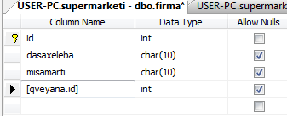
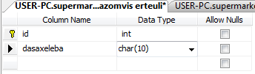
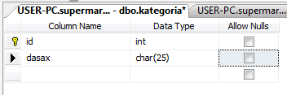
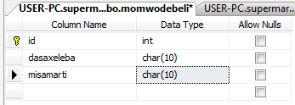
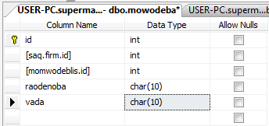
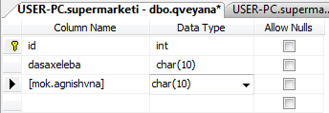
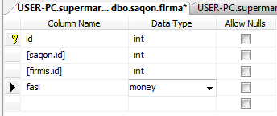
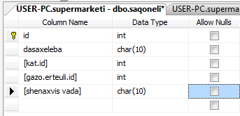

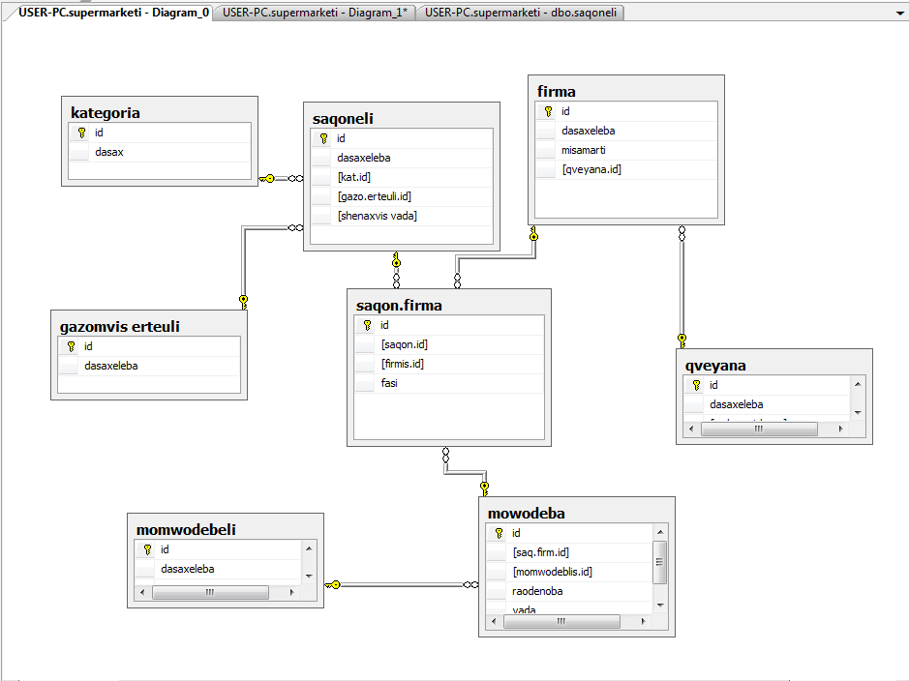

cxrilebis Sevseba:

firma
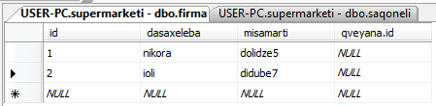

gazomvis erTeuli
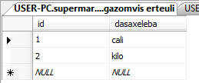
kategoria
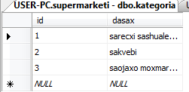

momwodebeli
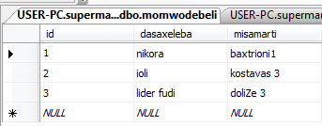
mowodeba
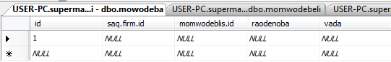

qveyana

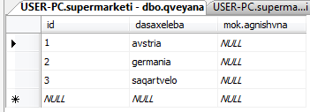
saqonlis firma
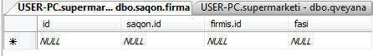

saqoneli
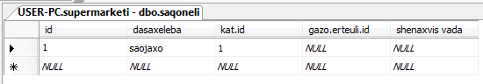

Select brZanebebi:
USE supermarketi;
SELECT firma.id, firma.dasaxeleba, qveyana.dasaxeleba
FROM qveyana;

USE supermarketi;
SELECT firma.misamarti, firma.[qveyana.id], [saqon.firma].id
FROM firma
WHERE [saqon.firma] = 'ID';

USE supermarketi;
SELECT momwodebeli.dasaxeleba, mowodeba.id
FROM momwodebeli
WHERE mowodeba = '1' ;

USE supermarketi;
SELECT saqoneli
FROM [saqon.firma]
WHERE [saqon.id] IN
(SELECT saqoneli
FROM [saqon.firma]
WHERE qveyana IN
(SELECT kategoria
FROM qveyana
WHERE qveyana = 'mok.agnishvna'));

