Bridge Pattern Assignment
Shape and Renderer implementation in Java 17
ShP-2216 Software Design Patterns
Astana IT University School of Computer Engineering
Assignment 3 Individual assignment

1 Introduction
This project separates shape geometry from rendering technology. Circle and Square can each use either an SVG vector renderer or a PNG raster renderer. The program changes the renderer of the same shape objects at runtime while keeping their geometry unchanged.
Bridge fits because shape types and output technologies are separate dimensions. A shape owns its coordinates and size; a renderer controls serialization or pixel painting. Connecting them through a Renderer reference avoids a separate shape subclass for each shape and backend combination.
Bridge role | Project component
Abstraction | Shape abstract class with a Renderer field
Refined Abstractions | Circle and Square
Implementor | Renderer interface
Concrete Implementors | VectorRenderer and RasterRenderer
Client | BridgeDemo constructs objects and switches renderers

Independent variation
A new renderer can implement the existing Renderer contract without changing Shape, Circle or Square. The test-only RecordingRenderer demonstrates this. A new shape can reuse available primitives; a new primitive, such as a triangle, would require extending the narrow Renderer interface and updating both backends.

Bridge and Adapter
Bridge establishes two collaborating hierarchies that can evolve separately. Adapter translates an existing incompatible API into the interface expected by a client. Here both renderers deliberately implement the same contract; no legacy interface needs adaptation. The assignment therefore demonstrates Bridge rather than Adapter [1, 2].

2 UML class diagram
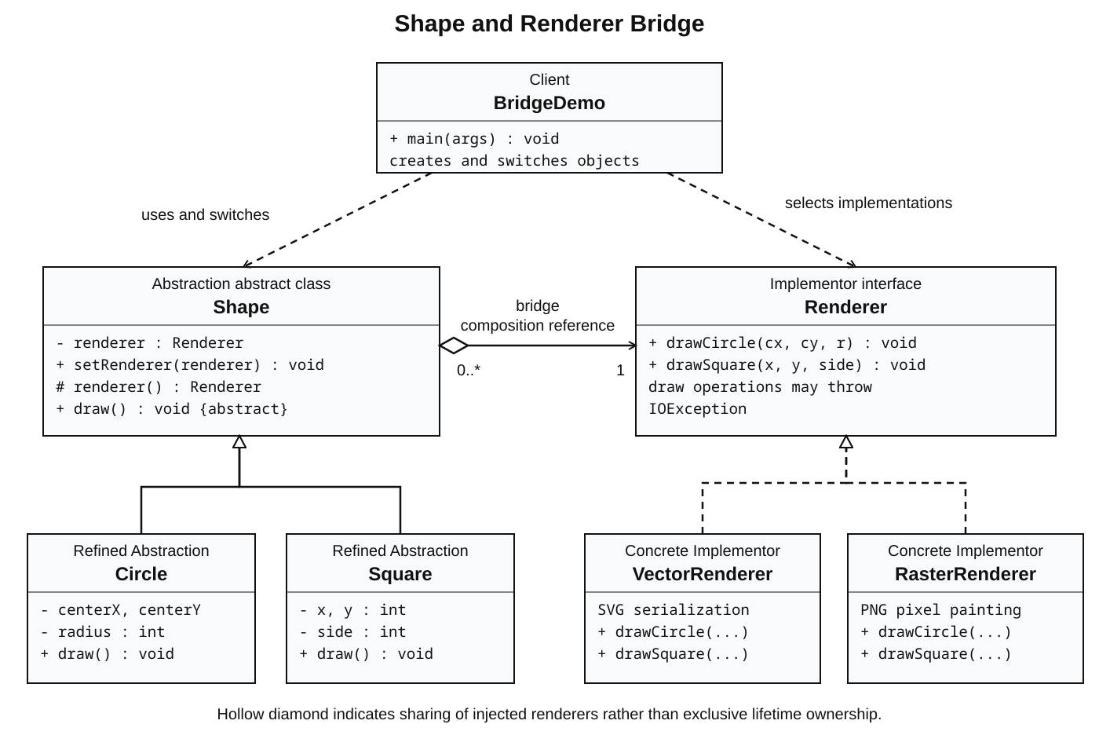
Shape holds one Renderer and delegates drawing through the bridge reference. The hollow diamond indicates sharing of injected renderers. This is composition through a field in the pattern, without exclusive UML lifetime ownership. RenderTarget is a shared output helper.

3 Clean Code principles
The annotated excerpts below come from the submitted implementation. Each shows a concrete boundary or safeguard and explains its effect.

3 1 Separate geometry from output responsibilities
Circle knows circle geometry and asks the implementor to draw it. It never imports SVG, BufferedImage or ImageIO. VectorRenderer handles SVG encoding, while RasterRenderer handles pixel painting. Changes to output encoding stay on the implementation side.
// Circle.java: geometry delegation only
@Override
public void draw() throws IOException {
renderer().drawCircle(centerX, centerY, radius);
}

3 2 Use meaningful names for roles and data
Shape and Renderer distinguish the abstraction from its implementor. VectorRenderer and RasterRenderer reveal the output technology. centerX, centerY, radius and side express the geometric meaning of each argument and field, avoiding opaque names such as a, b or mode.
// Renderer.java: named low-level operations
void drawCircle(int centerX, int centerY, int radius)
throws IOException;
void drawSquare(int x, int y, int side) throws IOException;

3 3 Keep methods focused and classes small
RasterRenderer.drawSquare constructs the square geometry and delegates common PNG encoding to writePng. The helper owns image allocation, background painting, disposal and encoding. The corresponding circle method uses that same helper rather than repeating the entire drawing pipeline.
// RasterRenderer.java: one operation at this level
@Override
public void drawSquare(int x, int y, int side) throws IOException {
writePng("square", new Rectangle2D.Double(x, y, side, side));
}

3 Clean Code principles continued

3 4 Remove repeated output preparation
Both implementations need to create their output directory and resolve a file name. RenderTarget performs that shared logic once. VectorRenderer and RasterRenderer use target.file with their own extension; they retain the distinct encoding work that belongs to each backend.
// RenderTarget.java: shared by both implementors
Path file(String shapeName, String extension) throws IOException {
Files.createDirectories(directory);
return directory.resolve(shapeName + "." + extension);
}

3 5 Depend on a stable interface for extension
Shape holds a Renderer rather than a VectorRenderer or RasterRenderer. A third backend can satisfy this interface and be injected without editing abstraction code. This supports the Open Closed Principle for new implementors, provided the existing primitive contract is sufficient. Runtime replacement remains explicit.
// Shape.java: the bridge depends only on the interface
private Renderer renderer;
public final void setRenderer(Renderer renderer) {
this.renderer = Objects.requireNonNull(renderer,
"renderer must not be null");
}

3 6 Validate invariants at the boundary
Circle and Square share a positive dimension check. Null renderers are rejected at construction and replacement. These guards produce an immediate explanation for invalid input instead of a later drawing failure. A rejected null replacement leaves the previous renderer intact.
// Shape.java: shared validation; subclasses call this once
protected static int requirePositive(int value, String name) {
if (value <= 0) {
throw new IllegalArgumentException(name + " must be positive");
}
return value;
}
// Circle constructor
this.radius = requirePositive(radius, "radius");

4 Demonstration and verification
Run ./run.sh with JDK 17, or run BridgeDemo in IntelliJ IDEA. The client constructs one Circle and one Square with a VectorRenderer, draws them, assigns a RasterRenderer to those same objects, draws again, and switches back. It creates circle.svg and square.svg under rendered/vector, and circle.png and square.png under rendered/raster.
// BridgeDemo.java: shapes were already created and drawn
for (Shape shape : shapes) {
shape.setRenderer(raster);
}
drawAll(shapes); // same objects and stored geometry
Run ./test.sh for the dependency-free checks. The project is compiled with --release 17, -Xlint:all and -Werror. Seven behavioral groups check exact delegation, switching and switching back, invalid input handling, SVG geometry, PNG dimensions and pixels, output failure propagation, and all four demo files. A RecordingRenderer independently verifies the bridge without relying on file encoding.

5 Conclusion
The bridge makes renderer replacement a reference change rather than a change to shape classes. It supports all four shape and backend combinations with two shape classes and two rendering classes. The trade-off is additional interfaces, objects and delegation compared with a single-purpose drawing class.
The narrow drawCircle and drawSquare interface keeps the assignment easy to follow, but introducing a genuinely new drawing primitive requires changes across implementations. A general path API could reduce that coupling at the cost of a more complex contract. The demo uses a fixed 320 by 320 canvas and one output file per shape type; repeated drawings overwrite their previous file, and out-of-viewport geometry is clipped. Concurrent writes to the same output directory are outside the scope of this example.
IOException is propagated so output failures remain visible. The tests verify observable behavior, including real SVG and PNG artifacts, while the in-class walkthrough demonstrates the design and the runtime switch directly.

6 Repository and references
Public GitHub repository
https://github.com/Ziyadin23/assignment-3-bridge-pattern
[1] Refactoring.Guru. Bridge. https://refactoring.guru/design-patterns/bridge
[2] Refactoring.Guru. Adapter. https://refactoring.guru/design-patterns/adapter
[3] Assignment 3 Bridge Pattern Instructions. ShP-2216 course document supplied with the assignment.

