Home Theater Facade Pattern Report
Assignment 4 | ShP-2216 Software Design Patterns
Ziyadinkhan Kudaibergenuly
Chosen topic: Option B Home Theater Facade
Language: Java 17

1 Introduction
A movie session requires coordinated work across a DVD player, amplifier, projector, screen, and room lights. A client that controls these devices directly must know when a disc can be loaded, when an audio or video source is ready, and how to restore the room after the session. Repeating this sequence in each client increases coupling and makes ordering mistakes more likely.
The implementation provides HomeTheaterFacade, a single entry point with watchMovie(String title) and endMovie(). It manages device construction, session order, movie settings, and recovery. Five independently usable subsystem classes retain their own behavior and validation. This is an executable stateful simulation; it does not claim physical hardware control or video decoding.

Subsystem responsibilities
Class | Responsibility
DvdPlayer | Validates the catalogue, loads a movie, and advances bounded playback time.
Amplifier | Routes a playing DVD source and validates volume from 0 to 10.
Projector | Checks lamp health, live video input, and lowered screen position.
Screen | Stores screen position and calculates diagonal size from width and aspect ratio.
TheaterLights | Validates brightness from 0 to 100 and retains the current setting.

Client.java uses only the facade. The amplifier and projector inspect the DVD player directly, and the projector also uses the screen. These interactions give the subsystem meaningful dependencies that the common client does not have to coordinate.

2 UML class diagram
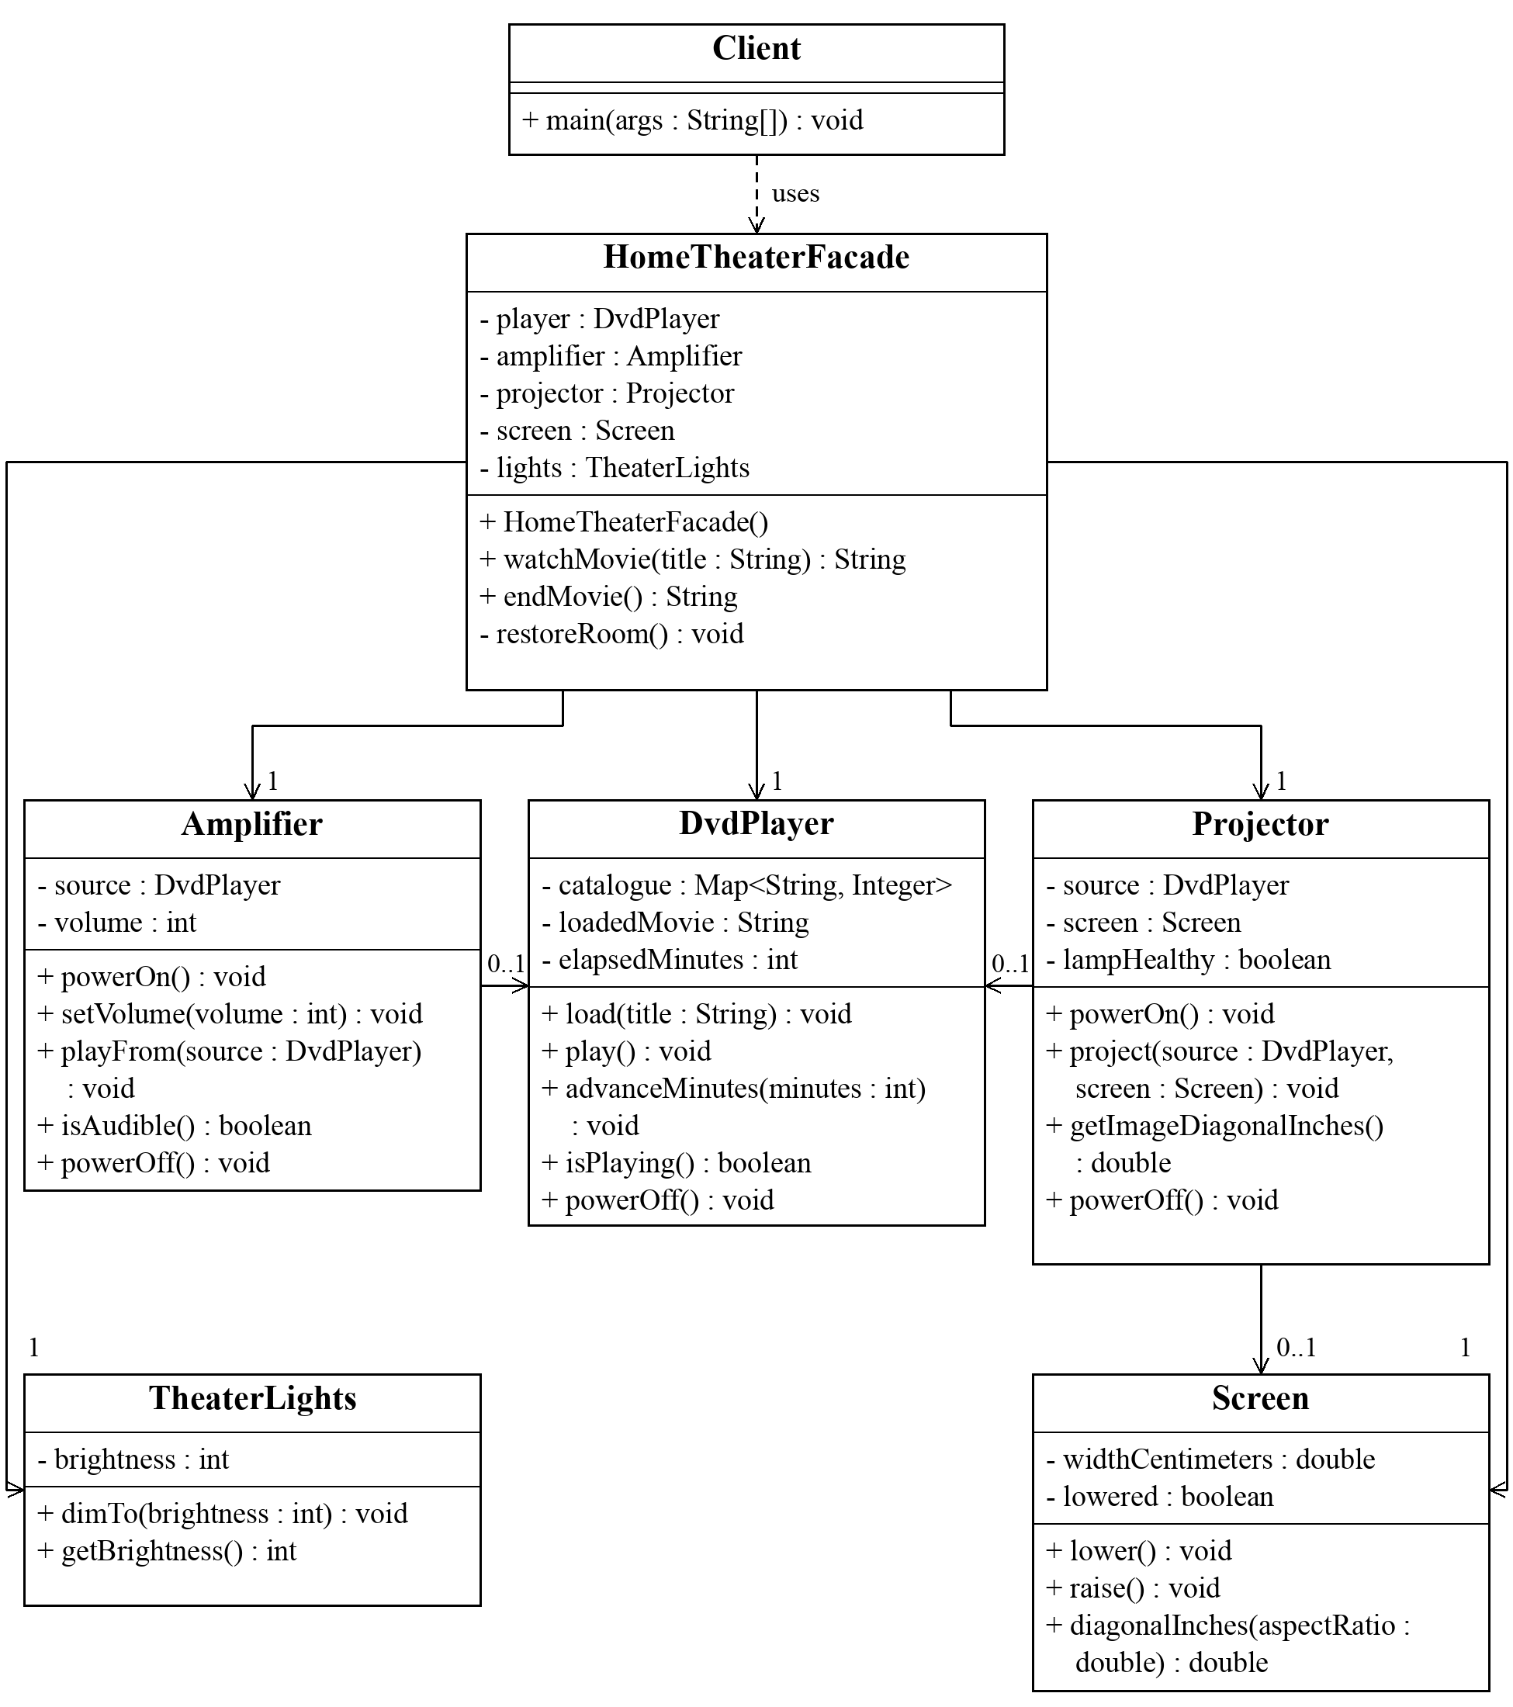
Figure 1. Class diagram with selected attributes and operations. Solid arrows show navigable associations; the dashed arrow shows the client dependency. A facade holds one of each device. Audio and video references are optional before a source is connected, hence 0..1. The symbols + and − mean public and private members. No subsystem references the facade.

3 Coordination and failure handling
The public no-argument constructor creates five devices. A package-private constructor accepts test fixtures without exposing device types in the public API. Both public session operations return readable session reports.

Starting and ending a session
Startup order: reject an overlapping session, validate the title, save the old brightness, dim lights, lower the screen, power on and load the DVD, begin playback, configure the amplifier and route audio, then power on the projector and route video to the lowered screen. The session is marked active only after all setup succeeds.
This order follows device preconditions: playback needs a powered player and loaded disc; audio routing needs a playing source; projection needs both a playing source and a lowered screen. Shutdown disconnects the projector and amplifier before stopping the shared DVD source, then raises the screen and restores the saved brightness.

Client before and after the facade
Before assumes device variables already exist; the submitted Client uses the after version.
lights.dimTo(15);
screen.lower();
player.powerOn();
player.load("Interstellar");
player.play();
amplifier.powerOn();
amplifier.setVolume(5);
amplifier.playFrom(player);
projector.powerOn();
projector.project(player, screen);
// The client must also implement shutdown and failure cleanup.
// After: the only application dependency is the facade.
HomeTheaterFacade theater = new HomeTheaterFacade();
theater.watchMovie("Interstellar");
theater.endMovie();

Recovery and scope
Invalid titles are rejected before any state changes. If setup subsequently fails, restoreRoom powers off devices, raises the screen, restores the saved brightness, and clears the active session. A new IllegalStateException keeps the original failure as its cause. Repeated endMovie calls are harmless.
The program is synchronous and designed for one caller. Cleanup operations cannot fail in this simulation. Physical hardware would require independent cleanup attempts, reporting of cleanup failures, and explicit timeout and concurrency policies.

4 Clean Code principles
Each principle below is justified by an annotated excerpt from the submitted implementation. The code paths are relative to src/main/java/theater.

Meaningful names
Names express user intent and device preconditions. watchMovie and endMovie describe the session outcome, while requireAvailable identifies catalogue validation. These names let a reader understand the client without learning internal power and routing operations. The public API avoids generic names such as execute or process.
// Client.java: operations describe the requested outcome.
System.out.println(theater.watchMovie(movie));
System.out.println(theater.endMovie());

Single responsibility
The facade coordinates and the DVD player owns playback logic. watchMovie delegates loading and playback instead of reproducing catalogue lookup or playback calculations. DvdPlayer advances time, prevents integer overflow by bounding the increment, and stops at the movie duration. Changes to playback rules stay inside DvdPlayer.
// HomeTheaterFacade.java: delegate device behavior.
player.load(title);
player.play();
// subsystem/DvdPlayer.java: the player enforces duration.
int duration = catalogue.get(loadedMovie);
elapsedMinutes += Math.min(minutes, duration - elapsedMinutes);

Encapsulation of subsystem details
Only a title and confirmation strings cross the public facade API. The device references are private and there are no public device getters. The ordinary client therefore cannot accidentally select a projector source or change a device halfway through setup. Independent device classes remain public for advanced users who deliberately bypass the facade.
// HomeTheaterFacade.java: hide device references.
private final DvdPlayer player;
private final Projector projector;
// Public signatures expose no subsystem classes.
public String watchMovie(String title)
public String endMovie()

5 Further Clean Code principles

Small focused subsystem classes
Each class owns a narrow set of rules. TheaterLights validates a brightness percentage; Screen manages position and geometry; Amplifier manages sound; Projector checks video readiness. These rules remain reusable without a movie-session controller. The light method rejects an out-of-range value before changing the stored state.
// subsystem/TheaterLights.java: one focused responsibility.
public void dimTo(int brightness) {
if (brightness < 0 || brightness > 100) {
throw new IllegalArgumentException("Brightness must be between 0 and 100.");
}
this.brightness = brightness;
}

Proper error handling
Validation precedes mutation, and setup failures preserve their cause. The facade first checks that a movie exists. A later failure, such as a defective projector lamp, returns the room to idle even when playback and audio have already started. The original exception remains available for diagnosis instead of being silently discarded.
// HomeTheaterFacade.java: validate before preparing devices.
player.requireAvailable(title);
previousBrightness = lights.getBrightness();
// Catch block after the ordered setup sequence.
} catch (RuntimeException failure) {
restoreRoom();
throw new IllegalStateException("Could not start movie: " + title, failure);
}

Named constants and shared cleanup
Named settings explain policy, and one cleanup method prevents divergence. MOVIE_BRIGHTNESS and MOVIE_VOLUME replace unexplained numbers in orchestration. Normal shutdown and failed startup both call restoreRoom, so future changes to the device shutdown order apply consistently. The previous brightness is restored rather than always forcing the room to full brightness.
// HomeTheaterFacade.java: readable movie settings.
private static final int MOVIE_BRIGHTNESS = 15;
private static final int MOVIE_VOLUME = 5;
// endMovie and the startup catch block both call:
restoreRoom();
// Cleanup restores the saved setting.
lights.dimTo(previousBrightness);

6 Verification and demonstration
The complete source and tests were compiled and executed using Eclipse Temurin JDK 17.0.20.1. Compilation used --release 17 -Xlint:all -Werror and produced no warnings. The dependency-free test runner completed 14 of 14 tests successfully. Full output is included in docs/test-results.txt.
Test | Expected behavior | Result
Complete session | All devices active, followed by an idle room. | Pass
Previous lighting | A saved brightness of 65 is restored. | Pass
Repeated shutdown | Ending an idle session is harmless. | Pass
Invalid titles | Null, blank, and unknown titles leave devices unchanged. | Pass
Overlapping sessions | A second request preserves the active movie. | Pass
Failed startup | A defective lamp triggers cleanup and retains the cause. | Pass
Repair and retry | A repaired lamp allows a new session. | Pass
Direct device use | An advanced client computes a 125 inch image without a facade. | Pass
Source state | Audio and video become inactive when playback stops. | Pass
Playback completion | Time is bounded by duration and replay resets position. | Pass
Numeric settings | Invalid ranges and non-finite geometry are rejected. | Pass
Unsafe ordering | Missing power, disc, source, or lowered screen is rejected. | Pass
API boundary | Public signatures contain no subsystem types. | Pass
Catalogue integrity | Invalid entries are rejected and the catalogue is copied. | Pass

Live demonstration
Run ./scripts/run.sh and ./scripts/test.sh from the repository root. The expanded demo shows numbered setup steps, device states, the image diagonal, and shutdown. Selected final messages appear below; the full verified transcript is in docs/demo-output.txt.
Now watching: Interstellar
Movie ended. Devices off, screen raised, previous lighting restored.
No movie session is active.
Running ./scripts/run.sh "Unknown Movie" reports an unavailable title and exits with status 1. The failed-lamp integration test demonstrates cleanup after partial setup, including restoration of a brightness of 42.

7 Conclusion and repository
The facade hides construction, setup order, routing, default settings, and recovery. The application expresses a movie-session request through two methods while five device classes enforce the underlying rules. This reduces the number of subsystem dependencies in Client to zero and gives the client one stable entry point.
Direct subsystem access remains available. Advanced clients can create their own devices, supply a different catalogue, select volume and brightness, set an aspect ratio, or replace the projector lamp. They take responsibility for the order and validity of their direct calls. The subsystem classes never call the facade and remain independently useful.
The implementation therefore satisfies the essential Facade properties: a genuinely simplifying interface, several collaborating subsystem classes, a facade-only ordinary client, and subsystem independence. A second facade is unnecessary for the present movie-session scope; a separate music or maintenance workflow could justify one later.

GitHub repository
https://github.com/Ziyadin23/assignment-4-home-theater-facade
The repository includes compiling Java source, build and test scripts, README.md, the UML image and editable PlantUML source, verification output, the report, and a defense guide. The commit history records separate implementation, facade, testing, and documentation stages.

Defense preparation
The walkthrough should begin at Client, follow watchMovie into the device preconditions, and end with restoreRoom and the failure test. The live demonstration shows a successful session, harmless repeated shutdown, and an invalid request. The test suite also demonstrates subsystem use without a facade.
Be ready to explain why this design is a Facade, what complexity it hides, why the devices remain directly usable, how it differs from Adapter and Mediator, and why cleanup order matters. Detailed prompts and answers are included in docs/defense-guide.md.

References
1. Assignment 4 Facade Pattern Instructions. ShP-2216 Software Design Patterns, Astana IT University. Supplied course document.
2. Refactoring Guru. Facade. https://refactoring.guru/design-patterns/facade
3. Oracle. Java SE 17 API documentation for IllegalStateException. https://docs.oracle.com/en/java/javase/17/docs/api/java.base/java/lang/IllegalStateException.html

