Strategy Pattern Calculator Report
Course ShP-2216 Software Design Patterns, Astana IT University Assignment 5, Option B Calculator Repository: Ziyadin23/assignment-5-strategy-pattern

1 Introduction
This calculator implements a family of binary arithmetic algorithms: addition, subtraction, and multiplication. Each algorithm implements OperationStrategy. Calculator keeps the selected strategy and delegates calculations to it. The client can replace that strategy while the same calculator object is running.
Strategy is a behavioral design pattern: an object changes its behavior by receiving a different implementation of a common algorithm interface. Here, the operands remain 12 and 4, while changing the strategy produces 16, 8, and 48. A separate division extension demonstrates adding an algorithm without changing the original application classes.

2 UML class diagram
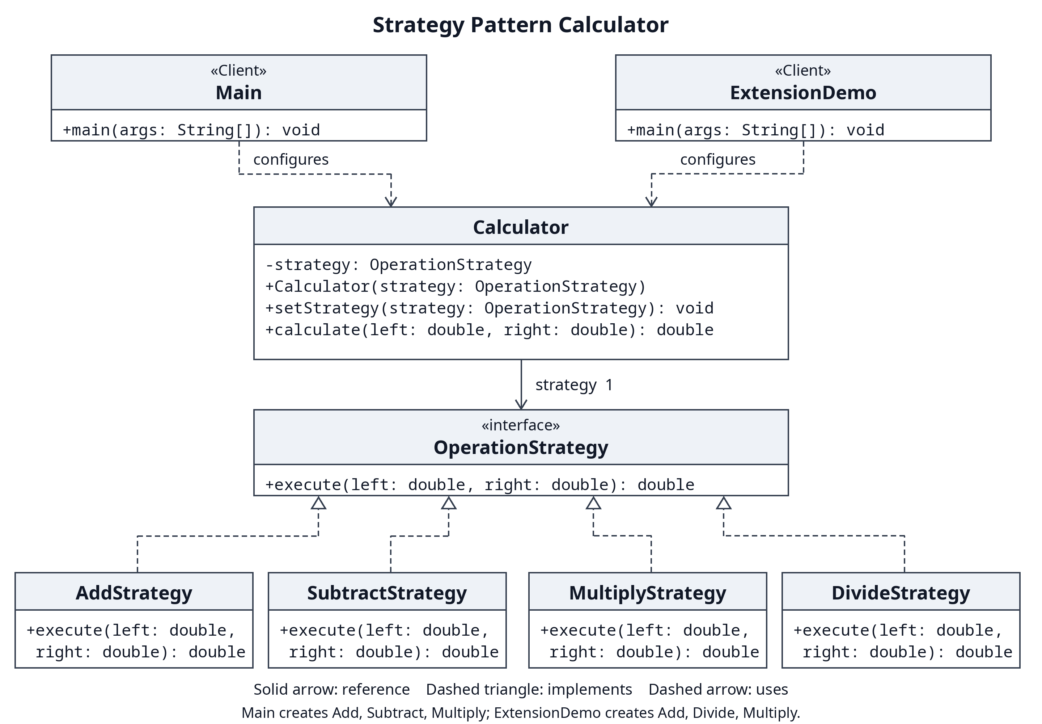
The editable diagram is uml.mmd; uml.svg is a vector copy.
Pattern role | Implementation | Responsibility
Strategy | OperationStrategy | Declares execute(double left, double right)
Concrete strategies | AddStrategy, SubtractStrategy, MultiplyStrategy | Encapsulate one arithmetic algorithm each
Context | Calculator | Stores one strategy, replaces it, and delegates execution
Client | Main | Creates strategies, selects them, and handles console input
Extension | DivideStrategy and ExtensionDemo | Add division and wire it into the original context

The solid arrow from Calculator to OperationStrategy represents its stored reference. Dashed arrows with hollow triangles mean that concrete strategies implement the interface. Dashed arrows from the clients mean they use the context. There is no ownership diamond: the context accepts a supplied object, and a stateless strategy could be shared.

3 Clean Code principles

1 Replace algorithm selection conditionals with polymorphism
A hypothetical earlier implementation would select arithmetic inside the context:
// Before: illustrative code, not part of the application.
return switch (operation) {
case "add" -> left + right;
case "subtract" -> left - right;
case "multiply" -> left * right;
default -> throw new IllegalArgumentException();
};
The actual context executes the selected object:
// Calculator.calculate: Java dispatches to the selected implementation.
return strategy.execute(left, right);
This removes the arithmetic decision tree from Calculator. The client's command lookup and input validation still use control flow. Strategy removes algorithm selection from the context; it does not eliminate all program branches.

2 Use meaningful names
// SubtractStrategy.execute names both the operation and operand order.
public double execute(double left, double right) {
return left - right;
}
SubtractStrategy, left, and right explain what happens without names such as Algorithm2 or x. Operand order matters for subtraction and division.

3 Give each class one responsibility
// AddStrategy has no parsing, printing, or strategy selection.
public double execute(double left, double right) {
return left + right;
}
An arithmetic change belongs to its strategy. A console interaction change belongs to Main. Calculator manages delegation. Separating these reasons to change keeps each class small and focused.

4 Depend on an abstraction
// Calculator stores the contract, not AddStrategy or another concrete type.
private OperationStrategy strategy;
public Calculator(OperationStrategy strategy) {
setStrategy(strategy);
}
The context knows only the common interface. A test supplies an unfamiliar implementation and verifies that the context forwards both operands once. This is dependency inversion and makes isolated testing straightforward.

5 Extend behavior without modifying stable classes
// In the new ExtensionDemo client:
calculator.setStrategy(new DivideStrategy());
System.out.println("DivideStrategy: " + calculator.calculate(12, 4));
DivideStrategy implements the existing interface. The division extension commit adds two production classes and changes no original Java class. The context and the three original algorithms therefore stay closed to this change while accepting the new behavior. Client wiring is still necessary; this example places it in a new client. Adding a division command to the original interactive menu would require changing that client's registry.

6 Keep methods small and cohesive
// One method updates the strategy and checks its invariant.
public void setStrategy(OperationStrategy strategy) {
this.strategy = Objects.requireNonNull(strategy, "Strategy must not be null");
}
The setter only replaces a valid reference; calculate only delegates. Main.runInteractive manages the input loop, and executeCommand processes one command. A null replacement fails before assignment, preserving the previous strategy. These boundaries make behavior easy to read and test.

4 Verification and runtime demonstration
Run with JDK 17 and Bash:
./scripts/run.sh
./scripts/run.sh --interactive
./scripts/extension.sh
./scripts/test.sh
The default demo reuses one context and prints 16.0, 8.0, and 48.0. The extension reuses another single context and prints 16.0, 3.0, and 48.0. All 34 named tests pass: 27 cover the core and console, and seven cover division. Tests check arithmetic, switching back to a previous strategy, delegation, null handling, invalid input recovery, and both signed zero divisors. They use explicit assertions and a failing process status without external libraries.
The project compiles with --release 17 -Xlint:all -Werror. Arithmetic uses double, so decimal rounding and overflow follow Java behavior. The console rejects non-finite input; division rejects zero. The example is single-threaded.

5 Advantages and disadvantages
Advantages in this project | Costs and limitations
Algorithms can change independently | Each named algorithm adds a small class
One context changes behavior at runtime | Clients must know which strategy to select
New strategies reuse the original context | New client wiring or registration is still needed
Algorithms and delegation can be tested separately | More indirection can be excessive for three simple operations

6 Conclusion
The calculator gains runtime flexibility through one interface and a replaceable reference. Division shows that the original context does not need to grow with the algorithm family. The cost is extra classes and client configuration. For a tiny fixed calculator a conditional would be shorter; this design becomes more useful as algorithms grow or change independently.

References
- Assignment 5 Strategy Pattern Instructions, supplied course document, sections 2 through 5.
- Refactoring Guru Strategy, pattern roles and tradeoffs.
- Oracle Java 17 Objects, requireNonNull contract.
Repository: https://github.com/Ziyadin23/assignment-5-strategy-pattern

