ASTANA IT UNIVERSITY
School of Computer Engineering
ShP-2216 Software Design Patterns

Assignment 1
Builder Pattern for a Car
Student: Ziyadinkhan Kudaibergenuly
Group: SE 2501

Astana 2026

1 Introduction
The topic of this assignment is the Builder creational design pattern. I chose Car as the product. A car is suitable for this pattern because it has several parts, such as a model, engine, number of seats, transmission, color, and additional features. These values can be added step by step instead of passing all of them to one long constructor.
The project creates two types of cars: a passenger car and a sports car. Both builders use the same construction methods, but they have different validation rules. The passenger car must have from four to seven seats. The sports car can have no more than two seats and must have at least 300 horsepower.

2 Implementation
Car is the Product class. CarBuilder is an abstract Builder class that stores temporary values and provides the common setter methods. PassengerCarBuilder and SportsCarBuilder are the two Concrete Builders. CarDirector contains two ready construction sequences, and Main is the Client that runs the program and prints the results.
The setter methods return the builder object. Because of this, the methods can be called one after another. This is called method chaining or a fluent API.
return builder
.setModel("Toyota Camry")
.setEngine("2.5L Hybrid", 218)
.setSeats(5)
.setTransmission("Automatic")
.setColor("White")
.addFeature("Air conditioning")
.addFeature("Parking camera")
.build();

3 UML Class Diagram
Figure 1 shows the main classes and their relationships. The two concrete builders inherit from CarBuilder. CarBuilder creates the Car product. CarDirector uses CarBuilder, while Main uses the Director.
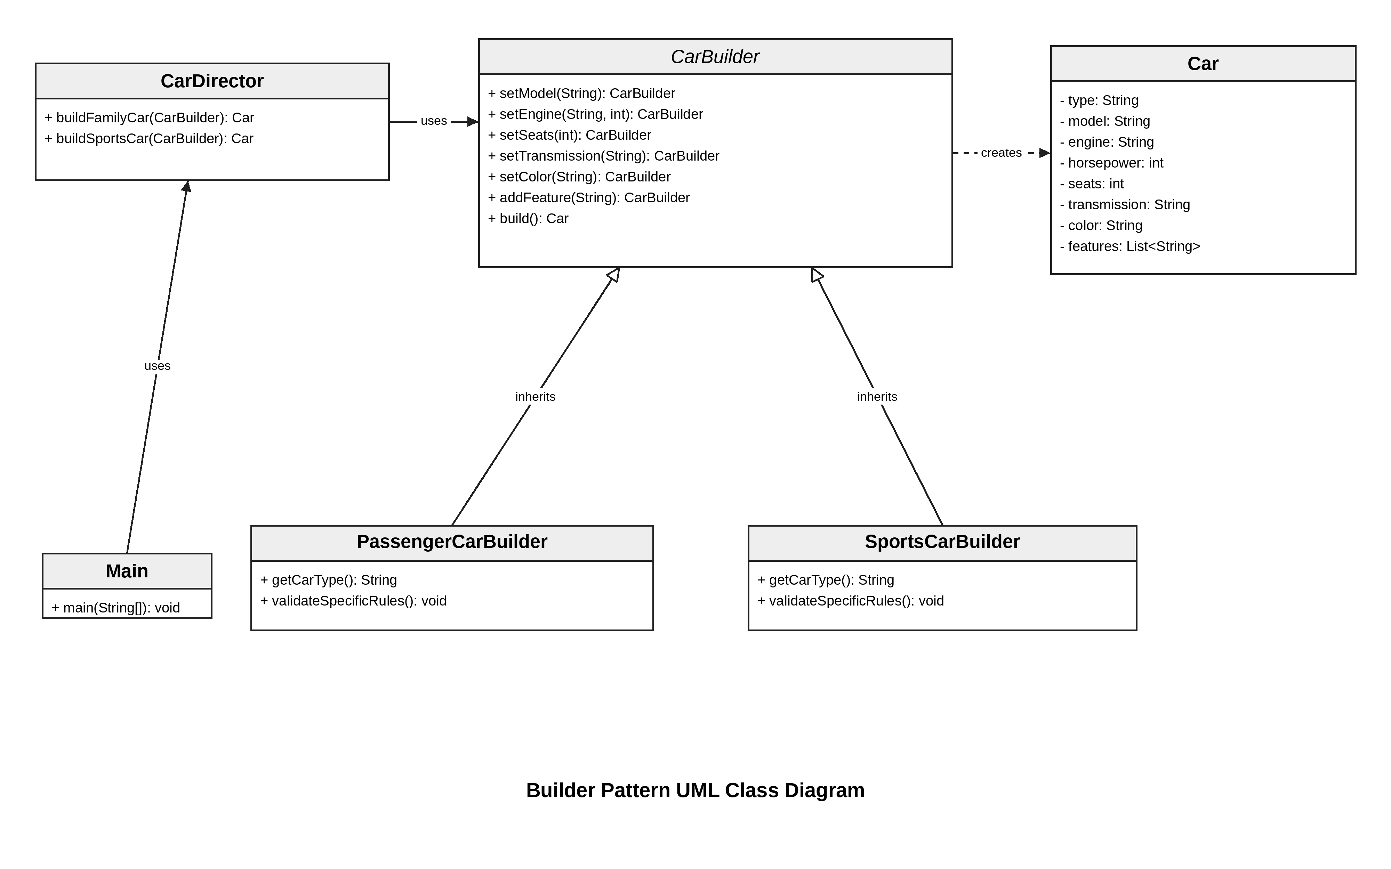
Figure 1 UML class diagram

4 Clean Code Principles
I applied the following Clean Code principles in the project. The examples below are taken from the source code.

4 1 Meaningful Names
The class and method names describe their purpose. For example, buildFamilyCar clearly says what kind of object will be created. A name such as build1 would not explain the method.
Car familyCar = director.buildFamilyCar(new PassengerCarBuilder());
Car sportsCar = director.buildSportsCar(new SportsCarBuilder());

4 2 Small Classes and Methods
Each class has one main responsibility. Car stores the final data, CarDirector contains the construction sequences, and the concrete builders contain their own rules. The following method only checks the passenger car seat rule.
protected void validateSpecificRules() {
if (seats < MIN_SEATS || seats > MAX_SEATS) {
throw new IllegalStateException(
"A passenger car must have 4 to 7 seats");
}
}

4 3 No Duplicated Builder Methods
The common setter methods are written once in CarBuilder. The concrete builders inherit them, so PassengerCarBuilder and SportsCarBuilder do not repeat the same code.
public CarBuilder setSeats(int seats) {
this.seats = seats;
return this;
}

4 4 Validation
The build method checks the data before creating a Car. If an important value is missing, the program gives a clear exception instead of creating an incorrect object.
if (model == null || model.isBlank()) {
throw new IllegalStateException("Model is required");
}
if (engine == null || engine.isBlank()) {
throw new IllegalStateException("Engine is required");
}

4 5 No Magic Numbers
The sports car limits are stored in named constants. The constants make the meaning of 2 and 300 clear and make the values easier to change later.
private static final int MAX_SEATS = 2;
private static final int MIN_HORSEPOWER = 300;

5 Conclusion
During this assignment, I found that the main advantage of Builder is readability. The named methods make it clear which value is being set, and optional features can be added without creating many constructors. The Director is also useful because it keeps common car configurations in one place.
The disadvantage is that the pattern needs more classes than a normal constructor. It also takes some time to decide which code belongs in the main builder and which code belongs in the concrete builders. For a very simple object, Builder would be unnecessary, but it is suitable for this Car example because the object has many parts and different configurations.

6 GitHub Repository
https://github.com/Ziyadin23/car-builder-pattern

