**وزارة التعليم**

**جامعة الملك سعود**

**كلية علوم الحاسب والمعلومات**

**قسم علوم الحاسب**

**مشروع قواعد البيانات**

**(HOSPITAL**)

**إعداد الطالبين/**

**الاسم:** زياد محمد السمحان **الرقم الجامعي:**435104871

**الاسم:** يوسف محمد المسعد  **الرقم الجامعي:**435104311

**دكتور المقرر/عامر طوير**

**المقرر: أسس نظم قواعد البيانات**

**رمز المقرر:CSC380**

**رقم الشعبة:21959**

**ER-Description**

-The hospital has (id,name) each hospital has many branches .

*ID must be unique and not null.

-Each hospital branch has (BNumber ,Location) and it must have a relation with one hospital.

every branch may have many department .

*Hospital branch number (BNumber) must be unique and not null.

-Each department has (DNumber ,DName) the department must have relation with one branch.

Each department must have a doctor that mange’s the department, and it must have at least one doctor works for it.

*Department number (DNumber) must be unique and not null.

-Each doctor has (SSN , FName , LName, Sex) every doctor must have a relation with one department.

Each doctor may mange’s a department.

Each doctor has one relation with the patient (appointment )the doctor may have one or more appointments with the patients.

*SSN must be unique and not null.

-Each patient has(ID, SSN, sex , Fname, Lname ) each patient may have one appointment or more with the doctors.

*ID must be unique and not null.

-each appointment has (AppNo,price,Ap_date(time ,date), prescription).

*Appointment number (AppNo) must be unique and not null.

**ER-** **diagram**

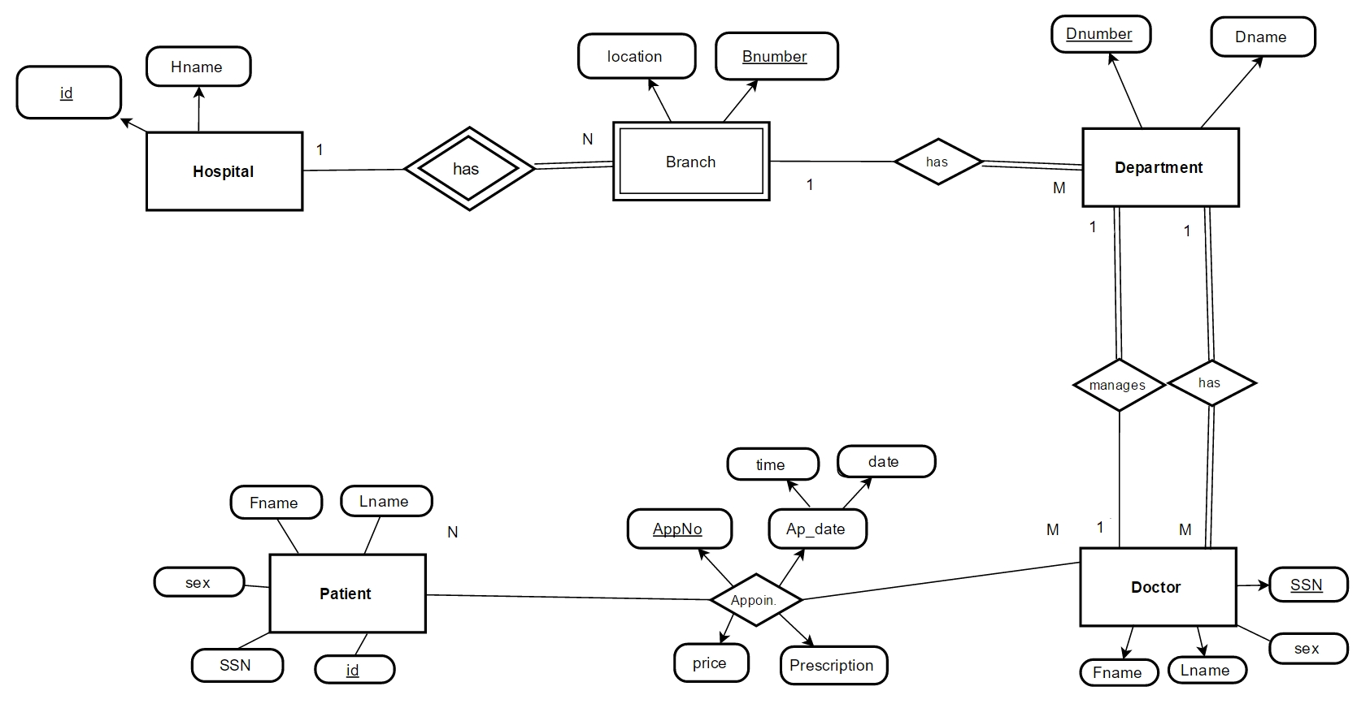

**Relational Schema**

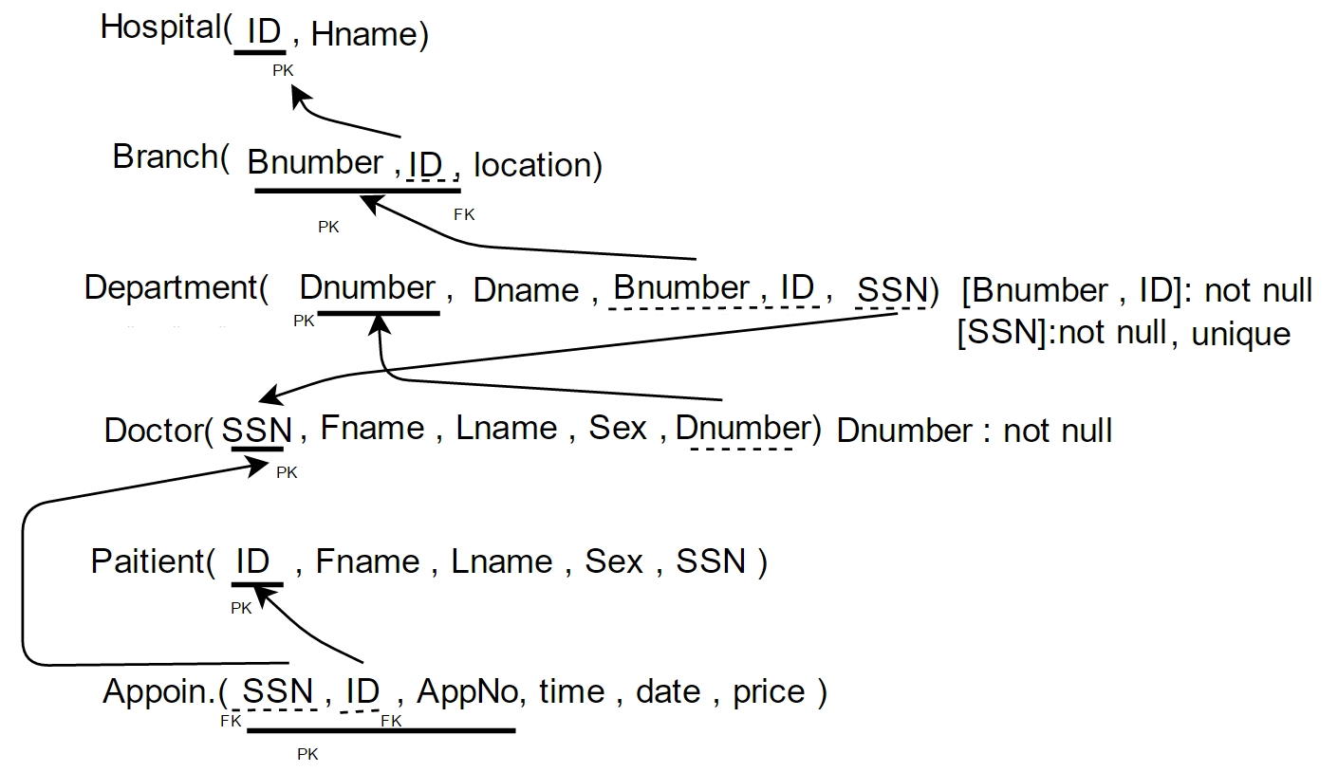

Our DBMS is MySQL and our environment will be Java.

and the connection was by using the “connection” attribute by importing the library java.sql.connection and using these statements.

**Class**.*forName*("com.mysql.jdbc.Driver");

con=**DriverManager**.*getConnection*("jdbc:mysql://localhost:3306/Hospital" , "root", "*********");

st = con.createStatement();

The methods that we are going to implement are:

**getData()**

this method will print information from the Database.

**Search()**

This method searches for the element\item that the user needs

**Insert()**

This method inserts tuples to the database

**Delete()**

This method deletes information from the database

We might also implement the method **edit()** .. that edits an information in the database