Corner Grocer Item Tracker – Design and Functionality
CS-210 Project Three
Design
The program is organized around a single GroceryTracker class that separates its public interface from its private data, satisfying the requirement for a class with public and private sections. The private section holds the input and backup file names along with a std::map<std::string, int> that pairs each item name with the number of times it was purchased. A map was chosen because it stores items in sorted order automatically and provides fast key lookups, which keeps the menu options simple and efficient. The public section exposes the methods main() needs: LoadDataFromFile, BackupDataToFile, GetFrequencyOfItem, PrintAllFrequencies, and PrintHistogram. A private helper, NormalizeCase, standardizes capitalization so that the same item written in different cases is counted only once.
Functionality
At startup, main() constructs a GroceryTracker, loads CS210_Project_Three_Input_File.txt, and immediately writes the backup file frequency.dat without any user action, fulfilling the data-file requirement. The program then loops on a four-option menu. Option One prompts for an item and reports its purchase count using a map lookup that returns zero when the item is absent. Option Two lists every item with its numeric frequency. Option Three prints the same data as a histogram, drawing one asterisk per purchase. Option Four exits cleanly by ending the loop. Input validation guards the menu: non-numeric entries and values outside the range 1 through 4 are rejected and the user is re-prompted, demonstrating the optional input-validation challenge.
Best Practices
The code applies industry-standard conventions throughout. Descriptive names such as itemFrequencies and GetFrequencyOfItem make the intent clear, the class interface is declared in a header and defined in a separate source file, and in-line comments explain the purpose of each method and the reasoning behind key decisions. File streams are checked before use and closed after reading or writing, and the menu loop confirms the program responds predictably to both valid and invalid input.
Screenshots
Menu Option 1 – Frequency of a specific item
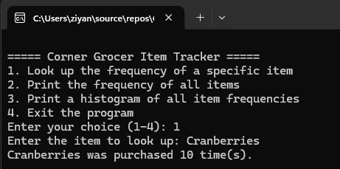
Menu Option 2 – Frequency of all items
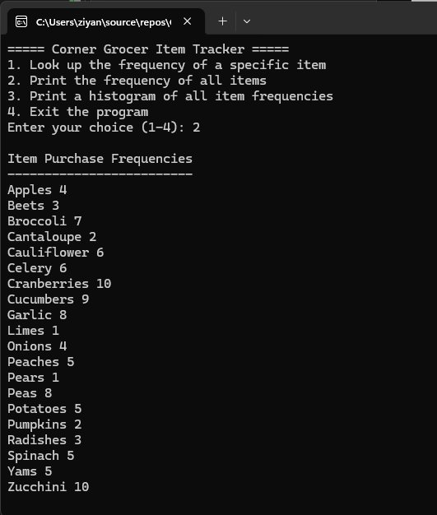
Menu Option 3 – Histogram of all item frequencies
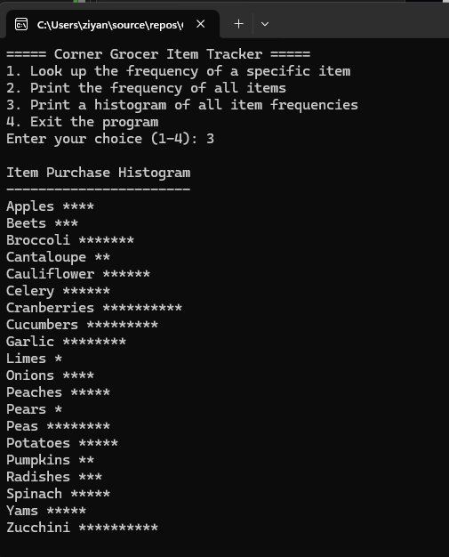
AI usage acknowledgment: Generative AI (Anthropic’s Claude) was used to assist with formatting and resolving syntax errors in this project.

