DAD 220 Project One Template
Quantigration RMA Database
Name: Ziyan Noorani
Course: DAD-220 Introduction to Structured Database Environments
Date: May 26, 2026
This document captures the SQL commands and verified results for each step of the Quantigration RMA database project. All commands were executed in the Codio MySQL environment.

Step One: Create a Database

1. Create the QuantigrationUpdates Database Schema
From the Codio terminal I logged into MySQL, created the QuantigrationUpdates database, ran SHOW DATABASES to confirm it appeared, and switched into it with USE.
SQL Commands:
CREATE DATABASE QuantigrationUpdates;
SHOW DATABASES;
USE QuantigrationUpdates;
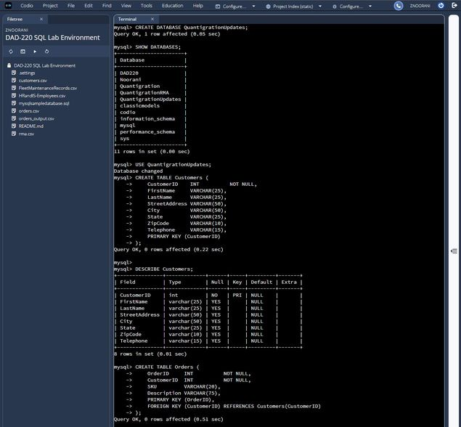
The screenshot confirms QuantigrationUpdates was created successfully and is listed by SHOW DATABASES. The USE statement switches the active schema so the subsequent CREATE TABLE commands run inside it.

2. Create the Customers Table
Based on the ERD, the Customers table uses CustomerID as its primary key and seven additional VARCHAR columns to store contact and address information.
SQL Commands:
CREATE TABLE Customers (
CustomerID INT NOT NULL,
FirstName VARCHAR(25),
LastName VARCHAR(25),
StreetAddress VARCHAR(50),
City VARCHAR(50),
State VARCHAR(25),
ZipCode VARCHAR(10),
Telephone VARCHAR(15),
PRIMARY KEY (CustomerID)
);
DESCRIBE Customers;
The screenshot above shows the table being created and DESCRIBE Customers confirming all eight columns with CustomerID marked as PRI (primary key).

3. Create the Orders Table
The Orders table uses OrderID as its primary key. CustomerID is a foreign key that links each order back to the customer who placed it.
SQL Commands:
CREATE TABLE Orders (
OrderID INT NOT NULL,
CustomerID INT NOT NULL,
SKU VARCHAR(20),
Description VARCHAR(75),
PRIMARY KEY (OrderID),
FOREIGN KEY (CustomerID) REFERENCES Customers(CustomerID)
);
DESCRIBE Orders;
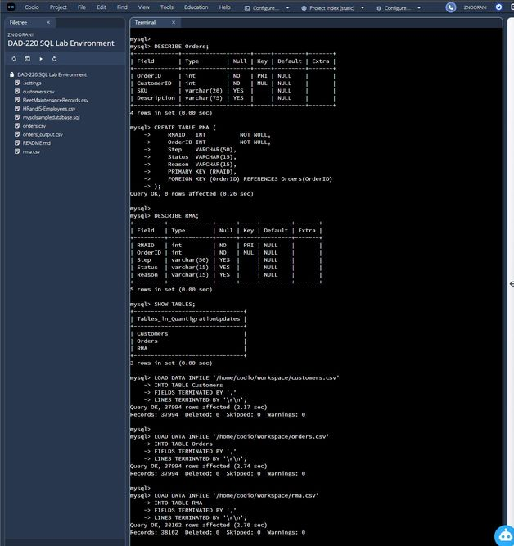
DESCRIBE Orders confirms OrderID is the primary key (PRI) and CustomerID is indexed as a foreign key (MUL). The relationship between Orders and Customers is now enforced by MySQL.

4. Create the RMA Table
The RMA table uses RMAID as its primary key and OrderID as a foreign key linking each return back to its original order. Step, Status, and Reason capture where the returned item is in the RMA workflow.
SQL Commands:
CREATE TABLE RMA (
RMAID INT NOT NULL,
OrderID INT NOT NULL,
Step VARCHAR(50),
Status VARCHAR(15),
Reason VARCHAR(15),
PRIMARY KEY (RMAID),
FOREIGN KEY (OrderID) REFERENCES Orders(OrderID)
);
DESCRIBE RMA;
SHOW TABLES;
DESCRIBE RMA confirms the structure, and SHOW TABLES (visible in the screenshot above) lists all three tables — Customers, Orders, and RMA — inside the QuantigrationUpdates schema, completing Step One.

Step Two: Load and Query the Data

5. Import Data from CSV Files
I used LOAD DATA INFILE with \r\n line terminators to import each CSV into its matching table. Per the project instructions, IGNORE 1 LINES was not used because the source files do not contain header rows.
SQL Commands:
LOAD DATA INFILE '/home/codio/workspace/customers.csv'
INTO TABLE Customers
FIELDS TERMINATED BY ','
LINES TERMINATED BY '\r\n';

LOAD DATA INFILE '/home/codio/workspace/orders.csv'
INTO TABLE Orders
FIELDS TERMINATED BY ','
LINES TERMINATED BY '\r\n';

LOAD DATA INFILE '/home/codio/workspace/rma.csv'
INTO TABLE RMA
FIELDS TERMINATED BY ','
LINES TERMINATED BY '\r\n';

SELECT COUNT(*) FROM Customers;
SELECT COUNT(*) FROM Orders;
SELECT COUNT(*) FROM RMA;
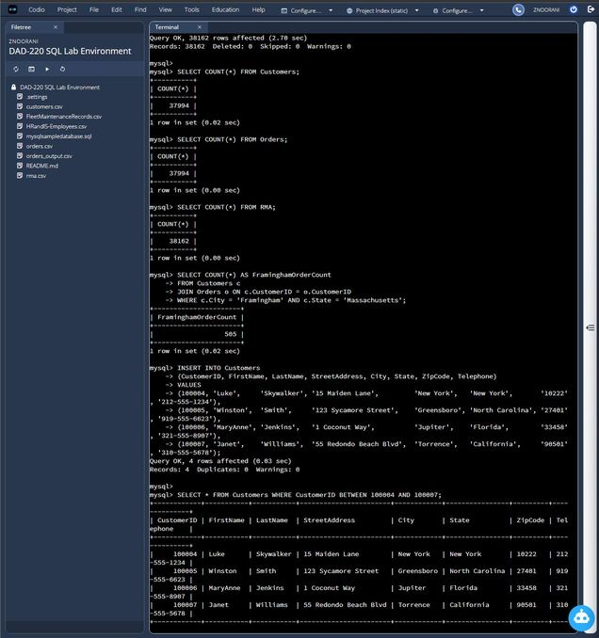
All three CSV files imported successfully. The COUNT(*) verifications return 37,994 rows in Customers, 37,994 rows in Orders, and 38,162 rows in RMA — matching the source data.

6. Query: Count Orders for Customers in Framingham, Massachusetts
This query joins Customers and Orders on CustomerID and uses a WHERE clause to keep only customers in Framingham, Massachusetts. COUNT(*) returns the total number of orders placed by those customers.
SQL Commands:
SELECT COUNT(*) AS FraminghamOrderCount
FROM Customers c
JOIN Orders o ON c.CustomerID = o.CustomerID
WHERE c.City = 'Framingham' AND c.State = 'Massachusetts';
Answer: 505 records were returned. There are 505 orders placed by customers located in Framingham, Massachusetts.
The INNER JOIN ensures only customers who actually have orders are counted, and the WHERE clause limits the result to the Framingham, Massachusetts location. The screenshot for this query is included in the screenshot above (alongside the imports) and the dedicated screenshot below.

7. Query: Select All Customers in Massachusetts
This query selects every column from the Customers table and uses a WHERE clause to keep only rows where the State value equals 'Massachusetts'.
SQL Commands:
SELECT * FROM Customers WHERE State = 'Massachusetts';
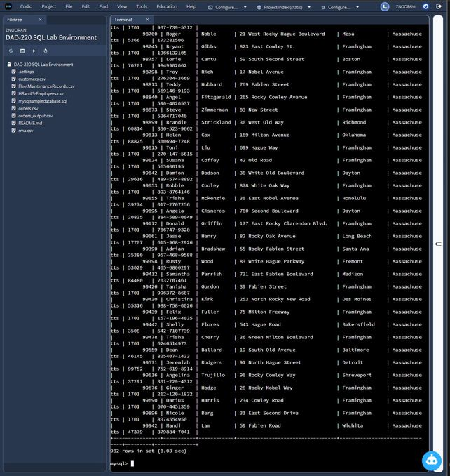
Answer: 982 records were returned. There are 982 customers in the database whose State equals Massachusetts.
The result set scrolls through every Massachusetts customer, and the row count at the bottom of the result confirms 982 records. Note: this screenshot was taken after the table rename in Step 14, so the query was run against the renamed Collaborators table — the underlying data is identical, only the table name changed.

8. Insert Four New Records into the Customers Table
A single INSERT statement with four value tuples added all of the required customer rows in one call.
SQL Commands:
INSERT INTO Customers
(CustomerID, FirstName, LastName, StreetAddress, City, State, ZipCode, Telephone)
VALUES
(100004, 'Luke', 'Skywalker', '15 Maiden Lane', 'New York', 'New York', '10222', '212-555-1234'),
(100005, 'Winston', 'Smith', '123 Sycamore Street', 'Greensboro', 'North Carolina', '27401', '919-555-6623'),
(100006, 'MaryAnne', 'Jenkins', '1 Coconut Way', 'Jupiter', 'Florida', '33458', '321-555-8907'),
(100007, 'Janet', 'Williams', '55 Redondo Beach Blvd', 'Torrence', 'California', '90501', '310-555-5678');

SELECT * FROM Customers WHERE CustomerID BETWEEN 100004 AND 100007;
MySQL confirmed Query OK, 4 rows affected. The follow-up SELECT (visible in the screenshot above) returns the four newly inserted customers with all fields populated correctly.

9. Insert Four New Records into the Orders Table
After the customer rows existed, I inserted the matching order rows. Each CustomerID value references one of the new customers, so the Orders.CustomerID foreign key constraint is satisfied.
SQL Commands:
INSERT INTO Orders (OrderID, CustomerID, SKU, Description) VALUES
(1204305, 100004, 'ADV-24-10C', 'Advanced Switch 10GigE Copper 24 port'),
(1204306, 100005, 'ADV-48-10F', 'Advanced Switch 10 GigE Copper/Fiber 44 port copper 4 port fiber'),
(1204307, 100006, 'ENT-24-10F', 'Enterprise Switch 10GigE SFP+ 24 Port'),
(1204308, 100007, 'ENT-48-10F', 'Enterprise Switch 10GigE SFP+ 48 port');

SELECT * FROM Orders WHERE OrderID BETWEEN 1204305 AND 1204308;
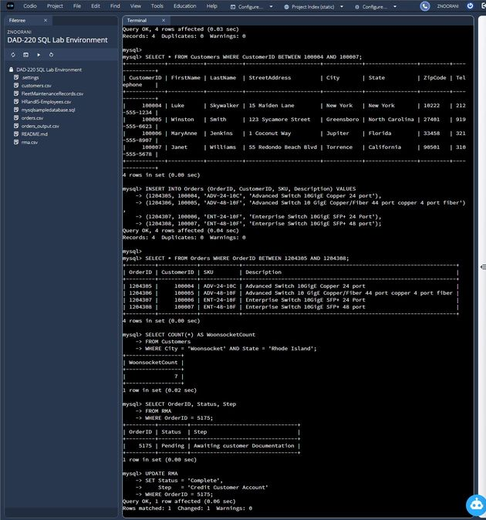
All four orders inserted (Query OK, 4 rows affected). The verification SELECT confirms each new order is correctly linked to its corresponding customer via the CustomerID foreign key.

10. Count Customers in Woonsocket, Rhode Island
This query counts the rows in the Customers table where the City is Woonsocket and the State is Rhode Island.
SQL Commands:
SELECT COUNT(*) AS WoonsocketCount
FROM Customers
WHERE City = 'Woonsocket' AND State = 'Rhode Island';
Answer: 7 records are in the Customers table where City equals Woonsocket and State equals Rhode Island.
The count is visible in the screenshot above (WoonsocketCount = 7) directly under the Orders verification.

11. RMA Update: Select Current Status and Step for OrderID 5175
Before updating the record, I selected the current Status and Step for OrderID 5175 to capture the before-state.
SQL Commands:
SELECT OrderID, Status, Step
FROM RMA
WHERE OrderID = 5175;
Answer: Current Status = Pending; Current Step = Awaiting customer Documentation.
Visible in the screenshot above at the bottom of the page — the row for OrderID 5175 shows Status = Pending and Step = Awaiting customer Documentation.

12. RMA Update: Set Status to 'Complete' and Step to 'Credit Customer Account'
An UPDATE with a WHERE clause targeting OrderID 5175 changes both fields for just that single record.
SQL Commands:
UPDATE RMA
SET Status = 'Complete',
Step = 'Credit Customer Account'
WHERE OrderID = 5175;

SELECT OrderID, Status, Step FROM RMA WHERE OrderID = 5175;
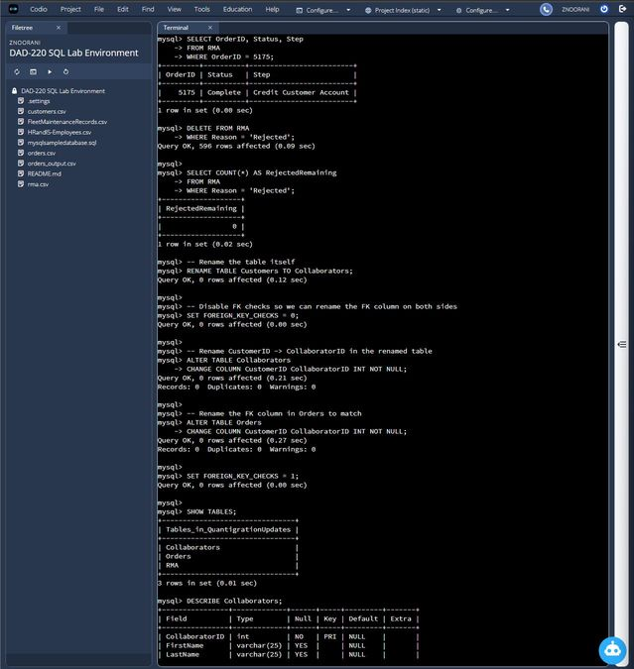
Answer: Updated Status = Complete; Updated Step = Credit Customer Account. MySQL reported "Query OK, 1 row affected" and "Rows matched: 1, Changed: 1", confirming exactly one record was updated.

13. Delete RMA Records with Reason 'Rejected'
This DELETE removes every RMA row whose Reason equals 'Rejected'. The follow-up COUNT(*) verifies that no Rejected records remain.
SQL Commands:
DELETE FROM RMA WHERE Reason = 'Rejected';

SELECT COUNT(*) AS RejectedRemaining
FROM RMA
WHERE Reason = 'Rejected';
Answer: 596 records were deleted. MySQL reported "Query OK, 596 rows affected", and the verification query returns 0 remaining Rejected records.

14. Rename the Customers Table to Collaborators
To support the new branding initiative, the Customers table is renamed to Collaborators, and the CustomerID column in both the renamed table and the Orders table is renamed to CollaboratorID. Foreign-key checks are temporarily disabled so the column rename can happen on both sides of the relationship.
SQL Commands:
-- Rename the table itself
RENAME TABLE Customers TO Collaborators;

-- Disable FK checks so we can rename the FK column on both sides
SET FOREIGN_KEY_CHECKS = 0;

-- Rename CustomerID -> CollaboratorID in the renamed table
ALTER TABLE Collaborators
CHANGE COLUMN CustomerID CollaboratorID INT NOT NULL;

-- Rename the FK column in Orders to match
ALTER TABLE Orders
CHANGE COLUMN CustomerID CollaboratorID INT NOT NULL;

SET FOREIGN_KEY_CHECKS = 1;

SHOW TABLES;
DESCRIBE Collaborators;
DESCRIBE Orders;
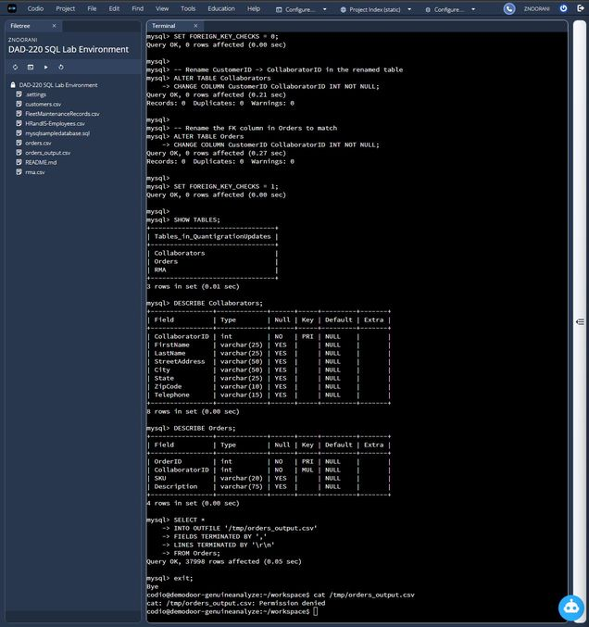
SHOW TABLES now lists Collaborators (instead of Customers), Orders, and RMA. DESCRIBE Collaborators confirms its primary key is now CollaboratorID, and DESCRIBE Orders confirms the foreign key column was also renamed to CollaboratorID — keeping the relationship between the two tables intact under the new naming.

15. Export the Orders Table to a CSV File
Finally, SELECT INTO OUTFILE writes the contents of the Orders table to a CSV file. Field and line terminators match the format used during the original import.
SQL Commands:
USE QuantigrationUpdates;

SELECT *
INTO OUTFILE '/home/codio/workspace/orders_output.csv'
FIELDS TERMINATED BY ','
LINES TERMINATED BY '\r\n'
FROM Orders;
After exiting MySQL, I changed ownership of the output file so it could be read from the shell, then used head to display the first several rows of the exported CSV:
sudo chown codio:codio /home/codio/workspace/orders_output.csv
head /home/codio/workspace/orders_output.csv
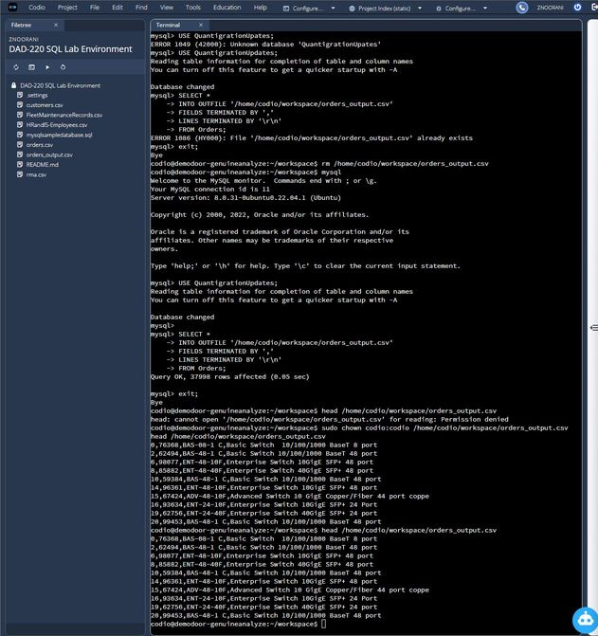
MySQL reported "Query OK, 37998 rows affected", which matches the original 37,994 orders plus the 4 new orders inserted in Step 9. The head output shows the file is a properly formatted CSV with comma-separated fields and contains the expected Orders data (BAS, ADV, ENT product lines).

Notes on AI Tool Usage
Per the SNHU AI usage guidelines for this assignment, generative AI was used to help draft and review the SQL syntax and explanations in this template. All commands were then executed by me in the Codio MySQL environment and verified against the project rubric before being documented here.

