DAD 220 Project Two Template

Overview
Review the scenario for this activity in the guidelines and rubric. Then complete the steps below as you work through the directions for this activity. Replace the bracketed text with your screenshots and responses to the prompts. Size each screenshot and its explanation to fit approximately one-quarter of the page with the description written below the screenshot. Review the Template Screenshot Example linked in the guidelines and rubric for this assignment to see an example of how screenshots for your assignment should look.

RMA Report
Write a report to respond to the manager’s requests. In the report, you should complete the following actions:

- Summarize the data you’ve been working with.
- Identify key information that will help the company streamline operations.

Your report should explain your findings in a way nontechnical stakeholders can understand and use.

Use the steps below to capture the required data and produce the analysis report.

- Begin by writing SQL commands to capture specific usable data for your analysis. You already preloaded the data you need into Codio.
- Specifically, the product manager wants you to complete the following analysis:

  - Analyze the number of returns by state and describe findings to include in your report.

SQL query:
SELECT c.State, COUNT(r.RMAID) AS NumberOfReturns
FROM RMA AS r
JOIN Orders AS o ON r.OrderID = o.OrderID
JOIN Customers AS c ON o.CustomerID = c.CustomerID
GROUP BY c.State
ORDER BY NumberOfReturns DESC;
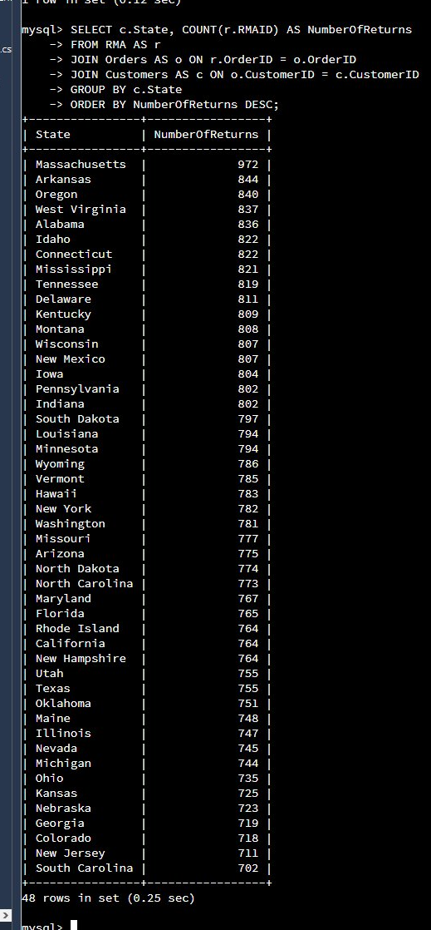
This query links each return to the state where the customer is located by joining the RMA, Orders, and Customers tables, then counts the returns for each state and lists them from highest to lowest. The most striking result is how evenly returns are spread: all 48 states fall within a narrow band, from a high of 972 down to 702. Massachusetts has the most returns (972), followed by Arkansas (844), Oregon (840), West Virginia (837), and Alabama (836), but no single state stands far apart from the rest. This even distribution suggests that returns are driven by company-wide or product-level factors rather than anything specific to one region, and it points the product manager toward the products themselves, rather than a particular location, as the better place to look for the root cause.

  - Analyze the percentage of returns by product type and describe findings to include in your report.

SQL query:
SELECT o.Description AS ProductType,
COUNT(r.RMAID) AS NumberOfReturns,
ROUND(COUNT(r.RMAID) * 100.0 / (SELECT COUNT(*) FROM RMA), 2) AS PercentOfTotal
FROM RMA AS r
JOIN Orders AS o ON r.OrderID = o.OrderID
GROUP BY o.Description
ORDER BY PercentOfTotal DESC;
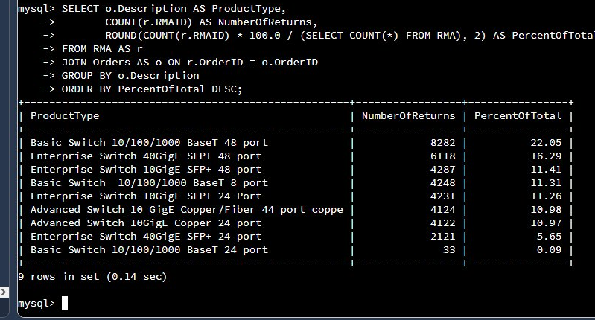
This query joins the RMA and Orders tables so that each return is matched to the product that was ordered, counts the returns for each product type, and converts that count into a percentage of all returns using a subquery for the overall total. Expressing the results as percentages makes it easy to compare products on equal footing. Unlike the state results, the product results are clearly top-heavy: the Basic Switch 10/100/1000 BaseT 48 port alone accounts for 22.05% of all returns, followed by the Enterprise Switch 40GigE SFP+ 48 port at 16.29% and the Enterprise Switch 10GigE SFP+ 48 port at 11.41%. Notably, the three highest return drivers are all 48-port switches, which together make up roughly half of every return. At the other extreme, the Basic Switch 10/100/1000 BaseT 24 port is almost never returned (0.09%). Because returns are so concentrated in the high-port-count switches, the product manager can focus quality and design reviews on those specific items rather than spreading effort across the entire catalog.

- Write a report to clearly summarize your RMA data analysis for stakeholders. When you summarize the results, consider the following questions:

  - How does the data provide the product manager with usable information?
  - What are the potential flaws in the data that has been presented?
  - Are there any limitations on your conclusions or any other ways of looking at your findings that you haven’t considered? Clearly communicate your findings to stakeholders.

RMA Data Analysis Report
Data summary. This analysis is based on Quantigration’s return merchandise authorization (RMA) records, which are stored across three connected tables. The RMA table records each authorized return and ties it back to an original order; the Orders table describes what was purchased, including the product and the customer who bought it; and the Customers table holds customer details such as the state where the customer is located. By joining these tables on their shared keys, every return can be traced back to both the product involved and the customer’s location. That linkage is what makes the two analyses below possible.
Key findings. Two questions were examined: where returns are coming from, and which products are being returned. The two paint very different pictures. Geographically, returns are spread remarkably evenly across all 48 states, ranging only from 702 to 972, with Massachusetts highest at 972 and no single state standing apart from the pack. By product, however, returns are heavily concentrated: the Basic Switch 10/100/1000 BaseT 48 port accounts for 22.05% of all returns, the Enterprise Switch 40GigE SFP+ 48 port for 16.29%, and the Enterprise Switch 10GigE SFP+ 48 port for 11.41% — and all three of these top return drivers are 48-port switches. In short, returns are not a regional problem; they are a product problem centered on high-port-count switches.
How this data is useful. These results give the product manager clear, actionable focus. Because returns are concentrated in a small group of products, the company knows exactly where quality, design, or supplier reviews will have the biggest impact, and the percentage view makes it easy to rank those products in priority order. The even spread of returns across states is just as useful: it effectively rules out a regional explanation, such as one warehouse or shipping carrier underperforming, so the team can avoid chasing location-based causes and instead concentrate its attention on the high-port-count switches that are actually driving the returns.
Potential flaws in the data. A few cautions apply. The data shows that returns happened but not why, so a high count does not by itself prove a product is defective. Return totals are also influenced by sales volume: a product or state with more orders will naturally produce more returns, so raw counts can mislead unless they are compared against how much was actually sold. Massachusetts showing the highest return count, for example, most likely reflects a larger customer base there rather than a quality issue unique to that state. Finally, the analysis relies on clean, consistent records; missing customer states, duplicate RMA entries, or inconsistent product descriptions would distort the totals.
Limitations and other perspectives. These findings describe the current data set and should be read as a snapshot, not a final verdict. The numbers do not account for time, so they cannot show whether returns are rising or falling, and they do not include the dollar value of returns, which may matter more to the business than the raw count. A sharper picture would come from calculating a return rate (returns divided by units sold) for each product and state, and from layering in the recorded reason for each return. As a next step, I recommend pairing this report with sales figures and return reasons so the product manager can separate genuine quality problems from normal, volume-driven returns.

