

Practices for Secure Software Report

Table of Contents
Document Revision History 3
Client 3
Instructions 3
Developer 4
1. Algorithm Cipher 4
2. Certificate Generation 4
3. Deploy Cipher 4
4. Secure Communications 4
5. Secondary Testing 4
6. Functional Testing 4
7. Summary 4
8. Industry Standard Best Practices 4

Document Revision History

Version | Date | Author | Comments
1.0 | 10/14/2026 | Ziyan Noorani | Completed report: SHA-256 checksum, HTTPS/TLS, dependency-check and functional testing

Client



Instructions

Submit this completed practices for secure software report. Replace the bracketed text with the relevant information. You must document your process for writing secure communications and refactoring code that complies with software security testing protocols.

- Respond to the steps outlined below and include your findings.
- Respond using your own words. You may also choose to include images or supporting materials. If you include them, make certain to insert them in all the relevant locations in the document.
- Refer to the Project Two Guidelines and Rubric for more detailed instructions about each section of the template.

Developer
Ziyan Noorani

Algorithm Cipher
Recommendation. Artemis Financial needs two protections: a checksum that proves data was not changed during transfer, and an encrypted channel so nobody can read or alter the data on the way. I recommend SHA-256 (Secure Hash Algorithm 2, 256-bit) for the checksum, delivered over TLS 1.3 or TLS 1.2 that encrypts traffic with AES-256-GCM, agrees on keys with ephemeral elliptic-curve Diffie-Hellman (ECDHE), and authenticates the server with a 3072-bit RSA certificate. Every piece is approved by NIST and ships inside the Java runtime, so the solution adds no new third-party library.
Overview of the algorithm
SHA-256 is a one-way cryptographic hash function from the SHA-2 family, designed by the NSA and published by NIST in FIPS 180-4 (National Institute of Standards and Technology [NIST], 2015). It takes input of any size and returns a fixed 256-bit digest, shown as 64 hexadecimal characters. The function is deterministic, so the same input always returns the same digest, and a one-bit change in the input flips roughly half the output bits. That makes it a good checksum: Artemis computes the digest before sending a file, the receiver computes it again, and any mismatch means the data changed. A hash cannot be reversed, so it does not hide data. Confidentiality comes from the AES encryption inside TLS.
Hash functions and bit levels
SHA-256 splits the message into 512-bit blocks and runs 64 rounds of compression on 32-bit words. Its 256-bit output gives about 128 bits of collision resistance (the birthday bound, 2^128 operations) and 256 bits of preimage resistance. For comparison:
Algorithm | Output / key size | Status
MD5 | 128-bit digest | Broken. Practical collisions since 2004; used to forge a Microsoft code-signing certificate in the 2012 Flame malware.
SHA-1 | 160-bit digest | Broken. Google and CWI produced a real collision in 2017 (Stevens et al., 2017). NIST retires it by December 31, 2030 (NIST, 2022).
SHA-256 | 256-bit digest | Approved (FIPS 180-4). Selected for the Artemis checksum.
SHA-512 / SHA-3 | 512-bit / 224 to 512-bit | Approved. Valid alternatives, but SHA-256 already exceeds the 112-bit minimum and has wider tool support.
AES-256 (in TLS) | 256-bit key, 128-bit block, 14 rounds | Approved (FIPS 197). Encrypts the data in transit.
RSA-3072 (certificate) | 3072-bit modulus | About 128-bit security strength (Barker, 2020). Used for the server certificate.

I chose SHA-256 over SHA-512 and SHA-3 for practical reasons. It is the standard checksum published next to software downloads, Windows PowerShell and Linux sha256sum can verify it without extra software, modern Intel and AMD processors accelerate it in hardware, and java.security.MessageDigest supports it in every Java runtime.
Random numbers and symmetric versus asymmetric keys
Random numbers. A hash function uses no randomness, which is correct for a checksum because both sides must compute the same value. Randomness matters for the keys around it. Keytool uses SecureRandom to generate the RSA primes for the certificate, and every TLS handshake uses fresh 32-byte client and server random values plus a new ECDHE key pair. Weak randomness breaks strong algorithms: in 2008 a Debian OpenSSL bug cut the possible keys to about 32,768, so attackers could list every key (NIST, n.d.). Any future random values in this application (tokens, salts, IVs) must come from java.security.SecureRandom, never java.util.Random.
Symmetric keys use one shared secret for encryption and decryption. AES is fast enough to encrypt every byte of a session, but both sides must already share the key. Asymmetric keys use a public and private pair. RSA and elliptic-curve algorithms solve the key-sharing problem and prove identity, but run far slower. TLS combines both. The handshake uses the RSA certificate to prove the server is genuine and ECDHE to agree on a session key, then AES-GCM encrypts the traffic and SHA-256 or SHA-384 protects the handshake and derives keys (Rescorla, 2018). Because the ECDHE keys are thrown away after each session, recorded traffic stays protected even if the server private key leaks later (forward secrecy). The negotiated settings can be checked in the browser (Chrome DevTools > Security tab), for example TLS 1.3 with X25519 key exchange and AES-GCM encryption.
History and current state of encryption algorithms
- Classical ciphers: substitution ciphers such as the Caesar shift, then machine ciphers such as the German Enigma, which Allied codebreakers defeated in World War II.
- DES (1977): the first U.S. federal standard. Its 56-bit key fell to the EFF "Deep Crack" machine in 56 hours in 1998. Triple DES extended its life, and NIST disallowed it for encryption after 2023 (Barker & Roginsky, 2019).
- Public-key cryptography: Diffie-Hellman key exchange (1976) and RSA (1977) made secure communication possible between strangers and became the basis for SSL and TLS.
- AES (2001): the Rijndael cipher won NIST's open competition and replaced DES. It remains the main symmetric cipher worldwide (NIST, 2023).
- Hash functions: MD5 (1992) and SHA-1 (1995) both fell to collision attacks. SHA-2 (2001) and SHA-3 (2015) are the approved families today.
- Protocols: SSL 2.0 and 3.0 are prohibited, TLS 1.0 and 1.1 were formally deprecated in 2021 (Moriarty & Farrell, 2021), and TLS 1.3 (2018) removed weak options such as RSA key transport and CBC-mode ciphers.
- Current state: a large quantum computer running Shor's algorithm would break RSA and elliptic-curve keys. Grover's algorithm only halves the strength of AES-256 and SHA-256, so they stay strong. In August 2024 NIST published its first post-quantum standards, FIPS 203 (ML-KEM), FIPS 204 (ML-DSA), and FIPS 205 (SLH-DSA) (NIST, 2024). Artemis should plan to move its certificates and key exchange to these algorithms as Java and browser support matures.
Justification for Artemis Financial
Artemis handles savings, retirement, and investment data, and the FTC Safeguards Rule requires financial institutions to encrypt customer information in transit over external networks (Standards for Safeguarding Customer Information, 2023). SHA-256 over TLS meets that requirement with approved algorithms, uses only the Java runtime's built-in providers, and gives the client a checksum it can check with free tools. One limit matters: anyone who can change the data in transit could also recompute a plain hash. TLS closes that gap here because it protects the checksum and the data together. If Artemis later sends checksums through a separate channel, the next step is HMAC-SHA256 with a shared secret key, which also proves who created the checksum.

Certificate Generation
I generated a self-signed certificate with the Java keytool from the Eclipse terminal and saved it in the project resources so Spring Boot can load it from the classpath:
keytool -genkeypair -alias artemis -keyalg RSA -keysize 3072 -sigalg SHA256withRSA
-validity 365 -storetype PKCS12 -keystore src/main/resources/keystore.p12
-dname "CN=localhost, OU=Ziyan Noorani, O=Artemis Financial, L=Little Rock, ST=Arkansas, C=US"
-ext "SAN=dns:localhost,ip:127.0.0.1"
Each option was a security decision:
- PKCS12 instead of JKS: PKCS12 is an open standard and the Java default keystore type since Java 9. JKS is a proprietary format.
- RSA 3072 with SHA256withRSA: about 128-bit security, which NIST considers acceptable past 2030 (Barker, 2020). A 2048-bit key meets today's minimum but has a shorter lifetime.
- 365-day validity: short-lived certificates limit how long a stolen key stays useful.
- Subject Alternative Name for localhost: browsers match the host against the SAN field and ignore the Common Name, so the certificate needs it to be trusted for https://localhost:8443.
I then exported the public certificate as a CER file and printed it to confirm the owner, key size, signature algorithm, and validity dates:
keytool -exportcert -alias artemis -keystore src/main/resources/keystore.p12 -storetype PKCS12 -rfc -file artemis.cer
keytool -printcert -file artemis.cer
Figure 1
Exported artemis.cer certificate printed with keytool, showing the owner, 3072-bit RSA key, SHA256withRSA signature, and localhost SAN
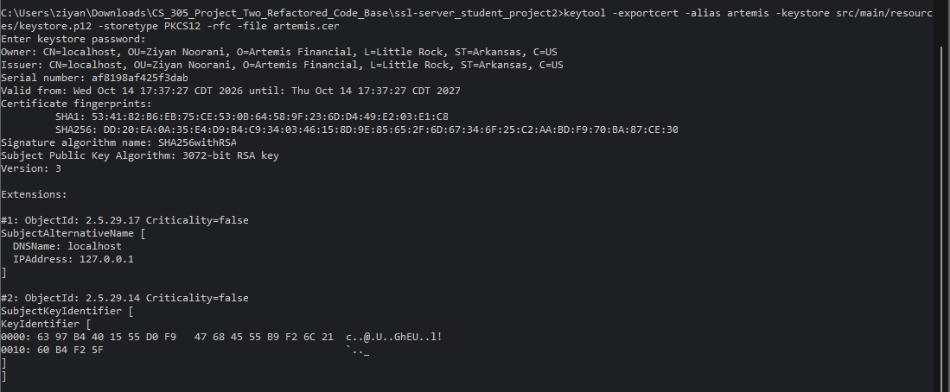

A self-signed certificate is fine for development and testing. For the public Artemis site, the same keystore setup should hold a certificate issued by a trusted certificate authority, because browsers will warn every visitor about a self-signed one.

Deploy Cipher
I added two classes to the com.snhu.sslserver package to resolve the FIXME in the starter code:
- ChecksumGenerator (service layer): a final utility class that hashes UTF-8 bytes with MessageDigest.getInstance("SHA-256"), converts the result to a fixed-width 64-character hex string, and verifies a received checksum with MessageDigest.isEqual, which compares in constant time.
- ChecksumController (controller layer): a @RestController that maps GET /hash, hashes a fixed data string that includes my name, verifies the result, and returns an HTML page with the developer name, data, algorithm, checksum, and PASS/FAIL result.
public static String sha256Hex(String data) {
if (data == null) {
throw new IllegalArgumentException("Data to hash must not be null.");
}
try {
MessageDigest digest = MessageDigest.getInstance(ALGORITHM); // "SHA-256"
byte[] hash = digest.digest(data.getBytes(StandardCharsets.UTF_8));
return toHex(hash);
} catch (NoSuchAlgorithmException e) {
throw new IllegalStateException(ALGORITHM + " is not available in this Java runtime.", e);
}
}
Unique data string: Hello World Check Sum! Artemis Financial data verification by Ziyan Noorani
Expected SHA-256 checksum: 47915b2b746ae64e609d95386c9eef0b9a0eecdbb4d515a68c9904a92193198a
The value matches independent SHA-256 tools, such as Linux sha256sum and the PowerShell commands in README-RUN-STEPS.md, which confirms the Java code hashes the exact UTF-8 bytes of the string. A unit test also checks the code against the published SHA-256 test vector for "abc" (ba7816bf...f20015ad).
Figure 2
Checksum verification page at https://localhost:8443/hash showing my name, the unique data string, SHA-256, the checksum, and a PASS result
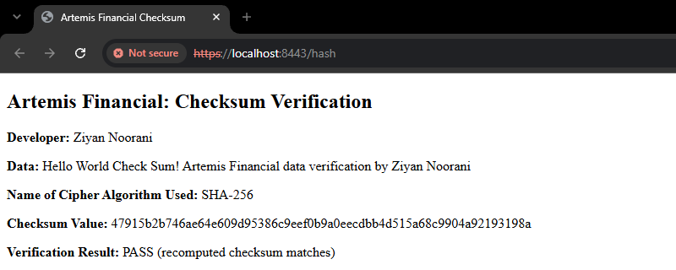

Secure Communications
The starter application.properties had ???? placeholders, so the server could not start with SSL. I replaced them so the application serves only HTTPS on port 8443:
server.port=8443
server.ssl.enabled=true
server.ssl.key-alias=artemis
server.ssl.key-store=classpath:keystore.p12
server.ssl.key-store-type=PKCS12
server.ssl.key-store-password=${SSL_KEYSTORE_PASSWORD:ArtemisSecure2026}
server.ssl.enabled-protocols=TLSv1.3,TLSv1.2
server.error.include-stacktrace=never
server.error.include-exception=false
- HTTPS only: no plain-HTTP connector exists, so the application never sends data unencrypted.
- TLS 1.2 and 1.3 only: without this line, the allowed protocols depend on the Tomcat and JDK versions, and older combinations still accept TLS 1.0 and 1.1. NIST requires federal servers to support TLS 1.2, and TLS 1.3 since January 2024 (McKay & Cooper, 2019).
- Keystore password from an environment variable: the password is read from SSL_KEYSTORE_PASSWORD. The value after the colon is a local fallback so the project runs for grading; in production it is deleted and the password comes from the environment or a secrets manager.
- No stack traces in error pages: error responses do not reveal class names, library versions, or file paths to an attacker.
After compiling and running the refactored code, the console showed Tomcat started on port(s): 8443 (https). I opened https://localhost:8443/hash in a new browser window. Because the certificate is self-signed, the browser first showed a warning; I reviewed the certificate, confirmed it was the Artemis certificate I created, and continued. The certificate viewer in Figure 3 shows the page was served with the Artemis Financial certificate, and its SHA-256 fingerprint (DD:20:EA:0A ... 87:CE:30) matches the fingerprint keytool printed in Figure 1. That match confirms the browser received the exact certificate I generated. Chrome marks the page "Not secure" only because no certificate authority signed it; the connection itself is encrypted with TLS.
Figure 3
Secure webpage over HTTPS on port 8443 with the certificate viewer showing the self-signed Artemis Financial certificate
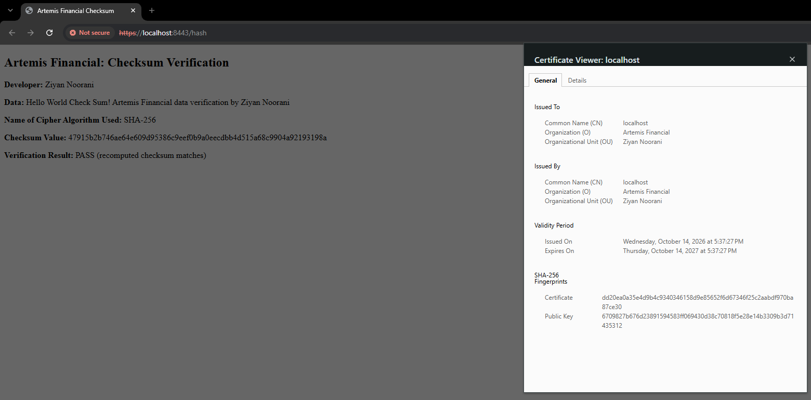

Secondary Testing
I ran the refactored application and confirmed it started without errors, then ran a static scan with the OWASP Dependency-Check Maven plug-in (Run As > Maven build, goal verify). The starter pom.xml pinned plug-in version 5.3.0, which depends on NVD data feeds that NIST has since retired. I removed the version element so Maven uses the current release (13.0.0 at the time of the scan) and added the NVD API key through my Maven settings.xml (${nvd.api.key}), so the key never appears in the project files.
Figure 4
Refactored code executed without errors: Tomcat started on port 8443 (https)
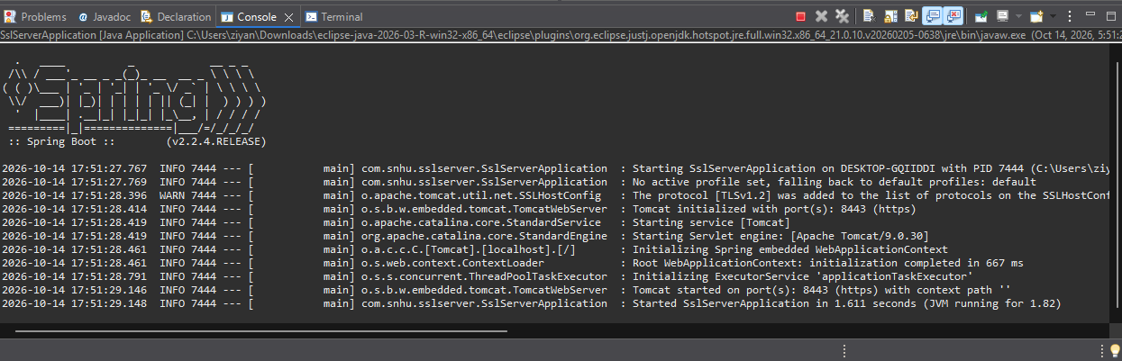
The one WARN line in Figure 4 is Tomcat 9.0.30 noting that TLSv1.2 was added to the protocol list without a + or - prefix. Both TLS 1.2 and TLS 1.3 are enabled as configured, and the application started normally.
Figure 5
OWASP Dependency-Check 13.0.0 report for the refactored code (top of report and vulnerable dependency summary)
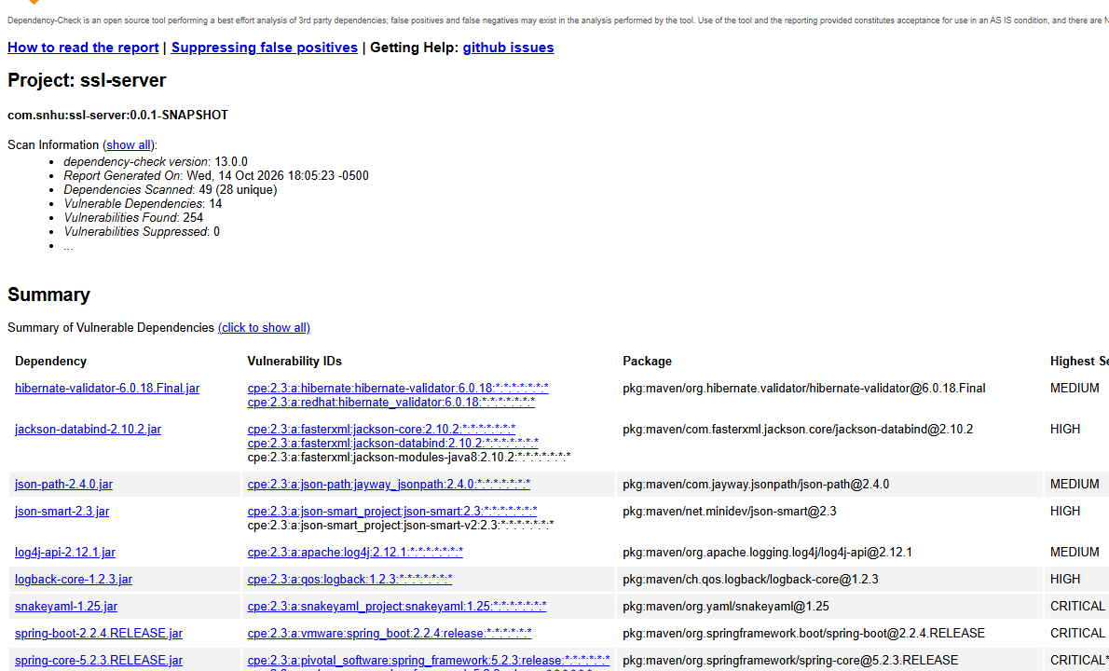
Result for the code I added: the refactoring introduced zero new dependencies. ChecksumGenerator imports only java.security, java.nio.charset, and java.util, and ChecksumController uses Spring classes (ResponseEntity, HtmlUtils, CacheControl) that were already on the classpath through spring-boot-starter-web. The list of scanned libraries matched the original code base exactly, so the scan found no vulnerability introduced by the refactoring.
Scan results: dependency-check 13.0.0 scanned 49 dependencies (28 unique) and reported 14 vulnerable dependencies with 254 vulnerabilities and 0 suppressed. Every one of the 14 comes from the original pom.xml and the Spring Boot 2.2.4 parent (released January 2020 and no longer supported). None of them is from the code I added.
Dependency (inherited) | Highest severity | CVEs | Brought in by
tomcat-embed-websocket 9.0.30 | CRITICAL* | 77 | spring-boot-starter-web (embedded Tomcat)
tomcat-embed-core 9.0.30 | CRITICAL* | 76 | spring-boot-starter-web (embedded Tomcat)
spring-web 5.2.3 | CRITICAL* | 30 | spring-boot-starter-web
spring-core 5.2.3 | CRITICAL* | 29 | Spring Framework (all starters)
jackson-databind 2.10.2 | HIGH | 11 | spring-boot-starter-json
spring-boot 2.2.4 | CRITICAL | 9 | Spring Boot parent
snakeyaml 1.25 | CRITICAL | 8 | spring-boot-starter
hibernate-validator 6.0.18 | MEDIUM | 3 | spring-boot-starter-web (validation)
log4j-api 2.12.1 | MEDIUM | 3 | spring-boot-starter-logging
logback-core 1.2.3 | HIGH | 2 | spring-boot-starter-logging
json-smart 2.3 | HIGH | 2 | spring-boot-starter-test (test scope only)
spring-data-rest-core 3.2.4 | HIGH | 2 | spring-boot-starter-data-rest
json-path 2.4.0 | MEDIUM | 1 | spring-boot-starter-test (test scope only)
spring-hateoas 1.0.3 | MEDIUM | 1 | spring-boot-starter-data-rest

* The report marks these with an asterisk because they include a known exploited vulnerability. These versions are affected by well-known CVEs such as CVE-2022-22965 ("Spring4Shell") in Spring Framework 5.2.3, CVE-2020-1938 ("Ghostcat") in Tomcat 9.0.30, and CVE-2022-1471 in SnakeYAML 1.25.
These findings existed before my changes and are outside the assignment's scope, so I documented them instead of changing the framework version. I did not suppress any of them, because suppressing a real finding only hides the risk. Two entries (json-smart and json-path) are test-scope libraries that never ship in the application JAR, which lowers their real risk. The fix for the rest is one change: upgrade the parent to a supported Spring Boot release (3.x, which requires Java 17), which pulls in patched versions of Tomcat, Spring Framework, Jackson, SnakeYAML, and Logback together. After the upgrade, Artemis should rerun the 11 tests and the scan to confirm the count drops.

Functional Testing
I reviewed every file in the project by hand, starting with the starter code and then my own changes, and sorted each finding by type. The table lists what I found and how I fixed it.
Type | Location | Finding | Fix
Syntactical | application.properties, line 1 | //FIXME: is not a comment in a .properties file (only # and ! are), so Spring loaded it as a junk property key. | Removed the line; all comments now start with #.
Syntactical | application.properties | ???? placeholders for alias, password, keystore, and type. The HTTPS server could not start. | Filled in the PKCS12 keystore settings.
Logical | SslServerApplication | No route existed for the required checksum (the FIXME). | Added ChecksumController with GET /hash.
Logical (avoided) | New checksum code | String.getBytes() without a charset uses the platform default, so Windows and Linux could produce different checksums for the same text. | Always encode as StandardCharsets.UTF_8.
Logical (avoided) | New checksum code | The common new BigInteger(1, hash).toString(16) shortcut drops leading zeros, giving a 63-character checksum about 1 time in 16. | Fixed-width hex conversion; a unit test asserts 64 characters.
Security | Checksum comparison | String.equals() stops at the first different character, which can leak timing information. | MessageDigest.isEqual (constant time).
Security | /hash response | Text written into HTML can enable cross-site scripting if it ever comes from a user. | HtmlUtils.htmlEscape, plus Content-Security-Policy: default-src 'none', X-Content-Type-Options: nosniff, and Cache-Control: no-store.
Security | application.properties | Keystore password in plain text; TLS versions not restricted; error detail settings left to defaults. | Environment variable for the password, TLS 1.2/1.3 only, stack traces and exception names disabled.
Security | pom.xml | dependency-check 5.3.0 cannot download current NVD data, so the scan would be stale or fail. | Current plug-in release with an NVD API key from settings.xml.
Security | Repository hygiene | A pushed keystore would publish the private key on GitHub. | Added *.p12 and *.jks to .gitignore.
Security (open) | pom.xml | Spring Boot 2.2.4 is end of life; spring-boot-starter-data-rest would expose any future repository as a REST API with no authentication. | Documented. Recommend upgrading Spring Boot and removing data-rest or adding Spring Security before adding repositories.

I also added 10 automated tests to back up the manual review. ChecksumGeneratorTests (8 tests) checks the published SHA-256 vectors for "abc" and the empty string, the exact checksum for my data string, the 64-character length, tamper detection (changing "$100" to "$900" fails verification), and null handling. ChecksumControllerTests (2 tests) uses MockMvc to confirm the page content and the security headers. All 11 tests, including the original contextLoads, passed in 2.2 seconds with 0 errors and 0 failures (Figure 6), and the application ran without errors (Figure 4).
Figure 6
Refactored code executed without errors: JUnit 5 results with 11/11 tests passing, 0 errors, 0 failures
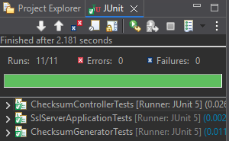

Summary
I refactored the Artemis Financial code base to add a SHA-256 checksum service, switch the server to HTTPS with a keystore and modern TLS, update the static-analysis tooling, and add automated tests. The table maps the work to the seven areas of security in the vulnerability assessment process flow diagram.
Area of security | What I addressed
Input Validation | The /hash route accepts no user input; the data is a server-side constant. ChecksumGenerator rejects null input, and all output is HTML-escaped in case the data source changes later.
APIs | One read-only GET endpoint with a fixed response type keeps the attack surface small. I flagged the unused data-rest starter as a future API exposure risk.
Cryptography | SHA-256 checksum, constant-time verification, RSA-3072 certificate, TLS 1.2/1.3 with AES-GCM. No custom cryptography; only the JDK's approved providers.
Client/Server | HTTPS only on port 8443, older TLS versions refused, PKCS12 keystore, responses marked no-store so browsers and proxies do not cache them.
Code Error | Stack traces and exception names hidden from error pages; the missing-algorithm case throws a clear exception instead of returning a blank or wrong checksum.
Code Quality | Fixed the properties syntax error, avoided the charset and leading-zero bugs, added 10 unit and MockMvc tests, and removed the outdated scanner version.
Encapsulation | Hashing logic sits in a final class with a private constructor, the controller only calls its public methods, and the keystore password lives outside the code.

Following the diagram's code review step, I reviewed the controller (ChecksumController), the service logic (ChecksumGenerator), the view it returns (escaped HTML), the plug-ins (dependency-check), and the API surface (/hash and data-rest). There is no data access layer or model yet.
Process for adding layers of security. I treated security as layers so that one failure does not expose the data:
- Transport: TLS encrypts and authenticates every request, so an attacker on the network cannot read or alter traffic.
- Integrity: the SHA-256 checksum lets the receiver confirm the data matches what was sent, and constant-time comparison prevents timing leaks.
- Output: escaping and the Content-Security-Policy header block script injection even if the data source changes.
- Configuration: restricted TLS versions, hidden error details, and an externalized password reduce what an attacker can learn or reuse.
- Verification: unit tests, manual review, and the dependency-check scan confirm the layers work and that I did not add new vulnerabilities. The scan's dependency list matches the original pom.xml, so the refactoring added no new components.

Industry Standard Best Practices
Maintaining the application's existing security. I did not change or remove any existing behavior, and I added no new libraries, so the set of third-party components (and their known vulnerabilities) stayed the same, which the dependency-check report confirms. I followed these industry standards:
- Use vetted cryptography, never custom code: SHA-256 and TLS through the Java Cryptography Architecture, matching OWASP Top 10 A02:2021 Cryptographic Failures (OWASP Foundation, 2021).
- Use approved algorithms and key sizes: SHA-256, AES, and RSA-3072 per NIST SP 800-131A and SP 800-57 (Barker & Roginsky, 2019; Barker, 2020).
- Secure configuration: TLS 1.2/1.3 only and no error detail leakage, matching OWASP A05:2021 Security Misconfiguration and NIST SP 800-52 (McKay & Cooper, 2019).
- Know your components: automated dependency scanning with a current NVD feed, matching OWASP A06:2021 Vulnerable and Outdated Components.
- Protect secrets: the NVD API key lives in settings.xml, the keystore password in an environment variable, and keystores are excluded from Git.
- Test security behavior: unit tests for tamper detection and security headers run on every Maven build, so a later change that breaks them fails the build.
Value to Artemis Financial. For a financial firm, one breach costs more than years of secure development. IBM's 2024 study put the average breach at USD 4.88 million worldwide and USD 6.08 million in the financial sector (IBM, 2024). The 2017 Equifax breach started with an unpatched Apache Struts library, the same class of problem dependency-check is built to catch, and exposed data on about 147 million people; the settlement reached up to USD 700 million (Federal Trade Commission, n.d.). Secure coding also keeps Artemis compliant with the FTC Safeguards Rule, protects the client trust its business depends on, and costs less when done during development than after an incident. These practices put Global Rain's motto, "Security is everyone's responsibility," into the code itself.

Attachments: Refactored Code Files
The refactored project is submitted as a zipped project folder. Files changed or added:
File | Change
src/main/java/.../ChecksumGenerator.java | New: SHA-256 hashing and constant-time verification
src/main/java/.../ChecksumController.java | New: GET /hash route with escaped output and security headers
src/main/resources/application.properties | HTTPS keystore, TLS 1.2/1.3, password from environment, no stack traces
src/main/resources/keystore.p12 | New: self-signed RSA-3072 PKCS12 keystore (alias artemis)
artemis.cer | New: exported public certificate
pom.xml | Current dependency-check plug-in with NVD API key from settings.xml
src/test/java/.../ChecksumGeneratorTests.java | New: 8 unit tests
src/test/java/.../ChecksumControllerTests.java | New: 2 MockMvc tests
.gitignore | Excludes keystore files
README-RUN-STEPS.md | New: how to generate the keystore, run, test, and scan

References
Anthropic. (2026). Claude (Opus 5.5) [Large language model]. https://claude.ai
Barker, E. (2020). Recommendation for key management: Part 1 – General (NIST Special Publication 800-57 Part 1, Rev. 5). National Institute of Standards and Technology. https://doi.org/10.6028/NIST.SP.800-57pt1r5
Barker, E., & Roginsky, A. (2019). Transitioning the use of cryptographic algorithms and key lengths (NIST Special Publication 800-131A, Rev. 2). National Institute of Standards and Technology. https://doi.org/10.6028/NIST.SP.800-131Ar2
Federal Trade Commission. (n.d.). Equifax data breach settlement. https://www.ftc.gov/enforcement/refunds/equifax-data-breach-settlement
IBM. (2024). Cost of a data breach report 2024. https://www.ibm.com/reports/data-breach
McKay, K., & Cooper, D. (2019). Guidelines for the selection, configuration, and use of Transport Layer Security (TLS) implementations (NIST Special Publication 800-52, Rev. 2). National Institute of Standards and Technology. https://doi.org/10.6028/NIST.SP.800-52r2
Moriarty, K., & Farrell, S. (2021). Deprecating TLS 1.0 and TLS 1.1 (RFC 8996). Internet Engineering Task Force. https://doi.org/10.17487/RFC8996
National Institute of Standards and Technology. (n.d.). CVE-2008-0166 detail. National Vulnerability Database. https://nvd.nist.gov/vuln/detail/CVE-2008-0166
National Institute of Standards and Technology. (2015). Secure Hash Standard (SHS) (FIPS PUB 180-4). https://doi.org/10.6028/NIST.FIPS.180-4
National Institute of Standards and Technology. (2022, December 15). NIST retires SHA-1 cryptographic algorithm. https://www.nist.gov/news-events/news/2022/12/nist-retires-sha-1-cryptographic-algorithm
National Institute of Standards and Technology. (2023). Advanced Encryption Standard (AES) (FIPS PUB 197, updated). https://doi.org/10.6028/NIST.FIPS.197-upd1
National Institute of Standards and Technology. (2024, August 13). NIST releases first 3 finalized post-quantum encryption standards. https://www.nist.gov/news-events/news/2024/08/nist-releases-first-3-finalized-post-quantum-encryption-standards
OWASP Foundation. (2021). OWASP Top 10:2021. https://owasp.org/Top10/
Rescorla, E. (2018). The Transport Layer Security (TLS) protocol version 1.3 (RFC 8446). Internet Engineering Task Force. https://doi.org/10.17487/RFC8446
Standards for Safeguarding Customer Information, 16 C.F.R. § 314.4 (2023). https://www.ecfr.gov/current/title-16/chapter-I/subchapter-C/part-314
Stevens, M., Bursztein, E., Karpman, P., Albertini, A., & Markov, Y. (2017). The first collision for full SHA-1. In J. Katz & H. Shacham (Eds.), Advances in Cryptology – CRYPTO 2017 (pp. 570–596). Springer. https://doi.org/10.1007/978-3-319-63688-7_19
AI Usage Acknowledgment
I used generative AI (Claude, Anthropic, 2026) to help refactor the code, format this document, and brainstorm how to word the responses. I generated the certificate, ran the application, unit tests, and dependency-check scan in my own Eclipse environment, captured all screenshots, and reviewed and verified the code, results, and conclusions in this report.

