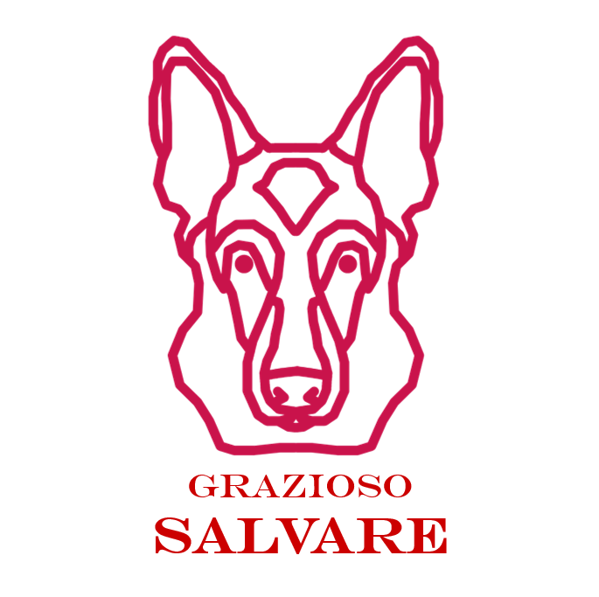
Grazioso Salvare Rescue Dog Dashboard
README | CS-340 Project Two | Ziyan Noorani

About the Project
This dashboard helps Grazioso Salvare find shelter dogs that fit its search-and-rescue training profiles. It reads the Austin Animal Center Outcomes data from MongoDB and lets you filter it by rescue type with one click. The data table, the breed pie chart, and the location map all update to match the filter you pick.
The project follows the Model-View-Controller pattern:
- Model: MongoDB stores the 10,000 shelter records in the aac database, animals collection.
- View: Dash widgets show the filter options, the data table, the pie chart, and the map.
- Controller: Dash callbacks call the AnimalShelter CRUD module from Project One to run each query.

Required Functionality

Filter queries
Each filter runs one query through the CRUD module’s read() method. The criteria come from the Rescue Type and Preferred Dog Breeds table in the specifications document. Every filter also limits results to animal_type "Dog".
Rescue type | Breeds (regex, start of string) | Sex | Age (weeks)
Water | Labrador Retriever Mix, Chesapeake Bay Retriever, Newfoundland | Intact Female | 26 to 156
Mountain or Wilderness | German Shepherd, Alaskan Malamute, Old English Sheepdog, Siberian Husky, Rottweiler | Intact Male | 26 to 156
Disaster or Tracking | Doberman Pinsch, German Shepherd, Golden Retriever, Bloodhound, Rottweiler | Intact Male | 20 to 300
Reset | Empty query {} | Any | Any

Breeds use a regular expression anchored to the start of the breed field, so mixed breeds such as "German Shepherd Mix" and "Newfoundland/Labrador Retriever" still match. Against the provided data set the filters return 17 water rescue dogs, 18 mountain rescue dogs, and 30 disaster rescue dogs. Reset runs an empty query and returns all 10,000 records.

Dashboard widgets
- Radio buttons for Water Rescue, Mountain or Wilderness Rescue, Disaster or Individual Tracking, and Reset, with a live count of matching records.
- Interactive data table with 10 rows per page, sorting, per-column filtering, and single-row selection.
- Pie chart of the top 10 breeds in the current table view, with remaining breeds grouped as Other.
- Leaflet geolocation map with a marker for the selected row. Hovering shows the breed and clicking shows the animal name.
- Grazioso Salvare logo linked to www.snhu.edu and a "Created by Ziyan Noorani" identifier at the top of the page.

Screenshots
Starting state (unfiltered):
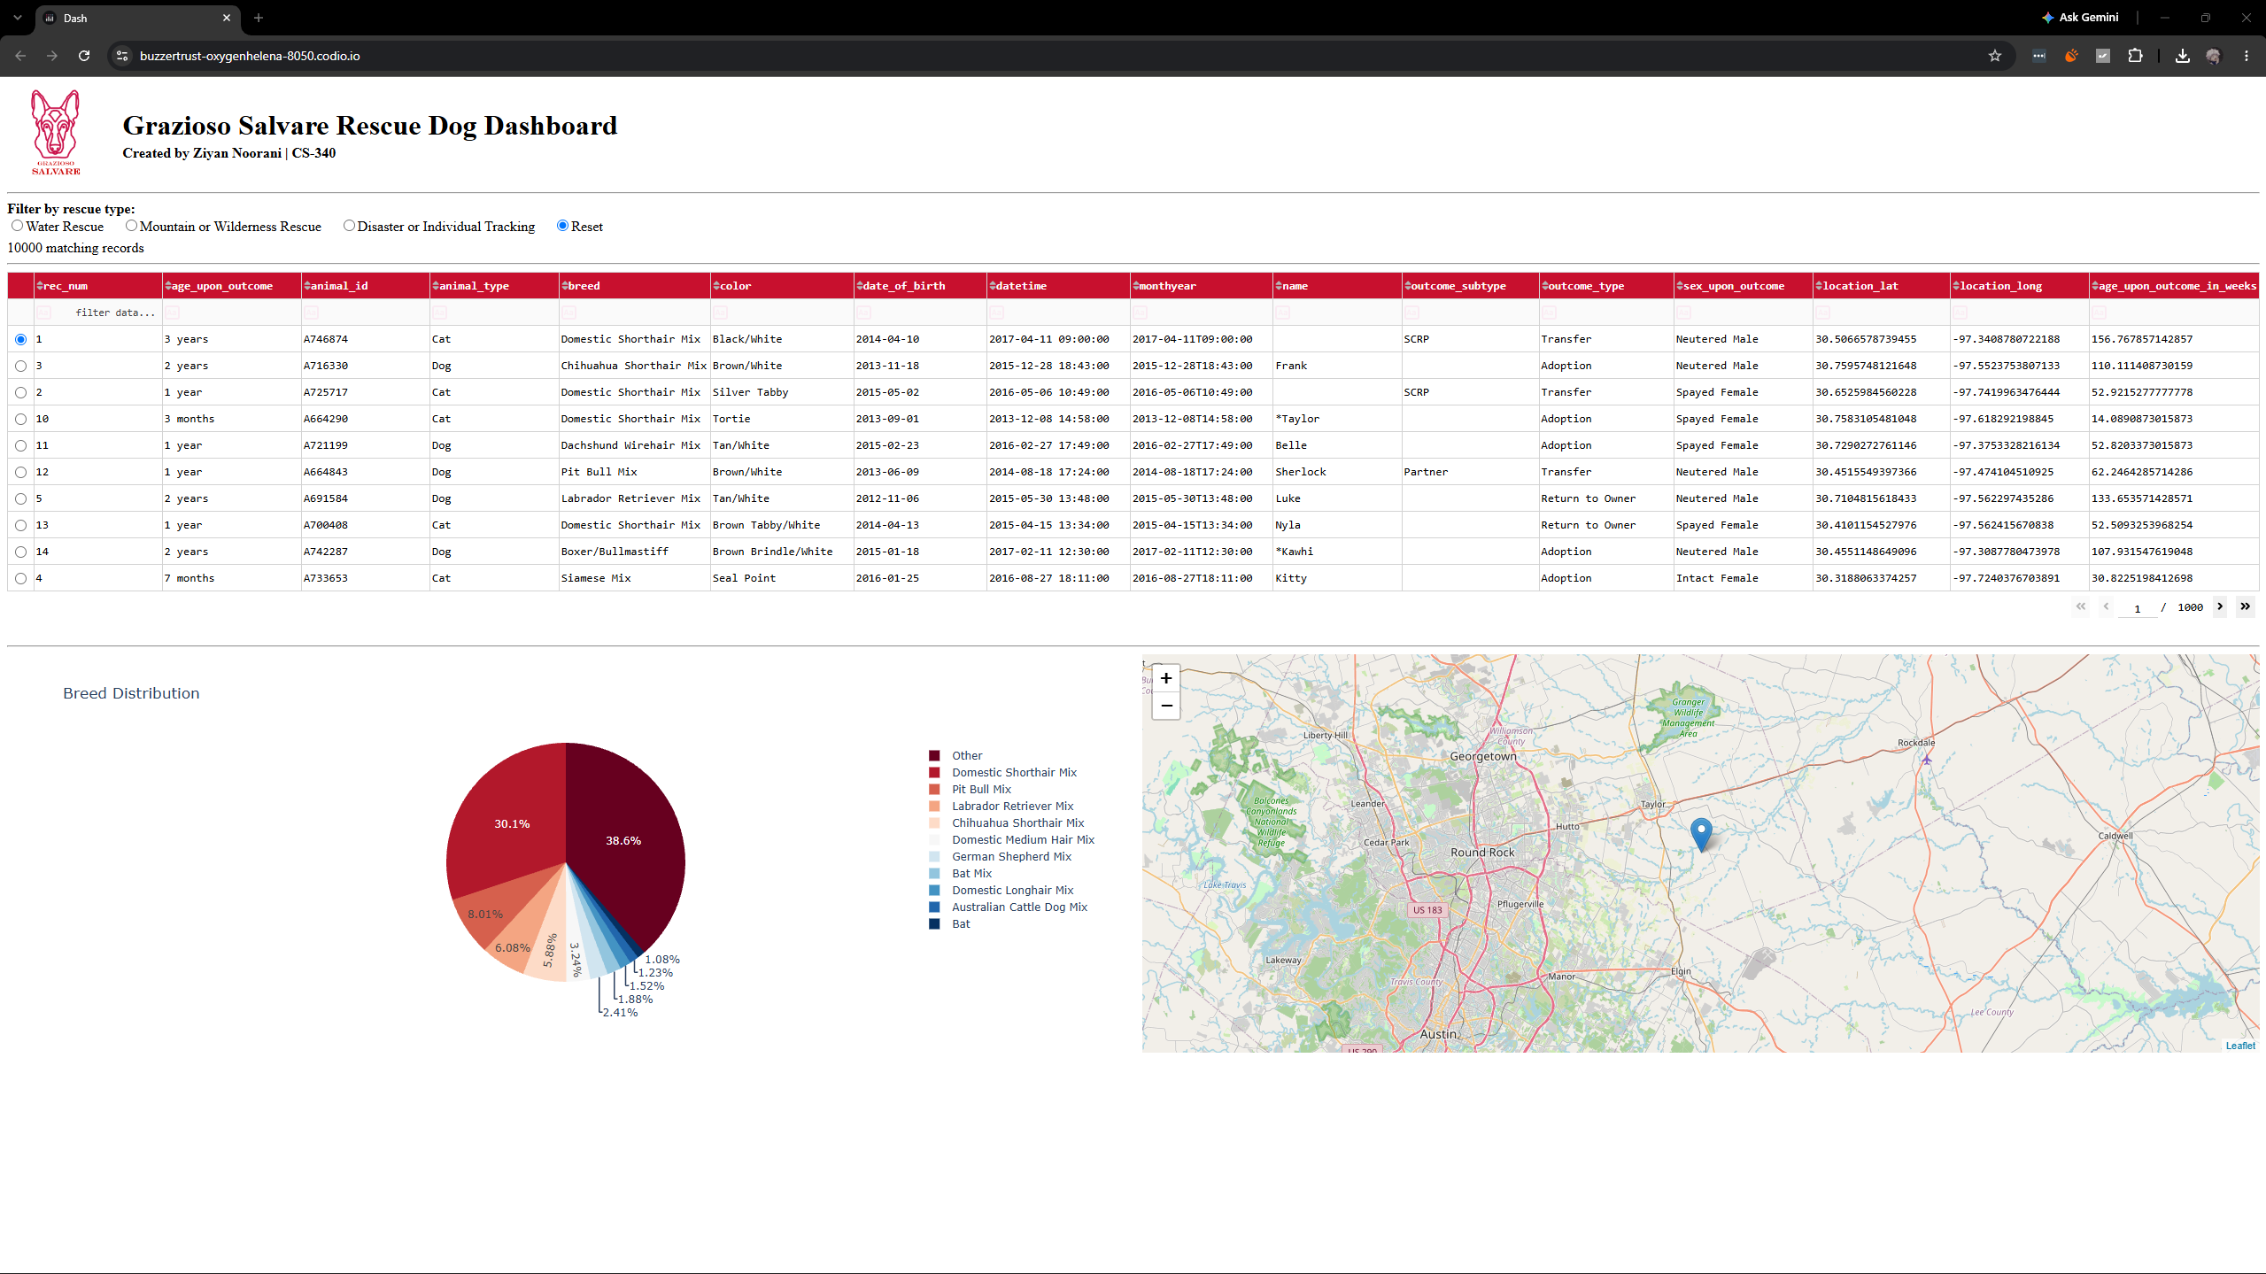
Figure 1. Starting state: Reset selected, 10,000 records, all breeds in the pie chart.
Water Rescue:
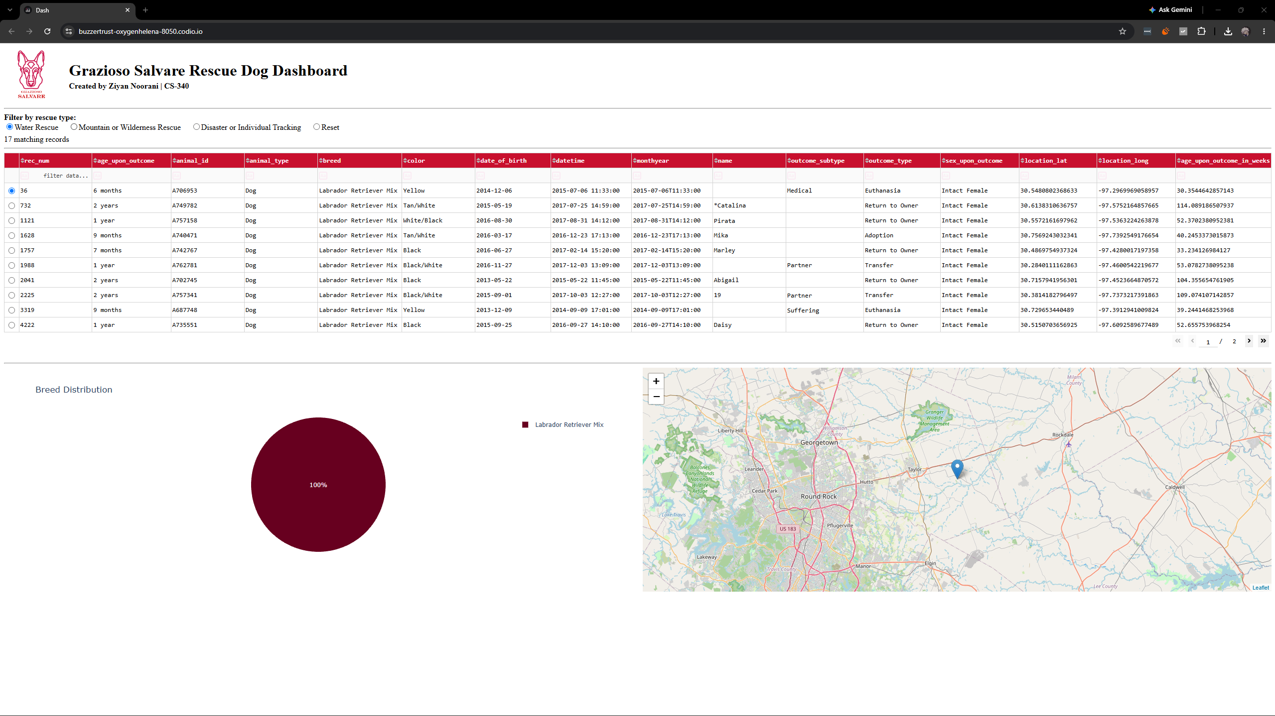
Figure 2. Water Rescue: 17 intact female Labrador Retriever Mix dogs, 26 to 156 weeks old.
Mountain or Wilderness Rescue:
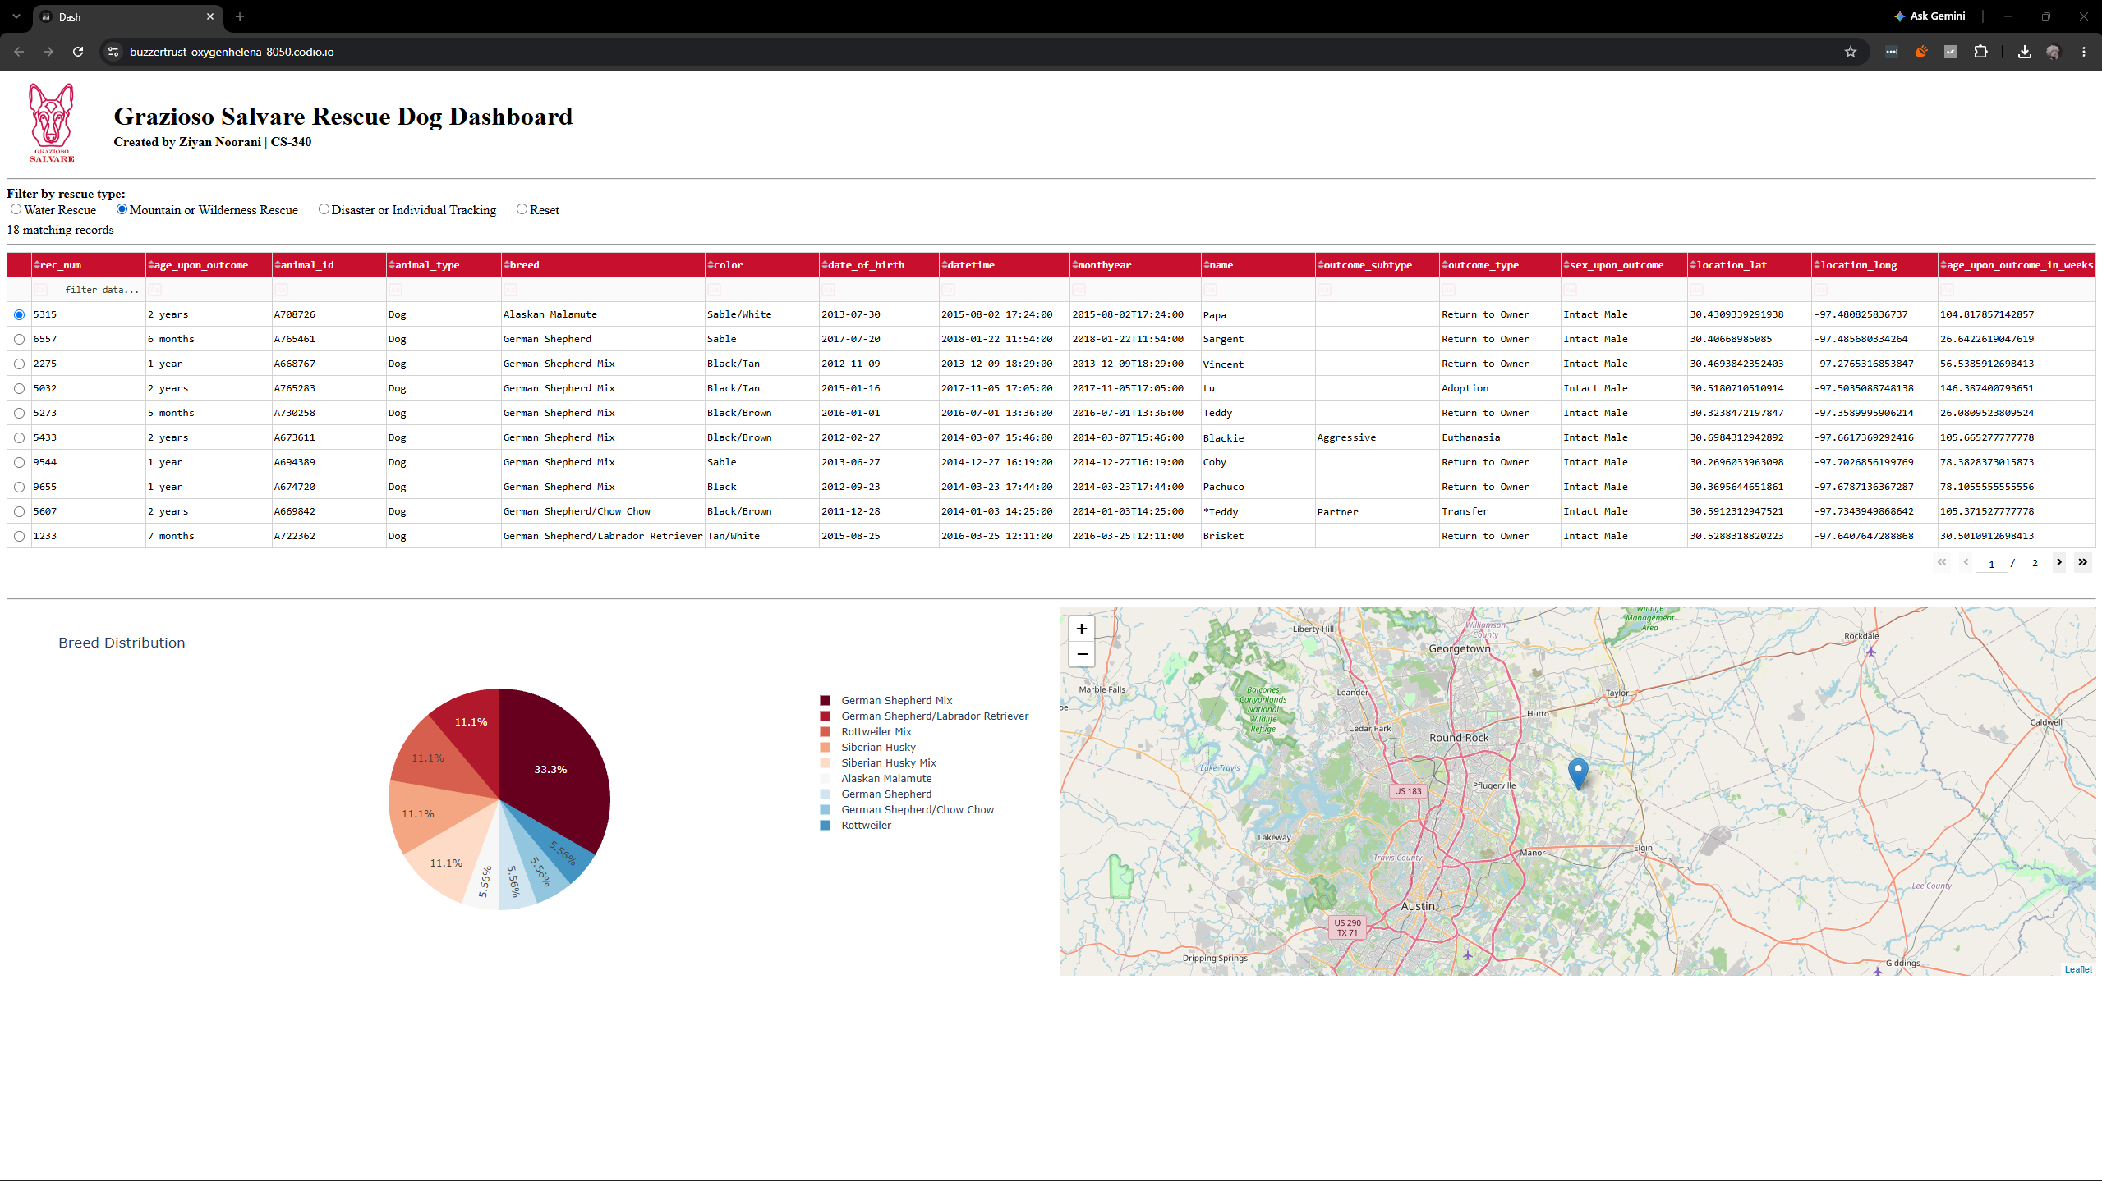
Figure 3. Mountain or Wilderness Rescue: 18 intact male dogs, 26 to 156 weeks old.
Disaster or Individual Tracking:
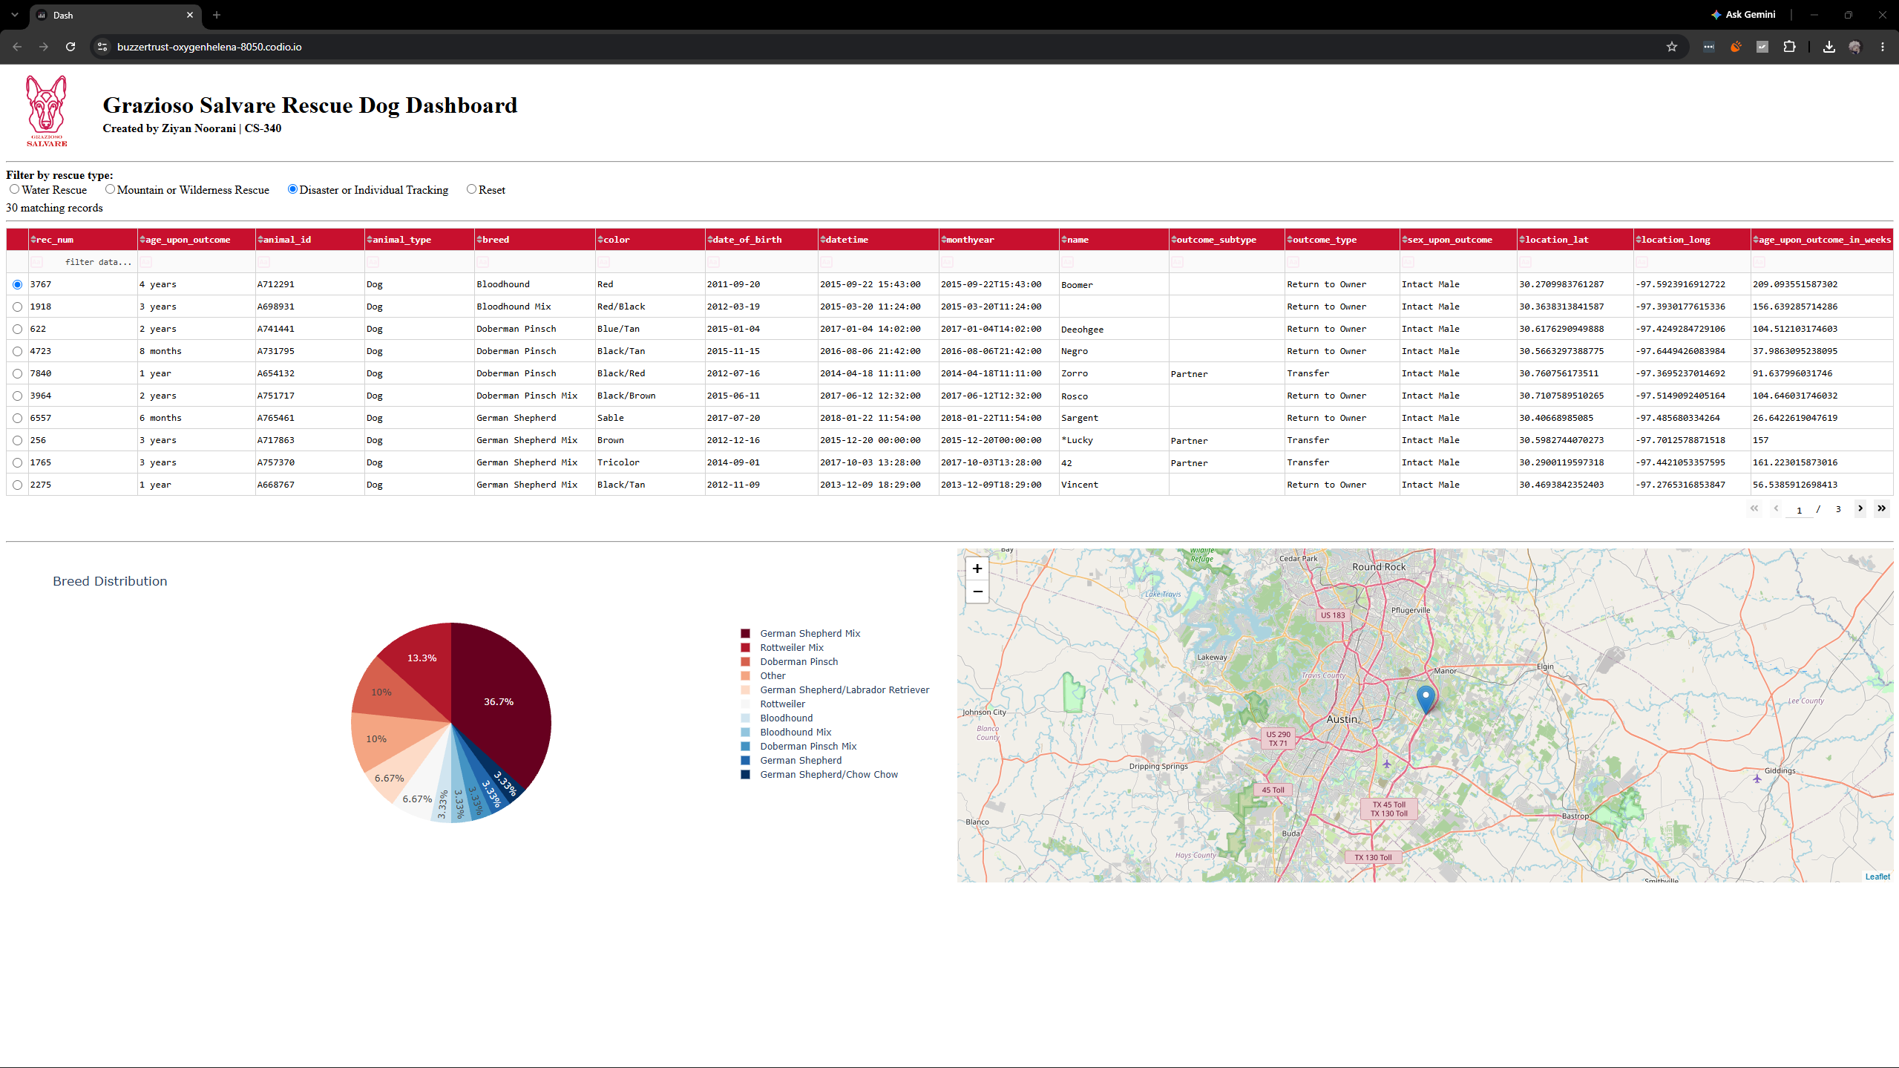
Figure 4. Disaster or Individual Tracking: 30 intact male dogs, 20 to 300 weeks old.
Reset:
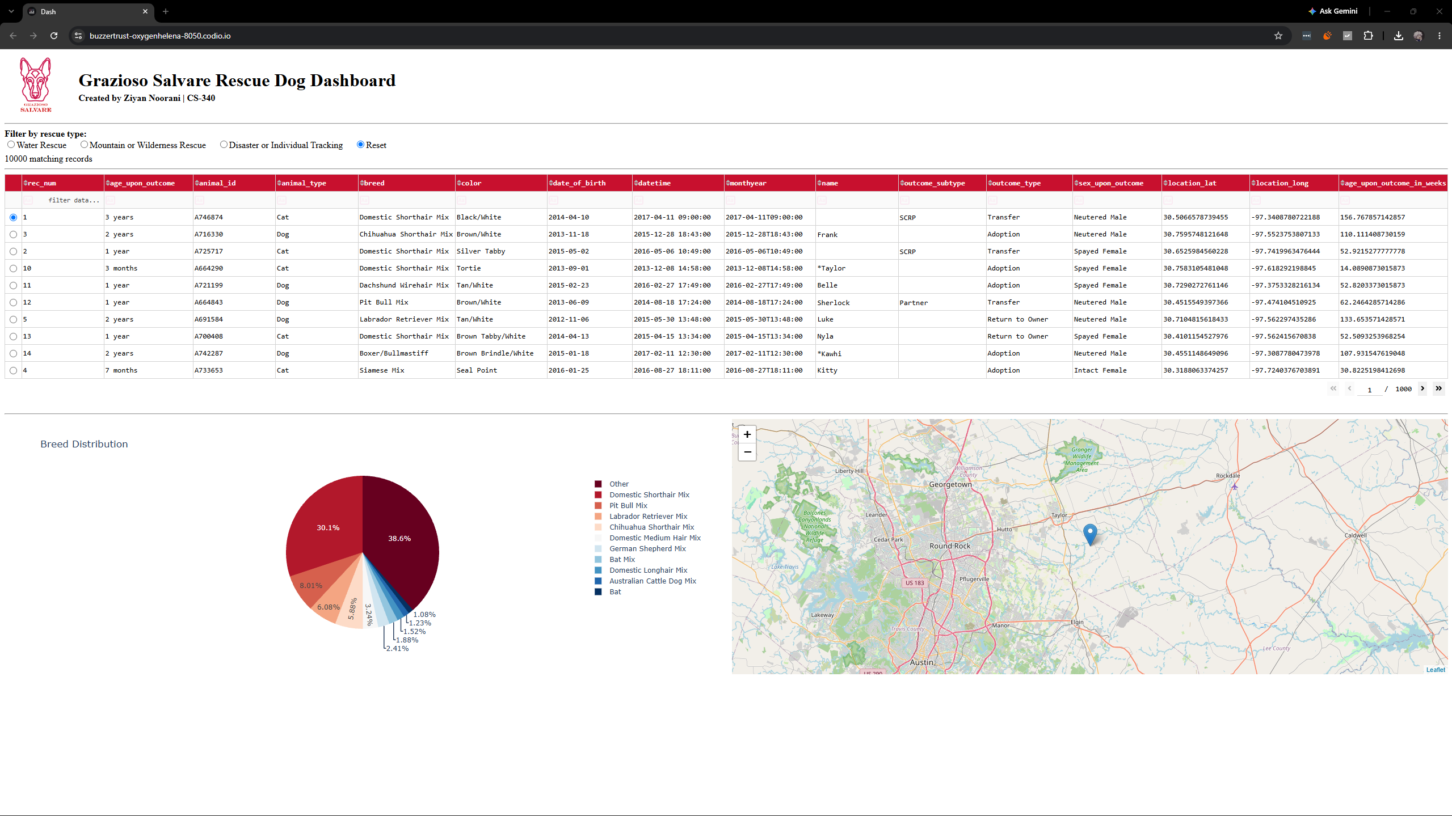
Figure 5. Reset after a filter: 10,000 records, and the table, pie chart, and map return to the starting state.

Tools and Rationale

MongoDB (Model)
MongoDB stores each shelter record as a JSON-style document, which maps straight onto a Python dictionary. That means the CRUD module passes queries such as {"sex_upon_outcome": "Intact Male"} to PyMongo with no translation layer, and results come back as dictionaries that pandas turns into a DataFrame in one line. MongoDB also supports the operators this project needs, including $regex for breed matching and $gte/$lte for age ranges. The schema is flexible, so the data set’s added columns (location_lat, location_long, age_upon_outcome_in_weeks) loaded without any table changes. Indexes on breed, built in Module Three, keep the filter queries fast. Role-based access through the aacuser account limits the dashboard to readWrite on the aac database.

Dash (View and Controller)
Dash is a Python framework from Plotly built on Flask, React, and Plotly.js. You write the whole web app in Python, so the dashboard and the CRUD module share one language. The layout (html and dcc components plus dash_table) forms the view. Callbacks form the controller: each one declares its Input and Output components, and Dash re-runs the function whenever an input changes. In this project, the radio buttons trigger a callback that re-queries MongoDB and refreshes the table. The table’s derived_virtual_data property then triggers the chart and map callbacks, so all widgets stay in sync.

Other libraries
- PyMongo: the official MongoDB driver for Python, used inside the CRUD module.
- pandas: converts query results into a DataFrame for the table and charts.
- Plotly Express: draws the pie chart.
- dash-leaflet: renders the interactive map from latitude and longitude.
- Jupyter Notebook in Codio: development and run environment.

Resources
- MongoDB Manual
- PyMongo Documentation
- Dash Documentation
- Dash Core Components
- Dash DataTable
- dash-leaflet
- Plotly Express Pie Charts
- PEP 8 Style Guide for Python Code
- Austin Animal Center Outcomes data set

Reproducing the Project

Requirements
- Python 3.8 or later with pymongo, pandas, dash, dash-leaflet, and plotly installed
- MongoDB running on localhost:27017
- Files: ProjectTwoDashboard.ipynb, CRUD_Python_Module.py, Grazioso Salvare Logo.png, aac_shelter_outcomes.csv

Steps
- Import the data into MongoDB:
mongoimport --db aac --collection animals --type csv --headerline --file aac_shelter_outcomes.csv
- Create the aacuser account on the admin database with readWrite on aac:
use admin
db.createUser({user: "aacuser", pwd: passwordPrompt(), roles: [{role: "readWrite", db: "aac"}]})
- Install the Python packages if needed:
pip install pymongo pandas dash dash-leaflet plotly
- Put CRUD_Python_Module.py and the logo PNG in the same folder as the notebook. Update USERNAME and PASSWORD in the notebook if your credentials differ.
- Run every cell in ProjectTwoDashboard.ipynb. The last cell starts the server on port 8050.
- Open the dashboard. In Codio, use https://<your-box-name>-8050.codio.io. On a local machine, use http://127.0.0.1:8050.
- Click each radio button and confirm the record count, table, pie chart, and map change.

How the work was completed
- Reviewed the specification document and mapped each rescue type to its breed, sex, and age criteria.
- Reused the Project One CRUD module and confirmed that read({}) returned all 10,000 records.
- Built the unfiltered data table with paging, sorting, and row selection.
- Wrote one query per rescue type and checked the record counts against the CSV in pandas.
- Added the radio buttons and the callback that re-queries MongoDB.
- Added the pie chart and map callbacks, driven by the table’s current view.
- Added the logo, the link, and the unique identifier, then tested each filter and took screenshots.

Challenges and Solutions
- Exact breed matches missed mixed breeds. An exact $in match on breed returned only 5 mountain rescue dogs, because names like "German Shepherd Mix" did not match "German Shepherd". Switching to an anchored $regex raised that to 18 and still excluded dogs where the preferred breed is only the second half of a mix.
- Truncated breed name. The data set stores Doberman Pinscher as "Doberman Pinsch". Searching the breed column for "Doberman" revealed the stored spelling, and the disaster query uses it.
- ObjectId in the data table. The CRUD module’s read() returns MongoDB’s _id field, an ObjectId the Dash DataTable cannot display. The notebook drops the _id column after every query, so the table and charts receive plain values.
- Authentication failure. aacuser lives on the admin database, so the connection string needs authSource=admin. Without it, MongoDB rejected the login.
- Dashboard link would not load in Codio. The 127.0.0.1 link and inline mode did not load. Running the server with host 0.0.0.0 on port 8050 and opening the box’s public 8050 URL fixed it.
- Private IP link timed out. The server output listed http://10.17.171.213:8050, which is the Codio box’s private address and timed out in the browser. The box’s public URL with -8050 added to the box name loaded the dashboard.
- Old notebook ran instead of the new one. After uploading the finished notebook, Jupyter threw an IndentationError from the starter file’s empty update_dashboard() function, because the old copy was still open. Closing the old tab, re-uploading, and running Restart & Run All fixed it.
- Map broke after filtering. A row selected under one filter could point past the end of a shorter filtered table. The filter callback now resets the selection to the first row, and the map callback falls back to row 0.
- Unreadable pie chart. The unfiltered view has hundreds of breeds. The chart now shows the top 10 and groups the rest as Other.

AI Usage Acknowledgment
Generative AI (Claude, Anthropic) was used to help draft and comment the dashboard code and to format and word this README. I ran, tested, and verified the dashboard in Codio, captured the screenshots, and checked each query’s results against the data set.

