CS 255 Business Requirements Document
DriverPass
Ziyan Noorani | Southern New Hampshire University

System Components and Design

Purpose
- DriverPass, owned by Liam, is a new company built around a real gap in the market: over 65% of DMV driving test applicants fail, and Liam wants to fix that by combining online practice exams with actual on-the-road training.
- What he needs from us is a system that handles customer registration, lesson reservations, driver and vehicle assignment, package selection, and online course content, all from a browser or phone.
- It also has to give his staff, himself, Ian, and the secretary, the tools to manage accounts, track activity, and keep training content current with DMV rules.

System Background
- DriverPass wants to replace informal, phone-based scheduling with an online system that customers can use themselves.
- The core problem is twofold: students are not well prepared for the DMV test, and DriverPass has no central way to track lessons, drivers, vehicles, or account activity.
- That points to several needed components: a customer/account module, a reservation and scheduling module that matches a customer to a driver, vehicle, date, and time, a package/pricing module, an online course and practice-test module, a DMV content-update module, and an activity log.
- Liam also wants to reach company data from any computer or device, and to download reports (into Excel, for example) for offline review.

Objectives and Goals
- Reduce the DriverPass customer failure rate on the DMV driving test by combining online practice exams with in-car training.
- Let customers create an account and independently schedule, modify, or cancel a lesson reservation online, or have the secretary do it by phone or in person.
- Match every two-hour lesson reservation to one of the company's 10 vehicles and its assigned driver, with no double-booking.
- Maintain an accurate activity log that identifies who created, modified, or canceled each reservation, and allow that log to be printed as a report.
- Notify DriverPass automatically whenever the DMV updates its rules, policies, or sample test questions, so course content stays current.
- Give each type of user, owner, IT officer, secretary, driver, and customer, the level of system access appropriate to their role.

Requirements

Nonfunctional Requirements

Performance Requirements
- Needs to run as a web app, usable from a standard browser on desktop or mobile.
- Booking, changing, or canceling a reservation has to show up right away, so a driver and vehicle never end up double-booked for the same slot.
- Data can only be created or changed while the user is online. Sam pointed out that allowing offline edits risks duplicate records once copies are later merged onto different servers.
- DMV rule, policy, or sample-question updates should be picked up and applied automatically, with staff notified when new content arrives.

Platform Constraints
- Web-based, ideally hosted in the cloud, so DriverPass isn't managing its own servers, backups, or security infrastructure.
- A backend database is needed for customer records, reservations, driver and vehicle assignments, package details, and the activity log.
- Has to work across common desktop and mobile browsers regardless of operating system.

Accuracy and Precision
- Users are distinguished by role: owner, IT officer, secretary, driver, and customer, each with different permissions.
- Structured fields like credit card number, expiration date, security code, and phone number need format validation before they're accepted.
- Ian should be notified of problems such as failed logins, scheduling conflicts, or bad payment information.

Adaptability
- Ian needs full access to add, reset, or disable accounts without waiting on a developer, useful for something as routine as an employee leaving the company.
- Per Sam, adding or removing an entire lesson package still needs a developer or systems analyst, though Liam should be able to disable an existing package on his own so new customers can't register for it.
- New DMV content should be able to come in as a content update rather than requiring a code change.

Security
- Customers log in to their own account to book, change, or cancel a reservation; the secretary can do the same on a customer's behalf by phone or in person.
- A forgotten password needs to reset automatically, with no staff involvement required.
- Ian needs full authority to reset a password or disable any account, for example when an employee is let go.
- Credit card number, expiration date, and security code need to be encrypted, both in storage and in transit between client and server.
- Every reservation change gets logged with who made it and when, and staff should be able to print that log as an activity report.

Functional Requirements
- The system shall allow a customer to create an account and register for one of the three available lesson packages.
- The system shall allow a customer to schedule, modify, and cancel a driving lesson reservation online.
- The system shall allow the secretary to schedule, modify, or cancel a reservation on behalf of a customer by phone or in person.
- The system shall assign a driver, vehicle, date, and time to each two-hour driving lesson reservation.
- The system shall prevent a driver or vehicle from being booked for two overlapping reservations.
- The system shall record the user who created, modified, or canceled each reservation, along with a timestamp.
- The system shall generate an activity report showing reservation history and the user responsible for each change.
- The system shall store customer information, including first name, last name, address, phone number, state, pickup location, and payment details, and shall default the drop-off location to match the pickup location.
- The system shall allow the owner to disable a lesson package so that no new customers can register for it.
- The system shall allow the IT officer to reset a password and to enable or disable any user account.
- The system shall allow a customer to reset a forgotten password automatically.
- The system shall display DMV rule, policy, and sample-question updates as they become available.
- The system shall track and display each customer's practice test progress and status (not taken, in progress, failed, or passed), along with the test name, time taken, and score.
- The system shall give Package Three customers access to the online course content and practice tests.
- The system shall allow staff to download reports, for example into Excel, for offline use.

User Interface
- The primary users of the interface are the owner (Liam), the IT officer (Ian), the secretary, drivers, and customers, each of whom needs a different view into the system.
- Customers need to register, log in, view and manage their own reservations, track their online test progress, and, for Package Three, access online course content.
- The secretary needs to look up customers, drivers, and vehicles, and create, modify, or cancel reservations on a customer's behalf.
- The IT officer needs administrative screens for resetting passwords and enabling or disabling accounts.
- The owner needs access to business-wide reports, the activity log, and the ability to enable or disable a lesson package.
- Drivers need to view their own lesson schedule and record driver notes and comments for each lesson.
- Liam's sketch calls for a dashboard-style home page with four sections: online test progress (test name, time taken, score, and status), customer information (name, address, city, state, zip, phone, email), driver notes (a table of lesson time, start hour, end hour, and driver comments), and a special-needs panel with driver and student photos.
- A separate registration form is needed for entering a new customer's first name, last name, address, and other contact details, along with a page for contacting DriverPass and a way to contact the student.
- The interface must be usable from both a browser and a mobile device, since customers and staff will access it from different platforms.

Assumptions
- Customers and staff will have reliable internet access, since the system does not support offline data entry.
- DriverPass will use third-party cloud hosting rather than maintaining its own servers.
- The initial release will work with the company's existing 10 vehicles and their assigned drivers, without a need to dynamically add or remove vehicles.
- Adding or removing an entire lesson package will continue to require a developer or systems analyst, though the owner can disable an existing package on his own.
- The DMV will provide some form of feed or notification that DriverPass can use to receive rule and policy updates.

Limitations
- The system will not let a non-developer add or remove an entire lesson package in this release; Sam noted that this still requires a developer or systems analyst.
- Because data can only be changed while online, this version does not support offline editing or multi-server synchronization.
- The initial release only allows an existing package to be disabled; it does not include a tool for building new custom packages.
- The project schedule and available resources limit this release to the core reservation, tracking, and interface features described in the interview; Liam agreed that additional features can be considered for a future release.
- The system's ability to stay current with DMV requirements depends on DriverPass receiving timely updates from the DMV, which is outside DriverPass's control.

Gantt Chart
The Gantt chart below was created in Lucidchart based on the schedule Sam and Jennifer built during their scheduling conversation in the interview transcript.
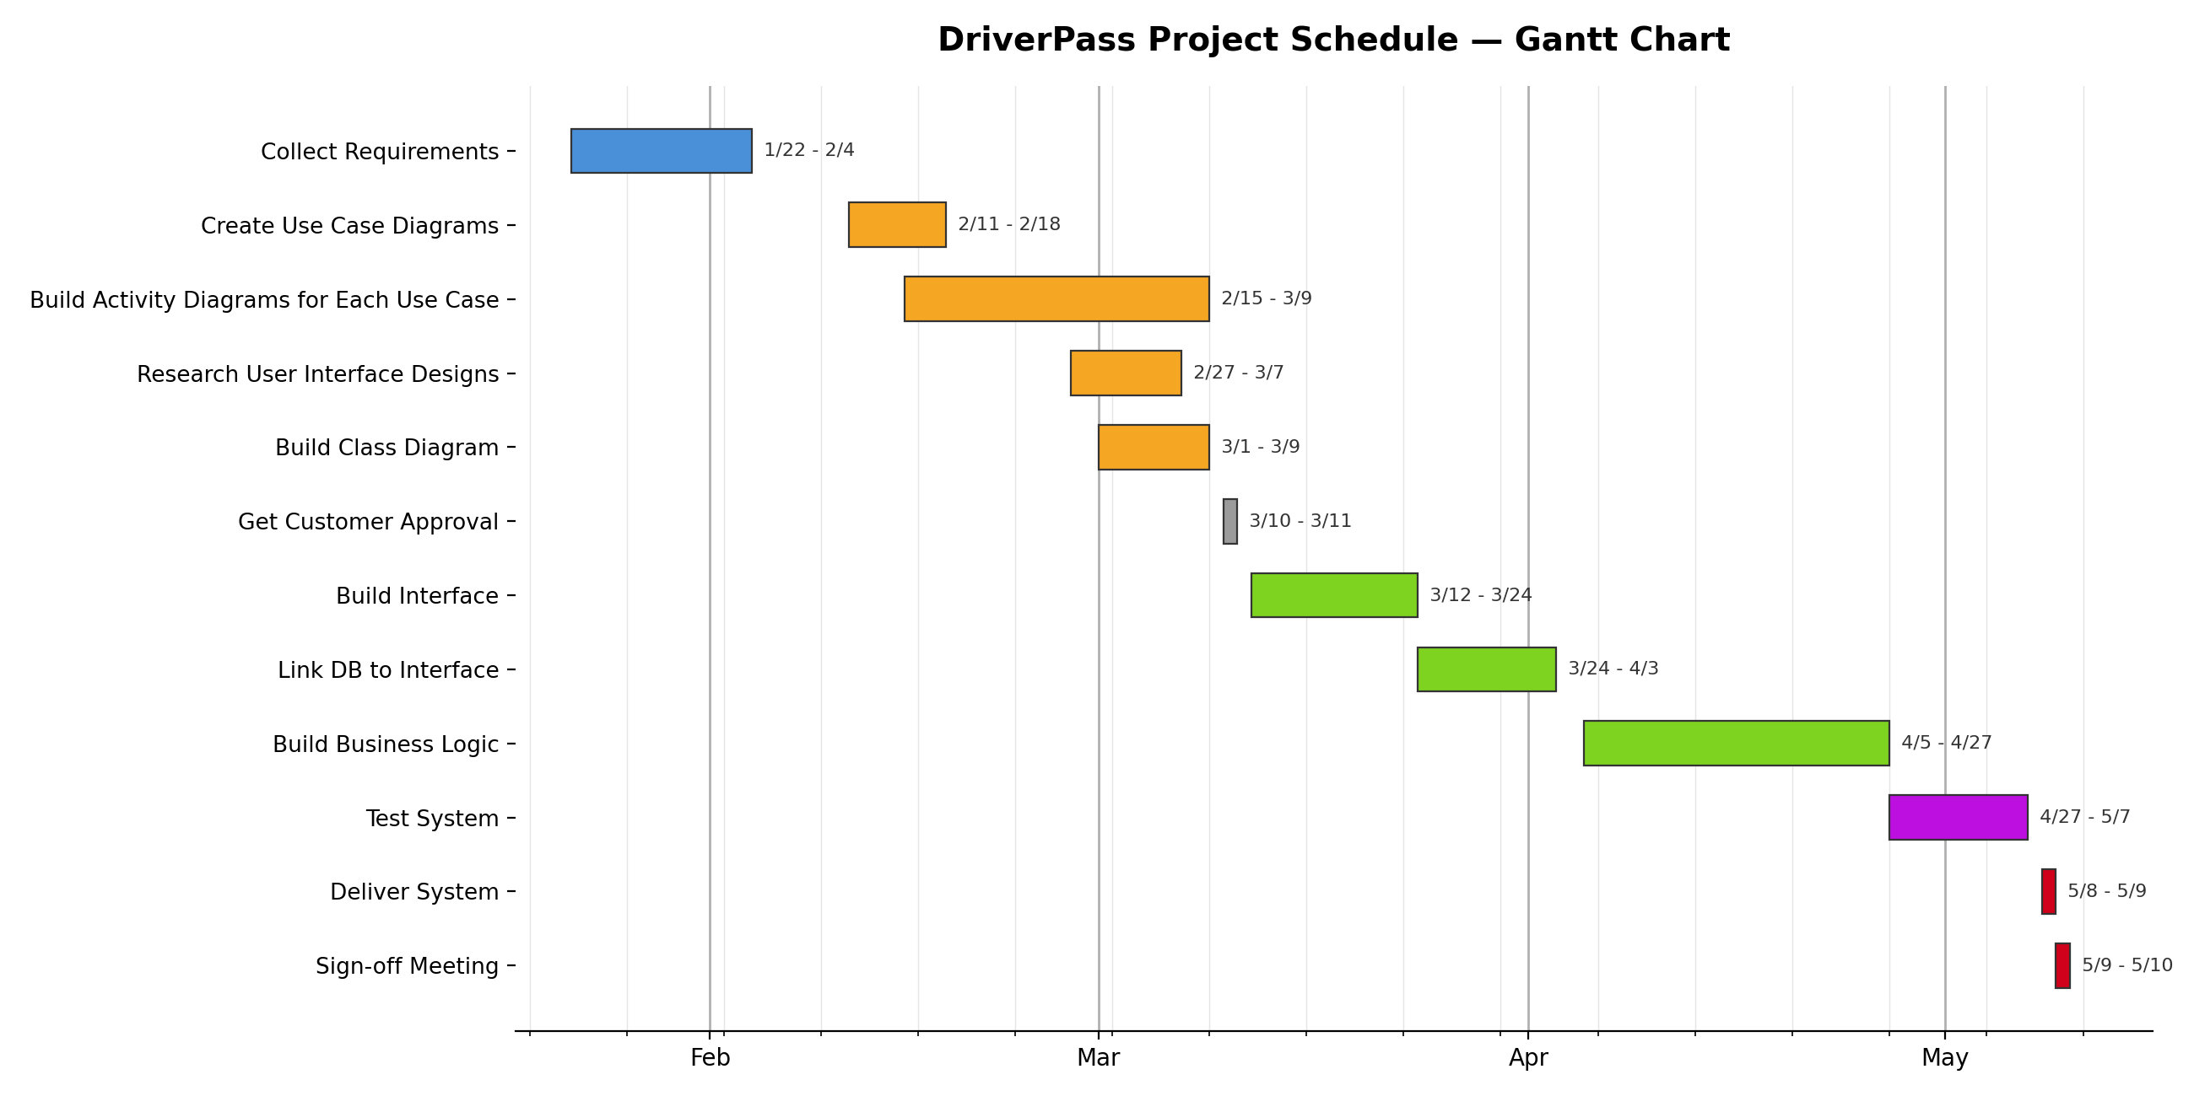
AI Usage: I used AI (Claude) to brainstorm how to word the responses in this document.

