DriverPass System Design Document

Ziyan Noorani
CS-255: System Analysis and Design
Southern New Hampshire University
August 13, 2026

UML Diagrams

UML Use Case Diagram
The use case diagram covers the six people and outside systems that touch DriverPass and the twenty things they need the system to do. Liam described a business with four internal roles and one outside connection, so the diagram keeps customer work on the left and staff and system work on the right.
Customers create an account, log in, buy one of the three training packages, book and change lessons, and work through the online class and practice tests. The secretary does the same scheduling work for customers who call or walk into the office. Instructors record the comments and lesson times that show up in the driver notes table Liam sketched. The IT officer manages accounts and access, which covers Ian's request to reset a forgotten password or block someone who has left the company. The owner pulls activity reports and turns packages on or off without a developer. The DMV connection feeds rule and question updates into the system.
Four include relationships mark work that always runs as part of a larger step. Booking a lesson always assigns an instructor, a car, and a time slot, because DriverPass has to know which student went out with which driver in which car. Buying a package always runs a payment authorization, so no enrollment is created until the card clears. Finishing a practice test always writes a result. The one extend relationship covers password reset, which only happens when a customer cannot get past the login page.
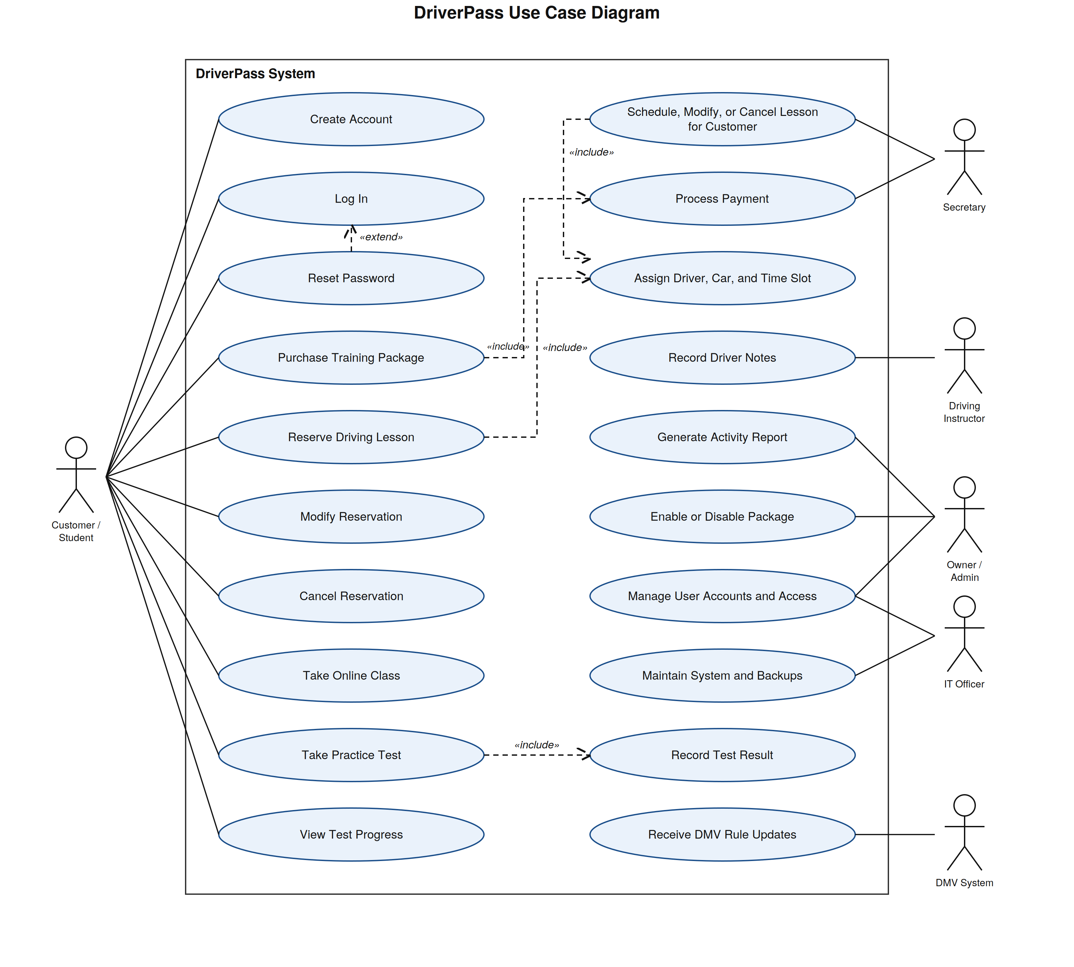
Figure 1. DriverPass UML use case diagram (created in Lucidchart).

UML Activity Diagrams
The first activity diagram breaks down Reserve a Driving Lesson, the use case that drives most of the day-to-day work at DriverPass. Guard conditions are written as expressions over the attributes in the class diagram so the development team can implement each branch without guessing at the rule behind it.
The flow reads hoursRemaining from the customer's enrollment before it offers a booking form, then tests [hoursRemaining >= 2]. Package One buys six in-car hours and every session runs two hours, so a customer who has used all three sessions is turned away with an upgrade message rather than a booking that later falls apart. The second decision tests whether the scheduling query returned a matching slot. DriverPass runs ten cars with one driver assigned to each, so a booking is only real when the student, the driver, the car, and the time slot all line up. On [no matchingSlot] the customer sees alternate times and the flow merges back above the date selection instead of restarting the whole use case.
Once the slot is held, the system deducts two hours from hoursRemaining. Making that state change an explicit action keeps the hours check on the next booking honest. The fork then runs two things at once: the confirmation goes out to the customer and an entry goes into the activity log. Liam asked to know who made, changed, or cancelled every reservation, so the log write sits inside the flow rather than off to the side where it could be skipped.
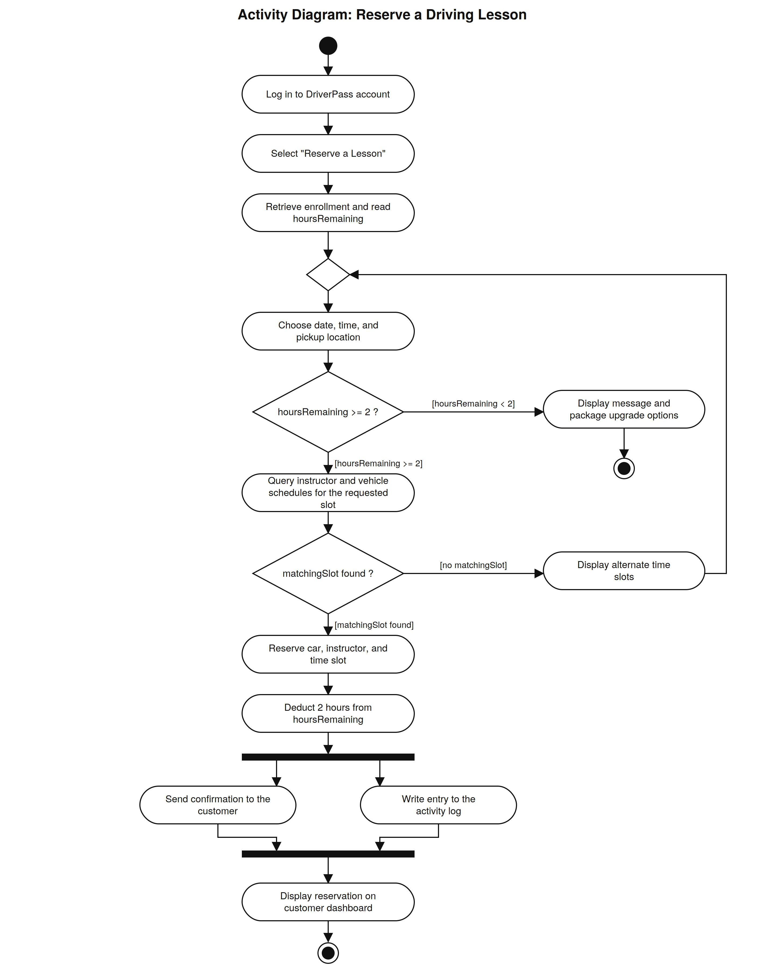
Figure 2. Activity diagram for Reserve a Driving Lesson (created in Lucidchart).

The second activity diagram breaks down Purchase a Training Package. Liam described collecting a card number, expiration date, and security code during registration, so this flow shows what the system does with that card and what happens when the bank says no.
The package list is filtered by [isActive = true], which is how Liam turns a package off without a developer. The system sets declineCount to zero before the first attempt, sends the card to the payment gateway, and tests [approved]. A decline increments declineCount by one, and only then does the flow test [declineCount < 3]. Keeping the increment as its own action makes it clear how the system knows a third failure has happened. After three declines the flow locks checkout and refers the customer to the office, which protects DriverPass from repeated authorization attempts on a stolen card.
On approval the system stores only the authorization code and the last four digits, creates the enrollment with hoursRemaining set to the package's in-car hours, and unlocks the online class when [includesOnlineClass = true]. That single flag is what separates Package Three from Packages One and Two. The receipt goes out by email and the purchase is written to the activity log, so the same audit trail that covers reservations also covers money.
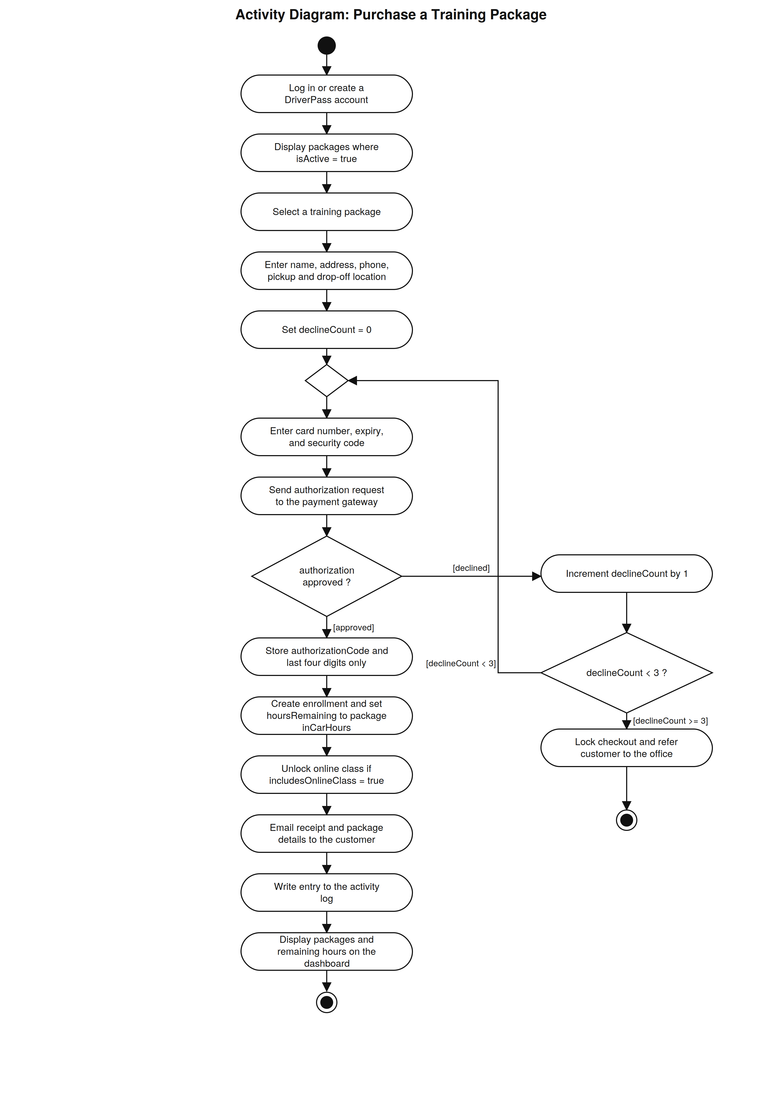
Figure 3. Activity diagram for Purchase a Training Package (created in Lucidchart).

UML Sequence Diagram
The sequence diagram takes the same reservation use case as Figure 2 and shows it as a conversation between objects over time. The customer works through the reservation page, which hands the request to a reservation manager. That manager coordinates everything else.
The manager asks the enrollment object how many lesson hours are left before it does any scheduling work. The alt block covers both outcomes of the same guard used in the activity diagram. When hoursRemaining is at least two, the scheduling service queries instructor and vehicle availability, the reservation is saved, the activity log entry is written, and the notification service sends the confirmation. When the customer is out of hours, the manager returns an error and the page offers package upgrade options.
Splitting scheduling out from the reservation manager keeps the availability rules in one place. If Liam later adds cars or changes how drivers are matched to students, the change lands in a single object instead of spreading through the booking code.
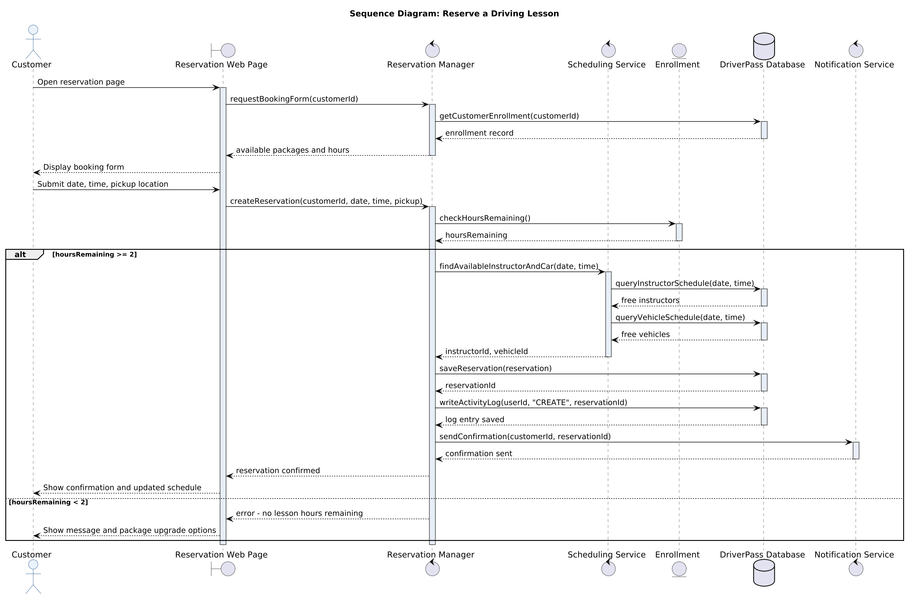
Figure 4. Sequence diagram for Reserve a Driving Lesson (created in Lucidchart).

UML Class Diagram
The class diagram holds seventeen classes, and each group of them answers a specific request from the interview. User carries what every account has in common: credentials, name, contact details, an active flag, and a last login stamp. Customer, Instructor, Secretary, and Administrator inherit from it. Ian asked for one place to reset a password or block an account, and inheritance gives him that: the isActive flag on User switches off any role.
Package, Enrollment, and Payment cover the sales side. Package stores inCarHours and the flags for the classroom lesson and the online class, which is how the three current packages are described and how Liam disables one later through isActive. Enrollment tracks hoursRemaining, and that number is what the reservation flow checks. Payment holds authorizationCode, cardLastFour, and cardExpiry, which is the design's answer to collecting card details without storing a full card number.
Reservation joins a customer, an instructor, a vehicle, a date, and a time, and it carries createdBy, lastModifiedBy, and lastModifiedDate. Liam asked to find out who made, cancelled, or modified a booking, and those three fields answer that question for the record itself while ActivityLog answers it across the whole system. Vehicle and LessonNote complete the on-the-road side: ten cars with availability, and the comments and lesson times from Liam's driver notes sketch.
OnlineCourse, PracticeTest, Question, and TestAttempt cover the training content. The composition diamonds mean a practice test does not exist without its course and a question does not exist without its test. TestAttempt stores the score, the time taken, and a status, which are the four columns in the progress table Liam drew. DMVUpdate records what the DMV sends and links to the questions it changes, so the material stays current with the test.
Fields that exist only to link one record to another are left out of the boxes, since the associations and their multiplicities already carry that information.

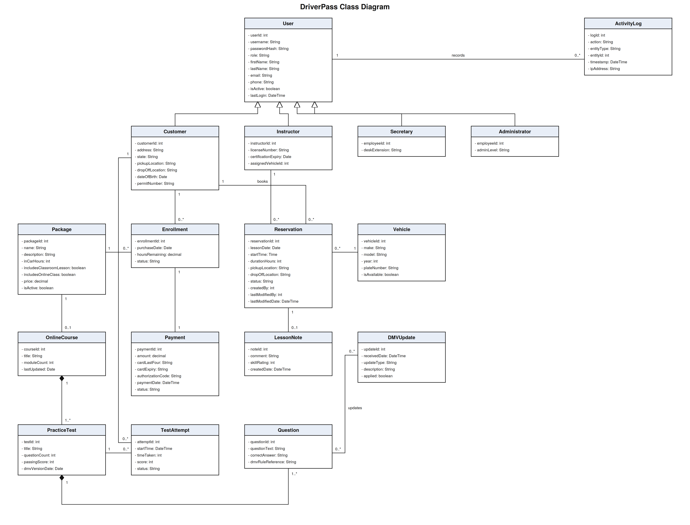
Figure 5. DriverPass UML class diagram (created in Lucidchart).

Technical Requirements
The requirements below follow from the diagrams and from what Liam and Ian asked for in the interview. Ian was clear that DriverPass wants to run the business, not a server room, so the design leans on managed cloud services wherever that removes work from his desk.

Hosting and Infrastructure
• A public cloud platform such as AWS or Microsoft Azure, using managed services so DriverPass does not patch operating systems or run its own backups.
• Two application server instances behind a load balancer, starting at 2 vCPU and 4 GB RAM each, in an auto scaling group spread across two availability zones.
• A managed relational database instance with a synchronous standby in a second zone for failover.
• Object storage plus a content delivery network for course video, images, and generated report files.
• A staging environment that mirrors production at half the instance size, used for client review before each release.

Server Software
• Ubuntu Server LTS on the application instances.
• A web application framework such as ASP.NET Core or Node.js with Express, exposing a REST API behind an Nginx reverse proxy.
• PostgreSQL 16 or Microsoft SQL Server for the relational data described in the class diagram.
• Redis for session storage, so any application instance can serve any request after a failover.
• TLS 1.3 certificates renewed automatically.

Client Hardware and Software
• Customers need a current version of Chrome, Safari, Edge, or Firefox on Windows, macOS, iOS, or Android. No install and no plugin. The layout works down to a 360 pixel wide screen.
• The front office needs two workstations with 8 GB RAM and a 1920 by 1080 display on a wired connection, which is enough for the secretary to hold a phone call and book a lesson at the same time.
• Instructors record lesson notes on a phone or tablet, so the notes form has to work on a small screen over a cellular connection.
• Reports download as .xlsx and .csv so Liam can open them in Excel at home.

External Integrations
• A payment gateway such as Stripe or Authorize.Net, reached over a server side REST API with tokenized cards. The gateway returns an approval or a decline, which is the decision the purchase activity diagram branches on. DriverPass stores only the last four digits, the expiration month, and the authorization code, which keeps the company at PCI DSS SAQ A scope.
• An email and SMS provider for booking confirmations, cancellations, receipts, and lesson reminders.
• The DMV connection runs as a REST API integration over HTTPS with two paths. A scheduled job pulls the rule, policy, and question feed nightly at 2:00 a.m., and a webhook endpoint accepts pushed changes as soon as the DMV publishes them. Each payload is written to a DMVUpdate record and raises an alert for the owner. If the DMV cannot support an API, the same DMVUpdate records are created from a signed CSV import that a staff member runs from the administrative screen.

Data, Backup, and Recovery
• Automated daily full backups with point in time recovery and 35 day retention.
• A recovery point objective of 5 minutes and a recovery time objective of 4 hours.
• Encryption at rest using AES-256 and encryption in transit using TLS 1.3.
• A quarterly restore test into the staging environment, documented so Ian can show it was done.

Security and Access Control
• Role based access control with five roles: customer, secretary, instructor, IT officer, and owner. Each role sees only the screens and records it needs.
• The IT officer can reset any password and disable any account, which handles both the forgotten password call and the employee who leaves.
• Self service password reset through a single use emailed link that expires after 30 minutes.
• Passwords stored as bcrypt hashes. Sessions time out after 20 minutes of inactivity.
• Every create, update, and delete on reservations, accounts, packages, and payments writes to the activity log with the user, the action, the record, the timestamp, and the IP address. The owner can print that log as a report.
• A web application firewall in front of the site, rate limiting on the login and password reset endpoints, and a three attempt limit on card authorization per checkout session.

Operational Constraints
• Every operation that changes data needs a live internet connection. Reports can be downloaded and read offline, but any edit has to go back through the system while online. Sam raised this in the interview, and it is the constraint that keeps two copies of the schedule from disagreeing.
• Adding or removing a package requires a developer. Disabling one does not, because Package.isActive is exposed on the administrative screen.
• Lesson capacity is bounded by ten vehicles and ten instructors. The system reports utilization so the owner can see when the fleet is the limit.
• Practice question accuracy depends on the DMV feed. Content is only as current as the last update received, and the update timestamp is shown on the administrative screen.

Measurable Acceptance Targets
• 99.5 percent uptime measured monthly, with maintenance windows outside business hours.
• Page loads under 2 seconds on a normal broadband connection.
• Support for 200 students working through the online class at the same time, and 50 booking actions per minute at peak.
• Double booking of a vehicle or an instructor at zero occurrences, verified by a nightly conflict report against the Reservation table.
• Card authorization round trip under 5 seconds at the 95th percentile.
• Every reservation and payment change traceable to a named user within 1 minute of the event.

Development Tools
• Lucidchart for the use case, activity, sequence, and class models in this document.
• Git with a hosted remote for source control, using a branch per feature and a pull request review before merge.
• Visual Studio Code as the editor, with a shared formatting and linting configuration.
• Unit tests in xUnit or Jest, browser tests in Playwright, and a continuous integration pipeline that runs both on every pull request.
• A tracking board for the schedule Sam and Jennifer laid out, from requirements collection through interface work, database tables, business logic, delivery, and sign off.

Requirements Traceability
The table below ties each need DriverPass stated in the interview to the part of the design that satisfies it and the technical requirement that supports it.
Client need from the interview | Where it appears in the design | Supporting technical requirement
Access account data from any computer or mobile device (Liam) | Log In and all customer use cases; browser client in the sequence diagram | Responsive browser client, no install, 360 pixel minimum width
Download reports and work on them in Excel (Liam) | Generate Activity Report use case | .xlsx and .csv export; edits require a live session
Different rights per employee, with full IT access to reset or block accounts (Ian) | Manage User Accounts and Access use case; User and Administrator classes | Role based access control across five roles; IT officer reset and disable
Know who made, cancelled, or modified a reservation and print a report (Liam) | Fork to the activity log in Figure 2; ActivityLog class; createdBy and lastModifiedBy on Reservation | Audit entry on every create, update, and delete with user, timestamp, and IP
Two hour lessons booked by day and time, online or through the office (Liam) | Reserve Driving Lesson and Schedule, Modify, or Cancel Lesson for Customer use cases; Figure 2 | One booking service behind both the customer site and the front desk screen
Match each student to a specific driver, car, and time (Liam) | Assign Driver, Car, and Time Slot include; Reservation associations to Instructor and Vehicle | Scheduling service queries instructor and vehicle schedules before the slot is held
Three packages of 6, 8, and 12 in-car hours with classroom and online options (Liam) | Package class attributes; entitlement checks in Figures 2 and 3 | Package record drives entitlement; hoursRemaining held on Enrollment
Disable a package without a developer (Liam) | Enable or Disable Package use case; Package.isActive filter in Figure 3 | Administrative screen toggles isActive; adding a package remains a developer task
Collect card number, expiry, and security code at registration (Liam) | Purchase a Training Package activity diagram; Payment class | Tokenized gateway; only last four digits, expiry, and authorization code retained
Let customers reset a forgotten password automatically (Ian) | Reset Password extends Log In | Single use emailed link that expires after 30 minutes
Stay current with DMV rules and sample questions, with a notification on update (Liam) | Receive DMV Rule Updates use case; DMVUpdate class | Nightly REST pull plus webhook, with a CSV import fallback and an owner alert
Online class with content and practice tests for Package Three (Liam) | OnlineCourse, PracticeTest, and Question classes; includesOnlineClass unlock in Figure 3 | Content delivery network for video; scoring service for tests
Progress table showing test name, time taken, score, and status (Liam's sketch) | View Test Progress use case; TestAttempt attributes | Progress page reads TestAttempt records for the signed in customer
Driver notes with comments and lesson times (Liam's sketch) | Record Driver Notes use case; LessonNote class | Mobile friendly notes form usable over a cellular connection
Run on the web over the cloud without handling backup or security (Ian) | Service layer in the sequence diagram | Managed cloud platform, daily backups, 35 day retention, provider patching

AI Usage Acknowledgment
Generative AI (Claude, Anthropic) was used to help organize the UML models and to draft and edit the wording of this document. The diagrams were built in Lucidchart and checked against the DriverPass interview transcript. All design decisions and the final content are my own.

