**Proposed Level of Achievement:** Gemini



**Technologies used:**



*Shown in order:* ReactJS, JavaScript, Material-UI, Node.js, MongoDB, HTML5, CSS

**Link to GitHub repository:**

[**https://github.com/Ziyang-98/NUS-University-Path-Planner**](https://github.com/Ziyang-98/NUS-University-Path-Planner)

**Motivations:**

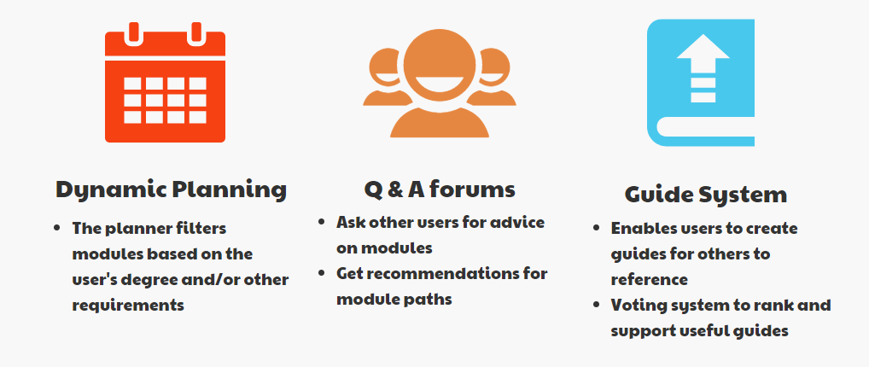

It is sometimes difficult to keep track of the current modular credits (MCs) you’ve accumulated so far while studying in NUS. Even more so if you’re taking special degree programmes such as double major programmes or double degree programmes. Such programmes introduce double counting or may exempt such students from particular modules. Even with the advice of seniors or friends, it can still be difficult to properly plan a desirable module path.

There are many factors (timetable clash, difficult style of teaching between semester 1 and 2, mapping of modules through the Student Exchange programme, etc.) that make each person’s module path unique. Wouldn’t it be nice to have a personalised planner catered to the needs of your own degree path?

**Goal:**

We aim to consolidate and simplify the process of keeping track of MCs obtained, planning for future modules and also introduce senior feedback.

**User Stories:**

1. As a student who wants a clear idea of my module path on my course, I would like to have recommendations or guides for what modules to take next.

2. As a senior who wants to help troubled juniors, I want to offer my review and recommendations of modules by creating a guide on a possible path to take.

3. As a student taking special degree programmes, it can be much more difficult to keep track of the requirements of my degree programme. For special cases such as double counting or exemptions or certain requirements, I would like an interface that would inform me as such.

**Scope of Project:**

A **website** that allows users to plan their modules ahead of time with access to module information, recommendations and guides.

The website would be able to

1. Allow users to select and plan their path, similar to NUSMods
   1. Furthermore, recommendations of what modules to take will be presented, based on the current year of study
2. Allow users to submit advice - two ways
   1. Users can submit reviews of specific modules as well as other user’s submitted module paths
   2. Users can also share their personal module path for people to take reference from
   3. Rating functionality (upvote/downvote) allows better and therefore, likely more useful, reviews to be easily accessed

**Features:**

**Green - Completed, Amber - In progress, Red - Not begun**

*-* ***Planner***

**Details:** The Planner serves as the main feature of this web application. Users are able to add modules to their planner and see information about modules (currently, only the module code, module name and number of module credits of each module is displayed).

**Design motive:**

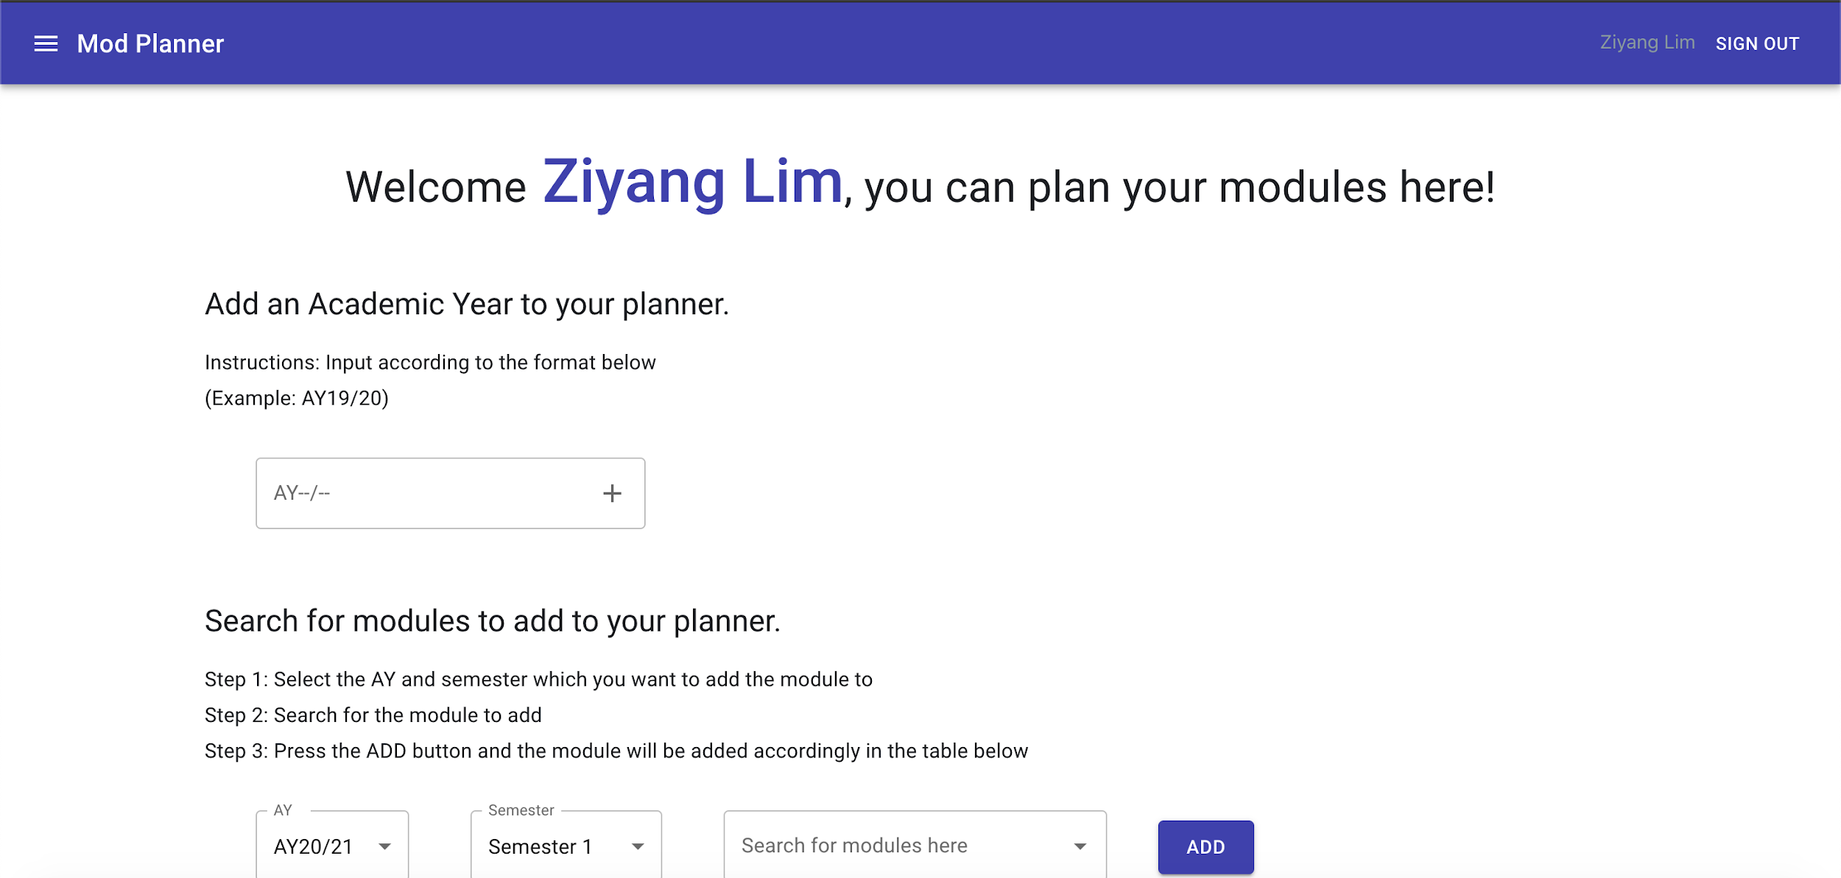

The Planner is designed to be minimalistic and easy for the user to use. Users simply add Academic Year to their planner. They can then edit a specific Academic Year and Semester by adding a module to the relevant fields.

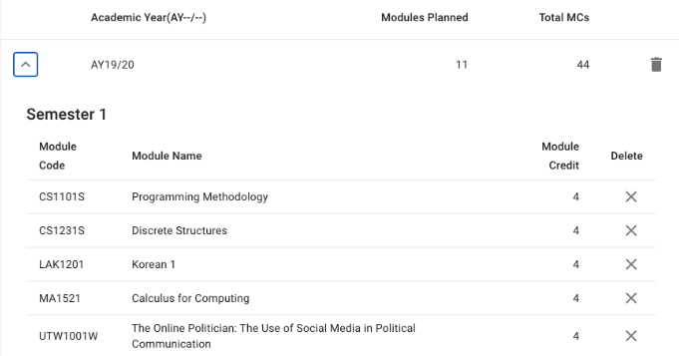

The information added is displayed in a form of a table, where users can keep track of the total amount of modules planned to be taken and credits to be cleared. The UI was designed with Material UI.

In addition to the main planner, ModPlanner offers two accompanying features.

*-* ***Reviews and Guides***

**Details:** The Reviews and Guides section features planners from other users. It serves to assist users in planning their own modules by getting inspiration or seeking helping from other users who have planned their modules.

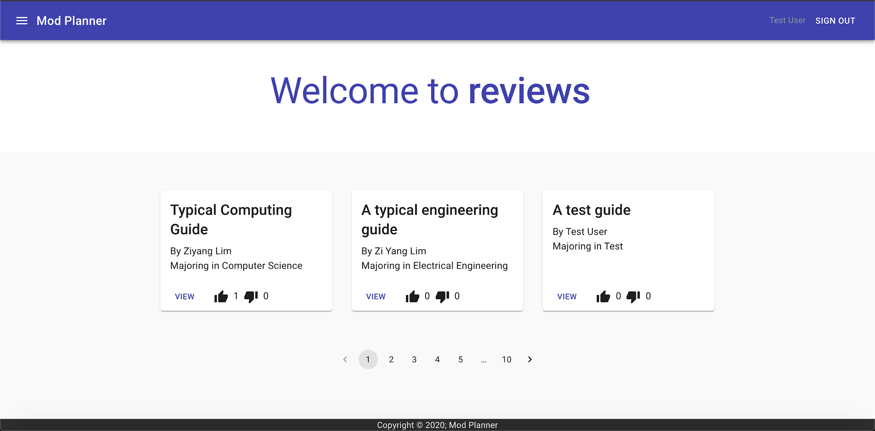

A user may export their planner as a guide or simply view a list of all other posted guides on the platform. The user would then have to input a title and a description for their guide.

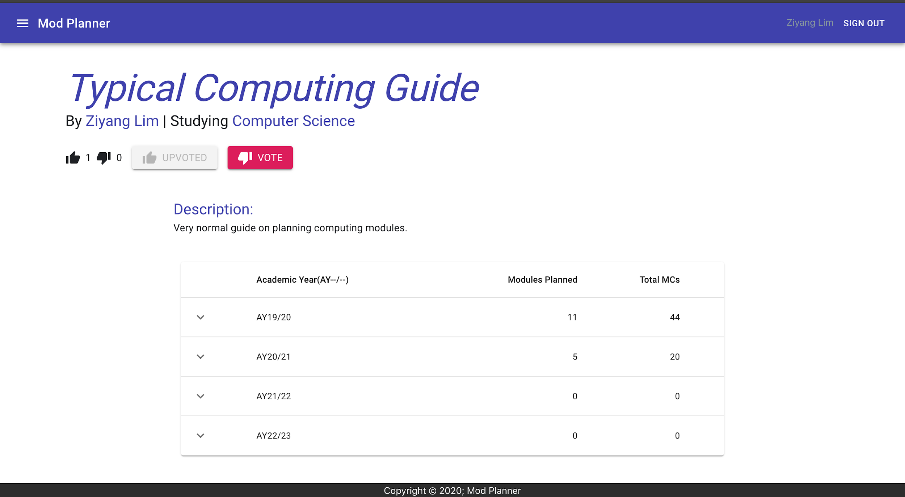

Each guide has a rating that users can choose to upvote or downvote. This is to filter out helpful guides and enhance user’s experience in planning modules

**Design motive:** The Reviews and Guides section’s design is inspired by an Album template from Material UI which features a collection of unique planners with their individual description. The rating feature is displayed in the form of stars for users to easily identify highly rated guides.

*-* ***Online Q&A Forum***

**Details:** The forum is a Q&A platform for users to post and answer queries. Users may also tag their questions for easy searching.

**Design motive:** 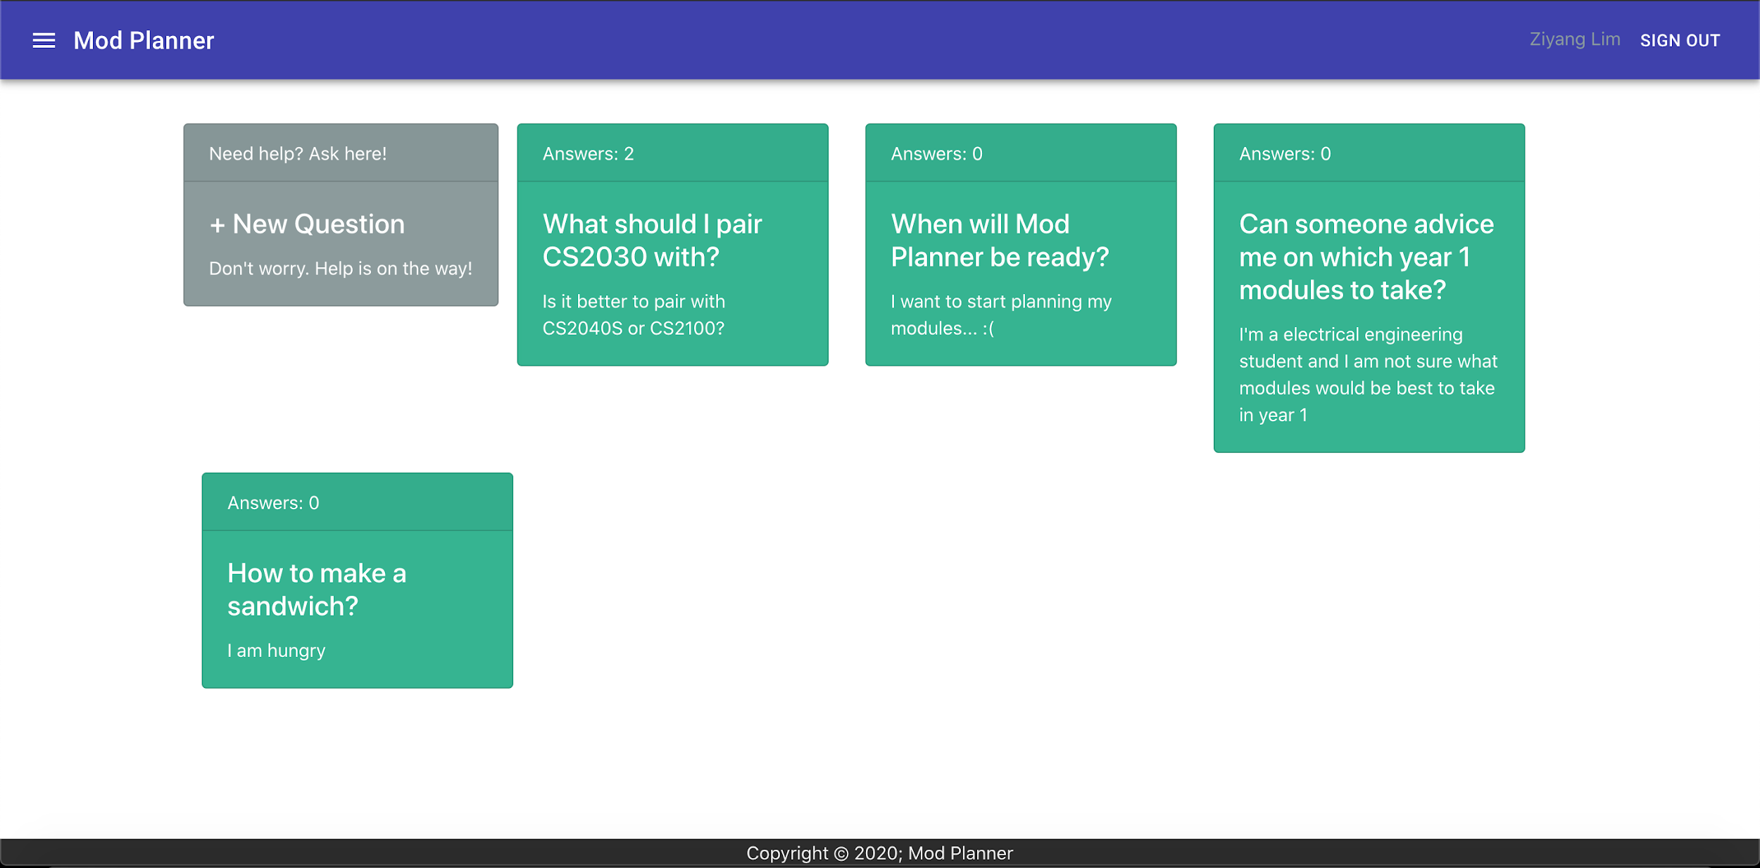

The forum is based on the tutorial found [here](https://auth0.com/blog/react-tutorial-building-and-securing-your-first-app/). The application that we learned to create in the tutorial was similar and applicable to our forum/Q&A feature. Hence, we decided to modify the program created in the tutorial to suit the needs of our application.

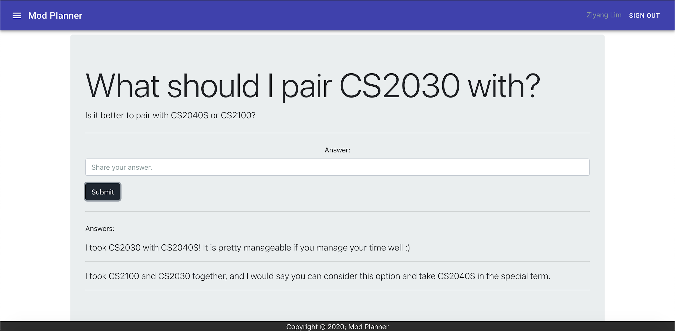

A sample post with questions and answers

**General Functionality:**

Upon accessing the site, the user would be prompted to log in with an Auth0 account. 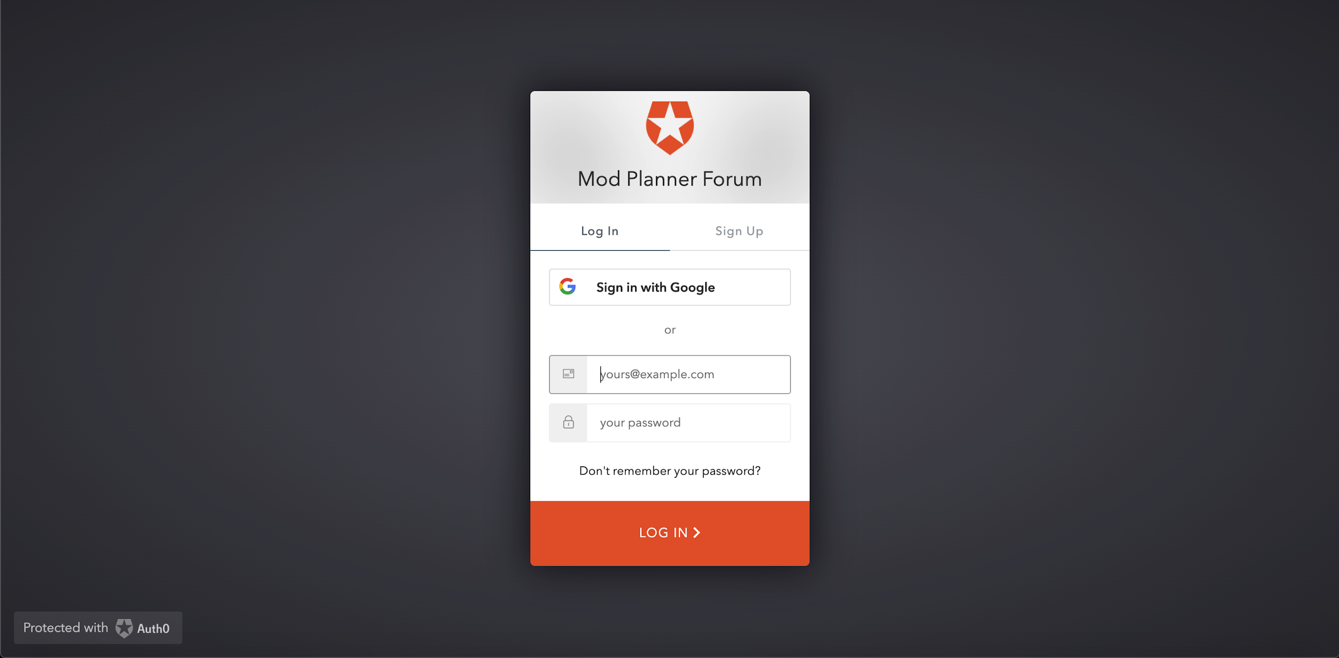This would allow the user to have their data saved automatically to be viewed again upon repeated visits to the site.

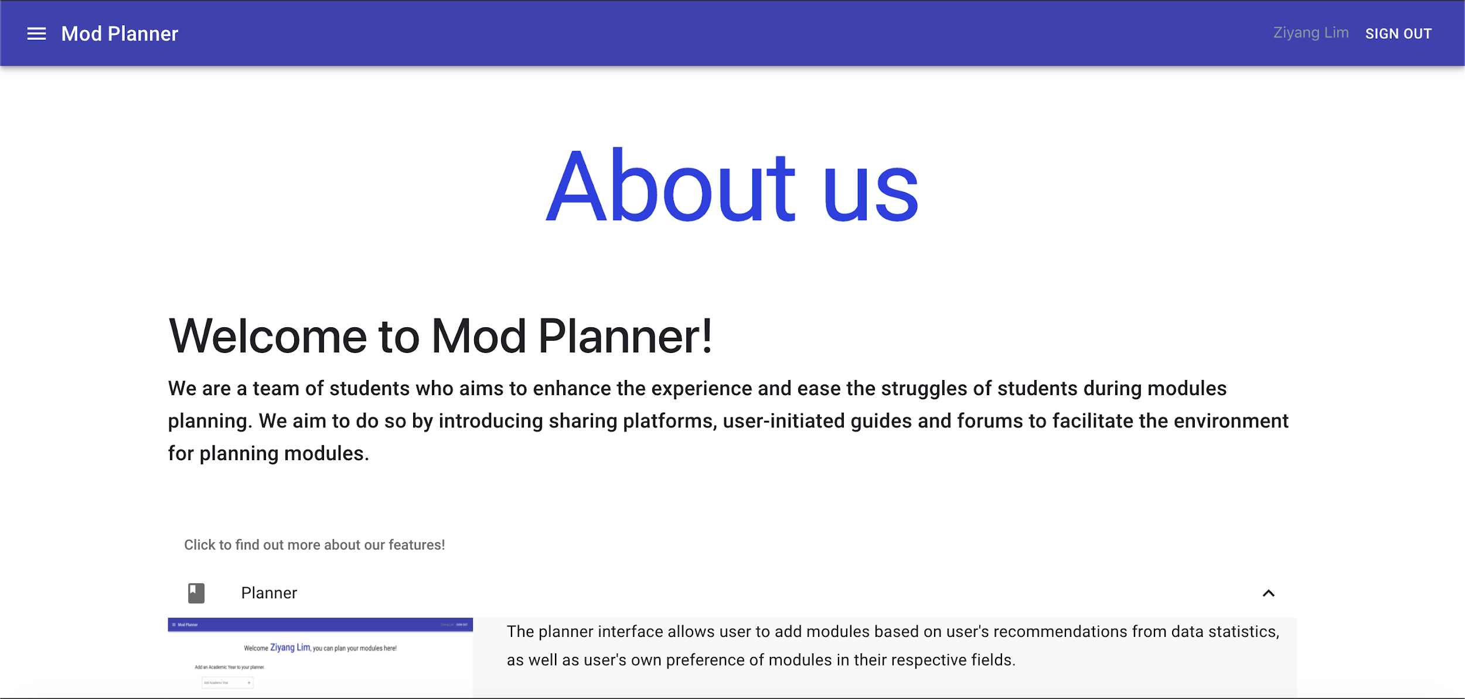

Users may also visit the “About Us” page to contact us for any possible suggestions or improvements.

Relevant module data is scraped from the [NUSMods API](https://api.nusmods.com/v2/#/). The data is collected and then processed before being entered into the database. Currently, the list of modules provided is of the latest AY (19/20).

Potential improvements may include: retrieving module data for later years (AY 20/21 and so forth), Q&A forums may allow tagging to allow categorisation of questions, possible profile page that links up the three main features of the API

Planned Changes: Tagging functionality in the forum questions; Commenting enabled for each semester by the owner of the planner (HARD); option for anonymity on forum posting

**What makes us different from NUSmods:**

* Mod Planner gives users the experience to plan the entire modular route in their university timeline, whereas NUSmods only allows planning for individual semesters
  + Additionally, guides on modular paths made by seniors, accompanied with reviews, are available to ease modular planning
* Mod Planner maintains an active forum to address urgent questions and facilitate a helpful community among students
* Essentially, ModPlanner can serve as a complement to the already successful NUSMods in order to provide more functionality regarding module planning.

**Project Log:**

|  |  |  |  |  |
| --- | --- | --- | --- | --- |
| **Task** | **Date** | **Lim Zi Yang (hrs)** | **Low Siang Ern (hrs)** | **Remarks** |
| Lift-off | 11/05/20 | 6 | 6 | Lift-off |
| Mission Control #1 | 16/05/20 | 0 | 3 | - ReactJS workshop to help familiarize with the framework and concepts in React  - Due to manpower constraints, only one member was supposed to participate |
| Team meeting: Initial planning and preparation | 18/05/20  -  19/05/20 | 8 | 8 | - Online discussion to finalize the features and design tools required    - Read up on relevant tutorials in React and JavaScript    - Delegated roles for the project |
| Team meeting:  Finalizing details of application features | 20/05/20  -  21/05/20 | 8 | 8 | - Decide on specific details of features included in the application    - Research for suitable templates for respective features |
| Development of application:    *ModPlanner’s Q&A forum* | 22/05/20 | 2 | 2 | - Created a skeleton for *Q&A forum* feature with frontend and backend    - Able to handle questions in *forum* without login/register feature |
| Development of application:    *ModPlanner’s Q&A forum* | 23/05/20 | 2 | 2 | - Implemented basic login/register feature    - Improved on usability |
| Development of application:    *ModPlanner’s Q&A forum* | 24/05/20 | 4 | 4 | - Set up secured routing and authentication    - Improved on design    - Set up a functional *Q&A forum* platform |
| Modification of README | 27/05/20 | 2 | 2 | - Modification of README for submission  - Updated poster and video to reference our actual created product (the forum) |
| Project consultation & Finalization of README for Milestone 1 | 30/05/20 | 1 | 1 | - Consulted advisor for advice on direction to move  - Finalized README for submission |
| Development of application:  *Web interface and backend* | 01/06/20 | 4 | 4 | - Initialized the About page  - Initialized the backend (Node.js + Express)   1. Temporary array to store information about user’s planner |
| Development of application:  *Web interface and backend* | 02/06/20 | 4 | 4 | - Design of the website was improved  - Started development on the server to handle the planner   1. Logging in using name 2. Entering a module into the planner using its module code |
| Development of planner | 03/06/20 | 4 | 4 | -Design of website was improved  -Implemented features of the planner   1. Implemented deletion of modules |
| Development of planner | 04/06/20 | 6 | 6 | -Implemented features of planner   1. Expanded the planner to include multiple semesters 2. Implemented a way to change the semester that was being edited |
| Testing and refinement of planner | 05/06/20 | 6 | 6 | -Created “About Us” page on the website  -Testing of planner   1. User input of modules 2. Prevented duplicate module inputs 3. Tested inputs across multiple semesters |
| Testing of planner alongside web design | 08/06/20 | 6 | 6 | -Implemented links to “Planner” and “Reviews” to prepare merging the backends  -Testing of planner   1. Continued testing of inputs across multiple semesters 2. Deletion of modules across multiple semesters |
| Merging of backend  Implementing the database (MongoDB) | 09/06/20 | 4 | 4 | -Began to merge the code for the planner into the backend for the website  -Initialised a MongoDB database to store information on:   1. Users and their planners 2. Module data |
| Integrating database into the backend | 10/06/20 | 4 | 4 | -Storing of user information was moved to database  - Debugging of the above to ensure database was working well |
| Integrating database into backend  Scraping module data | 11/06/20 | 5 | 5 | -Improved the database to also store the list of modules given a certain AY  -Implemented module data scraping from the NUSMods API |
| Refining database | 12/06/20 | 6 | 6 | -Adapted the server to now perform adding and deleting operations on the database  -Conducted testing on adding and removing modules from the database |
| Implementation of guides | 15/06/20 | 4 | 4 | -Implemented a basic template for reviews/guides  -Implemented buttons to export a user’s guide and also to view guides by all users |
| Implementation of guides  Implementing database to store the guides | 16/06/20 | 4 | 4 | -Database now has a document for reviews to store the exported planners  -Made the buttons functional and worked on display of the data |
| Improving on the guide interface  Testing and debugging of the frontend | 17/06/20 | 4 | 4 | -Implemented a confirmation page which required:   1. A title for the guide 2. A description of the guide   -Carried out testing on above functionality and continued to integrate the server into the frontend API |
| Testing and debugging of guide functionality  Improving web layout | 18/06/20 | 5 | 5 | -Continued testing and debugging on the exporting of planners  -UI of the planner was improved to make it easier to use |
| Debugging of various areas | 19/06/20 | 4 | 4 | -Debugging the integrated server with the website  -Debugging and testing the review functionality |
| Improving functionality | 22/06/20 | 4 | 0 | -Implemented search functionality for module input (planner) |
| Improving functionality | 23/06/20 | 4 | 4 | -Implemented upvote and downvote functionality to individual reviews |
| -Began integrating review page into the website  -Updated README | 24/06/20 | 4 | 4 | -Linking up of review page to the website  -Updated README to be up to date with the current progress of the project |
| Linking up of review page | 25/06/20 | 4 | 0 | -Linking up of review page to the website  -Conducted tests for debugging and user input |
| Gathering feedback | 26/06/20 | 4 | 4 | -Presented our project to friends to search for areas of improvement |
| -Editing of video  -Finalising README for Milestone 2 | 27/06/20 | 4 | 4 | -Edited the video to include screenshots of the features in our prototype  -Updated the README and project log |
| -Editing of video  -Finalising README for Milestone 2 | 28/06/20 | 4 | 4 | -Finished the video  -Finish updating README for milestone 3 |
| -QoL updates for inputting data  -Improved data displayed | 29/06/20 | 4 | 4 | -Now only first two digits of the AY is required when inserting a new AY  -Total module credits for each year and overall are now visible |
| -Improving planner exporting | 30/06/20 | 4 | 4 | -Input of major degrees are now more comprehensive to prepare for tagging purposes  -Included options for special degree requirements |
| -Added tagging functionality to exports | 01/07/20 | 6 | 6 | -Tags are now automatically added based on one’s degree and residency on campus  -Tags are also appropriately displayed in the preview of the reviews on the review page |
| -Added filtering functionality to reviews | 02/07/20 | 6 | 6 | -Users can now filter for reviews they would like to see based on certain tags. |
| -Implemented pagination for reviews page  -Sorted reviews  -Conducted peer reviews | 03/07/20 | 6 | 6 | -Users may now scroll through the list of reviews using page numbers at the bottom  -Reviews are now also sorted by number of upvotes / total votes  -Peer reviews were also done |