Software Requirements Specification
Distributed Job Scheduler
Version 1.0
July 02, 2026

Document Control
Version | Date | Author | Description
1.0 | 2026-07-02 | Engineering Team | Initial release

1. Introduction

1.1 Purpose
This Software Requirements Specification (SRS) defines the functional and non-functional requirements for the Distributed Job Scheduler — a production-inspired platform for reliably executing asynchronous background jobs across multiple worker processes.

1.2 Scope
The system provides authentication, project and queue management, job scheduling (immediate, delayed, scheduled, recurring, batch), atomic job claiming, worker fleet management, retry policies, dead letter queue handling, and a web dashboard for monitoring and administration.

1.3 Definitions
Job: A unit of work with a JSON payload to be executed asynchronously.
Queue: A named container for jobs within a project, with priority and concurrency settings.
Worker: A stateless process that polls for and executes jobs.
DLQ: Dead Letter Queue — storage for permanently failed jobs.
SKIP LOCKED: PostgreSQL row locking mode that skips already-locked rows during concurrent claims.

2. Overall Description

2.1 Product Perspective
The product is a self-hosted job scheduling platform comprising an Express REST API, PostgreSQL database, horizontally scalable worker fleet, and React dashboard. It is designed for teams needing reliable background job execution without external message broker infrastructure.

2.2 User Classes
Developer/Operator — creates projects, queues, and jobs via API or dashboard.
System Administrator — monitors workers, queue health, and DLQ entries.

2.3 Constraints
PostgreSQL 16+ required for SKIP LOCKED support.
Recurring jobs use interval-based scheduling, not cron expressions.
Dashboard uses HTTP polling, not WebSockets.

3. System Architecture
The architecture follows a decoupled monolithic API with distributed workers. All state is stored in PostgreSQL. Workers poll for eligible jobs, claim them atomically using row-level locking, execute concurrently, and report status back to the database.
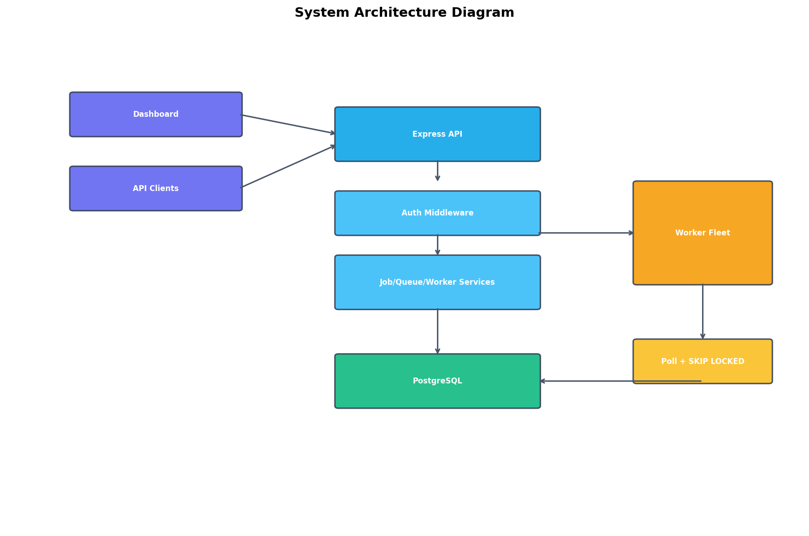

4. Functional Requirements

4.1 Functional Requirements
ID | Requirement | Priority
FR-001 | The system shall allow user registration with email and password (min 8 chars). | High
FR-002 | The system shall authenticate users via JWT tokens with 24-hour expiry. | High
FR-003 | Users shall create, read, update, and delete projects scoped to their account. | High
FR-004 | Each project shall support multiple job queues with unique names. | High
FR-005 | Queues shall be configurable with priority, max concurrency, pause/resume, and retry policy. | High
FR-006 | The system shall accept immediate, delayed, scheduled, recurring, and batch job types. | High
FR-007 | Workers shall claim jobs atomically using FOR UPDATE SKIP LOCKED. | High
FR-008 | Workers shall send heartbeats every 5 seconds. | High
FR-009 | Dead workers (no heartbeat > 30s) shall have their jobs requeued. | High
FR-010 | Failed jobs shall retry using fixed, linear, or exponential backoff. | High
FR-011 | Jobs exceeding max retries shall be moved to the Dead Letter Queue. | High
FR-012 | The system shall maintain execution logs and retry history per job. | High
FR-013 | Users shall manually retry failed/DLQ jobs via API. | Medium
FR-014 | The dashboard shall display queue health, workers, jobs, and DLQ with polling. | Medium
FR-015 | All list endpoints shall support pagination (page, limit). | Medium

5. Non-Functional Requirements

5.1 Non-Functional Requirements
ID | Requirement | Priority
NFR-001 | Job claiming shall prevent duplicate execution under concurrent workers. | High
NFR-002 | API shall return structured JSON error responses with error codes. | High
NFR-003 | Passwords shall be hashed with bcrypt (cost factor 12). | High
NFR-004 | Workers shall support graceful shutdown completing in-flight jobs. | High
NFR-005 | System shall be deployable via Docker Compose in under 10 minutes. | Medium
NFR-006 | API response time for list endpoints shall be < 500ms at 10K jobs. | Medium

6. External Interface Requirements

6.1 REST API
- POST /api/auth/register
- POST /api/auth/login
- GET/POST /api/projects
- GET/PATCH/DELETE /api/projects/{id}
- GET/POST /api/projects/{projectId}/queues
- GET/PATCH/DELETE /api/queues/{id}
- GET /api/queues/{id}/stats
- POST /api/queues/{queueId}/jobs
- GET /api/jobs
- GET /api/jobs/{id}
- POST /api/jobs/{id}/retry
- GET /api/dlq
- GET /api/workers
- POST /api/workers/register
- POST /api/workers/heartbeat
- GET /api/stats

6.2 User Interface
- Overview Dashboard
- Projects & Queues
- Job Explorer
- Workers Monitor
- DLQ Viewer

7. Data Requirements
The database schema is normalized to 3NF with 14 entity tables. Critical indexes support worker polling, queue statistics, and dead worker recovery.
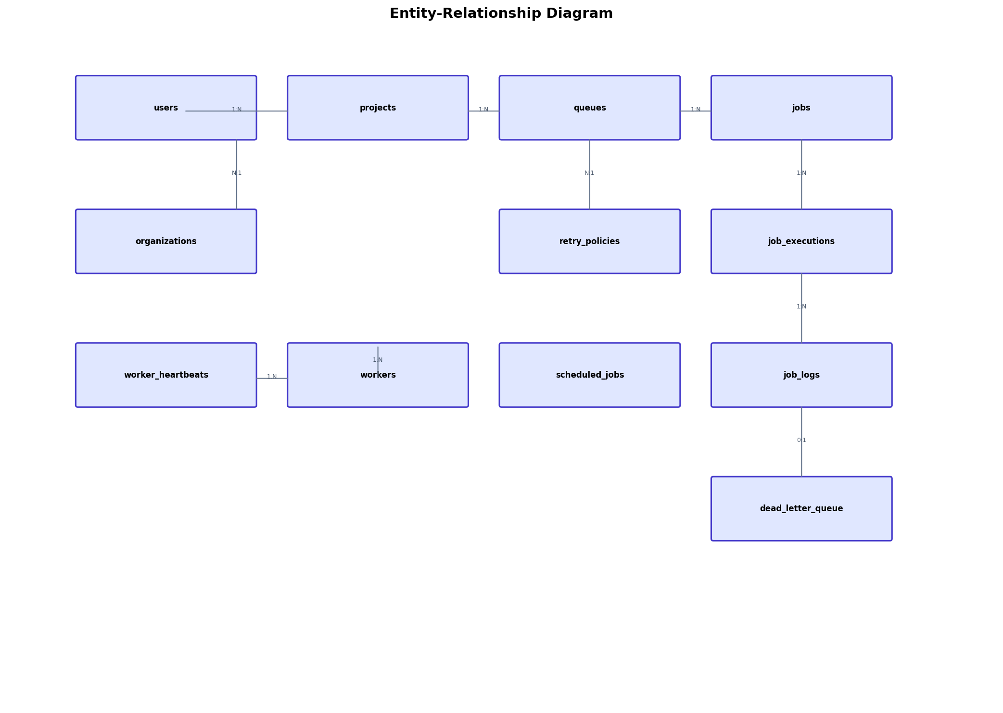

7.1 Entity Descriptions
users: Authenticated accounts with email and password hash.
projects: Logical grouping of queues owned by a user.
queues: Job containers with priority, concurrency, and pause state.
jobs: Work units with payload, status, scheduling metadata.
job_executions: Historical execution attempts with timing and results.
job_logs: Append-only execution log entries.
workers: Registered worker processes with heartbeat tracking.
dead_letter_queue: Permanently failed jobs with failure reason.
retry_policies: Configurable retry strategy definitions.

8. Design Model
The logical class diagram shows entity models, service layer, controllers, and worker components.
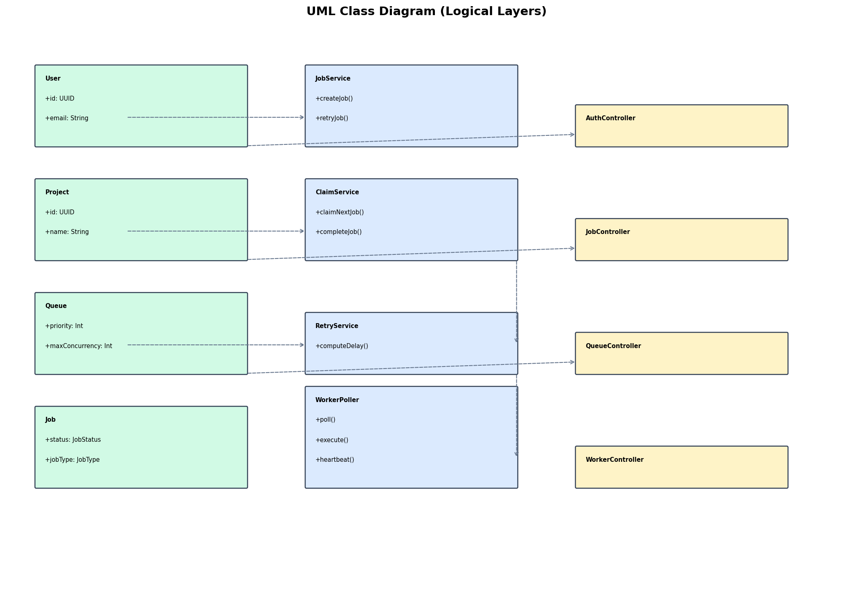

9. Appendices

9.1 Job Lifecycle States
QUEUED → SCHEDULED → CLAIMED → RUNNING → COMPLETED | FAILED → DLQ

9.2 Out of Scope
- Full cron expression parsing
- Workflow/job dependencies
- Rate limiting
- Queue sharding
- Distributed locking beyond DB
- WebSocket live updates
- RBAC
- AI failure summaries

9.3 References
IEEE Std 29148-2018 — Systems and software engineering — Life cycle processes — Requirements engineering
PostgreSQL Documentation — SELECT FOR UPDATE SKIP LOCKED
Project Repository — architecture.md, er-diagram.md, design-decisions.md, openapi.yaml

