

**TCP2201 Project**

Trimester 2310

*by TT5L Deneb*

Team Leader:

ENG ZI YING, 013-688 3338 , [1211112187@student.mmu.edu.my](mailto:1211112187@student.mmu.edu.my)

Team members:

TEOW WEI TING, 011-1080 6156, [1231302923@student.mmu.edu.my](mailto:1231302923@student.mmu.edu.my)

VENICE GOH KIT YEE, 011-2806 2253, [1211108846@student.mmu.edu.my](mailto:1211108846@student.mmu.edu.my)

WONG HUI TING, 011-5650 9931, [1211108527@student.mmu.edu.my](mailto:1211108527@student.mmu.edu.my)

# 

# 

# **Content**

**Content 1**

**Class Diagram 2**

**Use Case Diagram 3**

**Sequence Diagram for Each Use Case 4**

1.0 Start New Game 4

1.0.1 First Load Application 4

1.0.2 Click “New Game” 5

1.1 Update View Board 6

2.0 Save Game 7

3.0 Load Game 7

4.0 View Guide 8

5.0 Play Move 8

5.1 Select Piece 9

5.1.1 Highlight Piece and Possible Move 10

5.2 Move Piece 11

5.2.1 Track Turn 12

5.2.1.1 Tor Xor Exchange 13

5.2.2 Check End Game 14

5.2.2.1 Determine Winner 15

5.2.3 End Game 16

5.2.3.1 Reset Game 17

**Compile and Run Instructions 18**

**User Documentation 19**

1.0 Opening Project 19

2.0 Execute the project 20

3.0 Playing the Game 21

3.1 Main Window 21

3.2 Making Moves 22

3.3 Game Features 24

3.4 Game Rules 25

3.5 Ending the Game 29

# **Class Diagram**

<https://drive.google.com/file/d/1cdNeZrtdGlAAYWzhsEpXh1ncp3EmZHX6/view?usp=sharing>

|  |
| --- |
|  |

# **Use Case Diagram**

<https://drive.google.com/file/d/1NRVt3Wzkaxi0w30O4uYJx1sRX2wc7oCD/view?usp=sharing>

|  |
| --- |
|  |

# 

# 

# **Sequence Diagram for Each Use Case**

## 1.0 Start New Game

#### 1.0.1 First Load Application

(referencing to 1.1 Update View Board)

|  |
| --- |
| C:\Users\ziyin\Downloads\newgame1.png |

#### 1.0.2 Click “New Game”

(referencing to 1.1 Update View Board)

|  |
| --- |
| C:\Users\ziyin\Downloads\newgame2.png |

### 1.1 Update View Board

|  |
| --- |
|  |

## 2.0 Save Game

|  |
| --- |
|  |

## 3.0 Load Game

(referencing to 1.1 Update View Board)

|  |
| --- |
| C:\Users\ziyin\Downloads\loadGame.png |

## 4.0 View Guide

|  |
| --- |
|  |

## 5.0 Play Move

(referencing to 5.1 Select Piece & 5.2 Move Piece)

|  |
| --- |
| C:\Users\ziyin\Downloads\playMove.png |

### 5.1 Select Piece

(referencing to 5.1.1 Highlight Piece and Possible Move)

|  |
| --- |
| C:\Users\ziyin\Downloads\selectPiece.png |

#### 5.1.1 Highlight Piece and Possible Move

|  |
| --- |
|  |

## 

## 5.2 Move Piece

(referencing to 5.2.1 Track Turn & 5.2.2 Check End Game & 5.2.3 End Game & 1.1 Update View Board)

|  |
| --- |
| C:\Users\ziyin\Downloads\movePiece.png |

### 

### 5.2.1 Track Turn

(referencing to 5.2.1.1 Tor Xor Exchange)

|  |
| --- |
| C:\Users\ziyin\Downloads\trackTurn.png |

#### 5.2.1.1 Tor Xor Exchange

|  |
| --- |
| C:\Users\ziyin\Downloads\TorSorEx.png |

### 5.2.2 Check End Game

(referencing to 5.2.2.1 Determine Winner)

|  |
| --- |
| C:\Users\ziyin\Downloads\checkEndGame.png |

#### 5.2.2.1 Determine Winner

|  |
| --- |
| C:\Users\ziyin\Downloads\determinigWinner.png |

### 

### 

### 

### 

### 

### 5.2.3 End Game

(referencing to 5.2.3.1 Reset Game)

|  |
| --- |
| C:\Users\ziyin\Downloads\EndGame.png |

#### 5.2.3.1 Reset Game

(referencing to 1.1 Update View Board)

|  |
| --- |
| C:\Users\ziyin\Downloads\resetGame.png |

### 

### 

### 

### 

# Compile and Run Instructions

#### **Step 1: Extract the ZIP Folder**

1. Locate the CCP6224_TT5L_GroupDeneb ZIP file containing your .java files.
2. Extract the contents of the ZIP file into a directory (folder) on your computer.
   * Ensure the folder contains all the .java files, including ChessGame.java (the file with the main method).

#### **Step 2: Open the Command Line**

* **Windows:**
  + Press Win + R, type cmd, and hit Enter.
* **macOS/Linux:**
  + Open the Terminal application.

#### **Step 3: Navigate to the Program Folder**

Use the cd command to navigate to the folder where you extracted the ZIP file. For example:

cd path/to/CCP6224_TT5L_GroupDeneb

#### **Step 4: Compile Classes in Sequence**

1. **Compile Independent Classes** that other parts of the program rely on**:**

javac Position.java Piece.java TorXorLogic.java

1. **Compile Classes for Game Rules and State:**

javac GameState.java ChessModel.java TurnManager.java HighlightManager.java SaveLoadGame.java

1. **Compile Classes for Board Structure and Components:**

javac ChessBoard.java ChessBoardPanel.java MessagePanel.java MenuPanel.java

1. **Compile Controller Classes:**

javac BoardInteractionController.java GameFlowController.java ChessView.java

1. **Compile the Main Class (ChessGame):**

javac ChessGame.java

#### **Step 5: Run the Program**

After successful compilation, run the program by specifying the class containing the main method (ChessGame):

java ChessGame

# User Documentation

## 1.0 Opening Project

**Option A: Using Command Line (Platform Independent)**

1. Extract the CCP6224_TT5L_GroupDeneb ZIP file into a folder.
2. Open the terminal (macOS/Linux) or command prompt (Windows).
3. Navigate to the folder using the cd command:

cd path/to/CCP6224_TT5L_GroupDeneb

**Option B: Using BlueJ (Optional)**

* Launch BlueJ

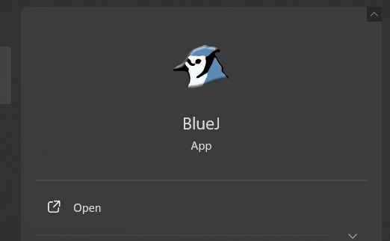

* Go to Project → Open Project

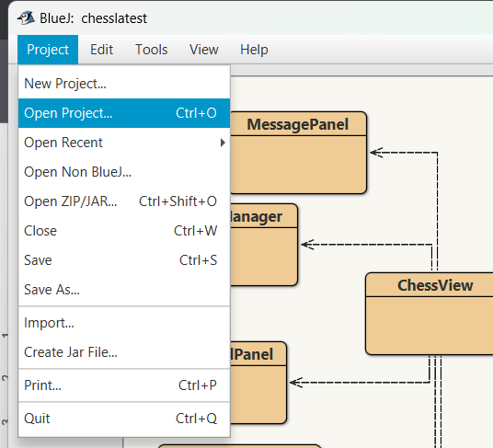

* Navigate to and select the “CCP6224_TT5L_GroupDeneb”



* Double click the file to open the project.

## 2.0 Execute the project

**Option A: Command Line (Recommended)**

1. Compile the program:

javac *.java

1. Run the program:

java ChessGame

**Option B: Using BlueJ (Optional)**

* In the BlueJ main window, select on the ChessGame class
* Right-click on the **ChessGame** class

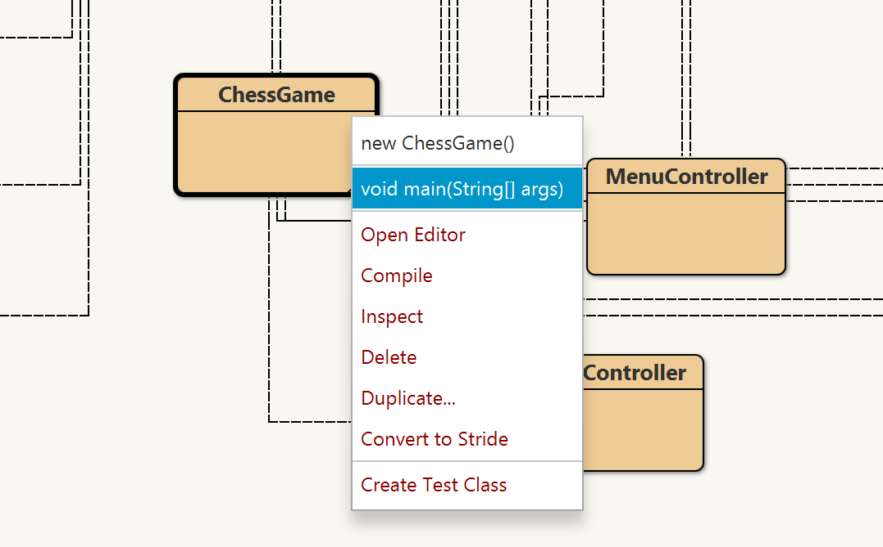

* Select void main(String[] args) from the menu
* Click "Ok" to start the game

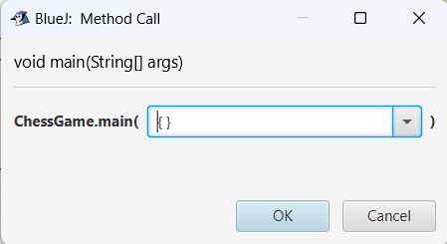

## 3.0 Playing the Game

### 3.1 Main Window

* The game window will appear showing:
  + A chess board with all pieces in their starting positions

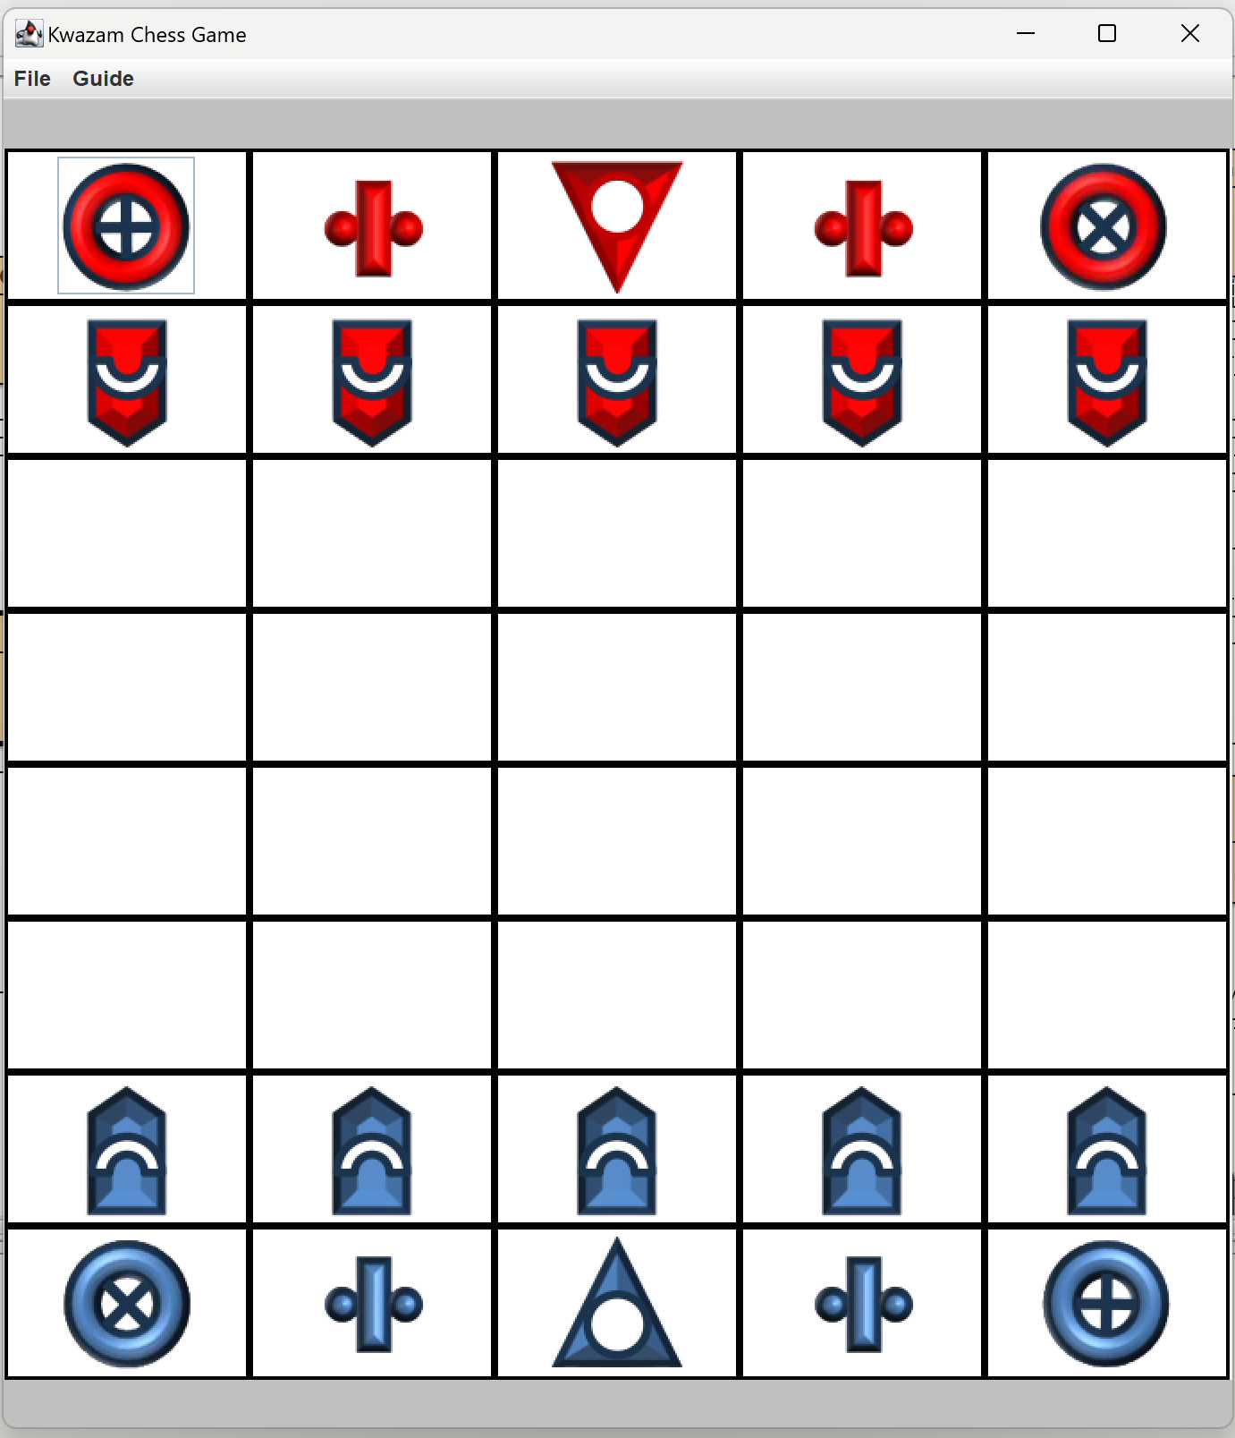

* + Menu options at the top



### 

### 3.2 Making Moves

1. Click on the piece you want to move
2. Valid moves will be highlighted on the board

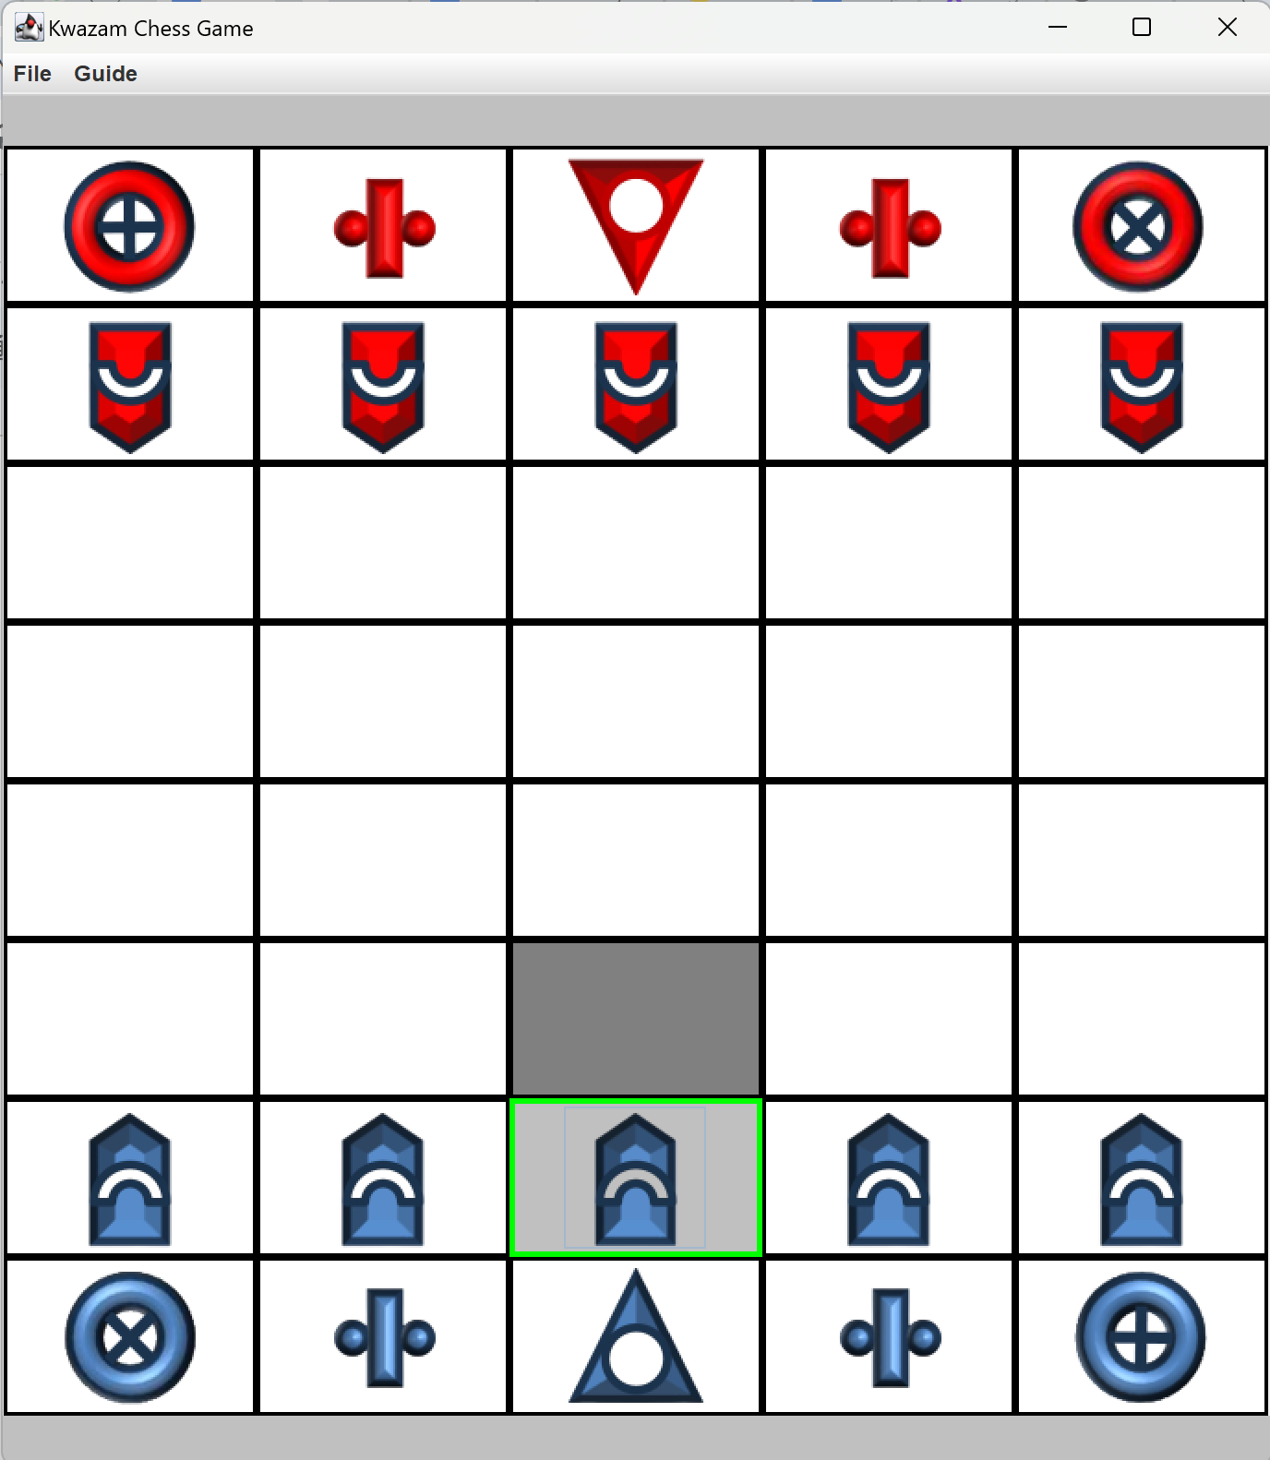

1. Click on a highlighted square to move your piece there

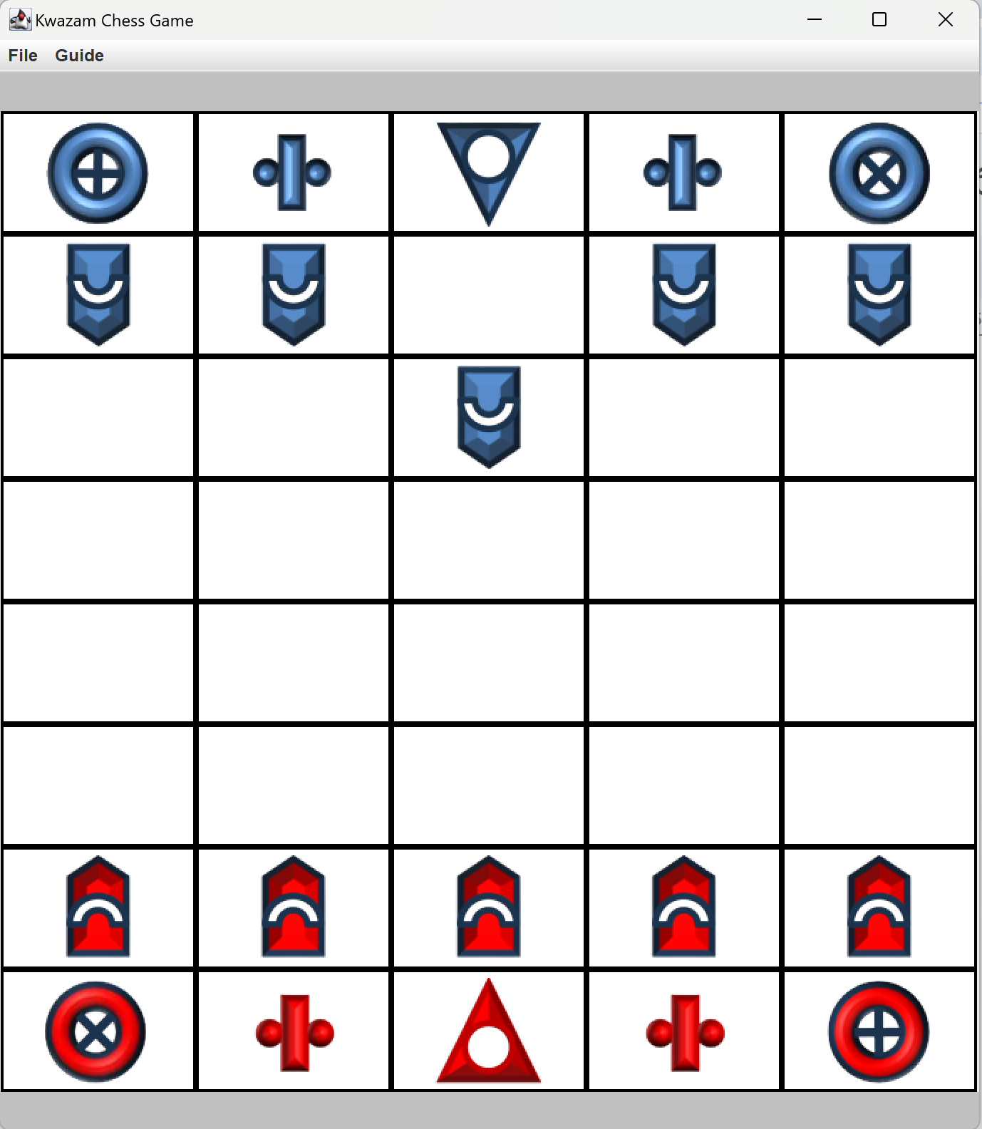

1. Invalid moves will be rejected automatically. The highlight will disappear.

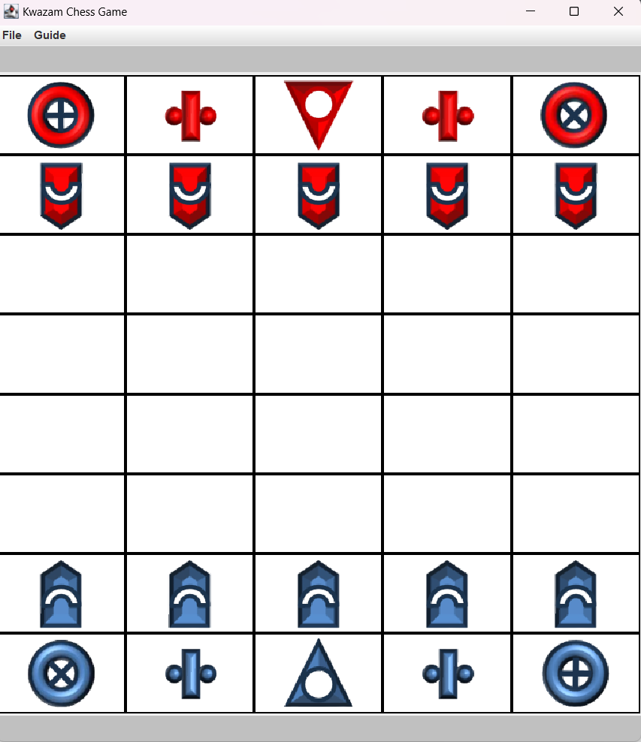

### 3.3 Game Features

* Starting a New Game
  + Go to File → New Game
  + The board will reset to the starting position

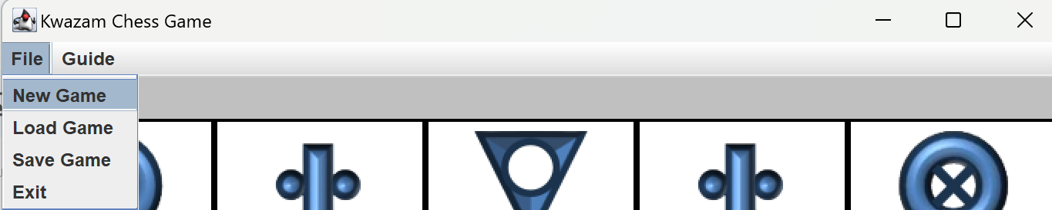

* Saving a Game
  + Go to File → Save Game

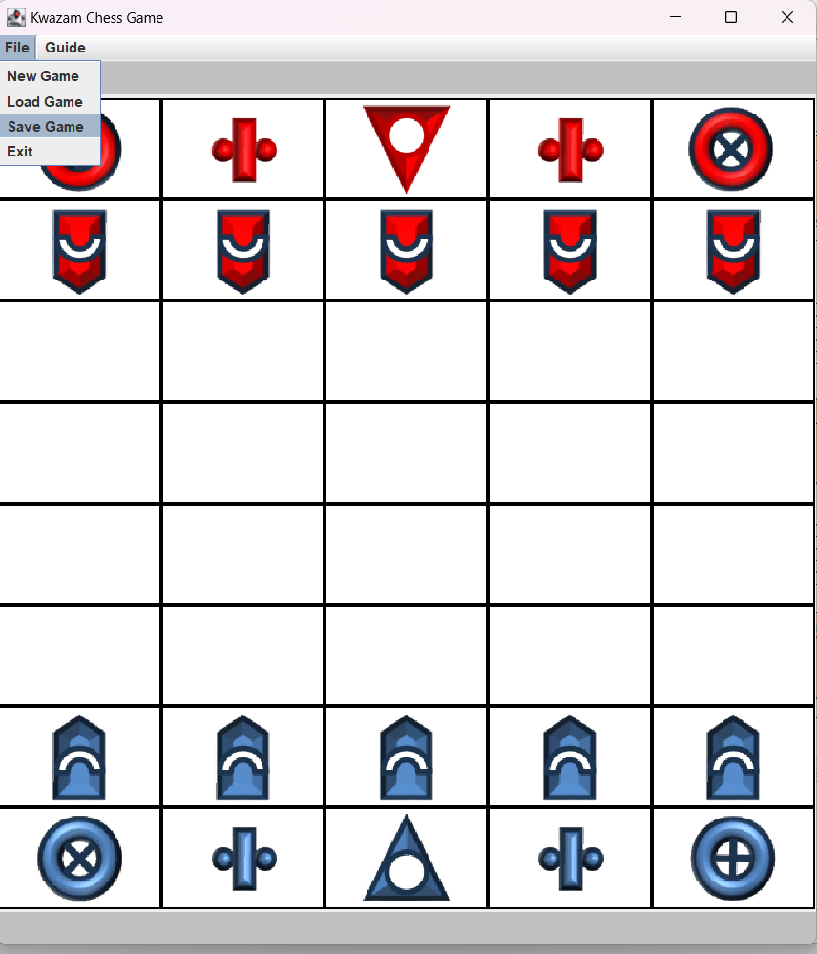

* + After clicking the “Save Game” button, it will show a message indicating that the game is saved successfully.

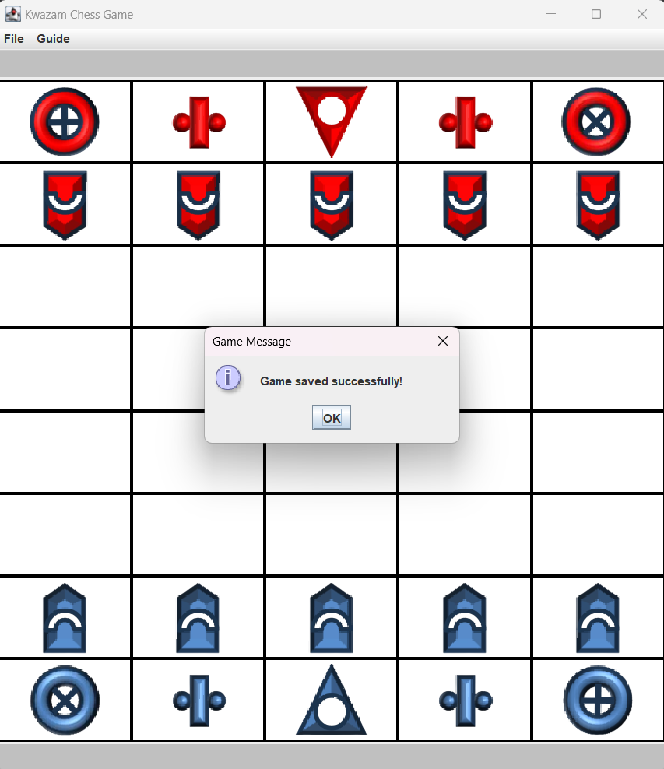

* Loading a Saved Game
  + Go to File → Load Game
  + The board will load the saved game

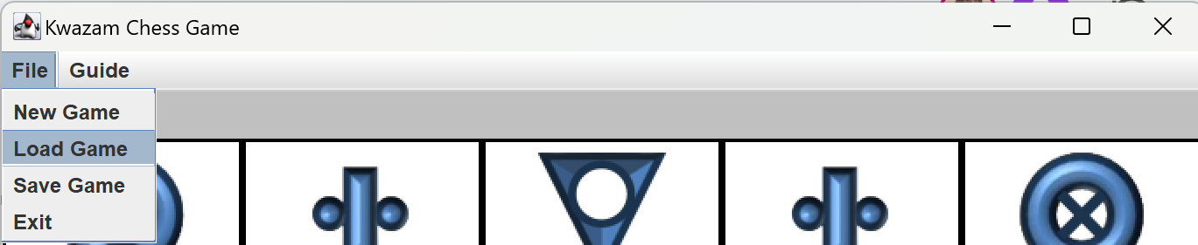

### 3.4 Game Rules

* Blue will be the first to move the piece
* Red take turns moving pieces
* Chess rules apply:
  + Ram move forward and capture diagonally

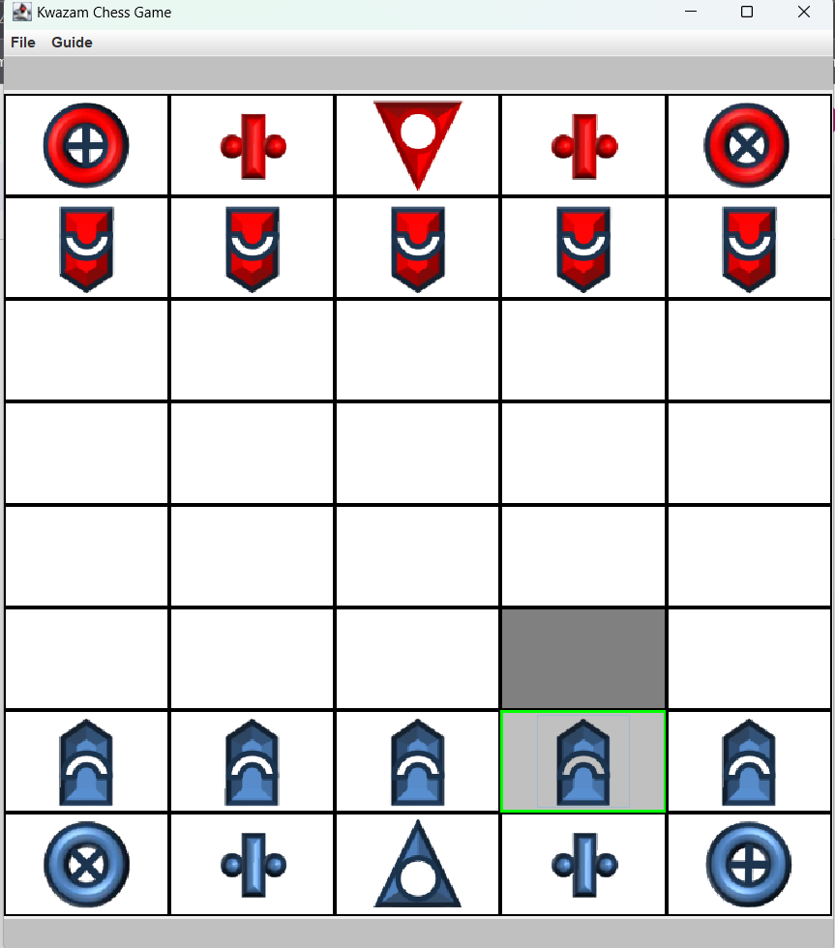

* + Biz move in L-shapes

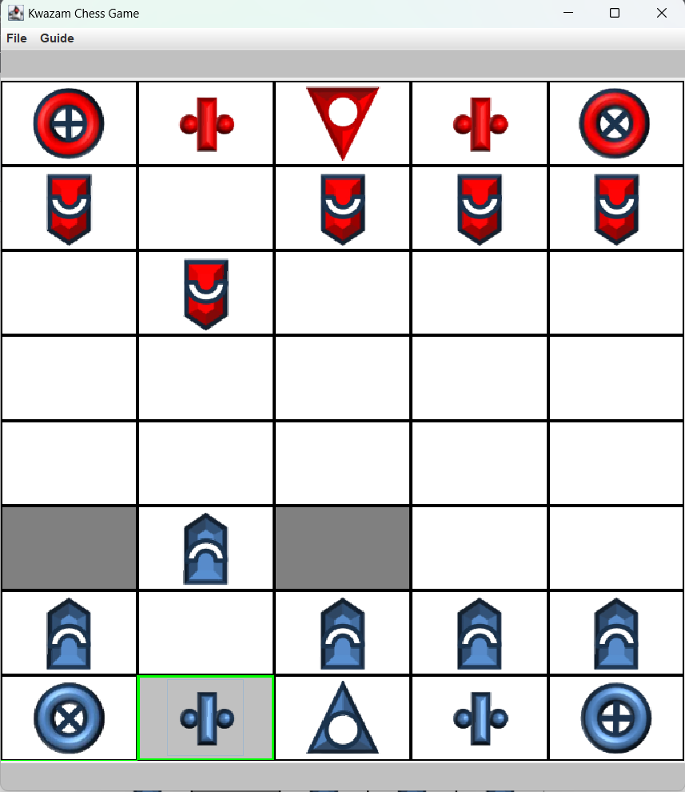

* + Xor move diagonally

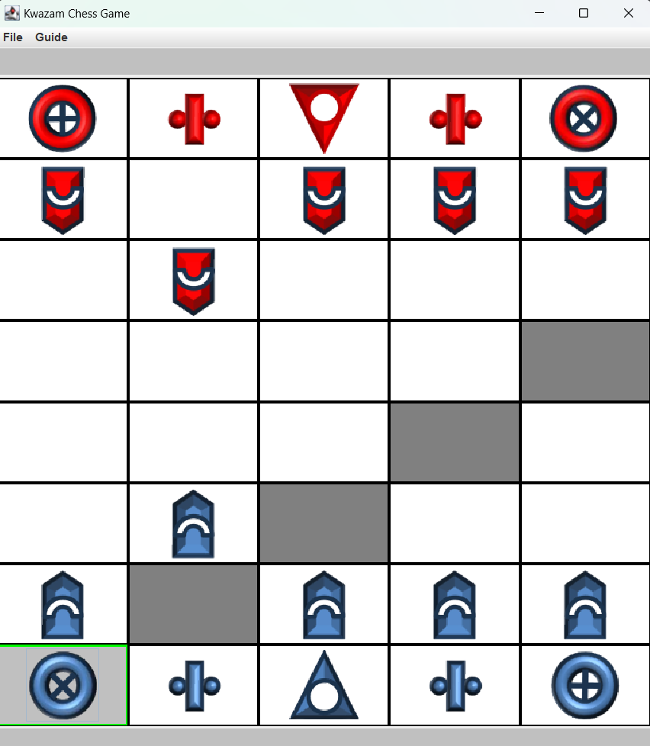

* + Tor move orthogonally

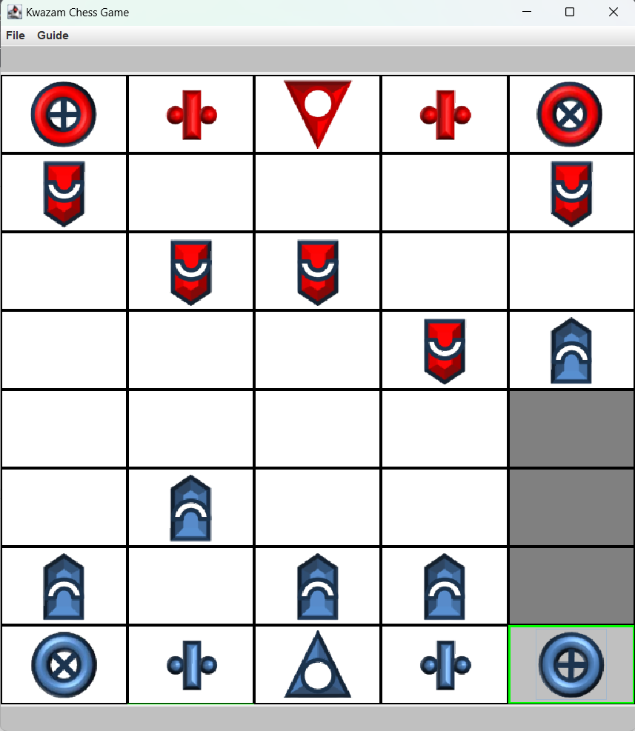

* + Sau move one square in any direction

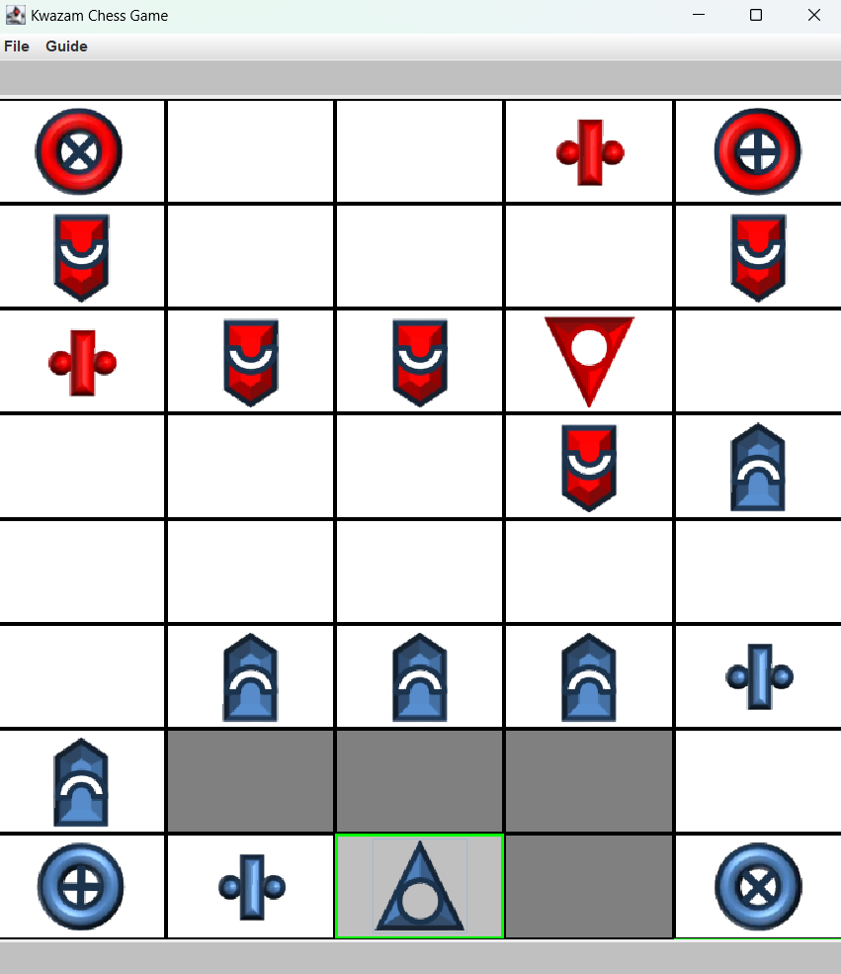

### 3.5 Ending the Game

* The game ends when the Sau is captured by the opposing team.

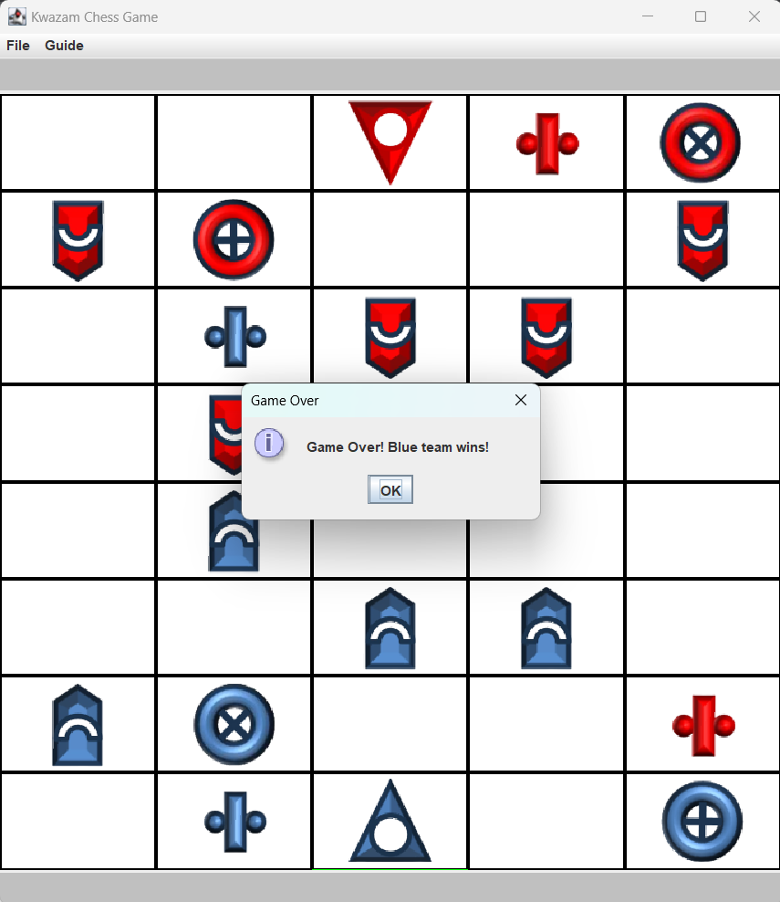

* Users can choose to continue a new game or choose to exit the game.