|  | **地区** | **房价中位数(元/㎡)** | **租金中位数(元/㎡)** | **中位数售租比** |
| --- | --- | --- | --- | --- |
| **0** | beitapingzhuang | 89942.528736 | 127.703488 | 704.307532 |
| **1** | shijicheng | 110303.030303 | 107.558140 | 1025.520066 |
| **2** | wanliu | 148027.432607 | 151.898734 | 974.513931 |
| **3** | suzhoujie | 79571.759259 | 126.491228 | 629.069387 |

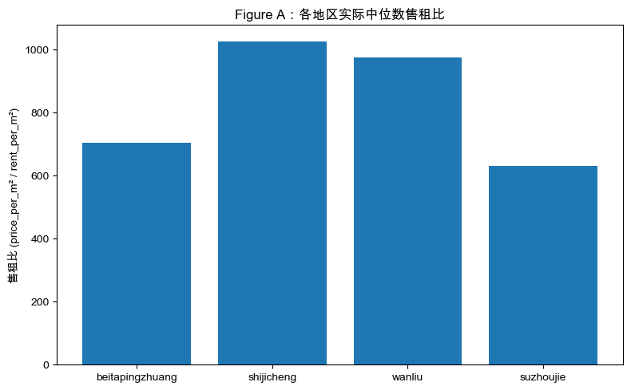

- 二手房数据.xlsx

- 北太平庄二手房数据.xlsx

- 北太平庄租房数据.xlsx

- 租房数据.xlsx

- 苏州街二手房数据.xlsx

- 苏州街租房数据.xlsx

Price: price_per_m2 = 74285.4879 + 252.1464 * 面积

Rent : rent_per_m2 = 117.9363 + 0.1062 * 面积

=== 各地区【预测】中位数（Homework 3.4） ===

|  | **地区** | **预测房价中位数(元/㎡)** | **预测租金中位数(元/㎡)** | **预测中位数售租比** |
| --- | --- | --- | --- | --- |
| **0** | beitapingzhuang | 97858.659325 | 123.886170 | 789.907856 |
| **1** | shijicheng | 115889.651822 | 135.042203 | 858.173589 |
| **2** | wanliu | 118904.062608 | 137.007789 | 867.863521 |
| **3** | suzhoujie | 91156.606737 | 124.417410 | 732.667612 |

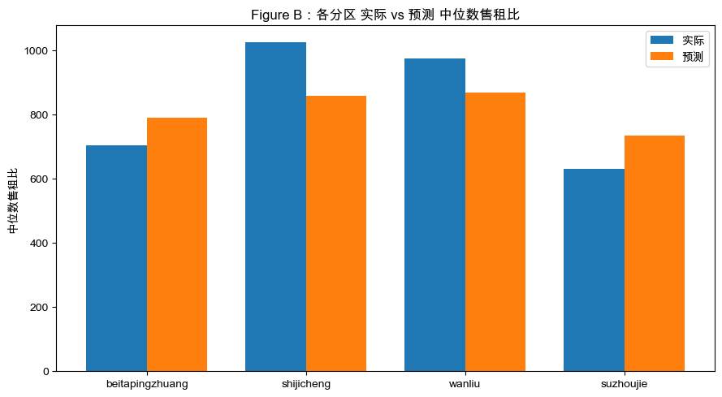

=== R² on TOTAL DATA ===

Price (linear) : R² = 0.3064

Price (quadr.) : R² = 0.3064

Rent (linear) : R² = 0.0384

Rent (quadr.) : R² = 0.0418

--- Price models (coefficients) ---

Linear: y = 74285.4879 + 252.1464 * area

Quadr.: y = 74682.4146 + 247.4225 * area + 0.011242 * area^2

--- Rent models (coefficients) ---

Linear: y = 117.9363 + 0.1062 * area

Quadr.: y = 114.1484 + 0.1448 * area + -0.000059 * area^2

=== 各地区：一次 vs 二次 模型的售租比（中位数） ===

|  | **地区** | **一次模型售租比(中位数)** | **二次模型售租比(中位数)** |
| --- | --- | --- | --- |
| **0** | beitapingzhuang | 789.907856 | 802.078635 |
| **1** | shijicheng | 858.173589 | 851.935928 |
| **2** | wanliu | 867.863521 | 859.432633 |
| **3** | suzhoujie | 732.667612 | 743.611353 |

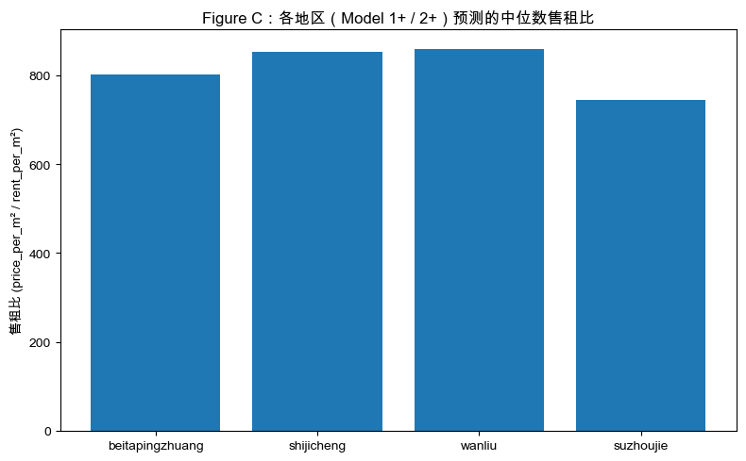

二次模拟的好一些