Yu Wang

Ziyun Shao

**Final Project Report**

1. Project Statement

Our project is about the contact. Our intention is making a contact to help pet hospital recording the information for pets. In this application, the user (hospital side) can input the name, photo, phone number, email address, last visit date and next appointment date. It is based on regular contact in Android, we add last visit date and next appointment date for this contact.

Our project is focus on hospitals, this application is benefits for hospitals. Nowadays, the world is more and more technicalization, mobile devices are important for our life. When pet hospitals use this application, they can search the information of patients very fast, the hospital will save a lot of time. And as a mobile application, it is very convenience for nurses. In the Android Maeket, there are already had some similar application. But for these applications, they have more founctions.

1. Application Design

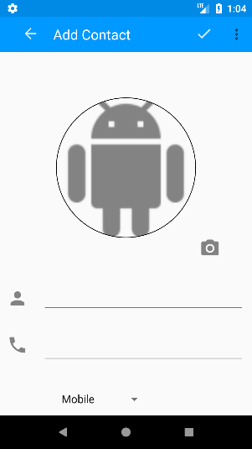Here is our input activity. Users can upload photo from gallery or take a picture, and input the basic information in this activity. And then click the “√” on the top, save to the database.

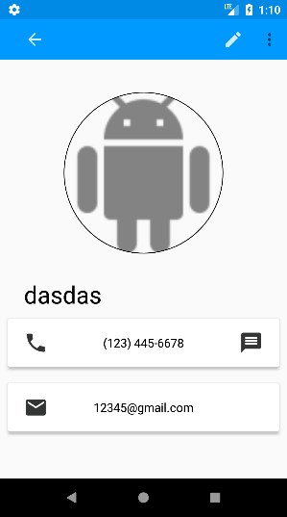This is the view activity. In this activity, the phone number and email will be shown, and user can click C:\Users\YUWANG~1\AppData\Local\Temp\1513836843(1).png button to do the secondary edition. Also, 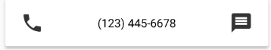 click left button, users can call the number, and right button for message.

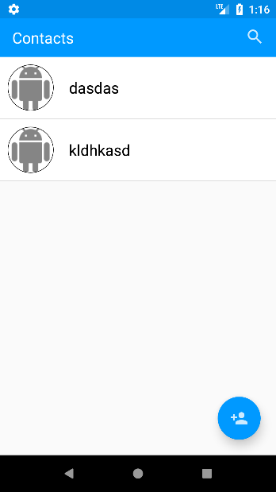This is the main activity for this app. In main activity, it lists all name sorted by alphabet. Also, I created a search bar for searching. You can search the name of the pet, and the app will show more information.

1. Application Implementation and Evaluation

This app has 5 basic function, for adding, viewing, editing, database, list. MainFunction can call them for running.

It was running well. I want to add more features, then ruin it… I still working on checking where the problem is.

1. Reference

Android Developer

<https://github.com/hdodenhof/CircleImageView> (For image viewing)

<https://github.com/nostra13/Android-Universal-Image-Loader> (For image loading)

1. Experiences and Thoughts.

In this project, we have learned lot of things. First of all, we know the datebase much better, and learn how to design more than one activites in one app. Also, according the presentation, we got lots new idea to enrich our proect.

I think the biggest changelle is R file. We have remade lots version of proeject because R file sometime disappear suddenlty, and cannot generate again.