# Report of Guided Capstone Project One: Big Mountain Resort

## 1. Problem Identification

The problem statement for this project to be solved can be demonstrated as: What ticket pricing strategy can help Big Mountain by the end of the current financial year to recover the new equipment investment and operating costa and to increase the profit without undermining the ticket price?

Big Mountain Resort is a ski resort located in Montana offers spectacular ski services to skiers and riders of all levels with professional configurations. Recently, Big Mountain Resort has installed an additional chair lift. To recover the investment and increase the profit , the company wants to find a new pricing strategy with a good sense of how important some facilities are compared to others by cutting costs without undermining the ticket price or setting an even higher ticket price.

## 2. Recommendation and key findings

Big Mountain Resort has been reviewing potential scenarios for either cutting costs or increasing revenue (from ticket prices). Ticket price is not determined by any set of parameters; the resort is free to set whatever price it likes. However, the resort operates within a market where people pay more for certain facilities, and less for others. Being able to sense how facilities support a given ticket price is valuable business intelligence. This is where the utility of our model comes in.

The business has shortlisted 4 options:

1. Permanently closing down up to 10 of the least used runs. This doesn't impact any other resort statistics.
2. Increase the vertical drop by adding a run to a point 150 feet lower down but requiring the installation of an additional chair lift to bring skiers back up, without additional snow making coverage
3. Same as number 2, but adding 2 acres of snow making cover
4. Increase the longest run by 0.2 mile to boast 3.5 miles length, requiring an additional snow making coverage of 4 acres

The expected number of visitors over the season is 350,000 and, on average, visitors ski for five days. Assume the provided data includes the additional lift that Big Mountain recently installed.

### 2.1 Scenario 1

As shown in the figure below, the model says closing one run makes no difference. Closing 2 and 3 successively reduces support for ticket price and so revenue. If Big Mountain closes down 3 runs, it seems they may as well close down 4 or 5 as there's no further loss in ticket price. Increasing the closures down to 6 or more leads to a large drop.

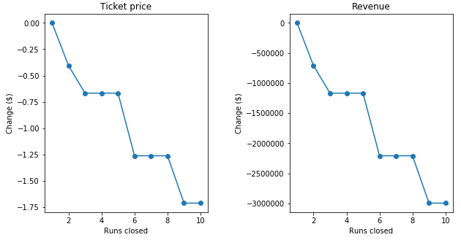

### 2.2 Scenario 2

In this scenario, Big Mountain is adding a run, increasing the vertical drop by 150 feet, and installing an additional chair lift.

The outcome of the model predicts that this scenario increases support for ticket price by $8.46. Over the season, the revenue could be expected to amount to $14811594

### 2.3 Scenario 3

In this scenario, Big Mountain is adding 2 acres of snow making. The model predicts that this scenario increases support for ticket price by $9.75. Over the season, the revenue could be expected to amount to $17068841

### 2.4 Scenario 4

This scenario calls for increasing the longest run by 0.2 miles and guaranteeing its snow coverage by adding 4 acres of snow making capability. The results predicted by the model show that there is no price and revenue changes.

The comparison between the 4 scenarios shows that the best scenario having the highest revenue increase is scenario 3. Therefore, we recommend Big Mountain to add 2 acres of snow making.