**MFKZIZ004**

**P4 Assignment**

**Question 1: Why I chose this region?**

I chose the West coast of South Africa because it is influenced by the Benguela current which gives the area cool temperatures. The region also experiences constant upwellings. It is interesting because vast marine life is supported in this region. Additionally, most kelp species grow well in this region, and I was hopeful that the maps will show which areas are most productive through the chlorophyll concentrations. This variation was also going to show me why areas such as Saldanha Bay are being used as aquaculture sites.

The datasets that were used in this assignment were from the ESA-CCI Ocean Colour Climatology and the Global Multi-Resolution Topography Data Synthesis (GMRT) websites. The ESA-CCI Ocean Colour Climatology website provided netCDF file that contains chlorophyll-a concentrations with a resolution spanning over 4 km. The bathymetry data was obtained from the Global Multi-Resolution Topography Data Synthesis (GMRT) website. These two datasets were loaded into python as paths for further analysis.

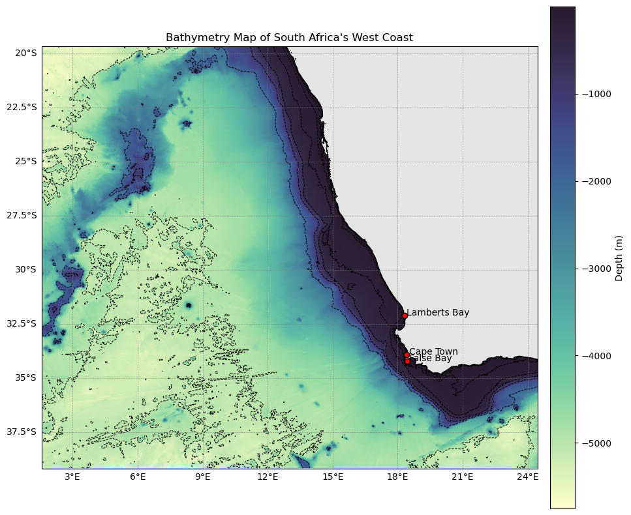

**Figure 1.** Map showing the bathymetry of the West Coast of South Africa. Near the coast the depth is shallow and as you move into the ocean the depth increases.

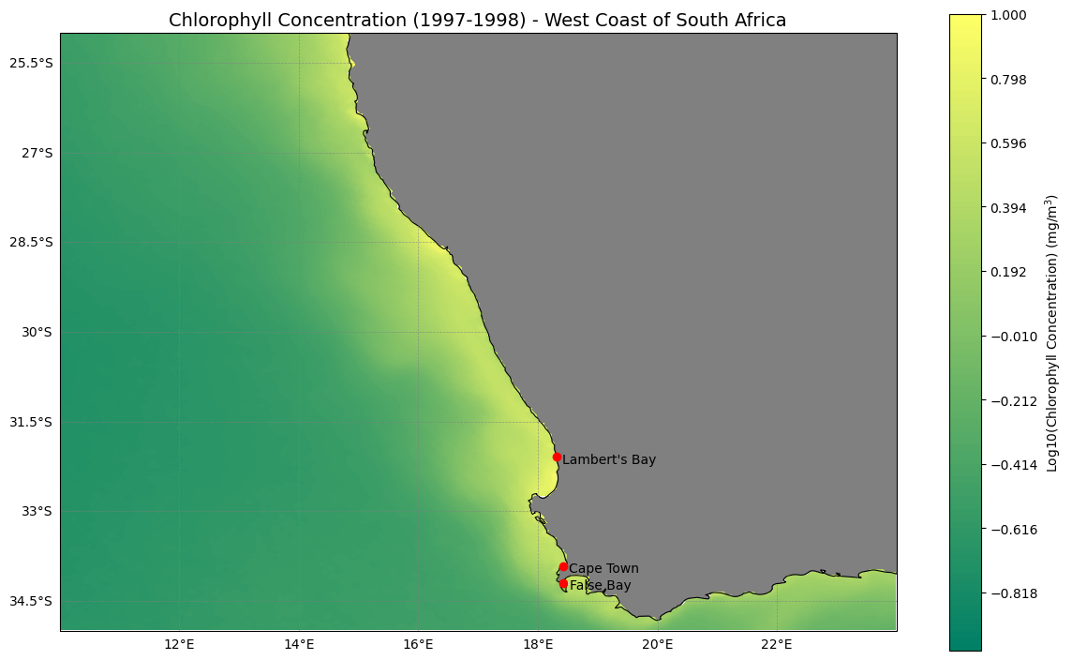

**Figure 2.** Map showing the log chlorophyll concentrations of along the West Coast of South Africa. Near the coast the chlorophyll concentrations are high, and this shows that those regions have higher productivity compared to other regions.

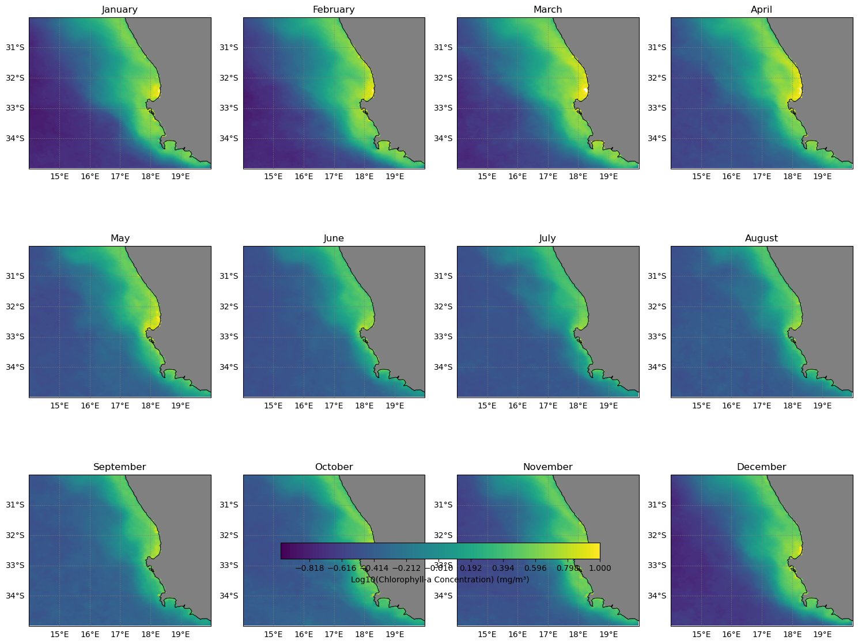

**Figure 3**. An annual faceted map showing the distribution of chlorophyll-a (mg/m³) along the west coast of South Africa. The plots show the variations in regional marine productivity.

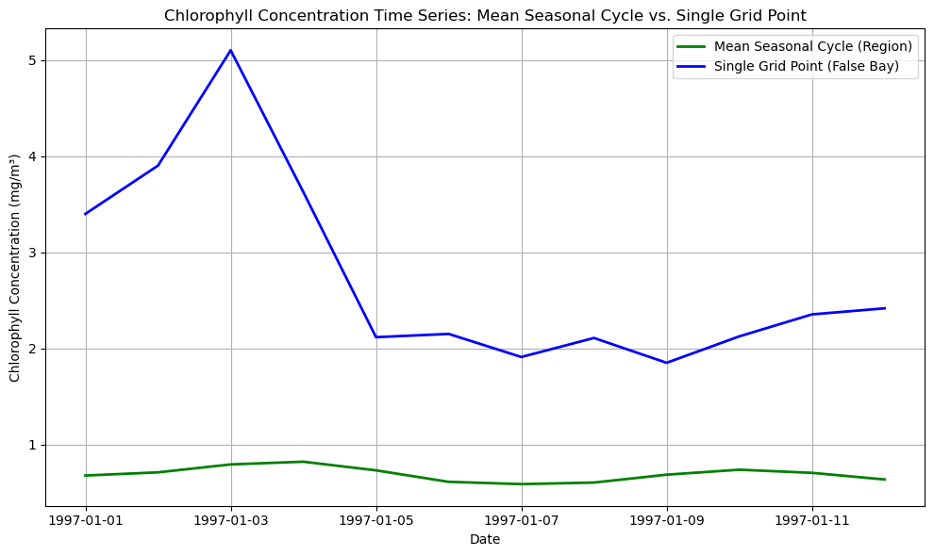

**Figure 4.** A time series showing the mean seasonal for the entire region (West Coast of South Africa) and the single point (False Bay) chlorophyll concentrations. There is much chlorophyll variations occurring at False Bay compared to the entire region. This may be the diurnal and nocturnal changes impacted by microorganisms such as phytoplankton.